Victorian Greenhouse Gas Emissions Report 2018

Acknowledgment
We are committed to genuinely partner, and meaningfully engage, with Victoria's Traditional Owners and Aboriginal communities to support the protection of Country, the maintenance of spiritual and cultural practices and their broader aspirations in the 21st century and beyond.

© The State of Victoria Department of Environment, Land, Water and Planning 2020
This work is licensed under a Creative Commons Attribution 4.0 International licence. You are free to re-use the work under that licence, on the condition that you credit the State of Victoria as author. The licence does not apply to any images, photographs or branding, including the Victorian Coat of Arms, the Victorian Government logo and the Department of Environment, Land, Water and Planning (DELWP) logo. To view a copy of this licence, visit http://creativecommons.org/licenses/by/4.0/
Printed by Finsbury Green, Port Melbourne
ISSN 2652-8495 (online PDF/Word)
ISSN 2652-8932 (print)

Disclaimer
This publication may be of assistance to you but the State of Victoria and its employees do not guarantee that the publication is without flaw of any kind or is wholly appropriate for your particular purposes and therefore disclaims all liability for any error, loss or other consequence which may arise from you relying on any information in this publication

Accessibility
If you would like to receive this publication in an alternative format, please telephone the DELWP Customer Service Centre on 136186, email customer.service@delwp.vic.gov.au, or via the National Relay Service on 133 677 www.relayservice.com.au. This document is also available on the internet at www.delwp.vic.gov.au.

Contents
Minister’s foreword 4
Summary 5
Introduction 7
1. Victorian emissions and indicators – 1990 to 2018 8
1.1 Emissions 1990 to 2018 8
1.2 Change in emissions since 2005 9
1.3 Victoria’s contribution to national emissions 10
1.4 Per capita emissions 11
1.5 Emissions and Gross State Product 11
2. Emissions by sector (IPCC categories) 13
2.1 Energy 16
2.1.1 Electricity generation 16
2.1.2 Direct combustion 20
2.1.3 Transport 24
2.1.4 Fugitive emissions from fuels 29
2.2 Industrial processes and product use 31
2.3 Waste 33
2.4 Agriculture 36
2.5 Land Use, Land-Use Change and Forestry 40
3. Emissions by economic sector – 2018 46
3.1 Direct emissions by economic sector 46
3.2 Allocation of emissions from electricity generation to end-users 47
3.3 Direct plus indirect emissions by economic sector 48
Appendix A 50
Revision of historical greenhouse gas emissions data 50
Appendix B 52
LULUCF definitions, sources and removals 52
Appendix C 55
Changes in LULUCF emissions estimates between the 2017 and 2018 Victorian Greenhouse Gas Emissions Reports 55
Abbreviations and acronyms 58
Reference List 59

Minister’s foreword
The Victorian Government is focused on taking strong and lasting action on climate change. This commitment is enshrined in our world-leading legislation: the Climate Change Act 2017. The Act establishes a target of net zero greenhouse gas emissions by 2050 and, as shown in this report, Victoria’s emissions are reducing strongly on the pathway towards this target.
Victorian climate action recognises the scientific consensus that meeting the goals of the Paris Agreement – to limit global average temperature increases to well below 2ºC above pre-industrial levels and to pursue efforts to limit the increase to 1.5ºC – will require global greenhouse gas emissions to decline to net zero by the second half of this century.
The Paris Agreement also establishes the basis for harmonised measurement, reporting and verification of emissions to enable a common system of transparency. Although this system only applies to national signatories to the Agreement, Victoria – along with a number of sub-national jurisdictions – is demonstrating leadership by measuring and reporting emissions at the state level.
As part of the statutory foundation for action in Victoria, the Climate Change Act 2017 requires the preparation of annual reports on Victoria’s greenhouse gas emissions.
The Victorian Greenhouse Gas Emissions Report 2018 is the third of these reports and has been prepared in accordance with the Act’s requirements. By releasing annual emissions reports, the Victorian Government is providing transparency through the public disclosure of Victoria’s emissions.
Annual emissions reports provide important data and analysis which inform the Victorian Government’s climate change policy, particularly the setting of the five-yearly interim emissions reduction targets and preparation of sector pledges, as required by Victoria’s Climate Change Act 2017.
I trust all Victorians will find this report informative in understanding the sources of, and trends in, Victoria’s greenhouse gas emissions.
The Hon. Lily D’Ambrosio MP
Minister for Energy, Environment and Climate Change
Minister for Solar Homes

Summary
This Victorian Greenhouse Gas Emissions Report 2018 is the third in a series of annual emissions reports required by Victoria’s Climate Change Act 2017 (the Act). It contains:
- an overview of the state’s greenhouse gas emissions from 1990 to 2018 with a focus on the change since 2005 (the reference year for interim emissions reduction targets under the Act)
- an explanation of sources of emissions and trends over time, including likely drivers for those trends.

Key points are:
- Victoria’s total net emissions in 2018 were 102.2 million tonnes (Mt) of carbon dioxide equivalent (CO₂-e)
- These consisted of emissions from electricity generation (45.4% of net emissions), transport (22.9%), direct combustion (17.4%), agriculture (15.3%), industrial processes and product use (3.8%), fugitive emissions from fuels (3.8%) and waste (2.5%).
- Land use, land-use change and forestry (LULUCF) provided net sequestration of 11.4 Mt CO₂-e (-11.2% of net emissions) – that is, the sector absorbed more emissions than it generated.
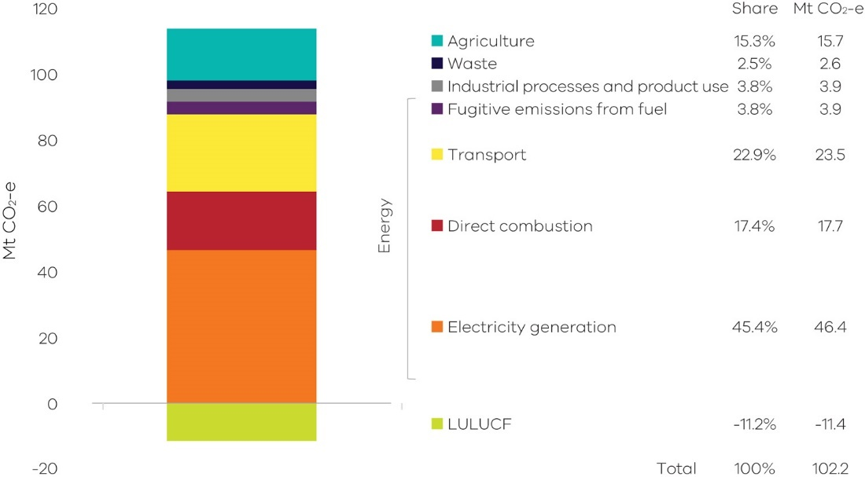
Figure 1: Victorian emissions by sector and energy sub-sector, 2018
Source: Australian Greenhouse Emissions Information System (DISER 2020b)
*Note – numbers may not sum due to rounding

- Victoria’s total net emissions fell by 21.6 Mt CO₂-e (17.5%) between 2005 and 2018
- Key contributors to this reduction were electricity generation, which saw emissions fall by 17.1 Mt CO₂-e (79% of the change in net emissions) and the LULUCF sector, which increased sequestration by 6.7 Mt CO₂-e (31% of the change in the state’s total net emissions).
- Reductions in emissions also occurred in waste (1.3 Mt CO₂-e), agriculture (1.1 Mt CO₂-e), and direct combustion (0.7 Mt CO₂-e).
- Emissions increased in transport (3.2 Mt CO₂-e), fugitive emissions from fuels (1.4 Mt CO₂-e) and industrial processes and product use (0.7 Mt CO₂-e).
- Between 2005 and 2018, the emissions intensity of the Victorian economy declined 41% from 0.40 to 0.24 kilograms (kg) CO₂-e per dollar of Gross State Product. Per capita emissions decreased 36%, from 24.8 to 15.8 tonnes (t) CO₂-e per person.
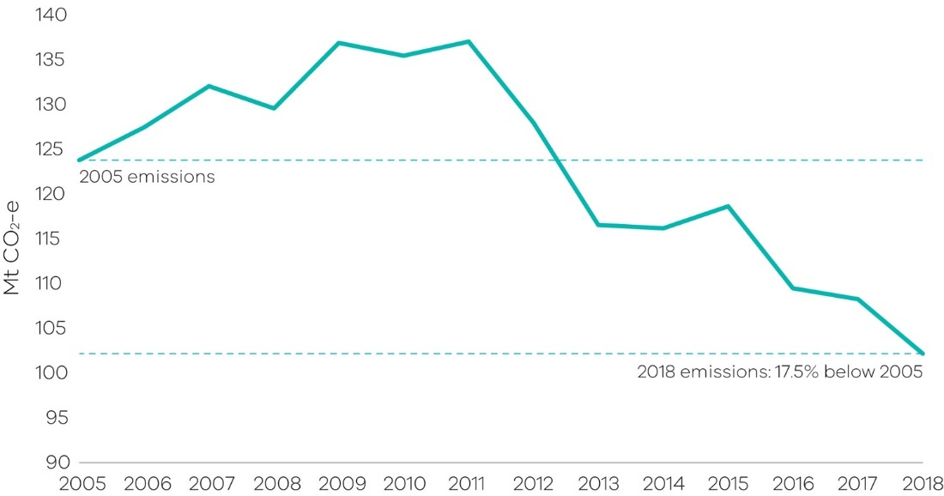
Figure 2: Victorian total net emissions, 2005-2018
Source: Australian Greenhouse Emissions Information System (DISER 2020b)

Introduction
Section 52 of the Climate Change Act 2017 (the Act) requires the Minister administering the Act to prepare annual greenhouse gas emissions reports for Victoria. The Act requires the annual reports to include an overview and collation of the best practicably available information about Victoria’s greenhouse gas emissions, and the extent to which greenhouse gas emissions have been reduced compared with 2005 levels (the reference year for emissions reduction targets under the Act).
This Victorian Greenhouse Gas Emissions Report presents information on Victoria’s emissions in two forms:
- reporting of emissions in accordance with sectors defined by the Intergovernmental Panel on Climate Change (IPCC) reporting framework for national greenhouse gas inventories, with disaggregation of data in the energy sector
- reporting of emissions by sectors of the economy categorised under the Australian and New Zealand Standard Industrial Classification (ANZSIC).
Data for the report is sourced from State and Territory Greenhouse Gas Inventories released in May 2020 by the Commonwealth Department of Industry, Science, Energy and Resources (DISER), and the Australian Greenhouse Emissions Information System online database. Both sources provide data at a state and territory level over the period 1990 to 2018. This is the most recent official data in Australia on annual greenhouse gas emissions. The data relates to production-based rather than consumption-based emissions in Victoria – that is, it accounts for emissions from goods and services produced in, and exported from, Victoria. This is in accordance with United Nations Framework Convention on Climate Change’s (UNFCCC) emissions accounting provisions. Throughout the report, numbers may not sum precisely to the totals due to rounding.
The DISER revises greenhouse gas data annually, consistent with international practices, to reflect improved estimation methods and updated data sources. As a result, some of the emissions data presented in this report for the years 1990 to 2017 vary from those presented in the Victorian Greenhouse Gas Emissions Report 2017 (see Appendix A).
Economic and population statistics for Victoria were used to calculate emissions intensity measures and to obtain insights into trends in the state’s emissions.
This report is structured as follows:
Chapter 1 presents the trend in Victoria’s emissions over the period 1990 to 2018, Victoria’s contribution to national emissions, and Victorian emissions per capita and per unit of Gross State Product (GSP).
Chapter 2 presents Victorian emissions by sector using Intergovernmental Panel on Climate Change (IPCC) sector categories. It describes historical trends in emissions in each sector and the key drivers of these trends.
Chapter 3 presents Victorian emissions by economic sector based on the Australian and New Zealand Standard Industry Classification (ANZSIC).

Victorian emissions and indicators – 1990 to 2018

1.1 Emissions 1990 to 2018
Victoria’s total net emissions generally fell from 1990 to 1996, rose to 2011, then fell again to 2018 (Figure 3). In 2018, total net greenhouse gas emissions were 7.3 million tonnes (Mt) of carbon dioxide equivalent (CO₂-e) (6.7%) lower than in 1990. Emissions decreased by 6.1 Mt CO₂-e (5.6%) between 2017 and 2018.
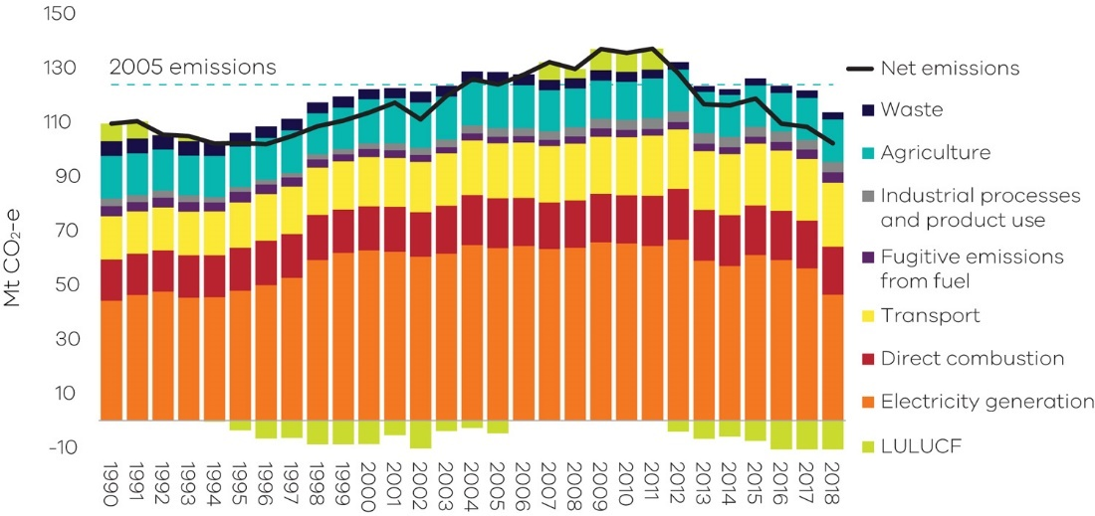
Figure 3: Total net emissions and emissions by sector – Victoria, 1990 to 2018
Source: Australian Greenhouse Emissions Information System (DISER 2020b)

Chapter 2 discusses the trends in sectoral emissions including the key factors driving these trends.

1.2 Change in emissions since 2005
The Act requires that Victoria’s greenhouse gas emissions reduction targets are set with 2005 as the reference year. Emissions fell by 21.6 Mt CO₂-e (17.5%) from 123.8 Mt CO₂-e in 2005 to 102.2 Mt CO₂-e in 2018 (Figure 4). As such, Victoria’s 2018 emissions have fallen to within the range of Victoria’s 2020 emissions reduction target of 15-20% below 2005 levels.
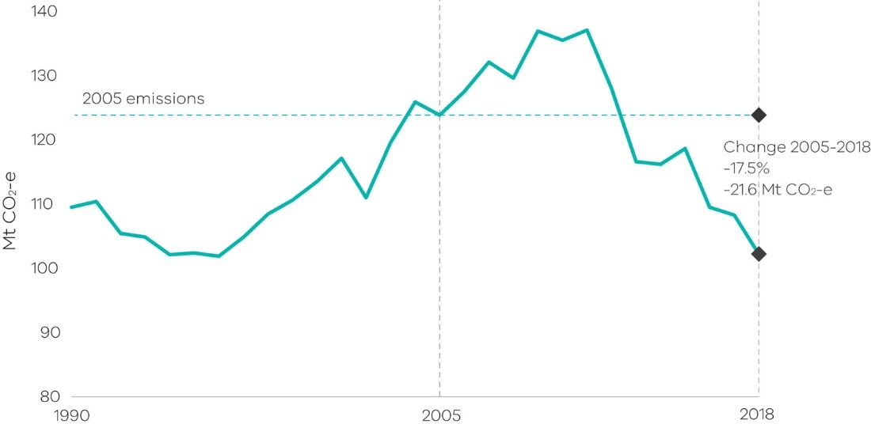
Figure 4: Trend in net emissions – Victoria, 2005 to 2018
Source: State and Territory Greenhouse Gas Inventories 2018 (DISER 2020e)

1.3 Victoria’s contribution to national emissions
Figure 5 shows that in 2018, Victoria was the third largest contributor to Australia’s total net emissions (19%), behind Queensland (32%) and New South Wales (25%).
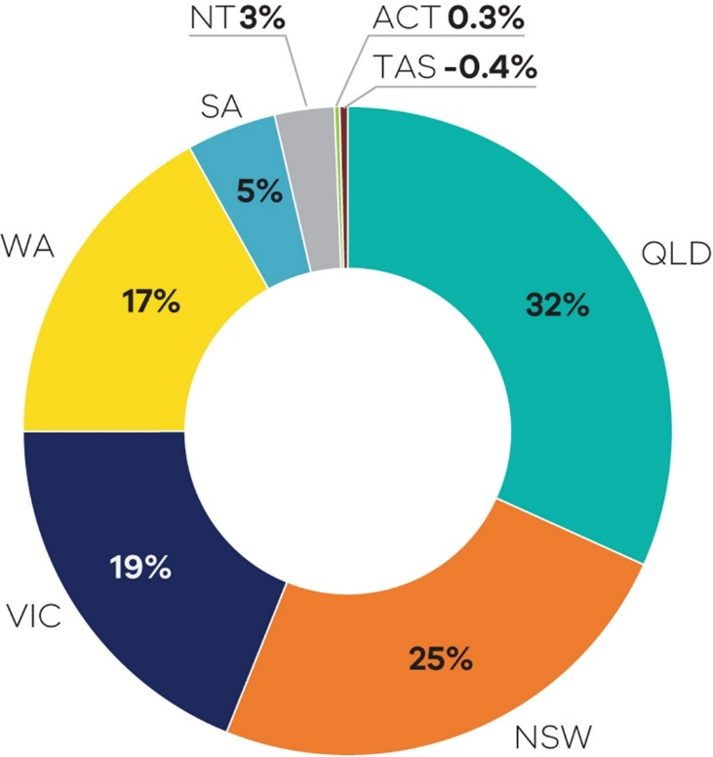
Figure 5: Contribution to national emissions by state and territory, 2018
Source: State and Territory Greenhouse Gas Inventories 2018 (DISER 2020e)
Figure 6 shows that Victoria’s share of Australia’s total net emissions increased from 18% in 1990 to a peak of 24% in 2011, before declining to 19% in 2018.
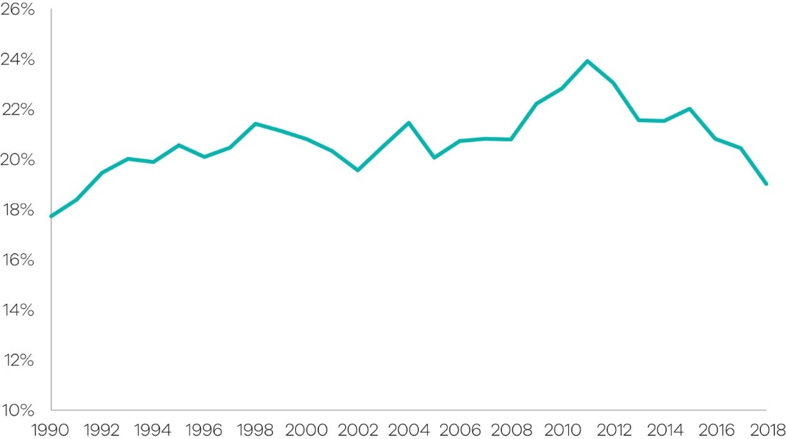
Figure 6: Contribution to national emissions – Victoria, 1990 to 2018
Source: State and Territory Greenhouse Gas Inventories 2018 (DISER 2020e)

1.4 Per capita emissions
Victoria’s per capita emissions of 15.8 tonnes (t) CO₂-e in 2018 were less than the national average (21.5 t CO₂-e), lower than the Northern Territory, Western Australia, Queensland and New South Wales, but higher than Tasmania, the Australian Capital Territory and South Australia (Figure 7).
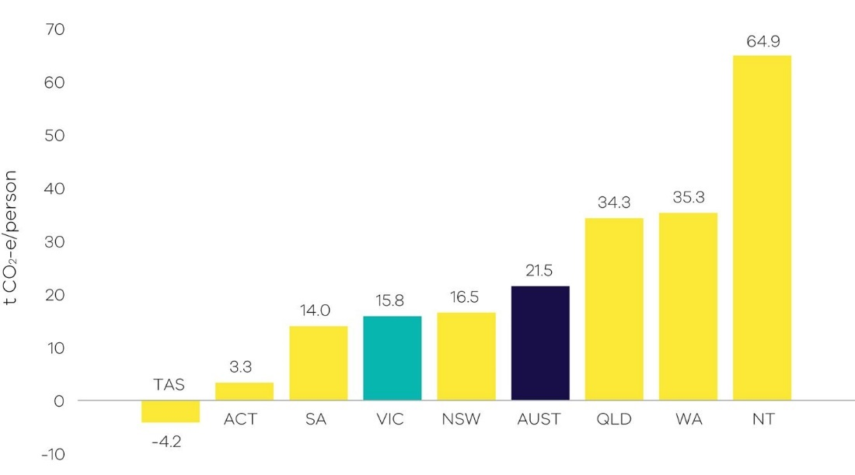
Figure 7: Per capita emissions in Australia and by state and territory, 2018
Source: Analysis based on State and Territory Greenhouse Gas Inventories 2018 (DISER 2020e) and Australian Demographic Statistics 2019 (ABS 2020) Note: Tasmania’s per capita emissions of -4.2 Mt CO₂-e largely reflect increased carbon sequestration in the LULUCF sector since 2005.
Victoria’s per capita emissions decreased from 25.0 to 15.8 t CO₂-e between 1990 and 2018. The majority of this decline took place from 2011 to 2018, when per capita emissions fell from 24.8 to 15.8 t CO₂-e (36%) – see Figure 8.
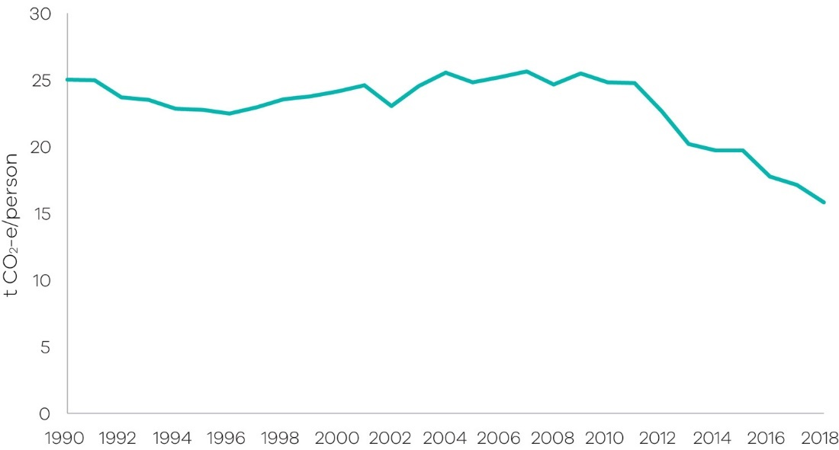
Figure 8: Trend in per capita emissions – Victoria, 1990 to 2018
Source: Analysis based on State and Territory Greenhouse Gas Inventories 2018 (DISER 2020e) and Australian Demographic Statistics 2019 (ABS 2020)

1.5 Emissions and Gross State Product
Victoria is transitioning to a less emissions intensive economy (Figure 9). Between 1990 and 2018, real GSP grew by 120% while emissions fell by 7%, resulting in a decline in the emissions intensity of the Victorian economy from 0.56 to 0.24 kg CO₂-e per $ GSP – a reduction of 58% (see Figure 10).
From 2005 to 2018, real GSP grew 39% while emissions fell by 17.5%. This resulted in a 40% reduction in emissions intensity from 0.40 to 0.24 kg CO₂-e per $ GSP.
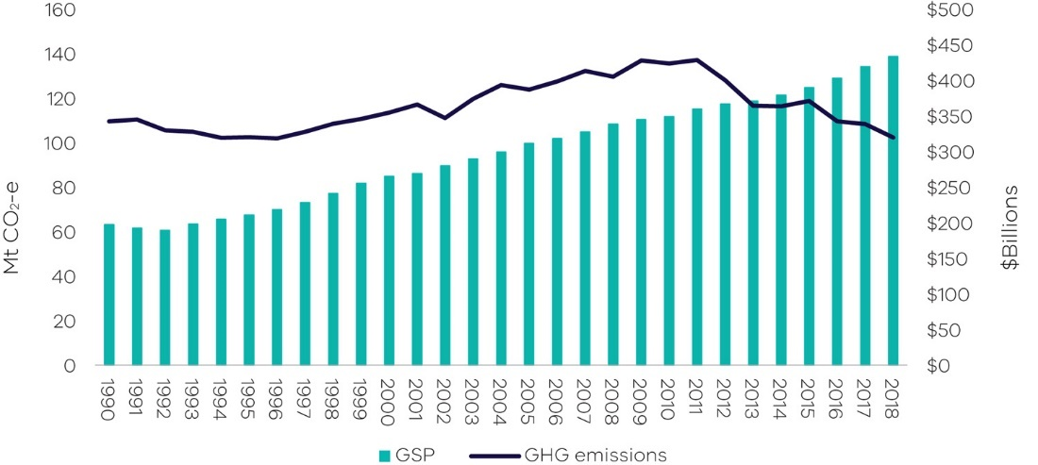
Figure 9: Greenhouse gas emissions and real GSP – Victoria, 1990 to 2018
Source: Analysis based on State and Territory Greenhouse Gas Inventories 2018 (DISER 2020e) and Australian National Accounts: State Accounts, 2017-18 (ABS 2019).

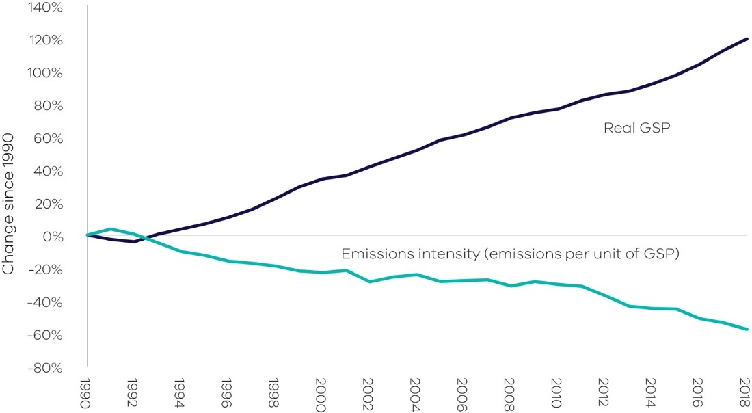
Figure 10: Percentage change in real GSP and emissions intensity – Victoria, 1990 to 2018
Source: Analysis based on State and Territory Greenhouse Gas Inventories 2018 (DISER 2020e) and Australian National Accounts: State Accounts, 2017-18 (ABS 2019).

Emissions by sector (IPCC categories)

This chapter presents information on Victoria’s greenhouse gas emissions by sector, the activities that drive these emissions and the key factors that have influenced emissions trends in each sector. Sectors are based on the five categories identified in Intergovernmental Panel on Climate Change (IPCC) international guidelines, namely:
- Energy
- Industrial processes and product use
- Agriculture
- Land use, land-use change and forestry (LULUCF)
- Waste.
Due to the significance of the energy sector in Victoria, this sector is disaggregated into four sub-sectors: electricity generation; direct combustion from stationary sources; transport; and fugitive emissions from fuels.
The National Inventory Report 2018 (DISER 2020d) is the primary source of information for the activities that drive sectoral emissions. Commonwealth Government statistics for Victoria, academic and Victorian Government publications and consultation with experts were used to obtain further insights into the factors that influenced sectoral emissions trends over the period 1990 to 2018. Figure 11 presents the share of Victoria’s net emissions in 2018 by sector and energy sub-sectors.
Figure 11: Victorian emissions by sector and energy sub-sectors, 2018
Source: Australian Greenhouse Emissions Information System (DISER 2020b)
*Note – numbers may not sum due to rounding
Figure 12 presents emissions by sector in 1990, 2005 and 2018. Key points to note include:
- emissions from electricity generation, direct combustion and agriculture increased between 1990 and 2005, but declined between 2005 and 2018
- emissions from transport, and industrial processes and product use increased between 1990 and 2005 and continued to increase to 2018
- emissions from the LULUCF and waste sectors declined between 1990 and 2005 and continued to do so to 2018.
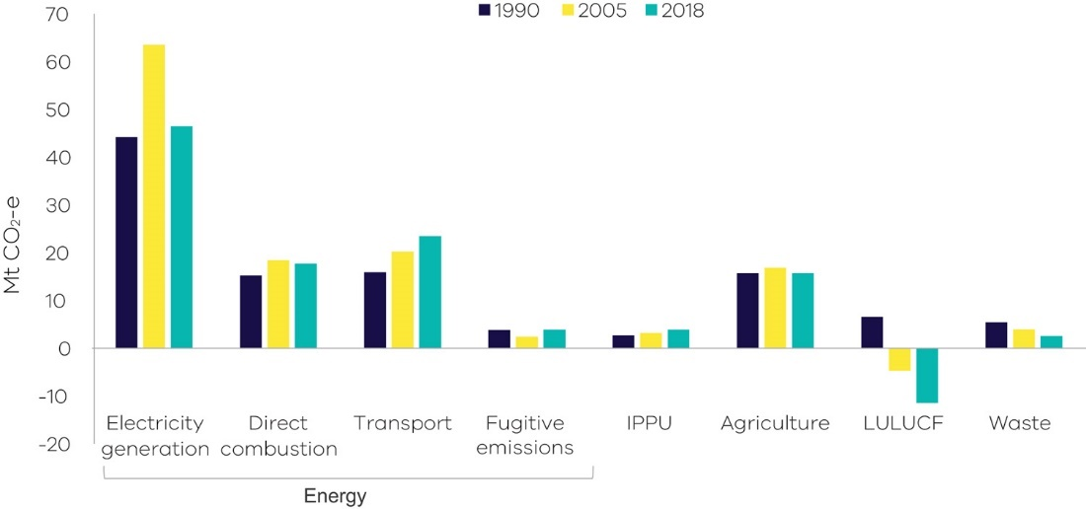
Figure 12: Emissions by sector – 1990, 2005 and 2018
Source: Australian Greenhouse Emissions Information System (DISER 2020b)
Table 1 and Figure 13 provide further details on the scale of change in sectoral emissions between 2005 and 2018. The electricity generation sub-sector experienced the largest reduction in net emissions, followed by LULUCF, waste, agriculture and direct combustion.

Table 1: Change in emissions by sector / sub-sector between 2005 and 2018, Victoria
Sector | 2005  Mt CO₂-e | 2018  Mt CO₂-e | Change 2005 to 2018  Mt CO₂-e
Electricity generation | 63.5 | 46.4 | -17.1 | ↓
Direct combustion | 18.4 | 17.7 | -0.7 | ↓
Transport | 20.2 | 23.5 | 3.2 | ↑
Fugitive emissions | 2.4 | 3.9 | 1.4 | ↑
IPPU | 3.2 | 3.9 | 0.7 | ↑
Agriculture | 16.8 | 15.7 | -1.1 | ↓
LULUCF | -4.7 | -11.4 | -6.7 | ↓
Waste | 3.9 | 2.6 | -1.3 | ↓
Total (net emissions) | 123.8 | 102.2 | -21.6 | ↓
Source: Australian Greenhouse Emissions Information System (DISER 2020b)
*Note – numbers may not sum due to rounding
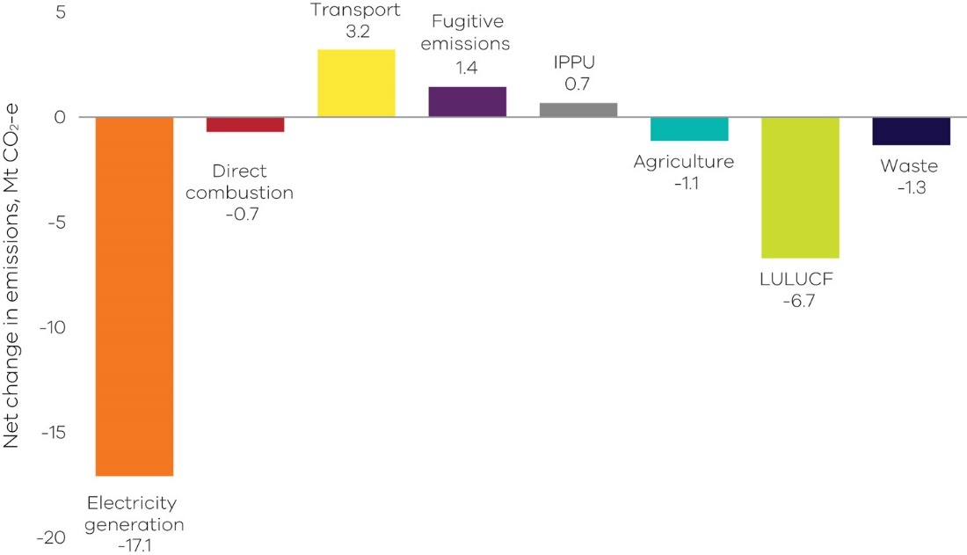
Figure 13: Change in emissions between 2005 and 2018 by sector / sub-sector, Victoria
Source: Australian Greenhouse Emissions Information System (DISER 2020b)

2.1 Energy
The energy sector – which comprises electricity generation, direct combustion, transport and fugitive emissions from fuels – produced 89.5% of Victoria’s total net emissions in 2018. Figure 14 provides a breakdown of emissions by each energy sub-sector.
Figure 14: Energy sub-sectors and their contributions to total net emissions in Victoria, 2018
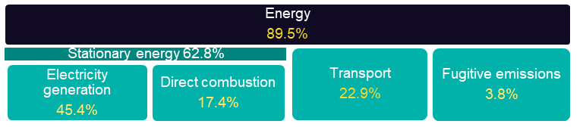

Source: Australian Greenhouse Emissions Information System (DISER 2020b)
The following sections discuss emissions trends for each energy sub-sector.

2.1.1 Electricity generation
Sources of emissions
Emissions from electricity generation arise from the combustion of fuels to generate power that is supplied to the electricity grid.
Consistent with international accounting provisions, this sub-sector covers emissions released from electricity generated in Victoria, some of which is exported for consumption in other states. Emissions from electricity imported from other states are not accounted for in this sub-sector.
Electricity generation in Victoria
In 2018, emissions from electricity generation accounted for a little under half of Victoria’s total net emissions. Approximately 76% of the state’s electricity was generated by brown coal-fired power stations, down from 83% in 2017 (DISER 2020a). Three brown coal-fired power stations were operating in 2018, all located in the Latrobe Valley: Yallourn, Loy Yang A and Loy Yang B. These power stations produced 42.7% of Victoria’s total net emissions (Table 2) in 2018. Additional emissions from the 8.1% of electricity generated in Victoria from gas brings the total emissions contribution of electricity generation to 45.4% (Figure 15).
In 2018, renewables accounted for 15.5% of Victorian electricity generation and produced zero emissions.
Table 2: Electricity production and emissions from Victorian brown coal-fired power plants in 2018
Facility | Electricity production (MWh) | Total direct emissions  (Mt CO₂-e) | Share of Victoria's net greenhouse gas emissions
Loy Yang A Power Station | 16,951,912 | 19.9 | 19.4%
Yallourn Power Station | 10,238,920 | 13.7 | 13.4%
Loy Yang B Power Station | 8,870,476 | 10.1 | 9.9%
Total | 36,061,308 | 43.7 | 42.7%
Source: Analysis based on Greenhouse and energy information for designated generation facilities 2017-18 (CER 2019)
Emissions trends and drivers
Emissions from electricity generation rose from 1990 until the mid-2000s and then were relatively steady from 2005 until their peak in 2012, followed by an overall downward trend (Figure 15). The drivers of these historical trends are discussed further in Box 1.
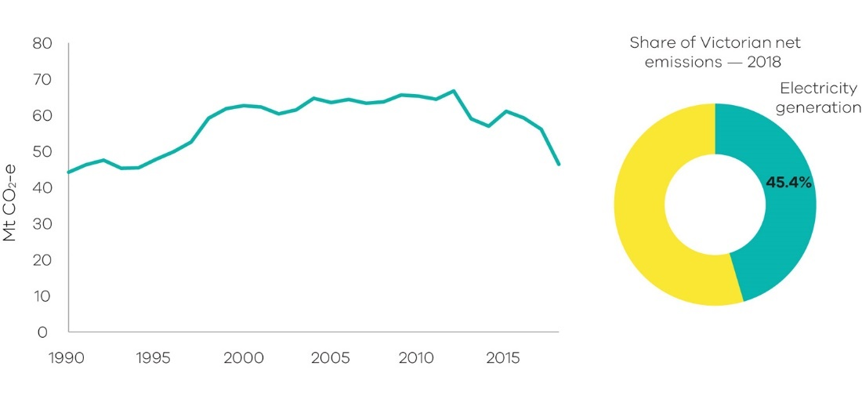
Figure 15: Emissions from electricity generation – Victoria, 1990 to 2018
Source: Australian Greenhouse Emissions Information System (DISER 2020b)
Electricity generation emissions have declined consistently since 2016. Over this period, renewable energy generation increased while emissions reduced with the closure of Hazelwood Power Station in March 2017 (Australian Energy Regulator 2018).
Over the two years between 2016 and 2018, emissions fell by 12.8 Mt CO₂-e, which is slightly less than Hazelwood’s 2016 emissions of 14.4 Mt CO₂-e. A small increase in production by other Victorian fossil fuel generators partially offset the reduction in emissions from the closure of Hazelwood:
- Emissions from the remaining coal-fired power stations increased by 0.6 Mt CO₂₋e between 2016 and 2018.
- In addition, gas-fired electricity generation increased in response to periods of high demand (AEMO 2020). Gas remains a small fraction of Victoria’s overall generation mix, producing 1.7 Mt CO₂-e in 2018 (CER 2019).

In June 2016, the Victorian Government committed to Victorian Renewable Energy Targets of 25% by 2020 and 40% by 2025. Between 2016 and 2018, zero emissions renewable electricity generation increased from 11.7% to 15.5% of total electricity generation. The major contributors in 2018 were wind (9.1%), solar (3.2%) and hydro (1.7%) (DISER 2020a). Over this period, the Commonwealth also had renewable energy targets in place.

Box 1: Key events and drivers for trends in emissions from electricity generation
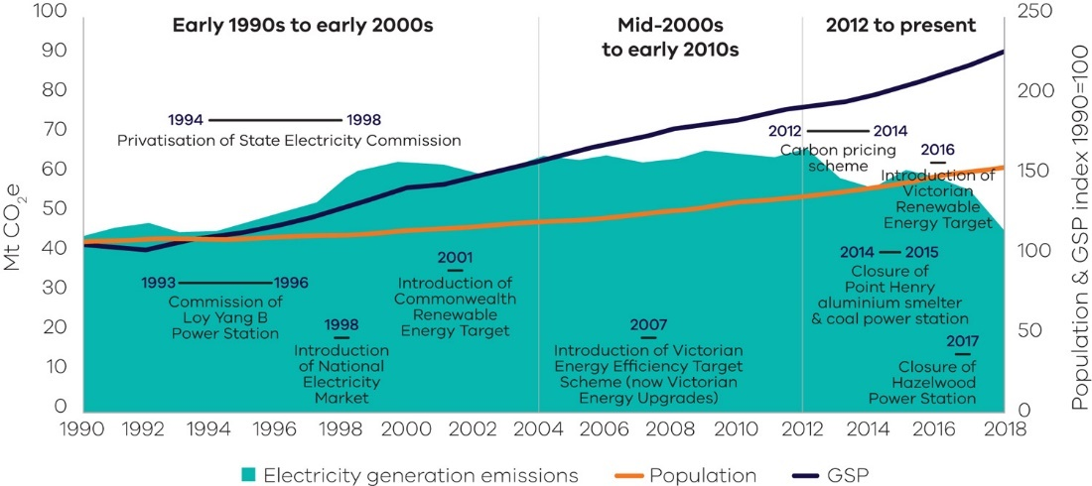
Figure 16: Emissions from electricity generation and trends in population and GSP
Early 1990s to early 2000s: The general trend of increased emissions reflected the underlying growth in Victoria’s economy and population. It also reflected the privatisation of the Victorian electricity sector in the mid- to late-1990s and the introduction of the National Electricity Market (NEM), which boosted the competitiveness of Victorian generators and saw an increase in generation volumes, including for export to other states. Loy Yang B Power Station was also commissioned in the mid-1990s. The Commonwealth Government’s Renewable Energy Target was introduced in 2001 to incentivise investment in large-scale renewable energy projects.
Mid 2000s to early 2010s: Despite continued economic growth, emissions growth flattened due to a range of factors, including a reduction in electricity demand after 2009, both in Victoria and across the NEM, as well as increased renewable electricity generation. Drivers of these trends included:
- energy efficiency and small-scale renewable energy policies and programs put in place from the early to mid-2000s that had a significant impact on residential energy consumption (Sustainabilty Victoria n.d). These include appliance Minimum Energy Performance Standards, energy efficiency standards in building regulations and the Victorian Energy Upgrades program, formerly the Victorian Energy Efficiency Target (VEET) scheme)
- a decline in Victorian manufacturing
- consumer responses to higher electricity prices
Over the decade to 2010, the installed capacity of renewables in Victoria grew from 668 megawatts (MW) to 1419 MW (Sustainabilty Victoria 2011).
2012 to present: A downward trend in emissions, with some variability, means economic and population growth is no longer correlated with emissions growth.
Over the period 2012 to 2014, emissions fell as Victoria generated less electricity from brown coal, although this was partially offset by an increase in gas-fired generation (NEM-Review 2019). The reasons for this included:
- operation of the Australian Carbon Pricing Mechanism, which commenced in July 2012 and was repealed in July 2014
- Yallourn power station generating less electricity from 2012 to 2014 due to factors including flooding of the neighbouring Yallourn coal mine (Morton 2012)
Brown coal-fired electricity emissions increased again in 2015 when Australia’s Carbon Pricing Mechanism was repealed and Yallourn became fully operational again, but dropped again in 2016 and 2017, with emissions also decreasing, due to the following factors:
- closure of the Point Henry aluminium smelter in 2014, which resulted in closure of Alcoa’s brown coal-fired Anglesea Power Station in August 2015
- the closure of Hazelwood Power Station in March 2017 and continued increase in renewable energy generation.

2.1.2 Direct combustion
Sources of emissions
Direct combustion emissions arise from burning fuels for a wide range of stationary energy activities, such as generating heat, steam or pressure for major industrial operations, and burning gas for household heating, hot water and cooking.
Activities creating these direct combustion emissions include: the production of fuels (such as oil and gas extraction and refining); and manufacturing, construction, agriculture, residential, and commercial activities.
The direct combustion sector does not include emissions from fuel combustion for either electricity generation or transport activities – these emissions are accounted for in the electricity generation and transport sectors respectively.
Direct combustion in Victoria
Residential activities are the largest source of emissions from direct combustion in Victoria, followed by manufacturing industries and construction, and fuel production (Figure 17).
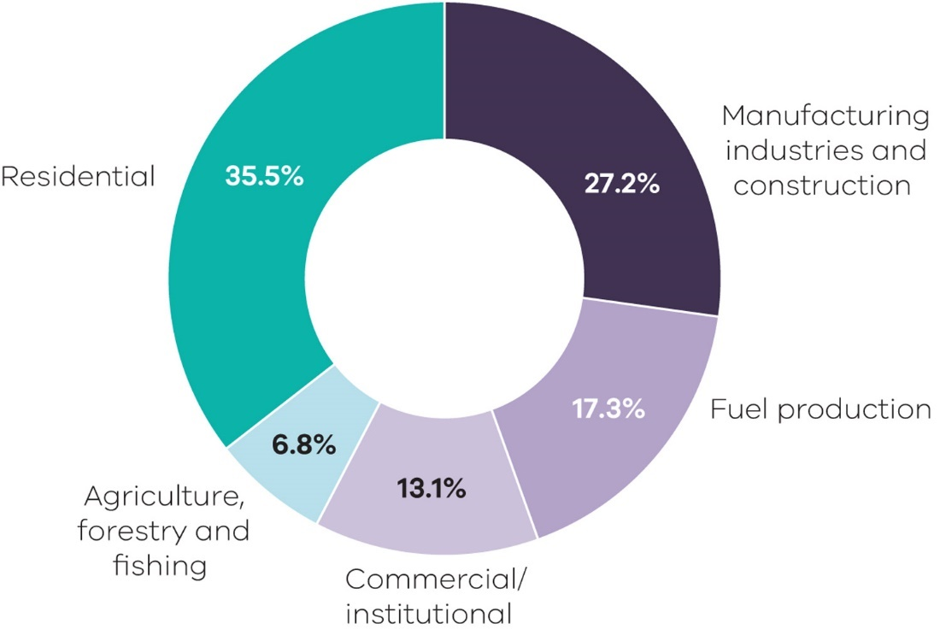
Figure 17: Direct combustion emissions by sub-categories – Victoria, 2018
Source: Australian Greenhouse Emissions Information System (DISER 2020b)
Natural gas is the major fuel used for direct combustion in Victorian industrial, commercial and residential sub-categories, representing 62% of the total fuels used in 2018. In that year, Victoria consumed a total of 237 petajoules (PJ) of natural gas in direct combustion activities, with the highest consumption in residential activities (46%), followed by manufacturing (25%) and commercial (15%) activities (DoEE 2019a).
Other fuels that contribute to direct combustion include on-site use of diesel, liquified petroleum gas and various petroleum-based oils.

Emissions trends and drivers
Direct combustion accounted for 17.4% of Victoria’s total net emissions in 2018 – the third largest share of total emissions behind electricity generation and transport. Direct combustion emissions grew from 15.2 Mt CO₂-e in 1990 to 17.7 Mt CO₂-e in 2018, with interannual variability in both total emissions for the sector and in emissions within sub-categories (Figure 18, Figure 19, Figure 20).
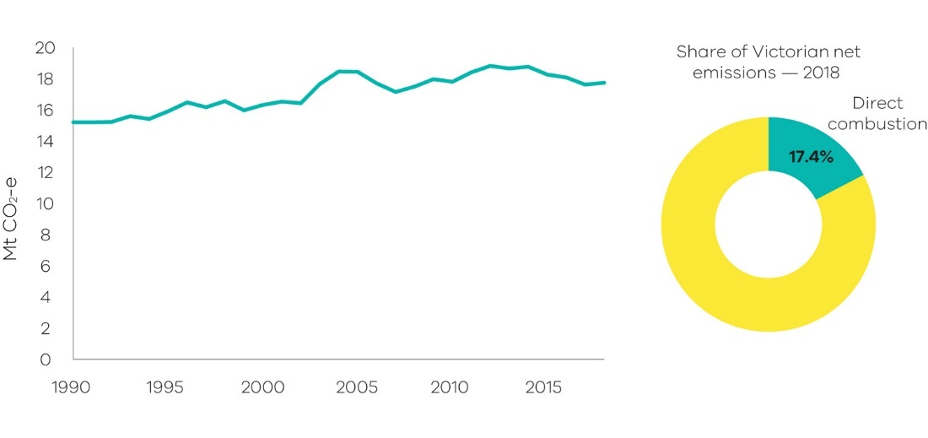
Figure 18: Emissions from direct combustion – Victoria, 1990 to 2018
Source: Australian Greenhouse Emissions Information System (DISER 2020b)

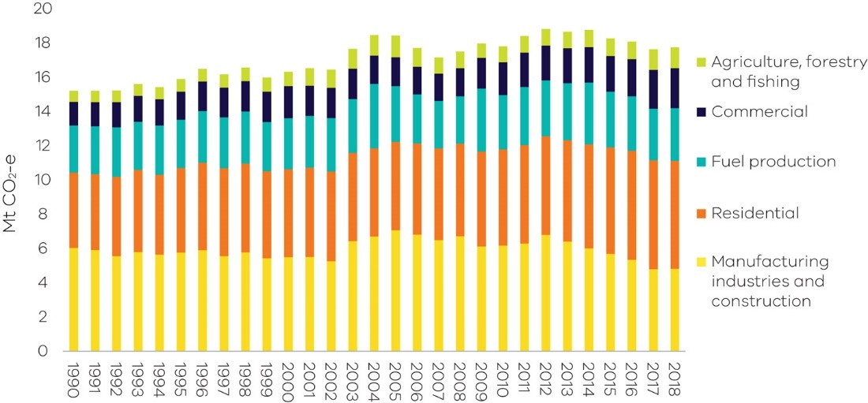
Figure 19: Emissions from direct combustion sub-categories – Victoria, 1990 to 2018

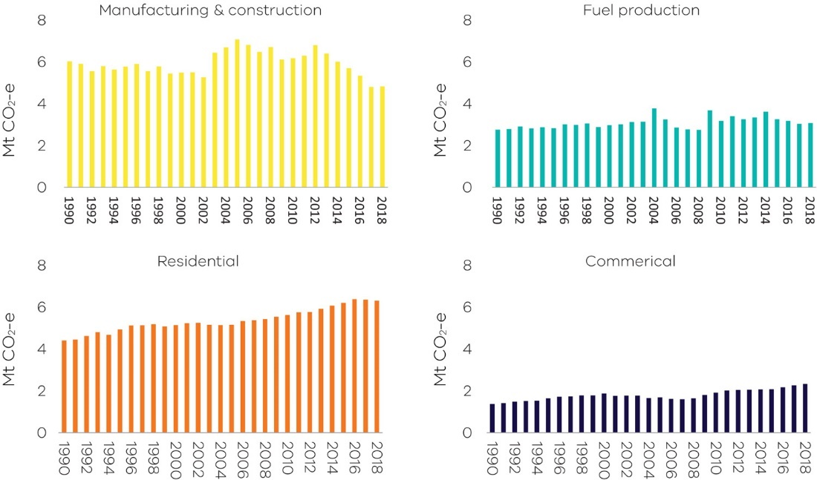
Figure 20: Individual trends in emissions from the main direct combustion sub-categories – Victoria, 1990 to 2018
Source: Australian Greenhouse Emissions Information System (DISER 2020b)

Factors that contributed to the trends include:

- The overall growth between 1990 and 2018 was associated with growth in population and economic activity in Victoria.
- Interannual variability in emissions was associated with changes in the rate of economic growth and variations in demand for residential heating due to variations in average temperatures in a given year.
- Direct combustion emissions from manufacturing and construction fell between 1990 and 2002 before increasing sharply in 2003 due to growth in the output of metal and mineral production and food processing. Following a peak in 2005, emissions from manufacturing and construction have declined gradually in line with the overall decline in manufacturing activity in the state.
- Total annual consumption of natural gas was relatively stable from 2012, with declining industrial gas use offset by increasing residential consumption during winters. The residential sector steadily increased its consumption and, from 2006, replaced manufacturing as the major user of natural gas in Victoria (DoEE 2019a). As shown in Figure 21, this increase in residential use is driven largely by population growth (DISER 2020a; ABS 2020).

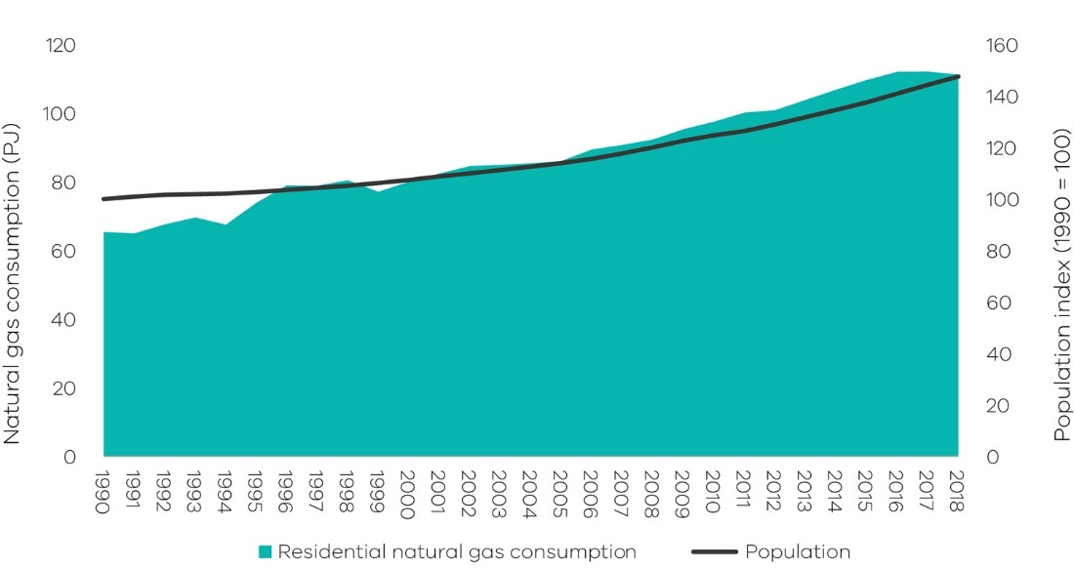
Figure 21: Trends in residential natural gas consumption and population

2.1.3 Transport
Sources of emissions
Emissions from transport are produced by the combustion of fuels such as petrol, diesel and LPG in passenger and commercial motor vehicles, railways, domestic aviation and shipping.
Emissions from electricity used to power public transport (e.g. metropolitan trains and trams) and to drive electric vehicles are not included here, as they are accounted for in electricity generation.
Transport in Victoria
Figure 22 shows that the major contributor to emissions from transport in 2018 was cars (51.8%) followed by heavy-duty trucks (19.6%) and light commercial vehicles (16.5%). Road transportation was responsible for the vast majority (87.9%) of emissions from this sub-sector.
In 2018 the transport sub-sector consumed 348 petajoules (PJ) of energy with the main fuels being petrol (46%), followed by diesel (39%), domestic aviation fuel (8%) and LPG (5%) (DoEE 2019a).
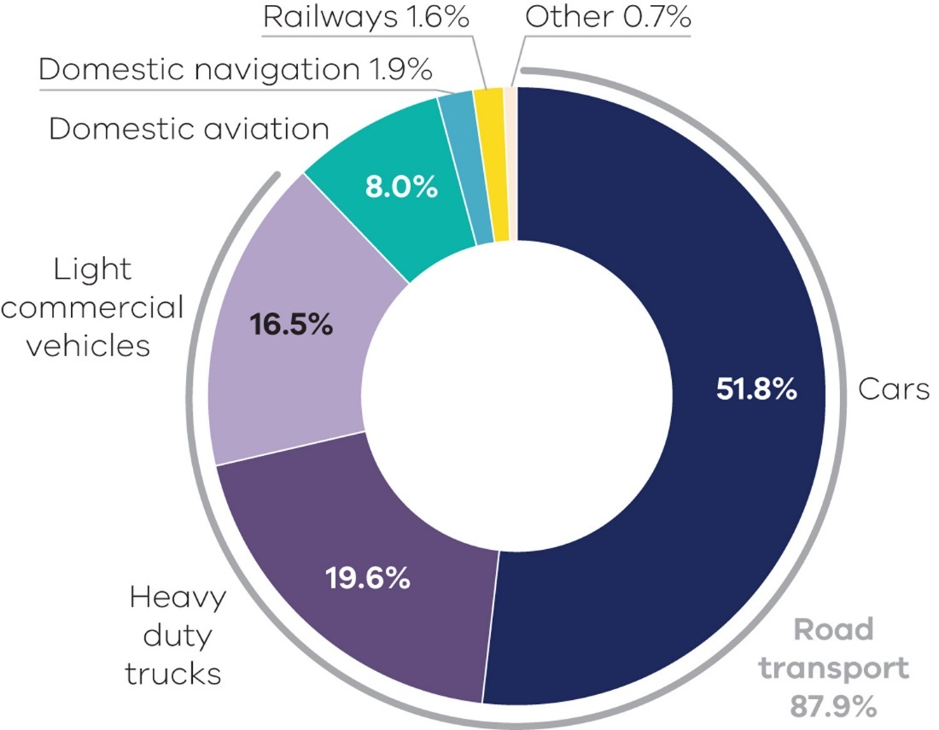
Figure 22: Transport emissions by mode and road transport sub-categories – Victoria, 2018

Within Melbourne, the dominant mode of transport is cars, despite an increase in public transport usage (by bus, light rail and heavy rail) since 1990 as presented in Figure 23.

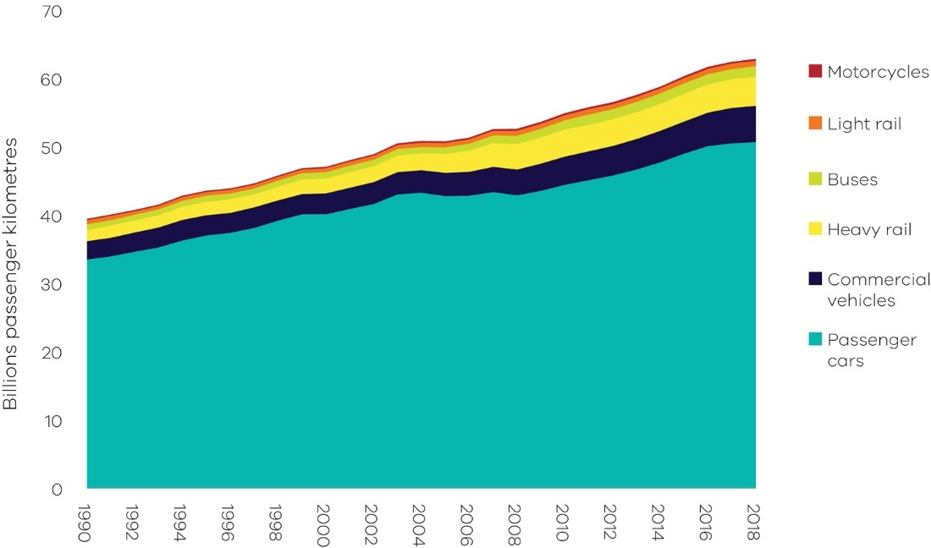
Figure 23: Total passenger kilometres travelled – Melbourne, 1990 to 2018
Source: Australian Infrastructure Statistics (BITRE 2019)
Emissions trends and drivers
Transport emissions grew by 7.5 Mt CO₂-e (47.4%) between 1990 and 2018 – the largest growth in emissions from any sector/sub-sector over this period (Figure 24). Transport contributed 22.9% of Victoria’s net emissions in 2018 – the second largest share behind electricity generation.

Figure 25 presents the trend in emissions from transport by activity sub-categories.
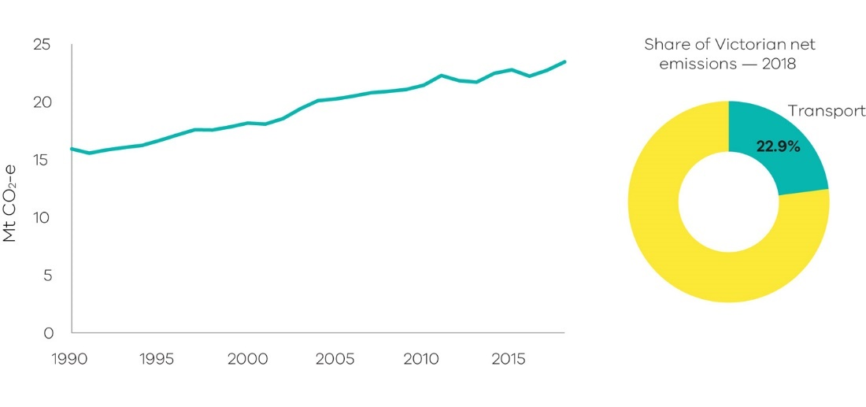
Figure 24: Emissions from transport – Victoria, 1990 to 2018
Source: Australian Greenhouse Emissions Information System (DISER 2020b)

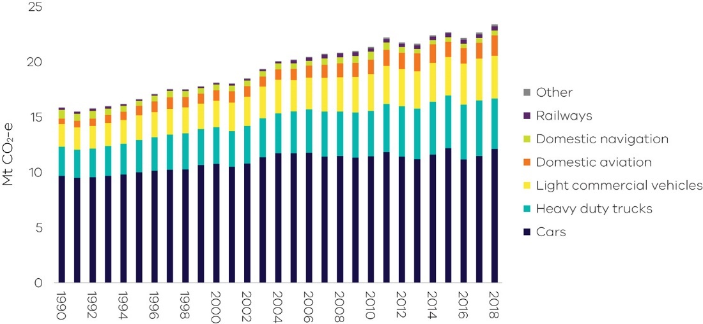
Figure 25: Emissions from transport sub-categories – Victoria, 1990 to 2018

Figure 26 presents individual trends in the four sub-categories with the most significant contribution to transport emissions.
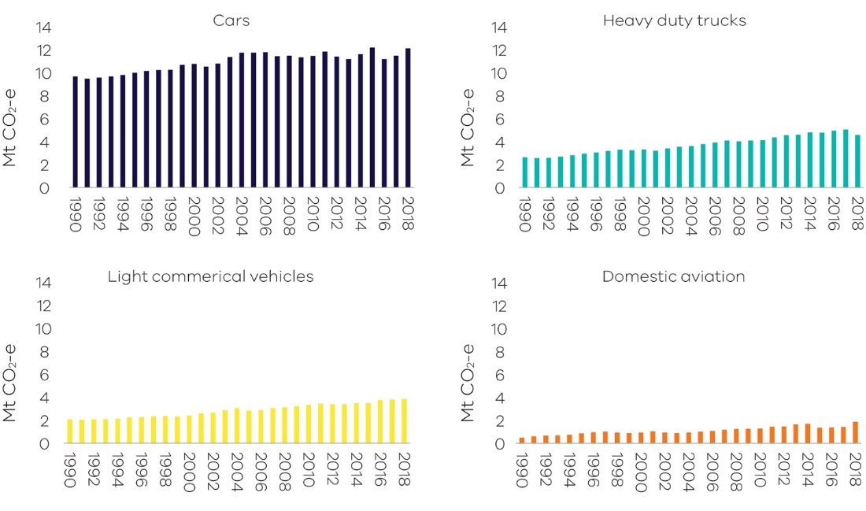
Figure 26: Individual trends in emissions from the main transport sub-categories – Victoria, 1990 to 2018
Source: Australian Greenhouse Emissions Information System (DISER 2020b)

Factors contributing to the steady growth in Victoria’s transport emissions are outlined below:
- Emissions from cars increased by 25.1% between 1990 and 2018. This was driven by a rise in the number of passenger vehicles and total passenger vehicle kilometres travelled, which reflected strong population growth in the state (see Figure 27).
- While freight contributes a smaller proportion of transport emissions than passenger travel, its emissions increased at a faster rate. Growth in emissions from heavy and light commercial vehicles (which increased by 74.4% and 87.7% respectively between 1990 and 2018) is largely correlated with GSP increases (see Figure 28).
- From 2014 to 2018, the number of diesel-fuelled vehicles grew by 45%, while the number of petrol vehicles grew by only 5%. The increase in diesel vehicles is associated with both the growth in freight transport and a shift in consumer preferences toward diesel passenger cars.
- Between 2002 and 2018 the average emissions intensity of passenger and light commercial vehicles purchased in Australia reduced from 252.4 g CO₂ per km to 180.9 g CO₂ per km (NTC 2020). Within this, improvements in vehicle emissions efficiency have been partially offset by increasing consumer preferences for larger vehicles, particularly sports utility vehicles (SUVs) (BITRE 2014).
- The domestic aviation sub-category experienced the largest growth, with emissions increasing by 276.4% between 1990 and 2018. In 2018 it contributed 8.0% of transport emissions. This reflects growth in business- and tourism-related air travel, with numbers of domestic passengers from Melbourne Airport increasing from 4.8 million in 1990 to 25.3 million in 2018 (BITRE 2020).

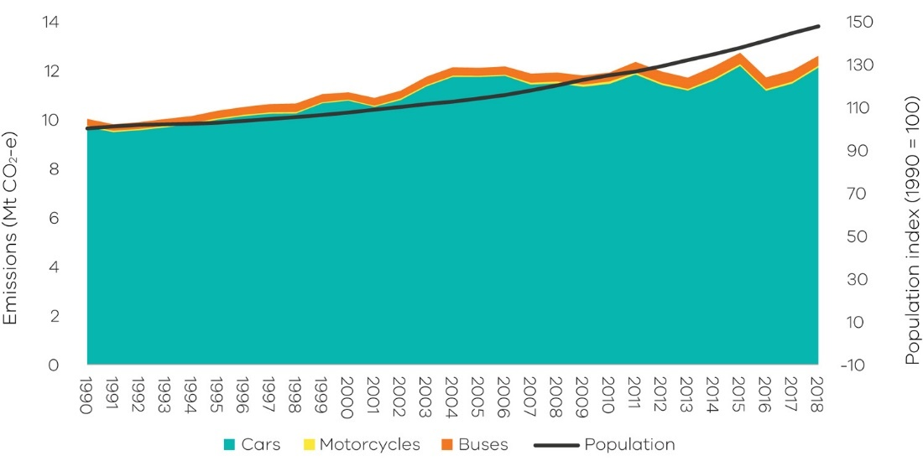
Figure 27: Trends in passenger motor vehicle emissions and population – Victoria, 1990 to 2018
Source: Analysis based on Australian Greenhouse Emissions Information System (DISER 2020b) and Australian Bureau of Statistics (ABS 2020)
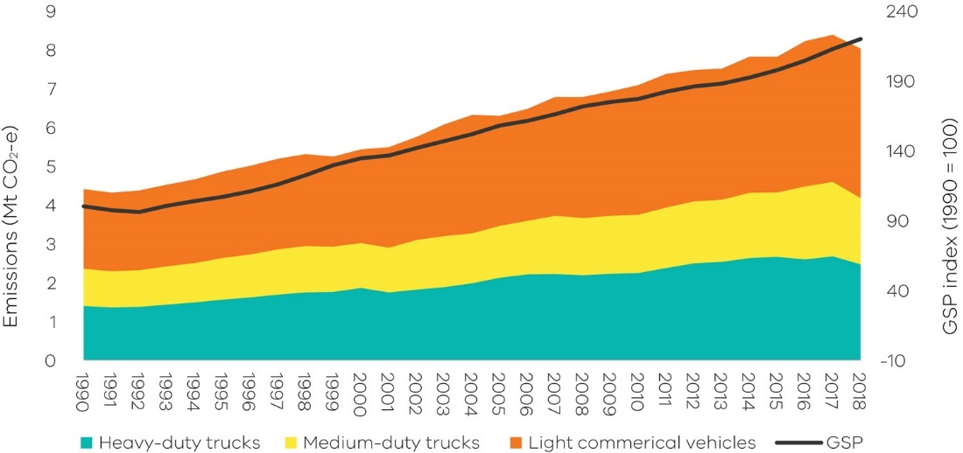
Figure 28: Trends in freight vehicle emissions and GSP – Victoria, 1990 to 2018
Source: Analysis based on Australian Greenhouse Emissions Information System (DISER 2020b) and Australian Bureau of Statistics (ABS 2019)

2.1.4 Fugitive emissions from fuels
Sources of emissions
Fugitive emissions result from leaks or from venting and flaring of gases during the exploration, extraction, production, processing, storage, transmission and distribution of fossil fuels including coal, oil and natural gas. Emissions from decommissioned coal mines are also included.
Fugitive emissions do not include emissions from the combustion of fuels in activities such as electricity generation, the operation of mining plants and equipment or the transportation of fossil fuels by road, rail or sea. These are accounted for in the electricity generation, direct combustion and transport sub-sectors.
Fugitive emissions from fuels in Victoria
Almost 61.0% of fugitive emissions in Victoria arise from leakage of gases during the exploration, production, transmission, storage and distribution of natural gas.
Most of Victoria’s remaining fugitive emissions relate to flaring and venting associated with oil and natural gas production and processing.
Some additional fugitive emissions also arise from Victoria’s petroleum industry, from leakage during the exploration, production, storage and distribution of oil and flaring not captured above. These emissions arise throughout the production chain, including exploration and development drilling when gas or liquid hydrocarbons are encountered. The industry’s activities are concentrated in the offshore regions of the Otway and Gippsland basins.
A very small contribution to Victoria’s total fugitive emissions (less than 1%) arises from the extraction of solid fuels, particularly from brown coal mines.
A description of the key Victorian petroleum and gas infrastructure associated with these emissions is provided in Box 2.

Box 2: Victoria’s petroleum and gas production and transmission infrastructure

Crude oil and gas are transported via pipeline from offshore facilities to stabilisation and gas processing plants where they are separated into wet gas, LPG and stabilised crude oil for distribution within the state, interstate or internationally. Stabilised crude oil is processed at refineries in Altona and Geelong into a range of refined petroleum products such as petrol, diesel, jet fuel, bitumen and solvents.
Natural gas is transmitted in Victoria through the Principal Transmission System (PTS), a 1,900 km pipe network covering Melbourne and central Victoria. The system also utilises storage facilities to help meet demand peaks.

Victoria’s fugitive emissions (3.8 Mt CO₂-e) are significantly lower than those in New South Wales (13.0 Mt CO₂-e), Western Australia (14.2 Mt CO₂-e) and Queensland (19.1 Mt CO₂-e). This is due to the greater levels of coal and liquefied natural gas extraction driven by exports from those states.

Emissions trends and drivers
Victoria’s fugitive emissions rose from 3.8 Mt CO₂-e in 1990 to a peak of 3.9 Mt in 1995. Emissions then declined to a low of 2.2 Mt CO₂-e in 2003 before increasing again – with interannual variability – to reach 3.9 Mt CO₂-e again in 2018 (Figure 29). In 2018 the sub-sector accounted for 3.8% of Victoria’s total net emissions.
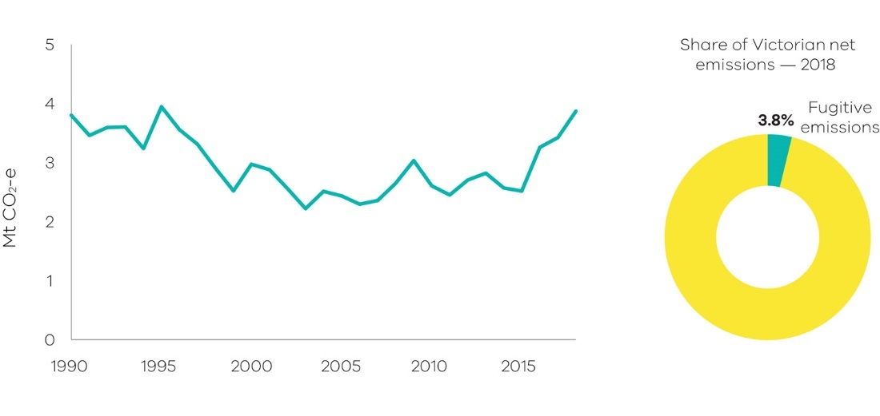
Figure 29: Emissions from fugitives – Victoria, 1990 to 2018
Factors that influenced these trends include:
- A 90% reduction in crude oil production in Victoria from 1990 to 2018 (DoEE 2019b).
- Changes in the volume of natural gas consumption, which fluctuated between 223 and 291 PJ per year between 1990 and 2018. The highest rate of gas consumption, 291 PJ, occurred in 2018. Other years of high gas consumption include 1996, 2009 and 2014 (DoEE 2019a). The scale of fugitive emissions associated with natural gas consumption was, however, moderated by improvements in transmission, storage and distribution which reduced natural gas leakages.
- A stable trend in natural gas production from 1990 until 2002, followed by a significant increase. Production peaked in 2011 and then fell slightly, with production in 2018 remaining at 175% of the level in 1990 (DoEE 2019b).
- A key driver of the increase in fugitive emissions since 2016 has been an increase in emissions from the flaring and venting during oil and gas production and processing sub-category.

2.2 Industrial processes and product use
Sources of emissions
The industrial processes sub-sector includes emissions generated from a range of production processes involving, for example:
- the use of carbonates (i.e. limestone, dolomite, magnesite, etc.)
- carbon when used as a chemical reductant (e.g. iron and steel or aluminium production)
- chemical industry processes (e.g. ammonia and nitric acid production).
The product use sub-sector includes emissions associated with the use of synthetic gases such as:
- hydrofluorocarbons (HFCs) in refrigeration and air conditioning, foam blowing, fire extinguishers, aerosols/metered dose inhalers and solvents
- sulphur hexafluoride (SF6) in electrical equipment.
Emissions associated with the consumption of electricity or combustion of fuels required by industrial production processes are accounted for in the electricity generation and direct combustion sub-sectors.
IPPU emissions in Victoria
In 2018, 80.6% of Victoria’s industrial processes and product use (IPPU) emissions came from the use of synthetic greenhouse gases, mainly HFCs for refrigeration and air conditioning for commercial, residential and transport activities.
The remaining 19.4% of IPPU emissions came from processes in activities such as metals and chemicals production.
Emissions trends and drivers
Victoria’s IPPU emissions fell between 1990 and 1995, then generally rose to 2018, with some interannual variability. In 2018 the sector accounted for 3.8% of Victoria’s total net emissions (Figure 30).
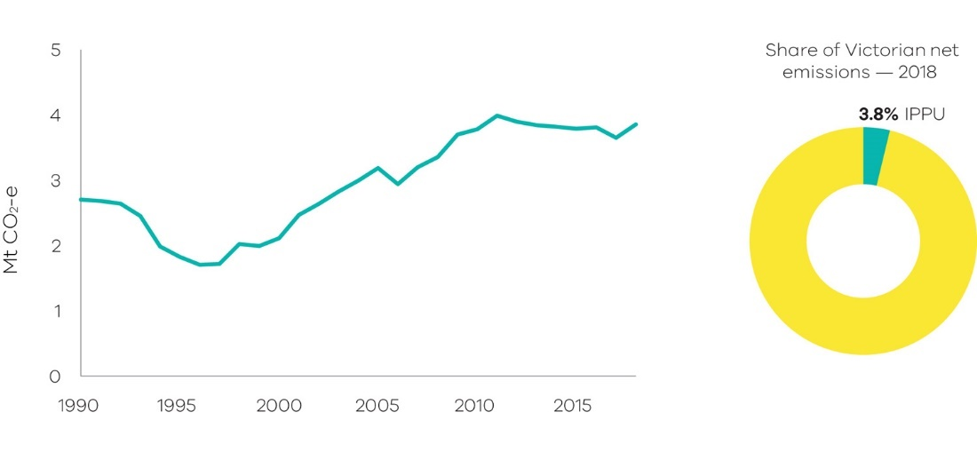
Figure 30: Emissions from industrial processes and product use – Victoria, 1990 to 2018
Source: Australian Greenhouse Emissions Information System (DISER 2020b)
A major driver of the increase in IPPU emissions is a rise in HFC use due to population growth and their use as a substitute for ozone-depleting refrigerant compounds. Between 1990 and 2018, Victoria’s population grew by 48% and IPPU emissions increased by 42.5%.
HFC compounds were introduced in Australia in 1994. Emissions from their use increased steeply until around 2016 and then flattened. The activities that use HFCs and the emissions associated with these uses are shown in Figure 31.
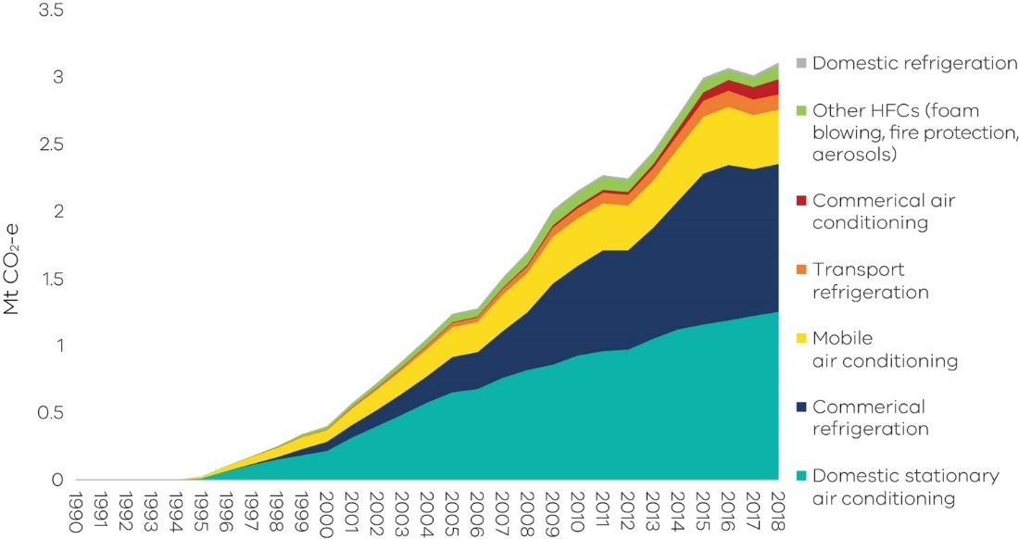
Figure 31: Emissions from the use of HFCs by activity – Victoria, 1990 to 2018
Source: Australian Greenhouse Emissions Information System (DISER 2020b)
In the mid-1990s a phase out of ozone depleting hydrochlorofluorocarbons (HCFCs) began, with HFCs being the primary substitute. This phase out was largely completed by 2018. A second phase out has now begun, to replace HFCs with alternative substances that have lower climate impacts (Brodribb and McCann 2019). Both phase outs are occurring under the Montreal Protocol on Substances that Deplete the Ozone Layer.
The growth in product use-related emissions driven by HFC use offset the reduction in emissions associated with a decline in industrial processing. Emissions from the chemicals industry dropped substantially after 1995 due to the closure of several chemical production facilities in Victoria. A reduction in economic growth in the early 1990s is likely to have contributed to the fall in IPPU emissions between 1990 and 1995.
Emissions from the minerals industry declined in 2014 and subsequent years due to the closure of facilities associated with the production of clinker and lime.

2.3 Waste
Sources of emissions
Emissions from the waste sector arise from the decomposition of organic waste in landfills, the biological treatment of solid waste such as composting, and from the direct release of greenhouse gases during wastewater treatment. Methane is produced from the anaerobic decomposition of organic matter from solid waste in landfills and from wastewater treatment plants. Nitrous oxide emissions are produced from the nitrification and denitrification of urea and ammonia in wastewater treatment plants.
Carbon dioxide emissions from the combustion of methane captured from landfills and wastewater treatment plants, and biomass for energy generation, are reported in the energy sector. Emissions associated with the energy use required for the management and transportation of waste are accounted for in the electricity generation, direct combustion and transport sub-sectors.

Carbon dioxide emissions from carbon stock transfers of harvested wood products (e.g. paper, wood) to landfill are reported in the LULUCF sector. However, methane emissions from the decomposition of wood and paper in landfill are reported in the waste sector.
Waste sector in Victoria
The main sources of waste sector emissions are the disposal of solid waste to landfill (61.2% of total waste sector emissions) and the treatment of wastewater from domestic, commercial and industrial sources (35.3% of total waste sector emissions).
Most landfills in Victoria operate in accordance with best practice in greenhouse gas management, such as the use of systems that capture and combust landfill gas. This significantly reduces greenhouse gas emissions from this sector.
Victoria's water sector comprises 10 Catchment Management Authorities and 19 water corporations, of which 16 provide water supply and sewage services to urban Victoria. Water for Victoria, the State’s water plan, commits water corporations and Catchment Management Authorities to be net-zero emissions by 2050. Victoria’s 19 water corporations have collectively pledged to reduce their greenhouse gas emissions by 42% below an aggregated 2011-2016 baseline by 2025 to demonstrate a pathway to net-zero. Water corporations have developed emission reduction pathways with commitments to reduce both energy-related emissions and direct emissions associated with treatment processes, some of which are being implemented.
Emissions trends and drivers
Victoria’s waste sector emissions generally fell from 1990 to 2013, rose to 2017, then fell again in 2018. In 2018, waste was responsible for 2.5% of Victoria’s total net emissions (Figure 32).
Figure 33 and Figure 34 present the trends in emissions from waste sector sub-categories – solid waste disposal; wastewater treatment and discharge; biological treatment of solid waste; and incineration and open burning of waste.
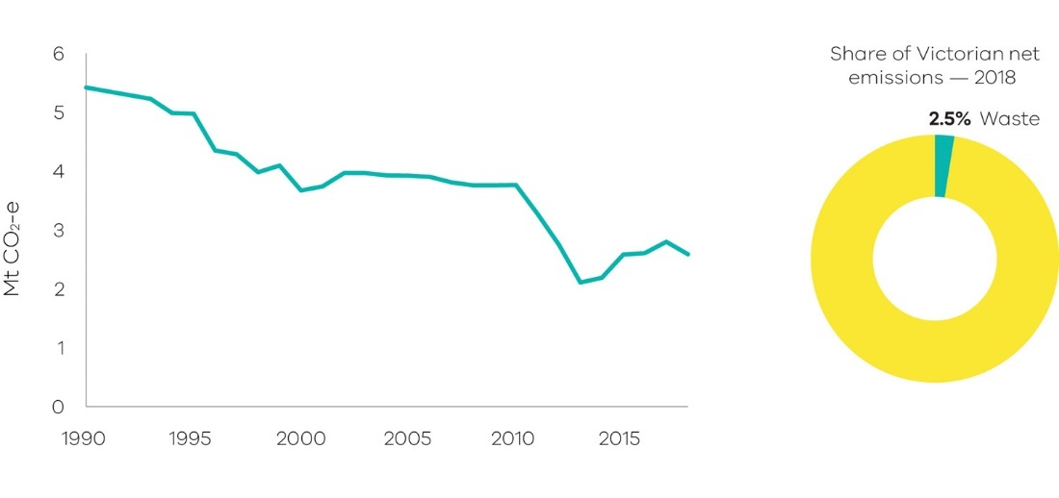
Figure 32: Emissions from waste – Victoria, 1990 to 2018
Source: Australian Greenhouse Emissions Information System (DISER 2020b)
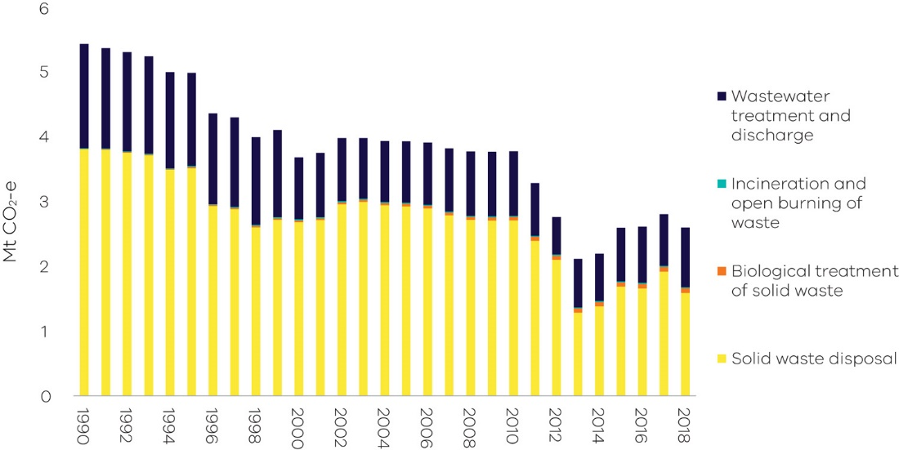
Figure 33: Waste emissions categories historical emissions, 1990 to 2018
Source: Australian Greenhouse Emissions Information System (DISER 2020b)

Figure 34: Individual emissions trends in the main waste sub-categories – Victoria, 1990 to 2018
Source: Australian Greenhouse Emissions Information System (DISER 2020b)

While solid waste generation increased between 1990 and 2018 in line with population growth, emissions from this waste category fell by 58.3% over this period. The reduction was due to increased landfill gas capture and combustion; improved landfill management practices reducing methane leakage; greater levels of materials recycling; and increased diversion of organics from the waste stream to composting and energy generation.
Emissions from wastewater decreased by 43.1% from 1990 to 2018, with steep decreases in 2000, 2011 and 2012. These decreases correspond with the implementation of more efficient wastewater treatment processes and increased methane capture from wastewater treatment plants. Factors influencing interannual variability in wastewater emissions include changing volumes of wastewater discharged by large industry, and changes in the operational management and efficiencies of wastewater treatment plants.

2.4 Agriculture
Sources of emissions
Agriculture sector emissions mainly come from livestock digestion (enteric fermentation), manure management, the release of nitrous oxide from cropping and pasture land, and the burning of agricultural residues.
Enteric fermentation of plant material that is digested by animals results in emissions. Agricultural soils reflect emissions from the release of nitrous oxide; nitrogen is added to soil by application of fertilisers, crop residues and animal waste. Manure management captures methane emissions produced through the anaerobic decomposition of the organic matter contained in manure, especially when a considerable number of animals are confined (e.g. piggeries).
Emissions associated with the use of electricity, fuel consumption from operating equipment and fuel consumption in transport are accounted for in the energy sector.
Agriculture emissions in Victoria
Livestock enteric fermentation was the main source of agriculture sector emissions in Victoria in 2018 (65.8%). Another activity contributing significantly to Victoria’s agriculture emissions is the release of nitrous oxide through the application of fertilisers (organic and inorganic), animal waste and crop residue to soils (20.6%).
A description of the Victorian agricultural sector by farm type and commodities is provided in Box 3.
Box 3: Overview of Victoria’s agricultural sector
Agricultural land in Victoria occupies around 56% of the state’s surface (ABARES 2020). The most prevalent land use by area is grazing of modified pasture which occupies 32% of the state as shown in Figure 35. In 2018 there were 19,739 farms in Victoria, representing 25% of all farm businesses in Australia. Of these, the most common farm types were beef cattle (25%), dairy cattle (18%), sheep (15%), and other grain growing farms such as wheat and barley (10%). The most important commodities in Victoria based on the gross value of agricultural production were milk, followed by cattle and calves, and sheep and lambs (ABARES 2020).
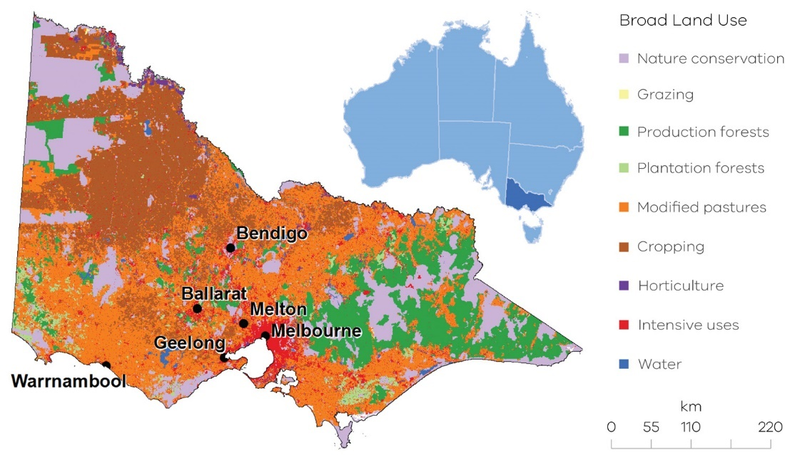
Figure 35: Broad land use in Victoria
Source: Australian Bureau of Agricultural and Resource Economics (ABARES 2020)

Emissions trends and drivers
Victoria’s agriculture emissions fluctuated significantly between 1990 and 2018. The sector accounted for 15.3% of Victoria’s net emissions in 2018 – the fourth largest share of total emissions behind electricity generation, transport and direct combustion (Figure 36).
Figure 37 presents the trend in agriculture emissions by activity sub-categories.
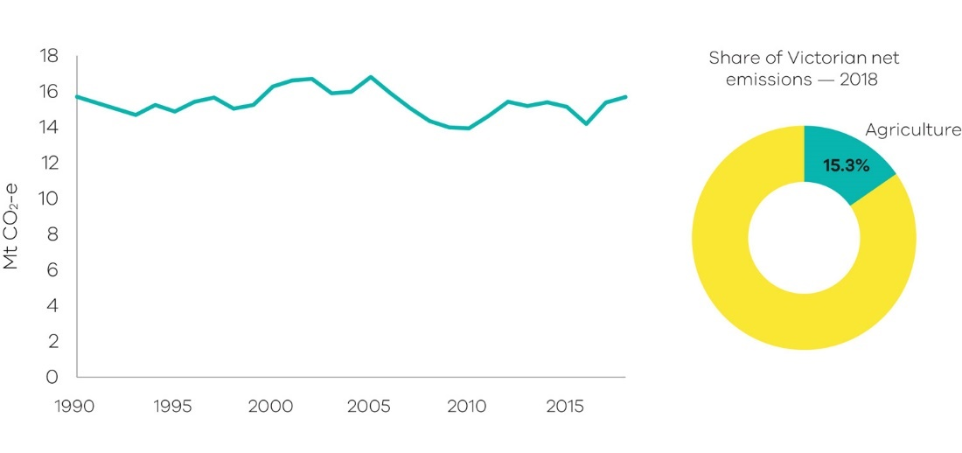
Figure 36: Emissions from agriculture – Victoria, 1990 to 2018
Source: Australian Greenhouse Emissions Information System (DISER 2020b)
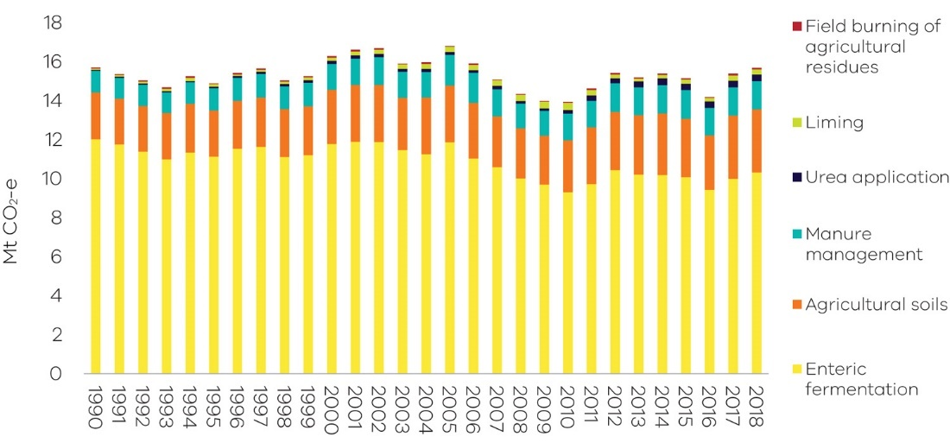
Figure 37: Emissions from agriculture sector sub-categories – Victoria, 1990 to 2018
Source: Australian Greenhouse Emissions Information System (DISER 2020b)

Figure 38 presents individual trends in the four sub-categories with the most significant contribution to emissions from agriculture.
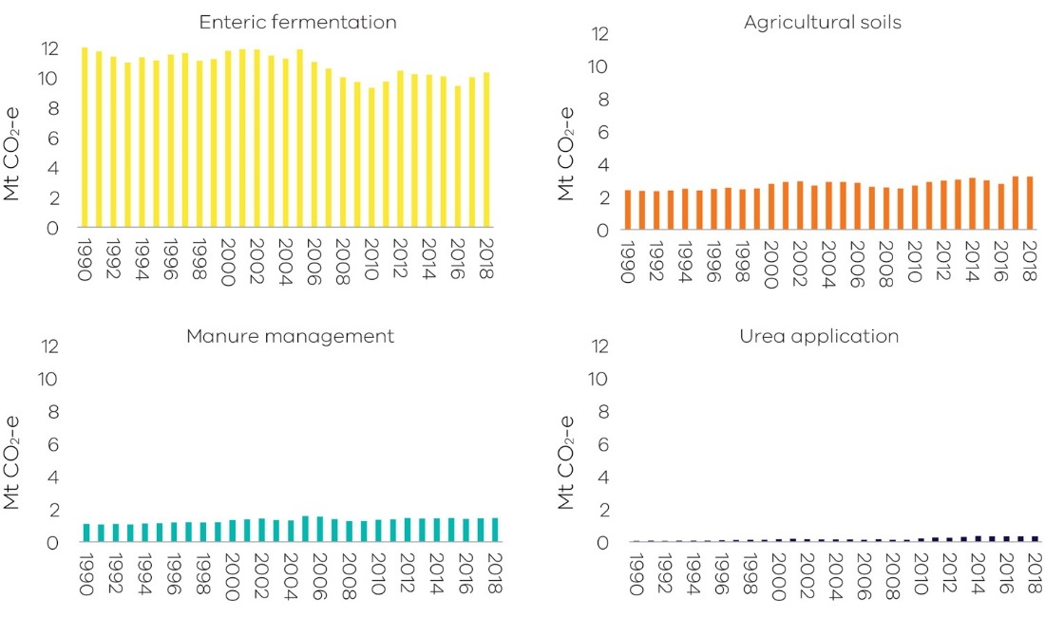
Figure 38: Individual trends in emissions from the main agriculture sub-categories – Victoria, 1990 to 2018
Source: Australian Greenhouse Emissions Information System (DISER 2020b)

The fluctuation in Victoria’s agriculture emissions between 1990 and 2018 has been driven mainly by seasonal conditions and by domestic food demand and exports. The following factors influenced the trend in emissions associated with livestock:
- Emissions from sheep grazing fell by 51.0% between 1990 and 2018, which is reflected in the overall decline in enteric fermentation emissions (Figure 38). This is primarily due to the overall decline in sheep numbers over this period due to falling wool prices. Victoria’s sheep population fluctuated during both drought and non-drought conditions.
- Emissions from cattle were 18.2% higher in 2018 compared with 1990 – however, interannual fluctuations occurred throughout the period reflecting variation in cattle numbers. Victoria’s cattle population was particularly influenced by the millennium drought that affected Victoria from 1997 to 2009. Cattle numbers initially remained steady, then declined rapidly towards the end of the drought in the late 2000s. Numbers rebounded with the return to wetter conditions in 2010 and 2011.
- Despite the decline in the sheep population since 1990, there were nearly four times as many sheep as cattle in Victoria in 2018 (Figure 39). Nonetheless, cattle emissions were just over three times higher than sheep emissions in 2018 due to the higher emissions intensity of cattle compared with sheep.

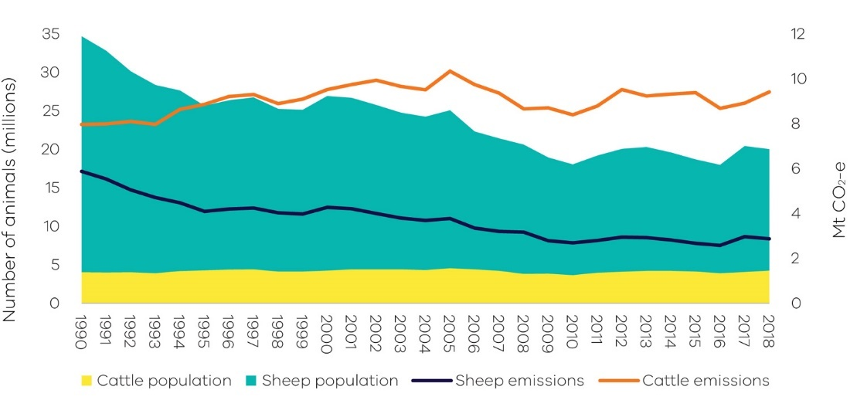

Figure 39: Sheep and cattle populations and emissions – Victoria, 1990 to 2018
Source: Analysis based on Australian Greenhouse Emissions Information System (DISER 2020b)

* Note – this chart includes all the mechanisms that cause emissions from livestock. These are: enteric fermentation, manure management, urine and faeces on grazing land, and atmospheric deposition of nitrous oxide

Factors influencing the trend in emissions from agricultural soils include an increase in crop land - particularly for wheat, barley and canola - and associated increases in the application of nitrogen fertilisers; crop residue; and animal wastes. The total area of crop cultivation in Victoria grew from 1.8 to 3.5 million hectares (94%) between 1990 and 2018, while the application of fertilisers increased from 50,000 to 290,000 tonnes of nitrogen (480%) over this period (DISER 2020b).

2.5 Land Use, Land-Use Change and Forestry
Sources of emissions
The land use, land-use change and forestry (LULUCF) sector includes emissions and removals (sequestration) of greenhouse gases resulting from direct human-induced land use, land-use change and forestry activities. This includes emissions and removals from the clearance of forested land and conversion to other land uses, from new forests planted on previously unforested land and from other practices that change emissions and removals (forest management, cropland management and grazing land management).
Fossil fuel combustion associated with forestry and land management activities – such as diesel used in logging machinery – is accounted for in the direct combustion sub-sector. Emissions from burning agricultural residues, and non-CO₂ emissions associated with land use such as the application of fertilisers, are accounted for in the agriculture sector.
Emissions in Victoria
The main sources of Victoria’s LULUCF emissions and removals – and of variations in these emissions – are forest lands, specifically from land classified as:
- Forest land remaining forest – comprising changes in the native forest estate and harvesting from that estate and pre-1990 plantations.
- Land converted to forest land – comprising plantations established since 1990 and regeneration of previously cleared land.
- Forest land converted to cropland, grasslands, wetlands and settlements – comprising primary and secondary clearing of forest land since 1972 to enable a change in land use and changes in soil carbon and other emissions resulting from land use change.
The definition of the land covered in each LULUCF sub-category and the principal sources of emissions and removals are set out in Appendix B.
The LULUCF emissions presented in this report for the years 1990 to 2017 are different to those presented in the Victorian Greenhouse Gas Emissions Report 2017 due to methodological improvements (see Appendix C).
Emissions trends and drivers
Victoria’s LULUCF emissions fluctuated significantly between 1990 and 2018 (Figure 40). LULUCF was a net sink from 1994 to 2006 and from 2012 to 2018, and a net source of emissions from 1990 to 1993 and from 2007 to 2011. Net LULUCF emissions averaged around -9.0 Mt CO₂-e between 2012 and 2018. In 2018, in net terms, the LULUCF sector sequestered emissions equivalent to 11.2% of total Victorian emissions (11.4 Mt CO₂-e). Over the period 1990 to 2018, LULUCF provided a cumulative net sink of approximately -86.1 Mt CO₂-e.

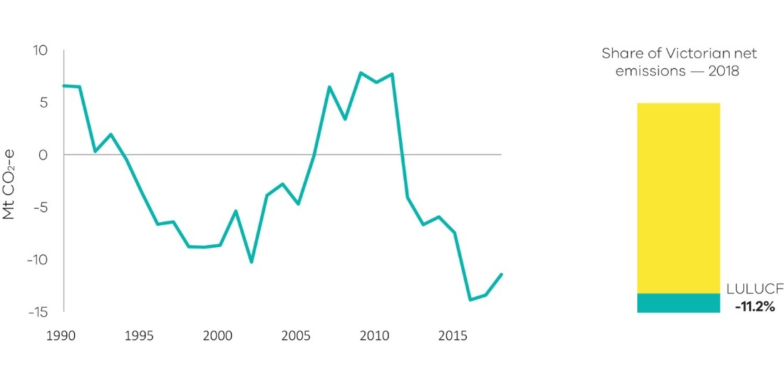
Figure 40: Emissions from LULUCF – Victoria, 1990 to 2018
Source: Australian Greenhouse Emissions Information System (DISER 2020b)

Figure 41 presents net emissions by LULUCF sub-category.
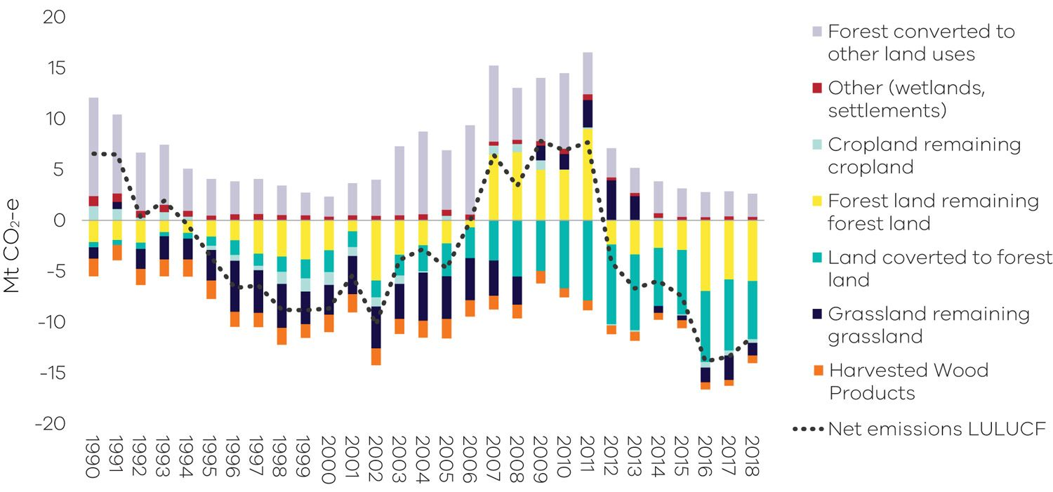
Figure 41: Emissions from LULUCF sub-categories – Victoria, 1990 to 2018
Source: Analysis based on Australian Greenhouse Emissions Information System (DISER 2020b) and LULUCF data by subcategory provided by DISER (DISER 2020c)

- Forest land remaining forest land
This sub-category includes emissions/removals derived from modelled changes in carbon pools in:
- harvested native forests
- other native forests
- plantations established before 1990.
Forest land remaining forest land was a net sink of 6.0 MtCO2-e in 2018. As shown in Figure 41, net emissions from this sub-category varied between 1990 and 2018. It was a net sink between 1990 and 2006, a net source of emissions from 2007 to 2011 and a net sink from 2012 to 2018.
A key driver of emissions from forest land remaining forest land is wildfire with emissions falling steeply between 2011 and 2016 – possibly due to forest recovery following major bushfires in the 2000s.
Figure 42 shows the total emissions from forest land remaining forest land. It distinguishes between total emissions from wildfire and prescribed burning and other sources of emissions (including changes in living biomass, dead organic matter and soil carbon) in harvested native forest and other native and pre-1990 plantation forests. The years where wildfire and prescribed burning are net emissions sinks indicates that carbon absorbed through regrowth after fires outweighs any carbon released during fires.
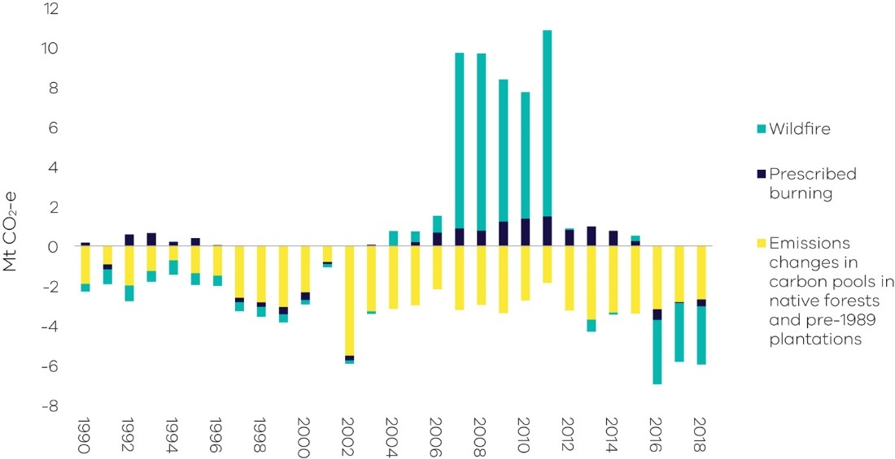
Figure 42: Emissions from fire (wildfire and prescribed burnings) and other sources – Victoria, 1990 to 2018
Source: Analysis based on Australian Greenhouse Emissions Information System (DISER 2020b) and LULUCF data by subcategory provided by DISER (DISER 2020c)
* Note – non-anthropogenic natural disturbances, including some but not all wildfires, are reported as a long run trend in emissions, reflecting the balance of the carbon lost and later re-absorbed by future regrowth. This approach is in accordance with the ‘natural disturbance’ provision under IPCC accounting rules and leaves anthropogenic emissions and removals as the main drivers.
- Land converted to forest land
This sub-category includes net emissions/removals from:
- for-harvest plantations established since 1990, which are mainly hardwood
- environmental plantings established since 1990
- regrowth of forest on land cleared for cropping or grazing
- regeneration of areas cleared of forest since 1972 from natural seed stocks. This may be a combination of regeneration for environmental purposes on protected land or on land that is maintained by the landowner. Regeneration on land cleared prior to 1990 is also captured in this sub-category.
Land converted to forest land was a net sink of 5.7 Mt CO₂-e in 2018. As shown in Figure 41, removals from this sub-category increased in scale from 1990 to a peak in 2011 before declining slightly – it nonetheless remained a substantial source of net removals from 2008 to 2018.
The area of hardwood plantations expanded rapidly in response to the Commonwealth Government’s Managed Investment Act 1998 which increased the finance available for plantation establishment. The Managed Investment Act was repealed in 2016. Harvest volumes have been increasing as short-rotation hardwood plantations are harvested.
The declining sink provided by plantations from 2012 shown in Figure 43 is likely driven by the harvesting of hardwood plantations established in the 2000s. These are being harvested as they mature, and the rate of plantation establishment in Victoria has been close to zero since 2013. Conversely, natural regeneration has been a source of declining emissions since mid-2000s and net removals since 2015. The years where natural regeneration is a net emissions source indicates the impacts of disturbances such as temporary forest dieback.
The net sink provided by regrowth on cleared land increased between 2008 and 2018.
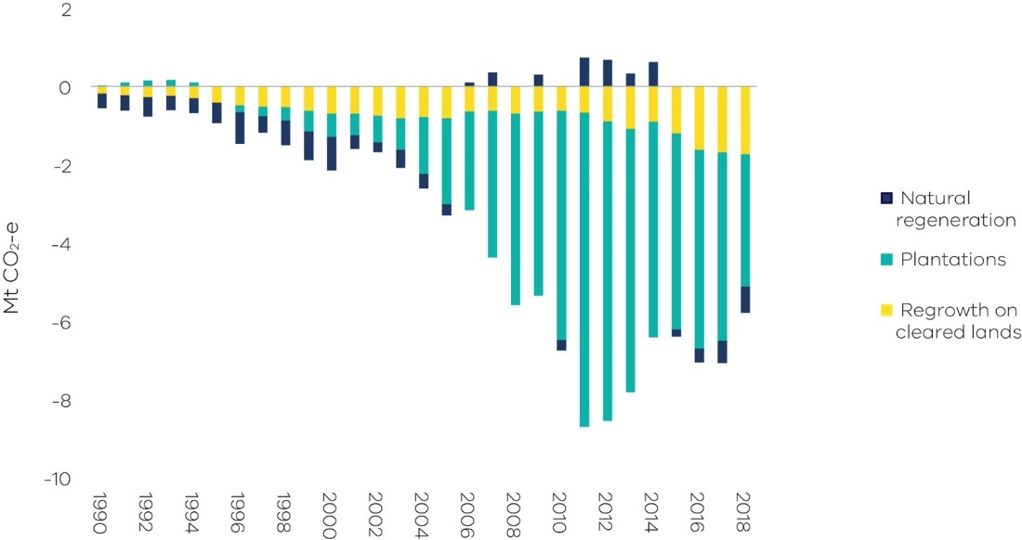
Figure 43: Net emissions from land converted to forest land – Victoria, 1990 to 2018
Source: Analysis based on Australian Greenhouse Emissions Information System (DISER 2020b) and LULUCF data by subcategory provided by DISER (DISER 2020c)

- Forest land converted to other land uses
This sub-category includes:
- emissions from the primary conversion of land that was forested in 1972
- emissions from secondary or re-clearance of forest which has regrown on cleared land. Where forest has regrown on these converted lands, the sequestration is included in the sub-category land converted to forest
- indirect emissions from loss of soil carbon and other emissions and removals associated with the new land use. Indirect emissions are highest in the two years after clearing and then decline. Non-CO₂ emissions associated with application of fertilisers and the management of crops are accounted for under agriculture sector emissions.
Figure 44 shows that emissions from forest land converted to other land uses fluctuated significantly over the period 1990 to 2018. Emissions fell substantially from 1990 to 2000 before increasing on average between 2001 and 2010, then declining to relatively low levels over the period 2011 to 2018. Most of the fluctuation in emissions resulted from primary forest clearing.
Historically, Australia-wide, the area of both primary and secondary clearing has been influenced by changes in farmers’ terms of trade and weather conditions. However, primary clearing in Victoria is now constrained by land clearing regulations.
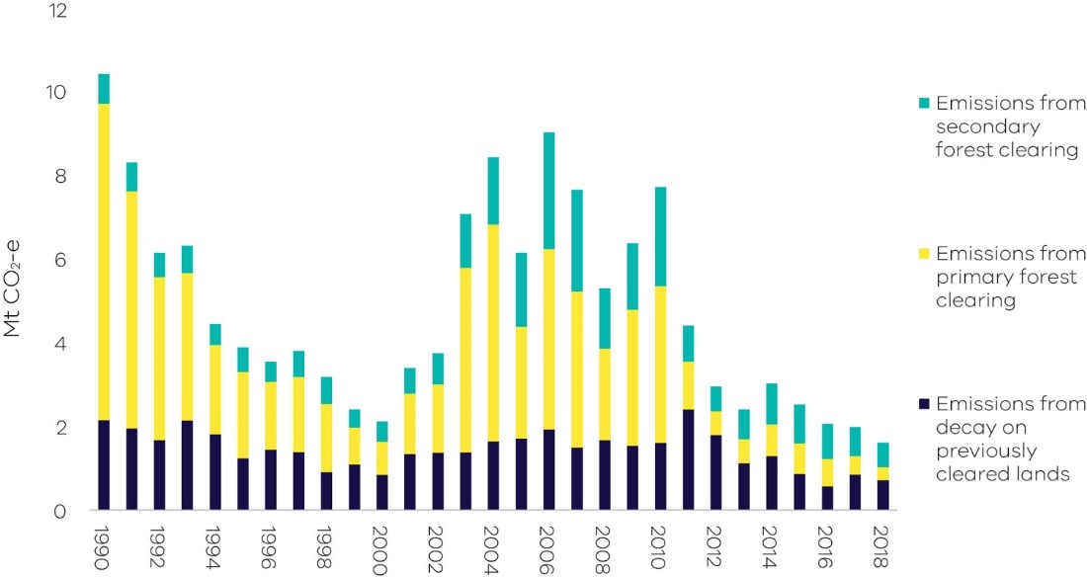
Figure 44: Sources of emissions and removals from forest land converted to other land uses – Victoria, 1990 to 2018
Source: Analysis based on Australian Greenhouse Emissions Information System (DISER 2020b) and LULUCF data by subcategory provided by DISER (DISER 2020c)

Uncertainty in LULUCF emissions estimates
Uncertainty is a feature of any estimation process. According to Australia’s National Greenhouse Gas Inventory 2018 (NGGI), the estimated uncertainties for 2018 emissions are plus or minus 3.3% and uncertainties for historic trends excluding LULUCF are plus or minus 3.5%. Uncertainty is higher at plus or minus 4.7% when LULUCF is included due to the complexity of biological processes, the measurement and data collection techniques and the challenges of representing biological processes in mathematical models.
It is not practicable to use direct estimation or measurement techniques alone to calculate LULUCF emissions. The Full Carbon Accounting Model (FullCAM) provides the modelling framework used in the NGGI for estimating emissions and removals arising from changes in above and below ground biomass, dead organic matter, soil carbon and changes in land use and management techniques. FullCAM models the exchange of carbon between the terrestrial biological system and the atmosphere in a full and closed mass-balance cycle. The model uses data on climate, soils and land management practices, plus land use changes observed from satellite imagery and is supplemented by additional data and models as appropriate.
The overarching approach to estimating Australia’s LULUCF emissions is continually reviewed by the Commonwealth Department of Industry, Science, Energy and Resources. Changes are made to the assumptions underpinning the model as scientific knowledge advances and to data as more reliable sources become available.
For consistency, when changes are made the whole time series is revised. Appendix C describes the main methodological changes and the impact they have had on LULUCF emissions data between the Victorian Greenhouse Gas Emissions Report 2017 and the current (2018) report.
Changes will continue to occur in future years as improvements in estimation methods are made.

Emissions by economic sector – 2018
Chapter 2 presented emissions data and analysis of emissions trends based on a set of sectors defined in accordance with IPCC guidelines. This chapter provides information on Victorian emissions by economic sector presented in accordance with the following Australian and New Zealand Standard Industry Classification (ANZSIC) divisions:
- electricity, gas, water and waste services
- manufacturing
- commercial services
- agriculture, forestry and fishing
- transport, postal and warehousing
- mining
- construction
- residential.

3.1 Direct emissions by economic sector
This section presents data on the direct emissions attributable to each economic sector (also known as Scope 1 emissions), released as a direct result of an activity within an organisation’s boundary (for example fuel use, energy use, manufacturing process activity, mining activity and on-site waste disposal). The following examples illustrate the scope of direct emissions for selected economic sectors:
- Direct emissions from the residential sector include emissions from transport activities, the consumption of gas for heating and cooking, and emissions associated with the use of waste and wastewater services.
- Direct emissions from agriculture, forestry and fishing include emissions from activities such as the application of fertilisers, livestock management, and the combustion of fuels required for agriculture and forestry activities. It also includes emissions and sequestration of carbon from forest and grassland management.
- Direct emissions from manufacturing include emissions related to the direct combustion of fuels, transport, the application of waste management practices and leaks from industrial processes that are directly related to manufacturing processes such as the production of food, paper, textiles and chemicals.

Figure 45 presents the results of this process. It shows that in 2018, the electricity, gas and water supply sector (50%) produced the largest share of direct emissions, followed by the residential sector (21%) and agriculture, forestry and fishing (9%).

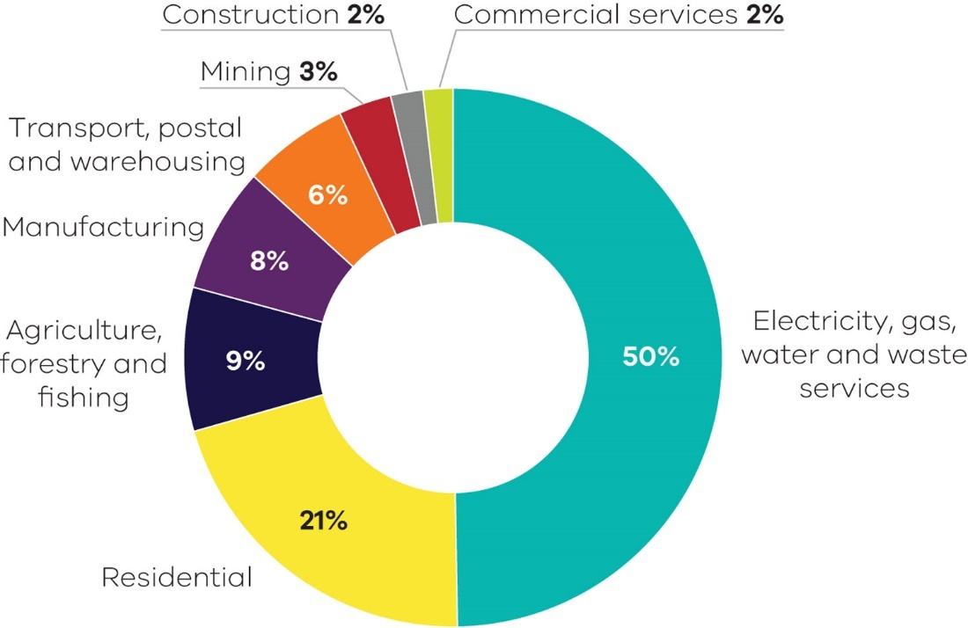
Figure 45: Scope 1 emissions by economic sector – Victoria, 2018
Source: Australian Greenhouse Emissions Information System (DISER 2020b)

3.2 Allocation of emissions from electricity generation to end-users
In this section, emissions associated with electricity generation are allocated to the end-users of electricity in each economic sector based on their consumption. The emissions attributable to electricity consumption are referred to as indirect or Scope 2 emissions.
Analysis of the emissions attributable to electricity consumption enables a deeper understanding of the demand drivers that contribute to electricity sector emissions.
Figure 46 presents the results of this process. The economic sector responsible for the largest share of Scope 2 emissions in 2018 was commercial services (36%), followed by residential (23%) and manufacturing (22%). The electricity, gas, water and waste services sector (14%) includes emissions associated with electricity that is consumed by this sector for its own use.
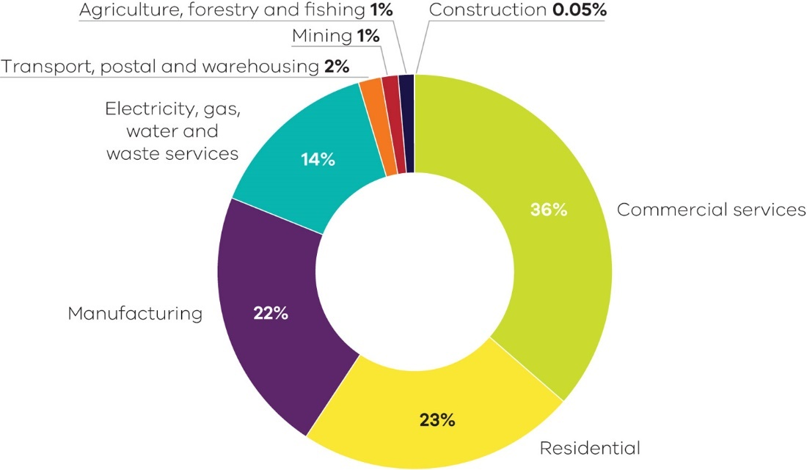
Figure 46: Scope 2 emissions by economic sector – Victoria, 2018
Source: Australian Greenhouse Emissions Information System (DISER 2020b)
* Note – Scope 2 emissions (Indirect Emissions from the Generation of Purchased Electricity) are based on the allocation of Scope 1 emissions from electricity generation to ANZSIC divisions, taking into account net imports and exports of electricity between States through the National Electricity Market. Scope 2 emission factors are derived from the generation and emissions allocated to each State.

3.3 Direct plus indirect emissions by economic sector
This section combines the analysis in the previous two sections to allocate direct (Scope 1) plus indirect (Scope 2) emissions to each economic sector.
The results are presented in Figure 47. In 2018, the residential sector was responsible for the largest share of direct plus indirect emissions in Victoria (31.5 Mt CO₂-e or 35%), followed by commercial services (18.0 Mt CO₂-e or 20%) and manufacturing (17.4 Mt CO₂-e or 19%).

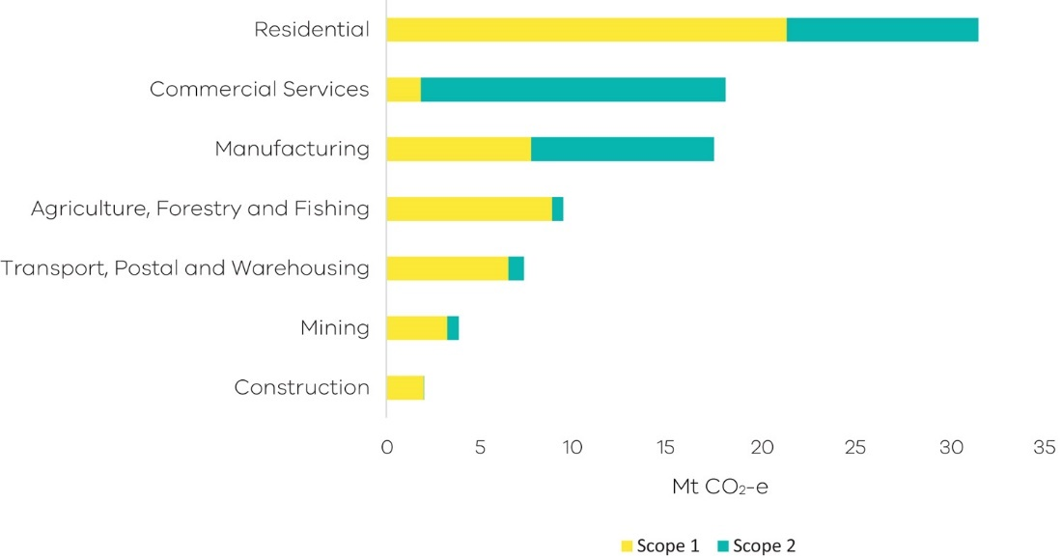
Figure 47: Scope 1 and 2 emissions by economic sector – Victoria, 2018
Source: Australian Greenhouse Emissions Information System (DISER 2020b)

* Note – Consistent with the Commonwealth, the chart above excludes Scope 1 and 2 emissions from electricity, gas, water and waste services industry. This is to avoid double counting direct emissions associated with electricity generation as they are already embodied within the indirect (scope 2) emissions from purchased electricity. Furthermore, indirect emissions are excluded as electricity generation consumed within the electricity, gas, water and waste services includes own use of generators and does not necessarily meet the NGA Factors 2018 definition of scope 2 emissions. Direct emissions from agriculture and forestry also include sequestration from forest and grassland management.

Appendix A

Revision of historical greenhouse gas emissions data
The Commonwealth Department of Industry, Science, Energy and Resources (DISER) revises historical greenhouse gas data annually, consistent with international practices, to reflect improved estimation methods.
Emissions estimation techniques and data sources for the Australian inventory are continuously refined, updated and improved. These revisions are aimed at reducing uncertainties in emissions estimates with a particular focus on key sectors, sectors with high uncertainties and sectors for which new estimation methods are available.
As a consequence of this process, DISER has revised historical emissions data between 1990 and 2017 nationally and for Victoria. A summary of these recalculations by sector and an explanation of the changes is presented in section 10.1 of the National Inventory Report 2018 – Volume 2 (DISER 2020d).
Table 3 presents a summary of the changes between the data presented in the Victorian Greenhouse Gas Emissions Report 2017 and the current (2018) report for Victoria’s greenhouse gas emissions by sector in 2005 and in 2017.
While there have been minor changes in historical data in most sectors and sub-sectors, the most significant change is in the LULUCF sector.
Table 3: Sectoral breakdown of Victoria’s greenhouse gas recalculations
Sector/sub-sector | Difference in emissions  (Mt CO₂e)
 | 2005 | 2017
Electricity generation | 0.00 | 0.00
Direct combustion | 0.00 | -0.45
Transport | -0.21 | 0.00
Fugitive emissions | 0.07 | 0.09
IPPU | 0.00 | -0.14
Agriculture | 0.50 | 0.45
LULUCF | 0.54 | -2.17
Waste | 0.00 | 0.20
Total | 0.90 | -2.02
Source: State and Territory Greenhouse Gas Inventories 2018 (DISER 2020e) and State and Territory Greenhouse Gas Inventories 2017 (DoEE 2019c)

Figure 48 shows the effect of this revised data on Victoria’s total net emissions between 2005 and 2017 as presented in the Victorian Greenhouse Gas Emissions Report 2017 and the current (2018) report. It shows that:
- Total net emissions in 2005 (the reference year under the Act for interim targets) have been revised upwards from 122.9 Mt CO₂-e to 123.8 Mt CO₂-e.
- Total net emissions in 2017 have been revised downwards from 110.3 Mt CO₂-e to 108.3 Mt CO₂-e.
- The reduction in total net emissions in 2017 is revised from 10.3% to 12.6% below 2005 levels.
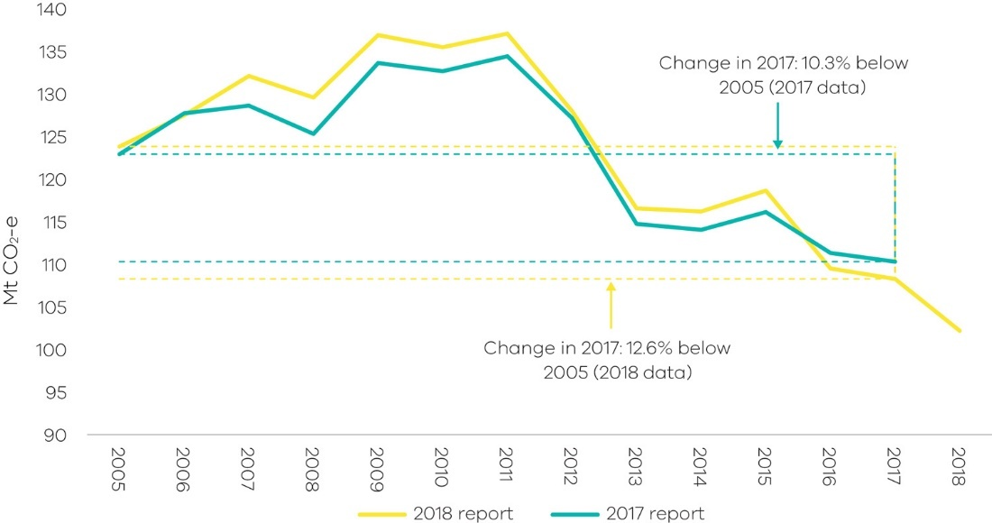
Figure 48: Impact of revised emissions on trends in Victoria’s total net emission from 2005-2017
Source: State and Territory Greenhouse Gas Inventories 2018 (DISER 2020e) and State and Territory Greenhouse Gas Inventories 2017 (DoEE 2019c)

Appendix B

LULUCF definitions, sources and removals
Category | Land areas | Sources of anthropogenic emissions and removals
Forest land
Forest land remaining forest land | This includes:  - Harvested native forests – multiple-use public forests as at 2008, and private native forests subject to harvest or regrowing from prior harvest.  - Other native forests – forests of endemic species that are not harvested native forests or plantations. It includes protected areas such as wilderness areas and national parks.  - For-harvest plantations established up until the end of 1989. | - Annual change in carbon pools due to forest growth and losses due to harvesting. Carbon transferred to wood products is accounted for as a carbon emission in this category, and as a carbon removal under Harvested Wood Products.  - Emissions from wildfires and fire management practices, including subsequent removals due to recovery. Non-anthropogenic natural disturbances, including some but not all wildfires are reported as a long run trend in emissions, reflecting the balance of the carbon lost and later re-absorbed by future regrowth. This approach is in accordance with the ‘natural disturbance’ provision under IPCC accounting rules and leaves anthropogenic emissions and removals as the main drivers.  - Annual change in carbon pools from plantation establishment and harvesting on land that was plantation land at the end of 1989. Carbon pools include above and below ground biomass, dead organic matter (DOM) and soil. Harvested wood products from plantations are treated the same way as wood from native forests.
Land converted to forest land | This includes:  - land on which forest has been established that was not forested as at 1972. It captures grassland, croplands, settlements and wetlands on which forest has been identified as emerging.  - Grassland converted to forest land includes post-1989 for-harvest and environmental plantations, forest that has regrown on land that had been cleared for other uses, and regeneration of forest from in situ seed sources.  - Wetlands converted to forest land captures mangrove forests that have emerged on tidal marshes. | Annual change in living biomass (above and below ground) on new and existing land in this category, losses due to harvesting, and changes in DOM and soil carbon.
Cropland
Cropland remaining cropland | This includes continuous cropping lands, lands cropped in rotation with pastures, and woody horticultural crops. Annual variations in use of land for cropping or pasture due to rotation are not recorded because they are not regarded as a permanent change in land use. | Changes in total cropping areas, crop type and rotation, stubble management practices (including burning), tillage techniques, and application of green manures, soil ameliorants, fertiliser and irrigation. CO₂ and nitrous oxide emissions associated with lime and fertiliser respectively are reported in the agriculture sector.
Land converted to cropland | This includes forest and wetlands converted to cropland since 1972. | Changes in all carbon pools (living biomass, DOM and soil) from:  - Primary clearing – arising when forest is cleared and maintained as cropland.  - Secondary clearing – arising when forest is cleared for cropland but then regrows and is re-cleared. (The regrowth is reported as land converted to forest land).  - Post-clearing land use – primarily changes in soil carbon.  .
Grassland
Grassland remaining grassland | This includes all areas of grassland not reported under land converted to grassland. Annual variations in land for cropping or pasture due to rotational use are not recorded because they are not regarded as a permanent change in land use.  It includes grasslands and shrublands (woody areas that do not meet the definition of forest). | Changes in pasture, grazing and fire management practices, changes in woody biomass in shrubland and changes in land use.
Land converted to grassland | This includes forest land and wetlands converted to grassland since 1972. | Changes in all carbon pools (living biomass, DOM, and soil) associated with:  - Primary clearing – arising when forest is cleared and maintained as grassland.  - Secondary clearing – arising when forest is cleared for grassland but then regrows and is re-cleared. (The regrowth is reported as land converted to forest land).  - Post-clearing land use – primarily changes in soil carbon.
Wetlands
Wetlands remaining wetlands | This includes coastal wetlands but will be extended in the future to include inland wetlands. It includes gains and losses of sparse woody vegetation on wetlands. | - For sparse woody areas – changes in all carbon pools (living biomass, DOM and soil) on wetlands using the same approaches as for sparse woody areas in the grassland category.  - For aquaculture production – emissions from activity estimated using production data published by the Australian Bureau of Agricultural and Resource Economics and Sciences (ABARES) and calculations for reporting emissions detailed in the National Inventory Report (NIR) 2018 s 6.10.1.  - For seagrass removal – emissions based on the area dredged calculated using the approach detailed in NIR 2018 s 6.10.1.
Land converted to wetland | This includes forests cleared as part of the construction of reservoirs and other land classified as flooded land. | Changes in all carbon pools (living biomass, DOM and soil) associated with the clearing.
Settlements
Settlements remaining settlements | This includes changes in sparse woody vegetation. It does not include land in settled areas that meets the definition of forest. | Changes in all carbon pools for sparse woody areas in settlements are modelled using the same approach as for sparse woody areas captured as part of grasslands.
Land converted to settlements | Includes forest land and wetlands converted to settlements. This includes mangrove forests cleared for commercial developments like marinas. | Changes in all carbon pools (living biomass, DOM and soil) associated with the clearing.
Harvested wood products (HWP)
HWP | This carbon pool includes the wood products in service in Australia and those that remain in solid waste disposal sites. The stock of HWP in service is estimated as the national production plus imports net of exports and product disposed to the waste system. | Annual emissions/removals are changes in this carbon stock based on:  - log flow from Australian forests – annual production by species grouping and product, for example sawlogs, veneer logs, pup logs, round wood and other  - fibre flow from processing by product class, imports and exports, recycling, entry and decomposition in landfill  - use for bioenergy and other losses to the atmosphere

Appendix C

Changes in LULUCF emissions estimates between the 2017 and 2018 Victorian Greenhouse Gas Emissions Reports
This section outlines the differences in Victoria’s LULUCF emissions data between the Victorian Greenhouse Gas Emissions Report 2017 (2017 report) and the current report (2018 report). It also describes the methodological changes that have given rise to these differences.
The time series for Victoria’s LULUCF emissions since 1990 in the 2017 and 2018 reports are presented in Figure 49. This shows that methodological changes have had different effects in LULUCF emissions data since 1990.
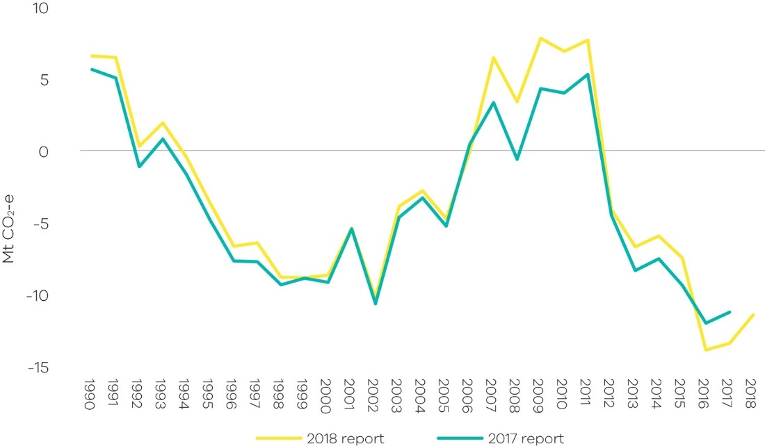
Figure 49: Victoria’s total net LULUCF emissions – Comparison of 2017 and 2018 reports
Source: State and Territory Greenhouse Gas Inventories 2018 (DISER 2020e) and State and Territory Greenhouse Gas Inventories 2017 (DoEE 2019c)
The changes in methodology have resulted in a small reduction in the net sink provided by the LULUCF sector in 2005 (the reference year against which emissions reduction targets are set in the Climate Change Act 2017). 2005 was recalculated from -5.3 Mt CO₂-e in 2017 report to -4.7 Mt CO₂-e in 2018 report which is an increase of 0.5 Mt CO₂-e. The changes have resulted in an increase in the net sink in 2017 of 2.2 Mt CO₂-e (-11.2 Mt CO₂-e in the 2017 report compared to -13.4 Mt CO₂-e in the 2018 report).

Differences by LULUCF sub-category
The 2017 and 2018 reports time series for Victorian LULUCF emissions in each major sub-category since 1990 are presented in Figure 50. The methodological changes have had the greatest and most variable impact on the time series for:
- Forest land remaining forest land – changes in this sub-category are the main contributors to the increased peak in net emissions seen in the 2018 report over the period 2007 to 2011 and subsequent deeper decline in net emissions by 2016. The main methodological changes include: modelling of wildfires updated to include carbon stock changes from the combustion and subsequent recovery of live biomass from wildfires; and incorporating satellite imagery-based forest cover change data to more accurately model the timing of harvesting and replanting of pre-1990 plantations.
- Forest land converted to other uses – recalculation has led to reduced sequestration across the timeseries by an average of 0.5 Mt CO₂-e, with the largest reductions in 2006 and 2017. Contributors to the recalculations include revised weather and climate data and new data showing generally slower biomass regrowth rates
- Land converted to forest land – changes have led to reduced removals across the timeseries, with the adjustment tending to be slightly larger after the early 2000s compared to the earlier period. Contributors to the recalculations include those listed above under forest land converted to other uses and improvements to the modelling of wildfires, as under forest land remaining forest land.

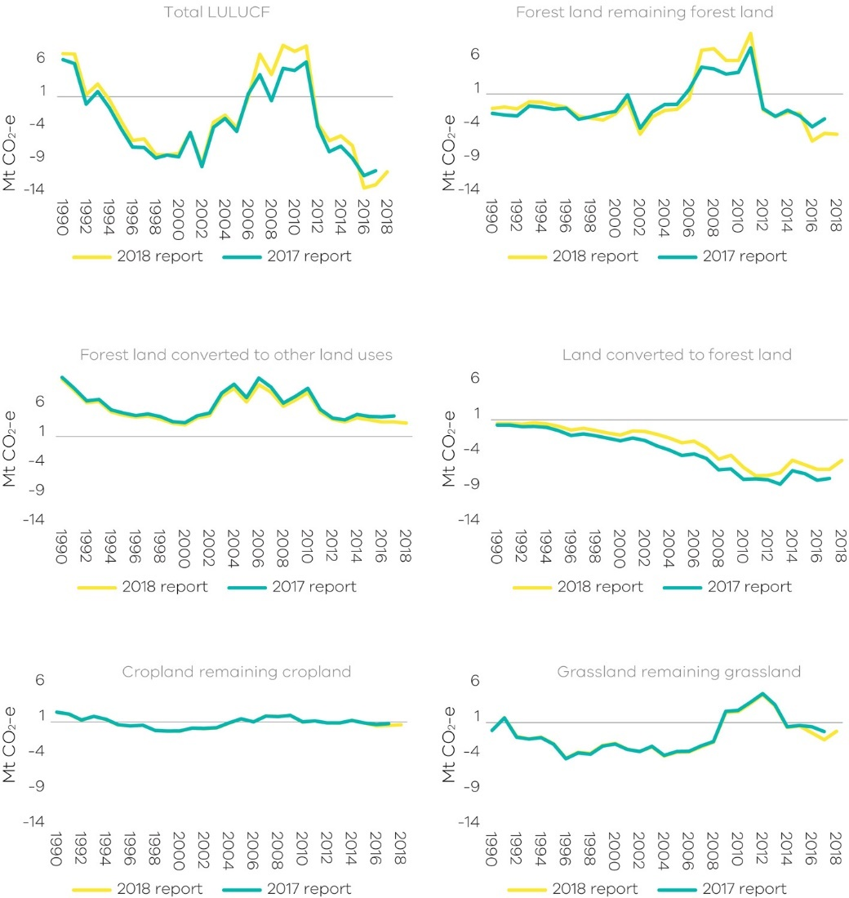
Figure 50: Emissions from Victoria’s main LULUCF sub-categories – Comparison of 2017 and 2018 reports

Abbreviations and acronyms
AEMO | Australian Energy Market Operator
AAP | Adaptation Action Plan
The Act | The Climate Change Act 2017
ANZSIC | Australian and New Zealand Standard Industrial Classification
CO₂ | Carbon dioxide
CO₂-e | Carbon dioxide equivalent
DISER | Commonwealth Department of Industry, Science, Energy and Resources
DoEE | Commonwealth Department of the Environment and Energy
GSP | Gross State Product
HFCs | Hydrofluorocarbons
IPCC | Intergovernmental Panel for Climate Change
IPPU | Industrial Processes and Product Use
KP | Kyoto Protocol
LULUCF | Land use, land-use change and forestry
Mt | Million tonnes
MW | Megawatt
MWh | Megawatt hours
NEM | National Electricity Market
PJ | Petajoules
UNFCCC | United Nations Framework Convention on Climate Change

Reference List
Australian Bureau of Agricultural and Resource Economics and Sciences (ABARES). 2020. 'About my region – Victoria', Canberra. Commonwealth of Australia Accessed 14 August. https://www.agriculture.gov.au/abares/research-topics/aboutmyregion/vic#regional-overview.
Australian Bureau of Statistics (ABS). 2019. "5220.0 - Australian National Accounts: State Accounts, 2018-19." Canberra. Commonwealth of Australia
———. 2020. "3101.0 - Australian Demographic Statistics, Dec 2019." Canberra. Commonwealth of Australia
Australian Energy Market Operator (AEMO). 2020. "Victorian Gas Planning Report Update." Gas Transmission Network Planning for Victoria. Australian Energy Market Operator Limited.
Australian Energy Regulator. 2018. "State of the Energy Market 2018." Melbourne. Commonwealth of Australia
Bureau of Infrastructure and Transport Research Economics (BITRE). 2014. "New passenger vehicle fuel consumption trends, 1979 to 2013." Canberra. Commonwealth of Australia.
———. 2019. "Australian infrastructure statistics Yearbook 2019." In Table T 3.3b Total passenger kilometres travelled by capital city—Melbourne. Canberra. Commonwealth of Australia
———. 2020. "Airport Traffic Data 1985–86 to 2018–19." Canberra. Commonwealth of Australia
Brodribb and McCann. 2019. "Cold hard facts " In, edited by Expert Group. Canberra Commonwealth of Australia.
Clean Energy Regulator (CER). 2019. "Greenhouse and energy information for designated generation facilities 2017-18." Canberra. Commonwealth of Australia
Department of Industry, Science, Energy and Resources (DISER). 2020a. "Australian Energy Statistics, Table O, May 2020 " Canberra. Commonwealth of Australia
———. 2020b. "Australian Greenhouse Emissions Information System." Canberra. Commonwealth of Australia
———. 2020c. "LULUCF historical emissions provided on 3 July 2020."
———. 2020d. "National Greenhouse Gas Inventory Report: 2018." Canberra. Commonwealth of Australia
———. 2020e. "State and Territory Greenhouse Gas Inventories 2018." Canberra. Commonwealth of Australia
Department of Environment and Energy (DoEE). 2019a. "Australian Energy Statistics, Table F." In Australian energy consumption, by state and territory, by industry and fuel type, energy units Canberra. Commonwealth of Australia
———. 2019b. "Australian Energy Statistics, Table I " In Australian production of primary fuels, by state and territory, physical units. Canberra. Commonwealth of Australia
———. 2019c. "State and Territory Greenhouse Gas Inventories 2017." In. Canberra Commonwealth of Australia
Morton 2012. 'Yallourn coal mine flood worsens', Fairfax, Accessed 27 July https://www.theage.com.au/national/victoria/yallourn-coal-mine-flood-worsens-20120715-224ef.html.
National Transport Commission (NTC). 2020. "Carbon Dioxide Emissions Intensity for New Australian Light Vehicles 2019." Melbourne. Commonwealth of Australia
Sustainabilty Victoria. 2011. "Electricity from Renewable Energy in Victoria " In. Melbourne. Victorian Government
———. n.d. "Victorian Energy Consumption Update – to 2016/17 "

. 2018 is the latest year for which official emissions data, published by the Commonwealth Government, is available.
. Percentage contributions of each sector are presented as net emissions (i.e. accounts for sequestration in the LULUCF sector).
. DISER prepares National Greenhouse Accounts that include a series of annual publications to meet Australia’s international obligations under the UNFCCC and Kyoto Protocol (KP). These include State and Territory Greenhouse Gas Inventories and the National Inventory Report.
. Financial years to June 30 – for example, the year 2012 refers to the Australian financial year from 1 July 2011 to 30 June 2012.
. UNFCCC accounting is used rather than KP accounting because it includes a more comprehensive set of land categories and the identification of emissions from land clearing events. It is also expected to be more widely used in the future than the KP provisions. The primary protocol for the preparation of the data are the UNFCCC reporting rules and guidelines adopted under decision 24/CP.19; known as the Revision of the UNFCCC reporting guidelines on annual inventories for Parties included in Annex I to the Convention, and the Intergovernmental Panel on Climate Change (IPCC) 2006 Guidelines for National Greenhouse Gas Inventories (IPCC 2006).
. DISER produces LULUCF emissions data under the rules for reporting applicable to both the UNFCCC and the Kyoto Protocol. The Victorian Greenhouse Gas Emissions Report uses LULUCF data following the UNFCCC emissions accounting provisions.
. Percentage contributions of each sector are presented as net emissions (i.e. they take into account sequestration in the LULUCF sector).
Sections 2.1 to 2.5 of this report discuss the interannual variability of emissions trends by sector between 1990 and 2018.
A target of 50% by 2030 has since been added.
Excluding gas consumption for electricity generation
. Fuel consumption data sourced from Australian Energy Statistics and adjusted to exclude international aviation fuel. This is to be consistent with UNFCCC accounting framework that excludes international aviation and shipping for national reporting.
Also includes emissions from flaring during exploration
These emissions are from the equipment operating as designed, as opposed to leakages.
. Biogenic carbon dioxide from paper, wood, garden, food or other biomass is assumed to have uptake and release within 100 years through photosynthesis. In the IPCC Fourth Assessment report, biogenic carbon dioxide is assumed to have a neutral global warming potential, and as such is reported as a memo item in the National Inventory Report.
. Principles of conversion of carbon and mass are respected to estimate rates of decomposition, so no double counting of carbon occurs.
. Enteric fermentation is a natural part of the digestive process of ruminants where microbes decompose and ferment food in the digestive tract or rumen producing methane emissions.
. DISER produces LULUCF emissions data under the rules for reporting applicable to both the UNFCCC and under the Kyoto Protocol. The Victorian Greenhouse Gas Emissions Report 2018 uses LULUCF data following the UNFCCC emission accounting provisions.
These three sub-categories account for more than 80% of total emissions from the LULUCF sector. While emissions from other sub-categories are not described in this section of the Report, their net emissions are accounted for in the total net LULUCF emissions presented in Figure 40 and Figure 41.

