**Independent Expert Panel:**

**Interim Emissions Reduction Targets for Victoria (2021-2030)**

**Issues Paper**

Author

Independent Expert Panel on Interim Targets

Editor

Secretariat, Department of Environment, Land, Water and Planning

© The State of Victoria Department of Environment, Land, Water and Planning 2017

Creative Commons Logo

This work is licensed under a Creative Commons Attribution 4.0 International licence. You are free to re-use the work under that licence, on the condition that you credit the State of Victoria as author. The licence does not apply to any images, photographs or branding, including the Victorian Coat of Arms, the Victorian Government logo and the Department of Environment, Land, Water and Planning (DELWP) logo. To view a copy of this licence, visit <http://creativecommons.org/licenses/by/4.0/>

ISBN 978-1-76047-952-7 (pdf)

Disclaimer

This publication may be of assistance to you but the State of Victoria and its employees do not guarantee that the publication is without flaw of any kind or is wholly appropriate for your particular purposes and therefore disclaims all liability for any error, loss or other consequence which may arise from you relying on any information in this publication.

Accessibility

If you would like to receive this publication in an alternative format, please telephone the DELWP Customer Service Centre on 136186, email [customer.service@delwp.vic.gov.au](mailto:customer.service@delwp.vic.gov.au), or via the National Relay Service on 133 677 [www.relayservice.com.au](http://www.relayservice.com.au). This document is also available on the internet at [www.delwp.vic.gov.au](http://www.delwp.vic.gov.au).

Contents

Executive summary 3

Background 3

The Panel and its task 3

Consultation on Victoria’s interim emissions reduction targets 3

1. Purpose of this issues paper 4

2. Overview of the Panel and its task 4

Principles for providing advice on interim targets 4

3. What climate change means for Victoria 6

Victoria has already become warmer and drier - a climate trend likely to continue 6

Victoria in a 4°C world 7

Climate comparisons 10

Avoiding the worst impacts 10

4. Climate change policy context 12

International 12

Australia 12

Victoria 12

Other sub-national jurisdictions 14

5. Australia’s emissions 15

6. Victoria’s emissions 16

7. Interim emissions reduction targets for Victoria for 2021-2030 and trajectories to 2050 19

Overview 19

Form and scope of the targets 19

Developing recommendations for interim targets and trajectories to net zero by 2050 20

National emissions reductions and targets 20

Emissions budgets 20

Illustration of interim targets (2021-2030) and trajectories to 2050 for Victoria 22

8. Emissions reduction opportunities 24

Electricity generation 24

Transport 25

Built environment 25

Industry 26

Land 26

Carbon offsets 27

9. Potential effects of reducing emissions to meet interim targets 28

General considerations 28

Economic and social benefits and costs 28

Costs of transition 30

Benefits of transition 31

Environmental benefits and costs 31

Appendix 1: Biographies of Interim Targets Independent Expert Panel Members 33

Appendix 2: Terms of Reference - Interim Targets Independent Expert Panel 35

Introduction 35

Scope of work 35

Process 36

Outputs and timetable 36

Appendix 3: Comparison of Australian state and territory emissions reduction targets 37

**Executive summary**

## Background

The Victorian Government has identified climate change as one of the biggest threats to the future of the state, with warmer and drier conditions projected to have negative consequences for health, infrastructure, agriculture, water, biodiversity, and alpine and coastal areas. The Victorian *Climate Change Act 2017* (the Act) responds to this challenge by establishing a legislative framework to drive action to achieve a net zero emissions, climate-resilient Victorian community and economy by 2050.

To establish a pathway to net zero emissions by 2050, the Act requires the Victorian Government to set five-yearly interim emissions reduction targets, starting in 2021. The Act requires independent expert advice to be sought to inform the setting of interim emissions reduction targets.

## The Panel and its task

The Minister for Energy, Environment and Climate Change, the Hon. Lily D’Ambrosio, has appointed an Independent Expert Panel (Panel) to provide advice on the first two sets of interim targets for 2021-25 and 2026-30. The Panel members are:

* + The Hon Greg Combet AM (Chair);
  + Dr Penny Whetton; and
  + Dr Lorraine Stephenson.

The Panel’s advice must include:

* + interim target recommendations for 2021-25 and for 2026-30;
  + indicative trajectories to net zero emissions by 2050; and
  + potential emissions reduction opportunities to achieve the targets.

Among other matters, the Panel must consider climate science, technology, existing national and global action on climate change, and potential impacts of interim targets and emissions reduction measures on the economy, environment and community.

Under its terms of reference, the Panel is required to present its final report to the Minister for Energy, Environment and Climate Change by **22 February 2019**.

## Consultation on Victoria’s interim emissions reduction targets

The Panel is seeking input from the Victorian community to inform the development of its advice to the Minister. This paper presents a discussion of issues relevant to Victorian interim emissions reduction targets, and seeks the community’s views.

The paper provides background information about what climate change means for Victoria; climate change policy at the international, Commonwealth and Victorian levels; historical trends in Victoria’s emissions; and projections for Australia’s emissions. It then discusses the specific context and requirements for interim targets for 2021-2025 and 2026-2030 and emissions trajectories to 2050. This includes:

* + existing national emissions reduction commitments, which are a starting point for thinking about Victoria’s interim targets; and
  + a discussion of the role an emissions budget could play in developing Victoria’s targets and trajectories, and trade-offs between earlier and later action to reduce emissions to reach net zero in 2050.

Next, the paper briefly outlines opportunities to reduce Victoria’s emissions in key sectors: electricity generation, transport, the built environment, industry, agriculture and other land uses (e.g. forestry). The potential role of carbon offsets from emissions reductions outside Victoria is also discussed. Finally, the paper considers some of the potential economic, social and environmental benefits and costs of reducing emissions to meet interim targets, including impacts on the state economy, jobs, health, water and biodiversity.

# Purpose of this issues paper

This paper explores the issues relevant to setting interim emissions reduction targets for Victoria for 2021-2025 and 2026-2030 and trajectories to net zero emissions by 2050.

The paper seeks submissions to inform the Interim Targets Independent Expert Panel and provide additional input and evidence for the Panel to consider in developing advice for the Victorian Government on interim targets.

You are invited to respond to the questions posed in this issues paper, and to note or provide any additional evidence you believe the Panel should consider in developing its advice (e.g. reports, data sets). Submissions should be uploaded on the Engage Victoria web platform or sent to [climate.change@delwp.vic.gov.au](mailto:climate.change@delwp.vic.gov.au) by **1 May 2018**.

# Overview of the Panel and its task

The *Climate Change Act 2017* (the Act)recognises the global agreement tokeep global average temperature rise this century to well below 2°C above pre-industrial levels and to pursue efforts to limit temperature increases to 1.5°C. The Act commits Victoria to a long-term emissions reduction target of net zero greenhouse gas emissions by 2050. The Act also requires five-yearly interim targets, starting in 2021, and establishes a pledging model for whole-of-government, key sectors and local government to meet these targets.

The Independent Expert Panel has been appointed by the Minister for Energy, Environment and Climate Change (the Minister) to provide advice on interim targets for Victoria for the periods 2021-25 and 2026-30. The Panel members are:

* + The Hon Greg Combet AM (Chair);
  + Dr Penny Whetton; and
  + Dr Lorraine Stephenson.

Further information about the Panel members can be found in **Appendix 1**.

The appointment of the Panel responds to a requirement under the Act for the Minister to seek independent expert advice when setting interim targets. The Act requires the Panel to provide advice on:

1. One or more recommended interim targets for reducing greenhouse gas emissions for the periods 2021-2025 and 2026-2030. These recommendations must have the following characteristics:
   1. Each recommended interim target must constitute a greater reduction in greenhouse gas emissions than any previous interim emissions reduction target;
   2. Each recommended interim target must be expressed against a 2005 base year.
2. Indicative trajectories for Victoria to achieve the long-term emissions reduction target (net zero greenhouse gas emissions by 2050) consistent with each recommendation under item 1.
3. Potential opportunities across the Victorian economy to reduce greenhouse gas emissions in the most efficient and cost-effective manner in each interim target period.

These requirements are reflected in the Panel’s terms of reference (**Appendix 2**).

The Panel’s advice will be delivered to the Minister by 22 February 2019. It will subsequently be tabled in Parliament. The Minister and the Premier will be responsible for setting the interim targets.

## Principles for providing advice on interim targets

The Panel has adopted a set of principles to guide their decision making in providing advice on interim targets. These principles reflect and build upon the guiding principles in sections 23-28 of the Actthat the Panel is obliged to consider.

The principles are:

1. **Environmental effectiveness**

The recommended targets and trajectories should be informed by up-to-date climate science and ensure that Victoria achieves its objective of net zero emissions by 2050 in a way that is consistent with keeping global temperature rise this century to below 2°C above pre-industrial levels.

1. **Economic efficiency**

The recommended targets and trajectories should facilitate the lowest cost approaches to emissions reductions, and take into account the economic and environmental impacts and opportunities they may create. This includes consideration of the competitiveness of Victorian industries, and of cost-effective trajectories to reach net zero emissions by 2050.

1. **Equity**

The Panel should have regard to the potential social impacts and opportunities created by emissions reduction opportunities and the recommended targets and trajectories:

* + between regions;
  + between socio-economic groups; and
  + between current and future generations.

The Panel should have particular regard for Victoria’s vulnerable communities.

1. **Flexibility**

The recommended targets should incorporate sufficient flexibility to allow Victoria to take account of and adjust to changes in the climate policy and ambition of the international community, the Commonwealth Government and Australia’s other states and territories. Flexibility is also desirable to adjust to other changing circumstances, such as developments in emissions accounting rules, climate science and low-emissions technology.

1. **Investor certainty**

The recommended targets and trajectories should provide businesses with the confidence to undertake long-term investments in energy generation, low emissions technology, infrastructure and processes.

1. **Policy coherence**

The recommended targets, trajectories and opportunities identified should be consistent with Victoria’s other relevant policy objectives to promote a coherent policy framework within the state.

# What climate change means for Victoria

Victoria and the international community have recognised the urgent threat of climate change and have agreed to keep global average temperature increases this century well below 2°C above pre-industrial levels and to pursue efforts to limit temperature increases even further to 1.5°C. If the world were not to act, then the impacts of climate change in Victoria could be significant.

## Victoria has already become warmer and drier - a climate trend likely to continue

Climate change is already affecting Victoria’s communities, economy and environment. While it will continue to have an impact in the future, the worst impacts can be avoided with strong global action.

Victoria has already seen a rise in temperature and fall in rainfall across the state since 1950 (**Figure 1**). The sea level around the coast of Australia has risen by an average of 2.1mm per year since the 1960s.[1] Heatwaves in Melbourne occur on average 17 days earlier and are 1.5°C hotter than between 1950-1980.[2]

**Figure 1. Temperature and rainfall change in Victoria since 1950**

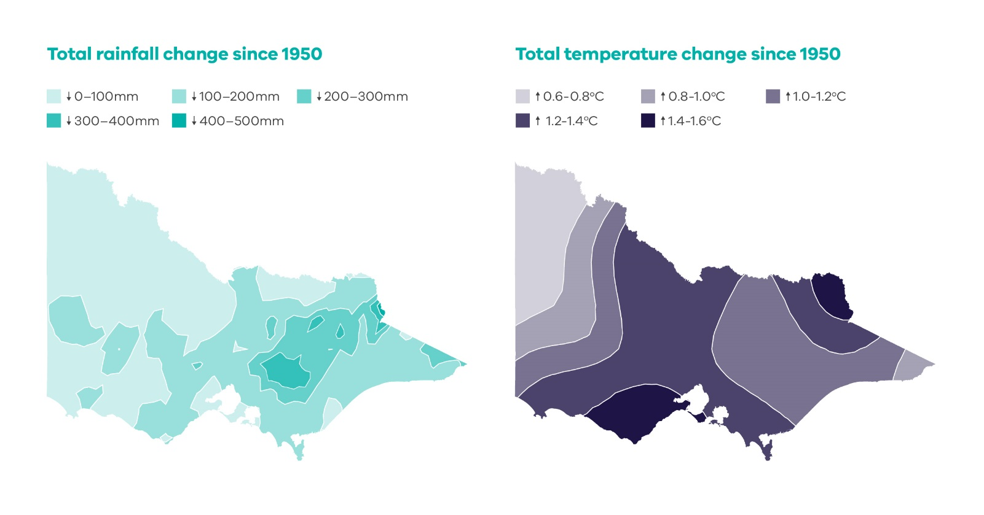

**Source:** Department of Environment, Land, Water and Planning (2015) *Climate-ready Victoria*.

The increase in the average temperature makes extreme hot weather (such as very hot days or warm nights, and heatwaves) more likely to occur (**Figure 2**). Due to the warmer atmosphere and ocean, extreme weather events such as extreme fire weather, droughts and extreme rainfall are also more likely.

Figure 2: The relationship between climate averages and extremes

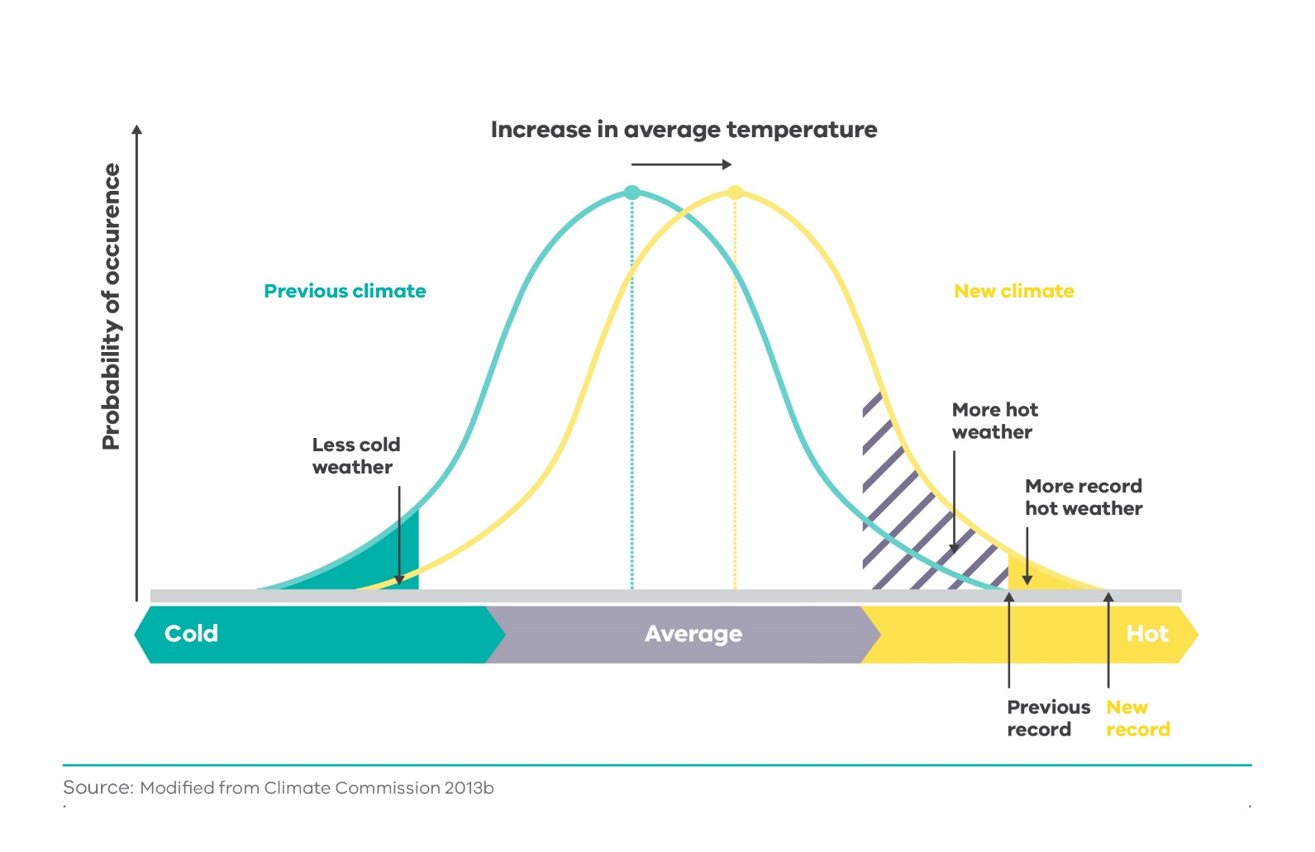

**Source:** Climate Change Authority (2014) *Reducing Australia’s Greenhouse Gas Emissions: Targets and Progress Review.*

## Victoria in a 4°C world

If greenhouse gas emissions continue to grow at the rate of recent decades, the world is likely to be 4°C warmer than pre-industrial times by the end of the century.[3] This will have wide-ranging and significant impacts for Australia and Victoria. The potential impacts on some important parts of society are outlined in **Box 1**.

|  |
| --- |
| Box 1. Potential impacts of Climate Change on Victoria |
| *Health*  In a world that is 4°C warmer, Melbourne is projected to experience 24 days per year over 35°C, more than double the current number. Heatwaves would become more frequent and longer, with their effects amplified in cities due to the heat built up and stored in urban areas (known as the “urban heat island effect”).[4]  Heatwaves cause more deaths than any other natural disaster in Victoria.[5] One study found that if the state doesn’t adapt, there will be an average of 400 extra deaths per year in Melbourne by 2050 from heatwaves caused by climate change.[6]  As well as the health impacts of heat, a 4°C world is projected to also see risks to health from the increased frequency of extreme weather events, and associated mental health impacts, and changes to the distribution of vector-borne diseases, such as Ross River Fever.[7]  *Infrastructure*  Both public and private infrastructure would be impacted by the increasing frequency and intensity of extreme weather events such as flooding, fire and heatwaves in a 4°C world. This could put critical water, transport, energy and telecommunications infrastructure under strain and leave Victorians at increased risk of outages of vital services.  For example, the heatwave in early 2009 in Victoria had significant impacts. Record demand for electricity as people kept cool with air conditioners led to the failure of parts of the electricity network, with 500,000 people in Melbourne losing power on one day. The train network also struggled, with buckled tracks, loss of power and air conditioning failures leading to over one-third of train services being cancelled.[8]  *Alpine areas*  In a 4°C world, one study estimates that the Victorian alpine resorts could receive about 60-80% less snow compared to recent decades.[9] While variation between years would continue, the ski season would likely be 65-90% shorter than at the start of this century.[10] The resulting decline in visitation would negatively affect the alpine communities that rely on winter tourism for their income. The fragile alpine environments that rely on snow cover would also suffer.  *Water*  Victorians are projected to face increasing risk of water shortages in a 4°C world. While the extent of projected changes in rainfall is less certain than for temperature, rainfall and consequently runoff in Victoria are projected to decline. The changes in cool-season rainfall observed during the Millennium Drought were equivalent to drier projections of rainfall at 2060.[11] Further rainfall declines would lead to less water being available for Victoria’s communities, industries and environment.  For example, Bendigo is projected to have a water supply shortfall from 2018 as population growth increases demand and climate change reduces supply. This is projected to continue over the long term, with the supply shortfall in 2065 projected to be as high as 28,000ML - an amount which is double current water use of 15,000ML.[12]  While the average annual rainfall is projected to decline, the rain that does fall is expected to fall in more intense downpours, leading to an increased risk of flooding of rivers and urban creeks and the resulting risks to safety and damage to infrastructure.  *Primary production*  The agriculture industry is highly sensitive to changes in climate. Rising temperatures and reduced water availability would likely affect crop yields, and change the locations of where certain crops are viable. In a 4°C world, livestock would need increased shelter from high temperatures. If the future climate is at the drier end of projections, it is expected that a significant decrease in agricultural productivity would occur in the Murray-Darling Basin.[13]  While many lessons about coping with drought were learned from the extended Millennium Drought from 1996-2009, the projected increase in frequency and duration of extreme droughts, when combined with the other pressures facing rural areas, would further test the agriculture industry and its contribution to the economy, and risk rising levels of farmer debt and mental health problems.[14]  *Biodiversity*  Victoria’s diverse and precious natural environment would be placed under increased stress and would face irreversible changes in a 4°C world. While some species have a capacity to adapt and cope with variation in climate, the extent of changes in temperature, moisture availability and fire regimes would likely lead to irreversible damage to and disappearance of some ecosystems. While climate change itself will have impacts on biodiversity, adaptation measures, including changes to agriculture systems, hazard reduction policies or water allocations, may also increase pressure on ecosystems.[15]  The impact of more frequent fires is already evident in the Victorian alpine region. For example, repeated fires from 2003 to 2013 killed mature alpine ash trees and prevented regrowth from reaching maturity and producing seed. The forest has only been retained through an active reseeding program.[16]  For marine biodiversity, warmer oceans would likely see species from warmer northern waters continue to move further southwards to Victoria, changing fisheries and potentially bringing new pest species. This, combined with increased ocean acidification that hinders the ability of marine organisms to form shells and skeletons, would drastically alter foodwebs and ecosystems.[17]  *Coasts*  Coastal areas in Victoria have already been impacted by climate change, with the risks posed to life, coastal infrastructure and biodiversity set to increase in a 4°C world.  The 0.4 to 0.9m of sea level rise projected for the Victorian coast in a 4°C world[18] is projected to lead to increased flooding of low-lying coastal areas, dune erosion, loss of beaches and coastal ecosystems, damage to coastal infrastructure and reduced public access to coastal environments. If the West Antarctic ice sheet began to collapse, the sea level would rise even higher.[19]  Taking into account the projected sea level rise, as well as storm surges, coastal assets would need to be built 0.8m higher than their current levels to maintain their current frequency of breaches from the ocean.[20] |

## Climate comparisons

Climate analogues illustrate the future climate of specific cities and towns by matching their projected climate to locations that currently have a similar rainfall and temperature.[21] The comparisons in **Figure 3** show that, in a 4°C world, Victorian towns are projected to become more like hotter and drier locations to the north.

Figure 3. Victoria in a 4°C world

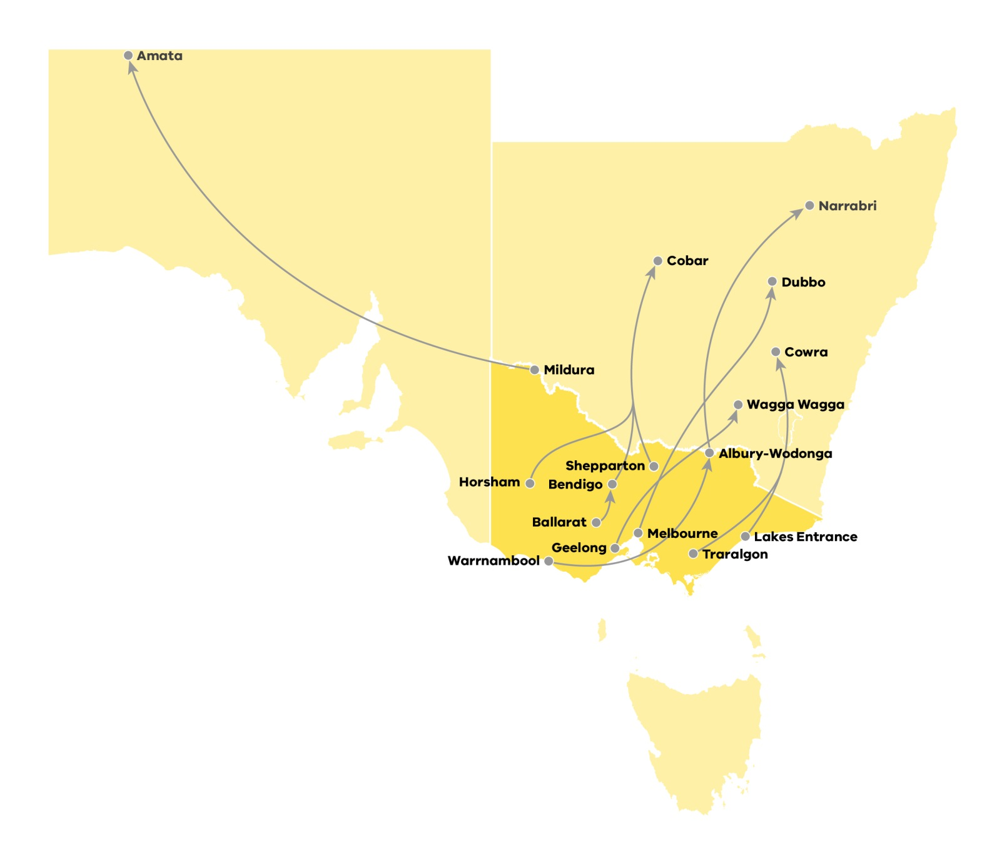

**Source:** Climate Change in Australia, *Climate analogues website*: [www.climatechangeinaustralia.gov.au/en/climate-projections/climate-analogues/about-analogues/](http://www.climatechangeinaustralia.gov.au/en/climate-projections/climate-analogues/about-analogues/).

## Avoiding the worst impacts

The international community has already committed to take action to limit global temperature increase this century to well below 2°C and to pursue efforts to limit the increase even further to 1.5°C. If the world is successful in limiting the global temperature increase to 1.5°C, many of the worst projected impacts of climate change in Victoria can be avoided. The impacts of climate change would still be felt in a 1.5°C world, but would be less severe than the 4°C world described above. **Table 1** gives a comparison of the future climate in a 1.5°C world and 4°C world.[22]

The reduced extent of the changes would mean that the Victoria’s communities, environment and economy are better able to cope with the impacts. The ability to adapt reduces the risk to many sectors to low or very low levels, seeing Victoria remain a prosperous and liveable state.[23]

Table 1: Projected changes for key climate variables in a 1.5°C and a 4°C world relative to 1995

| Variable | 1.5°C world south of Great Dividing Range | 4°C world south of Great Dividing Range | 1.5°C world north of Great Dividing Range | 4°C world north of Great Dividing Range |
| --- | --- | --- | --- | --- |
| Average annual temperature change relative to 1995 (°C) | 0.4 to 1.3 | 2.5 to 4.0 | 0.6 to 1.5 | 2.7 to 4.5 |
| Average annual rainfall  (% change) | -7.6 to +2.1 | -19.1 to +5.0 | -18.6 to +2.7 | -26.7 to +8.6 |
| Days above 35°C per year | 12 to 17 (Melbourne) | 19 to 32 (Melbourne) | 39 to 50 (Mildura) | 60 to 85 (Mildura) |
| Sea level rise (m)  (Stony Point) | 0.22 to 0.53 | 0.38 to 0.81 | - | - |

**Note:** Data taken from Climate Change in Australia, with 1.5°C world represented by RCP2.6 at 2090 and 4°C world be RCP8.5 at 2090. The ranges given correspond to the 10th and 90th percentiles of model simulations.

# Climate change policy context

The Panel is required to consider existing national and global action on climate change, including any undertakings relating to the reduction of greenhouse gas emissions that Australia has committed to under international climate change agreements.

## International

In December 2015, the international community agreed, through the Paris Agreement, to limit global average temperature increase to well below 2°C and to pursue efforts to limit the temperature increase even further to 1.5°C. The Paris Agreement builds upon the 1992 United Nations Framework Convention on Climate Change (UNFCCC) and 1997 Kyoto Protocol.

Australia is a Party to the Paris Agreement. The Agreement requires all Parties to set post-2020 emissions reduction targets, called Nationally Determined Contributions (NDCs). All Parties to the UNFCCC have submitted an NDC including United States of America, China, India and the members of the European Union.

Separate to the formal NDC process, Victoria has signed the “Under2 MOU” (Subnational Global Climate Leadership Memorandum of Understanding), joining a global community of state, regional and local governments committed to supporting the Paris Agreement goal of keeping the rise in global temperature well below 2°C. The goal of this MOU is to limit greenhouse gas emissions to 2 tons per capita by 2050 (equivalent to around 80-90% below 1990 levels). By comparison, in 2015, Victorians emitted about 18 tons of greenhouse gas emissions per capita.

## Australia

Australia has committed to reduce its emissions by **26-28% below 2005 levels by 2030** in its Nationally Determined Contribution. This follows earlier commitments to keep annual emissions to 108% of 1990 levels on average during the Kyoto Protocol first commitment period (2008-2012), to keep annual emissions to 99.5% of 1990 levels on average during the second commitment period (2013-2020), and to reduce emissions by 5% below 2000 levels by 2020.

The Climate Change Authority, an independent statutory agency established to provide expert advice to the Commonwealth Government on Australian climate change policy, recommended a national emissions reduction target of **36% below 2005 levels by 2025** and a target range of **45-65% below 2005 levels by 2030[24]** for a range of reasons including:

* + the benefits would outweigh the costs;
  + Australia’s efforts would be broadly consistent with Australia’s fair contribution to keeping temperature increases to below 2°C; and
  + these efforts would be reasonably aligned with commitments made by other developed countries.

The Climate Change Authority’s recommendations have not been endorsed by the Commonwealth Government.

Australia’s current key national climate change policies include the Renewable Energy Target, the Emissions Reduction Fund, the Emissions Reduction Fund Safeguard Mechanism, and the National Energy Productivity Plan.

The Commonwealth has also proposed a National Energy Guarantee, which would establish an emissions guarantee in the electricity market alongside a reliability guarantee. If implemented, this would apply from 2020.

In December 2017, the Commonwealth completed a Review of National Climate Change Policy. The review confirmed the continuation of Commonwealth’s current policy suite, with some adjustments, and committed to a process to ‘review and refine’ policies every 5 years.

## Victoria

The *Climate Change Act 2017* provides Victoria with a legislative foundation to drive Victoria’s transition to a net zero emissions, climate-resilient community and economy.

The Act:

* + legislates a long-term greenhouse gas emissions reduction target of net zero emissions by 2050;
  + requires the Premier and the Minister to set five-yearly interim targets from 2021, to keep Victoria on track to meet the long-term target;
  + requires the Minister to develop a Climate Change Strategy every five years (with the first due by 1 August 2020), setting out how Victoria will meet its targets and adapt to the impacts of climate change;
  + establishes a pledging model to reduce emissions from state and local governments’ own operations as well as from key emitting sectors of the economy;
  + introduces a new set of policy objectives and an updated set of guiding principles to embed climate change into government decision-making;
  + requires Adaptation Action Plans be prepared every five years (from 2021) for key systems such as water, farming and health that are either vulnerable to the inevitable impacts of climate change, or are essential to ensure Victoria is prepared for the impacts; and
  + establishes a system of regular reporting on Victoria’s emissions and actions to provide transparency and accountability.

Victoria’s Climate Change Framework(the Framework) provides a description of how the government will drive the economic transition to a net zero emissions economy through increasing energy efficiency and productivity; moving to a cleaner electricity supply; increasing electrification of transport, buildings and industry; switching to cleaner fuels; reducing non-energy emissions; and storing carbon in trees, plants and soil.

The Framework also outlines steps the government is already taking, including two key emissions reduction targets for 2020:

* + to reduce Victoria’s emissions by 15-20% below 2005 levels[25]; and
  + to reduce office-based emissions from government operations by 30% below 2015 levels.

The TAKE2 program is a pledge and review process focused on reducing emissions and building capacity on climate change action. TAKE2 pledges range from pledges made by the Victorian Government, such as the Greener Government Buildings program (estimated emissions reductions of 25,000 tonnes per year[26]) to voluntary pledges of various sizes made by local governments, businesses, community groups, education organisations and individuals.

Victoria’s *Renewable Energy (Jobs and Investment) Act 2017* legislates the Victorian Renewable Energy Targets (VRET) of 25% of electricity generated in the state by 2020 and 40% by 2025. Delivery of these targets is supported by the Victorian Renewable Energy Auction Scheme – a competitive reverse auction scheme. The first auction, for 650MW, ran from 14 November 2017 to 14 February 2018.

The Victorian Energy Upgrades program (previously the Victorian Energy Efficiency Target (VEET)) was established in 2009. It is the largest energy efficiency certificate program in Australia, and has assisted energy saving activities by over 1.7 million households and 70,000 businesses. Under the program, energy retailer companies must meet their share of an annual greenhouse gas reduction target by supporting the uptake of products and services that improve household and business energy efficiency. The target for 2020 is 6.5 megatonnes (Mt CO2-e).

The New Energy Technologies Strategy focuses on investing in clean energy generation technology, strengthening sector skills, collaboration and innovation, encouraging the development of new consumer-driven markets, and building state-wide capabilities. The strategy aims to capitalise on opportunities for new jobs and support growth in advanced manufacturing, installation services, and export markets.

In line with their guiding principle of “policy coherence”, the Panel will take the above policy measures into account when providing advice on interim targets.

## Other sub-national jurisdictions

A number of other Australian states and territories are advancing their climate policies. Like Victoria, New South Wales, Queensland, South Australia, Tasmania and the Australian Capital Territory (ACT) have committed to net zero emissions by 2050. Together these jurisdictions represent over 80% of Australia’s emissions. In the ACT and Victoria these targets have been set in legislation. Queensland and the ACT are the only jurisdictions to have set targets for the interim period as well: Queensland has set a target to reduce emissions 30% below 2005 levels by 2030, and the ACT has legislated a reduction of 40% below 1990 levels by 2020. Refer to **Appendix 3** for further details.

Sub-national jurisdictions in other countries are also acting on climate change. For example, California (US), British Columbia (Canada) and Baden-Württemberg (Germany) have set ambitious 2050 targets and interim targets (in 2020 or 2030). To date, 205 jurisdictions from 43 countries and 6 continents, including Victoria, have signed or endorsed the Under2 MOU.

# Australia’s emissions

Australia’s greenhouse gas emissions are significant on a global scale. In 2014, Australia had the 13th highest greenhouse gas emissions of 192 countries, just below Mexico and South Korea and higher than the United Kingdom and France, each of which have almost three times Australia’s population.[27] In fact, Australia had the highest emissions per capita out of all members of the Organisation for Economic Co-operation and Development (OECD), with over 22 tonnes of greenhouse gases being emitted per person in 2015.[28] This is due in part to the high emissions intensity of Australia’s electricity generation.

Data recently released by the Commonwealth Government Department of the Environment and Energy shows that Australia’s emissions are currently increasing[29] and projections show a continued steady increase in emissions. Under current policies, the Commonwealth Government Department of the Environment and Energy projects Australia’s emissions to be 5% below 2005 levels in 2030[30], whereas Australia’s 2030 target under the Paris Agreement is to reduce emissions by 26-28% below 2005 levels by 2030 (**Figure 4**).

**Figure 4. Australia’s emissions trends and projections, 1990 to 2030**

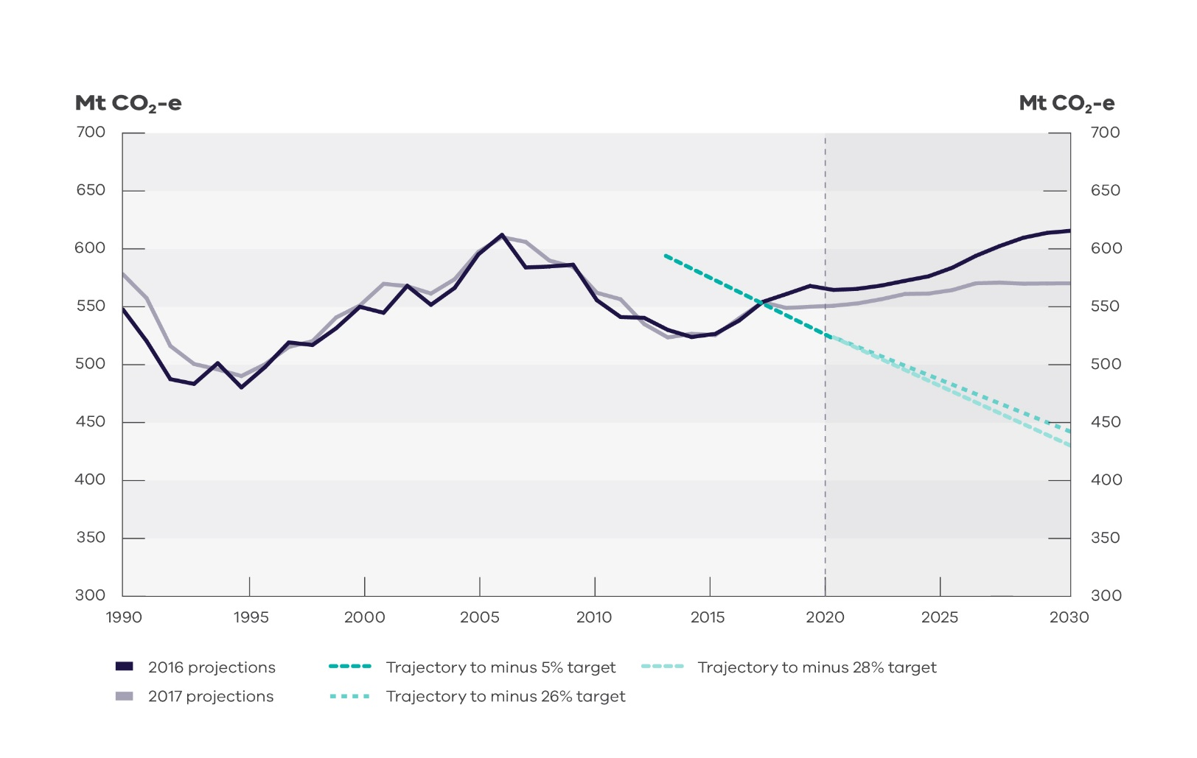

Source: Commonwealth Government Department of the Environment and Energy (2017), Australia’s emissions projections 2017

Commonwealth Government emissions reduction targets and policies have a significant impact on Victoria’s emissions. If Commonwealth policies do not drive a reduction in Victoria’s emissions, further Victorian action will be needed to keep Victoria on track to meet its legislated target of net zero emissions by 2050.

# Victoria’s emissions

*The Climate Change Act 2017* requires the Panel to consider “any progress towards the reduction of greenhouse gas emissions, including any annual greenhouse gas emissions report”, in developing its advice on interim targets.

In 2016, the latest year for which data is available in the Commonwealth’s State and Territory Greenhouse Gas Inventories, Victoria’s net greenhouse gas emissions were 113.9 MtCO2-e. With the closure of the Hazelwood brown coal-fired power station in March 2017, Victoria’s emissions will now be significantly lower; Hazelwood emitted about 15 Mt CO2-e per year.[31]

Victoria’s net emissions generally rose from 1995 and peaked in 2009, declined to 2013, rose slightly in 2014 and 2015, and fell again in 2016 (**Figure 5**). The downward trend in Victoria’s emissions since 2009 is predominantly due to a decline in electricity demand across the national electricity market, driven by improvements in energy efficiency and higher electricity prices, and to a decline in manufacturing activity.

The rise in Victoria’s net emissions between 2014 and 2015 can mainly be attributed to an increase in electricity generation from brown coal resulting from the Yallourn power station’s generation returning to historical levels after reduced operation following mine flooding in 2012, and also coincides with the repeal of the national carbon price. The drop in emissions in 2016 was mainly driven by a small reduction in emissions from electricity generation and an increase in carbon sequestration from Victoria’s land sector.

**Figure 5. Victoria’s emissions from 1990 to 2016, by sector**

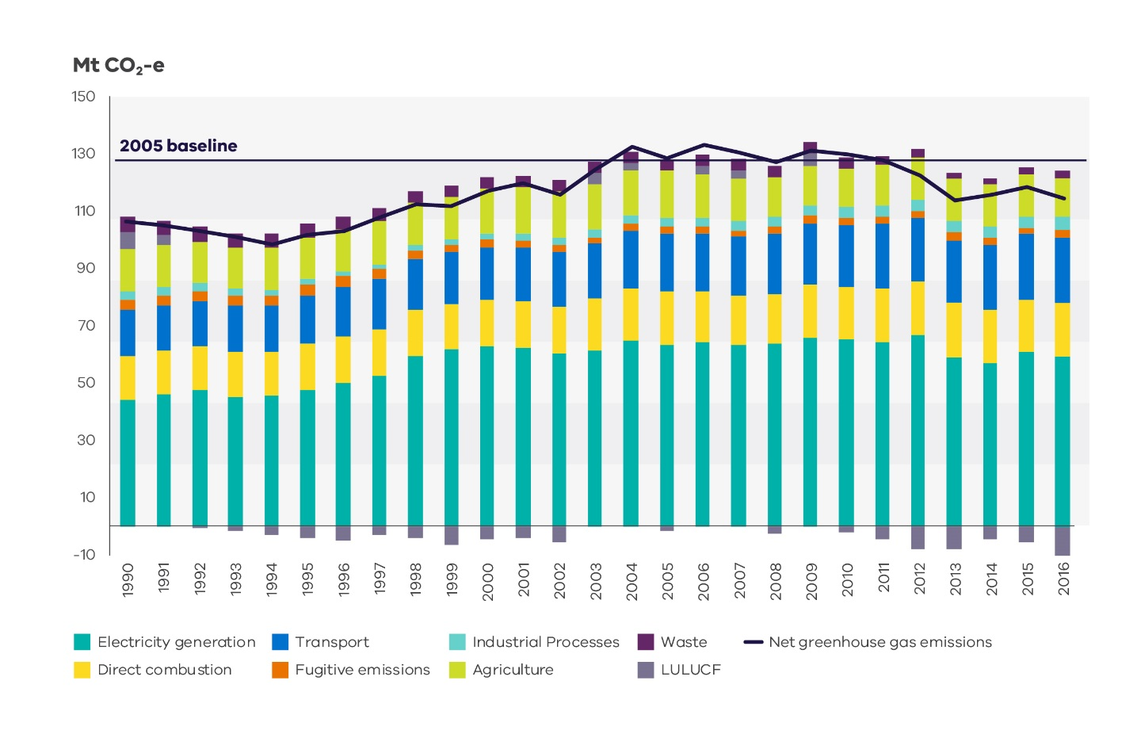

*Source:* ***Analysis based on State and Territory Greenhouse Gas Inventories (STGGI) data 2016***

Figure 6. Victoria’s emissions by sector in 2016

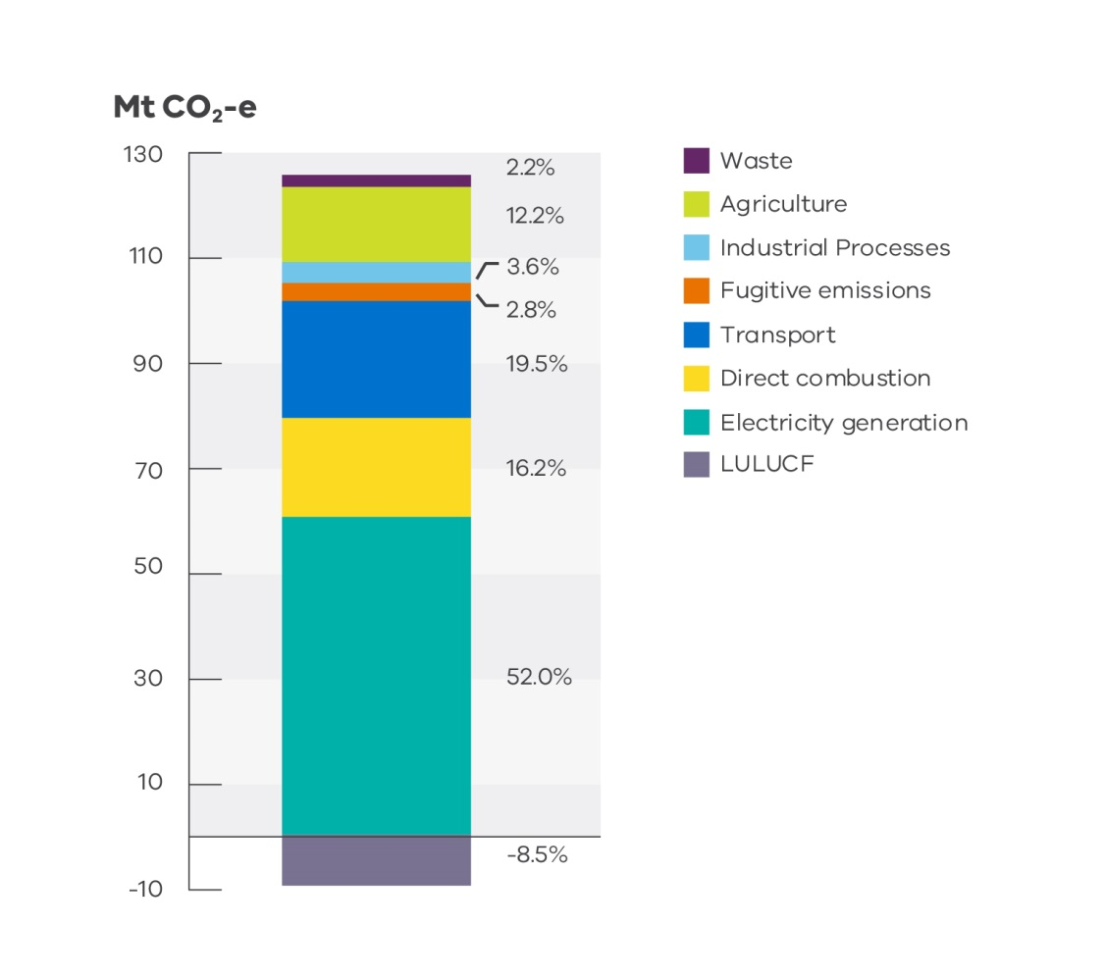

Source: Analysis based on State and Territory Greenhouse Gas Inventories (STGGI) data 2016

Electricity generation is the largest source of Victoria’s emissions. In 2016, it produced around half of Victoria’s emissions (**Figure 6**), though this will now be lower due to the closure of the Hazelwood power station. Around three quarters of electricity produced in Victoria continues to come from emissions-intensive brown coal generation. Victoria has three remaining brown coal-fired power plants, all located in the Latrobe Valley: Yallourn, Loy Yang A and Loy Yang B. These plants are between 21 and 35 years old. The operation of Victoria’s coal fired power plants is an important consideration for Victoria’s future emissions.

The largest end users of electricity in 2016 were commercial services (including buildings) (34%), followed by manufacturing (23%), residential users (22%) and electricity, gas and water supply (17%).

The second greatest contributor to Victoria’s emissions in 2016 behind electricity was transport (20%). Transport is also the sector with the highest growth in emissions in Victoria since 1990. This growth has mainly been driven by population growth and a reliance on road transportation for both passenger and freight transport in Victoria.

Direct combustion[32] (16%) had the third largest share of Victoria’s emissions in 2016. Emissions in this sector have been growing steadily, in line with growth in the population and economic activity.

Agriculture[33] (12%) was the fourth largest source of emissions in 2016. Emissions in the agriculture sector have fluctuated in line with weather conditions; for example, Victoria’s agriculture emissions declined steadily between 2005 and 2010 due to prolonged drought conditions which contributed to reductions in animal populations, crop production, and fertiliser use. While agriculture emissions rose slightly between 2010 and 2015, they fell again in 2016, and remain below 2005 levels.

The remaining sectors were responsible for relatively small proportions of Victoria’s emissions in 2016: industrial processes (4%), fugitive emissions from gases leaking out during fossil fuel production, storage and distribution (3%) and waste (2%). The waste sector has seen the largest percentage decrease in emissions in Victoria between 1990 and 2016 (an estimated -53%), driven by management and capture of methane from landfills and improved waste recovery.

In 2016, net land use, land use change and forestry (LULUCF)[34] emissions were estimated to be -9.7 Mt CO2-e – that is, they are a net carbon sink rather than source of emissions. As such, the LULUCF sector offsets emissions from other sectors. While net emissions from Victoria’s LULUCF sector have fluctuated considerably between 1990 and 2016 (from an estimated -10 Mt CO2-e to +5 Mt CO2-e), the sector has absorbed approximately 80 Mt CO2-e more than it has released over the period.

# Interim emissions reduction targets for Victoria for 2021-2030 and trajectories to 2050

## Overview

The Panel is required to recommend one or more interim targets for each of the periods 2021-2025 and 2026-2030, and to provide advice on indicative trajectories for the state to achieve net zero emissions by 2050 based on the interim target options proposed. The Victorian Government has already set an emissions reduction target of 15-20% below 2005 levels by 2020.[35] These elements are summarised in **Figure 7** below.

Environmental effectiveness, equity (intergenerational) and flexibility are key among the Panel’s principles in relation to the issues discussed in this section.

**Figure 7. Victoria’s historical emissions, indicative emissions to 2020 and future emissions reduction targets**

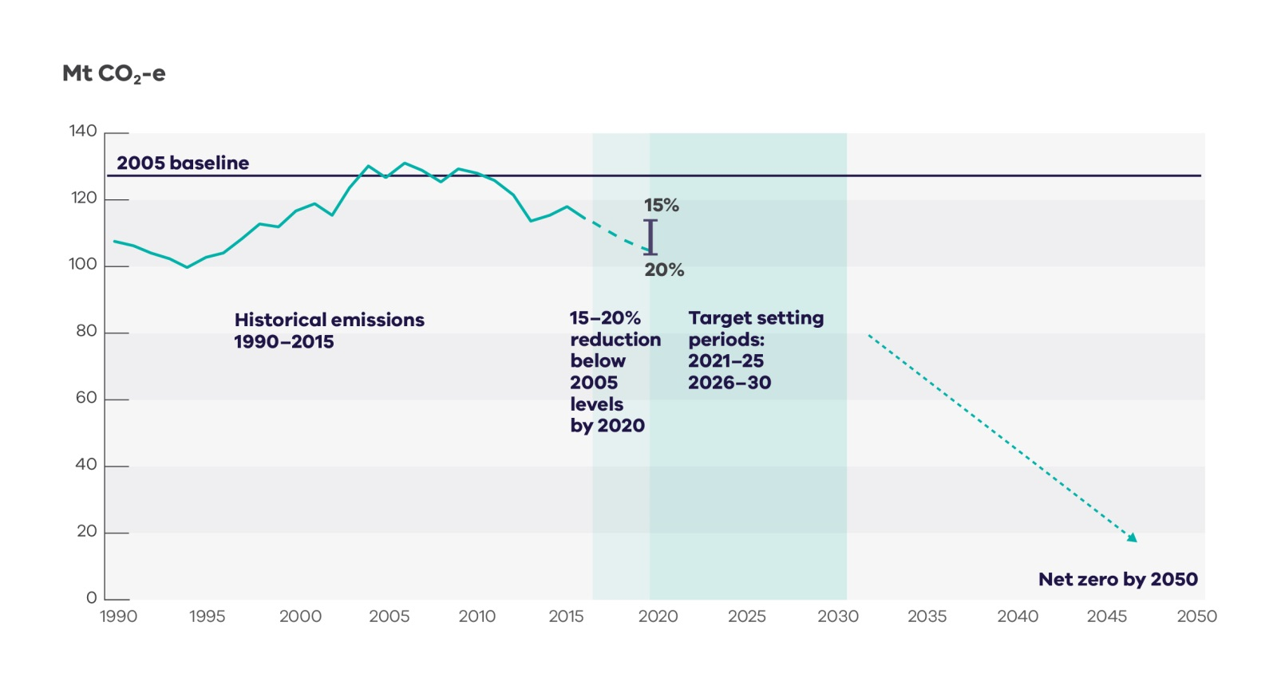

**Source:** Author

Form and scope of the targets

The *Climate Change Act 2017* sets out the following requirements for the interim targets:

* + interim targets are for pre-determined five-yearly periods;
  + targets must be expressed against a 2005 base year;
  + targets must include the six greenhouse gases covered under the United Nations Framework Convention on Climate Change (UNFCCC) and the Kyoto Protocol[36]; and
  + each target must constitute a greater reduction in greenhouse gas emissions than any previous target.

The interim targets:

* + relate to emissions generated in Victoria,[37] rather than emissions arising from goods and services consumed in Victoria; and
  + exclude Victoria’s share of international aviation and shipping emissions.[38]

This is in line with the methodology for calculating national emissions under the UNFCCC.

A number of choices remain in relation to the form and type of interim targets. The Panel is considering:

* + the type of targets, for example an annual year-on-year reduction during each 5-year period, or an average reduction over each five-year period, or five-year emissions budgets;
  + whether the targets should be set as a range (X-Y% below 2005 levels) or a single point (Z% below 2005 levels); and
  + whether targets should be in the form of a single economy wide target or, for example, a number of targets for different sectors of the economy.

## Developing recommendations for interim targets and trajectories to net zero by 2050

The core task of the Panel is to recommend options for the interim targets during the periods 2021-2025 and 2026-2030, and to provide advice on indicative trajectories to achieve net zero emissions by 2050.

Work to consider targets and emissions reductions at a national level and the concept of an emissions budget provide context for thinking about targets and trajectories at the Victorian level.

Exploring emissions reduction opportunities in Victoria (section 8) and understanding the impacts of emissions reductions (section 9) will also help inform the development of options for targets and indicative trajectories.

Emissions reduction targets in other states and territories may also be a relevant factor to consider in setting interim targets for Victoria (see section 4).

### National emissions reductions and targets

The national context is an important factor to consider in setting Victoria’s targets. There has been significant work carried out to consider potential emissions reductions at the national level. This work provides a useful starting point when considering the level of Victoria’s interim targets; for example, these targets could be applied directly to Victoria, or modified based on differences in Victoria’s circumstances compared to the national level and to other Australian states and territories.

The Commonwealth Government’s target of **26-28% below 2005 levels in 2030**, a commitment made under the Paris Agreement, provides one reference point. The Paris Agreement includes a request to provide updated targets in 2020 and then a five-yearly review process to build ambition over time. During these reviews, Australia will be requested to submit further updates to its target, each of which should be stronger than the previous.

In 2014, the Climate Change Authority (CCA) recommended national emissions reductions of **36% below 2005 levels by 2025** and a rangeof **45-65% below 2005** **levels in 2030**. According to the CCA, the middle of this range is consistent (if emissions were reduced on a straight-line basis) with a national emissions budget representing Australia’s fair share of a global budget with a 67% probability of keeping global temperature rise to less than 2°C above pre-industrial levels. The CCA indicated that greater ambition within this range would be consistent with a lower temperature goal or higher probability of limiting temperature increases to 2°C (and vice versa). A short-term target and mid-term range were recommended to provide sufficient certainty to industry while retaining flexibility to respond to changing circumstances.

### Emissions budgets

An **emissions budget**, also known as a carbon budget, is a tool that can inform the development of emissions trajectories (**Box 2**).

|  |
| --- |
| Box 2. Emissions budgets |
| A global emissions budget, also known as a carbon budget, is an estimate of the total cumulative amount of greenhouse gases that could be emitted consistent with a certain probability (e.g. 50%, 67%, 90%) of keeping global temperature rise within a set limit above pre-industrial levels (e.g. 1.5°C, 2°C).  An emissions budget does not prescribe when emissions should peak and at what rate they should fall; as such, there are many emissions trajectories consistent with a single emissions budget.  However, delays in reducing emissions in the short term mean that emissions must be reduced more rapidly in future years and the emissions budget runs out earlier (and vice versa) **Figure 8**).  Figure 8. Illustrative alternative emissions trajectories for a given emissions budget  Graph of three alternative emissions trajectories for a given emissions budget.  **Note:** The emissions budget is the area under the curve.  **Source:** Climate Change Authority (2014), *Reducing Australia’s Greenhouse Gas Emissions - Targets and Progress Review Final Report*. |

An emissions budget for Victoria could:

* + link Victoria’s total emissions to climate science and the global goal to limit temperature increases, and help set interim targets and trajectories that are consistent with these. This relates to the Panel’s principle of environmental effectiveness; and
  + highlight trade-offs between short- and long-term action to reduce emissions. This relates to the Panel’s guiding principles of flexibility and equity (in terms of equity between current and future generations).

As part of its Nationally Determined Contribution under the Paris Agreement, Australia has committed to developing an emissions budget for 2021-2030 that is aligned with its emissions reduction target of 26-28% below 2005 levels.[39]

Emissions budgets for nations can be calculated as a share of a global emissions budget. For example, the Climate Change Authority developed an emissions budget for Australia for the period 2013-2050.[40] This is calculated as 0.97% of a global emissions budget that is estimated to provide a 67% chance of limiting temperature rises above pre-industrial levels to 2°C. It comes to 10.1 gigatonnes of carbon dioxide equivalent for the period 2013-2050. At Australia’s current annual emission levels this budget would run out in 2032.

A Victorian emissions budget could be estimated as a share of an Australian emissions budget. There are a range of ways that Victoria’s share could be calculated, for example it could be based on Victoria’s share of national Gross State Product (absolute or per capita), or population, or emissions, or emissions per capita over time.

## Illustration of interim targets (2021-2030) and trajectories to 2050 for Victoria

For the purposes of understanding a range of possible targets and trajectories for Victoria, three stylised approaches are presented below:

* + Less ambition to 2030 (followed by greater action post-2030);
  + Steady emissions reductions to 2050; and
  + More ambition to 2030 (followed by more gradual action post-2030).

**Figure 9** provides an illustration of these three stylised approaches consistent with limiting overall emissions within the same emissions budget to 2050 for each approach to a target in 2030.

Figure 9. Stylised target and trajectory options

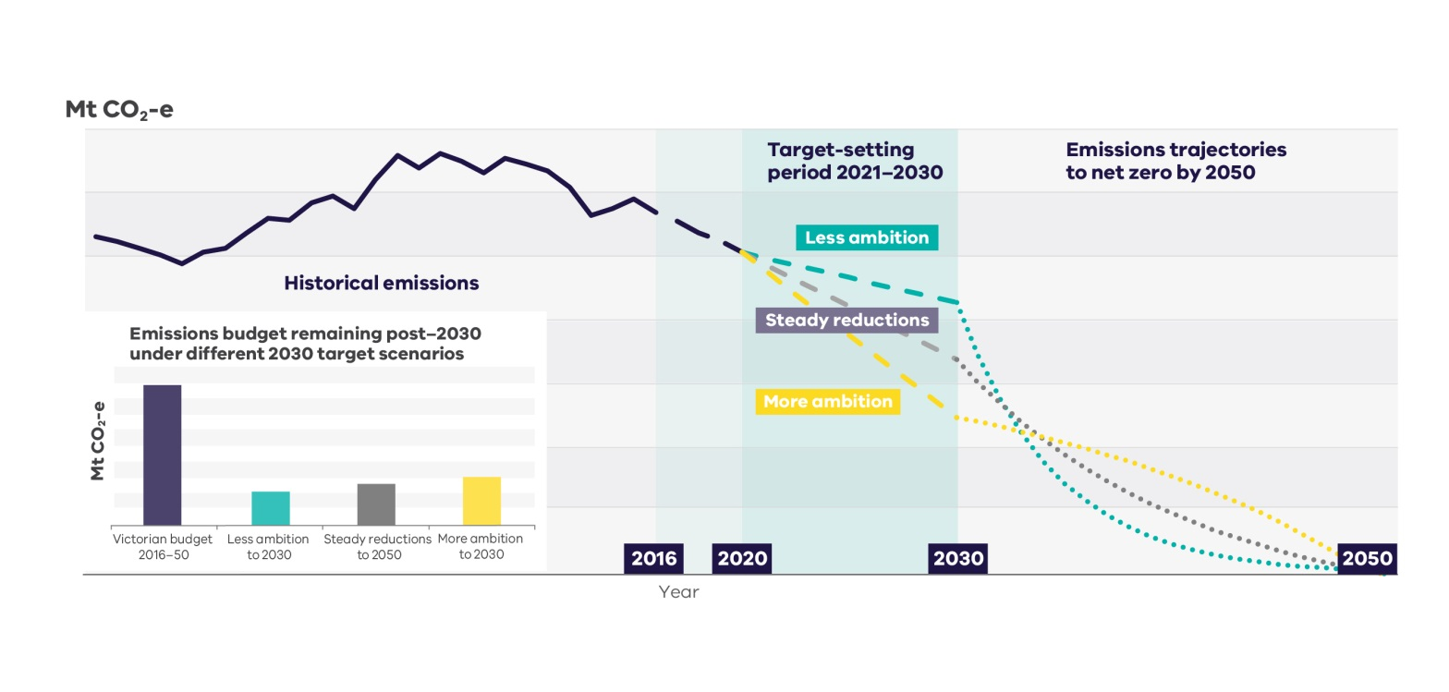

**Note:** Actual emissions may vary from these targets and trajectories if offsets from outside Victoria are used. The *Climate Change Act 2017* provides for the use of offsets to achieve *net* zero emissions in 2050 and to meet interim targets. Offsets are discussed further in section 8 below.

**Source:** Author

There is substantial evidence showing the benefits of early global action to reduce emissions.[41] This is true at the local level too, particularly for high emission economies such as those of Australia and Victoria. As stated in the Commonwealth Treasury’s “Strong Growth, Low Pollution” report[42], “every year of deferring action on climate change will lead to higher long-term costs” because it allows further investment in emissions-intensive infrastructure and defers investment in low-emissions technology and jobs.

A **less ambitious target** for Victoria in 2030 would require less action in the near term (with fewer associated costs and benefits). As such, it risks locking in high-emissions investments and deferring low-emissions investments, which would make it more challenging or expensive to reach net zero in 2050. A less ambitious target in 2030 also uses up the largest share of an emissions budget to 2030, implying steeper emissions reductions post-2030 to stay within an emissions budget (**Figure 9**). A less ambitious target in 2030 also reduces flexibility to strengthen efforts in future years (e.g. to join higher international ambition and limit overall Victorian emissions to a level consistent with a lower global temperature increase). This is illustrated in **Figure 9**, which shows that a less ambitious target in 2030 leads to a small remaining emissions budget to 2050 and steep post-2030 emissions reductions as a result. Supporting strengthened global ambition would mean adopting a smaller emissions budget for Victoria, which would imply infeasibly steep emissions reductions post-2030. In terms of intergenerational equity (another guiding principle of the Panel), the less action that is taken now, the greater the mitigation burden and/or climate change consequences for future generations.

A **more ambitious target** in 2030 would require more action in the near term, with greater associated costs and benefits from this change. It is more likely to avoid lock-in of emissions-intensive infrastructure and technology and, as it leads to fewer emissions, it would provide greater flexibility (a principle of the Panel) to increase ambition in future years (i.e. adopt a smaller emissions budget, which would make the post-2030 trajectory steeper) or adapt to changing circumstances. Making greater emissions reductions in earlier years may also support stronger global ambition by demonstrating a greater willingness to act. Early ambition also allows for slower emissions reductions in the future, in case it is more difficult to reduce emissions in these later years when the easier and cheaper options, at least according to current knowledge and technology, have already been taken up.

A **steady reduction in emissions** provides a signal for gradual emissions reductions and low carbon investment, with no step change in the speed of emissions reduction required. On this pathway, the risk of higher costs to reach net zero in 2050 and the available flexibility to move to greater ambition in later years fall between the less ambitious and more ambitious pathways.

|  |
| --- |
| Questions: Targets and Trajectories  1a. Should Victoria’s interim emissions reduction targets relate to a national reference point?  1b. If yes, what is the most relevant reference point?   * + - * 1. Australia’s current national emissions reduction target of 26-28% below 2005 levels by 2030         2. The Climate Change Authority’s recommendation of 45-65% below 2005 levels by 2030)         3. Other (please specify)   1c. If yes, how should Victorian interim targets relate to this national reference point?   * + - * 1. Direct application of the national figure to Victoria’s 2005 emissions.         2. Recalculated to take into account differences between Victoria and Australia as a whole.         3. Other (please specify)   2. What would you recommend Victoria’s targets be for 2021-25 and 2026-30, and why?  3a. Do you think a Victorian emissions budget should be used as a tool in the Panel’s analysis?  3b. If yes, what global temperature outcome should a Victorian emissions budget be consistent with (e.g. 2°C above pre-industrial levels)?  3c. If yes, how should Victoria’s share of a global or Australian emissions budget be calculated?  4. What do you see as the relative advantages and disadvantages of early versus late action to reduce Victoria’s emissions to reach net zero by 2050?  5. What lessons can be learned from other state and local governments that have set emissions reduction targets? |

# 

# Emissions reduction opportunities

The Panel is required to provide advice on potential opportunities across the Victorian economy for reducing greenhouse gas emissions in the most efficient and cost-effective manner in the interim target periods. Economic efficiency, equity and policy coherence will be key among the Panel’s principles in considering emissions reduction opportunities.

As set out above, there are a range of Commonwealth and Victorian policies already in place to achieve emissions reductions. However, further action will likely be needed to ensure Victoria’s emissions continue to decline to reach net zero by 2050. A range of existing reports and studies have identified cost-effective emissions reduction opportunities across the economy including in electricity generation, transport, the built environment, industry and the land sector (agriculture and LULUCF), as summarised below.

Which of these emissions reduction opportunities are taken up and the resulting level of emissions in Victoria will depend on a range of factors including the future evolution of technology and its costs; the growth of Victoria’s population and economy; changing social attitudes and preferences; and, importantly, Commonwealth and Victorian policies.

The relative level of emissions reductions may vary across sectors, with some sectors providing greater reductions and other sectors (where emissions reductions are more difficult or costly) providing less.

An overview of the potential benefits and impacts of reducing emissions is provided in Section 9.

## Electricity generation

Electricity generation is currently the single largest contributor to Victoria’s emissions. Electricity generation produced around half of Victoria’s emissions in 2016, primarily through the combustion of coal and some gas.

Electricity generation is the sector with the largest currently identified, cost-effective potential to reduce emissions, through reductions in energy demand and shifting to low carbon electricity generation. Low-carbon electricity generation is also a key enabler for emissions reductions in the transport, buildings and industry sectors.

There is significant opportunity to reduce electricity sector emissions through reduced energy demand, primarily through measures to improve energy efficiency, particularly in the built environment and industry (see below). Switching to electricity to power transport and provide heating in buildings and industry would increase demand for electricity but could still reduce overall emissions if supplied by low carbon generation.

A number of studies have found that Australia’s electricity generation system can transition to net zero emissions by 2050 while providing Australians with secure and affordable electricity,[43] given the improvements in and falling costs for low-carbon electricity generation technologies[44] coupled with the aging of existing high-emissions generation assets.[45]

The operation of Victoria’s three brown coal generators, together with other existing coal and gas generators, is a significant factor when considering emissions reductions during the period of interim targets (2021- 2030). There is a range of low carbon technologies that could replace or retrofit existing coal and gas generation assets and supplement these to meet any increased demand. These include renewable generation, biomass and carbon capture and storage.[46] According to the Australian Electricity Market Operator (AEMO), wind is already the cheapest form of new energy generation and large scale solar is expected to become cheaper than gas by around 2021.[47] There has also been a significant uptake of roof top solar, which is predicted to continue.[48] A mixture of technologies is likely to be needed in the transition to maintain security, reliability and affordability. A shift toward renewable generation sources may require further investments in grid infrastructure.

Victoria’s electricity sector operates as part of the National Electricity Market (NEM). The Commonwealth, states and territories work together to set policies for the NEM. The provision of reliable energy services is administered at the state level. The Victorian Renewable Energy Targets are an example of current state-level policy supporting the electricity sector’s transition to net zero emissions.

## Transport

Transport is currently the second largest source of emissions in Victoria and emissions in this sector increased by around a quarter since 2000 (primarily due to increased car and truck use by a growing population).

There is potential to reverse this trend and to reduce transport emissions.[49],[50] Significant emissions reduction may be possible by 2030 using existing technologies.[51] Existing emissions reduction measures include:

* + increased vehicle efficiency;
  + increased uptake of low-emissions vehicles (e.g. electric vehicles,[52] plug-in hybrids, fuel cell vehicles);
  + fuel switching in freight transport from diesel/petrol to gas/bioenergy;
  + reduced transport demand (for example, through telecommuting); and
  + mode shift from road transport to active and public transport for individuals; from road to rail transport for freight; and a shift from aviation to rail, where feasible.

Many of these emissions reduction measures would require changes or improvements in transport infrastructure or replacement of existing vehicles as the vehicle fleet turns over.

Low emission vehicles may present one of the most significant opportunities for transport emissions reduction. There are a range of projections for how quickly and which types of low emission vehicles will be taken up, depending on relative fuel costs, policy support and infrastructure investment and technology development. For example, estimates for electric vehicle use in Australia by 2030 range from a few per cent to around half of all vehicles.[53] These projections are changing rapidly, with predicted take up of low emission vehicles increasing as costs fall. Another consideration is that reducing transport emissions through electric vehicle use will depend on the availability of low emission electricity[54] either from a decarbonised grid or by charging from off-grid renewable electricity.

The Victorian Government can take policy action to reduce transport emissions through its responsibilities for transport and land planning, the public transport system and infrastructure investment. Examples of existing policies include measures to encourage a shift to active transport (cycling, walking) and public transport [55] and from road to rail freight[56] and reduced government fees for low emission vehicles.[57]

The Commonwealth Government has responsibility for other significant policy levers such as vehicle efficiency standards and fuel excise tax.

## Built environment

Residential and commercial buildings primarily produce emissions through the combustion of fuels (mostly gas combustion for space and hot water heating) and the use of electricity. In 2015, the built environment used around half of all gas consumed in Victoria and around half of all purchased electricity.

Some studies of Australia’s built environment have found that all of our buildings could be made zero or close to zero emissions by 2050 through use of existing technology.[58] This would involve switching from gas (and other fuels) to electricity or biomass (e.g. for space and water heating and cooling); access to zero emissions electricity (e.g. solar photovoltaic (PV)); and improvements in the energy efficiency of appliances and buildings (e.g. improved insulation).

Victoria has high levels of gas use for heating compared to many other states, presenting significant opportunities for emissions reductions (subject to access to low carbon electricity) [59] and potential cost savings.[60]

More than 300,000 small scale solar systems are currently installed in Victoria. As noted above, strong uptake of roof top solar is predicted to continue (modelling for AEMO shows installed capacity in Victoria may triple by 2030 to reach over 3,000 MW[61]). This is being driven by falling installation costs, the Victorian feed-in tariff and the Commonwealth small-scale renewable energy scheme.

It is widely recognised that there are significant non-financial barriers to energy efficiency improvement.[62] This means that even though increased energy efficiency would save businesses and households money, strong policy action is required to drive take up.

While the Commonwealth holds important policy levers in this space, such as the National Construction Code and Minimum Energy Performance standards for appliances, the Victorian Government can play an important role, including through regulations (e.g. planning requirements), information instruments and subsidies to overcome high up-front costs. Victoria’s Energy Efficiency and Productivity Strategy outlines current state level measures to improve energy efficiency in buildings, for example through the Victorian Energy Upgrades, Better Commercial Buildings, Beyond 6-Star Homes and Residential Efficiency Scorecard programs.

## Industry

Industry produces emissions through the combustion of fuels, particularly of gas; in fact, industry uses around one third of the gas consumed in Victoria. Industry also generates industrial process and fugitive emissions.[63]

ClimateWorks Australia estimates that there is potential to reduce industrial emissions by more than 50% by 2050 using currently available technologies, with industrial value-added more than doubling at the same time.[64] The potential for this to occur lies in direct combustion energy efficiency improvements, electrification and fuel shift to low-carbon energy sources[65] (e.g. for heating processes), and reducing process and fugitive emissions (e.g. through improved operational processes[66], eradication of refrigerant gases (hydrofluorocarbons (HFCs)) and use of carbon capture and storage (CCS)).

Emissions reduction opportunities and costs will vary widely between different industry sectors and businesses. Some emissions-intensive industries will be able to cost effectively decarbonise, for example through access to low carbon electricity or through investment in changes to production methods. However, for many industries, options may be more limited or costly and may depend on the development of new technologies.

Industrial users are also some of Victoria’s largest electricity consumers. Emissions from electricity use by industry can be reduced through energy efficiency and access to low carbon electricity.

Victoria’s Energy Efficiency and Productivity Strategy sets out current Victorian policies to support energy efficiency improvements in industry, for example providing grants for energy assessments and improving gas efficiency, and building capabilities through training and mentoring programs.

## Land

The agricultural sector is a significant source of emissions in Victoria (12% in 2016). Other land based activities in Victoria (commonly called the land use, land use change and forestry (LULUCF) sector) have removed more emissions from the atmosphere than they created since 1990.

Emissions can be reduced in the land sector through a combination of best practice agriculture and (re)vegetation.[67]

Cow and sheep farming produces almost three quarters of Victoria’s agricultural emissions.[68] Meat and Livestock Australia recently announced an ambition for the red meat industry to be zero carbon by 2030.[69] Policy support and investment in research and development will be needed to achieve this. Potential measures to reduce emissions include manure management, on or off farm planting and, in the future, potentially using feed additives,[70] vaccination or genetic selection to reduce methane emissions from livestock.

Other examples of emissions reduction options in Victoria’s agriculture sector include converting methane from piggeries to bioenergy, more efficient fertiliser use, and using coated fertilisers to limit emissions.[71] Options such as more efficient fertiliser use also have the potential to improve farm productivity.

Victoria also has significant potential for carbon forestry (planting trees to sequester carbon)[72] – however, there are a number of barriers to overcome and the potential trade-offs and synergies with agricultural production and biodiversity would need to be carefully considered.

The Victorian Government could influence land sector emissions, including through agricultural and forestry industry policies and its responsibilities for biodiversity, land use planning and public land management. The key Commonwealth policy relevant to land sector emissions is the Emissions Reduction Fund.

## Carbon offsets

Carbon offsets (also known as carbon credits) are generated from projects that prevent or reduce greenhouse gas emissions, or remove them from the atmosphere. Common offset projects include planting trees, energy efficiency improvement and methane capture.

The *Climate Change Act 2017* allows for ‘eligible’ offsets from outside of the state[73] to be used in meeting the net zero emissions target for 2050. Regulations will be used to prescribe which offsets will be ‘eligible’. The Act is silent on the use of interstate and international offsets to meet interim targets.

Existing offset schemes include Australian Carbon Credit Units under the Commonwealth’s Carbon Farming Initiative and Certified Emissions Reductions under the Kyoto Protocol. The international system for offsets post-2020, under the Paris Agreement, has yet to be finalised.

Key considerations regarding use of offsets to meet interim targets include additional flexibility, potential for lower costs for Victoria and the potential for increased interstate or international economic efficiency in reducing emissions if offsets were to be used. This is set against the objective of reducing emissions in Victoria to transition our economy, reducing our exposure to future carbon risk and realising the benefits of reducing emissions. It cannot be assumed that offsets will remain cheap in a future low emissions world.

If offsets from outside of Victoria were to be used to meet interim targets, there is potential to restrict the amount and/or type of offsets that are allowable.

A further consideration in using offsets to meet Victoria’s future targets is that the purchase or holding of offsets is currently not tracked at a state level.

|  |
| --- |
| Questions: Emissions Reduction Opportunities   1. What are the most significant opportunities and technologies for reducing emissions in Victoria during the period 2021-2030 and to reach net zero emissions by 2050? 2. What are the key barriers to reducing Victoria’s emissions by 2025 and 2030? 3. What further steps can the Victorian Government take to support emissions reduction opportunities and the uptake of low carbon technologies? 4. What lessons can be learned about reducing emissions in Victoria from actions taken in other states and countries to reduce emissions? 5. What additional infrastructure will be required to support low carbon transformation within each sector? (e.g. electricity generation, transport, the built environment, industry, agriculture, other land-based activities) 6. What steps could the Victorian Government take to accelerate turnover of capital assets with significant emissions to deliver emissions reductions? (e.g. old road vehicles, industrial equipment) 7. What are the price and non-price factors influencing business and industry decisions to switch to less emissions-intensive fuels?   13a. Should international and interstate offsets be used to meet Victoria’s interim targets?  13b. Why? |

# Potential effects of reducing emissions to meet interim targets

The *Climate Change Act 2017* (the Act) requires the Panel to consider the economic, social and environmental impacts and opportunities associated with interim emissions reduction targets in the context of transitioning to a net zero emissions economy. The objectives of the Act also include support to regions, industries and communities to adjust in the transition to a net zero greenhouse gas emissions economy, support to vulnerable communities, and intergenerational equity.

Key among the Panel’s principles in considering the effects of reducing emissions are economic efficiency, equity and investor certainty.

## General considerations

Setting interim targets and understanding key benefits and impacts will build confidence in future policy action and provide a clear forward signal for investment in and planning for a low carbon future.

The economic, social and environmental costs and benefits of emissions reductions (and their impacts across regions, industries and households) will depend heavily on the policies implemented to achieve targets.[74] The Act requires the Victorian Government to develop sector strategies and pledges that will contribute to meeting the interim targets before each interim target period begins. For example, the sector strategies and pledges to meet the interim target for 2021-2025 must be complete by 1 August 2020.

Actions to reduce emissions to meet the interim targets will occur within the broader context of ongoing structural change in the Victorian economy. The impact of targets is likely to be relatively small compared to these changes that will continue regardless of action Victoria takes to meet interim targets.[75] For example, the Victorian economy is experiencing a sustained shift from manufacturing to the commercial and services sector: the manufacturing sector’s contribution to Victoria’s Gross Value Added (GVA) fell from 20% in 1990 to 8% in 2017, while services grew from 65% to 79% of GVA.[76] Nonetheless, advanced manufacturing will continue to play an important role in the Victorian economy, given Victoria’s strengths including a highly skilled workforce, well-developed freight and logistics systems, expertise in design, engineering and digital technology, and world-leading research and development capabilities. The Victorian Government’s Advancing Victorian Manufacturing – A Blueprint for the Future details the government’s commitment to and support for advanced manufacturing in the state.[77] The emissions intensity of most energy intensive industries will fall as the emissions intensity of electricity generation declines.

Emissions reductions will also take place in the context of ongoing and significant technology development. Wind power has already become the cheapest form of energy generation in Australia.[78] Between 2010 and 2016, the average total installed cost of residential solar PV systems fell by 74%, making Australian systems among the most cost competitive in the world.[79] The costs of other technologies, such as electric vehicles, are also reducing rapidly (see section 8).

## Economic and social benefits and costs

A number of authoritative studies[80] have assessed the impacts of climate change and of reducing emissions on the global and Australian economies. They have consistently found that:

* + the economic benefits of avoiding the worst impacts of climate change through reducing emissions outweigh the costs of implementing emissions reduction measures (particularly in the long term);
  + economies are able to maintain robust growth under emissions reduction policies;
  + early action is cheaper than delayed action to meet internationally agreed goals; and
  + the costs of inaction are high.

Further details can be found in **Box 3**.

|  |
| --- |
| Box 3. The economic costs of action vs inaction on climate change |
| Victoria and the international community have committed to taking action to avoid climate change, in part, because the economic costs of action are expected to be much lower than the costs of inaction.  This has been consistently demonstrated through a number of studies that have examined the economic costs of climate change action and inaction (see sources below). While these range in age, assumptions and metrics used, they arrive at the same overall conclusion.  Since earlier studies were carried out, climate science has shown that some of the impacts of climate change are happening more quickly than originally expected. Moreover, significant advances and cost reductions in emissions reduction technologies such as solar power have led to unprecedented uptake of these technologies at a lower cost than economic models had anticipated. This means that earlier economic studies have tended to overestimate the economic costs of action, while underestimating the costs of inaction.  The most recent Australian study, the *Australian National Outlook 2015* by CSIRO, confirms that scenarios where Australia and the world take stronger action to reduce greenhouse gas emissions show higher long-term economic growth and better environmental outcomes for Australia compared to current trends.  The costs of action  A range of studies have found that taking strong action to reduce greenhouse gas emissions is not expected to significantly reduce economic growth. This holds across a range of macroeconomic measures such as Gross Domestic Product (GDP) and other indicators that more closely align with consumption, such as Gross National Product (GNP) or Gross National Income (GNI).  The *Garnaut Climate Change Review* (2008) was commissioned by Australia’s Commonwealth, state and territory Governments. It estimated that the costs associated with stabilising greenhouse gases at 450 parts per million (in line with limiting temperature increase to 2°C) would result in GNP growing, on average, by approximately 1.6% per year from 2021-2050, rather than by 1.7% with unmitigated climate change. From 2051-2100 the average growth rate is estimated to be 2.2% under the stabilisation to 450 ppm scenario, 0.2% *greater* than the estimated 2% growth rate under unmitigated climate change.  Modelling performed for the Climate Change Authority’s *Targets and Progress Review* (2014) to inform its advice on the 2020 target for Australia found that moving from a national target of 5% to 15% below 2000 levels would lead GNI and GNI per capita to grow at a slightly slower rate. Specifically, Australia's GNI per capita was projected to grow on average by 0.8% per year by 2020 under a 5% target, while growth was projected to be 0.78% per year under a 15% target. Similarly, the impact on GDP growth is estimated to be around a 0.1% reduction in underlying growth rates over the period between 2020 to 2030 (this is, GDP growth is projected to continue at a slightly lower rate, from an estimated 3.0% per annum with the weaker target to 2.9% per annum with the stronger target).  These results are broadly consistent with global results in the *Stern Review: The Economics of Climate Change (2006).* This landmark study prepared for the Government of the United Kingdom found the cost of reducing global emissions consistent with stabilisation of 500-550 parts per million is likely to be around 1% of global GDP by 2050 (equivalent to decreasing GDP annual growth rates by 0.01%), with a range of ±3% to account for uncertainties about the scale of mitigation required, innovation and policy flexibility.  The costs of inaction  Left unchecked, climate change will have major impacts on the global and Australian community, environment and economy. Significant economic impacts on Australia are expected due to its relatively large agricultural sector and highly trade-exposed economy.  Garnaut (2008) estimated that unmitigated climate change would reduce Australia’s GDP by 2.1% in 2050, and 7.5% in 2100. The impact on Victoria is estimated at a 2.2% reduction in Gross State Product (GSP) in 2050, which is due primarily to the costs that higher temperatures and water shortages will impose on the agriculture sector. For example, irrigated agriculture production in the Murray Darling Basin is projected to fall by 49% by 2050. Many of the effects of climate change that cannot be modelled were assessed qualitatively. Taken together, the modelled and un-modelled market costs are estimated to reduce Australia’s GDP by 8% in 2100, and GNP by 10% in 2100.  The SternReview (2006) provides overall cost and risks of extreme weather events associated with climate change. It estimated that unmitigated climate change would reduce global GDP by 2.7% in 2100. In terms of what this means for overall income, the impact on GDP is equivalent to losing 5% of global consumption per person each year, now and forever, increasing to 20% or more if a wider range of non-market impacts is considered.  All of these studies concluded that the economic costs of inaction, through the impacts of climate change, outweigh the costs of action to reduce emissions. In other words, over the long run, the world is projected to be economically better off if global emissions are reduced.  Sources: CSIRO (2015), *Australian National Outlook 2015,* [www.csiro.au/nationaloutlook/](http://www.csiro.au/nationaloutlook/); Stern, N. (2006), *The Economics of Climate Change: The Stern Review,* [www.lse.ac.uk/GranthamInstitute/publication/the-economics-of-climate-change-the-stern-review/](http://www.lse.ac.uk/GranthamInstitute/publication/the-economics-of-climate-change-the-stern-review/); Garnaut, R. (2008), *The Garnaut Climate Change Review,* [www.garnautreview.org.au/2008-review.html](http://www.garnautreview.org.au/2008-review.html); Commonwealth Treasury (2008) *Australia’s Low Pollution Future*, <http://lowpollutionfuture.treasury.gov.au/>; Commonwealth Treasury (2011) *Strong Growth, Low Pollution*, <https://carbonpricemodelling.treasury.gov.au/content/report/downloads/Modelling_Report_Consolidated_update.pdf>; Climate Change Authority (2014) *Targets and Trajectories,* [www.climatechangeauthority.gov.au/reviews/targets-and-progress-review-3](http://www.climatechangeauthority.gov.au/reviews/targets-and-progress-review-3); Stern, N. (2015), *Economic development, climate and values: making policy,* Proceedings of the Royal Society B, Volume 282, Issue 1812<http://rspb.royalsocietypublishing.org/content/282/1812/20150820>. |

Costs of transition

Broadly speaking, as Victoria transitions to a net zero emissions economy, the structure of the economy would be expected to shift away from more emissions-intensive production methods, goods and services to less emissions-intensive ones. Available studies have shown that the overall economic impact of this shift is likely to be low, particularly as new and expanding low carbon industries create jobs.[81] Nevertheless, it is important to note that some impacts may be concentrated in particular industries and communities:

* + Emissions-intensive, trade-exposed sectors may see a decline in competitiveness, or movement of plants to outside Victoria (“carbon leakage”), if other states and countries have weaker emissions reduction policies than Victoria.[82] The strength of this effect is likely to be moderated by the fact that the majority of Australia’s other states and territories (Australian Capital Territory, New South Wales, Queensland, South Australia and Tasmania) have also committed to achieving net zero emissions by 2050 (Appendix 3).
  + Communities that depend on emissions-intensive industries for employment may also face challenges, particularly where there are limited cost-effective emissions reduction options or alternative employment opportunities.
  + Low-income households are more vulnerable to policies that increase bills of essential services such as electricity, as these represent a larger share of their disposable income.[83]

All of these impacts can be avoided or minimised through careful policy design and government assistance measures.[84] For example, offsets may play a role in supporting emissions-intensive, trade-exposed industries. In line with the Panel’s principle of equity, it will be necessary to consider different community needs, for example, in the Latrobe Valley, where the brown coal generators are sited, compared to Western Victoria, which is hosting a growing number of renewable energy projects. There will also be different needs and opportunities in metropolitan areas compared to regional Victoria, for example, in reducing transport emissions.

Benefits of transition

Clear and credible interim targets provide certainty that can increase industry confidence to invest, reduce the cost of capital and draw in low carbon investment.[85]

Victoria’s transition to a net zero economy can potentially deliver a range of social and economic co-benefits. For example:

* + Moving to low carbon electricity can reduce health impacts from air pollution. For example, air pollutants (SO2, NO­x­, PM10, PM2.5) produced by Australia’s fossil fuel generators are estimated to create health costs across Australia of around $2.6 billion per year.[86]
  + Energy efficiency measures can reduce energy bills. For example, lighting upgrades under the Victorian Energy Upgrades program is estimated to save Victorian businesses $79 million on energy bills annually.[87]
  + Increased use of public and active transport (walking, cycling) can provide health benefits through increased exercise.[88]
  + Reduced use of road vehicles can reduce air pollution, noise and congestion. For example, the avoidable social cost of congestion in Melbourne was estimated to be $4.6 billion in 2015, and is projected to rise to $10.2 billion in 2030.[89]
  + Building retrofits and improved building design can increase thermal comfort, improve disaster resilience, and reduce noise and energy costs.[90]

## Environmental benefits and costs

Joining the global effort to reduce emissions may help avoid or reduce the negative impacts that climate change is having on Victoria’s environment (see Section 3).

Emissions reduction measures in Victoria may also deliver co-benefits or create risks for the environment. For example:

* + Reforestation and afforestation can strengthen ecosystems which, in addition to storing carbon, provide services including nutrient cycling, water and air purification, and habitat for wildlife. There are also potential environmental risks associated with reforestation and afforestation, including reduced surface water flows.[91],[92] Biodiversity can also be improved through other measures that provide new habitats like green (vegetated) roofs in urban areas.
  + The net impact of energy sector emissions reduction measures on water supply will depend on the technologies used. Coal-fired power stations use more water per gigawatt hour than any other form of electricity generation except for hydroelectricity,[93] while certain renewable energy generation technologies such as CCS, solar thermal and geothermal generation plants also require water for generation and cooling. Given Victoria’s history of drought and the future pressures of climate change and population growth on water supply – Melbourne’s metropolitan water industry estimates that demand in Melbourne could outstrip supply as early as 2028[94] – water supply impacts are an important consideration in emissions reduction measures.
  + Reducing air pollution from combustion in transport and by electricity producers and industry will have benefits for ecosystems.
  + Intense biofuel cropping may negatively impact habitat and wildlife.[95]

|  |
| --- |
| Questions: Benefits and Costs   1. What are the potential impacts and benefits of interim emissions reduction targets? 2. What specific regional or local issues should the Panel consider? 3. Please provide any other information or evidence you believe the Panel should consider in preparing its advice on interim emissions reduction targets. |

## Appendix 1: Biographies of Interim Targets Independent Expert Panel Members

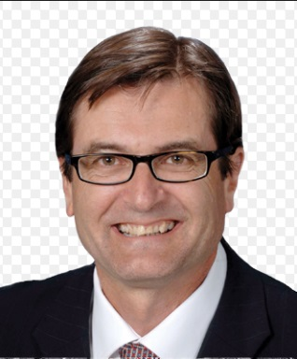

**CHAIR**

**Greg Combet**

Mr Greg Combet AM is the Chair of the Defence Council Victoria and Victoria’s Defence Industry Advocate. Mr Combet is also Deputy Chair of IFM Investors, Deputy Chair of Industry Super Australia and a Director of ME Bank.

Mr Combet held numerous Ministerial and Parliamentary Secretary roles in the Australian Government from 2007 to 2013, including Minister for Industry and Innovation, Minister for Climate Change and Energy Efficiency and Minister for Defence Personnel, Materiel and Science.

Prior to this Mr Combet held the role of ACTU Secretary for eight years and Assistant Secretary for six years before that.

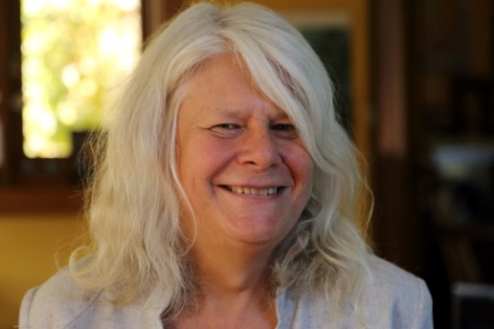

**SCIENCE EXPERT**

**Dr Penny Whetton**

Dr Penny Whetton is an Honorary Research Fellow with the School of Earth Sciences at the University of Melbourne and with CSIRO Oceans and Atmosphere. In Dr Whetton’s 25 year career with CSIRO she took a leading role in Australian science on projecting regional climate change and the use of projections in impact assessment. Through this and her community engagement she has made a unique contribution to national understanding of, and preparedness to respond to, climate change. Dr Whetton was a lead author of the regionalisation and climate scenarios chapters of the Third Assessment Report of the Intergovernmental Panel on Climate Change (IPCC), the regional projections chapter of the Fourth Assessment Report of IPCC, and of the Australasia chapter of the Fifth Assessment Report.



**ENERGY/INDUSTRY EXPERT**

**Dr Lorraine Stephenson**

Lorraine has over 30 years of technical, policy and corporate experience with a strong strategic focus on the energy sector. In her current role in Lightning Consulting Services, Lorraine works with clients to mitigate risks and create opportunities for Australian businesses and governments to respond to climate change challenges including options to drive investments in low emission technologies and abatement options.

Lorraine’s other current roles include Non-Executive Director of **Queensland Electricity Transmission Corporation Limited (Powerlink),** Non-Executive Director of Good Environmental Choice Australia and member of the NSW Climate Change Council. She was formerly the Chief Clean Energy Advisor to the Queensland Government, a Partner at Ernst & Young, Non-Executive Director of Ergon Energy and Non-Executive Director of the Australian Industry Greenhouse Network, and held executive positions at Origin Energy for 12 years. Lorraine is a Fellow of the Academy of Technology and Engineering and has formal qualifications in governance, management and science.

## Appendix 2: Terms of Reference - Interim Targets Independent Expert Panel

## *Introduction*

The *Climate Change Act 2017* (**the Act**) provides Victoria with a world-leading legislative foundation to manage climate change risks; maximise the opportunities that arise from taking decisive action; and drive Victoria’s transition to a net zero emissions, climate-resilient community and economy. The Act came into effect on 1 November 2017.

In January 2017, the Victorian Government released Victoria’s Climate Change Framework. The Framework included a target to reduce Victoria’s emissions by 15-20 per cent below 2005 levels by 2020.

Section 10 of the Act requires the Premier and the Minister responsible for administering the Act (the Minister for Energy, Environment and Climate Change, hereafter **the Minister**) to set five-yearly interim targets to keep Victoria on track to meeting the Act’s long-term target of net zero greenhouse gas emissions by 2050. The Victorian Government will announce the first two interim targets – for 2021-25 and 2026-30 – in 2018.

Section 12 of the Act requires the Minister to “obtain advice from one or more persons who are appropriately qualified, in the Minister’s opinion, to act as an independent expert”. The Interim Targets Independent Expert Panel (**the Panel**) has been established for this purpose. The Panel will consist of a Chair and two members.

Section 12 of the Act sets out the scope of advice to be provided by the independent expert(s) and the issues they must consider in formulating their advice. The following scope of work has been framed in light of the provisions of the Act.

## *Scope of work*

1. Section 12 of the Act requires the Panel to provide advice to the Minister on:
2. One or more recommended interim targets for reducing greenhouse gas emissions for the periods 2021-2025 and 2026-2030. These must have the following characteristics:
   * Each interim target must constitute a greater reduction in greenhouse gas emissions than any previous interim emissions reduction target, as per Section 14(d) of the Act;
   * Each interim target must be expressed against a 2005 base year, as per Section 11(1) of the Act.
3. Indicative trajectories for Victoria to achieve the long-term emissions reduction target (net zero greenhouse gas emissions by 2050) based on each option identified under 1a).
4. Potential opportunities across the Victorian economy as a whole to reduce greenhouse gas emissions in the most efficient and cost-effective manner in each interim target period.
5. In forming advice in relation to 1), Section 12 of the Act requires the Panel to consider the following:
6. Victoria’s legislated long-term target of net zero emissions by 2050.
7. Relevant up-to-date climate science.
8. Technologies relevant to climate change.
9. Economic circumstances – in particular the likely impact of the interim targets on the economy and the competitiveness of particular sectors of the economy.
10. Social circumstances – in particular the likely impact of the interim targets on the health and wellbeing of Victorians.
11. Environmental circumstances – in particular the benefits to the environment of emissions reduction.
12. Existing national and global action on climate change, including any undertakings relating to the reduction of greenhouse gas emissions that Australia has given under international climate change agreements.
13. Progress to date towards the reduction of greenhouse gas emissions in Victoria. This includes the government’s 2020 emissions reduction target and trends in emissions reflected in annual greenhouse gas emissions reports such as State Greenhouse Gas Inventories while recognising the lags inherent in inventory data.
14. The policy objectives of the Act, as laid out in Section 22 of the Act. These are:
    1. To reduce the State’s greenhouse gas emissions consistent with the long term and interim emissions reduction targets;
    2. To build the resilience of the State’s infrastructure, built environment and communities through effective adaptation and disaster preparedness action;
    3. To manage the State’s natural resources, ecosystems and biodiversity to promote their resilience;
    4. To promote and support the State’s regions, industries and communities to adjust to the changes involved in the transition to a net zero greenhouse gas emissions economy, including capturing new opportunities and addressing any impacts arising from the need to reduce greenhouse gas emissions across the economy;
    5. To support vulnerable communities and promote social justice and intergenerational equity.
15. The guiding principles of the Act, as laid out in Sections 23 to 28 of the Act. These are:
    1. Informed decision making;
    2. Integrated decision making;
    3. Risk management;
    4. Equity;
    5. Community engagement;
    6. Compatibility.

## *Process*

In formulating its advice, the Panel may obtain specialist technical advice regarding the considerations listed under Section 2(2) of this Terms of Reference.

DELWP will work with the Panel to design and implement public consultation, with the objective of informing the Panel in developing its advice on interim targets.

The Panel will be supported by a Secretariat provided by the Department of Environment Land Water and Planning (DELWP).

## *Outputs and timetable*

The Panel will submit a final report to the Minister providing advice on the matters listed under Section 2(1) of this Terms of Reference by 22 February 2019.

The final report and recommendations will be tabled in Parliament and made publicly available in accordance with the requirements of Section 13 of the Act.

The Panel will not publish any form of the report before it has been published by the Victorian Government.

## Appendix 3: Comparison of Australian state and territory emissions reduction targets

| **STATE OR TERRITORY** | **LONG-TERM TARGET** | **INTERIM EMISSIONS REDUCTION TARGET/S** | **OTHER KEY TARGETS** |
| --- | --- | --- | --- |
| **ACT** | * Net zero emissions by 2050 *(legislated)* | * 40% below 1990 levels by 2020 *(legislated)* | * 100% renewable electricity by 2020 |
| **NSW** | * Net zero emissions by 2050 |  |  |
| **Queensland** | * Net zero emissions by 2050 | * 30% below 2005 levels by 2030 | * 50% renewable energy by 2030 |
| **South Australia** | * Net zero emissions by 2050 * This supersedes the target in South Australia’s *Climate Change and Greenhouse Emissions Reduction Act 2007* to reduce emissions by at least 60% below 1990 levels by 2050 *(legislated)* |  | * 50% of electricity from renewable sources by 2025 |
| **Tasmania** | * Net zero emissions by 2050 * This supersedes the target in Tasmania’s *Climate Change (State Action) Act 2008* 60% below 1990 levels by 31 December 2050 *(legislated)* |  |  |
| **Victoria** | * Net zero emissions by 2050 *(legislated)* | * 15-20% below 2005 levels by 2020 | * 25% of electricity generated from renewable sources by 2020 and 40% by 2025 *(legislated)* * Victorian Energy Upgrades Program annual greenhouse gas emissions reduction target: 6.5 MtCO2e in 2020. *(obligation on energy retail companies)* |

**End notes**

1. Grose, M. et al., 2015, *Southern Slopes Cluster Report*, Climate Change in Australia Projections for Australia’s Natural Resource Management Regions: Cluster Reports, eds. Ekström, M. et al., CSIRO and Bureau of Meteorology, Australia
2. Steffan W (2015) *Quantifying the impact of climate change on extreme heat in Australia*, Climate Council of Australia
3. The Intergovernmental Panel on Climate Change (IPCC) describes Representative Concentration Pathway (RCP) 8.5 as about as likely as not to exceed 4oC above pre-industrial temperatures by 2100. In this paper, RCP8.5 by 2090 is taken to represent a world in which global temperatures are on average 4oC warmer. Over recent decades global greenhouse gas emissions have been growing at a rate similar to RCP8.5.
4. Grose, M. et al., 2015, *Southern Slopes Cluster Report*, Climate Change in Australia Projections for Australia’s Natural Resource Management Regions: Cluster Reports, eds. Ekström, M. et al., CSIRO and Bureau of Meteorology, Australia.
5. Steffen, W, Hughes, L and Perkins, S (2014) *Heatwaves: Hotter, Longer, More Often*, Potts Point: Climate Council of Australia.
6. Keating, A and Handmer, J (2013) *Future potential losses from extremes under climate change: the case of Victoria, Australia*, Melbourne: Victorian Centre for Climate Change Adaptation Research.
7. McMichael, A (2014) Health impacts in Australia in a Four Degree World. In P. Christoff (Ed.), *Four degrees of global warming: Australia in a hot world* (pp. 63-83). London: Routledge.
8. Climate Institute (2012) *Infrastructure interdependencies and business-level impacts: a new approach to climate risk assessment.*
9. Ibid.
10. Ibid.
11. Hope P, Timbal B, Hendon H, Ekström M, Potter N (2017) *A synthesis of findings from the Victorian Climate Initiative (VicCI)*, Bureau of Meteorology, Australia.
12. Coliban Water (2017) *Urban Water Strategy 2017: Appendices* [[https://www.coliban.com.au/site/root/water_security/documents/ColibanWaterUrban  
    WaterStrategy2017_Appendices.pdf](https://www.coliban.com.au/site/root/water_security/documents/ColibanWaterUrbanWaterStrategy2017_Appendices.pdf)]
13. Reisinger A, Kitching RL, Chiew F, Hughes L, Newton PCD, Schuster SS, Tait A, Whetton P (2014) *Australasia*. In: Climate Change 2014: Impacts, Adaptation, and Vulnerability. Part B: Regional Aspects. Contribution of Working Group II to the Fifth Assessment Report of the Intergovernmental Panel on Climate Change [Barros VR, Field CB, Dokken DJ, Mastrandrea MD, Mach KJ, Bilir TE, Chatterjee M, Ebi KL, Estrada YO, Genova RC, Girma B, Kissel ES, Levy AN, MacCracken S, Mastrandrea PR, White LL (eds.)]. Cambridge University Press, Cambridge, United Kingdom and New York, NY, USA, pp. 1371-1438.
14. Kiem AS, Askew LE, Sherval M, Verdon-Kidd DC, Clifton C, Austin E, McGuirk PM, Berry H (2010) *Drought and the future of rural communities: Drought impacts and adaptation in regional Victoria, Australia*, Gold Coast: National Climate Change Adaptation Research Facility.
15. Hughes, L (2014). Changes to Australian terrestrial biodiversity. In P. Christoff (Ed.), *Four degrees of global warming: Australia in a hot world*(pp. 63-83). London: Routledge.
16. Bassett OD, Prior LD, Slijkerman CM, Jamieson D, Bowman DMJS (2015) *Aerial sowing stopped the loss of alpine ash (*Eucalyptus delegatensis*) forests burnt by three short-interval fires in the Alpine National Park, Victoria, Australia*, Forest Ecology and Management, 342, pp. 39-48.
17. Poloczanska ES, Hobday AJ, Richardson AJ (2012) Marine Climate Change in Australia Impacts and Adaptation Responses 2012 Report Card, CSIRO Climate Adaptation Flagship.
18. Grose, M. et al., 2015, *Southern Slopes Cluster Report*, Climate Change in Australia Projections for Australia’s Natural Resource Management Regions: Cluster Reports, eds. Ekström, M. et al., CSIRO and Bureau of Meteorology, Australia.
19. Ibid.
20. Ibid.
21. Climate Analogues match projected rainfall and maximum temperature with the current climate experienced in another location. For more information, visit the Climate Change in Australia climate analogues website: <https://www.climatechangeinaustralia.gov.au/en/climate-projections/climate-analogues/about-analogues/>
22. Figures shown in Table 1 are based on a 1986-2005 baseline and show the additional change projected by 2090 compared to the recent climate.
23. Reisinger A, Kitching RL, Chiew F, Hughes L, Newton PCD, Schuster SS, Tait A, Whetton P (2014) *Australasia*. In: Climate Change 2014: Impacts, Adaptation, and Vulnerability. Part B: Regional Aspects. Contribution of Working Group II to the Fifth Assessment Report of the Intergovernmental Panel on Climate Change [Barros VR, Field CB, Dokken DJ, Mastrandrea MD, Mach KJ, Bilir TE, Chatterjee M, Ebi KL, Estrada YO, Genova RC, Girma B, Kissel ES, Levy AN, MacCracken S, Mastrandrea PR, White LL (eds.)]. Cambridge University Press, Cambridge, United Kingdom and New York, NY, USA, pp. 1371-1438.
24. The Climate Change Authority recommended targets of 30% below 2000 levels in 2025 and 40-60% below 2000 levels in 2030. The targets in the text have been adjusted to a 2005 baseline. Climate Change Authority (2015), Final Report on Australia’s Future Emissions Reduction Targets, July 2015, <http://climatechangeauthority.gov.au/sites/prod.climatechangeauthority.gov.au/files/Final-report-Australias-future-emissions-reduction-targets.pdf>
25. Noting this is a policy setting and not a legislated interim target.
26. Victorian Government (2016), “Greener Government Buildings to Save $100 million”, 22 August 2016, https://www.premier.vic.gov.au/greener-government-buildings-to-save-100-million/
27. World Resources Institute, Climate Analysis Indicators Tool (CAIT) Climate Data Explorer, Historical emissions, <http://cait.wri.org/historical>, accessed 27 November 2017.
28. OECD.stat, Greenhouse gas emissions, <https://stats.oecd.org/Index.aspx?DataSetCode=AIR_GHG>, accessed 27 November 2017.
29. Australian Government Department of the Environment and Energy (2017), Quarterly Update of Australia’s National Greenhouse Gas Inventory: march 2017, released August 2017, <http://www.environment.gov.au/system/files/resources/6cc33ded-14aa-4ddc-b298-b6ffe42f94a1/files/nggi-quarterly-update-march-2017.pdf>
30. Australian Government Department of the Environment and Energy (2017), *Australia’s emissions projections 2017*, December 2017,<http://www.environment.gov.au/system/files/resources/eb62f30f-3e0f-4bfa-bb7a-c87818160fcf/files/australia-emissions-projections-2017.pdf>
31. Estimated by applying emissions intensity estimates provided by Acil Allen Consulting to the Australian Energy Market Operator in May 2016 (https://www.aemo.com.au/Electricity/National-Electricity-Market-NEM/Planning-and-forecasting/National-Transmission-Network-Development-Plan/-/media/76109DEF94684C3C84035625EEC5EFFB.ashx) to the Hazelwood power station’s electricity generation output. This estimate is published in multiple sources including Frontier Economics (2016) “Victorian GPG forecasts”, December 2016, [www.aer.gov.au/system/files/APA%20VTS%20-%20C1%20-%20Victorian%20Gas%20Powered%20Generation%20forecasts%20-%2020161221%20-%20Public.pdf](http://www.aer.gov.au/system/files/APA%20VTS%20-%20C1%20-%20Victorian%20Gas%20Powered%20Generation%20forecasts%20-%2020161221%20-%20Public.pdf) and Dylan McConnell (20160, “Closing Victoria’s Hazelwood power station is no threat to electricity supply”, The Conversation, 26 September 2016, <https://theconversation.com/closing-victorias-hazelwood-power-station-is-no-threat-to-electricity-supply-66024>
32. Direct combustion covers emissions from stationary fuel combustion by industries (such as aluminium, petroleum refining, paper, gas production, agriculture, forestry and waste), construction, and residential and commercial sectors (mainly the built environment). Direct combustion does not include fuel combustion for the production of electricity.
33. Emissions in the agriculture sector come mainly from livestock (enteric fermentation), fertiliser application on soils, and manure management. Energy related emissions are not included in this category.
34. The main three subsectors contributing to the LULUCF sector in Victoria are afforestation and reforestation, forest management, and deforestation.
35. The 2020 target is not a requirement of the *Climate Change Act* 2017 and therefore is non-legislated.
36. The greenhouse gases covered by the Kyoto Protocol are carbon dioxide, methane, nitrous oxide, hydrofluorocarbons, perfluorocarbons, and sulphur hexafluoride. Nitrogen trifluoride has been added for the second commitment period of the Protocol.
37. For example, this includes emissions from electricity that Victoria generates and exports, and excludes emissions from electricity that Victoria imports from other states.
38. Emissions from international aviation are managed by the International Civil Aviation Organisation (ICAO) through the Carbon Offsetting and Reduction Scheme for International Aviation (CORSIA). A global approach to shipping emissions is being developed by the International Maritime Organisation (IMO).
39. Commonwealth Government Department of Foreign Affairs and Trade (2015), Australia’s Intended Nationally Determined Contribution to a new Climate Change Agreement, August 2015, <http://dfat.gov.au/international-relations/themes/climate-change/submissions/Pages/australias-intended-nationally-determined-contribution-to-a-new-climate-change-agreement-august-2015.aspx>
40. Climate Change Authority (2014), *Reducing Australia’s Greenhouse Gas Emissions = Targets and Progress Review*, February 2014, <http://climatechangeauthority.gov.au/files/files/Target-Progress-Review/Targets%20and%20Progress%20Review%20Final%20Report.pdf>
41. For example, The Garnaut Review, 2011, The Economics of Climate Change (The Stern Review), 2007; United Nations Environment Programme Gap Report, 2013; Intergovernmental Panel on Climate Change, 2014.
42. Australian Government Treasury, Strong Growth, Low Pollution: Modelling a Carbon Price (2011).
43. ClimateWorks Australia (2017), *Power up: Australia’s electricity sector can and should do more to deliver on our climate commitments,* <https://climateworks.com.au/publication/report/power-australias-electricity-sector-can-and-should-do-more-deliver-our-climate>*;* Energy Networks Australia and CSIRO (2017), *Electricity Network Transformation Roadmap: Final report,* [www.energynetworks.com.au/roadmap-final-report](http://www.energynetworks.com.au/roadmap-final-report); ClimateWorks Australia(2014) *Pathways to deep decarbonisation in 2050: How Australia can prosper in a low carbon world,* [www.climateworksaustralia.org/project/national-projects/pathways-deep-decarbonisation-2050-how-australia-can-prosper-low-carbon](http://www.climateworksaustralia.org/project/national-projects/pathways-deep-decarbonisation-2050-how-australia-can-prosper-low-carbon)
44. Finkel, A et al. (2017), *Independent Review into the Future Security of the National Electricity Market: Blueprint for the Future* <https://www.energy.gov.au/publications/independent-review-future-security-national-electricity-market-blueprint-future>
45. Engineers Australia (2017), *The Future of Australian Electricity Generation,* [www.engineersaustralia.org.au/sites/default/files/resources/Public%20Affairs/The%20Future%20of%20Australian%20Electricity.pdf](http://www.engineersaustralia.org.au/sites/default/files/resources/Public%20Affairs/The%20Future%20of%20Australian%20Electricity.pdf)
46. In addition, gas generation is less emission intensive than coal generation and battery storage is emerging as a key technology to provide reliability.
47. Bloomberg New Energy Finance as quoted in AEMO (2017) *Integrated System Plan consultation,* <http://www.aemo.com.au/-/media/Files/Electricity/NEM/Planning_and_Forecasting/ISP/2017/Integrated-System-Plan-Consultation.pdf>
48. Jacobs for AEMO (2017), *Projections of uptake of small-scale systems* *https://www.aemo.com.au/Electricity/National-Electricity-Market-NEM/Planning-and-forecasting/Electricity-Forecasting-Insights/Key-component-consumption-forecasts/PV-and-storage.*
49. Climate Change Authority (2014) *Targets and progress review* <http://www.climatechangeauthority.gov.au/reviews/targets-and-progress-review-3>
50. CSIRO (2017), *Low emissions technology roadmap,* <https://www.csiro.au/en/Do-business/Futures/Reports/Low-Emissions-Technology-Roadmap>
51. ClimateWorks Australia(2014) *Pathways to deep decarbonisation in 2050: How Australia can prosper in a low carbon world,* [www.climateworksaustralia.org/project/national-projects/pathways-deep-decarbonisation-2050-how-australia-can-prosper-low-carbon](http://www.climateworksaustralia.org/project/national-projects/pathways-deep-decarbonisation-2050-how-australia-can-prosper-low-carbon)
52. AEMO (2016), *Electric Vehicles,* AEMO Insights, [www.aemo.com.au/Media-Centre/~/-/media/5A0AB3A41BC8468BBB97A1C79E8AD1BA.ashx](http://www.aemo.com.au/Media-Centre/~/-/media/5A0AB3A41BC8468BBB97A1C79E8AD1BA.ashx)
53. Brinsmead, T.S., Graham, P., Hayward, J., Ratnam, E.L., and Reedman, L. (2015). *Future Energy Storage Trends: An Assessment of the Economic Viability, Potential Uptake and Impacts of Electrical Energy Storage on the NEM 2015–2035*. CSIRO, Australia.
54. In Victoria, the relatively high emission intensity of the grid means that currently, on average Electric Vehicles charged from the grid have higher emissions than the equivalent petrol or diesel vehicle. See: Campey, T., Bruce, S., Yankos, T., Hayward, J., Graham, P., Reedman, L., Brinsmead, T., Deverell, J. (2017) *Low Emissions Technology Roadmap.* CSIRO, Australia <https://www.csiro.au/en/Do-business/Futures/Reports/Low-Emissions-Technology-Roadmap>
55. For example, [Plan Melbourne](http://www.planmelbourne.vic.gov.au/), and the [Principal Public Transport Network](http://economicdevelopment.vic.gov.au/transport/about-transport-for-victoria/planning-our-transport-system/transport-strategies-and-plans/principal-public-transport-network)
56. [Mode Shift Incentive Scheme](http://economicdevelopment.vic.gov.au/transport/freight/mode-shift-incentive-scheme)
57. <https://www.vicroads.vic.gov.au/registration/registration-fees/concessions-and-discounts/hybrid-vehicle-registration-discount>
58. ClimateWorks Australia (2016), *Zero carbon buildings: policy roadmap,* <https://climateworks.com.au/project/buildings-transport/zero-carbon-buildings-policy-roadmap>*;* Australian Sustainable Built Environment Council(2016), *Low Carbon, High Performance,* <http://www.asbec.asn.au/research-items/low-carbon-high-performance-report/>; ClimateWorks Australia(2014) *Pathways to deep decarbonisation in 2050: How Australia can prosper in a low carbon world,* [www.climateworksaustralia.org/project/national-projects/pathways-deep-decarbonisation-2050-how-australia-can-prosper-low-carbon](http://www.climateworksaustralia.org/project/national-projects/pathways-deep-decarbonisation-2050-how-australia-can-prosper-low-carbon)
59. Victoria’s residential sector is the most gas-intensive in Australia, indicating a high potential for electrification. See ClimateWorks Australia (2016), *Gas-electricity substitution projections to 2050,* [www.energynetworks.com.au/sites/default/files/climateworks_australia_gas-electricity_substitution_projections_to_2050_september_2016.pdf](http://www.energynetworks.com.au/sites/default/files/climateworks_australia_gas-electricity_substitution_projections_to_2050_september_2016.pdf)
60. <http://energy.unimelb.edu.au/__data/assets/pdf_file/0007/1993309/switching-off-gas-an-examination-of-declining-gas-demand-in-eastern-australia.pdf>
61. Jacobs for AEMO (2017), *Projections of uptake of small-scale systems* <https://www.aemo.com.au/Electricity/National-Electricity-Market-NEM/Planning-and-forecasting/Electricity-Forecasting-Insights/Key-component-consumption-forecasts/PV-and-storage>
62. Low Carbon Living CRC (2017), Best Practice Policy and Regulation for Low Carbon Outcomes in the Built Environment <http://lowcarbonlivingcrc.com.au/resources/crc-publications/crclcl-project-reports/sp0009-research-report-best-practice-policy-and>
63. Industrial process emissions are non-energy emissions arising from production processes and the use of synthetic greenhouse gases. Fugitive emissions are the gases that leak or are vented during the extraction, production, processing, storage, transmission and distribution of fossil fuels such as coal, crude oil and natural gas and emissions from decommissioned underground coal mines. (As defined in Australia’s National Greenhouse Gas Inventory).
64. ClimateWorks Australia(2014) *Pathways to deep decarbonisation in 2050: How Australia can prosper in a low carbon world,* [www.climateworksaustralia.org/project/national-projects/pathways-deep-decarbonisation-2050-how-australia-can-prosper-low-carbon](http://www.climateworksaustralia.org/project/national-projects/pathways-deep-decarbonisation-2050-how-australia-can-prosper-low-carbon)
65. E.g. to bioenergy and solar PV. See IT Power (2015), *Renewable energy options for Australian industrial gas users,* <http://arena.gov.au/assets/2017/05/ITP-RE-options-for-industrial-gas-users-Summary.pdf>
66. CSIRO low carbon technology roadmap.
67. ClimateWorks Australia(2014) *Pathways to deep decarbonisation in 2050: How Australia can prosper in a low carbon world,* [www.climateworksaustralia.org/project/national-projects/pathways-deep-decarbonisation-2050-how-australia-can-prosper-low-carbon](http://www.climateworksaustralia.org/project/national-projects/pathways-deep-decarbonisation-2050-how-australia-can-prosper-low-carbon)
68. Non-energy agricultural emissions. Source: NGGI.
69. <https://www.mla.com.au/news-and-events/industry-news/red-meat-industry-can-be-carbon-neutral-by-2030/>
70. For example, see “FutureFeed”, a seaweed supplement developed by CSIRO that can reduce the production of enteric methane by more than 80%. [www.csiro.au/en/Research/AF/Areas/Food-security/FutureFeed](http://www.csiro.au/en/Research/AF/Areas/Food-security/FutureFeed)
71. ClimateWorks Australia(2014) *Pathways to deep decarbonisation in 2050: How Australia can prosper in a low carbon world,* [www.climateworksaustralia.org/project/national-projects/pathways-deep-decarbonisation-2050-how-australia-can-prosper-low-carbon](http://www.climateworksaustralia.org/project/national-projects/pathways-deep-decarbonisation-2050-how-australia-can-prosper-low-carbon)
72. Identified in the CSIRO Land-Use Trade Offs (LUTO) model, which informs the ClimateWorks Australia (2014) *Pathways to deep decarbonisation in 2050: How Australia can prosper in a low carbon world* report*,* [www.climateworksaustralia.org/project/national-projects/pathways-deep-decarbonisation-2050-how-australia-can-prosper-low-carbon](http://www.climateworksaustralia.org/project/national-projects/pathways-deep-decarbonisation-2050-how-australia-can-prosper-low-carbon)
73. All activities that remove emissions, such as reforestation, are counted as negative emissions in the state inventory and therefore directly reduce Victoria’s net emissions.
74. Climate Change Authority (2014), *Targets and Progress Review,* [www.climatechangeauthority.gov.au/reviews/targets-and-progress-review-3](http://www.climatechangeauthority.gov.au/reviews/targets-and-progress-review-3); McKibben Software Group (2015), *Report 1: 2015 Economic modelling of international action under a new global climate change agreement,* prepared for the Commonwealth Government Department of Foreign Affairs and Trade, <https://dfat.gov.au/about-us/publications/Documents/economic-modelling-international-action-under-new-global-cc-agreement.pdf>
75. Modelling by the Commonwealth Treasury and the former Department of Industry, Innovation, Climate Change, Science, Research and Tertiary Education in 2013 to inform the Climate Change Authority (2014) *Targets and Progress Review* found that at the broad sectoral level, structural changes due to mitigation policy (e.g. carbon prices) would be relatively small compared to other ongoing changes in the economy.
76. Services are defined as all sectors of the economy except for agriculture, forestry, fishing, mining, manufacturing and construction. Data is drawn from Australian Bureau of Statistics (2017), 5220.0 – Australian National Accounts: State Accounts, 2016-17, released 17 November 2017, http://www.abs.gov.au/AUSSTATS/abs@.nsf/DetailsPage/5220.02016-17?OpenDocument
77. Victorian Government (2017), Advancing Victorian Manufacturing: A blueprint for the future, September 2017, <https://economicdevelopment.vic.gov.au/__data/assets/pdf_file/0009/1543761/10764-DEJTR-EIT-Advanced-Manufacturing-Statement-.pdf>
78. Bloomberg New Energy Finance (2017), New Energy Outlook 2017.
79. International Renewable Energy Agency (IRENA) (2017), IRENA Cost and Competitiveness Indicators – Rooftop Solar PV, December 2017, [www.irena.org/-/media/Files/IRENA/Agency/Publication/2017/Dec/IRENA_Cost_Indicators_PV_2017.pdf?la=en&hash=C5365850EE3BB69F323640BDD441E1D71AE2DEB1](http://www.irena.org/-/media/Files/IRENA/Agency/Publication/2017/Dec/IRENA_Cost_Indicators_PV_2017.pdf?la=en&hash=C5365850EE3BB69F323640BDD441E1D71AE2DEB1)
80. Stern, N. (2006), *The Economics of Climate Change: The Stern Review,* [www.lse.ac.uk/GranthamInstitute/publication/the-economics-of-climate-change-the-stern-review/](http://www.lse.ac.uk/GranthamInstitute/publication/the-economics-of-climate-change-the-stern-review/); Garnaut, R. (2008), *The Garnaut Climate Change Review,* [www.garnautreview.org.au/2008-review.html](http://www.garnautreview.org.au/2008-review.html); Commonwealth Treasury (2008) *Australia’s Low Pollution Future*. <http://lowpollutionfuture.treasury.gov.au/>; Commonwealth Treasury (2011) *Strong Growth, Low Pollution*. <https://carbonpricemodelling.treasury.gov.au/content/report/downloads/Modelling_Report_Consolidated_update.pdf>; Climate Change Authority (2014) *Targets and Trajectories,* [www.climatechangeauthority.gov.au/reviews/targets-and-progress-review-3](http://www.climatechangeauthority.gov.au/reviews/targets-and-progress-review-3). McKibben Software Group (2015), *Reports 1 and 2: 2015 Economic modelling of international action under a new global climate change agreement,* prepared for the Commonwealth Government Department of Foreign Affairs and Trade, <https://dfat.gov.au/about-us/publications/Documents/economic-modelling-australian-action-under-new-global-cc-agreement.pdf>; CSIRO (2015), *Australian National Outlook 2015,* [www.csiro.au/nationaloutlook/](http://www.csiro.au/nationaloutlook/)
81. Fankhauser, Sehlleier and Stern (2008) found that modelling of average employment over the life of a facility suggests that solar PV requires 7 to 10 times the total jobs of coal and gas (<http://www.lse.ac.uk/GranthamInstitute/publication/climate-change-innovation-and-jobs/>). Modelling by EY for the Climate Council (2016) *Renewable Energy Jobs: Future Growth in Australia,* [www.climatecouncil.org.au/uploads/7b40d7bbefbdd94979ce4de2fad52414.pdf](http://www.climatecouncil.org.au/uploads/7b40d7bbefbdd94979ce4de2fad52414.pdf), found that in a scenario where 50% of Australia’s electricity generation is met by renewables in 2030, Victoria’s energy sector would experience a net gain of 4000 jobs. That is, more jobs would be gained in renewable energy than lost in brown coal generation.
82. Climate Change Authority (2016), *Towards a Climate Policy Toolkit*: *Special Review of Australia’s climate goals and policies,* <http://climatechangeauthority.gov.au/reviews/special-review/towards-climate-policy-toolkit-special-review-australias-climate-goals-and>
83. Climate Change Authority (2014), *Targets and Progress Review,* [www.climatechangeauthority.gov.au/reviews/targets-and-progress-review-3](http://www.climatechangeauthority.gov.au/reviews/targets-and-progress-review-3)
84. Climate Change Authority (2014), *Targets and Progress Review,* [www.climatechangeauthority.gov.au/reviews/targets-and-progress-review-3](http://www.climatechangeauthority.gov.au/reviews/targets-and-progress-review-3)
85. Finkel et al. (2017), *Independent Review into the Future Security of the National Electricity Market*, June 2017, https://www.energy.gov.au/government-priorities/energy-markets/independent-review-future-security-national-electricity-market
86. Australian Academy of Technological Sciences and Engineering (2009) *The Hidden Costs of Electricity: Externalities of Power Generation in Australia* ([www.atse.org.au/Documents/Publications/Reports/Energy/ATSE%20Hidden%20Costs%20Electricity%202009.pdf](http://www.atse.org.au/Documents/Publications/Reports/Energy/ATSE%20Hidden%20Costs%20Electricity%202009.pdf))
87. Victorian Government (2017), *Energy Efficiency and Productivity Strategy,* [www.energy.vic.gov.au/__data/assets/pdf_file/0030/89292/Energy-Efficiency-and-Productivity-Strategy-Web.pdf](http://www.energy.vic.gov.au/__data/assets/pdf_file/0030/89292/Energy-Efficiency-and-Productivity-Strategy-Web.pdf)
88. VicHealth (2009), “Active transport: Adults – An overview of recent evidence”; The Heart Foundation (2014), “Move it: Australia’s Healthy Transport Options”, [www.heartfoundation.org.au/images/uploads/publications/Move-It-Australias-Healthy-Transport-Options.pdf](http://www.heartfoundation.org.au/images/uploads/publications/Move-It-Australias-Healthy-Transport-Options.pdf)
89. Australian Government Department of Infrastructure and Regional Development (2016) *Traffic and congestion cost trends for Australian capital cities,* <https://bitre.gov.au/publications/2015/files/is_074.pdf>
90. Victorian Government (2017), *Energy Efficiency and Productivity Strategy,* [www.energy.vic.gov.au/__data/assets/pdf_file/0030/89292/Energy-Efficiency-and-Productivity-Strategy-Web.pdf](http://www.energy.vic.gov.au/__data/assets/pdf_file/0030/89292/Energy-Efficiency-and-Productivity-Strategy-Web.pdf)
91. Philip J. Wallis et al (2014), “The water impacts of climate change mitigation measures”, *Climatic Change*, 125, pp. 209-220.
92. CSIRO (2015), *Australian National Outlook 2015,* [www.csiro.au/nationaloutlook/](http://www.csiro.au/nationaloutlook/)
93. Smart, A. and Aspinal, A. (2009), “Water and the electricity generation industry – Implications of use”, Waterline Report Series 18, published by the National Water Commission.
94. City West Water, South East Water, Yarra Valley Water and Melbourne Water (2017), “Water for a Future-Thriving Melbourne”, <https://www.melbournewater.com.au/sites/default/files/2017-10/Water-for-future-thriving-Melbourne_0.pdf>
95. Intergovernmental Panel on Climate Change (IPCC) (2014), Fifth Assessment Report, <https://www.ipcc.ch/report/ar5/>