Vv

GREENHOUSE GAS EMISSIONS BUDGETS FOR VICTORIA
WP_0
AUTHORS: MALTE MEINSHAUSEN, YANN ROBIOU DU PONT AND ANITA TALBERG

BRIEFING PAPER

Table of Contents

EXECUTIVE SUMMARY 3

PART I - THE AUSTRALIAN 2°C EMISSION BUDGET 4
KEY POINTS 4
- INTRODUCTION AND BACKGROUND: THE CHARACTERISTICS OF EMISSION BUDGETS 6
  - THE GLOBAL CCA BUDGET IN CONTEXT 6
  - CURRENT EMISSION TRENDS AND THEIR EFFECTS ON EMISSION BUDGETS 8
  - CARBON BUDGETS VS. EMISSIONS BUDGETS 9
  - THE TEB / TAB DISTINCTION 10
- CHECKING THE ONGOING VALIDITY OF THE AUSTRALIAN CCA BUDGET 10
  - START YEAR AND DATA FROM 2013 11
  - LIKELIHOOD OF STAYING BELOW TEMPERATURE TARGET (‘LIKELY’) 11
  - INCLUDING NON-CO₂ GASES 12
  - TIME HORIZON TO 2050 13
  - GLOBAL WARMING POTENTIAL (GWP) 13
  - UNFCCC LAND-USE ACCOUNTING METHOD 14
  - CURRENT TEMPERATURE LEVELS (I.E. WHAT IS PRE-INDUSTRIAL TEMPERATURE)? 14
  - BUDGET-SHARING ASSUMPTION 15
- CONCLUSION 18

PART II - SHARING AN AUSTRALIAN BUDGET BETWEEN STATES AND TERRITORIES 19
KEY POINTS 19
- INTRODUCTION AND BACKGROUND 21
  - DIVIDING THE AUSTRALIAN BUDGET INTO STATE ALLOCATIONS 23
    - APPROACH A: EQUAL PER CAPITA EMISSIONS 23
    - APPROACH B: RESPONSIBILITY 24
    - APPROACH C: CAPABILITY 25
    - APPROACH D: GRANDFATHERING 25
  - SYNTHESIS OF THE FOUR APPROACHES 26
    - VICTORIAN RANGE OF EMISSIONS TRAJECTORIES 29
    - LIMITATIONS OF THE APPROACH 31

PART III - A BUDGET IN LINE WITH A LOWER LEVEL OF WARMING 32
KEY POINTS 32
- A 1.5°C TARGET AND ITS GLOBAL EMISSION BUDGET 33
  - WHY A PRECISE DEFINITION OF THE ‘1.5°C TARGET’ MATTERS 35
- CONCLUSIONS 35

REFERENCES 36
APPENDIX 38

Research and analysis to inform greenhouse emissions budgets for Victoria

Executive Summary

In 2015, the Paris Agreement established a global goal of limiting the increase in warming to well below 2°C. Statelevel action on greenhouse gas emission reductions in Australia can be a significant driver for meeting the Paris Agreement goals and delivering an Australian contribution to the common global challenge of avoiding dangerous levels of climate change. This report on emissions budgets is provided for consideration of the independent expert panel to support their work in advising the Victorian government on interim targets.

In 2014, the Climate Change Authority (CCA) determined a global 2000-50 budget of 1700 GtCO₂eq for a 67% chance of global warming staying within 2°C. The CCA then determined Australia’s ‘fair share’ of the global budget at 0.97%, resulting in 10.1 GtCO₂eq for 2013-50. Since 2014, there have been many studies on emissions budgets.

In Part I of this report, we review recent studies on carbon and emissions budget to assess whether the CCA budget remains valid in the context of scientific and methodological developments and update the budget where there are direct scientific means for doing so. From this we derive an Australian 2017-50 budget. In Part II, we propose and test various budget-sharing approaches to determine a Victorian share of the Australian budget and present resulting trajectories for a range of 2030 emissions reduction targets. In Part III, we explore how Victoria’s target could account for the Paris Agreement’s decision to pursue a 1.5°C warming limit, from a budget perspective.

We find that the global CCA budget still represents a ‘likely’ chance of staying below 2°C, where ‘likely’ is defined as 67% to 90%. However, using new scenario families from the Intergovernmental Panel on Climate Change (IPCC), the CCA budget is closer to a 90% likelihood than a 67% likelihood. We also suggest that it places Australia in line with the Paris Agreement’s decision to limit warming to ‘well below’ 2°C. After updating the CCA budget to recent measures of global warming potential and subtracting 2013-16 Australian emissions of approximately 2.3 GtCO₂eq due to the passing of time, we derived an Australian 2017-50 budget of 8.1 GtCO₂eq.

To divide this budget among states and territories we tested a series of budget-sharing approaches. These yielded a range of Victorian 2017-50 emissions budgets. The range for four of these approaches was 1758 to 1918 MtCO₂eq, with an average of 1851 MtCO₂eq. In percentage terms, this results in a Victorian share of Australian emissions as 22.9%. Comparing the trajectories derived from the budget-sharing approaches to proposed 2005-30 emissions reductions suggests that mitigation targets of 28% and 45% would require greater emissions reduction rates after 2030 than before; pursuing a 55% target or higher mostly results in less steep reduction rates beyond 2030. However, these conclusions are heavily dependent on the chosen trajectory. For a Victorian budget of 1851 MtCO₂eq, a purely linear trajectory from 2020 to 2050 suggests a 48.8% emissions reduction target in 2030 on 2005 levels.

Due to developments in climate scenarios and the continued global growth in emissions over the last few years, options are limited for tightening the CCA’s 2017-50 budget to be in line with lower levels of global warming, such as pursuing a limit of 1.5°C. We must instead look to the 2050-2100 period. We find that for a 90% chance of staying within 2°C, global emissions from 2050 to 2100 remain constant at 2050 levels (which is net-zero carbon emissions). This would provide a 50% chance of staying below 1.5°C by 2100. For a 67% chance of staying below 1.5°C by 2100, and to be in line with the Paris Agreement to aim ‘well below’ 2°C and ‘pursue best efforts to limit warming at 1.5°C’, a downward trajectory of emissions is needed post-2050. This means that CO₂ must be removed from the atmosphere so that the result is net negative emissions.

Part I - The Australian 2°C emission budget

Key points
- Over the period to 2050, if the Paris Agreement targets are to be respected, there is an almost 1:1 linear relationship between cumulative amounts of CO₂ emissions and induced average global surface warming - thus, to limit warming, CO₂ emissions must be reduced almost to net-zero.

- Budgets are useful tools for allocating limited resources, such as emissions space. However, our ability to provide clear guidance on budget sizes is limited by inherent complexities and uncertainties in climate science - particularly in converting emissions, to concentrations, and then to induced warming.

- In 2014, the CCA determined a global budget of 1700 GtCO2eq for the 2000-50 period for a 67% chance of global warming staying within 2°C. From that, the CCA determined an Australian budget of 10.1 GtCO₂eq for the 2013-50 period, on the basis of this being 0.97% of global emissions and representing a ‘fair share’ of the global budget. The calculations were based on a study by Meinshausen et al. (2009) that made a number of methodological assumptions affecting the likely emissions trajectories and its derived warming.

- As a result of high emissions rates over the 2010-15 period, the CCA’s global budget will be exhausted by 2034, which is 1.5 to 2 years earlier than previously estimated. This continued growth in global emissions over recent times also suggests that steeper emissions reductions are needed earlier.

- Since 2014, there has been a proliferation of new studies on carbon and emissions budgets, but these have been based on a broad range of assumptions and methodologies. Key characteristics of this recent literature include the reliance on new families of climate scenarios; a trend of producing carbon budgets rather than emissions budgets; and the production of budgets to 2100 rather than 2050, where the aim is temperature stabilisation rather than avoidance. For these reasons, updating the CCA budget in the context of recent literature is problematic.

- Instead, we assess whether the CCA budget continues to be valid in the context of scientific and methodological developments, and only update the budget where there are direct scientific means for doing so.

- To do this, we re-evaluate the global CCA global budget using the nearest (but slightly modified) new scenario family (known as SSP1-1.9). Due to high levels of uncertainty, the new scenarios do not neatly align with clear probabilities of staying within certain temperature targets (see Figure A1 in the Appendix).
  - We find that the global CCA budget still represents a ‘likely’ chance of staying below 2°C, where ‘likely’, as defined by the IPCC, is between 67% and 90%. However, under this new scenario family, the CCA budget is now closer to the 90% likelihood than the 67% likelihood (see Figure A2 in the Appendix).
○ Choosing the next closest scenario family would not be a robust approach because it introduces a larger range of uncertainty for a given budget, where many of the scenarios provide an ‘unlikely’ chance of remaining below 2°C. The actual likelihood is determined less by the budget and more by the emissions trajectory (how the budget is spent over time).
○ We conclude that based on the most recent scientific evidence, a budget in the vicinity of the former CCA budget is relatively certain to be in line with meeting the 2°C target and the Paris Agreement’s decision to limit warming to ‘well below’ 2°C.

- The shift from a 67% to a 90% likelihood of staying within 2°C is predominantly due to a number of methodological and scientific updates that collectively result in a slightly larger pre-2050 budget. These include updates to climate uncertainties such as climate sensitivity; higher aerosol emissions at peak warming; a methodological change in how pre-industrial emissions are calculated; and a steeper decline rate in emissions early in the century due to higher than anticipated emissions rate.

- We then assessed the CCA’s determination of 0.97% as a fair Australian share of the global budget and found it to be within the range of five approaches against which we tested - it fell short of what is considered a ‘fair share’ under three of five approaches but exceeded that of two approaches. It thus remains valid and within a plausible range. For Australia’s target to be consistent with all five approaches for estimating a ‘fair share’, it would need to be reduced to 0.52% of global emissions.

- Finally, we updated the CCA budget in two ways to be in line with current climate science and most recent Commonwealth emissions accounting methods:
  - We updated to more recent measures of global warming potential, which increased the figure by 3%:
a 1700 GtCO₂eq global budget for 2000-50 became 1750 GtCO₂eq and a 10.1 GtCO₂eq Australian budget for 2013-50 became 10.4 GtCO₂eq; and
○ We subtracted actual 2013-16 Australian emissions due to the passing of time, which was approximately 2.3 GtCO₂eq, to yield a remaining budget starting in 2017.

- The portion of the CCA budget that remains for the 2017-50 period is 8.09 GtCO2eq. This is figure that is used for the analysis in Parts II and III.

1. Introduction and background: The characteristics of emission budgets
The majority of human-induced climate change is due to carbon dioxide (CO₂) emissions. According to Allen et al. (2009) and Meinshausen et al. (2009), there is an almost 1:1 linear relationship between cumulative amounts of CO₂ emissions and induced global warming in terms of average global surface temperature. This is because the natural uptake of CO₂ from the atmosphere by land and ocean sinks is almost in balance with the temperature inertia of the Earth (in terms of the induced extra warming for each kilogram of CO₂ emissions). Therefore, any CO₂ emissions - whether emitted 10 years ago, today, or in 20 years - triggers approximately the same change in global temperatures.

The consequence of this relationship is straightforward: to limit global warming, CO₂ emissions must be reduced almost to net zero; and to reverse global warming, for example in order to stabilise sea-level rise in the longer term, the build-up of atmospheric concentrations has to be reversed by removing CO₂ from the atmosphere.

As policy tools, emission budgets have similar advantages and disadvantages to financial budgets. The key advantage is that whatever finite amount of resources is available is clear from the start (i.e. the overall budget). The decision maker then merely determines how to spend that budget over time. Thus, within the terms of the budget, there is time-flexibility. Intuitively, carbon budgets highlight the fact that the higher emissions are today, the lower they must be in the future (with steeper reduction rates therefore needed) if the budget is to be respected.

The key disadvantage of budgets is that they are often overdrawn. In the early days of a budget term, when the budget seems relatively generous, there is a natural bias towards spending rather than saving. This is because of perceptions of discounted futures, higher future risks associated with scientific and institutional uncertainty, and technological optimism. This can result in limited resources, or in this case limited ‘emissions space’, for future generations.

In light of this, it is important that budget timeframes and allocations are consistent with broader overall goals. In the case of Victorian emissions reductions, budgets should represent waypoints along a trajectory to zero emissions by 2050. For example, using budgets to evaluate 2030 targets can inform trade-offs between a higher early target and a steeper post-2030 decline of emissions. The crucial point is that for multi-decadal timescales, emissions budgets are most effective when designed as checkpoints along a path that has been determined by an overarching target, rather than as replacements for interim milestones themselves.

The Victorian Climate Change Act 2017 establishes that these milestones are to be expressed as five-year targets, and the independent expert panel advising the Minister for Energy, Environment and Climate Change has requested quantifications of budgets to inform the setting of these targets.

1.1. The global CCA budget in context of other 2°C compatible carbon and emission budgets
The methodology adopted by the CCA in 2014 to determine Australia’s emissions target began with the determination of a global emissions budget (CCA, 2014). At that time, only a handful of studies had been published on the relationship between cumulative greenhouse gas emissions and global warming. The CCA report drew heavily on Meinshausen et al. (2009), a study that explored 2000-49 greenhouse gas and CO₂ emission budgets and their likelihood of exceeding 2°C.

Since 2014, a multitude of new studies have been published exploring carbon budgets for different purposes. These studies differ in their chosen methodology, in how they treat non-CO₂ gases, in their determination of recent and pre-industrial temperatures and in many more technical aspects; for a recent overview see for example Rogelj et al. (2016) . Further, in its Fourth Assessment Report (AR4) Synthesis Report (SYR) published in 2014, the IPCC provided estimates of carbon budgets in line with various probabilities of staying below (or in most cases exceeding) certain temperature levels such as 1.5°C and 2°C.

Another contributing factor is that new families of scenarios have been developed since the CCA completed its analysis. As scenario families are developed and endorsed by the scientific community they become the norm. Findings from old literature using outdated scenarios are not directly comparable to findings of newer literature using new scenarios. The newest family of scenarios is known as the Shared Socio‐Economic Pathways (SSPs). There are five categories of SSPs; only the SSP-1 category, which reflects a world progressing towards sustainability, includes scenarios that provide a likelihood of limiting the temperature increase to 2°C.

As previously noted, the figures underlying the CCA’s calculations for a 67% likelihood of not exceeding 2°C were from Meinshausen et al. (2009). These figures can be compared to estimates from the IPCC’s Working Group III, which were based on an analysis of climate model data (CMIP5) for two divergent scenarios: RCP2.6 and RCP8.5. The former assumes that global greenhouse gas emissions peak by 2020, whereas the latter assumes that emissions do not level off by 2100. These two scenarios were chosen because they represented the lower and upper ends of the range of scenarios available at the time.

The comparison finds that the IPCC cumulative CO₂ emission figures over a timeframe of 1870-2100 were about 3.6% higher than those of Meinshausen et al. (2009). When the CO₂-only budget is compared on the basis of the remainder budget from 2000 onwards, the difference is about 10%. The likely primary cause for this discrepancy is climate sensitivity or ‘transient climate response’ distributions, and different future aerosol and non-CO₂ emission levels (the Meinshausen et al. (2009) study assumed low aerosol future forcing compared to some IPCC CMIP5 models).

Figure 1 provides a comparison of some key studies in the climate modelling literature relating to global carbon budgets, including those mentioned here in the text. It is important to note that few studies are performed on the basis of greenhouse gas emission budgets; mostly carbon budgets are used. When studying only CO₂ there is a simple linear relationship with carbon and with warming, however the relationship is more complex when non-CO₂ greenhouse gases are incorporated. That said, over short timescales, using greenhouse gas emission budget and assuming a linear relationship is a justifiable approach (see below Section 1.3). Considering total greenhouse gas emission budgets rather than carbon budgets would likely bring the literature values closer together in Figure 1 because one of the underlying differences is non-CO₂ emissions. Table A1 in the Appendix provides details on how the studies in Figure 1 were adapted for comparability and illustration in one graph.

Another point to note from Figure 1 is that, mostly, budgets are calculated to 2100. However, limiting the time-horizon to the approximate time by which maximal global warming is to be reached enhances the usefulness of emission budgets. For 1.5°C and 2°C, peak temperatures are expected to occur within a 20402060 timeframe. Therefore, the most appropriate choice for emission budgets is to limit emissions to around 2050 rather than applying emission budgets over the whole century. The latter approach could result in overshooting temperature levels, with net negative emissions relied upon to reduce cumulative emission levels in the second half of the century.

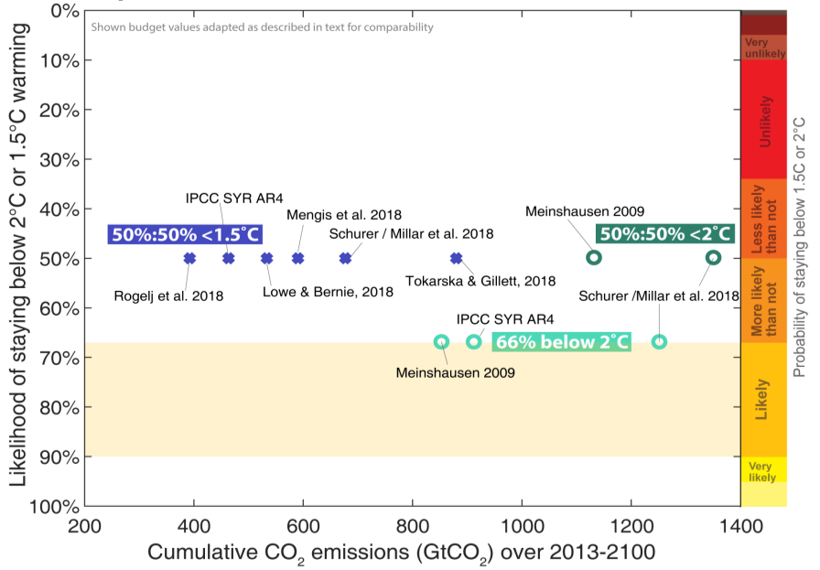
Figure 1 - Comparison of some key literature studies relating to the global carbon budget (Source: Climate and Energy College)

1.2. Current emission trends and their effects on emission budgets
Under current global emission levels, approximately 1/17th of the remaining emission budget is consumed every year. This means that if current emission levels are not reduced, global emissions will exceed the CCA budget by 2034; this holds both when considering CO₂ emissions alone and all greenhouse gases. Given that current global emission trends are relatively stable both historically to 2016 and projected to 2020 under the most conservative scenario in the new scenario families (known as SSP1-1.9), the year by which the global carbon budget is fully consumed varies little (see Table 1). SSP-1-1.9 represents the lower end of the SSP family of scenarios. In this new set of scenarios, there are five shared socio-economic storylines - the SSP-1 family of scenarios reflects a world heading towards sustainability. The ‘1.9’ reflects the anticipated level of global average radiative forcing in 2100 (in watts per square metre) resulting from the scenario. This group of 1.9 W/m² scenarios is often taken to be synonymous with 1.5°C scenarios (depending on the definition of 1.5°C scenarios as explained in Section 5.1).

Since the CCA completed its study, global emissions have continued to grow. As a result, to remain consistent with the same emissions budget requires steeper reductions from now. To accommodate this, global emissions budgets are now ‘front-loaded’, meaning that more emissions are allocated over the 200050 period, leaving fewer emissions for the 2050-2100 period.

For our analysis, we assume that the global emission budget remaining after 2013 is not updated and redistributed among nations. This is to ensure a fair and equitable emission budget sharing algorithm over time. To use a simple analogy, if a birthday cake were divided fairly at the beginning of the party but Peter ate comparatively slower than the other children, it would be unfair for the other children to re-apply a sharing principle to Peter’s half-eaten slice.

Table 1 - Current emission trends and impact on remaining time of emission budget. First and second columns are CO₂; third and fourth columns are all greenhouses gases under Kyoto Protocol (GWP-100 AR4)
Year | Global CO₂ emissions: historical to 2016 & projected under SSP1-1.9 (GtCO2/yr) | Year ‘CO₂-part of CCA budget (Meinshausen et al. 2009) is exhausted at current emission rates | Global greenhouse gas emissions: historical to 2016  & projected under SSP1-1.9  (GtCO₂eq GWP-AR4) | Year in which CCA budget (Meinshausen et al. 2009) is exhausted at current emission rates
2010 | 36.1 | 2036.7 | 49.90 | 2035.5
2011 | 37.3 | 2035.9 | 51.26 | 2034.9
2012 | 38.0 | 2035.5 | 52.13 | 2034.5
2013 | 38.8 | 2035.0 | 52.98 | 2034.2
2014 | 39.6 | 2034.6 | 53.97 | 2033.8
2015 | 39.2 | 2034.8 | 53.42 | 2034.0
2016 | 39.3 | 2034.8 | 53.44 | 2034.0
2017 | 39.4* | 2034.7 | 53.46* | 2034.0
2018 | 39.5* | 2034.7 | 53.48* | 2034.0
2019 | 39.6* | 2034.6 | 53.51* | 2034.0
2020 | 39.7* | 2034.6 | 53.53* | 2034.0
* Global emissions estimated as under new SSP1-1.9 scenario.

1.3. Carbon budgets vs. emissions budgets
As much of the preceding analysis has shown, there is a difference between applying carbon budgets and emissions budgets (see Figure 2). Mostly, the literature outlines carbon budgets rather than emissions budgets. This is because assuming a linear relationship between carbon emissions and induced warming is more robust than assuming, as we have done, a 1:1 relationship between cumulative greenhouse gas emissions and induced warming. Over long timescales our assumption does not hold because several non-CO₂ gases that contribute to warming have finite lifetimes.

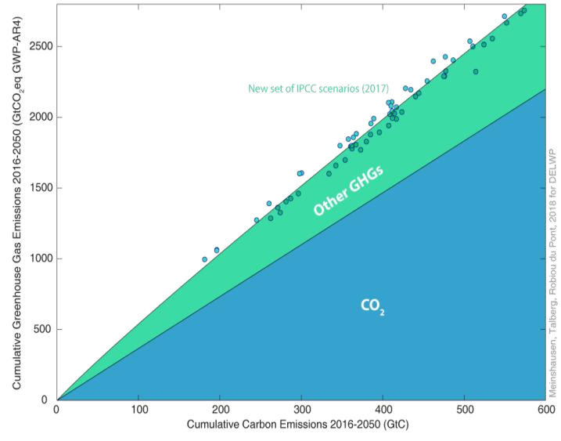
Figure 2 - Relationship between cumulative CO₂ & greenhouse gas emissions (source: Climate and Energy College)

However, when considering relatively low temperature thresholds like 1.5°C and 2°C, there is a strong case for looking at emissions between now and the time that warming peaks - which is why a short time-horizon to 2050 is appropriate. That in turn means that looking at emission budgets rather than carbon budgets can be a superior option. This is because carbon budgets inherently depend on non-CO₂ emission assumptions - while emission budgets actually include those non-CO₂ emissions in the approximation.

1.4. The TEB / TAB distinction
A number of recent carbon budget estimates suggest higher allowable emissions than others, such as some the IPCC SYR estimates, Meinshausen et al. (2009) and Rogelj et al. (2018). One reason for this is purely methodological. As pointed out in Rogelj et al. (2016), there are two approaches to determining budgets:

- One approach considers only those emission scenarios that stay below the stated temperature threshold, that is 1.5°C or 2°C warming and produces what are known as a Temperature Avoidance Budgets (TABs).
- The other approach considers emission scenarios that overshoot those temperature thresholds but then stabilise at the stated target of 1.5°C or 2°C and produces what are known as a Temperature Exceedance Budgets (TEBs).

Logically, TEBs lead to more generous budget estimates. The scenarios underlying TEBs feature relatively high aerosol emissions at the time of crossing the temperature level, so that impact of the CO₂-induced warming is partially masked, leading to higher allowable carbon budget estimates. There is also a small lag time in the system (around 10 years) so that in higher emission scenarios the full effect of cumulative emissions is not yet observed when the temperature thresholds are crossed - they will ultimately be overshot.

In the context of designing policy that reflects the Paris Agreement targets, the more suitable method is that followed by TABs. Unfortunately, TEBs are more prevalent in the literature. The methodological toolbox for the TEB approach is readily available. It simply requires processing existing outputs from existing complex climate models (CMIP3 or CMIP5), ruling a line at the desired temperature threshold, and including only those models that are below the line. In contrast, adopting the TAB approach requires running simulations under a number of additional scenarios, which in turn requires adopting an interpolation technique or using a lower complexity climate model. The effect of the higher prevalence of TEB approaches in the literature has a skewing effect on estimated global budgets towards the more generous end.

2. Checking the ongoing validity of the Australian CCA budget
The budget developed by the CCA is a result of a series of assumptions and methodological choices, many of which are based on Meinshausen et al. (2009), that were valid in 2014. These assumptions resulted in a global budget of 1700 GtCO₂eq (using then-current global warming potentials - see section 2.5) over the 2000-50 period and an Australian budget of 10.1 GtCO₂eq or 0.97% of global budget for 2013-50. In this section we outline clearly the assumptions and decisions adopted by the CCA in its 2014 report and discuss those in light of the recent literature. The objective of this section is to provide ongoing confidence in the scientific integrity of adopting the CCA Australian budget as a basis for state-level budgets, and to update the CCA budget in the context of any new science.

In particular, this section discusses:
- The chosen start year for the budget and the effect of using updated data (Section 2.1);
- How uncertainties are relevant in budget estimates and how ‘likely’ the CCA budget is to meet its stated objectives (Section 2.2);
- The effect of including non-CO₂ gases and whether the CCA’s approach remains justifiable (Section
  - 3);
- The effect of selecting a time-horizon to 2050 in calculating emissions budgets and whether this is appropriate given the CCA’s objectives (Section 2.4);
- Updated Global Warming Potentials (GWPs) and how this alters the final budget estimate (Section
  - 5);
- How land-use was accounted for by the CCA and whether this remains appropriate (Section 2.6);
- What temperature level ‘warming’ is compared to and the effect of updating the CCA budget in line with recent methodologies in this regard (Section 2.7); and
- Assumptions around the method for sharing the global budget between nations and how the CCA’s decision fares against other options (Section 2.8).

2.1. Start year and data from 2013
The CCA released its report in 2014 and thus opted for the most recent Australian emissions inventory data at the time, which dated from 2012. We update these Australian emission figures with the most recent data from 2016. We begin the trajectory from the last point of the CCA study, that is 2013, however we subtract actual 2013-16 emissions to yield a remaining budget starting in 2017. It is worth noting that using updated Australian emissions inventory figures introduces retrospective differences in the data. For example, in 2013 the Department of the Environment and Energy (DEE) reported seasonally adjusted emissions of 135.6 Mt of CO₂eq for the September 2013 quarter; yet in the 2016, the DEE reported 131.8 Mt of CO₂eq for that same September 2013 quarter. This is due to advances in the science and an update in GWPs (see discussion later). However, the impact of this represents a difference of less than 3%.

2.2. Likelihood of staying below temperature target (‘likely’)
The IPCC defines ‘likely’ as anywhere between 67% and 90%. Consistent with the upper end of this definition, the CCA considered that Australia’s budget could be consistent with at least a 67% likelihood of limiting warming to 2°C.

The Paris Agreement shifts the global goal from ‘below 2°C’ (as in the Copenhagen Accord), to ‘well below 2°C’. While a formal determination of the associated likelihood level has not taken place within international climate negotiations, it can be argued that it remains at the threshold of ‘likely’, that is 67%.

We re-evaluated the CCA budget using (but slightly modifying) one of the nearest SSP scenarios, namely the SSP1-1.9 scenario, and applying a distribution of climate and carbon cycle parameters consistent with the latest IPCC AR5 report (this also includes a consideration of permafrost carbon cycle feedback, previously not included in Meinshausen et al. (2009) or in the previous IPCC AR5 probabilistic considerations). This is included in the Appendix as Figures A1, A2 and A3. After 2050, we assumed two variants, one holding greenhouse gas emissions constant and one continuing SSP1-1.9 emissions, leading to a strong net-negative emission trajectory in the second half of the 21st century. We found that the CCA budget, on the basis of the SSP1-1.9 scenario has relatively low exceedance probabilities for 2°C. In other words, we find that the CCA budget is now associated with a higher likelihood of meeting the 2°C target (see Figure A2 in the Appendix), now sitting around 90%.

The shift from a 67% to a 90% likelihood of staying within 2°C is predominantly due to a number of methodological and scientific updates:

- The adaptation of underlying climate uncertainties to reflect IPCC AR5 findings with a slightly lower median climate sensitivity compared to IPCC AR4. This increases the remaining carbon budget.
- A stronger front-loading of emissions due to recent (2000-15) surges of global emissions and steeper decline rate - which in turn leaves more emissions in the 2000-50 period compared to emissions after 2050. Although the total carbon budget across time is nominally not affected, more emissions occur before 2050 and correspondingly less thereafter, which leads to an increase in the ‘up-to-2050’ carbon budget.
- Higher aerosol emissions at the time of peak warming compared to previous assumptions in Meinshausen et al. (2009). This leads to more permissible warming from greenhouse gases, which slightly increases the remaining carbon budget.
- A methodological change of calculating temperature evolutions against a recent (2005-16 or 201016) base period, rather than against the models’ pre-industrial times (see Section 2.7). Depending on the assumed base period, this could increase or decrease the budget. However, to the extent that these recent base-period are still ‘cooler’ than the long-term climatic trend (‘hiatus’), the perceived remaining carbon budget is larger (temporarily).

The next higher SSP pathways that we could have used for this re-evaluation (namely the SSP1-2.6 scenario family) offers a large range of likelihoods; depending on the chosen scenario the likelihood of staying below 2°C could be either ‘likely’ or ‘unlikely’. Therefore, while it may be theoretically possible to achieve a 2°C target with a ‘likely’ chance by pursuing a higher budget in line with SSP1-2.6, this would not provide any guarantee of staying below 2°C (the likelihood would depend on the chosen pathway rather than strictly the budget - given the variations on non-CO₂ emission shares and timing).

2.3. Including non-CO₂ gases
As previously noted, recent literature tends to provide estimates as carbon budgets rather than cumulative greenhouse gas emission budgets. Cumulative greenhouse gas emissions are not the determinants of induced climate effects for short-lived greenhouse gases (in which case the rate of emissions is important). However, as explained above, for policy purposes, the approximation of including all short-, medium- and long-lived non-CO₂ greenhouse gas emissions 2050 in one budget does have advantages, as long as two criteria are met: (1) that the timing of said emissions within the budget term is constrained by realistic multi-gas emission pathways; and (2) that the envisaged temperature target levels are relatively low.

The second criterion is met by the CCA’s compliance with Paris Agreement objectives which reflect relatively low temperature targets. On the first criterion, we tested whether over the 2016-2050 timeframe the newest generation of multi-gas emission scenarios indicates a strong variation from scenario to scenario in terms of the share or timing of non-CO₂ emissions. We found that the CCA assumption to pursue a multi-gas emission budget is still valid and in fact may be superior to a more confined carbon budget over the 2050 timeframe.

Thus, the CCA budget approach of pursuing a greenhouse gas emission, rather than only a carbon budget, over this limited time period until 2050 is valid and has the benefit of directly relating to the complete aggregate of greenhouse gases that are to be regulated.

2.4. Time horizon to 2050
The CCA report relied on global budget figures from Meinshausen et al. (2009), which are specified for 2000–49, and added an extra year of data to produce budgets to 2050. While some studies pursue a longer time-horizon to 2100, the 2050 endpoint has several advantages and newer scenario modelling approaches are beginning to reflect these. A key advantage is that a focus on emissions up to 2050 links decision-making to when temperatures are expected to peak if a 2°C or 1.5°C temperature threshold is to be respected. What then becomes important is whether after 2050, net negative emissions are pursued on a large scale or not, and how fast global temperatures are reduced from the peak temperature level (or whether they are held constant). Thus, while a budget over the full century would help inform decisions about stabilising temperatures in a Paris Agreement compliant world, a budget to 2050 helps inform on peak temperatures, allows the inclusion of non-CO₂ greenhouse gases (because time-flexibility of non-CO₂ emissions is less of an issue over short timescales), and makes clear the distinction between strong early mitigation and strong subsequent net-negative emissions (also known as carbon dioxide removal strategies).

2.5. Global Warming Potential (GWP)
In total, more than 40 greenhouse gases feature within emissions scenarios and many more small industrial gases also exist. Per kilogram of emission, different greenhouse gases have different effectiveness in terms of warming the climate. Two factors determine how effective a certain greenhouse gas will be in warming the climate: their ‘blanking’ effect (radiative efficiency) and their lifetime. The most important greenhouse gas by far is CO₂, which is why all other gases are measured against CO₂. To measure all greenhouse gases in one metric, they are adjusted using their GWPs.

GWP values (relative warming comparison values) for greenhouse gases change over time as scientific understanding of the concept evolves. As a result, reported emissions budgets change as GWPs are updated. However, it is important to understand that GWPs only change the reported numeric value of the emission budget - this is essentially only important for accounting purposes. The actual amount of emissions remains unchanged, it is merely how we understand them that changes. A simple analogy is to think of foreign currency exchanges: for accounting purposes whether a budget is expressed in Yens or in Euros does not change the value of the sum as long as the accounting metric is used consistently throughout the dealings.

For consistency with Meinshausen et al. (2009), the CCA used GWPs from the IPCC’s Second Assessment Report (SAR). However, the CCA acknowledged that the same budget expressed in GWP-AR4 values would be slightly higher. We have opted in our study to update the budget to GWP AR4 values, as this is consistent with both the latest international reporting guidelines under the 2013-20 second commitment period of the Kyoto Protocol and the latest Australian emissions inventory data. A new set of more recent GWPs has been published - AR5 - but these are not yet widely used. The update from GWP-SAR values to GWP-AR4 values results in an increase of the nominal budget by around 3% (see Figure 3). The use of AR5 figures would again lead to a slightly higher nominal budget value.

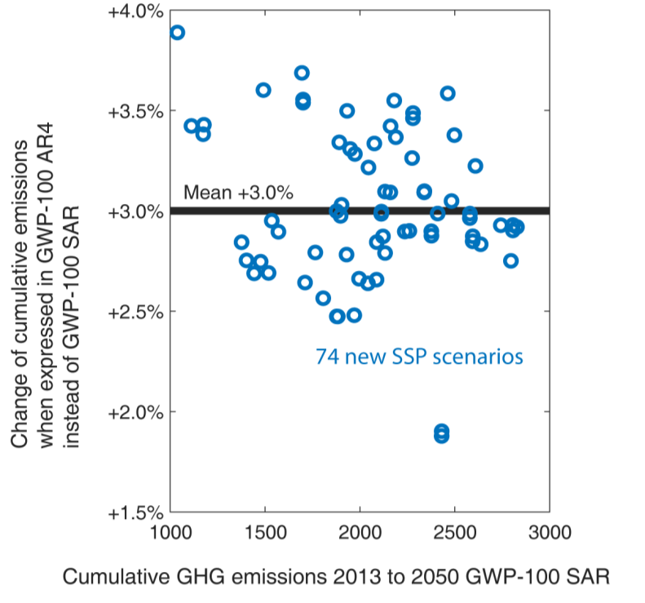
Figure 3 - The relationship between cumulative greenhouse gas emissions accounted for under GWP-SAR and GWP-AR4 (source: Climate and Energy College)

2.6. UNFCCC land-use accounting method
At times land-use has been a net sink of Australian emissions and at other times it has accounted for as much as 15% of Australia’s emissions. How land-use is accounted for can have a notable effect on the total budget. Many academic and analytical institutions choose to omit land-use emissions from national comparisons because of the large uncertainties and time-dependencies that these can introduce. The budget reported by Meinshausen et al. (2009) and used by CCA included some default estimates for landuse-related CO₂ emissions. The CCA opted for land-use accounting that was consistent with Australia’s international reporting method. Using this method, emissions and removals from cropland management, grazing land management and revegetation are all included. We find this decision to remain valid and consistent with the latest available estimates of greenhouse gas emissions for Australia’s States and Territories.

2.7. Current temperature levels (i.e. what is pre-industrial temperature)?
In checking the ongoing validity of the CCA budget, we updated the Meinshausen et al. (2009) methodology to meet a recent practice adopted in new studies: rather than calculating warming compared to a 18501900 or similar ‘pre-industrial’ period, we calculate the temperature difference in relation to a recent period, namely 2010-16. The difference between this recent period and pre-industrial times is then added separately, based on a recent compilation by Schurer et al. (2018).

The reason for this change is that historical uncertainties of global-mean temperatures are then separated from the future projection uncertainties. The former (global-mean temperature) requires methods for assimilating observational data (of the kind that Schurer et al. (2018) highlight, for example in relation to merging sea surface and surface air temperature over land or infilling high polar areas). The latter (future projection uncertainty) is still best reflected by a probabilistic climate model setup of the kind undertaken for this study.

An international debate exists within the climate modelling community on what exactly recent temperature levels are in relation to pre-industrial levels. This debate was re-ignited with the publication of a particular study, Millar et al. (2017), that used a relatively low estimate that did not include polar temperature and mixed sea surface and land air temperatures. Accounting for those effects, Schurer et al. (2018) indicate that a 1.5°C warming level is only ~0.43°C away from current (2010-16) temperatures (when using a fully in-filled HadCRUT4 observational temperature record). Millar et al. (2017) instead assumed that a 1.5°C target is 0.6°C away from current temperature levels; an assumption that (is dubious and) can lead to markedly higher carbon budgets.

Here we apply the most recent Schurer et al. (2018) estimate and find that the global CCA emission budget continues to have a likely chance of staying below 2°C.

2.8. Budget-sharing assumption
The basis for dividing the global budget among nations is the decision that most affects the final budget. The CCA opted for the Garnaut Review’s (2008) ‘modified contraction and convergence’ as an equitable and feasible means of dividing the global budget between nations. This approach sees a gradual convergence of per-capita emissions by 2050 but allows developing countries additional ‘headroom’ for a transitional period, while developed countries must reduce emissions more quickly. This approach resulted in allocating to Australia 0.97% of the global emissions over the 2013-50 period (including emissions from land-use, land-use change and forestry - LULUCF). Other approaches are also valid and could be considered. Which approach is selected is a value judgement - there is no correct or incorrect approach. Some other approaches are explored below.

The IPCC does not explicitly explore a ‘modified contraction and convergence’ method (as defined by Garnaut (2008) and adopted by the CCA) in discussing national budgets, but it does recognise some of the principles embedded within that approach. Specifically, the IPCC’s AR5 identified three equity principles to guide the distribution of the global emissions reduction burden between countries: ‘equality’, ‘capability’ and ‘responsibility’. The IPCC synthesised over 40 individual studies and ultimately quantified five categories of burden-sharing approaches reflecting combinations (or interpretations) of the principles of equality, capability and responsibility. However, these 40+ studies were regional in scope and were based on different assumptions, priorities, trajectories, and metrics making them difficult to combine and compare on a global or national basis (Clarke et al., 2014).

Broadly, the five burden-sharing approaches discussed by the IPCC for the international context were:

- ‘Equal per capita’: annual emissions per person converge towards equal per-capita emissions (can be likened to ‘contraction and convergence’ but may not be exactly the same due to chosen assumptions)
- ‘Equal cumulative per capita’: emissions allocations for each nation are subtracted from historical per capita emissions, so that over the 1990-2050 period each nation has the same ratio of cumulative emissions over cumulative population for the given period
- ‘Capability’: emissions allocations are inversely related to GDP per capita
- ‘Responsibility-capability-need’: mitigation requirements preserve a ‘right to development’
- ‘Staged approaches’: current emissions ratios are maintained between nations; this approach is often referred to as ‘grandfathering’

Robiou du Pont et al. (2016) used these categories to derive an equity framework that allocates emissions of cost-optimal mitigation scenarios across nations. The framework, applied to the cost-optimal scenarios selected to meet the Paris Agreement goals of 2°C or 1.5°C, provides national emissions pathways consistent with five equity approaches representative of the five IPCC equity categories: ‘equal per capita’, ‘equal cumulative per capita’, ‘capability’, ‘Greenhouse Development Rights’, and ‘constant emissions ratio’ (Table 2).

We used each of these five approaches to derive Australian budgets. We used a large set of emission scenarios underlying the IPCC AR5 as a basis when applying alternative fair-share algorithms. These scenarios had been categorised in IPCC studies as having either a ‘likely’ (67% to 90%) chance of staying below 2°C, or an ‘above 50%’ chance of returning to 1.5°C in 2100 (Table 3). We use the results of our calculations to determine whether the CCA’s 0.97% calculation remains valid and sits within a plausible range of approaches.

One key difference in the methodology used to derive our shares that must be noted, is that these calculations do not include LULUCF emissions; however, this does not fundamentally alter the comparison. Table 3 presents the Australian share of the global budget (excluding LULUCF emissions) for each of the five burden-sharing approaches discussed.

Table 2 - Burden-sharing approaches from Robiou du Pont et al. (2017) and corresponding IPCC categories
Allocation type | Corresponding IPCC Category | Description
Equal per capita | Equality | For all nations, annual emissions per person converge towards an equal value in 2040.
Equal cumulative per capita | Equal cumulative per capita | Each nation has the same ratio of cumulative emissions over cumulative population over the 1990-2050 period. Nations with high historical per capita emissions have low emissions allocations.
Capability | Capability | Allocation is based on nations’ abilities to pay for emissions reductions. Nations with high GDP per capita have low emissions allocations.
Greenhouse  Development  Rights | Responsibility-capabilityneed | This approach preserves a ‘right to development’ through the allocation of required emissions reductions.
Constant emissions ratio | Staged approaches | Maintains current emissions ratios (preserves status-quo in emissions allocations). This approach, often referred to as ‘grandfathering’, is generally not considered an equitable option and is not supported as such by any country for dividing a global budget between nations.

Table 3 - Australia’s share of the global budget under five burden-sharing approaches
Allocation type | Global scenarios with 67% chance of staying below 2°C in 2100 | Global scenarios with 50% chance of returning to 1.5°C in 2100
Garnaut (2008) method of modified contraction and convergence (as adopted by the CCA) | 0.97% (assumed) | not known
Equal per capita 2040 convergence | 0.73% | 0.78%
Equal cumulative per capita | 0.68% | 0.62%
Capability | 0.52% | 0.59%
Greenhouse Development Rights | 1.19% | 0.98%
Constant emissions ratio | 1.27% | 1.27%

The Garnaut Review’s (2008) assumptions and method for deriving a ‘modified contraction and convergence’ results in different allocation than our method of ‘equal per capita convergence’. The Garnaut Review (2008) began in 2012, it chose a convergence date of 2050, and chose linear convergence, but provided ‘headroom’ to 2020 in such a way that allowed “developing countries growth in emissions allocations at half the rate of their GDP, if this is greater than the growth in allocations under the convergence rule” (Garnaut Review, 2008). Also, the global scenario that the Garnaut Review’s (2008) calculation was based on decreased relatively rapidly but never reached net zero emissions. We have not been able to gain access to the data used by the Garnaut Review (2008) and as a result we have not been able to conduct a direct comparison.

The methodology of Robiou du Pont et al. (2016), instead, begins in 2010 (which implies slightly lower emissions), adopts a 2040 convergence date, is based on scenarios that do reach zero emissions, but it does not account for developing country ‘headroom’. As shown in Table 3, this results in an Australian share of the global budget at 0.73%. Including ‘headroom’ in this per-capita convergence calculations would further lower the share below 0.73%.

We have not performed a detailed surgical analysis of the exact origin and derivation of the 0.97% figure from the Garnaut review. To make firm conclusions in this regard, a detailed historical analysis would be needed as to the exact derivations and methodological choices that led to the 0.97%.

An Australian budget representing 0.97% of the global budget is clearly within the range of approaches tested in our analysis as it meets two of the five burden-sharing approaches discussed. One is the ‘constant emissions ratio’ approach, which reflects the status-quo. The other is the Greenhouse Development Rights approach, which generally favours developing countries, but in the case of Australia, modelling results in generous allocations early in the century and large negative emissions in the second half of the century due to assumptions about business-as-usual emissions. For Australia’s target to be consistent with all five perceptions of a ‘fair share’ against which we tested, it would need to be reduced to 0.52% of global emissions.

3. Conclusion
Since 2014, when the CCA completed its analysis, a number of developments have occurred in the climate modelling space, in some cases reflecting the slow progress in global emissions reduction. A new series of climate scenarios has been released that provides only a handful of options at the more ambitious end of the scale. And methodological trends have emerged in the literature that tend to skew results from ‘temperature avoidance budgets’ towards so-called ‘temperature exceedance budgets’ with a more generous allocation of emissions for a targeted temperature threshold. These factors are important departures from the methods employed and assumptions made by the CCA. Given the wide spectrum of possible warming implications for the next higher class of SSP scenarios (with some of those scenarios resulting in ‘likely’, others in ‘unlikely’, chances of staying below 2°C), in this report we opted to re-evaluate the CCA budget with adjusted probabilistic climate projections on the basis of the SSP1-1.9 scenario.

Assessing the ongoing validity of the CCA’s assumptions and final budgets against developments in the science, we find that the CCA Australian budget is still defensible as reflecting an Australian effort in line with a global likely chance of staying below 2°C. Rather than representing the low edge of the ‘67% to 90%’ likelihood of staying below 2°C, the CCA’s global budget now represents a higher end of that ‘likely’ range of staying below 2°C, perhaps as high as 90%. This budget would also position Australia to be in line with a world that meets the Paris Agreement’s decisions to limit warming to ‘well below’ 2°C.

The portion of the CCA budget that remains for the 2017-50 period equates to 8.09 GtCO₂eq (GWP-100 AR4). This is the figure that is used for the analysis in Parts II and III.

Part II - Sharing an Australian budget between states and territories

Key points
- The concept of Victoria’s ‘fair share’ of the emissions budget can be interpreted and operationalised in different ways, with different assumptions on key metrics. We chose five such interpretations to test the sensitivity of Victoria’s budget to these. Our analysis divides the Australian emissions trajectory by jurisdictions and determines the budgets by summing the trajectories over the period. The approaches adopted are:
○ An ‘equal per capita emissions’ (contraction and convergence) approach, where emissions rights per person contract over time in a linear fashion in all states and territories to reach net-zero emissions at the same point in time. We test two variants of this, a convergence date of 2030 and of 2050.
○ An ‘equal cumulative per capita’ approach, where each individual has an equal right to the emissions space (an equal right to pollute) over the budget period. This approach takes into consideration historical emissions.
○ A ‘GSP per capita’ approach, where the budget is based on the ‘ability to pay for emissions reduction’, on a per-capita basis, of Australian states.
○ A ‘relative status quo maintained’ approach, where emissions ratios across states are maintained from the start of the allocation period onwards.

- We find that more populated states have a greater share of national emissions; the choice of convergence date under the ‘contraction and convergence’ approach impacts jurisdictions in different ways both in absolute terms and per-capita, but for Victoria the effect on both measures is minimal; and of the five approaches, four provide budget allocations that are relatively similar in all jurisdictions, with the ‘equal cumulative per capita’ approach a clear outlier, as evidenced in the table below.

Relative emission shares of Australian budgets for states and territories 2017-50
 | ACT | NSW | NT | QLD | SA | TAS | VIC | WA
Contraction & convergence - 2030 | 1.2% | 28.1% | 1.8% | 24.1% | 5.9% | 1.1% | 23.7% | 14.1%
Contraction & convergence - 2050 | 0.8% | 26.1% | 2.5% | 26.8% | 5.3% | 0.5% | 22.7% | 15.4%
Equal cumulative per capita | 4.3% | 36.8% | -1.4% | 7.8% | 9.0% | 0.6% | 31.1% | 11.7%
Emissions per GSP/capita | 0.7% | 25.0% | 2.4% | 27.8% | 5.2% | 0.4% | 23.4% | 15.1%
Relative status quo maintained | 0.3% | 25.1% | 3.1% | 29.0% | 5.0% | 0.0% | 21.7% | 15.7%
Average | 1.5% | 28.2% | 1.7% | 23.1% | 6.1% | 0.5% | 24.5% | 14.4%
Average excluding ‘equal cumulative per capita’ | 0.8% | 26.1% | 2.5% | 26.9% | 5.4% | 0.5% | 22.9% | 15.1%

- Excluding the ‘equal cumulative per capita’ approach, Victoria’s 2017-50 emissions budget ranges from 1758 to 1918 MtCO₂eq, depending on the budget-sharing approach, with an average of 1851 MtCO₂eq. In percentage terms, Victoria’s share of Australian emissions ranges from 21.7% to 23.7%, with an average of 22.9%. This share of 22.9% is used as a basis for subsequent analysis.
- A straight-line emissions trajectory from 2020 to 2050 adopting an approach that reflects an average of the burden-sharing approaches tested (excluding ‘equal cumulative per capita) suggests an emissions reduction target in 2030 of 48.8% below 2005 emissions. A smaller target suggests greater emissions reduction rates after 2030, whereas a larger target suggests less steep reduction rates beyond 2030.

- The arguments in favour of early action relate to harnessing low-cost options and creating inertia for economic transformation. Arguments in favour of delaying action relate to future techno-optimism.

- There are key limitations to this study. The inclusion of land-use emissions introduces methodological issues by allowing net negative emissions, which affects the calculation of trajectories and budgets. There are significant uncertainties associated with estimating emissions budgets where time-horizons are short; this results in large ranges of estimates in the literature. The chosen budget-sharing approach, and specific settings applied, have substantial impacts on the results, and yet there is potentially a countless number of settings that could be tested.

4. Introduction and background: budget-sharing categories that could be applied to the subnational context

With the CCA 2013-50 budget of 10.1 GtCO₂eq now expressed as 10.4 GtCO₂eq in updated global warming potentials (GWP-100 AR4), state-level budgets can be derived and used to inform interim targets for 2030. The 10.4 GtCO₂eq budget refers to emissions over the 2013-50 period. Historical emissions from 2013 to 2016 of approximately 2.3 GtCO₂eq are subtracted from the 10.4 GtCO₂eq budget. The remainder of the Australian budget available for the 2017-50 period is then used by assuming a 2020 point close to the original CCA budget line and linearly reducing national emissions thereafter - until emissions reach zero in 2046. This Australian emission trajectory serves as a basis for the subnational burden-sharing approaches presented in this section.
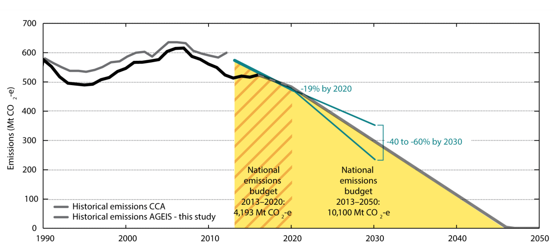
Figure 4 - Central figure of the Climate Change Authority 2014 report (grey historical line) overlaid with this study’s historical emission estimates from AGEIS - aggregated to the national total (thick black line). Although the change of GWP metrics, moving from GWP-100 SAR to GWP-100 AR4 should result in a higher volume of emissions, the sum of the recent state-by-state level data indicates lower Australian emissions in the 1990s and in recent years after 2010. This is likely due to methodological and scientific updates in Australian emissions accounting methods. In the future, the assumed Australian budgets of 10.1 GtCO₂eq (GWP-100 SAR) or 10.4 GtCO₂ (GWP-100 AR4) are almost identical.

The UNFCCC outlines a number of guiding principles that are fundamental to the Paris Agreement. One of these principles influences how all countries are to share the task of global mitigation: this is the principle of ‘common but differentiated responsibilities and respective capabilities’ (CBDR-RC) (UNFCCC, 1992). The operationalisation of this principle has spawned a series of approaches for sharing mitigation efforts, developed by scientists, subject experts and NGOs. As noted in the previous section, the IPCC’s AR5 discussed five burden-sharing approaches for the international context: ‘equal per capita’; ‘equal cumulative per capita’; ‘capability’; ‘responsibility-capability-need’; and ‘staged approaches’.

It is not always possible or relevant to apply these approaches, or approaches derived from them, at the subnational scale, even ignoring issues where the data may not be available. For example, the Greenhouse Development Rights approach (conveying the IPCC category of ‘responsibility-capability-need’) is based on the need to ensure a right to development to populations in developing countries. The relative homogeneity of development across Australian states makes this approach irrelevant. Instead, the equity principles championed by the Greenhouse Development Rights approach (the principles of capability and of historical responsibility) must be explored at the subnational level through other approaches, such as GSP per capita and equal cumulative emissions per capita.

Similarly, it can be argued that historical emissions are less important between subnational jurisdictions than between nations because of higher levels of internal mobility. This is not a justification for ignoring historical emissions at the subnational scale, but they should be contextualised.

The production-based method of emissions accounting, recommended under the UNFCCC and adopted by the Australian Department of Environment and Energy, also poses ethical questions, given that it disadvantages exporting states and advantages importing ones. For example, a state that produces much of its own food and goods will have higher emissions than a state that imports these items. Jurisdictions that import most of its food and goods effectively outsource emissions. In the same way, there are questions around the extent to which electricity produced in one state and consumed in another, or in some cases, electricity produced and consumed in one state but purchased by another can be reflected in emissions budget accounting. Some jurisdictions such as New South Wales, the Australian Capital Territory (ACT), and the Northern Territory (NT) import much of their energy for electricity, which can compromise their ability to choose lower emissions-intensity options. The NT relies primarily on gas and diesel; reducing energy emissions requires installing solar and wind plants. In contrast, the ACT, which is connected to the National Electricity Market, has opted to contract out electricity from renewable energy to other states, such as Victoria and South Australia. How does electricity from renewable sources produced and consumed in South Australia but purchased by the ACT get factored into the determination of equitable allocations of emission budgets? These strong interlinkages between states pose new ethical quandaries regarding the distribution of emission allocations between jurisdictions within a federal system.

An alternative method of addressing this issue would be to adopt a consumption-based accounting method rather than a production-based (or also called ‘territorial’) accounting method. Consumption-based accounting, that is where the emissions embedded within products and services are accounted for by the jurisdiction where these products are consumed, could provide a more accurate metric for emissions in smaller Australian states. On the other hand, a production-based accounting method has the advantage that emissions are accounted for where there is operational control over them. For example, the operational decision to switch a food manufacturing process from natural gas to renewables lies within the territory of the manufacturer, not with the consumers. Nonetheless, as the ultimate aim of this exercise is for state and territory emissions to sum up to the Australian trajectory (as recommended under the UNFCCC) we are constrained to using the accounting method adopted by the UNFCCC, that is productionbased/territorial accounting.

Without delving deeper into these questions of equity, we chose four appropriate approaches to reflect a range of options (one of the four approaches has two variants, bringing the total number to five):
- Approach A: Equal per capita emissions (also known as contraction and convergence) (“Equality”):
○ In 2030
○ In 2050
- Approach B: Equal cumulative emissions per capita (“Responsibility”)
- Approach C: GSP per capita (“Capability”)
- Approach D: Grandfathering – constant share of Australia’s total emissions (“Status quo”)

These five approaches form the basis of our study on ways to divide an Australian emissions budget into state allocations.

4.1. Dividing the Australian budget into state allocations
The following section describes the rationale and basic modelling principles of the budget-sharing approaches used in the Victorian case. The approaches modelled here result in state emissions trajectories that add up, at any point in time, to Australian emissions equivalent to the trajectory derived by the CCA, in line with limiting global warming to 2°C.

Box. Background information on method applied in this study
For this study, we use a modelling framework for all four burden-sharing approaches in a way that allocates the emissions of cost-optimal mitigation scenarios across countries (Robiou du Pont et al., 2016). The direct outcome of this framework is a set of multi-gas emissions trajectories for each entity, normally a nation in the international context. We adopted this framework to derive sub-national (state and territory) emissions trajectories under a chosen country scenario for each of the burden-sharing approaches. However, as the primary focus of this work relates to emission budgets and not emission trajectories, the shares of emission budgets have been determined by summing emissions trajectories of each state over the relevant period.

4.1.1. Approach A: Equal per capita emissions (also known as contraction and convergence)
Under an ‘equal per capita emissions’ (contraction and convergence) approach, emissions rights per person contract over time in a linear fashion in all states and territories to reach net-zero emissions at the same point in time (Figure 5a).

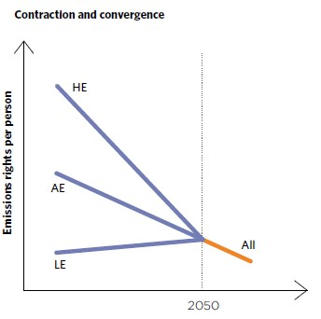
Figure 5a - Schematic representation of a standard contraction and convergence approach, adapted from CCA (2014)
The CCA adopted a modified version of this approach developed by Professor Ross Garnaut (Garnaut, 2008) to estimate Australia’s share of a global emissions budget. The so-called ‘modified contraction and convergence’ approach allows fast-growing countries additional growth in their per-person emissions rights for a transitional period, while developed countries’ rights contract more quickly to provide this ‘headroom’ (Figure 5b). This approach was considered by the CCA as the most equitable way of sharing a global emissions budget as it allows rapidly growing developing countries to make a more gradual adjustment towards equal share of global emissions per capita.

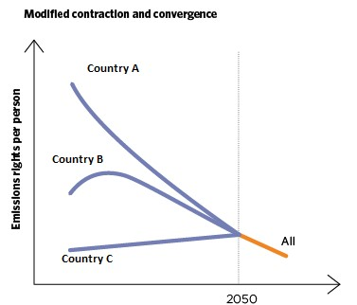
Figure 5b - Schematic representation of the modified contraction and convergence approach, adapted from CCA (2014)
Given the relative homogeneity of development across Australian states and territories, there is not the same rationale for adopting a ‘modified’ version of this approach when sharing an Australian budget. We applied a ‘basic’ version of ‘contraction and convergence’ so that each state’s share of national emissions starts at their current values and their per-capita emissions linearly converge by a certain year.

The equity concept behind this approach is that each individual, whether in Hobart or Bendigo, deserves equal access to the emission space - that is, they have the same right to pollute each year. From a philosophical standpoint, equal-per-capita approaches treat each Australian equally and do not account for the specificity of each state (economic capacity or historical responsibility). This approach suggests an ‘isolationist’ view of emissions allocations, where emissions are allocated across people regardless of other parameters.

We have chosen to explore two convergence years - 2050 and 2030:
- 2050 was chosen because it is the year by which Victoria must (and many other states and territories have pledged to) reach net-zero emissions. However, 2050 is considered late in the context of international burden-sharing. By the time Australian emissions reach zero in 2050, the entire budget is consumed, meaning that this 2050-contraction-and-convergence approach yields results similar to those of the grandfathering approach (see Approach D).
- 2030 was chosen because of the above reasons, thus to provide an alternate option. The earlier convergence reflects a stronger influence of the equity principle of this approach, and results in smaller budgets for states with current per-capita emissions higher than the Australian average, but larger budgets for states with current per-capita emissions higher than the Australian average, compared to a 2050 convergence.

State level population projections are from the Australian Bureau of Statistics, more details on data are available in the Appendix.

4.1.2. Approach B: Responsibility (equal cumulative per-capita)
The equity principle of historical responsibility is based on the notion that each individual should have an equal right to the emissions space (an equal right to pollute) over a certain period. This approach differs from Approach A in that historical emissions are taken into account; it thus reflects a different perspective of intergenerational equity. It is the answer to the following question that divides supporters of Approaches A and B: “should individuals living now in a certain state have their emissions space restricted because of the past emissions intensive actions of other individuals in that state?”. Approach B reflects a positive answer to the question.

In this study, the allocation of emissions rights refers to the entire 1990-2050 period so that over the entire period, the cumulative emissions of any state or territory, divided by the cumulative population of that state or territory, is the same for any jurisdiction. This approach is also ‘isolationist’ and does not account for states’ capabilities to undertake mitigation effort. However, this approach indirectly accounts for the potential long-lasting benefits that a state may have gained from higher emissions levels (for instance to develop its industry) by reducing the budget allocation. While this rationale is relevant at the international level, the greater mobility of population across states than across countries makes it more difficult to define a population accountable through time.

State-level population projections are from the Australian Bureau of Statistics, more details on the data are available in the Appendix.

4.1.3. Approach C: Capability (GSP per capita)
The capability approach is based on the ‘ability to pay for emissions reduction’, on a per-capita basis, of Australian states. States with high Gross State Product (GSP) per capita are given low emissions allocations; the logic being that the richer states can afford more emissions reduction. In any given year, each state has a share of the Australian emissions (from the CCA trajectory) that is proportional to their projected population divided by their per-capita GSP. A convergence period allows for a near-linear transition from current state emissions levels to the ‘capability’ based levels at a chosen year.

Unlike the other approaches, the capability approach is not ‘isolationist’ and takes in account parameters other than emissions quantities. It is considered to be a ‘prioritarian’ approach that provides more emissions space (this is equivalent to less mitigation efforts or more revenue from a potential trading scheme) to those worse-off.

In terms of parameterisation, the GSP-dependency feature of the capability approach does not have a strong influence on emissions budgets when the convergence date is set at 2050. In the context of this work, where Australian emissions reach zero by 2050, this 2050-capability approach yields results similar to those of the grandfathering approach (Approach D) (much like the 2050-contraction-and-convergence approach).

State level population and GSP projections are from the Australian Bureau of Statistics, more details on the are available in the Appendix.

4.1.4. Approach D: Grandfathering (relative status quo maintained)
The underlying philosophy to this approach is that climate policy is not a tool for emissions redistribution among states, only for emissions reduction. The approach preserves the emissions ratios across states from the start of the allocation period onwards. So if Victoria accounts for x% of Australian emissions at the start of the allocation period, it continues to account for x% of Australian emissions until these reach zero.

It can be argued that this approach is not based on a concept of fairness. However, it is justifiable at the subnational level by assuming that a fair budget-sharing amongst states can be enacted through other mechanisms, such as financial support across states or from the federal government. For example, the federal government may choose to support states by compensating for disproportionate efforts through redistribution mechanisms that are outside the climate space.

4.2. Synthesis of the four approaches
The application of the four effort-sharing approaches, plus using both a 2030 or 2050 convergence date for the contraction-and-convergence approach, results in five emissions budgets for each state over the 2017-
50 period. The results are presented in absolute and percentage terms in Figures 6 and 7, Tables 4 and 5.

Unsurprisingly, more populated states have a greater share of national emissions. For the reasons detailed earlier, the capability, the 2050-contraction-and-convergence and grandfathering approaches yield similar results for all states and territories. The 2030 convergence date (Approach A, variation) yields slightly different results, and the historical responsibility approach (Approach B) is a clear outlier.

State emissions budgets can also be expressed in terms of their population expected over the same period (2017-50) (see Figure 7). The choice of convergence date under the contraction and convergence approach impacts jurisdictions in different ways both in absolute terms and per-capita, as can be seen by the aqua blocks and grey outlines in Figures 6 and 7. The 2030 convergence date is relatively close to the year in which Australian emissions are expected to reach zero in this modelling (that is 2046, based on the CCA methodology). An earlier convergence date would have provided a greater difference. For the NT, a 2030 convergence date reduces the per-capita budget markedly, for Tasmania it offers a per-capita budget 2.5 times bigger. Note that the effect on Victoria on both measures is minimal.

The clear outlier in Figures 6 and 7 is the historical responsibility approach depicted by the yellow blocks. For example, this approach results in a negative budget of the NT. This is explained by the NT’s high percapita emissions since 1990 (compared to the Australian average) due to high land-use emissions and a heavy reliance on gas and diesel for electricity supply, meaning that the NT now has a greater ‘responsibility’ towards reducing Australia's emissions. There are similar outcomes for QLD and WA but to a lesser scale, due to the electricity sector plus fluctuating land-clearing regulations in QLD and due to the mining sector in WA. The converse applies for the ACT, NSW, South Australia and Victoria where lower historical emissions means less of an ongoing ‘responsibility’ to reduce emissions, and thus larger budgets.

Surprisingly, Tasmania’s emissions budgets are significantly lower than the less populated NT and ACT. This result is due to the LULUCF accounting method which results in negative emissions for Tasmania in 2016 (or near zero). Since budgets are heavily influenced by the latest available annual emissions levels, Tasmania’s budgets are very low. The inclusion of LULUCF emissions thus represents a serious limitation of the results presented here. LULUCF emissions originate from activities that depend more on natural assets than on the local population’s activities. Emissions budgets of states with a low population density can be heavily affected.

Victoria’s emissions budget for 2017-50 ranges from 1758 to 2513 MtCO₂eq, depending on the budgetsharing approach, with an average of 1983 MtCO₂eq. Excluding the ‘outlier’ approach of ‘responsibility’, even though this is a highly appropriate and justifiable approach to adopt, provides a range of 1758 to 1918 MtCO₂eq and an average of 1851 MtCO₂eq. In percentage terms, Victoria’s share of Australian emissions ranges from 21.7 to 31.7%, with an average of 24.5%. Excluding the ‘responsibility’ approach provides a range of 21.7 to 23.7% and an average of 22.9%.

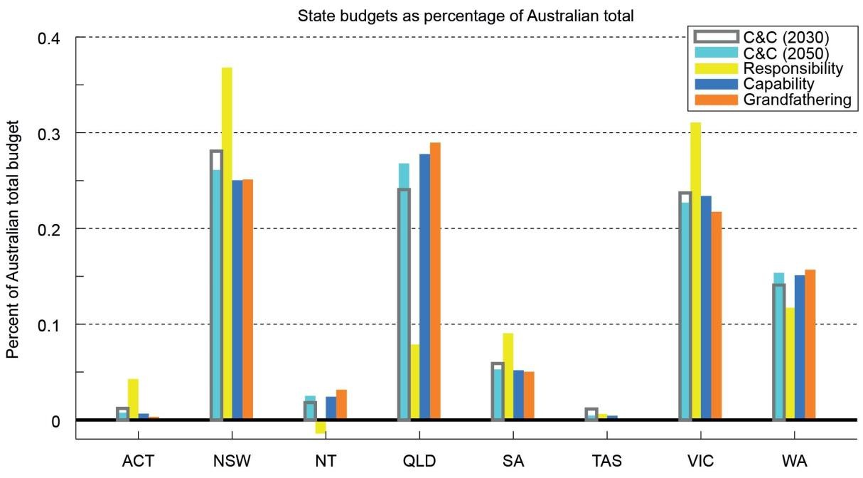
Figure 6 - State budgets (2017-50) as percentage of Australian total under five budget-sharing approaches

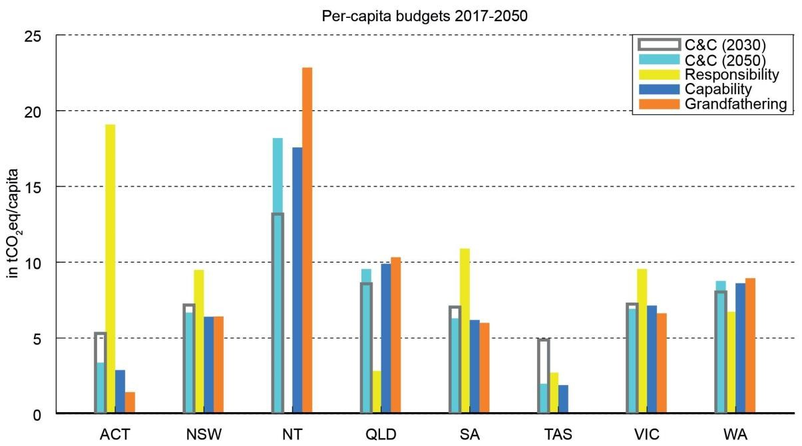
Figure 7 - Per-capita budget (2017-50) under five budget-sharing approaches

Table 4 - Emission budgets for states and territories 2017-50 in MtCO₂eq (GWP-100 AR4)
Approach | ACT | NSW | NT | QLD | SA | TAS | VIC | WA | Subtotal
Contraction & convergence - 2030 convergence | 97 | 2270 | 147 | 1946 | 477 | 92 | 1918 | 1139 | 8086
Contraction & convergence - 2050 convergence | 62 | 2112 | 203 | 2167 | 427 | 38 | 1836 | 1243 | 8086
Responsibility (Equal cumulative per capita)* | 346 | 2976 | -115 | 637 | 732 | 51 | 2513 | 947 | 8086
Capability (emissions per GSP/capita) | 53 | 2024 | 196 | 2245 | 419 | 36 | 1892 | 1221 | 8086
Grandfathering | 26 | 2031 | 255 | 2342 | 406 | 0 | 1758 | 1268 | 8086
Min-Max | 26 to  346 | 2024 to  2976 | -115 to  255 | 637 to  2342 | 406 to  732 | 0 to 92 | 1758 to  2513 | 947 to  1268 | 8086 to  8086
Average | 117 | 2283 | 137 | 1867 | 492 | 43 | 1983 | 1164 | 8086
Average excluding ‘equal cumulative per capita’ | 60 | 2109 | 200 | 2175 | 432 | 42 | 1851 | 1218 | 8086
* due to the methodology under the ‘responsibility’ approach, there is a small rounding error that has been addressed by re-scaling statelevel results to match - in aggregate - the national total of 8.089 GtCO2eq (GWP-100 AR4).

Table 5 - Relative emission shares of Australian budgets for states and territories 2017-50
Approach | ACT | NSW | NT | QLD | SA | TAS | VIC | WA | Subtotal
Contraction & convergence - 2030 convergence | 1.2% | 28.1% | 1.8% | 24.1% | 5.9% | 1.1% | 23.7% | 14.1% | 100.0%
Contraction & convergence - 2050 convergence | 0.8% | 26.1% | 2.5% | 26.8% | 5.3% | 0.5% | 22.7% | 15.4% | 100.0%
Responsibility (Equal cumulative per capita) | 4.3% | 36.8% | -1.4% | 7.8% | 9.0% | 0.6% | 31.1% | 11.7% | 100.0%
Capability (emissions per GSP/capita) | 0.7% | 25.0% | 2.4% | 27.8% | 5.2% | 0.4% | 23.4% | 15.1% | 100.0%
Grandfathering | 0.3% | 25.1% | 3.1% | 29.0% | 5.0% | 0.0% | 21.7% | 15.7% | 100.0%
Min-Max | 0.3% to  4.3% | 25% to  36.8% | -1.4% to  2.5% | 7.8% to  29% | 5% to 9% | 0% to  1.1% | 21.7% to  31.1% | 11.7% to  15.7% | 100% to  100%
Average | 1.5% | 28.2% | 1.7% | 23.1% | 6.1% | 0.5% | 24.5% | 14.4% | 100.0%
Average excluding ‘equal cumulative per capita’ | 0.8% | 26.1% | 2.5% | 26.9% | 5.4% | 0.5% | 22.9% | 15.1% | 100.0%

4.2.1. Victorian range of emissions trajectories
Emissions budgets can be understood as quantities that each state is free to use to use over time following a trajectory that reflects that state’s circumstances and interests. So for example, from an economic perspective it may suit one state to emit more earlier and then reduce emissions steeply, whereas for another state it may make economic sense to reduce emissions more slowly and gradually but start immediately. This choice is individual to the state. For our modelling we employ linear emissions trajectories for Victoria’s pathways. This is the same method as employed by the CCA to derive the Australian trajectory. The emissions reduction rate, and the date when the budget is exhausted will therefore depend on both the emissions budget and current emissions levels.

Figure 8 shows linearised trajectories for Victoria based on 2017-50 budgets under our five budget-sharing approaches. These trajectories reach zero before or around 2050 under all budget-sharing approaches, except for historical responsibility.
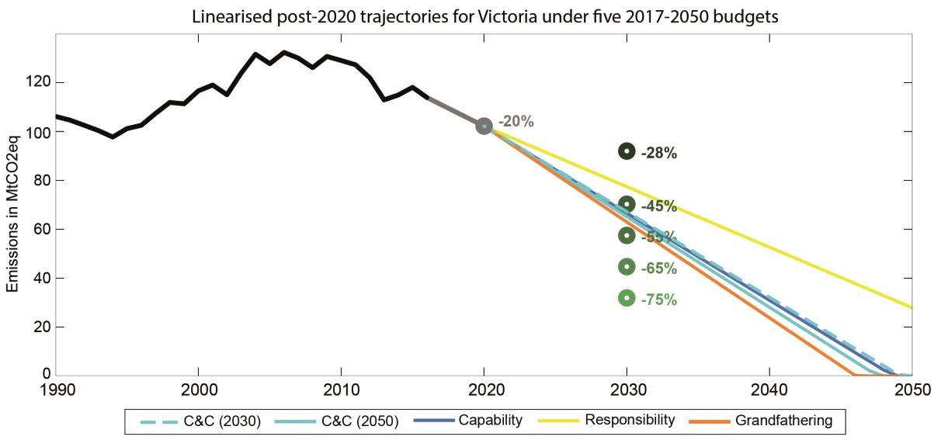
Figure 8 - Linearised trajectories for Victoria for 2017-50 budgets under five effort-sharing approaches - shown with a range of 2005-30 mitigation targets levels

In the following, we analyse a Victorian budget that results from the average of four of the five approaches (excluding the ‘equal cumulative per capita’). That average across four approaches results in a Victorian share of 22.9% of Australia’s budget that can then be applied over time - consistent with a 2020 Victorian target emission level of -20% below 2005 and consistent with various 2030 target options. The remainder of this Victorian budget is then ‘smoothly’ applied from 2030 to 2050 - assuming that emissions do not increase again after 2030 (see Figure 9). This means that in Figure 9 the area under each curve from 2017 to wherever the zero level is reached is the same within each budget-sharing category across all interim 2030 target options.

A linear trajectory would result in an emissions reduction target in 2030 of 48.8% of 2005 emissions. Therefore, as Figure 9 shows clearly, 28% and 45% mitigation targets would require greater emissions reduction rates after 2030. Given the relatively low cost (some negative) of current emissions reduction technology, and the uncertainty of the availability of deep decarbonisation or negative emissions technology, leaving greater effort for a distant future represents a risk (Dooley and Kartha, 2018). Pursuing the 55% target results in less steep reduction rates beyond 2030, and targets of 65% or 75% reductions increase the chance of providing less stringent post-2030 mitigation needs.
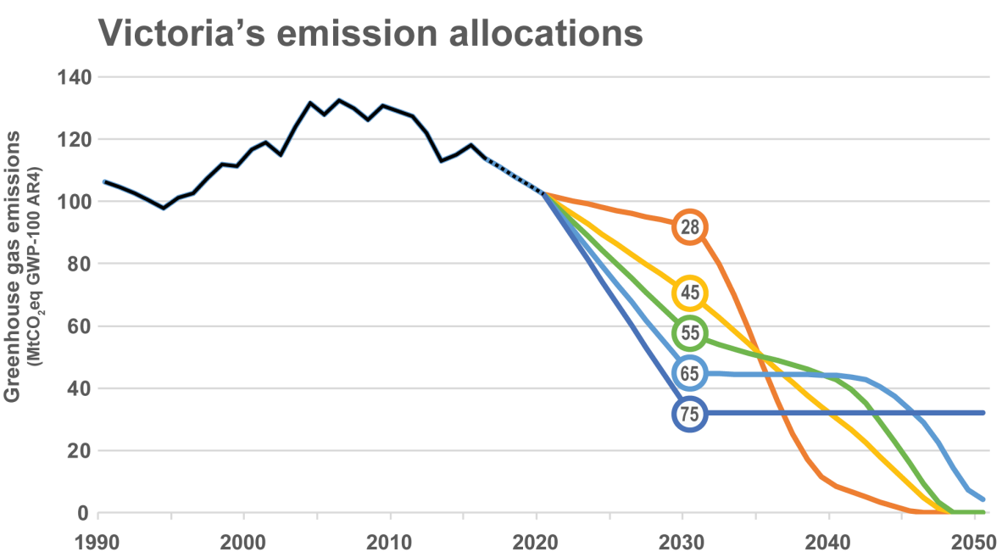
Figure 9 - Victoria’s emission allocation trajectories under the average of four budget-sharing approaches based on 2017-50 budgets following a 20% reduction in 2020 and a 28%, 45% 55%, 65% or 75% reduction in 2030 compared to 2005 levels.

We do not make specific recommendations on any particular target, as this decision depends on multiple factors, including sectoral emission reduction potentials and costs, the opportunities to build up long-term growth sectors (like renewables) and to attract jobs and growth to Victoria, the lifetime of existing infrastructure and its renewal rates, political considerations and so on. However, we make the observations on the relevance of pre- and post-2030 emissions reduction targets.

On the path to net-zero emissions in 2050, 2030 can be considered almost a mid-point milestone. As noted, a linear trajectory is provided if a 2030 target of 48.8% of 2005 emissions is adopted. However, an interesting question is: ‘how should emission reduction efforts (and associated opportunities) be distributed: more before 2030 or after?’ The absolute rate of reductions in MtCO₂eq/yr can only be a rough proxy for this effort, but the comparison of those reductions before and after 2030 can be informative.

There are several lines of arguments that support stronger emissions reductions before 2030 with less step reduction post-2030. These include:
- Harnessing the low-hanging fruits of low-cost emission reduction options early on;
- Assuming a stronger responsibility for international mitigation efforts as a big state within the highestper-capita emitter of the developed world;
- Focussing early on transformative electricity-supply, building, transport and industrial zero emission technologies can create inertia and bring future economic opportunities to Victoria.

Alternatively, reasons for delaying strong emissions reduction until post 2030 might include:
- The expectation that new innovations will make the task of emissions reduction easier in the future or that emissions reduction technologies will become cheaper over time;
- Ensuring that Victoria’s efforts do not exceed those of other high-per-capita emitting jurisdictions around the world;
- Maximising the life-cycle cost-effectiveness of high-emitting machinery/systems by extending their lifetimes;
- Leaving ‘room’ to increase efforts at a later date when there may be political benefits of doing so.

4.2.2. Limitations of the approach
This section provides a summary of some general limitations of the chosen approaches and calculations presented in this study. These apply to both the derivation of the Australian budget as well as the derivation of the state budgets.

The inclusion of LULUCF introduces methodological issues, as the example of Tasmania, whose current emissions are close to zero, shows. Approaches that include a convergence towards zero emission levels in 2050 automatically assign a zero allocation for the whole time-horizon. It might therefore be more appropriate (as often discussed in international negotiations) to separate LULUCF from energy/industrial emissions targets because the sectors face different challenges, have spatially different circumstances, and benefit from separate policy designs. A follow-up study could consider how to separate LULUCF-related emissions and work through various options of sharing the efforts to keep them either net negative (as in the case of Tasmania) or limit deforestation and land clearing emissions (as in the case of Queensland).

Regarding climate science, there are uncertainties associated with estimating emissions budgets, for example in line with the Paris Agreement targets, and these can be significant. Although, overall, emission budgets are a robust concept, a series of dependent uncertainties lead to a high total error margin. For instance, a 0.1°C difference in the target, a 0.1°C difference in the assessment of how much higher current global-mean temperatures are in relation to pre-industrial levels, a 0.1°C difference in our estimate of the Earth system’s transient climate response or likewise a 0.1°C difference induced by different forcing assumptions (e.g. including an assumption about natural volcanic forcing or not) can have strong implications for the small remaining emission budget. This is why current literature estimates differ on the small remaining emissions budgets - although percentage differences are much narrower when considering total carbon budgets since pre-industrial times.

Lastly, any chosen effort-sharing principle can come in multiple flavours and assumptions around convergence years and starting points of the analysis can have a substantial impact on the results. This was evident in the effect of altering the convergence year in Approach A. This is why we modelled a number of different approaches. If, as for the derivation of the Australian budget from a global budget, a single effortsharing approach is chosen, uncertainties can be constrained to that normative decision. The choice of the ‘(modified) contraction and convergence’ approach to derive Australia’s budget determined the size of the Australian budget and all follow-up results for Victoria and the other states.

A lower Australian budget would imply lower allowable emissions for the different states. In other words, the presentation of different effort-sharing results hides the fact that the overall range of options would increase, if a similar range of options was chosen to inform the overall Australian budget (rather than assuming a single 0.97% share - as done in this study and the CCA). Victorian budget shares could be as much as halved if the overall Australian share were determined by a ‘capability’ based effort sharing principle (which implies an Australian share of 0.52% rather than 0.97% of global emissions). Further, a smaller Australian budget would affect 2030 emission levels if a straight-line approach were chosen to determine the 2030 level between the most recent historical emission point (2016) and a zero-emission level before 2050. For example, applying a 0.73% (rather than 0.97%) Australian share of the global budget under a per-capita convergence approach (see Table 3), and assuming the same 22.9% Victorian share of this Australian budget, would result in a 2030 emission level of -59.9% following a straight line - rather than the 48.8% under a straight line in the case of an 0.97% Australian share of the global budget.

Part III - A budget in line with a lower level of warming

Key points

- The Paris Agreement opened political discussion to ‘pursuing efforts to limit the temperature increase to 1.5°C above pre-industrial levels’ (Paris Agreement, 2015). How could the Victorian targets take this into account from an emissions budget perspective?

- For a series of scientific and methodological reasons, and because of recent high levels of global emissions, the global CCA 2000-50 budget of 1750 GtCO₂eq (GWP-100 AR4) is now in line with the most ambitious scenarios of recent scenario families. Constraining global emissions pre-2050 increases chances of staying below 2°C and of avoiding dangerous tipping points without needing to rely on uncertain deep negative emissions post-2050. However, even within the most ambitious scenarios many do not describe futures that maintain even a 50% chance of staying below 1.5°C warming, instead they lead to global temperatures returning to 1.5°C by 2100.

- None of the considered new scenarios, nor the CCA budget modelled on the basis of SSP1-1.9 characteristics, is realistically close to staying below 1.5°C warming across the 21st century. Options for tightening the CCA’s budget, within current scenarios, are thus limited and we must look to the 2050-2100 period for a budget that is in line with lower levels of warming. By the end of the century, by 2100, a 1.5°C warming level comes once again within reach, with an exceedance risk that drops to 33% if strong negative emissions are pursued.

- Accepting that there are high levels of scientific uncertainty associated with calculations of trajectories and budgets in line with warming of 1.5°C, we determine that for a likely chance of staying within 2°C, but only a 50% chance of staying below 1.5°C by 2100, global emissions from 2050 to 2100 remain constant at 2050 levels (which is net-zero carbon emissions). For a 67% chance of staying below 1.5°C by 2100, and to be in line with the Paris Agreement to aim ‘well below’ 2°C, a downward trajectory of global emissions is needed post-2050. This means that CO₂ must be removed from the atmosphere so that the result is net negative emissions.

- Options of carbon removal being floated include large-scale afforestation, bioenergy with carbon capture and storage, enhancing natural weathering of silicates or carbonates, and direct air capture machines. However, many of these technologies are nascent and under-researched and are currently not considered economically (and in many cases environmentally or socially) viable. Policy decisions are needed around the desirability and feasibility of negative emissions that do not conflict with food security, biodiversity targets and other competing land uses. Many of these questions need to be addressed on global, national and state levels.

5. A 1.5°C target and its global emission budget
As laid out in the previous sections, the global CCA budget of 1750 GtCO₂eq (GWP-100 AR4) for 2000-50 is in line with the most ambitious scenarios of recent scenario families. This was not always the case. It is due to points raised earlier around revised climate sensitivities, higher aerosol emissions at the time of peak warming compared to previous assumptions, a methodological change regarding pre-industrial temperature calculations, and recent high level of global emissions.

An outcome of this is that the question around whether 1.5°C of global warming can be reached by the end of the century depends not only on emissions to 2050, but also on whether a substantial amount of netnegative emissions occurs post-2050. The key message is that a strong likelihood of meeting a 1.5°C target requires that carbon emissions are taken out of the atmosphere, such that net emissions are negative, between now and 2100.

Natural processes already sequester carbon, taking it out of the atmosphere. For example, the oceans absorb around 40% of emissions of CO₂. However, for these processes to outweigh the rapid increase in emissions, and become net sinks of CO₂, they must be bolstered. Options for emissions removal that are being discussed include:
- Afforestation on previously unforested land;
- Bioenergy with carbon, capture and storage: this involves using agriculture or municipal waste (or other forms of biomass) for energy, capturing the resulting emissions, and sequestering them underground;
- Enhanced weathering on land, in lakes or on coasts: this involves the dispersion of carbonate or silicate minerals over land or water as a means to capture CO₂ from the atmosphere; and
- Direct air capture: this involves specially designed machines (sometimes referred to as artificial trees) that use chemical or other processes to separate CO₂ from the ambient air, to ultimately be sequestered underground.

It is important to note that most of these techniques and technologies are nascent and under-researched and are currently not considered economically (and in many cases environmentally or socially) viable. Considerable research and development is needed in these areas.

In Figure 10, the red dotted line shows the original CCA trajectory derived in 2014. The blue dashed line shows the updated CCA trajectory that is needed to accommodate the expended emissions between 2013 and 2017. At 2050, the dashed blue line diverges:
- The horizontal dashed line after 2050 shows a constant emissions rate. This represents a likely chance of staying within 2°C, but only a 50% chance of staying below 1.5°C by 2100.
- The downward tracing dashed line shows effective and increasing negative emissions beyond 2050. This represents a 67% chance of staying below 1.5°C by 2100.

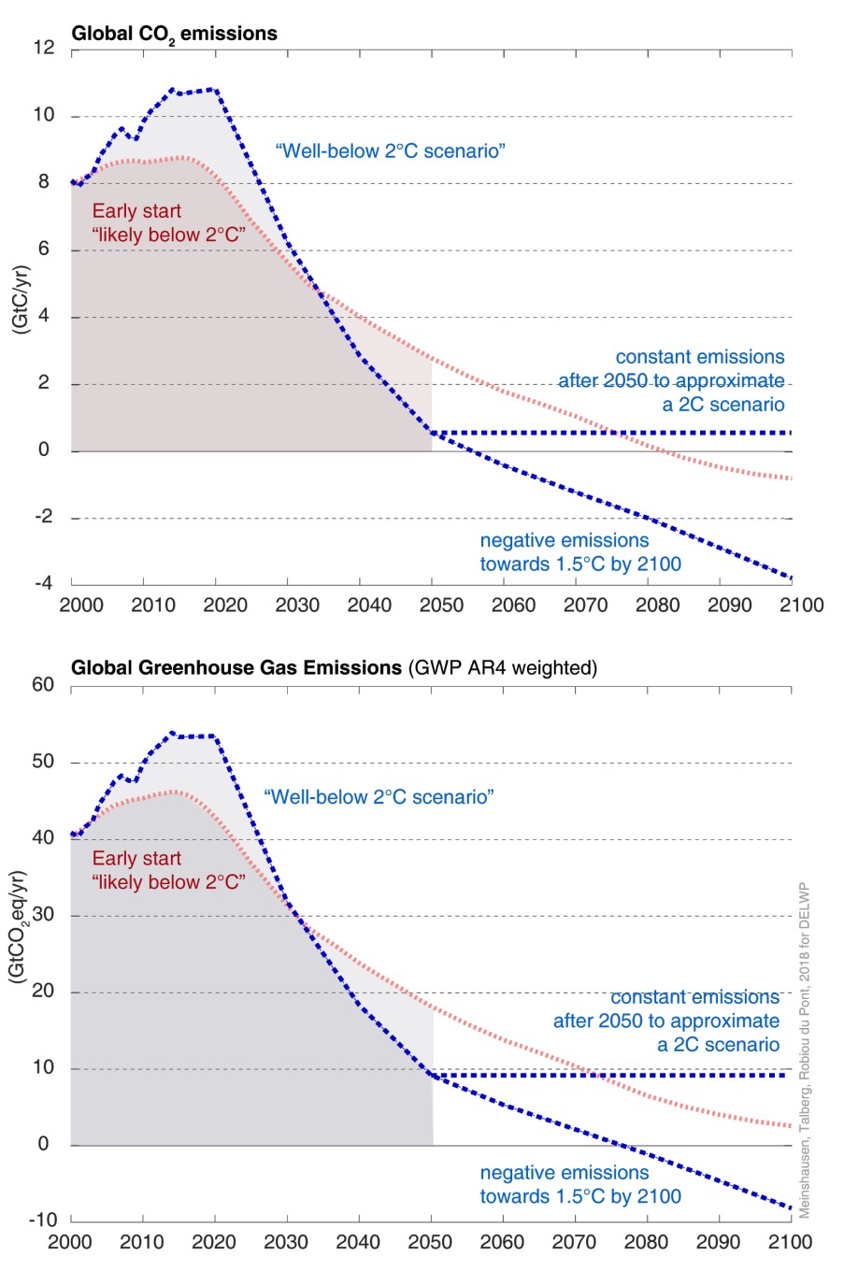
Figure 10 - Comparison of CO₂ (top panel) and greenhouse gas (lower panel) emission pathways. The original global CCA budget based on Meinshausen et al. (2009) is approximately in line with the ‘early start’ trajectory of staying below 2°C. With increased real-world emissions to 2016, a stronger decline of emissions is necessary to stay within a similar budget to 2050 (blue pathways). After 2050, constant near-zero emissions would approximately stabilise peak temperatures - while the continuation of lowering emissions into the net-negative realm would be able to achieve a 1.5°C target again by 2100.

5.1. Why a precise definition of the ‘1.5°C target’ matters
The achievability of a 1.5°C target depends on its exact definition. The new set of SSP scenarios does not contain any scenarios that remain, with at least a likely or higher than 50% chance, below 1.5°C.

However, if a 1.5°C goal is understood as ‘temperatures return to 1.5°C or lower levels at some stage by the end of the century’, then several scenarios within the SSP1.1.9 scenario family are compliant. In this case, the reference in the Paris Agreement to ‘well below’ 2°C (scenarios that limit peak temperatures to ‘well below’ 2°C, or say 1.7°C, over the course of the century) is consistent with a 1.5°C goal in 2100 if emissions are sufficiently low or net negative by the end of the century.

6. Conclusions
As detailed above, our assessment of the global CCA budget suggests that it is both compatible with a ‘well below’ 2°C target as well as a 1.5°C target (if defined as ‘1.5°C by 2100’). Victoria could consider adopting an approach the goes beyond the one outlined in Part II, to spur investment in technological growth sector, or to hedge against the potential need for negative emission technologies later on. An emphasis on how to establish carbon dioxide removal activities in the coming decades in a sustainable manner in Victoria could be a complementary policy option for enhanced emission trajectories to 2050.

As mentioned in the limitations of Part II, the largest value judgement in the question of whether Victorian targets are in line with the Paris Agreement comes from the decision to allocate a 0.97% share of global emissions to Australia. As an example, if an equal per-capita convergence approach were chosen with a 2040 convergence date, Victoria’s 2030 emission levels could be substantially lower, e.g. 59.9% compared to 48.8% below 2005 levels - assuming a simple straight-line approach.

References
Allen, M. R., Frame, D. J., Huntingford, C., Jones, C. D., Lowe, J. A., Meinshausen, M., & Meinshausen, N.
(2009). Warming caused by cumulative carbon emissions towards the trillionth tonne. Nature, 458(7242), 1163–1166. https://doi.org/10.1038/nature08019

Clarke L., K. Jiang, K. Akimoto, M. Babiker, G. Blanford, K. Fisher-Vanden, J.-C. Hourcade, V. Krey, E.
Kriegler, A. Löschel, D. McCollum, S. Paltsev, S. Rose, P., R. Shukla, M. Tavoni, B., C. C. van der Zwaan, and
D.P. van Vuuren, 2014: Assessing Transformation Pathways. In: Climate Change 2014: Mitigation of Climate Change. Contribution of Working Group III to the Fifth Assessment Report of the Intergovernmental Panel on Climate Change [Edenhofer, O., R.
Pichs-Madruga, Y. Sokona, E. Farahani, S. Kadner, K. Seyboth, A. Adler, I. Baum, S. Brunner, P. Eickemeier, B. Kriemann, J. Savolainen, S. Schlömer, C. von Stechow, T. Zwickel and J.C. Minx (eds.)]. Cambridge University Press, Cambridge, United Kingdom and New York, NY, USA.

Climate Change Authority (2014), Targets and Progress Review, Canberra, Australia. ISBN 978-0-9873828-
6-3 http://climatechangeauthority.gov.au/reviews/targets-and-progress-review-3

Dooley, K., & Kartha, S. (2018). Land-based negative emissions: risks for climate mitigation and impacts on sustainable development. International Environmental Agreements: Politics, Law and Economics, 18(1), 79–98. https://doi.org/10.1007/s10784-017-9382-9

Garnaut ,R. (2008). The Garnaut Climate Change Review: Final Report, Cambridge University Press, Melbourne, Australia

Gütschow, J., Jeffery, M L., Gieseke, R., Gebel, R., Stevens, D., et al. (2016). Earth System Science Data, 8(2), 571-603.

IPCC (2014). Climate Change 2014: Mitigation of Climate Change. Contribution of Working Group III to the
Fifth Assessment Report of the Intergovernmental Panel on Climate Change
[Edenhofer, O., R. Pichs-Madruga, Y. Sokona, E. Farahani, S. Kadner, K. Seyboth, A. Adler, I. Baum, S. Brunner, P. Eickemeier, B. Kriemann, J. Savolainen, S. Schlömer, C. von Stechow, T. Zwickel and J.C. Minx (eds.)]. Cambridge University Press, Cambridge, United Kingdom and New York, NY, USA.

Meinshausen, M., Meinshausen, N., Hare, W., Raper, S. C. B., Frieler, K., Knutti, R., Allen, M. R. (2009). Greenhouse-gas emission targets for limiting global warming to 2 °C. Nature, 458(7242), 1158–1162.
https://doi.org/10.1038/nature0801

The Paris Agreement to the United Nations Framework Convention on Climate Change, opened for signature 22 April 2016.

Robiou du Pont, Y., Jeffery, M. L., Gütschow, J., Rogelj, J., Christoff, P., & Meinshausen, M. (2017).
Equitable mitigation to achieve the Paris Agreement goals. Nature Climate Change, 7(1).
https://doi.org/10.1038/nclimate3186

Robiou du Pont, Y., Jeffery, M. L., Gütschow, J., Christoff, P., & Meinshausen, M. (2016). National contributions for decarbonizing the world economy in line with the G7 agreement. Environmental Research Letters, 11(5). https://doi.org/10.1088/1748-9326/11/5/054005

Millar, R. J., J. S. Fuglestvedt, P. Friedlingstein, J. Rogelj, M. J. Grubb, H. D. Matthews, R. B. Skeie, P. M. Forster, D. J. Frame and A. R. Allen (2017). Emission budgets and pathways consistent with limiting warming to 1.5 degrees C. Nature Geoscience.

UNFCCC. (2015). Adoption of the Paris Agreement. Report No. FCCC/CP/2015/L.9/Rev.1 (Vol. 21932).
Paris, France. Retrieved from http://unfccc.int/resource/docs/2015/cop21/eng/l09r01.pdf

Rogelj, J., M. Schaeffer, P. Friedlingstein, N. P. Gillett, D. P. van Vuuren, K. Riahi, M. Allen and R. Knutti (2016). Differences between carbon budget estimates unravelled. Nature Climate Change 6(3): 245-252.

Rogelj, J., A. Popp, K. V. Calvin, G. Luderer, J. Emmerling, D. Gernaat, S. Fujimori, J. Strefler, T. Hasegawa,
G. Marangoni, V. Krey, E. Kriegler, K. Riahi, D. P. van Vuuren, J. Doelman, L. Drouet, J. Edmonds, O. Fricko, M. Harmsen, P. Havlik, F. Humpenoder, E. Stehfest and M. Tavoni (2018). "Scenarios towards limiting global mean temperature increase below 1.5 degrees C." Nature Climate Change 8(4)

Schurer, A. P., K. Cowtan, E. Hawkins, M. E. Mann, V. Scott and S. F. B. Tett (2018). Interpretations of the Paris climate target. Nature Geoscience 11(4): 220-221.

UNFCCC. (1992). United Nations Framework Convention on Climate Change. Report No. FCCC/INFORMAL/84. Report No. FCCC/INFORMAL/84. Rio. Retrieved from
https://unfccc.int/resource/docs/convkp/conveng.pdf

Appendix

Table A1 - Background on calculated values from Figure 1
Label | Target | Remainder cumulative emissions after  2013 | Comment
Rogelj et al. 2018 | 50% for <1.5C | 392 GtCO2 | Study based on new SSP scenarios and MAGICC. The SSP2 median of 275 GtCO2 over 2016-2100, as reported in the supplementary material of Rogelj et al. 2018 (doi:10.1038/s41558-018-0091-3) extended by 117 GtCO2 emissions for 2013-2015. The full range stated by Rogelj et al. is 175 to 475 GtCO2 for the 2016-2100 timeframe.
IPCC SYR AR4 | 50% for <1.5C | 463 GtCO2 | Value derived from complex models based on RCP8.5 scenario (TEB). Reported in IPCC Synthesis Report AR4 Table 2.2 as 550 GtCO2 as of 2100, then adjusted for 2013 startyear.
Lowe & Bernie, 2018 | 50% for <1.5C | 533 GtCO2 | Value derived from IPCC and MAGICC, with 720 GtCO2 estimated over 2011-2100 timeframe, with 100 GtCO2 reduction due to Earth System feedbacks - then adjusted for 2013 startyear. Study available at: https://doi.org/10.6084/m9.figshare.c.4033756
Mengis et al. 2018 | 50% for <1.5C | 590 GtCO2 | Mengis et al. estimate a carbon budget of 129 PgC remaining after 2015. Here adjusted for startyear 2013. Study available at:  https://doi.org/10.1038/s41598-018-24241-1
Tokarska & Gillett, 2018 | 50% for <1.5C | 880 GtCO2 | Tokarska and Gillett use the complex models from CMIP5 and a temperature-exceedance budget (TEB) to derive 208 PgC from Jan 2016 onwards. Adjusted for 2013 startyear. Study available at: https://doi.org/10.1038/s41558-018-0118-9
Schurer et al. 2018/ Millar et al. 2017 | 50% for <1.5C | 677 GtCO2 | Tables 1 and 2 in Millar et al. 2017 provide various temperature exceedance budgets (TEB). While Millar applied a (much criticized) HadCRUT4 estimate of current temperatures to estimate 0.93C warming above pre-industrial, we here apply the Schurer et al. (2018) findings by assuming that the 1.5C target is 0.4C above the 2010-2019 average.  For 1.5C and a 50% likelihood, Schurer / Millar et al. then imply 155 PgC and 173 PgC when using CMIP5 RCP2.6 and RCP8.5 values respectively. Taking the average and adjusting for 2013 start-year yields then 677 GtCO2.
Schurer et al. 2018 / Millar et al. 2017 | 66% below 2C | 1253 GtCO2 | As above. For the 2C 66% temperature exceedance budget (TEB), Table 1 in Millar et al. specifies 321 PgC, which, adjusted for 2013 startyear, is 1253 GtCO2.
Schurer et al. 2018 / Millar et al. 2017 | 50% below 2C | 1351 GtCO2 | As above. For the 2C 50% temperature exceedance budget (TEB), Table 1 in Millar et al. specifies 348 PgC, which, adjusted for 2013 startyear, is 1253 GtCO2.
Meinshausen et al., 2009 | 66% below 2C | 854 GtCO2 | The 2000 - 2049 cumulative CO2 emission finding for the “illustrative default case” (1158 GtCO2) is adjusted for post-2050 emissions of about 153 GtCO2 based on RCP2.6 to make value comparable on a 2013-2100 timescale. Then adjusted for startyear 2013. This is the cumulative emission value underlying the CCA budget.
Meinshausen et al., 2009 | 50% below 2C | 1332 GtCO2 | As above, but for 50%:50% likelihood of staying below 2C.

Figure A1 Evaluation of the newest generation of multi-gas scenarios (the so-called SSP scenarios, 2017) with a probabilistic climate model setup that closely matches the one used in IPCC AR4 (in addition to including permafrost related feedbacks). The peaking temperatures distributions derived from these performed 30’600 climate model runs are related to 2010-2016 observed temperatures - with the 20102016 average assumed to be 1.07°C above pre-industrial (see Schurer et al. 2018).

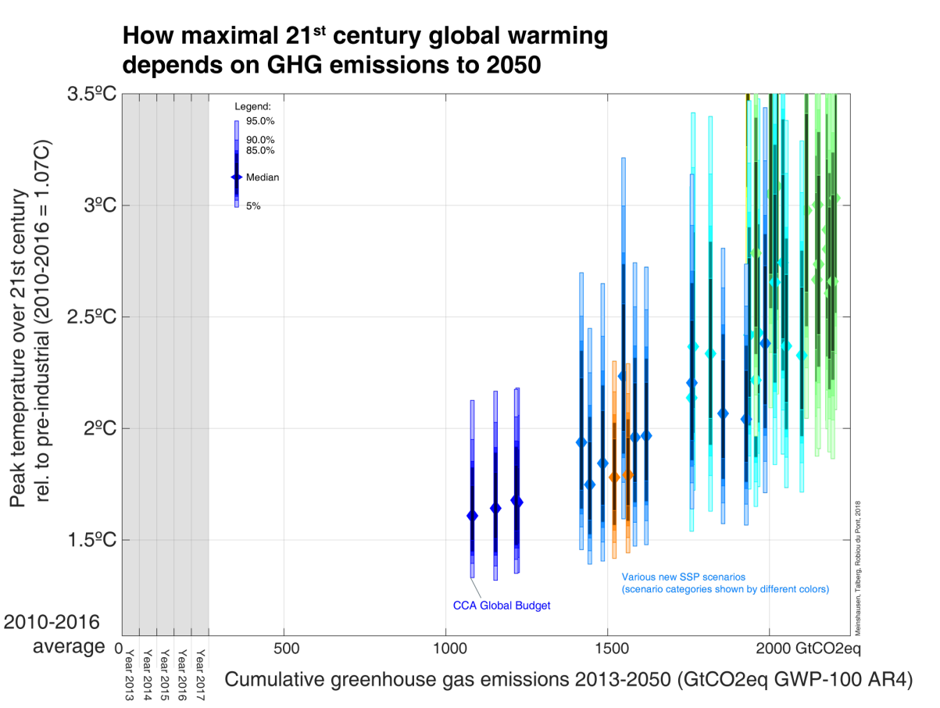

Figure A2 Probability of exceeding 2°C for the new set of SSP scenarios, using a probabilistic climate model setup that closely matches that of IPCC AR5 (with the addition of assuming permafrost feedbacks). The multi-gas pathway that is modelled here with the CCA budget numbers on the basis of the SSP 1.9 scenario has relatively low exceedance probabilities for 2°C, the next higher set of scenarios (with cumulative emissions around 1400 GtCO₂eq) already show exceedance probabilities of nearly 50% in relation to a 2°C warming threshold).

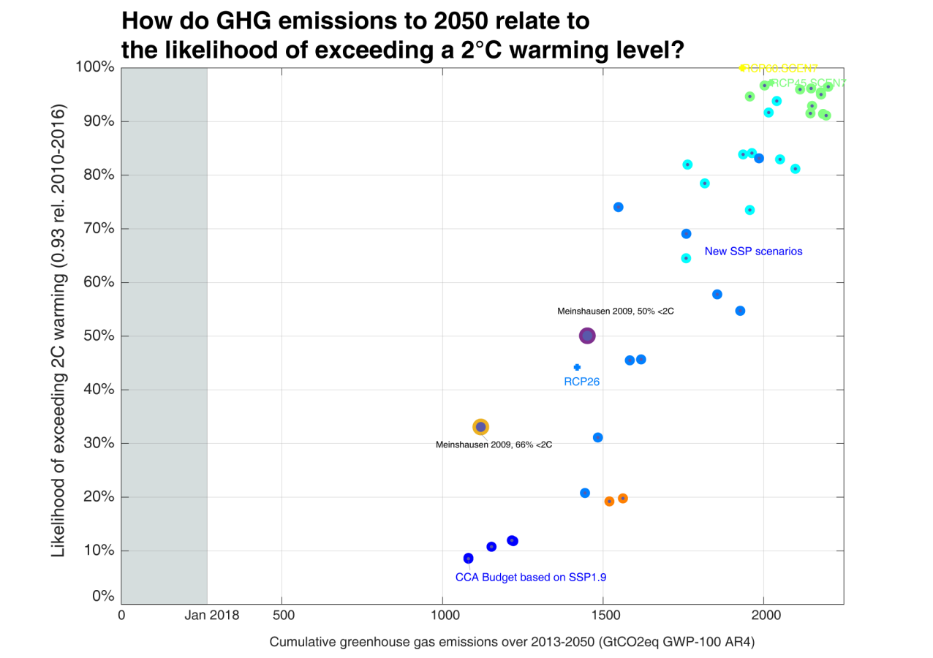

Figure A3 Probability of exceeding 1.5°C at any time (top panel) and 1.5°C by 2100 (lower panel) for the new set of SSP scenarios, using a probabilistic climate model setup that closely matches that of IPCC AR5 (with the addition of assuming permafrost feedbacks). Top panel: None of the considered new scenarios, nor the CCA budget modelled on the basis of SSP 1.9 characteristics, is realistically close to staying below 1.5°C warming across the 21st century. By the end of the century, by 2100, a 1.5°C warming level comes once again within reach, with an exceedance risk that drop to 33% if strong negative emissions are pursued.

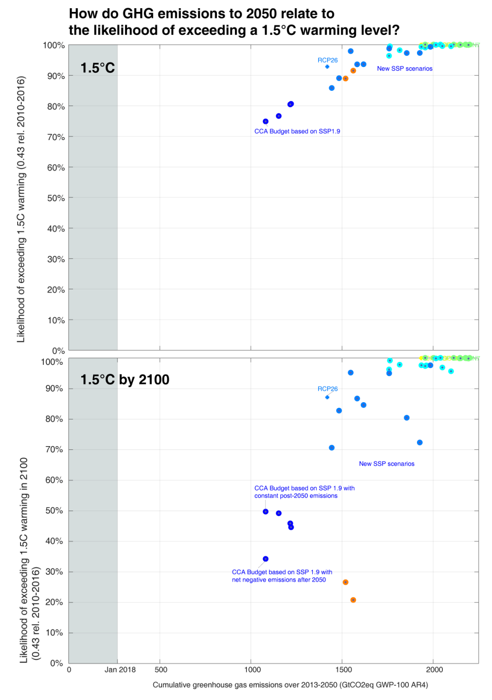

Additional information on the modelling data of effort-sharing approaches

This section provides some background on methodological steps taken to derive the state-level emissions budgets in Part II of this report.

Aside from the emissions budgets presented in Part I, three types of state-level data were used to derive state emissions budgets and targets: historical emissions, historical and projected population and historical and projected GSP.

In this report, state-level historical data is taken from the ‘State and Territory Greenhouse Gas Inventories
2016’. Historical and projected population data is from the Australian Bureau of Statistics. Historical Gross State Product (GSP) data is from the Australian Bureau of Statistics. GSP projections are derived using trends (growth rates) from a national GDP scenario (scenario based on RCP scenario downscaled to country level using GDP data from SSP scenarios. For methodology see Gütschow et al. (2016). As a result, GSP trends are similar across states and the capability approach does not capture the future trends of GSPs. Using state-specific GSP projections would provide results under the capability approach that reflect future trends in states’ relative financial capabilities.

Available at: https://www.environment.gov.au/climate-change/climate-science-data/greenhouse-gasmeasurement/publications/state-and-territory-greenhouse-gas-inventories-2016
Available at: http://www.abs.gov.au/ausstats/abs@.nsf/mf/3222.0
Available at: http://www.abs.gov.au/Ausstats/abs@.nsf/mf/5220.0

