Victorian Greenhouse Gas Emissions Report
  - 2019

Acknowledgment
We acknowledge and respect Victorian Traditional Owners as the original custodians of Victoria’s land and waters, their unique ability to care for Country and deep spiritual connection to it. We honour Elders past and present whose knowledge and wisdom has ensured the continuation of culture and traditional practices.
We are committed to genuinely partner, and meaningfully engage, with Victoria’s Traditional Owners and Aboriginal communities to support the protection of Country, the maintenance of spiritual and cultural practices and their broader aspirations in the 21st century and beyond.
© The State of Victoria Department of Environment, Land, Water and Planning 2019
This work is licensed under a Creative Commons Attribution 4.0 International licence. You are free to re-use the work under that licence, on the condition that you credit the State of Victoria as author. The licence does not apply to any images, photographs or branding, including the Victorian Coat of Arms, the Victorian Government logo and the Department of Environment, Land, Water and Planning (DELWP) logo. To view a copy of this licence, visit http://creativecommons.org/licenses/by/4.0/
ISBN 978-1-76077-867-5 (Print)
ISBN 978-1-76077-868-2

Disclaimer
This publication may be of assistance to you but the State of Victoria and its employees do not guarantee that the publication is without flaw of any kind or is wholly appropriate for your particular purposes and therefore disclaims all liability for any error, loss or other consequence which may arise from you relying on any information in this publication.

Accessibility
If you would like to receive this publication in an alternative format, please telephone the DELWP Customer Service Centre on 136186, email customer.service@delwp.vic.gov.au , or via the National Relay Service on 133 677 www.relayservice.com.au. This document is also available on the internet at www.delwp.vic.gov.au.

Contents

Minister’s Foreword 3
Summary 4
Introduction 5
Victorian emissions and indicators – 1990 to 2017 6
Emissions 1990 to 2017 6
Change in emissions since 2005 7
Victoria’s contribution to national emissions 8
Per capita emissions 10
Emissions and Gross State Product 11
Emissions by sector (IPCC categories) 13
Energy 15
Electricity generation 16
Direct combustion 17
Transport 20
Fugitive emissions from fuels 25
Industrial processes and product use (IPPU) 26
Waste 28
Agriculture 31
Land Use, Land-Use Change and Forestry (LULUCF) 35
Emissions by economic sector – 2017 40
Direct emissions by ANZSIC sector 41
Allocation of emissions from electricity generation to end-users 41
Direct plus indirect emissions by ANZSIC sector 42
Appendix A 43
Revision of historical greenhouse gas emissions data 43
Appendix B 45
LULUCF definitions, sources and removals 45
Appendix C 47
Changes in LULUCF emissions estimates between the 2018 and 2019 Victorian Greenhouse Gas Emissions Reports 47
Abbreviations and acronyms 52
Reference List 53

Minister’s Foreword
The Victorian Government recognises the overwhelming scientific consensus that human activity is causing climate change and that global greenhouse gas emissions need to decline to net zero by the second half of this century if the goals of the Paris Agreement – to limit global average temperature increases to well below 2oC above pre-industrial levels and to pursue efforts to limit the increase to 1.5oC – are to be met.
The Paris Agreement also establishes the basis for harmonised measurement, reporting and verification of emissions to enable a common system of transparency. Although this system only applies to national signatories to the Agreement, Victoria – along with a number of sub-national jurisdictions – is demonstrating leadership by measuring and reporting emissions at the state level.
We established the Climate Change Act 2017 to provide a statutory foundation for action in Victoria to reduce greenhouse gas emissions to net zero by 2050; and to ensure the state’s economy, community and natural environment are resilient to the impacts of climate change.
The Act requires the preparation of annual reports on Victoria’s greenhouse gas emissions.
The Victorian Greenhouse Gas Emissions Report 2019 has been prepared in accordance with this requirement and follows the first annual emissions report released in October 2018. By releasing annual emissions reports, the Victorian Government is providing transparency through the public disclosure of Victoria’s emissions.
This report provides information on Victoria’s greenhouse gas emissions, including trends in total net emissions since 1990, a comparison with other Australian jurisdictions, the contribution of different sectors to the state’s emissions, the trends in sectoral emissions and the factors driving those trends.
Annual emissions reports provide important data and analysis which informs the Victorian Government’s climate change policy, particularly the setting of interim emissions reduction targets for 2021-25 and 2026-30 and preparation of sector pledges for 2021-25 as required by Victoria’s Climate Change Act 2017.
I trust all Victorians will find this report informative in understanding the sources of, and trends in, Victoria’s greenhouse gas emissions.
The Hon. Lily D’Ambrosio MP
Minister for Energy, Environment and Climate Change
Minister for Solar Homes

Summary
This Victorian Greenhouse Gas Emissions Report 2019 is the second in a series of annual emission reports required by Victoria’s Climate Change Act 2017 (the Act). It contains:
- an overview of the state’s greenhouse gas emissions from 1990 to 2017 (the latest year for which official emissions data, published by the Commonwealth government, is available) with a focus on the change since 2005 (the reference year for interim emissions reduction targets under the Act)
- an explanation of sources of emissions and trends over time, including likely drivers for those trends.
Key points are:
- Victoria’s total net emissions in 2017 were 110.3 million tonnes (Mt) of carbon dioxide equivalent (CO2-e)
- These consisted of emissions from electricity generation (50.9% of net emissions), transport (20.6%), direct combustion (16.4%), agriculture (13.5%), industrial processes and product use (3.4%), fugitive emissions from fuels (3.0%) and waste (2.4%).
- Land use, land-use change and forestry (LULUCF) provided net sequestration of emissions amounting to 11.2 Mt CO2-e (-10.2% of net emissions).
Figure 1: Victorian emissions by sector and energy sub-sectors, 2017
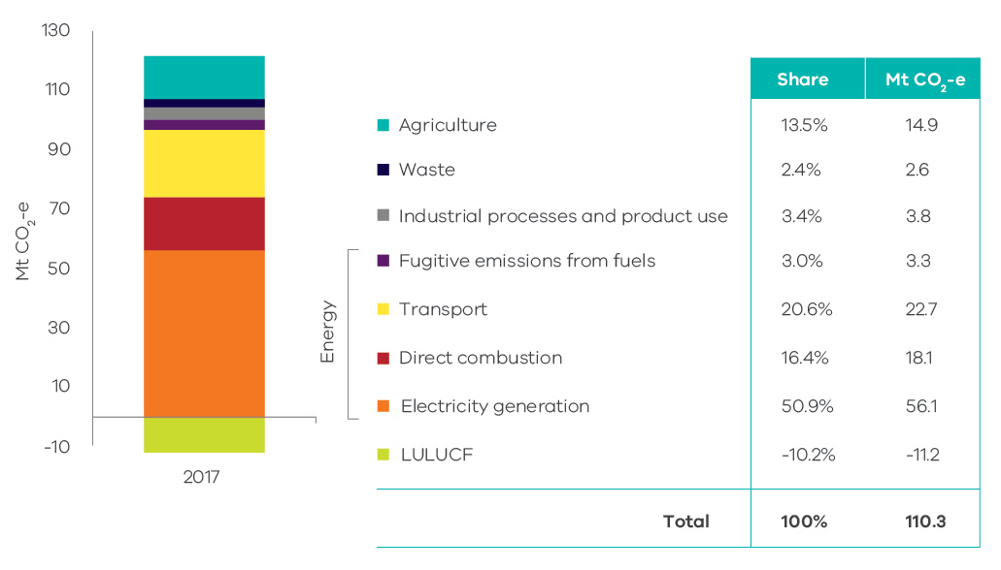
Source: Australian Greenhouse Emissions Information System (Department of the Environment and Energy 2019d)
- Victoria’s total net emissions fell by 12.6 Mt CO2-e (10.3%) between 2005 and 2017
- Key contributors to this reduction were the LULUCF sector, which increased sequestration by 6.0 Mt CO2-e (47% of the change in the state’s total net emissions) and electricity generation, which saw emissions fall by 7.4 Mt CO2-e (59% of the change in net emissions).
- Reductions in emissions also occurred in agriculture (1.4 Mt CO2-e), waste (1.3 Mt CO2-e) and direct combustion (0.4 Mt CO2-e).
- Sectors that experienced increases in emissions over this period were transport (2.3 Mt CO2-e), fugitive emissions from fuels (1.0 Mt CO2-e) and industrial processes and product use (0.6 Mt CO2-e).
- Between 2005 and 2017, the emissions intensity of the Victorian economy declined from 0.41 to 0.27 kilograms (kg) CO2-e per dollar of Gross State Product (34%). Per capita emissions decreased from 24.6 to 17.4 t CO2-e (29%).
Figure 2: Victorian total net emissions, 2005-2017
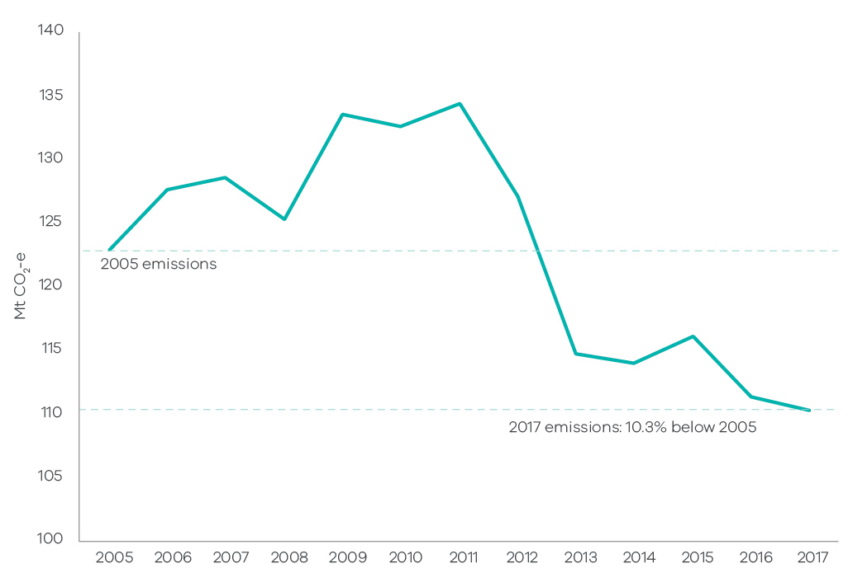

Source: State and Territory Greenhouse Gas Inventories 2017 (Commonwealth of Australia 2019h)

Introduction
Section 52 of the Climate Change Act 2017 (the Act) requires the Minister administering the Act to prepare annual greenhouse gas emissions reports for Victoria. The Act requires the annual reports to include an overview and collation of the best practicably available information about Victoria’s greenhouse gas emissions, and the extent to which greenhouse gas emissions have been reduced compared with 2005 levels (the reference year for emissions reduction targets under the Act).
This Victorian Greenhouse Gas Emissions Report presents information on Victoria’s emissions in two forms:
    - reporting of emissions in accordance with sectors defined by the Intergovernmental Panel on Climate Change (IPCC) reporting framework for national greenhouse gas inventories, with disaggregation of data in the energy sector
    - reporting of emissions by sectors of the economy categorised under the Australian and New Zealand Standard Industrial Classification (ANZSIC).
Data for the report was sourced from State and Territory Greenhouse Gas Inventories released in June 2019 by the Commonwealth Department of the Environment and Energy (DoEE), and the Australian Greenhouse Emissions Information System database. Both sources provide data at a state and territory level over the period 1990 to 2017. This is the most recent official data in Australia on annual greenhouse gas emissions. The data relates to production-based rather than consumption-based emissions in Victoria – that is, it accounts for emissions from goods and services produced in, and exported from, Victoria. This is in accordance with the United Nations Framework Convention on Climate Change’s (UNFCCC) emissions accounting provisions.
Economic and population statistics for Victoria were used to calculate emissions intensity measures and to obtain insights into trends in the state’s emissions.
This report is structured as follows:
Chapter 1 | presents the trend in Victoria’s emissions over the period 1990 to 2017, Victoria’s contribution to national emissions, and Victorian emissions per capita and per  unit of Gross State Product (GSP).
Chapter 2 | presents Victorian emissions by sector using IPCC sector categories. It describes historical trends in emissions in each sector and the key drivers of these trends.
Chapter 3 | presents Victorian emissions by economic sector based on the ANZSIC classification.

Victorian emissions and indicators – 1990 to 2017

Emissions 1990 to 2017
Figure 3 presents Victoria’s annual greenhouse gas emissions over the period 1990 to 2017. Total net greenhouse gas emissions increased by 2.3 million tonnes (Mt) of carbon dioxide equivalent (CO2-e) (2.1%) between 1990 and 2017. Emissions decreased by 1.0 Mt CO2-e (0.9%) between 2016 and 2017.
Figure 3: Total net emissions and emissions by sector – Victoria, 1990 to 2017
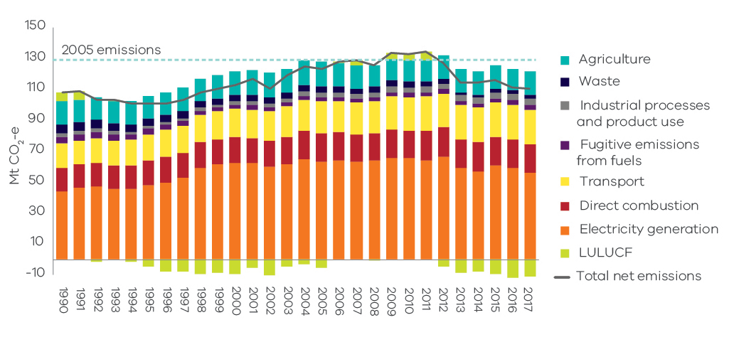
Source: Australian Greenhouse Emissions Information System (Department of the Environment and Energy 2019d)
Chapter 2 discusses the trends in sectoral emissions including the key factors driving these trends.

Change in emissions since 2005
The Act requires that Victoria’s greenhouse gas emissions reduction targets are set with 2005 as the reference year. Emissions fell by 12.6 Mt CO2-e (10.3%) from 122.9 Mt CO2-e in 2005 to 110.3 Mt CO2-e in 2017 (Figure 4).
Figure 4: Trend in net emissions – Victoria, 2005 to 2017
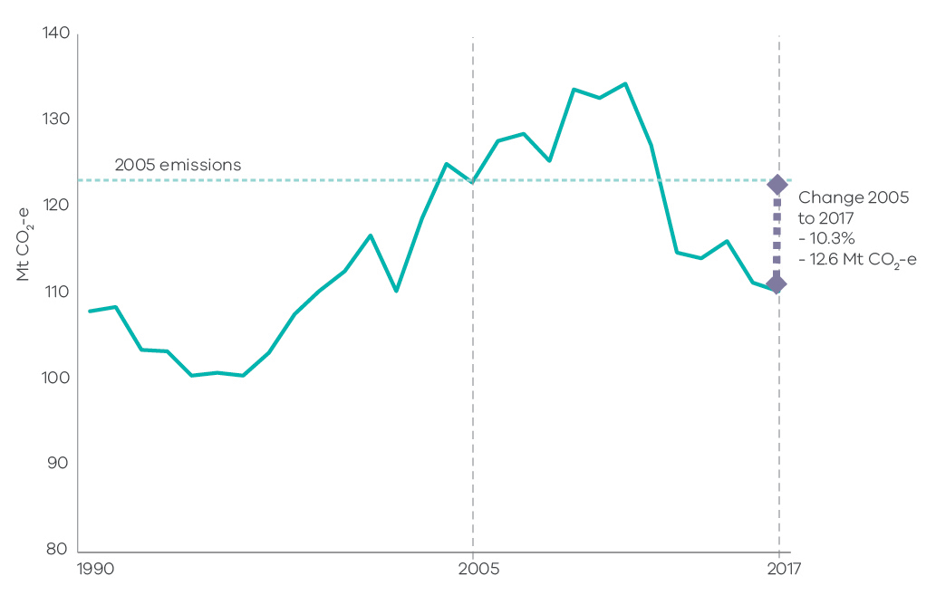Source: State and Territory Greenhouse Gas Inventories 2017 (Commonwealth of Australia 2019h)

Victoria’s contribution to national emissions
Figure 5 shows that in 2017, Victoria – with a 20.7% share – was the third largest contributor to Australia’s total net emissions (535 Mt), behind Queensland (30.3%) and New South Wales (24.7%).
Figure 5: Contribution to national emissions by State and Territory, 2017
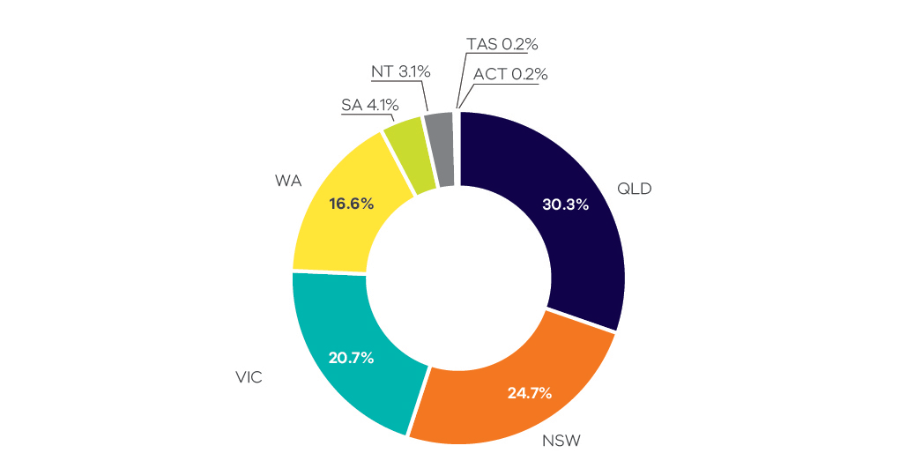
Source: State and Territory Greenhouse Gas Inventories 2017 (Commonwealth of Australia 2019h)
Figure 6 shows that Victoria’s share of Australia’s total net emissions increased from 18% in 1990 to a peak of 24% in 2011, before declining to 21% in 2017.
Figure 6: Contribution to national emissions – Victoria, 1990 to 2017
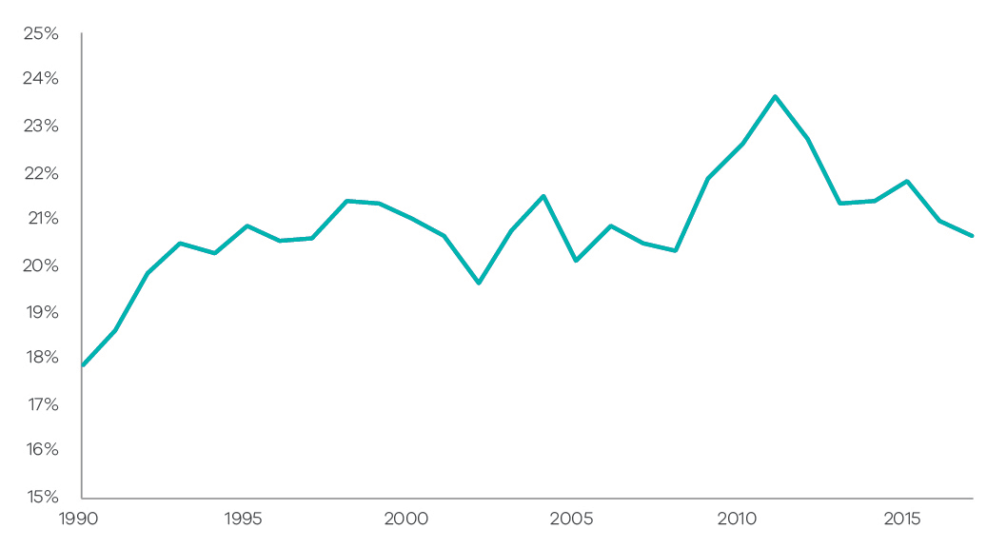
Source: Analysis based on State and Territory Greenhouse Gas Inventories 2017 (Commonwealth of Australia 2019h)

Per capita emissions
Victoria’s per capita emissions of 17.4 tonnes (t) CO2-e in 2017 were less than the national average (21.7 t CO2-e), lower than the Northern Territory, Western Australia and Queensland, but higher than Tasmania, the Australian Capital Territory, South Australia and New South Wales (Figure 7).
Figure 7: Per capita emissions in Australia and by State/Territory, 2017
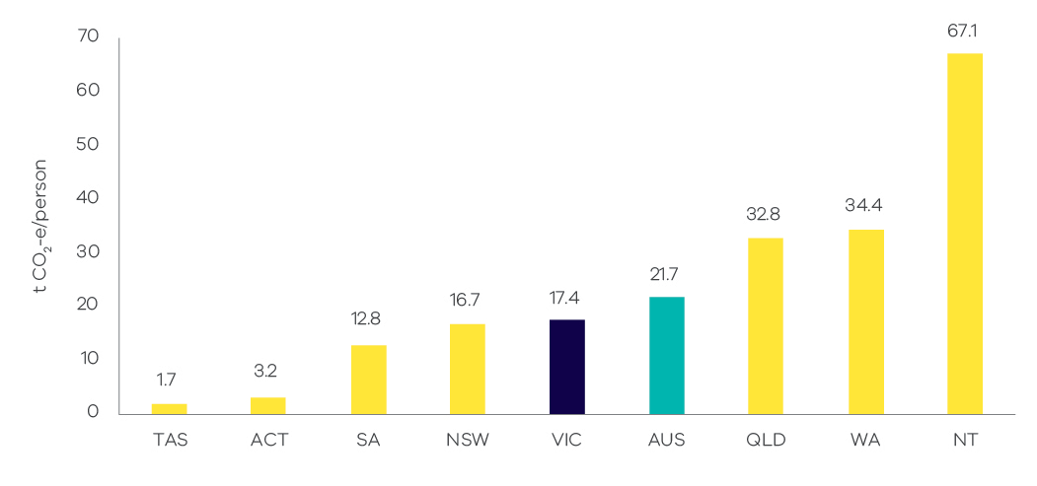
Source: Analysis based on State and Territory Greenhouse Gas Inventories 2017 (Commonwealth of Australia 2019h) and Australian Demographic Statistics 2018 (Australian Bureau of Statistics 2018a)
Victoria’s per capita emissions decreased from 24.7 to 17.4 t CO2-e between 1990 and 2017. In the period from 2005 to 2017, per capita emissions fell from 24.6 to 17.4 t CO2-e (29%) – see Figure 8.
Figure 8: Trend in per capita emissions – Victoria, 1990 to 2017
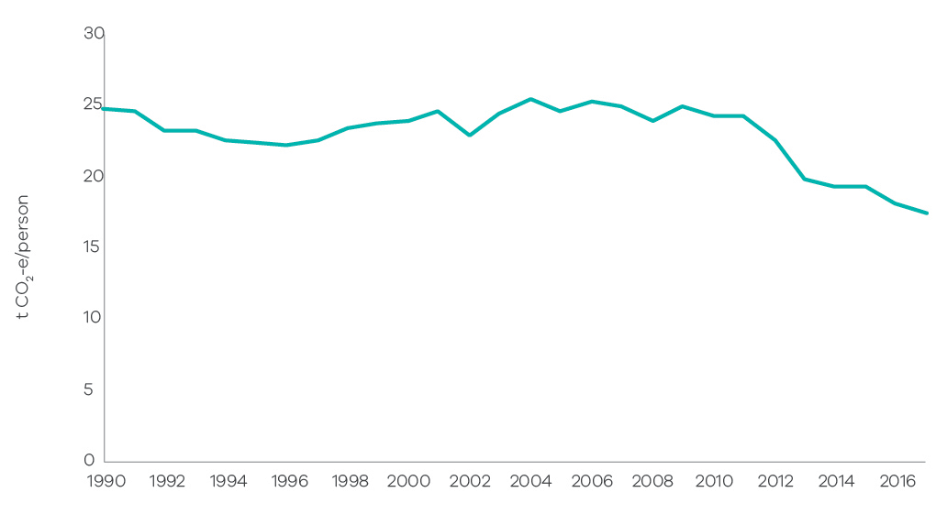
Source: Analysis based on State and Territory Greenhouse Gas Inventories 2017 (Commonwealth of Australia 2019h) and Australian Demographic Statistics 2018 (Australian Bureau of Statistics 2018a)

Emissions and Gross State Product
Figure 9 presents the trends in Victorian emissions and real Gross State Product (GSP) (in 2017 $A) over the period 1990 to 2017 indicating that Victoria is transitioning to a less carbon intensive economy. Over this period, real GSP grew by 113% while the emissions intensity of the Victorian economy declined from 0.56 to 0.27 kg CO2-e per $ GSP – a reduction of 52% (see Figure 10).
From 2005 to 2017, real GSP grew 35% while emissions fell by 10%. This resulted in a reduction in emissions intensity from 0.41 to 0.27 kg CO2-e per $ GSP (34%).
Figure 9: Greenhouse gas emissions and real GSP – Victoria, 1990 to 2017
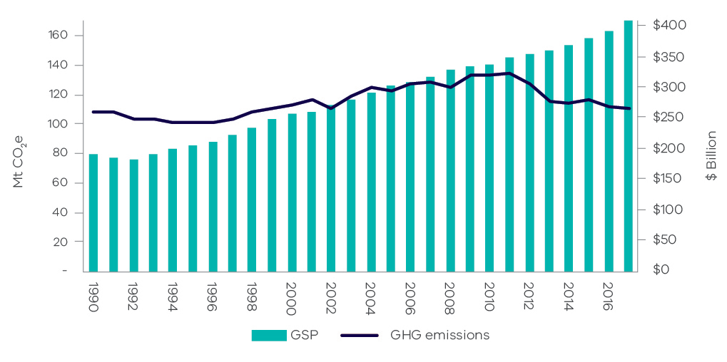
Source: Analysis based on State and Territory Greenhouse Gas Inventories 2017 (Commonwealth of Australia 2019h) and Australian National Accounts: State Accounts, 2017-18 (Australian Bureau of Statistics 2018b).
Figure 10: Percentage change in real GSP and emissions intensity – Victoria, 1990 to 2017
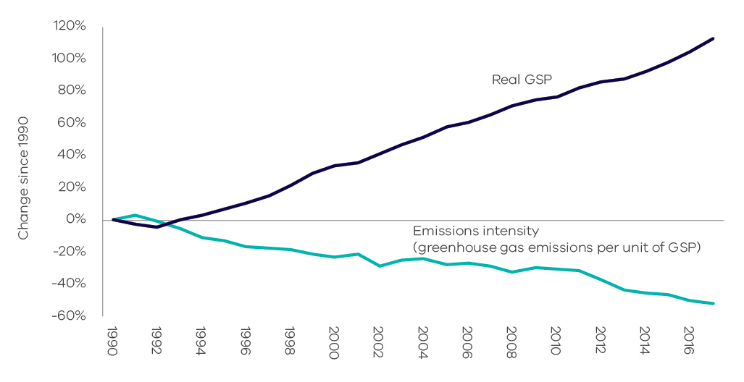
Source: Analysis based on State and Territory Greenhouse Gas Inventories 2017 (Commonwealth of Australia 2019h) and Australian National Accounts: State Accounts, 2017-18 (Australian Bureau of Statistics 2018b).

Emissions by sector (IPCC categories)
This chapter presents information on Victoria’s greenhouse gas emissions by sector, the activities that drive these emissions and the key factors that have influenced emissions trends in each sector. Sectors are based on the five categories identified in Intergovernmental Panel on Climate Change (IPCC) international guidelines, namely:
- Energy
- Industrial processes and product use
- Agriculture
- Land use, land-use change and forestry (LULUCF)
- Waste.
Due to the significance of the energy sector in Victoria, this sector is disaggregated into four sub-sectors: electricity generation; direct combustion from stationary sources; transport; and fugitive emissions from fuels.
The National Inventory Report 2017 (Commonwealth of Australia 2019g) is the primary source of information for the activities that drive sectoral emissions. Commonwealth Government statistics for Victoria, academic and Victorian Government publications and consultation with experts were used to augment the National Inventory Report 2017 to obtain insights into the factors that influenced sectoral emissions trends over the period 1990 to 2017.
Figure 11 presents the share of Victoria’s net emissions in 2017 by sector and energy sub-sectors.
Figure11: Victorian emissions by sector and energy sub-sectors, 2017
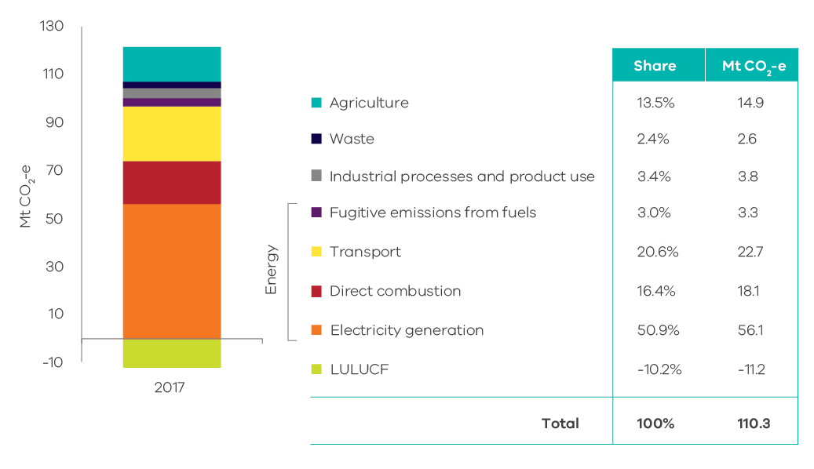
Source: Australian Greenhouse Emissions Information System (Department of the Environment and Energy 2019d)
Figure 12 presents emissions by sector in 1990, 2005 and 2017. Key points to note include:
- emissions from electricity generation and agriculture increased between 1990 and 2005, but declined between 2005 and 2017
- emissions from direct combustion, transport, and industrial processes and product use increased between 1990 and 2005 and continued to increase to 2017
- emissions from the LULUCF and waste sectors declined between 1990 and 2005 and continued to do so to 2017.
Figure 12: Emissions by sector – 1990, 2005 and 2017
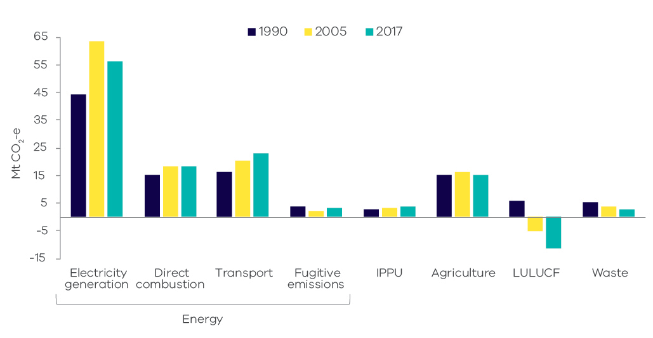
Source: Australian Greenhouse Emissions Information System (Department of the Environment and Energy 2019d)
Table 1 and Figure 13 provide further details on the scale of change in sectoral emissions between 2005 and 2017. The electricity generation sub-sector experienced the largest reduction in net emissions, followed by LULUCF, agriculture and waste.
Table 1: Change in emissions by sector / sub-sector between 2005 and 2017, Victoria
Sector | 2005  Mt CO2-e | 2017  Mt CO2-e | Change 2005 to 2017*  Mt CO2-e
Electricity generation | 63.5 | 56.1 | -7.4 | ↓
Direct combustion | 18.4 | 18.1 | -0.4 | ↓
Transport | 20.4 | 22.7 | 2.3 | ↑
Fugitive emissions | 2.4 | 3.3 | 1.0 | ↑
IPPU | 3.2 | 3.8 | 0.6 | ↑
Agriculture | 16.3 | 14.9 | -1.4 | ↓
LULUCF | - 5.3 | - 11.2 | -6.0 | ↓
Waste | 3.9 | 2.6 | -1.3 | ↓
Total (net emissions) | 122.9 | 110.3 | -12.6 | ↓
Source: Australian Greenhouse Emissions Information System (Department of the Environment and Energy 2019d)
* Note – numbers may not add due to rounding.
Figure 13: Change in emissions between 2005 and 2017 by sector / sub-sector, Victoria
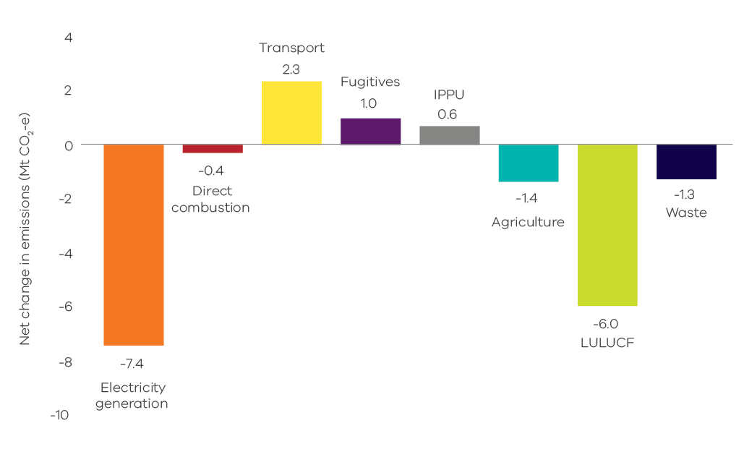
Source: Australian Greenhouse Emissions Information System (Department of the Environment and Energy 2019d)

Energy
The energy sector – which comprises electricity generation, direct combustion, transport and fugitive emissions from fuels – was responsible for 91% of total net emissions in Victoria in 2017. Figure 14 provides a breakdown of emissions by each energy sub-sector.
Figure 14: Energy sub-sectors and their contributions to total net emissions in Victoria, 2017
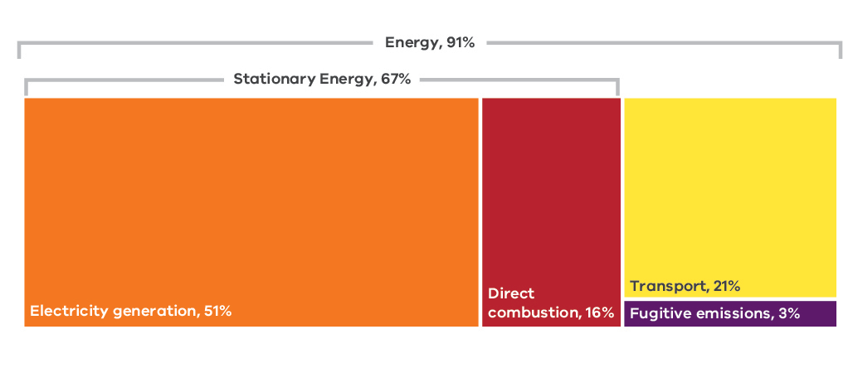
Source: Australian Greenhouse Emissions Information System (Department of the Environment and Energy 2019d)
A discussion of emissions trends for each energy sub-sector follows.

Electricity generation

Sources of emissions
Emissions from electricity generation arise from the combustion of fuels to generate power that is supplied to the electricity grid.
Consistent with a production-based approach, this sub-sector covers emissions released from the electricity that is generated in Victoria, some of which is exported for consumption in other states. Emissions from electricity imported from other states are not accounted for in this sub-sector.

Electricity generation in Victoria
In 2017, emissions from electricity generation accounted for more than half of Victoria’s total net emissions. In that year, around 75% (Commonwealth of Australia 2018) of the State’s electricity was generated by brown coal-fired power stations, down from 80% in 2016 (National Electricity Market-Review 2019). Four brown coal-fired power plants were operating in 2017, all located in the Latrobe Valley: Hazelwood, Yallourn, Loy Yang A and Loy Yang B. Table 2 presents production and emissions statistics for these plants in 2017 – this shows that 48.9% of Victoria’s total net emissions arose from brown coal-fired electricity generation (emissions also arose from gas-fired generation bringing the total contribution of electricity generation to 51% – see Figure 15).
Table 2: Electricity production and emissions from Victorian brown coal-fired power plants in 2017
Facility | Electricity production (MWh) | Total direct emissions  (Mt CO2-e) | Share of Victoria’s net greenhouse gas emissions
Loy Yang A Power Station | 15,885,288 | 18.7 | 17.0%
Yallourn Power Station | 11,473,837 | 14.8 | 13.4%
Hazelwood Power Station | 7,700,208 | 10.8 | 9.8%
Loy Yang B Power Station | 8,572,256 | 9.6 | 8.7%
Total | 43,631,588 | 54.0 | 48.9%
Source: Analysis based on Greenhouse and energy information for designated generation facilities 2016-17 (Clean Energy Regulator 2018)

Emissions trends and drivers
The trend in emissions from electricity generation in Victoria is presented in Figure 15.
Figure 15: Emissions from electricity generation – Victoria, 1990 to 2017
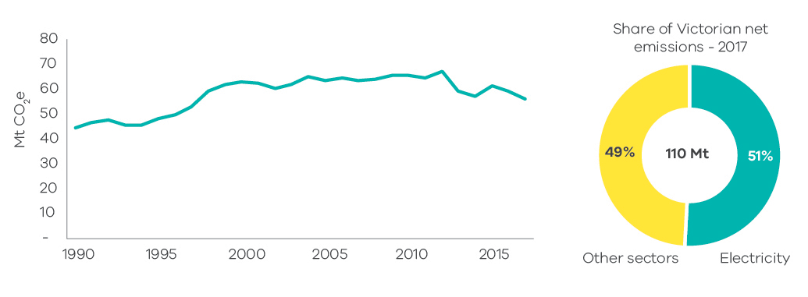
Source: Australian Greenhouse Emissions Information System (Department of the Environment and Energy 2019d)
Figure 15 shows that electricity generation emissions increased significantly between 1990 and 2004. Emissions were relatively steady from 2005 through to their peak in 2012 before falling in 2013 and 2014, increasing in 2015 and falling again in 2016 and 2017. Factors that contributed to the trends include:
- The general trend of increased emissions through the 1990s into the early part of the 2000s reflected the underlying growth in Victoria’s economy and population. It also reflected the privatisation of the Victorian electricity sector in the mid- to late-1990s and the introduction of the National Electricity Market (NEM), which boosted the competitiveness of Victorian generators and saw an increase in generation volumes, including for export to other states. Loy Yang B Power Station was also commissioned in the mid-1990s.
- The flattening of emissions growth from the mid-2000s was due to a range of factors, including a reduction in electricity demand after 2009, both in Victoria and across the NEM, as well as increased renewable electricity generation. The flattening and reduction in demand stemmed from:
  - improvements in energy efficiency (due to policies including appliance Minimum Energy Performance Standards, energy efficiency standards in building regulations and the Victorian Energy Upgrades program, formerly the Victorian Energy Efficiency Target (VEET) scheme)
  - a decline in Victorian manufacturing
  - consumer responses to higher electricity prices
  - energy efficiency and small-scale renewable energy policies and programs put in place from the early to mid-2000s that had a significant impact on residential energy consumption.
- Over the period 2012 to 2014, Victoria generated less electricity from brown coal with an increase in generation from gas-fired power stations resulting in lower greenhouse gas emissions in those years (NEM-Review 2019). The reasons for the fall included:
  - operation of the Australian Carbon Pricing Mechanism, which commenced in July 2012 and was repealed in July 2014
  - Yallourn power station generating less electricity from 2012 to 2014 due to factors including flooding of the neighbouring Yallourn coal mine (Morton 2012)
- Brown coal generation increased again in 2015 when Australia’s Carbon Pricing Mechanism was repealed and Yallourn became fully operational again, but dropped again in 2016 and 2017 due to the following factors:
  - closure of the Point Henry aluminium smelter in 2014, which resulted in closure of Alcoa’s brown coal-fired Anglesea Power Station in August 2015
  - Hazelwood power station ceasing operations in March 2017, removing 1600 MW of brown coal generation from the NEM (Australian Energy Regulator 2018).
Greenhouse gas emissions data from electricity generation in the year 2017 reflects the effect on electricity generation emissions for the three months to June 2017 after Hazelwood ceased operations. The full year effect of Hazelwood’s closure will be reflected in 2018 emissions data that will be reported in the Victorian Greenhouse Gas Emissions Report 2020.
The increasing use of renewable energy also influenced trends in electricity generation emissions. The Commonwealth Government’s Renewable Energy Target, introduced in 2001, drove investment in large-scale renewable energy projects in Victoria, primarily wind farms located in Western Victoria. Around 1,500 MW of wind projects were constructed in Victoria between 2001 and 2017 (Australian Energy Market Operator 2018a). Growth also occurred in the number of small (household) solar photovoltaic systems installed per year in Victoria. After relatively slow growth between 2001 and 2009, around 35,000 systems were installed during 2010, reaching a peak of 66,000 systems during 2012. From 2013 to 2017 the number of systems installed averaged 33,000 per year (Clean Energy Regulator 2019).

Direct combustion

Sources of emissions
Direct combustion emissions arise from burning fuels for a wide range of stationary energy activities, such as generating heat, steam or pressure for major industrial operations, and burning gas for household heating and cooking.
The activities giving rise to these emissions include the production of fuels (such as oil and gas extraction and refining); and manufacturing, construction, agriculture, residential, and commercial activities.
The direct combustion sector does not include emissions associated with electricity consumption or emissions from fuel combustion in transport activities – these emissions are accounted for in the electricity generation and transport sub-sectors respectively.

Direct combustion in Victoria
Figure 16 shows that residential activities are the largest source of emissions from direct combustion in Victoria, followed by manufacturing industries and construction, and fuel production.
Figure 16: Direct combustion emissions by sub-categories – Victoria, 2017
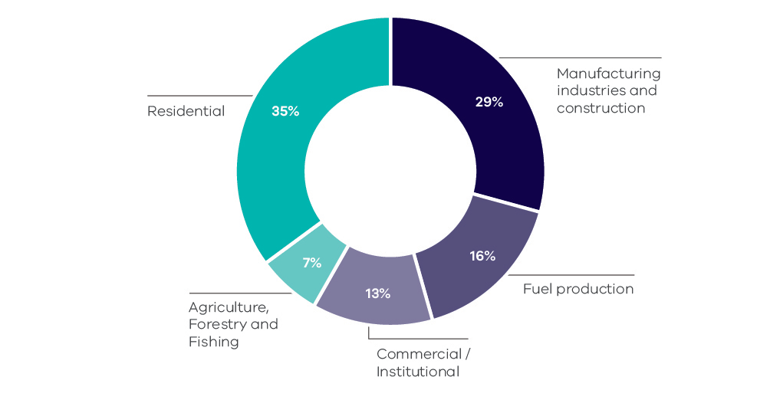
Source: Australian Greenhouse Emissions Information System (Department of the Environment and Energy 2019e)
Natural gas is the major fuel used for direct combustion in Victorian industrial, commercial and residential sub-categories, representing 60% of the total fuels used in 2017. In that year, Victoria consumed a total of 250 petajoules (PJ) of natural gas, with the highest consumption in residential activities (45%), followed by manufacturing (29%) and commercial (14%) activities.

Emissions trends and drivers
The trend in emissions from direct combustion in Victoria over the period 1990 to 2017 is presented in Figure 17. Direct combustion contributed 16% of Victoria’s total net emissions in 2017 – the third largest share of total emissions behind electricity generation and transport.
Figure 18 presents information on the trend in emissions from direct combustion by activity sub-categories.
Figure 17: Emissions from direct combustion – Victoria, 1990 to 2017
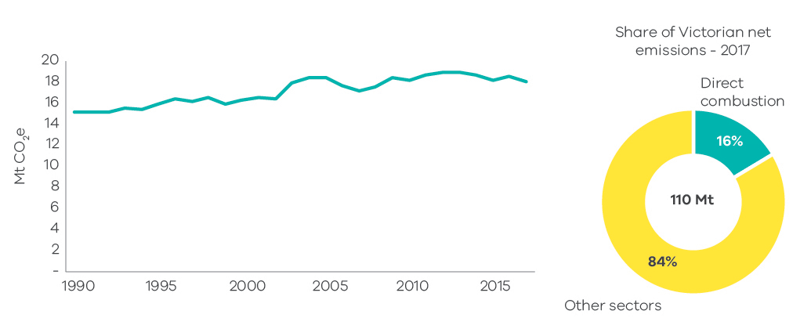
Source: Australian Greenhouse Emissions Information System (Department of the Environment and Energy 2019d)
Figure 18: Emissions from direct combustion sub-categories – Victoria, 1990 to 2017
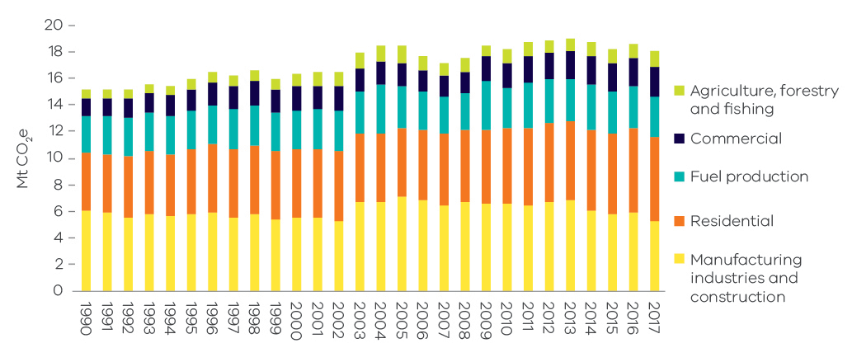
Source: Australian Greenhouse Emissions Information System (Department of the Environment and Energy 2019d)
Figure 19 presents the individual trends in the four sub-categories with the most significant contribution to direct combustion emissions.
Figure 19: Individual trends in emissions from the main direct combustion sub-categories – Victoria, 1990 to 2017
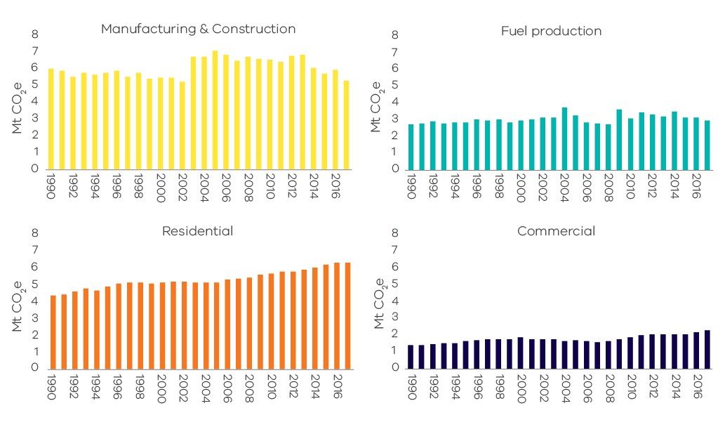
Source: Australian Greenhouse Emissions Information System (Department of the Environment and Energy 2019d)
Direct combustion emissions grew from 15.2 Mt CO2-e in 1990 to 18.1 Mt CO2-e in 2017, with interannual variability. Factors that contributed to the trends include:
- The overall growth between 1990 and 2017 was associated with growth in population and economic activity in Victoria. Interannual variability in emissions was associated with changes in the rate of economic growth and seasonal variations in demand.
- Annual consumption of natural gas was relatively stable from 2013, with declining industrial gas use offset by increasing residential consumption in winter (Australian Energy Market Operator 2018b). Manufacturing was the largest user of natural gas in Victoria from 1990 to 2005, but its consumption steadily decreased over that time. The residential sector steadily increased its consumption and, from 2006, was the major user of natural gas in Victoria. Between 1990 and 2017, the manufacturing sector decreased its consumption of natural gas by 25%, while the consumption for residential and commercial activities increased by 71% and 101% respectively.
- Direct combustion emissions from manufacturing fell between 1990 and 2002 before experiencing a notable increase in 2003 due to growth in the output of metal and mineral production and food processing. Emissions from manufacturing peaked in 2005 then declined gradually in line with the overall decline in manufacturing activity in the state.

Transport

Sources of emissions
Emissions from the transport sub-sector are produced by the consumption of fuels such as petrol, diesel and LPG in passenger and commercial motor vehicles, railways, domestic aviation and shipping.
Emissions from electricity used to power public transport (e.g. metropolitan trains and trams) and to drive electric vehicles are not included here but are accounted for in the electricity generation sub-sector.

Transport in Victoria
Figure 20 shows that the major contributor to emissions from transport in 2017 was cars (50.3%) followed by heavy-duty trucks (22.1%) and light commercial vehicles (16.6%). Road transportation was responsible for the vast majority (approximately 90%) of emissions from this sub-sector.
In 2017 the transport sub-sector consumed 378 petajoules (PJ) of energy with petrol representing the highest share (42%), followed by diesel (34%), aviation fuel (16%) and LPG (6%).
Figure 20: Transport emissions by mode and road transport sub-categories – Victoria, 2017
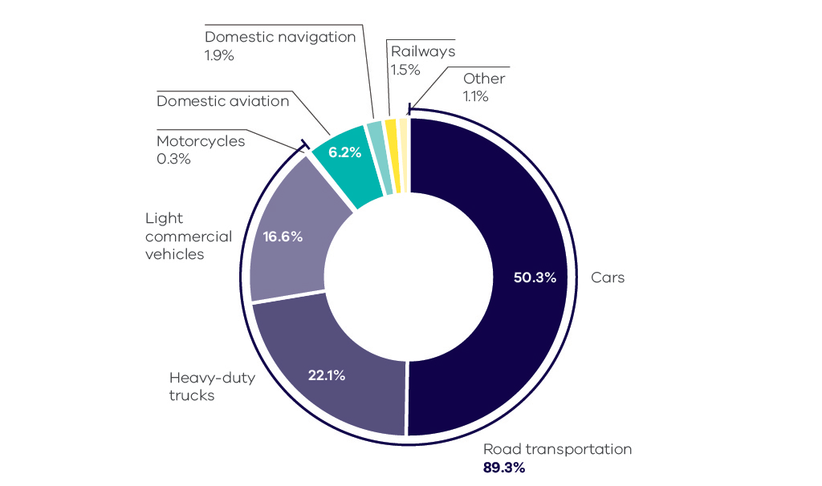
Source: Australian Greenhouse Emissions Information System (Department of the Environment and Energy 2019d)
Within Melbourne, the dominant mode of transport is cars, despite an increase in public transport usage since 1990 as presented in Figure 21.
Figure 21: Total passenger kilometres travelled – Melbourne, 1990 to 2017
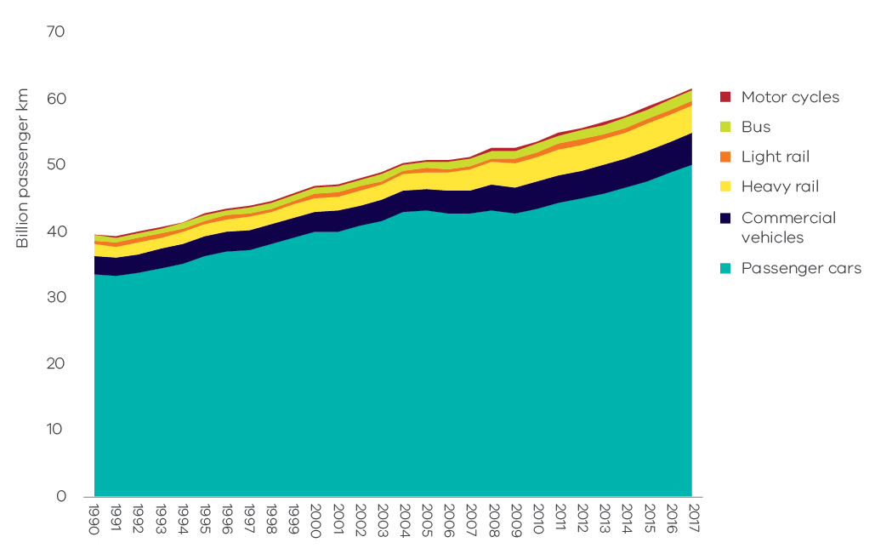
Source: Australian Infrastructure Statistics (Bureau of Infrastructure, Transport and Regional Economics 2018)

Emissions trends and drivers
The trend in transport emissions over the period 1990 to 2017 is presented in Figure 22. Transport contributed 21% of Victoria’s net emissions in 2017 – the second largest share behind electricity generation.
Figure 23 presents the trend in emissions from transport by activity sub-categories.
Figure 22: Transport emissions – Victoria, 1990 to 2017
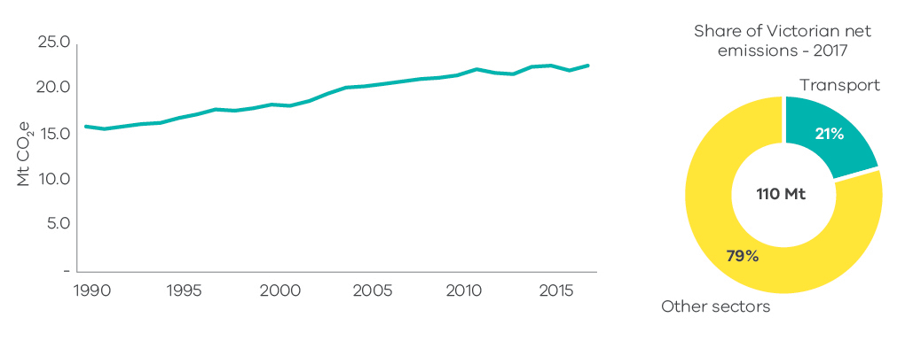
Source: State and Territory Greenhouse Gas Inventories 2017 (Commonwealth of Australia 2019h)
Figure 23: Emissions from transport sub-categories – Victoria, 1990 to 2017
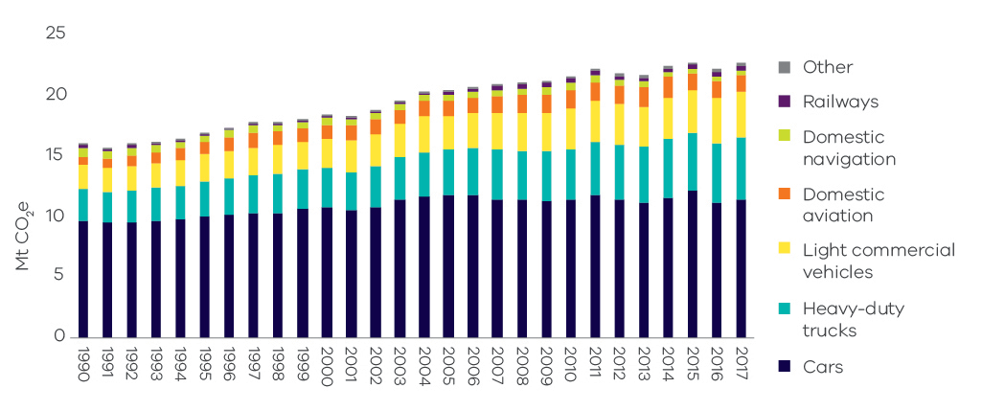
Source: Australian Greenhouse Emissions Information System (Department of the Environment and Energy 2019d)
Figure 24 presents individual trends in the four sub-categories with the most significant contribution to transport emissions.
Figure 24: Individual trends in emissions from the main transport sub-categories – Victoria, 1990 to 2017
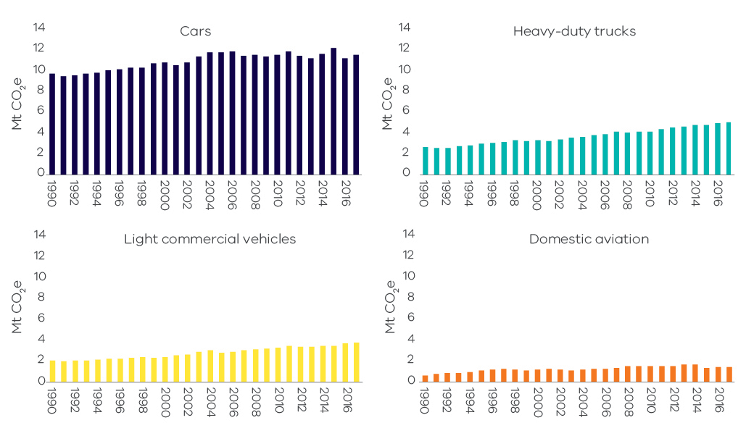
Source: Australian Greenhouse Emissions Information System (Department of the Environment and Energy 2019d)
Transport emissions grew by 6.7 Mt CO2-e (42%) between 1990 and 2017 – the largest growth in emissions from any sector/sub-sector over this period. Contributing factors are outlined below:
- Growth in emissions from cars (which increased by 18.4% between 1990 and 2017) was driven by growth in the number of passenger vehicles and total passenger vehicle kilometres travelled, which reflected strong population growth in the State (see Figure 25). For example, the number of registered passenger vehicles in Victoria increased by approximately 79,000 each year from 2012 to 2017.
- While freight contributes a smaller proportion of transport emissions than passenger travel, its emissions increased at a faster rate. Growth in emissions from heavy and light commercial vehicles (which increased by 92.1% and 84.7% respectively between 1990 and 2017) is largely correlated with GSP increases (see Figure 26).
Figure 25: Trends in passenger motor vehicle emissions and population – Victoria, 1990 to 2017
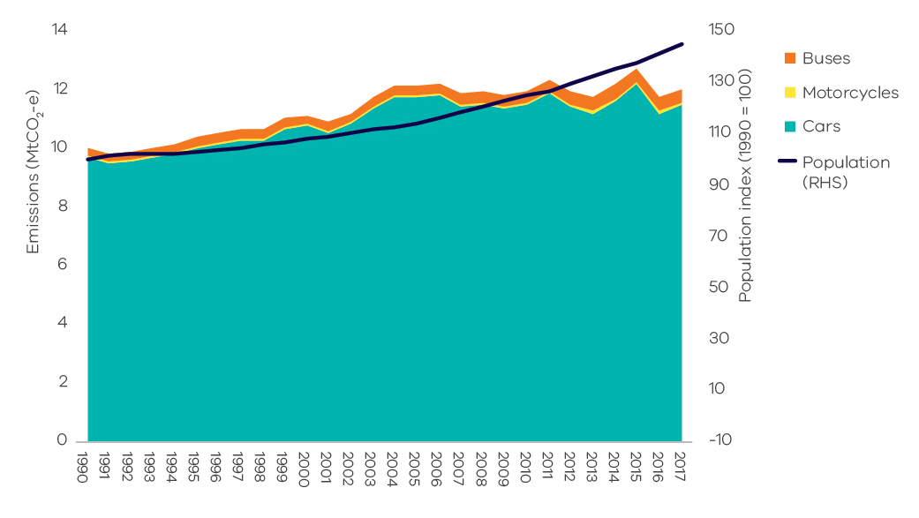
Source: Analysis based on Australian Greenhouse Emissions Information System (Department of the Environment and Energy 2019d) and Australian Demographic Statistics 2018 (Australian Bureau of Statistics 2018a).
Figure 26: Trends in freight vehicle emissions and GSP – Victoria, 1990 to 2017
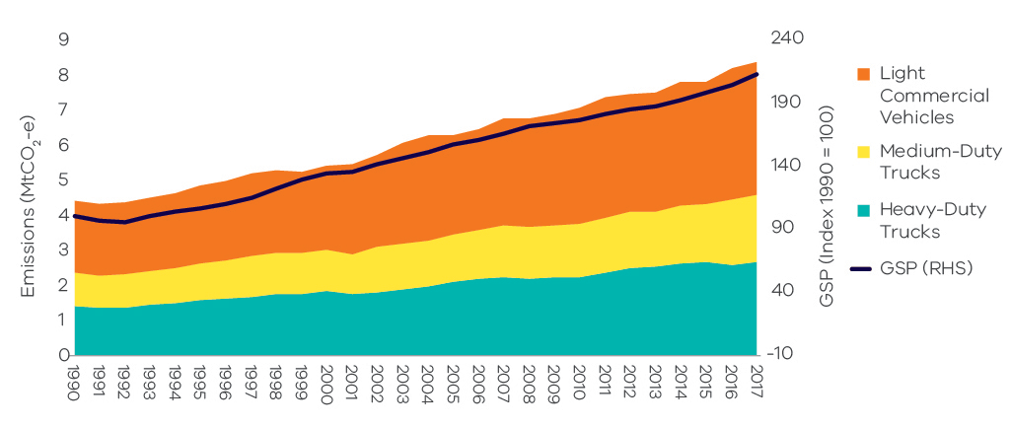
Source: Analysis based on Australian Greenhouse Emissions Information System (Department of the Environment and Energy 2019d) and Australian National Accounts: State Accounts, 2017-18 (Australian Bureau of Statistics 2018b).
The volume of petrol consumed in road transport activities was relatively stable between 1990 and 2017 despite the substantial growth in vehicle registration. This was due to improvements in the average fuel efficiency of the passenger vehicle fleet and an increase in the share of diesel vehicles which nearly tripled in number over this period. From 2012 to 2017, the number of petrol vehicles grew by 6% while diesel-fuelled vehicle numbers increased by 66%. Substantial growth in the number of diesel vehicles was also associated with growth in freight transport.

Fugitive emissions from fuels

Sources of emissions
Fugitive emissions result from leaks or from venting gases during the extraction, production, processing, storage, transmission and distribution of fossil fuels including coal, oil and natural gas. Emissions from decommissioned coal mines are also included.
Fugitive emissions do not include emissions from the combustion of fuels in activities such as electricity generation, the operation of mining plant and equipment or the transportation of fossil fuels by road, rail or sea. These are accounted for in the electricity generation, direct combustion and transport sub-sectors.

Fugitive emissions from fuels in Victoria
Almost 77% of fugitive emissions in Victoria arise from losses involved in the production, transmission, storage and distribution of natural gas. Natural gas is transmitted in Victoria through the Principal Transmission System (PTS), a 1,900km pipe network covering Melbourne and central Victoria. The system also utilises storage facilities to help meet demand peaks.
Victoria’s petroleum industry, which involves the exploration and production of oil, contributes around 23% of total fugitive emissions. These emissions arise throughout the production chain, including exploration and development drilling when gas or liquid hydrocarbons are encountered. The industry’s activities are concentrated in the offshore regions of the Otway and Gippsland basins.
Crude oil and gas are transported via pipeline from offshore facilities to stabilisation and gas processing plants where they are separated into wet gas, LPG and stabilised crude oil for distribution within the state, interstate or internationally. Stabilised crude oil is processed at refineries in Altona and Geelong into a range of refined petroleum products such as petrol, diesel, jet fuel, bitumen and solvents.
A small contribution to Victoria’s total fugitive emissions (less than 1%) arises from the extraction of solid fuels, particularly from brown coal mines. This contrasts with New South Wales and Queensland where total fugitive emissions are around double those in Victoria, and where 93% and 73% of their total fugitive emissions respectively in 2017 were from the extraction of solid fuels (black coal).

Emissions trends and drivers
The trend in fugitive emissions from fuels over the period 1990 to 2017 is presented in Figure 27. In 2017 the sub-sector contributed 3% of Victoria’s total net emissions.
Figure 27: Fugitive emissions – Victoria, 1990 to 2017
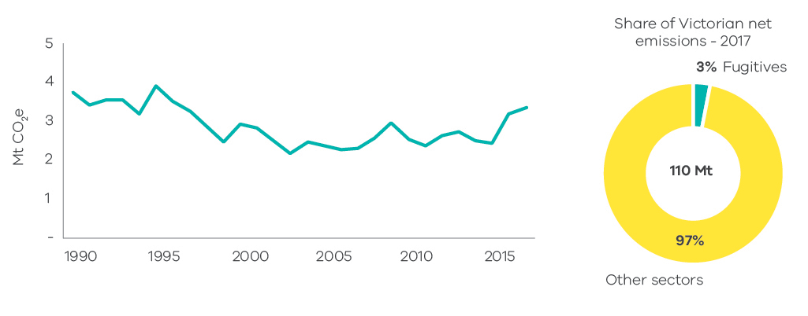
Source: State and Territory Greenhouse Gas Inventories 2017 (Commonwealth of Australia 2019h)
Fugitive emissions rose from 3.8 Mt CO2-e in 1990 to a peak of 3.9 Mt in 1995. Emissions then declined through to the latter half of the 1990s and first half of the 2000s – reaching a low of 2.2 Mt CO2-e in 2003 before increasing again – with interannual variability – to 3.3 Mt CO2-e in 2017. Factors that influenced these trends include:
- A reduction of 88% in crude oil production in Victoria from 1990 to 2017.
- A significant increase in natural gas production from 1990 to 2017 (134%) with a stable trend between 1990 to 2002, an overall increase from 2003 to 2014 and a peak from 2015 to 2017.
- Changes in the volume of natural gas consumption, which fluctuated between 223 and 287 PJ per year between 1990 and 2017 (with peaks in 1996, 2009 and 2014). The scale of fugitive emissions associated with natural gas consumption was, however, moderated by improvements in transmission, storage and distribution which reduced natural gas leakages.

Industrial processes and product use (IPPU)

Sources of emissions
The industrial processes sub-sector includes emissions generated from a range of production processes involving, for example, the use of carbonates (i.e. limestone, dolomite, magnesite, etc.); carbon when used as a chemical reductant (e.g. iron and steel or aluminium production); and chemical industry processes (e.g. ammonia and nitric acid production).
The product use sub-sector includes emissions associated with the use of synthetic gases such as:
- hydrofluorocarbons (HFCs) in refrigeration and air conditioning, foam blowing, fire extinguishers, aerosols/metered dose inhalers and solvents
- sulphur hexafluoride (SF6) in electrical equipment.
Emissions associated with the consumption of electricity or combustion of fuels required by industrial production processes are accounted for in the electricity generation and direct combustion sub-sectors.

IPPU emissions in Victoria
In Victoria in 2017, 83% of IPPU emissions arose from the use of synthetic greenhouse gases mainly for refrigeration and air conditioning purposes for commercial, residential and transport activities.
HFC compounds were introduced in Australia in 1994 and have been increasing in use since then. The activities that use HFCs and the emissions associated with these uses are shown in Figure 28.
Figure 28: Emissions from the use of HFCs by activity – Victoria, 1990 to 2017
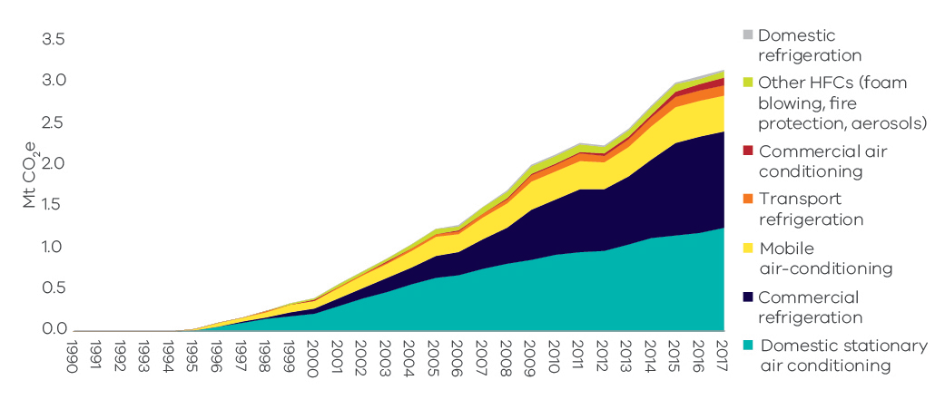
Source: Australian Greenhouse Emissions Information System (Department of the Environment and Energy 2019d)
The remaining 17% of IPPU emissions resulted from processes in activities such as metals and chemicals production.

Emissions trends and drivers
The trend in IPPU emissions over the period 1990 to 2017 is presented in Figure 29 – in 2017 the sub-sector contributed 3% of Victoria’s total net emissions.
Figure 29: Industrial process and product use emissions – Victoria, 1990 to 2017
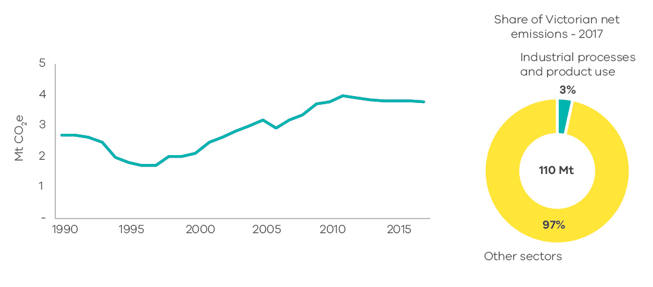
Source: State and Territory Greenhouse Gas Inventories 2017 (Commonwealth of Australia 2019h)
A major driver of emissions trends in this sector is an increased HFC use due to population growth. Between 1990 and 2017, Victoria’s population grew by 44% and IPPU emissions increased by 40%. The growth in product use-related emissions offset the reduction in emissions associated with a decline in industrial processing. Emissions from the chemicals industry dropped substantially after 1995 due to the closure of several chemical production facilities in Victoria. A reduction in economic growth in the early 1990s is likely to have contributed to the fall in IPPU emissions between 1990 and 1995.
Emissions from the minerals industry declined in 2014 and subsequent years due to the closure of facilities associated with the production of clinker and lime.

Waste

Sources of emissions
Emissions from the waste sector arise from the decomposition of organic waste in landfills, the biological treatment of solid waste such as composting, and from the direct release of greenhouse gases during the treatment of wastewater. Methane is produced from the anaerobic decomposition of organic matter from solid waste in landfills and from wastewater treatment plants. Nitrous oxide emissions are produced from the nitrification and denitrification of urea and ammonia in wastewater treatment plants.
Emissions produced from the combustion of methane captured from landfills and wastewater treatment plants, and biomass for electricity generation are reported in the electricity generation sub-sector. Emissions associated with the electricity and energy use required for the management and transportation of waste are accounted for in the electricity generation, direct combustion and transport sub-sectors. Carbon dioxide emissions from the decomposition of wood and paper products in landfill are reported in the LULUCF harvested wood products sub-category.

Waste sector in Victoria
The main sources of waste sector emissions are the disposal of solid waste to landfill (66.1% of total waste sector emissions) and the treatment of wastewater from domestic, commercial and industrial sources (30.5% of total waste sector emissions).
Most landfills in Victoria operate in accordance with best-practice in greenhouse gas management, such as the use of systems that capture and combust landfill gas. This significantly reduces greenhouse gas emissions from this sector.
Victoria’s water sector comprises 10 Catchment Management Authorities and 19 water corporations, of which 16 provide water supply and sewage services to urban Victoria. Water for Victoria, the State’s water plan, commits water corporations and Catchment Management Authorities to be net-zero emissions by 2050. Victoria’s 19 water corporations have collectively pledged to reduce their greenhouse gas emissions by 42% below an aggregated 2011-2016 baseline by 2025 to demonstrate a pathway to net-zero. Water corporations have developed emission reduction pathways with commitments to reduce both energy-related emissions and direct emissions associated with treatment processes, some of which are being implemented.

Emissions trends and drivers
The trend in waste sector emissions over the period 1990 to 2017 is presented in Figure 30. In 2017, waste was responsible for 2% of Victoria’s total net emissions.
Figure 31 presents the trend in emissions from waste sector sub-categories – solid waste disposal; wastewater treatment and discharge; biological treatment of solid waste; and incineration and open burning of waste.
Figure 30: Waste emissions – Victoria, 1990 to 2017
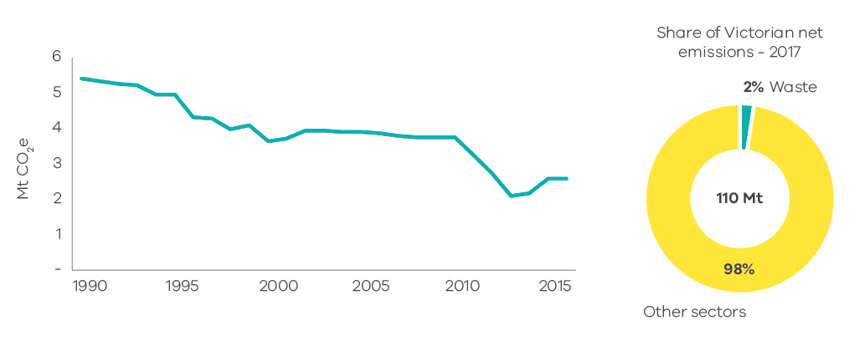
Source: State and Territory Greenhouse Gas Inventories 2017 (Commonwealth of Australia 2019h)
Figure 31: Waste emissions categories historical emissions, 1990 to 2017
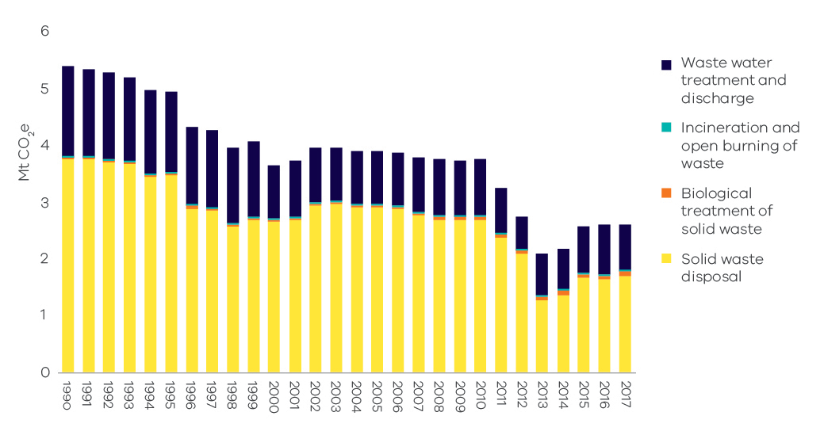
Source: State and Territory Greenhouse Gas Inventories 2017 (Commonwealth of Australia 2019h)
Figure 32 presents the individual emissions trends in waste sub-categories.
Figure 32: Individual trends of emissions from the main waste sub-categories – Victoria, 1990 to 2017
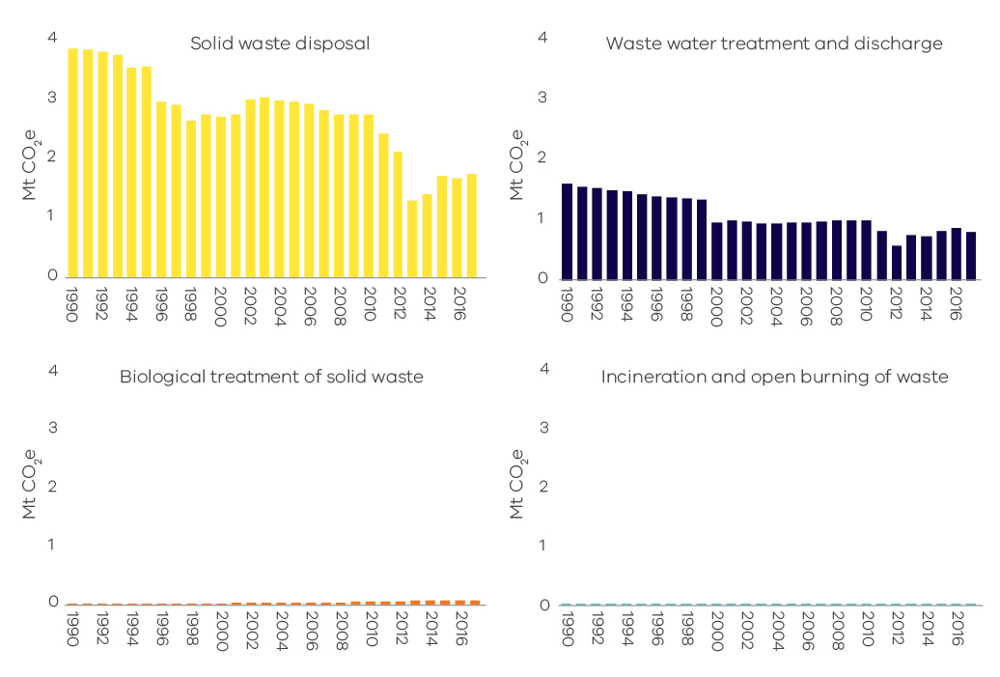
Source: State and Territory Greenhouse Gas Inventories 2017 (Commonwealth of Australia 2019h)
While the production of waste is strongly correlated with population growth and Victoria’s population grew strongly between 1990 and 2017, emissions from solid waste fell by around 52% over this period. The reduction was due to increased landfill gas capture and conversion to energy; improved landfill management practices reducing methane leakage; greater levels of materials recycling; and increased diversion of organics from the waste stream to composting or energy generation.
Emissions from wastewater decreased by 51% from 1990 to 2017, with steep decreases in 2000, 2011 and 2012. These decreases corresponded with the implementation of more efficient wastewater treatment processes and increased capture of methane from wastewater treatment plants.

Agriculture

Sources of emissions
Agriculture sector emissions arise predominantly from livestock digestion (enteric fermentation), manure management, the release of nitrous oxide from cropping and pasture land, and the burning of agricultural residues.
Enteric fermentation of plant material that is digested by animals results in emissions. Manure management produces emissions through the anaerobic decomposition of the organic matter contained in manure, especially when a considerable number of animals are confined (e.g. piggeries).
Emissions associated with the use of electricity, fuel consumption from operating equipment and fuel consumption in transport are accounted for in the energy sector.

Agriculture emissions in Victoria
Agricultural land in Victoria occupies around 56% of the state’s surface (Commonwealth of Australia 2019). The most prevalent land use by area is grazing of modified pasture which occupies 32% of the state as shown in Figure 33.
Livestock enteric fermentation was the main contributor (67%) to agriculture sector emissions in Victoria in 2017.
Another activity contributing significantly to agriculture emissions in Victoria (21%) is the release of nitrous oxide through the application of fertilisers (organic and inorganic) and crop residue to soils.
In 2017 there were 21,860 farms in Victoria (25% of all farm businesses in Australia). Of these, the most common farm types were beef cattle (25.8%), dairy cattle (18.0%), sheep (12.8%), and ‘other’ grain growing (10.6%). The most important commodities in Victoria based on the gross value of agricultural production were milk, followed by cattle and calves, and sheep and lambs (Commonwealth of Australia 2019).
Figure 33: Broad land use in Victoria
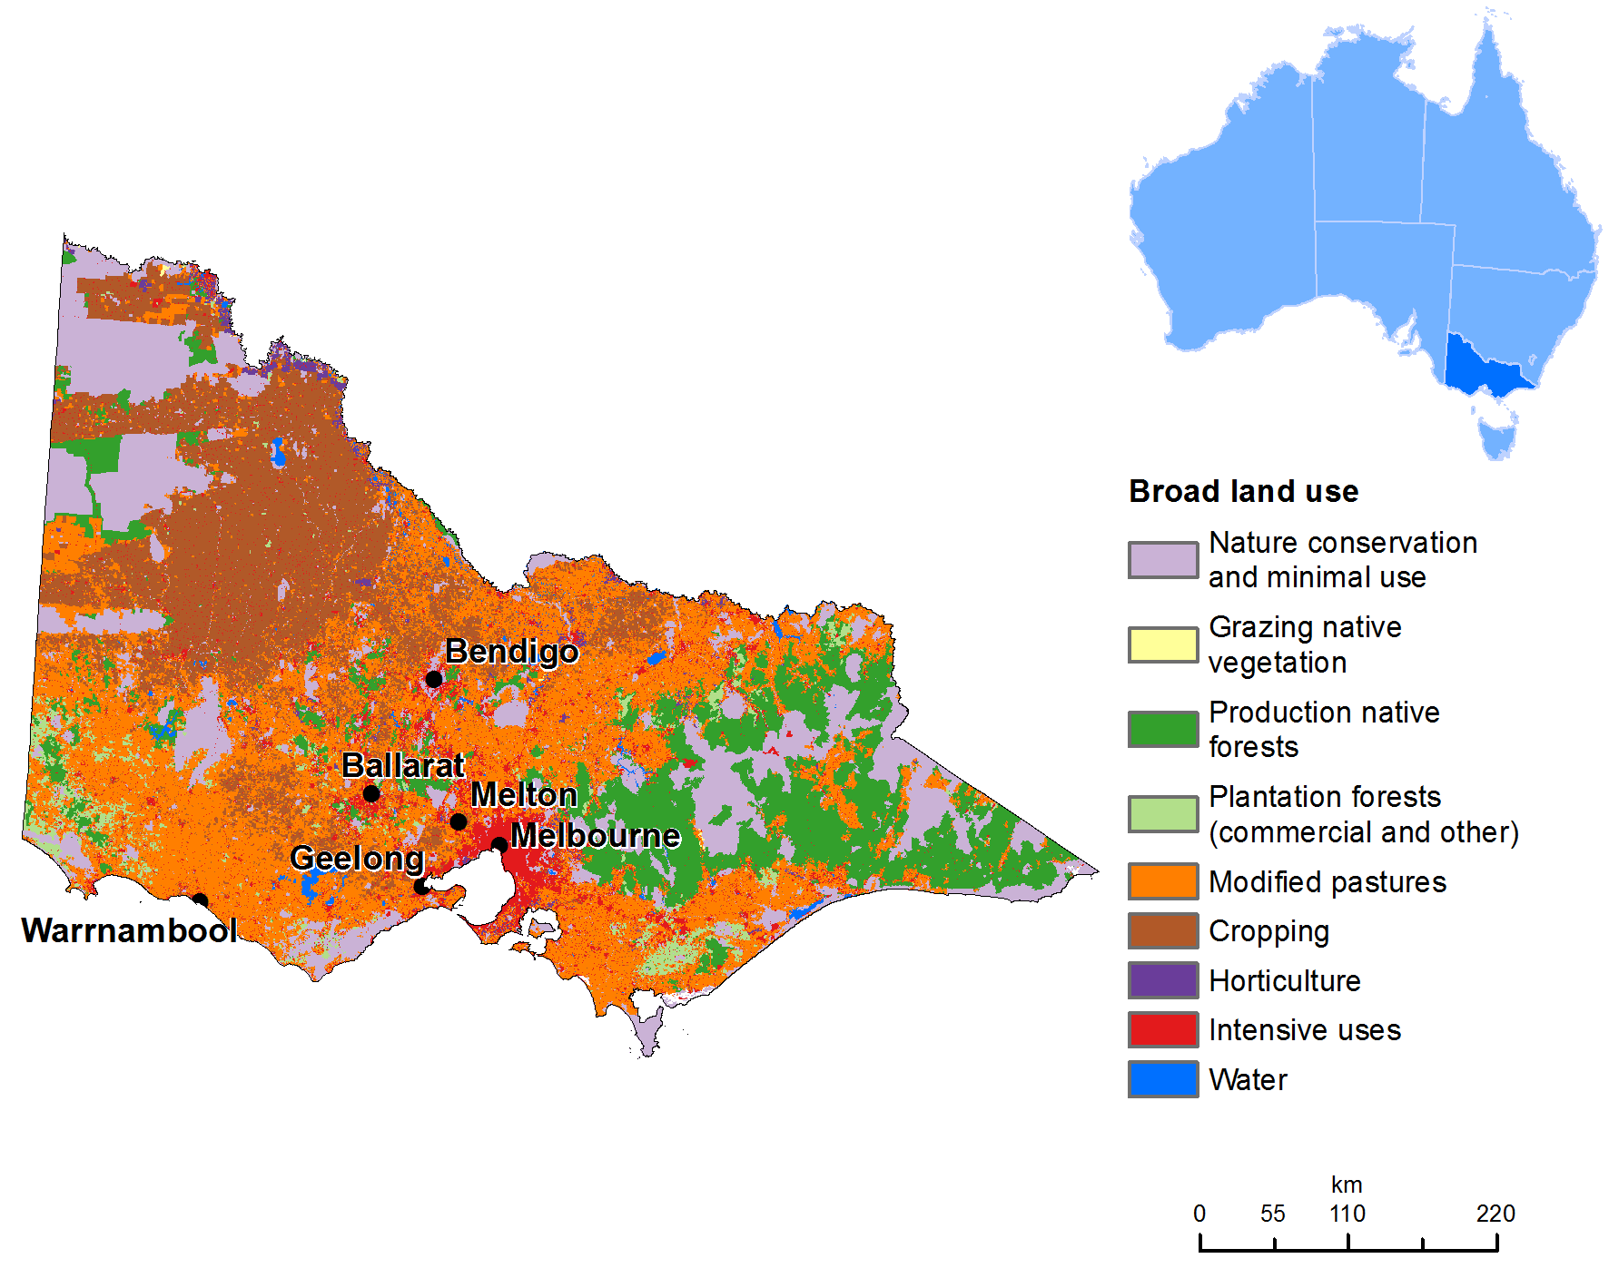
Source: Commonwealth of Australia 2019a

Emissions trends and drivers
The trend in agricultural emissions over the period 1990 to 2017 is presented in Figure 34. The sector contributed 14% of Victoria’s net emissions in 2017 – the fourth largest share of total emissions behind electricity generation, transport and direct combustion.
Figure 35 presents the trend in emissions from agriculture by activity sub-categories.
Figure 34: Agriculture emissions – Victoria, 1990 to 2017
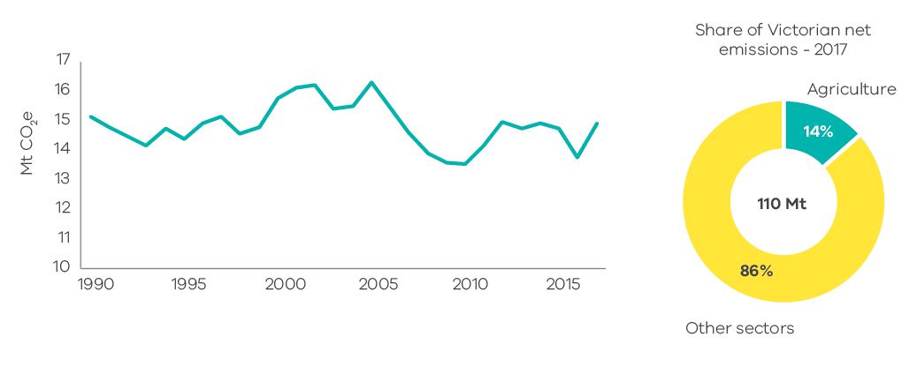
Source: State and Territory Greenhouse Gas Inventories 2017 (Commonwealth of Australia 2019h)
Figure 35: Emissions from agriculture sector sub-categories – Victoria, 1990 to 2017
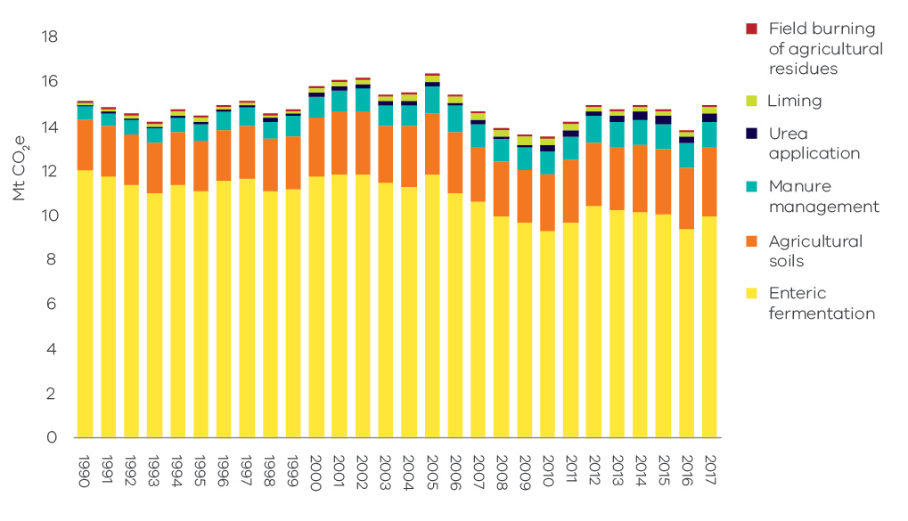
Source: State and Territory Greenhouse Gas Inventories 2017 (Commonwealth of Australia 2019h)
Figure 36 presents individual trends in the four sub-categories with the most significant contribution to emissions from agriculture.
Figure 36: Individual trends in emissions from the main agriculture sub-categories – Victoria, 1990 to 2017
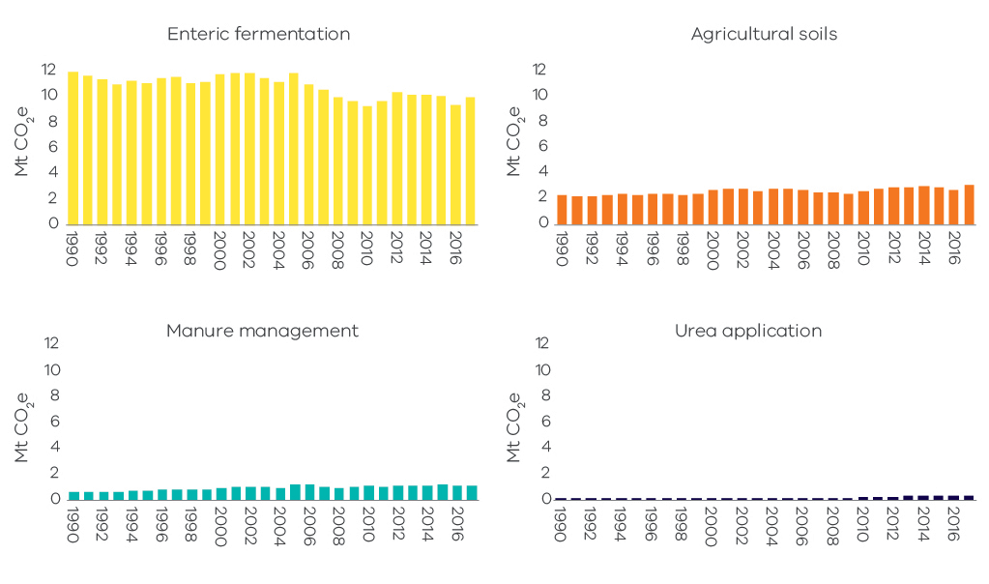
Source: State and Territory Greenhouse Gas Inventories 2017 (Commonwealth of Australia 2019h)
Emissions from the agriculture sector varied significantly over the period 1990 to 2017 driven mainly by seasonal conditions and by domestic food demand and exports. Factors that influenced the trend in emissions associated with livestock include:
- Sheep population fluctuated during both drought and non-drought conditions. However, the overall trend was one of a decline in numbers between 1990 and 2017 attributable to declining wool prices. Emissions from sheep grazing fell by 49% over this period which is reflected in an overall decline in enteric fermentation emissions.
- Cattle population also fluctuated, especially through the millennium drought that affected Victoria from 1997 to 2009. Cattle numbers initially remained steady, then declined rapidly towards the end of the drought. Numbers rebounded with the return to wetter conditions in 2010 and 2011. Emissions from beef cattle were slightly higher in 2017 compared with 1990 – however, interannual fluctuations occurred throughout the period reflecting variation in cattle numbers.
Despite the decline in sheep population since 1990, there were nearly four times as many sheep as cattle in Victoria in 2017 as shown in Figure 37. Nonetheless, cattle emissions were nearly three times higher than sheep emissions in 2017 due to the higher emissions intensity of cattle compared with sheep.
Figure 37: Sheep and cattle population and emissions – Victoria, 1990 to 2017
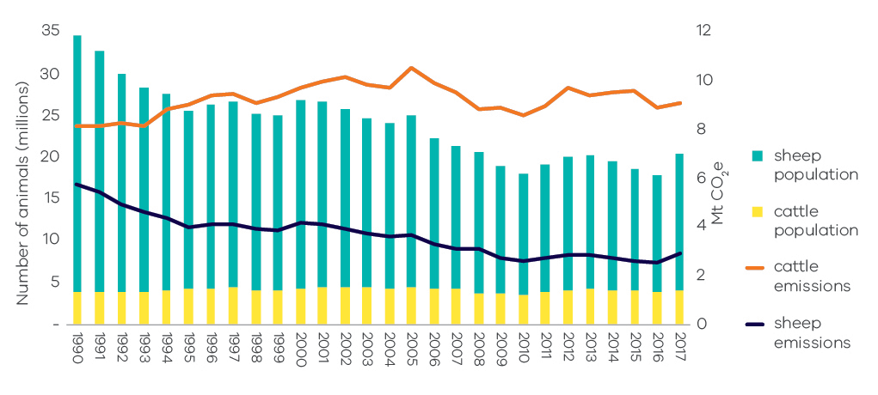
Source: Analysis based on Australian Greenhouse Emissions Information System (Department of the Environment and Energy 2019c) (Department of the Environment and Energy 2019d)
* Note – this chart includes all the mechanisms that cause emissions from livestock. These are: enteric fermentation, manure management, urine and faeces on grazing land, and atmospheric deposition of nitrous oxide.
Factors influencing the trend in emissions from the agricultural soils sub-sector include an increase in crop land particularly for wheat, barley and canola, and associated increases in the application of nitrogen fertilisers, crop residue and animal wastes. The total area of crop cultivation in Victoria grew from 1.8 to 3.2 million hectares between 1990 and 2017, while the application of fertilisers increased from 50,000 to 279,000 tonnes over this period (Commonwealth of Australia 2019b).

Land Use, Land-Use Change and Forestry (LULUCF)

Sources of emissions
The land use, land-use change and forestry (LULUCF) sector includes emissions and sequestration (removal) of greenhouse gases resulting from direct human-induced land use, land-use change and forestry activities. This includes emissions and sequestration associated with the clearance of forested land and conversion to other land uses, from new forests planted on previously unforested land and from other practices that change emissions and sequestration (forest management, cropland management and grazing land management).
Combustion of fossil fuels associated with forestry and land management activities – such as diesel used in logging machinery – are accounted for in the direct combustion sub-sector. Emissions from the burning of agricultural residues, and non-CO2 emissions associated with, for example application of fertilisers, are accounted for in the agriculture sector.

Emissions in Victoria
The main sources of Victoria’s LULUCF emissions and removals – and of variations in these emissions – are forest lands, specifically from land classified as:
    - Forest land remaining forest – comprising changes in the native forest estate and harvesting from that estate and pre-1990 plantations.
    - Land converted to forest land – comprising plantations established since 1990 and regeneration of previously cleared land.
    - Forest land converted to cropland, grasslands, wetlands and settlements – comprising primary and secondary clearing of forest land since 1972 to enable a change in land use and changes in soil carbon and other emissions resulting from land use change.
The definition of the land covered in each LULUCF sub-category and the principal sources of emissions and removals are set out in Appendix B.
The LULUCF emissions presented in this report for the years 1990 to 2016 are different to those presented in the Victorian Greenhouse Gas Emissions Report 2018 due to methodological improvements (see Appendix C).

Emissions trends and drivers
Victoria’s net LULUCF emissions between 1990 and 2017 are presented in Figure 38. Figure 39 presents net emissions by LULUCF sub-category.
Over the period 1990 to 2017, LULUCF provided a cumulative net sink of approximately -105 Mt CO2-e. LULUCF emissions fluctuated between 1990 and 2017. LULUCF was a net sink in 1992, from 1994 to 2005, in 2008, and from 2012 to 2017, and a net source of emissions between 1990 and 1991, in 1993, between 2006 and 2007, and from 2009 to 2011. Net LULUCF emissions averaged around -9 Mt CO2-e between 2012 and 2017. In 2017, in net terms, the LULUCF sector sequestered emissions equivalent to 10% of total Victorian emissions (11.2 Mt CO2-e).
Figure 38: LULUCF emissions – Victoria, 1990 to 2017
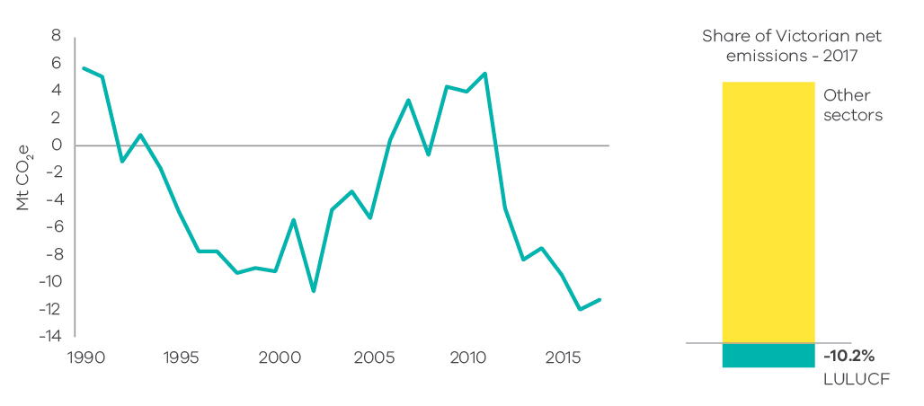
Source: State and Territory Greenhouse Gas Inventories 2017 (Commonwealth of Australia 2019h)
Figure 39: Emissions from LULUCF sub-categories – Victoria, 1990 to 2017
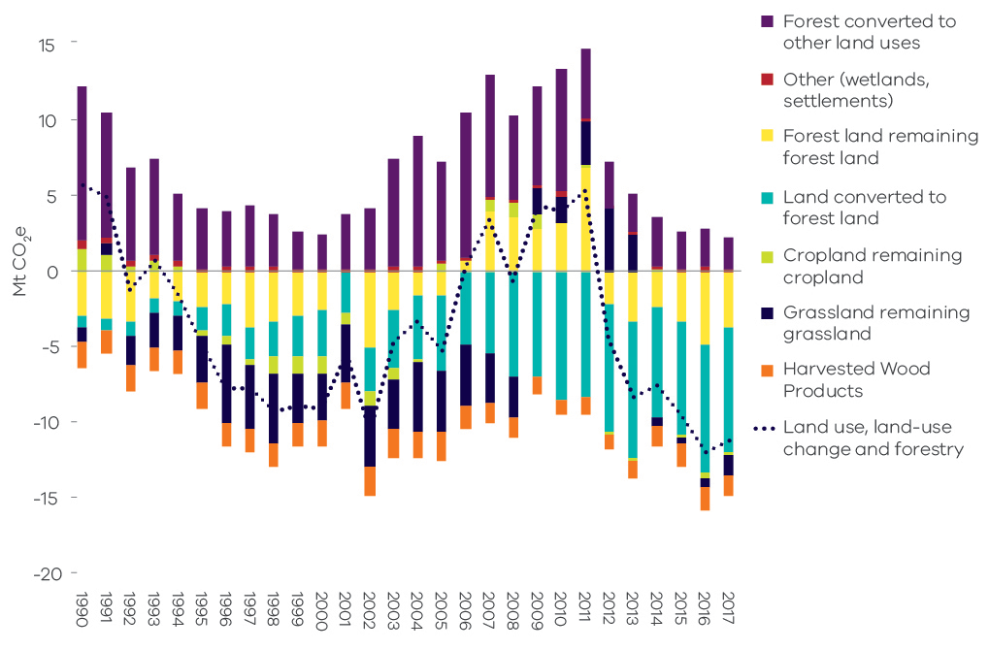
Source: State and Territory Greenhouse Gas Inventories 2017 (Commonwealth of Australia 2019h) and data for Victoria provided to DELWP by DoEE, August 2019
    - Forest land remaining forest land
This sub-category includes emissions/removals derived from modelled changes in carbon pools in:
- harvested native forests
- other native forests
- plantations established before 1990.
Forest land remaining forest land was a net sink of 3.7 MtCO2-e in 2017. As shown in Figure 39, net emissions from this sub-category varied between 1990 and 2017. It was a net sink between 1990 and 2005, a net source of emissions from 2006 to 2011 and a net sink from 2012 to 2017.
A key driver of emissions from forest land remaining forest land is wildfire and fire management practices. Combined emissions from prescribed burning and wildfires fell steeply between 2011 and 2017 – possibly attributable to forest recovery following major bushfires in the 2000s.
Figure 40 shows the total emissions from forest land remaining forest land. It distinguishes between total emissions from wildfire and prescribed burning and other sources of emissions (including changes in living biomass, dead organic matter [DOM] and soil carbon) in harvested native forest and other native and pre-1990 plantation forests.
Figure 40: Emissions from fire (wildfire and prescribed burnings) and other sources – Victoria, 1990 to 2017
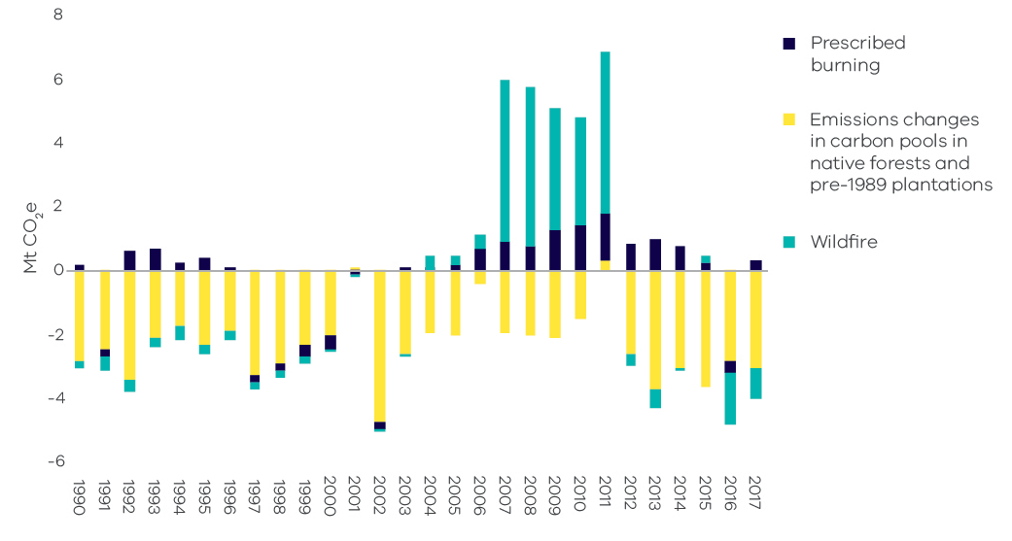
Source: State and Territory Greenhouse Gas Inventories data for Victoria provided to DELWP by DoEE, August 2019
* Note – non-anthropogenic natural disturbances, including some but not all wildfires, are modelled to average out over time, leaving anthropogenic emissions and removals as the main drivers. When a fire is excluded from the historical time series, both the direct emissions from the fire and the subsequent removal of carbon by the recovering forest (strongest in the first couple of years post-fire) are excluded from the time series. This may explain part of the peak in emissions in years that do not appear to correspond to significant bushfires in Victoria.
    - Land converted to forest land
This sub-category includes net emissions/removals from:
- For-harvest plantations established since 1990 which are mainly hardwood
- Environmental plantings established since 1990
- Regrowth of forest on land cleared for cropping or grazing
- Regeneration of areas cleared of forest since 1972 from natural seed stocks. This may be a combination of regeneration for environmental purposes on protected land or on land that is maintained by the landowner. Regeneration on land cleared prior to 1990 is also captured in this sub-category.
Land converted to forest land was a net sink of 8.2 Mt CO2-e in 2017. As shown in Figure 39, sequestration from this sub-category increased in scale from 1990 to a peak in 2013 before declining slightly – it nonetheless remained a substantial source of sequestration from 2008 to 2017.
The area of hardwood plantations expanded rapidly in response to the Commonwealth Government’s Managed Investment Act 1998 which increased the finance available for plantation establishment. The Managed Investment Act was repealed in 2016. Harvest volumes have been increasing as short-rotation hardwood plantations are harvested.
The declining sink provided by plantations from 2011 shown in Figure 41 is likely driven by the harvesting of hardwood plantations established in the 2000s. These are being harvested as they mature and the rate of plantation establishment in Victoria has been close to zero since 2013. Conversely, natural regeneration has been a source of declining emissions since 2011 and net sequestration since 2015.
The net sink provided by regrowth on cleared land increased between 2007 and 2017.
Figure 41: Net emissions from land converted to forest land – Victoria, 1990 to 2017
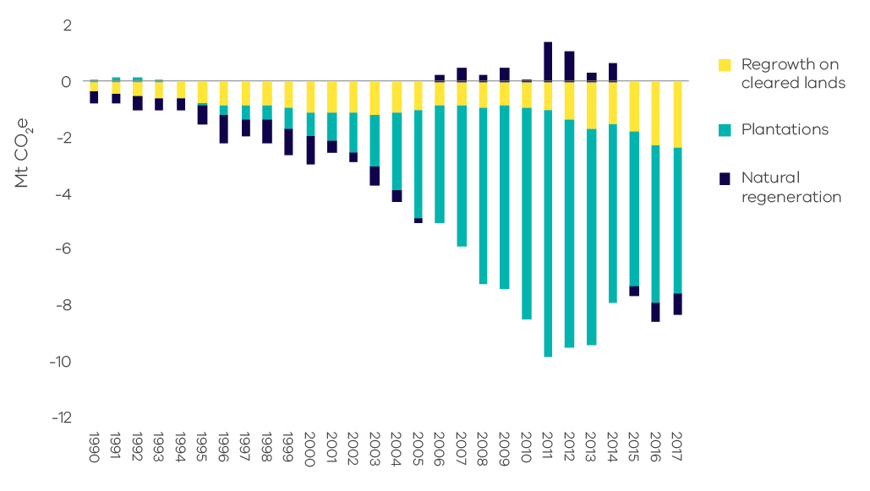
Source: State and Territory Greenhouse Gas Inventories data for Victoria provided to DELWP by DoEE, August 2019
    - Forest land converted to other land uses
This sub-category includes:
- Emissions from the primary conversion of land that was forested in 1972.
- Emissions from secondary or re-clearance of forest which has regrown on cleared land. Where forest has regrown on these converted lands, the sequestration is included in the sub-category land converted to forest.
- Indirect emissions from loss of soil carbon and other emissions and removals associated with the new land use. Indirect emissions are highest in the two years after clearing and then decline. Non-CO2 emissions associated with application of fertilisers and the management of crops are accounted for under agriculture sector emissions.
Figure 42 shows that emissions arising from forest land converted to other land uses fluctuated significantly over the period 1990 to 2017. Emissions fell substantially from 1990 to 2000 before increasing on average between 2001 and 2010, then declining to relatively low levels over the period 2011 to 2017. Most of the fluctuation in emissions resulted from primary forest clearing.
Historically, Australia-wide, the area of both primary and secondary clearing has been influenced by changes in farmers’ terms of trade and weather conditions. However, primary clearing in Victoria is now significantly constrained by land clearing regulations.
Figure 42: Sources of emissions and removals from forest land converted to other land uses – Victoria, 1990 to 2017
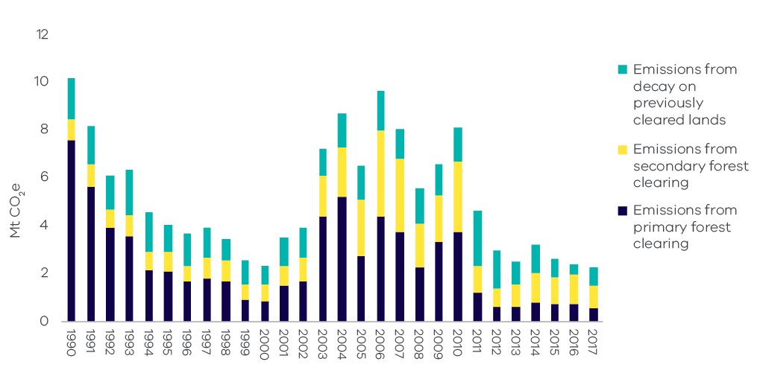
Source: State and Territory Greenhouse Gas Inventories data for Victoria provided to DELWP by DoEE, August 2019

Uncertainty in LULUCF emissions estimates
Uncertainty is a feature of any estimation process. According to Australia’s National Greenhouse Gas Inventory (NGGI), the estimated uncertainties for emissions from energy consumption and some industrial processes tend to be low (plus or minus 1 to 5%). Uncertainty is higher for LULUCF and agriculture due to the complexity of biological processes, the measurement and data collection techniques and the challenges of representing biological processes in mathematical models.
It is not practicable to use direct estimation or measurement techniques alone to calculate LULUCF emissions. The Full Carbon Accounting Model (FullCAM) provides the modelling framework used in the NGGI for estimating emissions and removals arising from changes in above and below ground biomass, dead organic matter, soil carbon and changes in land use and management techniques. FullCAM models the exchange of carbon between the terrestrial biological system and the atmosphere in a full and closed massbalance cycle. The model uses data on climate, soils and land management practices, as well as land use changes observed from satellite imagery and is supplemented by additional data and models as appropriate.
The overarching approach to estimating Australia’s LULUCF emissions is continually reviewed by the Commonwealth Department of the Environment and Energy. Changes are made to the assumptions underpinning the model as scientific knowledge advances and to data as more reliable sources become available.
For consistency, when changes are made the whole time series is revised. Such a revision occurred in 2019 and resulted in significant changes to the times series presented in the Victorian Greenhouse Gas Emissions Report 2018. Changes will continue to occur in future years as improvements in estimation methods are made.
Appendix C describes the main methodological changes and the impact they have had on LULUCF emissions data between the Victorian Greenhouse Gas Emissions Report 2018 and the current (2019) report.

Emissions by economic sector – 2017
Chapter 2 presented emissions data and analysis of emissions trends based on a set of sectors defined in accordance with IPCC guidelines. This chapter provides information on Victorian emissions presented in accordance with Australian and New Zealand Standard Industry Classification (ANZSIC) groups, including:
- electricity, gas, water and waste services
- manufacturing
- commercial services
- agriculture, forestry and fishing
- transport, postal and warehousing
- mining
- construction
- residential.

Direct emissions by ANZSIC sector
This section presents data on the direct emissions attributable to each ANZSIC sector. Direct (also known as Scope 1) emissions are released to the atmosphere as a direct result of an activity within an organisation’s boundary (for example fuel use, energy use, manufacturing process activity, mining activity and on-site waste disposal). The following examples illustrate the scope of direct emissions for selected ANZSIC sectors:
- Direct emissions from the residential sector include emissions from transport activities, the consumption of gas for heating and cooking, and emissions associated with the use of waste and wastewater services.
- Direct emissions from agriculture, forestry and fishing include emissions from activities such as the application of fertilisers, livestock management, and the combustion of fuels required for agriculture and forestry activities. It also includes emissions and sequestration of carbon from forest and grassland management.
- Direct emissions from manufacturing include emissions related to the direct combustion of fuels, transport, the application of waste management practices and leaks from industrial processes that are directly related to manufacturing processes such as the production of food, paper, textiles and chemicals.
Figure 43 presents the results of this process. It shows that in 2017, the electricity, gas and water supply sector (54%) produced the largest share of direct emissions, followed by the residential sector (19%) and manufacturing (5%).
Figure 43: Scope 1 emissions by ANZSIC sector – Victoria, 2017
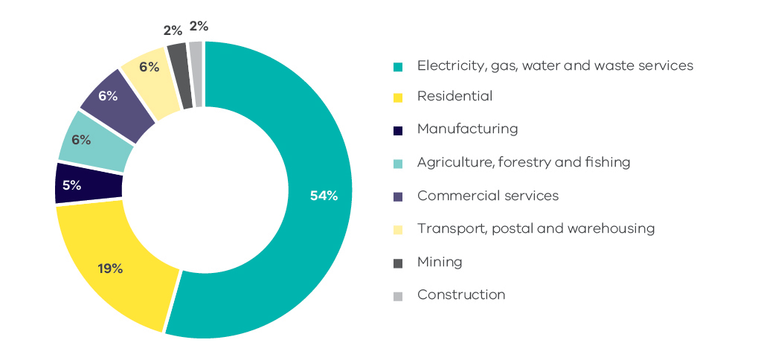
Source: Australian Greenhouse Emissions Information System (Department of the Environment and Energy 2019e)

Allocation of emissions from electricity generation to end-users
In this section, emissions associated with the generation of electricity are allocated to the end-users of electricity in each ANZSIC sector. The emissions attributable to electricity consumption are referred to as indirect or Scope 2 emissions.
Analysis of the emissions attributable to electricity consumption enables a deeper understanding of the demand drivers that contribute to emissions from the electricity sector.
Figure 44 presents the results of this process. The economic sector responsible for the largest share of Scope 2 emissions in 2017 was commercial services (30%), followed by manufacturing (28%) and residential (22%). The electricity, gas, water and waste services sector (16%) includes emissions associated with electricity that is consumed by this sector for its own use.
It should be noted that the data in Figure 44 relates only to electricity that is generated in Victoria and to the share of this generation that is consumed by ANZSIC sectors in Victoria. Net exports of electricity between jurisdictions in the National Electricity Market are not accounted for in the calculations.
Figure 44: Scope 2 emissions by ANZSIC sector – Victoria, 2017
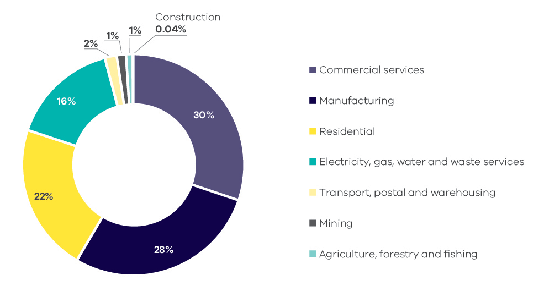
Source: Australian Greenhouse Emissions Information System (Department of the Environment and Energy 2019f)

Direct plus indirect emissions by ANZSIC sector
This section combines the analysis in the previous two sections to allocate direct (Scope 1) plus indirect (Scope 2) emissions to each ANZSIC sector.
The results are presented in Figure 45. In 2017, the residential sector was responsible for the largest share of direct plus indirect emissions in Victoria (31.4 Mt CO2-e or 28.2%), followed by commercial services (21.2 Mt or 19.0%) and manufacturing (18.6 Mt or 16.8%).
Figure 45: Scope 1 + 2 emissions by ANZSIC sector* – Victoria, 2017
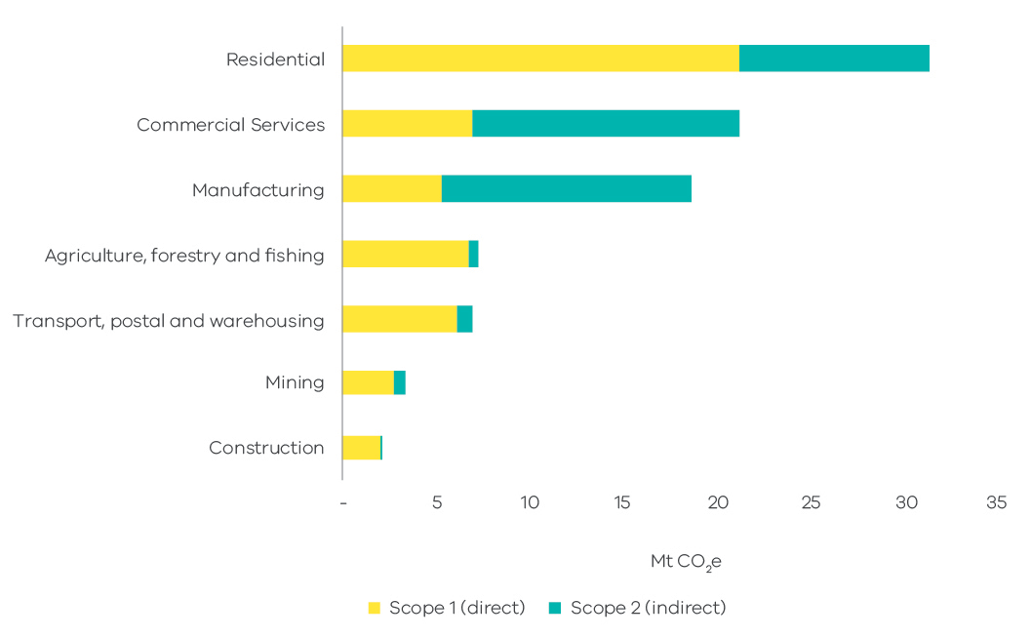
Source: analysis based on Australian Greenhouse Emissions Information System (Department of the Environment and Energy 2019e), (Department of the Environment and Energy 2019f)
* Note – consistent with the approach adopted by the Commonwealth, emissions from electricity generation consumed by the electricity, gas, water and waste services sector are not included in this figure as this electricity use includes ‘own use’ of generators and does not necessarily meet the National Greenhouse Accounts Factors 2017 definition of Scope 2 emissions. Direct emissions from agriculture and forestry also include sequestration from forest and grassland management.

Appendix A

Revision of historical greenhouse gas emissions data
The Commonwealth Department of the Environment and Energy (DoEE) revises greenhouse gas data annually consistent with international practices to reflect improved estimation methods.
Emissions estimation techniques and data sources for the Australian inventory are continuously refined, updated and improved. These revisions are aimed at reducing uncertainties in emission estimates with a particular focus on key sectors, sectors with high uncertainties and sectors for which new estimation methods are available.
As a consequence of this process, DoEE has revised historical emissions data between 1990 and 2016 nationally and for Victoria. A summary of these recalculations by sector and an explanation of the changes is presented in section 10.1 of the National Inventory Report 2017 – Volume 2.
Table 3 presents a summary of the changes in Victoria’s greenhouse gas emissions by sector for 2005 and 2016 between the data presented in the Victorian Greenhouse Gas Emissions Report 2018 and the current (2019) report.
While there have been minor changes in historical data in most sectors and sub-sectors, the most significant change is in the LULUCF sector.
Table 3: Sectoral breakdown of Victoria’s greenhouse gas recalculations
Sector/sub-sector | Difference in emissions (Mt CO2-e)
 | 2005 | 2016
Electricity generation | 0.00 | 0.00
Transport | 0.00 | -0.09
Direct combustion | 0.00 | 0.11
Fugitives from fuels | -0.04 | -0.02
Industrial processes and product use | 0.00 | -0.25
Agriculture | -0.02 | -0.10
Waste | 0.00 | 0.05
LULUCF | -4.78 | -2.27
Total | -4.84 | -2.58
Source: State and Territory Greenhouse Gas Inventories 2017 (Commonwealth of Australia 2019h) and State and Territory Greenhouse Gas Inventories 2016 (Commonwealth of Australia 2018c)
Figure 46 shows the effect of this revised data on Victoria’s total net emissions between 2005 and 2016 as presented in the Victorian Greenhouse Gas Emissions Report 2018 and the current (2019) report. It shows that:
- Total net emissions in 2005 (the reference year under the Act for interim targets) have been revised downwards from 127.8 to 122.9 Mt CO2-e.
- Total net emissions in 2016 have been revised downwards from 114 to 111.3 Mt CO2-e.
- The reduction in total net emissions between 2005 and 2016 is revised from 10.8 to 9.4%.
Figure 46: Impact of revised emissions on trends in Victoria’s total net emission from 2005-2016
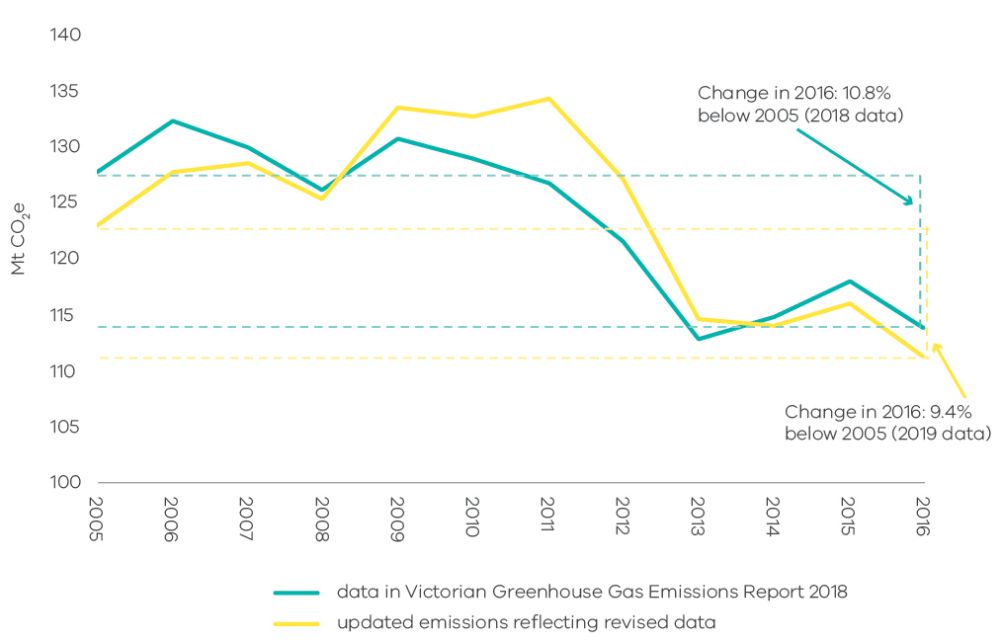
Source: analysis based on State and Territory Greenhouse Gas Inventories 2016 (Commonwealth of Australia 2018c) and State and Territory Greenhouse Gas Inventories 2017 (Commonwealth of Australia 2019h)

Appendix B

LULUCF definitions, sources and removals
Category | Land areas | Sources of anthropogenic emissions and removals
Forest land
Forest land remaining forest land | This includes:  - Harvested native forests – multiple-use public forests as at 2008, and private native forests subject to harvest or regrowing from prior harvest.  - Other native forests – forests of endemic species that are not harvested native forests or plantations. It includes protected areas such as wilderness areas and national parks.  - For-harvest plantations established up until the end of 1989. | - Annual change in carbon pools due to forest growth and losses due to harvesting. Carbon transferred to wood products is accounted for as a carbon emission in this category, and as a carbon removal under Harvested Wood Products.  - Emissions from wildfires and fire management practices, including subsequent removals due to recovery. Non-anthropogenic natural disturbances, including some but not all wildfires, are modelled to average out over time, leaving anthropogenic emissions and removals as the main drivers.  - Annual change in carbon pools from plantation establishment and harvesting on land that was plantation land at the end of 1989. Carbon pools include above and below ground biomass, DOM and soil. Harvested wood products from plantations are treated the same way as wood from native forests.
Land converted to forest land | - This includes land on which forest has been established that was not forested as at 1972. It captures grassland, croplands, settlements and wetlands on which forest has been identified as emerging.  - Grassland converted to forest land includes post-1989 for-harvest and environmental plantations, forest that has regrown on land that had been cleared for other uses, and regeneration of forest from in situ seed sources.  - Wetlands converted to forest land captures mangrove forests that have emerged on tidal marshes. | Annual change in living biomass (above and below ground) on new and existing land in this category, losses due to harvesting, and changes in DOM and soil carbon.
Cropland
Cropland remaining cropland | This includes continuous cropping lands, lands cropped in rotation with pastures, and woody horticultural crops. Annual variations in use of land for cropping or pasture due to rotation are not recorded because they are not regarded as a permanent change in land use. | Changes in total cropping areas, crop type and rotation, stubble management practices (including burning), tillage techniques, and application of green manures, soil ameliorants, fertiliser and irrigation. CO2 and nitrous oxide emissions associated with lime and fertiliser respectively are reported in the agriculture sector.
Land converted to cropland | This includes forest and wetlands converted to cropland since 1972. | Changes in all carbon pools (living biomass, DOM and soil) from:  - Primary clearing – arising when forest is cleared and maintained as cropland.  - Secondary clearing – arising when forest is cleared for cropland but then regrows and is re-cleared. (The regrowth is reported as land converted to forest land).  - Post-clearing land use – primarily changes in soil carbon.
Grassland
Grassland remaining grassland | This includes all areas of grassland not reported under land converted to grassland. Annual variations in land for cropping or pasture due to rotational use are not recorded because they are not regarded as a permanent change in land use.  It includes grasslands and shrublands (woody areas that do not meet the definition of forest). | Changes in pasture, grazing and fire management practices, changes in woody biomass in shrubland and changes in land use.
Land converted to grassland | This includes forest land and wetlands converted to grassland since 1972. | Changes in all carbon pools (living biomass, DOM, and soil) associated with:  - Primary clearing – arising when forest is cleared and maintained as grassland.  - Secondary clearing – arising when forest is cleared for grassland but then regrows and is re-cleared. (The regrowth is reported as land converted to forest land).  - Post-clearing land use – primarily changes in soil carbon.
Wetlands
Wetlands remaining wetlands | This includes coastal wetlands but will be extended in the future to include inland wetlands. It includes gains and losses of sparse woody vegetation on wetlands. | - For sparse woody areas – changes in all carbon pools (living biomass, DOM and soil) on wetlands using the same approaches as for sparse woody areas in the grassland category.  - For aquaculture production – emissions from activity estimated using production data published by the Australian Bureau of Agricultural and Resource Economics and Sciences (ABARES) and calculations for reporting emissions detailed in the National Inventory Report (NIR) 2016 s 6.10.1.  - For seagrass removal – emissions based on the area dredged calculated using the approach detailed in NIR 2016 s 6.10.1.
Land converted to wetland | This includes forests cleared as part of the construction of reservoirs and other land classified as flooded land. | Changes in all carbon pools (living biomass, DOM and soil) associated with the clearing.
Settlements
Settlements remaining settlements | This includes changes in sparse woody vegetation. It does not include land in settled areas that meets the definition of forest. | Changes in all carbon pools for sparse woody areas in settlements are modelled using the same approach as for sparse woody areas captured as part of grasslands.
Land converted to settlements | Includes forest land and wetlands converted to settlements. This includes mangrove forests cleared for commercial developments like marinas. | Changes in all carbon pools (living biomass, DOM and soil) associated with the clearing.
Harvested wood products (HWP)
HWP | This carbon pool includes the wood products in service in Australia and those that remain in solid waste disposal sites. The stock of HWP in service is estimated as the national production plus imports net of exports and product disposed to the waste system. | Annual emissions/removals are changes in this carbon stock based on:  - log flow from Australian forests – annual production by species grouping and product, for example sawlogs, veneer logs, pup logs, round wood and other  - fibre flow from processing by product class, imports and exports, recycling, entry and decomposition in landfill  - use for bioenergy and other losses to the atmosphere.

Appendix C

Changes in LULUCF emissions estimates between the 2018 and 2019 Victorian Greenhouse Gas Emissions Reports
This section outlines the differences in Victoria’s LULUCF emissions data between the Victorian Greenhouse Gas Emissions Report 2018 (2018 Report) and the current report (2019 Report). It also describes the methodological changes that have given rise to these differences.
The time series for Victoria’s LULUCF emissions since 1990 in the 2018 and 2019 Reports are presented in Figure 47. This shows that methodological changes have had different effects in LULUCF emissions data since 1990.
Figure 47: Victoria’s total net LULUCF emissions – Comparison of 2019 and 2018 Reports
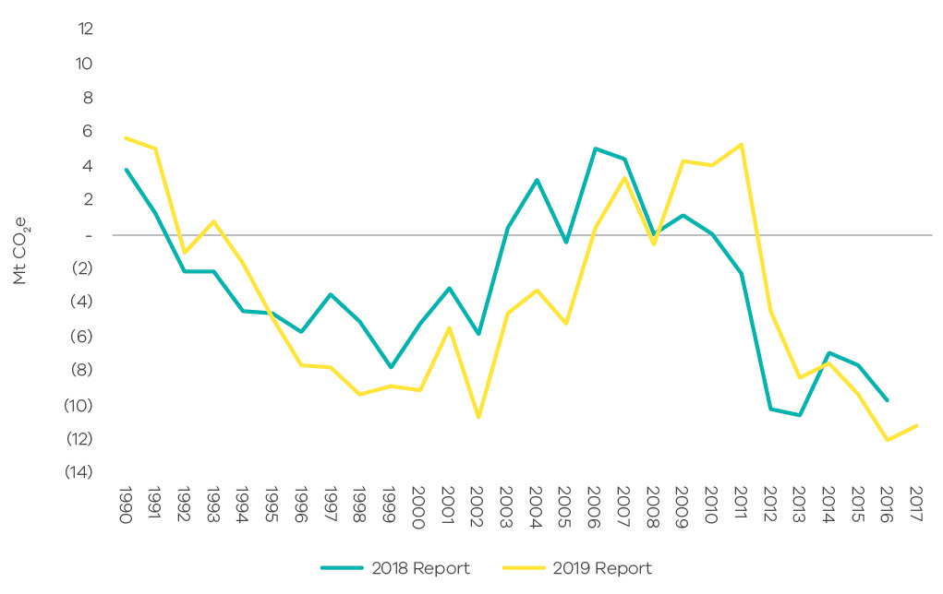
Source: State and Territory Greenhouse Gas Inventories 2017 (Commonwealth of Australia 2019h) and State and Territory Greenhouse Gas Inventories 2016 (Commonwealth of Australia 2018c)
The changes in methodology have resulted in an increase in the net sink provided by the LULUCF sector of approximately 5 Mt CO2-e (-5 Mt CO2-e compared to 0 Mt CO2-e) in 2005 (the reference year against which emissions reduction targets are set in the Climate Change Act 2017); and an increase in 2016 of around 2 Mt CO2-e (-12 MtCO2-e compared to -10 Mt CO2-e) in the 2019 Report compared with the 2018 Report.

Differences by LULUCF sub-category
The 2019 Report and 2018 Report time series for Victorian LULUCF emissions in each major sub-category since 1990 are presented in Figure 48. This shows that methodological changes have had the greatest and most variable impact on the time series for:
- Forest land remaining forest land – the spike in net emissions in 2011 in the 2019 Report compared with the 2018 Report is due to spikes in net emissions associated with both native wildfire and changes in pre-1990 plantations. It does not correspond to a significant fire event in that year although there was a slight increase in softwood plantations’ harvest volumes. The modelling approaches that could explain this feature of the time series are described in Table 4.
- Cropland remaining cropland – the changes in data between the 2018 and 2019 time series for cropland remaining cropland are relatively large. On average – between 2005 and 2016 – the methodological changes have seen this sub-category go from being a small net sink to a small net source of emissions. The methodological changes that have brought about this outcome include more accurate approaches to accounting for changes in management practices and in soil carbon (in particular in response to changes in weather patterns).
- Grassland remaining grassland – the differences in emissions reported between the 2018 and the 2019 Reports for grassland remaining grassland are also relatively large. In particular, the difference in the 2005 base year for this sub-category of around -3.1 Mt CO2-e accounts for a large proportion of the total change in 2005 LULUCF emissions. On average from the 2005 base year to 2016, the change in this sub-category is relatively small (0.02 Mt CO2-e). The methodological changes that have resulted in these changes primarily reflect more accurate approaches to accounting for changes in soil carbon (in particular in response to changes in weather patterns).
The impact of methodological changes on the data for the sub-category forest land converted to other land uses is small. The impact on land converted to forest land is slightly larger in magnitude but more consistent over time (a small increase in the size of the net sink in most years).
Figure 48: Emissions from Victoria’s main LUCLUF sub-categories – Comparison of 2019 and 2018 Reports
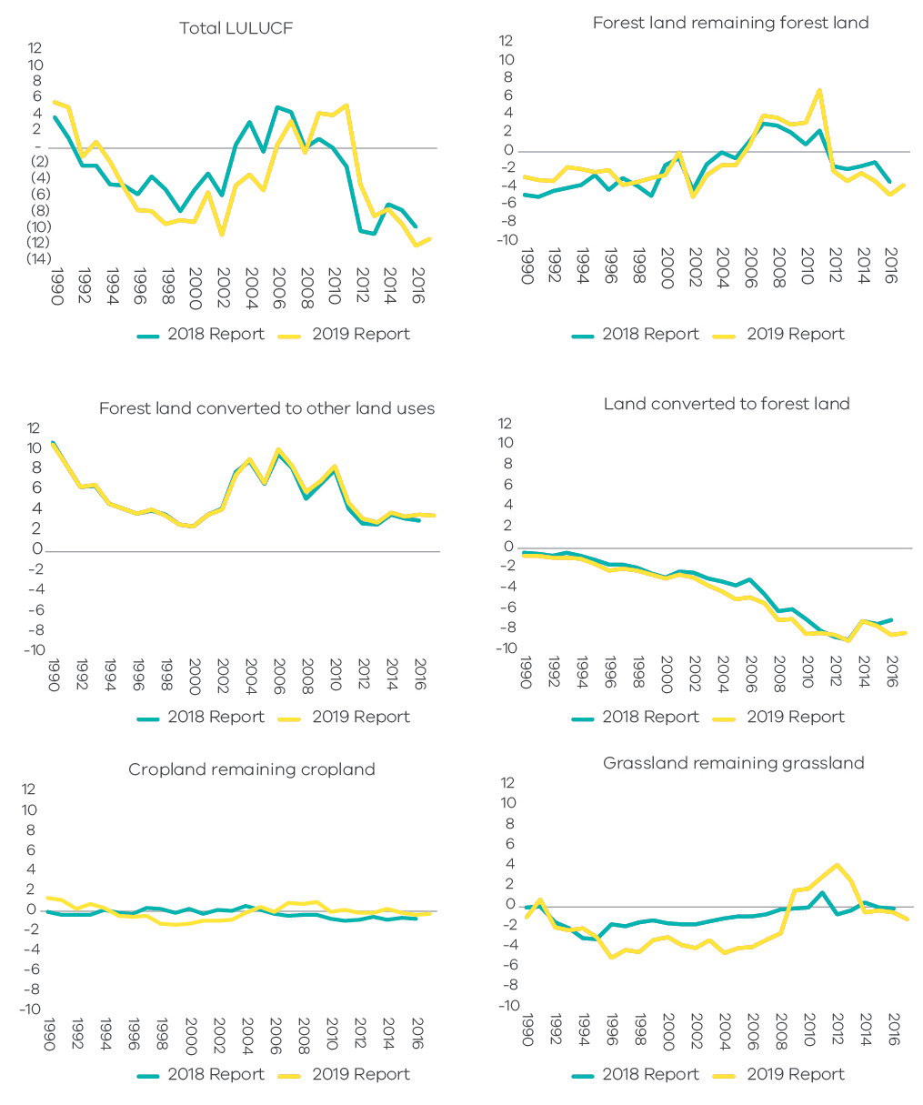
Source: State and Territory Greenhouse Gas Inventories 2017 (Commonwealth of Australia 2019h), State and Territory Greenhouse Gas Inventories 2016 (Commonwealth of Australia 2018c) and data for Victoria provided to DELWP by DoEE, August 2019

Summary of methodological changes in estimating LULUCF emissions
The principal changes in the methodologies used to estimate emissions in each LULUCF sub-category that have been incorporated in the 2019 Report are outlined in Table 4.
Table 4: Main changes in estimation methodology
Category | Methodological Change
Forest land remaining forest
Other native forests | In 2019, a spatial simulation of fires was incorporated into FullCAM for tropical forests and temperate forests. Three main changes were made, each of which has increased accuracy of the models while also increasing the variation between years. The changes were:  - More accurate simulation of the carbon dynamics of fuels and changes in soil carbon following wildfires through the inclusion of standing dead carbon pools.  - More accurate measures of fire emissions and recoveries through inclusion of varying site productivity and fire return intervals for the area that was burnt.  - Changes in the identification of natural disturbances and anthropogenic fires in temperate forests.  When a fire is excluded from the historical time series, both the direct emissions from the fire and the subsequent removal of carbon by the recovering forest (strongest in the first couple of years post-fire) are excluded from the revised historical time series. This may explain part of the peak in emissions in 2011 that does not correspond to significant bushfires in Victoria in that year.
Pre-1990 plantations | Previously, pre-1990 plantations were estimated using FullCAM estate mode based on 36 plots representative of each National Plantation Inventory (NPI) region. In the 2019 Report, net emissions from pre-1990 plantations are estimated using spatial simulation in FullCAM based on information from ABARES, which provides more accurate spatial, temporal and species information.  This change has resulted in better accounting for plantation areas within NPI regions, including spatial variability in productivity across areas, and better identification of planting dates and harvesting (based on the model’s relevant pre-set regime).The modelled harvesting regimes can result in spikes in harvesting emissions (for example 2011) where plantations that were established at a similar time reach maturity – in reality, these harvest volumes may be spread over a number of years. In general, these changes have resulted in greater variability in the time series.
Land converted to forest land | This primarily relates to cropland and grassland converted to forest land. In addition to general refinements to FullCAM, changes have been made to:  - Improve the key site productivity parameter in FullCAM’s growth model, which has generally increased the estimated sequestration in all carbon pools (plants, debris and soil).  - Capture the distinction between changes in standing dead carbon pools, and the ground-based debris that occur after thinning and other disturbances. This has generally reduced the rate of carbon loss following disturbances and thinning as standing dead carbon pools break-down more slowly than ground-based debris.  - Improvements in the analysis of satellite imagery and monitoring of changes in forest area and forest states.  The overall effect is to increase the net sink provided by this sub-category in most years.
Cropland remaining cropland | The main changes have been to:  - Improve consistency with other estimation methods in the LULUCF sector and with UNFCCC requirements around reporting emissions and removals relating to managed lands (called the Managed Land Proxy) by revising the methodology to report absolute rather than relative changes in carbon stocks.  - Capture greater changes in land management practices building on Australian Bureau of Statistics’ (ABS) land survey census data.  These changes improve the estimates of changes in soil carbon in response to climate conditions and, overall, increase the variability of the time series.
Grassland remaining grassland | As for cropland remaining cropland, the main change affecting these estimates has been the change from a relative to an absolute basis for modelling carbon stock changes (the move to the Managed Land Proxy mentioned above). These improve the estimates of changes in soil carbon in response to climate conditions and, overall, the changes increase the variability of the time series.  This has a relatively large effect on emissions in part due to the large proportion of land that is grassland remaining grassland in Victoria (compared to cropland remaining cropland).

Abbreviations and acronyms
AEMO | Australian Energy Market Operator
AAP | Adaptation Action Plan
The Act | The Climate Change Act 2017
ANZSIC | Australian and New Zealand Standard Industrial Classification
CO₂ | Carbon dioxide
CO₂-e | Carbon dioxide equivalent
DoEE | Commonwealth Department of the Environment and Energy
GSP | Gross State Product
HFCs | Hydrofluorocarbons
IPCC | Intergovernmental Panel for Climate Change
IPPU | Industrial processes and product use
KP | Kyoto Protocol
LULUCF | Land use, land-use change and forestry
Mt | Million tonnes
MW | Megawatt
MWh | Megawatt hours
NEM | National Electricity Market
PJ | Petajoules
UNFCCC | United Nations Framework Convention on Climate Change

Reference List
Australian Bureau of Statistics 2018a, Australian Demographic Statistics, December quarter 2018, Cat. No. 3101.0, ABS, Canberra, viewed 27 June 2019, <https://www.abs.gov.au/AUSSTATS/abs@.nsf/DetailsPage/3101.0Dec%202018?OpenDocument>
Australian Bureau of Statistics 2018b, Australian National Accounts: State Accounts, 2017-18, Cat. No. 5220.0, ABS, Canberra, viewed 27 June 2019, <https://www.abs.gov.au/AUSSTATS/abs@.nsf/DetailsPage/5220.02017-18?OpenDocument>
Australian Bureau of Statistics 2017c, Motor Vehicle Census, Australia, Cat. No. 9309.0, ABS, Canberra, 31 Jan 2017, Viewed 27 July 2018, <http://www.abs.gov.au/AUSSTATS/abs@.nsf/allprimarymainfeatures/AFE43252F544460ACA2582D60014CB0F?opendocument>
Australian Energy Market Operator 2018a, Electricity – Generation Information Page, NEM Regional Generation Information Pages, AEMO, viewed 27 July 2018, <https://www.aemo.com.au/Electricity/National-Electricity-Market-NEM/Planning-and-forecasting/Generation-information>
Australian Energy Market Operator 2018b, Victorian Gas Planning Report Update, Gas Transmission Network Planning for Victoria, March 2018, viewed 27 July 2018, < https://aemo.com.au/-/media/Files/Gas/National_Planning_and_Forecasting/VGPR/2017/2018---Victorian-Gas-Planning-Report-Update.pdf>
Australian Energy Regulator 2018, State of the Energy Market 2018, December 2018, viewed 2 July 2019, <https://www.aer.gov.au/system/files/State%20of%20the%20Energy%20Market%202018%20-%20Full%20report%20A3%20spread_2.pdf>
Bureau of Infrastructure, Transport and Regional Economics (BITRE) 2018, Yearbook 2018: Australian Infrastructure Statistics, Statistical Report, January 2019, viewed 20 August 2019, < https://www.bitre.gov.au/publications/2018/files/infrastructure-statistics-yearbook-2018.pdf>
Clean Energy Regulator 2018, Electricity sector emissions and generation data 2016-17, Greenhouse and Energy Information for Designated Generation Facilities 2016-17, Published 15 October 2018, Viewed 27 July 2019, <http://www.cleanenergyregulator.gov.au/DocumentAssets/Pages/Greenhouse-and-energy-information-for-designated-generation-facilities-2016-17.aspx>
Clean Energy Regulator 2019, Postcode data for small-scale installations, Summary of postcode data, Small generation unit - solar (deemed), viewed 2 July 2019, <http://www.cleanenergyregulator.gov.au/RET/Forms-and-resources/Postcode-data-for-small-scale-installations#Installation-numbers-for-smallscale-systems-by-stateterritory>
Commonwealth of Australia 2017, Australian Energy Update 2017, Table F – Australian Energy Consumption by State, by industry, by fuel, energy units, Department of the Environment and Energy, Published September 2017, Viewed 27 July 2018, <https://www.energy.gov.au/publications/australian-energy-update-2017>
Commonwealth of Australia 2018, Australian Energy Update 2018, Department of the Environment and Energy, Published August 2018, Viewed 18 July 2019, <https://www.energy.gov.au/sites/default/files/australian_energy_update_2018.pdf>
Commonwealth of Australia 2018a, Australian Energy Update 2018, Table F – Australian Energy Consumption by State, by industry, by fuel, energy units, Department of the Environment and Energy, Viewed 18 July 2019, <https://www.energy.gov.au/publications/australian-energy-update-2018>
Commonwealth of Australia 2018b, Australian Energy Update 2018, Table I – Australian Production of Primary Fuels, physical units, Department of the Environment and Energy, Viewed 19 September 2019, <https://www.energy.gov.au/publications/australian-energy-update-2018>
Commonwealth of Australia 2018c, State and Territory Greenhouse Gas Inventories 2016, Department of the Environment and Energy - Australian National Greenhouse Accounts, 2018), viewed 22 June 2019, <http://www.environment.gov.au/climate-change/climate-science-data/greenhouse-gas-measurement/publications/state-and-territory-greenhouse-gas-inventories-2016 >
Commonwealth of Australia 2019, About My Region – Victoria – Agricultural Sector, Department of Agriculture and Water Resources ABARES, Viewed 27 July 2019, <http://www.agriculture.gov.au/abares/research-topics/aboutmyregion/vic#agricultural-sector>
Commonwealth of Australia 2019a, About My Region – Victoria – Regional Overview, Department of Agriculture and Water Resources ABARES, Viewed 27 July 2019, < http://www.agriculture.gov.au/abares/research-topics/aboutmyregion/vic#regional-overview>
Commonwealth of Australia 2019b, Australian Crop Report, Australian Bureau of Agricultural and Resource Economics and Sciences ABARES, viewed 20 September 2019, <https://doi.org/10.25814/5d71bf5551775>
Commonwealth of Australia 2019c, Australian Greenhouse Emissions Information System – Activity Tables, Victoria, Department of the Environment and Energy, sourced July 2019, <http://ageis.climatechange.gov.au/QueryAppendixTable.aspx>
Commonwealth of Australia 2019d, Australian Greenhouse Emissions Information System - National Greenhouse Gas Inventory Trend, Victoria, Department of the Environment and Energy, sourced July 2019, <http://ageis.climatechange.gov.au/NGGITrend.aspx>
Commonwealth of Australia 2019e, Australian Greenhouse Emissions Information System - National Inventory by Economic Sector, Victoria, Department of the Environment and Energy, sourced July 2019, <http://ageis.climatechange.gov.au/ANZSIC.aspx>
Commonwealth of Australia 2019f, Australian Greenhouse Emissions Information System -– Scope 2 Emissions, Indirect emissions from purchased electricity - Victoria, Department of the Environment and Energy, sourced 27 July 2018, <http://ageis.climatechange.gov.au/Electricity.aspx>
Commonwealth of Australia 2019g, National Inventory Report 2017, Department of the Environment and Energy, published May 2019, viewed 22 June 2019, <http://www.environment.gov.au/climate-change/climate-science-data/greenhouse-gas-measurement/publications/national-inventory-report-2017>
Commonwealth of Australia 2019h, State and Territory Greenhouse Gas Inventories 2017, Department of the Environment and Energy, 2019, Australian National Greenhouse Accounts, viewed 22 June 2019 <http://www.environment.gov.au/climate-change/climate-science-data/greenhouse-gas-measurement/publications/state-and-territory-greenhouse-gas-inventories-2017 >
Department of Environment, Land, Water and Planning 2016, Water for Victoria – Water Plan, viewed 17 September 2019, < https://www.water.vic.gov.au/__data/assets/pdf_file/0030/58827/Water-Plan-strategy2.pdf>
National Electricity Market-Review 2019, Metered Generation (As Generated), Sourced 2 July 2019, < http://v6.nem-review.info/use/index.aspx>
Morton, A 2012, ‘Yallourn coal mine flood worsens’, The Age, 16 July 2012, viewed 27 July 2018, <https://www.theage.com.au/national/victoria/yallourn-coal-mine-flood-worsens-20120715-224ef.html>

. Percentage contributions of each sector are presented as net emissions (i.e. they take into account sequestration in the LULUCF sector).
. DoEE prepares National Greenhouse Accounts that include a series of annual publications to meet Australia’s international obligations under the UNFCCC and Kyoto Protocol (KP). These include State and Territory Greenhouse Gas Inventories and the National Inventory Report.
. Financial years to 30 June – for example, the year 2012 refers to the Australian financial year from 1 July 2011 to 30 June 2012.
. DoEE revises greenhouse gas data annually, consistent with international practices to include improved estimation methods. Further information on the latest revisions of Victoria’s greenhouse gas emissions data is presented in Appendix A.
. UNFCCC accounting is used rather than KP accounting because it includes a more comprehensive set of land categories and the identification of emissions from land clearing events. It is also expected to be more widely used in the future than the KP provisions. Total net Victorian emissions in 2017 estimated under UNFCCC rules were 0.92 Mt CO2-e lower than those estimated using KP accounting.
. DoEE produces LULUCF emissions data under the rules for reporting applicable to both the UNFCCC and the Kyoto Protocol. The Victorian Greenhouse Gas Emissions Report uses LULUCF data following the UNFCCC emissions accounting provisions.
. Percentage contributions of each sector are presented as net emissions (i.e. they take into account sequestration in the LULUCF sector).
. Sections 2.1 to 2.5 of this report discuss the interannual variability of emissions trends by sector between 1990 and 2017.
. Hazelwood Power Station ceased operations at the end of March 2017.
. Sustainability Victoria’s analysis based on 2017 Australian Energy Statistics, Table F - Australian energy consumption, by industry and fuel type, energy units (Commonwealth of Australia 2017).
. Natural gas analysis based on Australian Energy Statistics (Commonwealth of Australia 2018a)
. Natural gas analysis based on Australian Energy Statistics (Commonwealth of Australia 2018a)
. Transport fuel analysis based on Australian Energy Statistics (Commonwealth of Australia 2018a)
. Analysis based on 2017 Motor Vehicle Census (Australian Bureau of Statistics 2017c)
. Transport fuel analysis based on Victorian energy consumption (Commonwealth of Australia 2018a)
. Analysis based on the 2017 Motor Vehicle Census (Australian Bureau of Statistics 2017c)
. Analysis of the production of primary fuels in Victoria based on Australian Energy Statistics (Commonwealth of Australia 2018b)
. Natural gas analysis based on Australian Energy Statistics (Commonwealth of Australia 2018a)
. According to the National Inventory Report 2017, emissions of carbon dioxide from waste to energy processes which use biogas or biomass feedstocks are not included in the national inventory but are required to be reported as a memo item. Methane and nitrous oxide emissions from these processes are reported in the electricity generation sub-sector.
. Enteric fermentation is a natural part of the digestive process of ruminants where microbes decompose and ferment food in the digestive tract or rumen producing methane emissions.
. DoEE produces LULUCF emissions data under the rules for reporting applicable to both the UNFCCC and under the Kyoto Protocol. The Victorian Greenhouse Gas Emissions Report 2019 uses LULUCF data following the UNFCCC emission accounting provisions.
. These three sub-categories account for more than 80% of total emissions from the LULUCF sector. While emissions from other sub-categories are not described in this section of the Report, their net emissions are accounted for in the total net LULUCF emissions presented in Figures 38 and 39.
. National Inventory Report 2017, Vol 2 (Commonwealth of Australia 2019b)
. National Inventory Report 2016, s6.4.1.3, consistent with IPPC 2006 Volume 4.1.5
. Note that the information in Table 4 relates to methodological changes for the entire Australian National Greenhouse Gas Inventory Report – not all the information is relevant to Victoria (i.e. not all land use types are present in Victoria)
. National Inventory Report 2017, Vol 2, Section 6.4.5 p 54 (Commonwealth of Australia 2019b), and discussions with DoEE in September 2019
National Inventory Report 2017, Vol 2, Section 6.4.1.2, p 33 (Commonwealth of Australia 2019b)
. National Inventory Report 2017, Vol 2, Section 6.5.5 p 68 (Commonwealth of Australia 2019b)
. National Inventory Report 2017, Vol 2, Section 6.6.5 p 76-77, and Table 6.39 (Commonwealth of Australia 2019b)
. Discussions with DoEE, September 2019
. National Inventory Report 2017, Vol 2, Section 6.8.5 p 90, and tables 6.45a and 6.45b (Commonwealth of Australia 2019b), and discussions with DoEE, September 2019

