Acknowledgments
The State of Victoria wish to acknowledge the assistance of John Clarke, Dr Michael Grose, Dr Marcus Thatcher,
Dr Kathy McInnes, Dr Vanessa Hernaman, Dr Xuebin Zhang from CSIRO; Dr Pandora Hope, Dr Lynette Bettio,
Ben Hague, Dr Scott Power and Dr Karl Braganza, from the Bureau of Meteorology; Professor David Karoly, from the
Earth Systems and Climate Change Hub; and Dr Ailie Gallant from Monash University.
Editorial support Karen Pearce, Bloom Communication
Figures, design and layout Carmel Reilly, ceeDesign
Illustrations Kate Doyle

Acknowledgment
We acknowledge and respect Victorian Traditional Owners as the original custodians of Victoria's land and waters, their unique ability to care for Country and deep spiritual connection to it. We honour Elders past and present whose knowledge and wisdom has ensured the continuation of culture and traditional practices.
We are committed to genuinely partner, and meaningfully engage, with Victoria's Traditional Owners and Aboriginal communities to support the protection of Country, the maintenance of spiritual and cultural practices and their broader aspirations in the 21st century and beyond.

© The State of Victoria Department of Environment, Land, Water and Planning 2019
This work is licensed under a Creative Commons Attribution 4.0 International licence. You are free to re-use the work under that licence, on the condition that you credit the State of Victoria as author. The licence does not apply to any images, photographs or branding, including the Victorian Coat of Arms, the Victorian Government logo and the Department of Environment, Land, Water and Planning (DELWP) logo. To view a copy of this licence, visit creativecommons.org/licenses/by/4.0/
Printed by Finsbury Green, Melbourne.
ISBN 978-1-76077-852-1 (print)
ISBN 978-1-76077-853-8 (pdf)

Disclaimer
This publication may be of assistance to you but the State of Victoria and its employees do not guarantee that the publication is without flaw of any kind or is wholly appropriate for your particular purposes and therefore disclaims all liability for any error, loss or other consequence which may arise from you relying on any information in this publication.

Accessibility
If you would like to receive this publication in an alternative format,
please telephone the DELWP Customer Service Centre on 136 186, or email customer.service@delwp.vic.gov.au, or via the National Relay Service on 133 677, www.relayservice.com.au. This document is also available on the internet at
www.delwp.vic.gov.au

Contents

Minister’s foreword 5
Executive summary 6
1.0 The big climate picture 8
2.0 Victoria’s changing climate 11
2.1 Victoria’s climate 11
2.2 Victoria’s climate is shaped by
weather systems, seasonal influences
and large-scale climate drivers 11
2.2.1 Weather systems and
seasonal influences 11
2.2.2 Large-scale climate drivers 13
2.3 Victoria’s climate has changed 15
2.3.1 Warmer and drier 15
2.3.2 Changing climate drivers 17
2.3.3 Sea level 18
2.3.4 Fire danger 18
2.3.5 Snow 18
3.0 Understanding climate science 19
3.1 Modelling the future climate 19
3.1.1 Model resolution 19
3.1.2 Representing emissions 19
3.1.3 Global modelling efforts 19
3.2 Climate science assessment 20
3.3 National climate projections 20
3.4 Climate science for Victoria 20
4.0 Victoria’s future climate 22
4.1 Interpreting projections 22
4.2 Major climate influences 22
4.2.1 Weather systems 22
4.2.2 Climate drivers 23
4.3 Temperature 24
4.3.1 Average temperature 24
4.3.2 Extreme temperatures 24
4.4 Rainfall 25
4.4.1 Average rainfall 25
4.4.2 Extreme rainfall 26
4.5 Regional changes in climate 27
4.5.1 Regional temperature changes 27
4.5.2 Regional rainfall changes 28
4.6 Fire danger 29
4.7 Snow 29
4.8 Sea level rise 30
4.8.1 Mean sea level 30
4.8.2 Extreme sea level events 30
4.8.3 Waves 30
5.0 Using climate science
to support decision making 32
5.1 Climate change and water
resource management 32
5.2 Climate change and fire management 33
5.3 Climate change and snow tourism 33
5.4 Climate change and agriculture 33
5.5 Biodiversity conservation
in a changing climate 33
Shortened forms 34
Glossary 35
References 37

List of figures
Figure 1. The enhanced greenhouse effect explained. 9
Figure 2. Australia’s average annual temperature relative to the 1850–1900 period. 10
Figure 3. The influence of the sub-tropical ridge. 12
Figure 4. The influence of large-scale climate drivers. 14
Figure 5. Observed average annual temperature in Victoria from 1910–2018 compared
to the 1961–1990 baseline average. 15
Figure 6. Maps showing warm season (November–March) and cool season
(April–October) rainfall deciles. 16
Figure 7. Days per year when Victorian average temperature is ‘unusually hot’. 17
Figure 8. The number of very high fire danger days in spring has increased. 18
Figure 9. Topography of Victoria as represented in a typical global climate model
(GCM about 150 km), intermediate downscaling model (CSIRO’s modelling at 50 km)
and the VCP19 modelling at 5 km. 20
Figure 10. Projected changes that will influence Victoria’s future climate. 23
Figure 11. Average annual temperature of Victoria in observations and models
relative to the pre-industrial era, showing the highest emissions pathway (RCP 8.5)
and the lowest (RCP 2.6) separately. 24
Figure 12. Comparison of the observed average annual temperatures for Victoria
with the projected range of change. 25
Figure 13. Observed rainfall averaged over Victoria and the projected rainfall change. 26
Figure 14. Comparison of the median number of hot days per year currently (between
1986 and 2005) and in the 2050s under high emissions (RCP 8.5). 27
Figure 15. Average decline in annual rainfall in percent for locations across Victoria
for the 2050s under high emissions scenario (RCP 8.5) compared to 1986–2005. 28
Figure 16. Sea level rise projections relative to the baseline (1986–2005) for key
Victorian locations under high (RCP8.5) emissions scenarios for the 2030s and the 2070s. 29

Minister’s foreword
Evidence is the strongest base for decisions about the future.
Our state is a fantastic place to live, work and raise a family. A healthy environment is vital for a healthy future for our state, and the generations to come. Victoria has many world-renowned climate scientists to turn to for help in making good decisions. As well as making a valuable contribution to the global evidence base, local scientists give us valuable insight into both how our climate is changing and what that might mean for the future.
The Victorian Government is committed to understanding our climate and exploring the impacts of our future climate with the Victorian community.
Victoria’s Climate Science Report 2019 provides a summary of the best available scientific evidence on climate for our state. The report builds on the knowledge gained from the Victorian Government’s ongoing investment in climate science, such as the Victorian Climate Projections 2019 and the Victorian Water and Climate Initiative, as well as research from our leading academic institutions.
The report tells us that Victoria’s climate has already changed – becoming hotter and drier in recent years. It also shows how these trends are projected to continue in the future, along with more frequent high fire danger days and rising sea levels. By explaining the changes projected for Victoria, this report is the evidence base for taking strong steps to reduce our emissions and adapt to climate change.
By outlining the changes that Victoria could experience if the global community does not reduce its greenhouse gas emissions, this report demonstrates the need for Victoria to play its part and reduce our own emissions. This will also ensure Victoria is well-placed to take advantage of the opportunities of switching to a net zero emission economy.
The report also makes clear that our regions and sectors must prepare for the future by understanding and adapting to the projected changes in our climate. The Victorian Government has laid a strong foundation for effective adaptation through Victoria’s Climate Change Adaptation Plan 2017–2020.
We know the Victorian community is looking for strong and lasting action on climate change, and the time for that action is now. We will continue to work with the scientific community to gather evidence of future climate change risks and opportunities for Victoria. For the health of our community and environment, to strengthen our state’s economy, to ensure there are jobs for Victorians now and for future generations, our government is acting strongly on climate change for Victoria.

The Hon. Lily D’Ambrosio MP
Minister for Energy, Environment and Climate Change
Minister for Solar Homes

Executive summary
Victoria’s climate has changed in recent decades, becoming warmer and drier. These changes are expected to continue in the future. Understanding the drivers and impacts of these changes, as well as what we can expect in the future, will help us to plan and adapt.

Victoria’s changing climate
Victoria’s climate varies across the state, with distinct climate zones. Northwest Victoria is hotter and drier, the south and east are milder with higher rainfall, while the northeast has an alpine region. Victoria’s climate also varies from year to year and decade to decade due to the influence of large-scale climate drivers such as the El Niño Southern Oscillation.
Long-term observed records show that Victoria’s climate is changing under the influence of both natural variability and global warming. The average temperature across the state has warmed by just over 1.0°C since official Bureau of Meteorology records began in 1910. Over the past 30 years, Victoria’s cool season rainfall has declined compared to last century. Mean sea level for Melbourne (recorded at Williamstown) has risen by approximately 2 mm per year since 1966. There has been an increase in dangerous fire weather and in the length of the fire season across southern Australia since the 1950s.
Determining changes to come
The climate experienced over the long term is no longer a good indicator of the climate we can expect in the future. Instead, we rely on information from climate models, along with other information. Climate models help us to understand the changes that are already happening and provide guidance on the changes to come.
Climate models give robust projections of the future climate, providing a solid evidence base from which to assess the risks of climate change and inform decisions that will support Victoria's resilience into the future.
Victoria’s future climate
Climate projections suggest that Victoria will continue to become warmer and drier in the future. However, natural year-to-year and decade-to-decade variability mean that relatively cooler periods and very wet years will still occur.
Annual rainfall is projected to decrease across the state, due to declines across autumn, winter and spring. When extreme rainfall events do occur, they are likely to be more intense. Areas of the Victorian Alps are projected to see a greater reduction in rainfall than the surrounding areas. Victorian alpine areas are also projected to continue to experience declining snowfall (35–75% by the 2050s under high emissions). Comparison of observations and projections in Victoria suggest that temperature has been tracking towards the upper limit of projections while winter rainfall has been tracking towards the drier end of projections.
By the 2050s, if the current rate of global warming continues, Victorian towns could experience around double the number of very hot days each year compared to the 1986–2005 average. By the 2090s, Victoria is projected to warm on average by 2.8 to 4.3°C under a high emissions scenario compared to 1986–2005. This would see Victoria frequently experiencing currently unprecedented high temperatures. Victoria is likely to have a significantly lengthened fire season with the number of very high fire danger days likely to continue to increase. Sea levels along the Victorian coast are also likely to continue to rise.
Science supporting decision making
Climate change poses a serious risk for Victoria and the science underpinning this report has shown that not every region in Victoria will change in the same way. Using robust science to understand the potential impacts of climate change is essential to build a more resilient Victoria in the future.

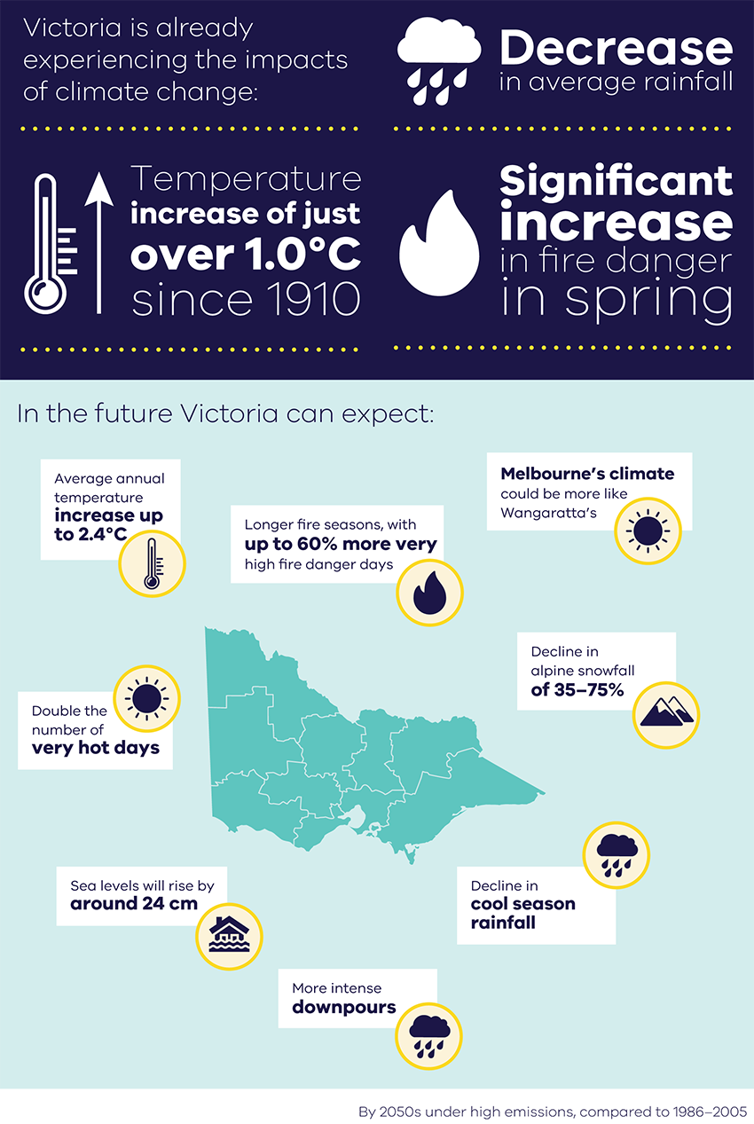

1.0 The big climate picture
Increasing concentrations of greenhouse gases in the Earth’s atmosphere are warming the planet at an unprecedented rate. It is clear that this warming is the result of human activity (IPCC, 2013).

Atmospheric carbon dioxide concentrations have risen from around 280 parts per million at the start of the industrial revolution, to above 400 parts per million today (Global Carbon Project, 2018). These increasing concentrations of carbon dioxide and other greenhouse gases are trapping heat in the Earth’s atmosphere and warming the planet as a result of the enhanced greenhouse effect (Figure 1).
In the recent geological history of the Earth, equivalent rates of change in atmospheric carbon dioxide have taken thousands of years to occur. The Earth’s climate system has not seen atmospheric carbon dioxide levels above 400 parts per million since around 2.3 million years ago (BoM and CSIRO, 2018).
Global warming is causing changes in the climate system. The warming atmosphere is not only making the world hotter but is also affecting the water cycle, causing both drying and extreme rainfall events. Sea levels are rising as ice sheets melt and sea water expands; circulation patterns in the atmosphere and ocean are also changing.
During the peak of the last ice age around 21,000 years ago, Victoria was colder and drier, with lower sea levels exposing the land bridge between Victoria and Tasmania. However, the rate of change associated with glacial-interglacial cycles is much slower than the speed of global warming over the 20th century (BoM and CSIRO, 2018). Ice cores, corals, tree rings and other palaeoclimate archives that provide a record of past climate confirm that our climate warmed faster over the past 100 years than it has during any other time in the past 2000 years and that a warming period is now affecting the whole planet at the same time for the first time (Neukom et al., 2019a; Neukom et al., 2019b; Allen et al., 2019).
Experiments simulating the global climate with and without human emissions clearly show that this unprecedented warming can only be explained by human activity (Figure 2).
How much the climate changes will depend strongly on the greenhouse gas emissions pathway that the world follows. The already increased concentrations of carbon dioxide in the atmosphere, compared to pre-industrial levels, have locked in further global warming of up to half a degree above the present 1°C rise (IPCC, 2018). The oceans will continue to warm in response to emissions already present in the atmosphere trapping heat.

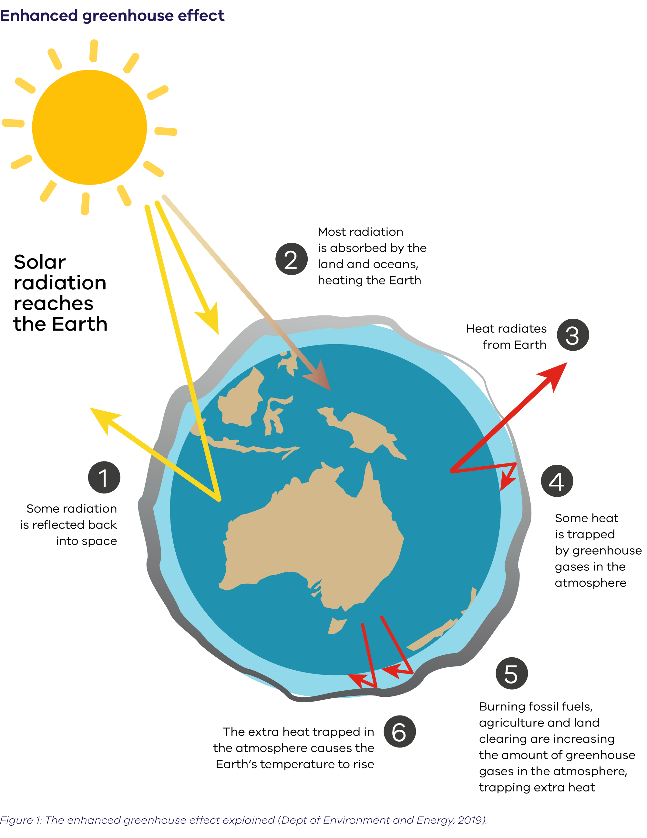

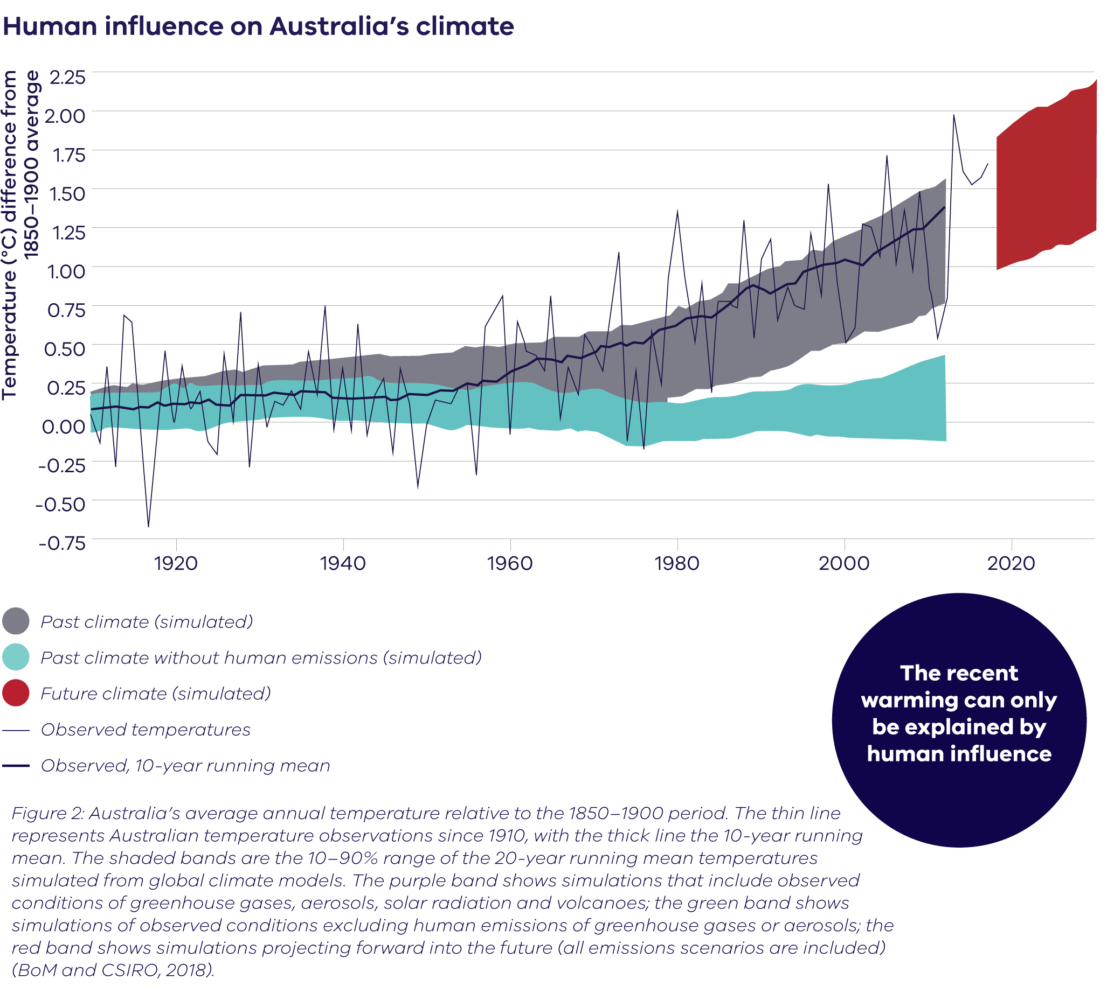

Can we say an extreme weather event was caused by human-induced global warming?
Attribution studies allow us to understand the links between climate change and individual extreme events by working out if the likelihood or severity of an event happening now is different to what it would be in a world that was not warming in response to human activities.
An analysis of more than 230 peer-reviewed studies looking at extreme weather events around the world — including Hurricane Katrina and Russia’s 2010 heatwave — suggests 68% of all extreme weather events studied to date were made more likely or more severe by human-caused climate change (Carbon Brief, 2019). Of the 80 attribution studies that looked at heatwaves around the world, 76 (95%) found that climate change had made such an event more likely or more severe.
While attribution can indicate if an event was more likely due to climate change, it does not allow us to say that climate change ‘caused’ a particular event. Also, where attribution science finds that climate change is making a given type of extreme weather more likely, natural variability means that there will still be ups and downs in the strength and frequency of extreme events from year to year (Carbon Brief, 2019).
Researchers from the national Earth Systems and Climate Change Hub have been conducting attribution studies on Australian extreme events, as well as supporting the development of a real-time attribution service.
For more information see http://nespclimate.com.au/science-update-understanding-the-role-of-climate-change-in-climate-extremes/
2.0 Victoria’s changing climate
Victoria is known for its highly variable weather. However, long-term observed records show that Victoria’s climate is changing. Our changing climate presents a significant challenge to Victorian communities, governments, businesses and the environment.

2.1 Victoria’s climate
Victoria experiences a temperate climate with variations across the state from the hot dry conditions in Mildura in the northwest, alpine conditions in the mountain areas, to the wet elevated areas of Gippsland.
The state’s average temperature ranges from 10°C in winter to 20°C in summer, with regional variations (Timbal et al., 2016). Widespread frost can occur in the cooler seasons and there is seasonal snow on the mountains.
Rainfall totals vary across the state, from 917 mm per year in the southeast and 730 mm per year in the southwest regions, to the drier area north of the Great Dividing Range with an average of 562 mm per year (Timbal et al., 2016). Over much of Victoria, most of the rain falls during the cool season (April to October).
Climate represents the long-term average weather conditions experienced in a location. Climate is what you expect, but weather is what you get.
2.2 Victoria’s climate is shaped by weather systems, seasonal influences and large-scale climate drivers
Victoria’s rainfall is highly variable, as it is influenced by a range of weather systems and large-scale climate drivers over different time scales (Hope et al., 2017). The amount of rainfall, where and when it falls, varies from year to year and decade to decade (Power et al., 1999b).
2.2.1 Weather systems and seasonal influences
Victoria’s average climate is controlled by the transfer of excess energy from the tropics to the south pole that, through atmospheric circulations such as the Hadley Cell, controls the position of the band of semi-stationary high-pressure systems called the sub-tropical ridge (Nguyen, 2013). The sub-tropical ridge influences the passage of rain-bearing weather systems over Victoria. In winter, the sub-tropical ridge typically moves north allowing fronts to bring rain to Victoria. In summer, it moves south limiting the passage of fronts and associated rain (Timbal et al., 2016) (Figure 3).
Most of the rain for western Victoria comes from the cold fronts and troughs embedded within the predominant westerly flow over Victoria (Hope et al., 2017). In eastern Victoria, east coast lows can cause heavy and widespread rainfall, particularly in autumn and winter (Pepler et al., 2013). Thunderstorms are also important for rainfall in this region (Dowdy and Catto, 2017).
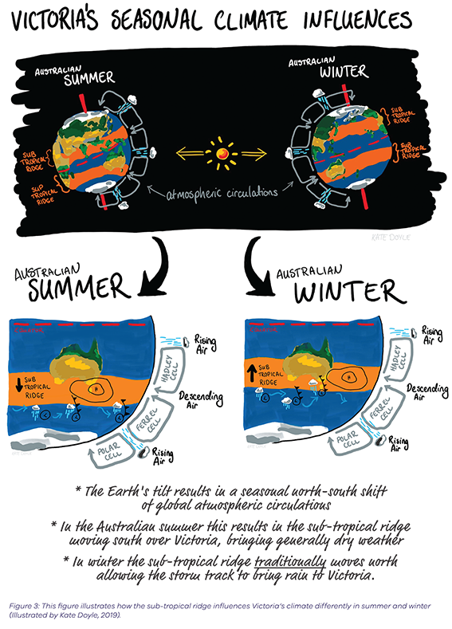

2.2.2 Large-scale climate drivers
The El Niño Southern Oscillation (ENSO) influences rainfall over much of Victoria on year-to-year time scales. During its El Niño phase, Victoria generally experiences hotter and drier conditions, especially in winter and spring (Power et al., 1999a). During a La Niña, Victoria experiences cooler and wetter conditions in winter, spring and summer (Power et al., 1999a; Risbey et al., 2009; Hope et al., 2017) (Figure 4).
The Indian Ocean Dipole (IOD) works on the same times scale as ENSO. It influences the region to the northwest of Australia and that can in turn influence Victoria’s rainfall in winter and spring, but generally not through into summer. In its positive phase, the IOD is generally linked to below-average rainfall in Victoria. A negative IOD typically is linked to above-average rainfall (Ashok et al., 2003).
Both the IOD and ENSO have strong individual influences on Victoria’s climate (Pepler et al., 2014). When occurring at the same time, the two drivers may reinforce each other – the combination of an El Niño and positive IOD has contributed to some of the driest June to October periods in Victoria. Strong positive IOD events are linked to heatwaves, which dry out the environment and increase the risk of bushfires (Cai et al., 2009).
The year-to-year variations associated with ENSO and the IOD are affected over longer time periods by the Interdecadal Pacific Oscillation (IPO) (Power et al., 1999a). During the cold phase of the IPO (which is La Niña-like) there is an increased tendency for positive IOD events to occur in conjunction with La Niña, which lessens the higher rainfall usually associated with La Niña events (Hope et al., 2017).
The Southern Annular Mode (SAM) varies on shorter timescales (approximately two weeks) and changes through positive, neutral and negative phases (BoM, 2019). It has the strongest influence on Victorian rainfall in winter, where a positive SAM typically indicates lower rainfall. A positive SAM in spring or summer tends to result in enhanced rainfall in Victoria (Hope et al., 2017).
Like the IOD, the SAM can enhance the influence of ENSO. Heavy spring rainfall in Victoria during the major La Niña event of 2010 was enhanced by a positive SAM. Conversely, drought conditions from an El Niño in 2002 were drier due to a negative SAM in spring (Hope et al., 2017).
Learn more about the large-scale climate drivers influencing Victoria’s rainfall in the Victorian Government’s Climate Dogs animations at http://agriculture.vic.gov.au/agriculture/
weather-and-climate/understanding-weather-and-climate/climatedogs.

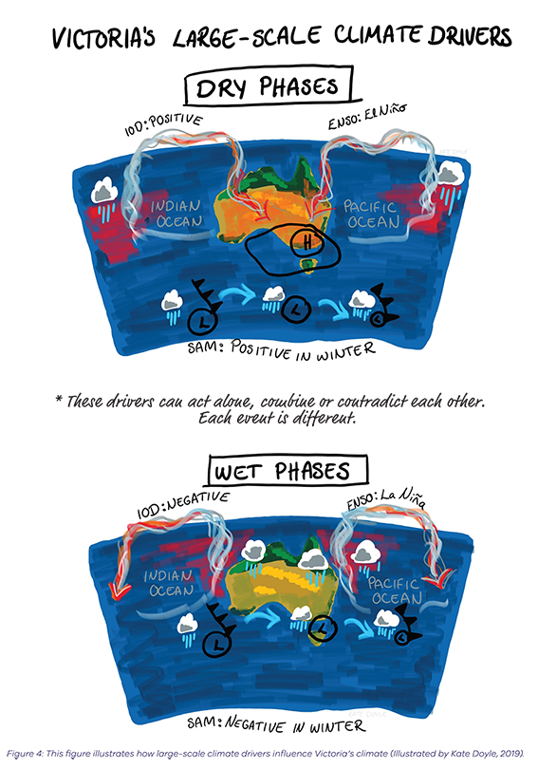
2.3 Victoria’s climate has changed
2.3.1 Warmer and drier
Victoria’s climate has warmed by just over 1.0°C since official records began in 1910 (BoM, 2019). There have been many more warm years than cool years since the 1960s. Using the standard baseline of 1961–1990, the last year with below-average temperature was 1996 (CSIRO, 2019) (Figure 5).
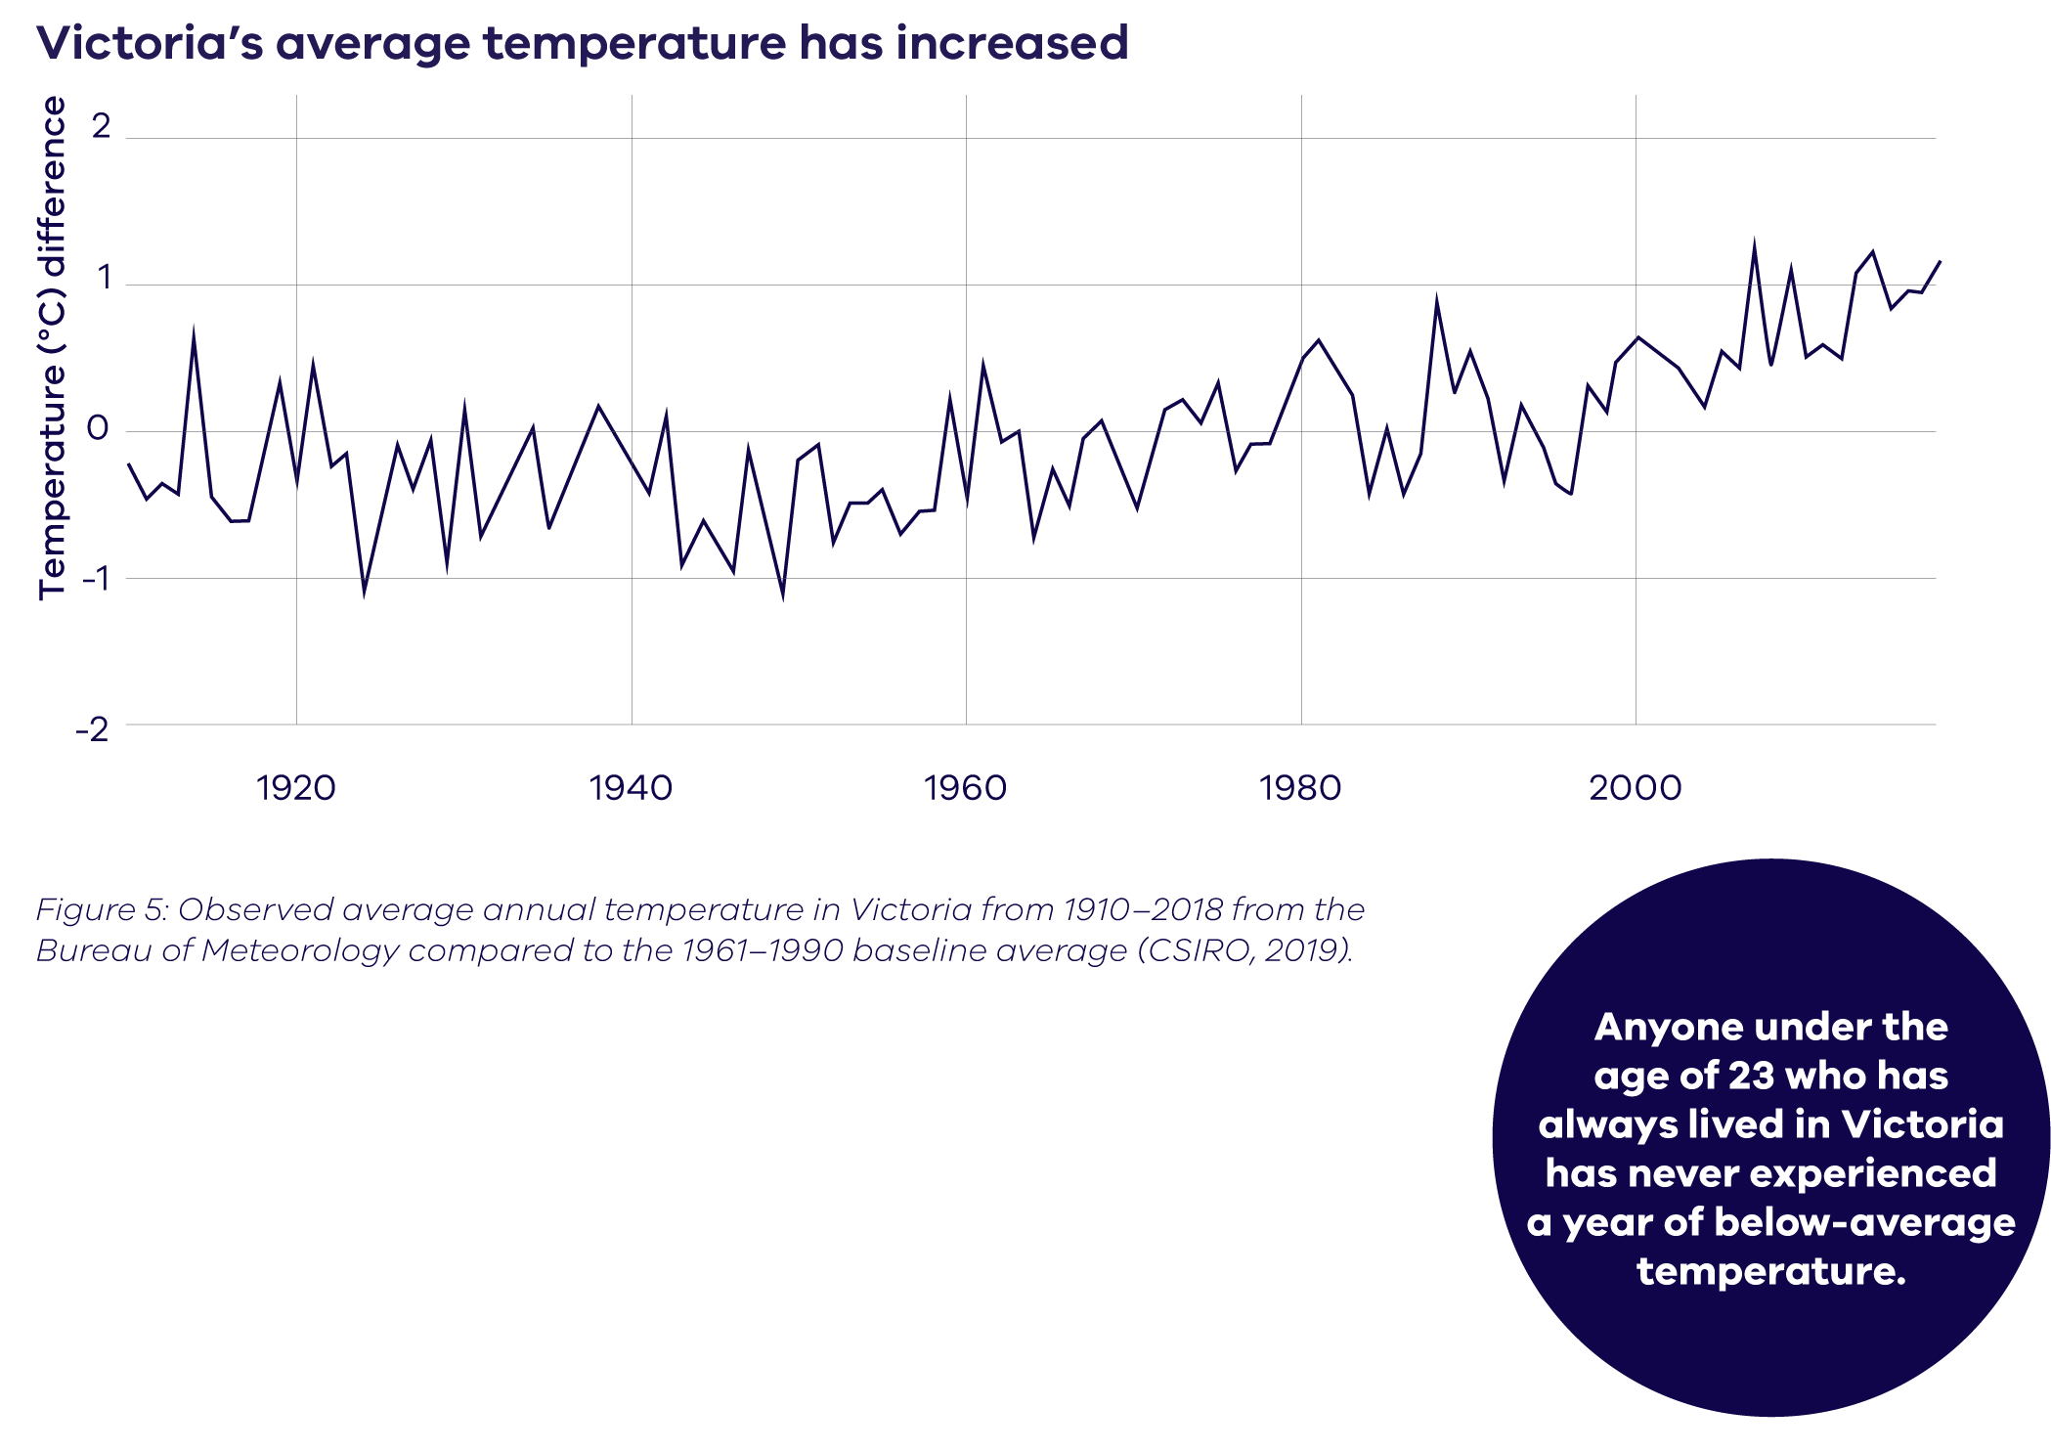
Victoria has also become drier, especially in the cooler months. Over the past 30 years, cool season rainfall has declined compared to last century (Hope et al., 2017) (Figure 6). This is due to changes in global wind and ocean movements in the Australian region that are consistent with global warming, although natural variability is also likely to be a factor.

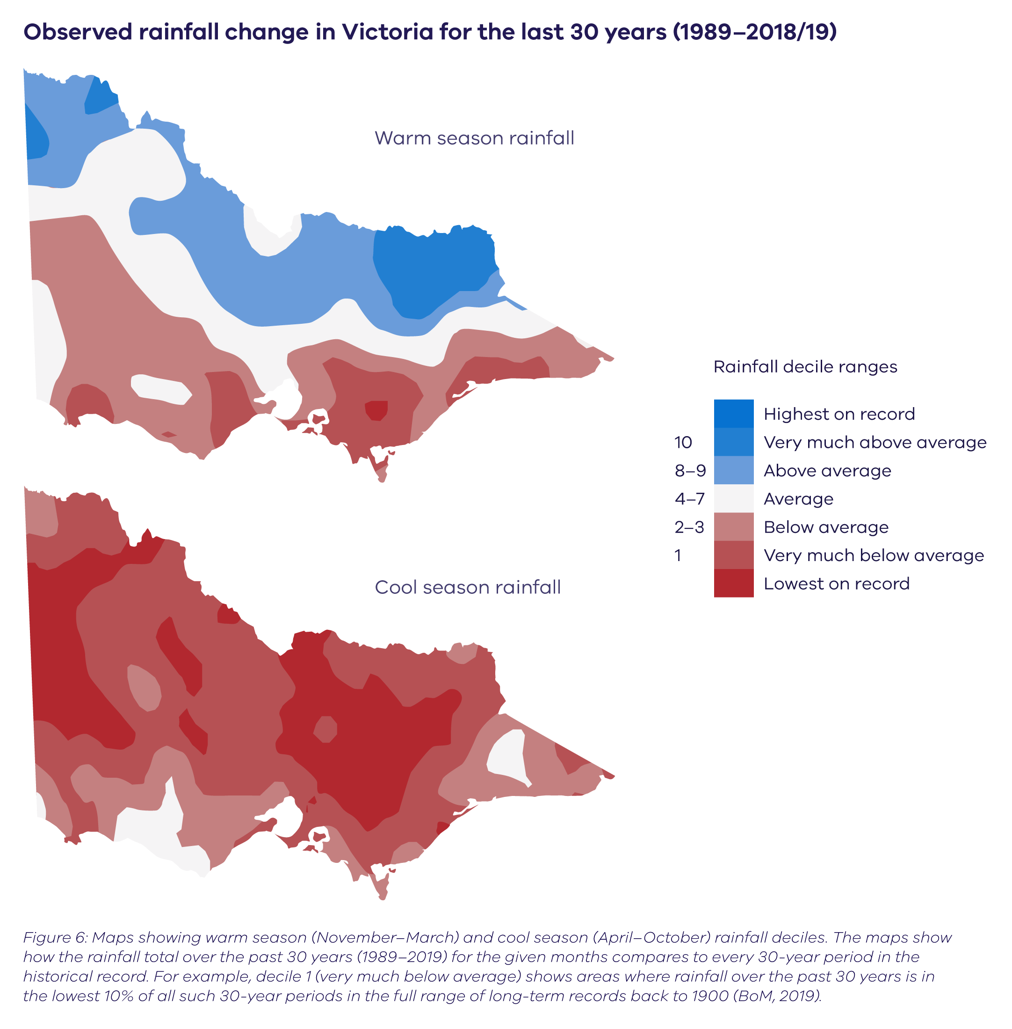

Victoria has also experienced an overall increase in the frequency of unusually hot days (Figure 7).
Extreme heat events already cost the Victorian economy on average $87 million a year, and this cost is projected to rise as heatwave events become more frequent (Natural Capital Economics, 2018)
2.3.2 Changing climate drivers
It is also possible that the large-scale drivers associated with natural rainfall variability in Victoria are changing, resulting in less rainfall from low-pressure systems and cold fronts than in the past (Pepler, 2018). However, the complex interactions between natural climate variability and climate change mean that the large-scale climate drivers influence the weather patterns very differently, depending on the season. This may result in, for example, rainfall reducing in some seasons, but increasing in others.
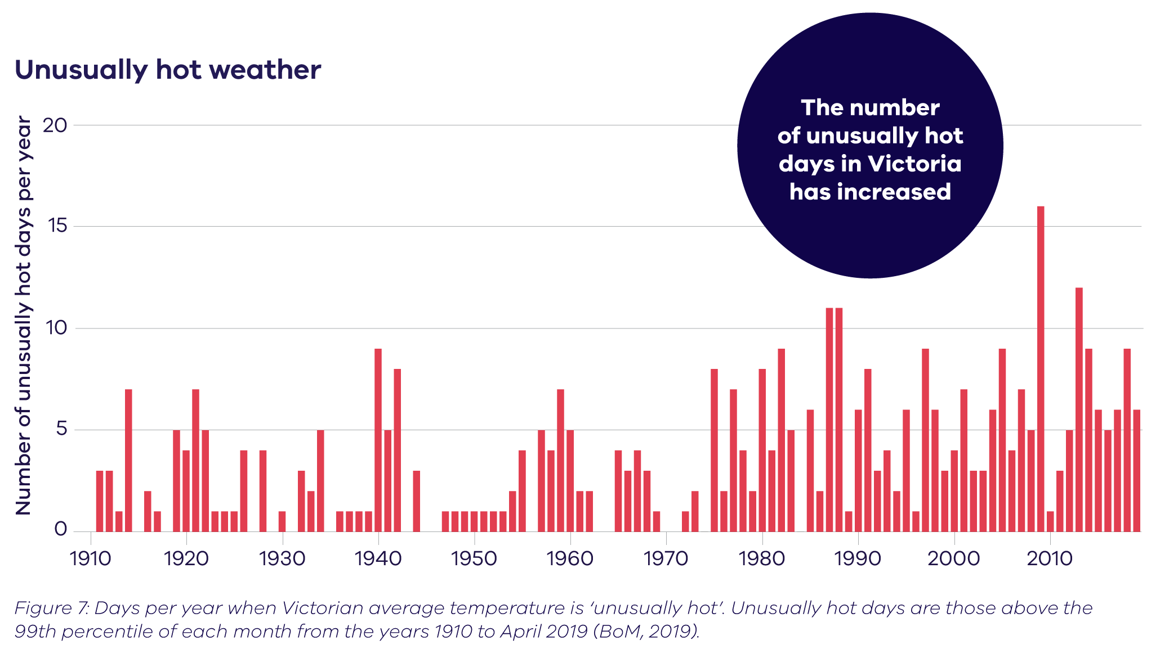
Due to the influence and interactions of large-scale climate drivers, decadal and year-to-year rainfall variability is still a dominant feature of Victoria’s climate within the overall drying trends. Victoria has experienced extended dry periods, such as during the Millennium Drought (from 1997 to 2009), and
seen occasional extremely wet years (e.g. 2010 and 2016) (Hope et al., 2017), due to natural variability, however global warming may have also been a factor. To put this in context, palaeoclimate archives (e.g. tree rings, ice cores, corals and sediment records) suggest that the Millennium Drought covered a larger area and was longer than any other drought in southern Australia over the past 400 years (Freund et al., 2017).
Changes in weather systems that have been linked to global warming include:
- a southerly shift in the mid-latitude storm track that brings rainfall to Victoria in the cooler months of the year (Hope et al., 2015)
- an intensification of the sub-tropical ridge that
is linked to drier conditions, and has an influence on the amount of rain associated with the mid-latitude storm track (Grose et al. (2015b)
- an expansion of the Hadley Cell (Nguyen, 2015), possibly contributing to reduced cool-season rainfall and enhanced summer rain (Hope et al., 2017).
In recent decades there has also been a trend towards a positive SAM in winter that has contributed to reduced cool-season rainfall (Hope et al., 2017).

2.3.3 Sea level
Sea level rises due to ice sheets on land melting and sea water expanding as it warms. However, sea level does not rise uniformly and varies locally due differences in coastal topography and nearshore processes. Tide gauges show that Victoria’s mean sea level has been increasing, with average increases between 1.57 cm and 5.31 cm per decade between 1993 and 2017. Melbourne (recorded at Williamstown), has the longest continuous record of observations in Victoria, and reported an average increase in mean sea level of 1.95 cm per decade (that is, approximately 2 mm per year) since 1966.
2.3.4 Fire danger
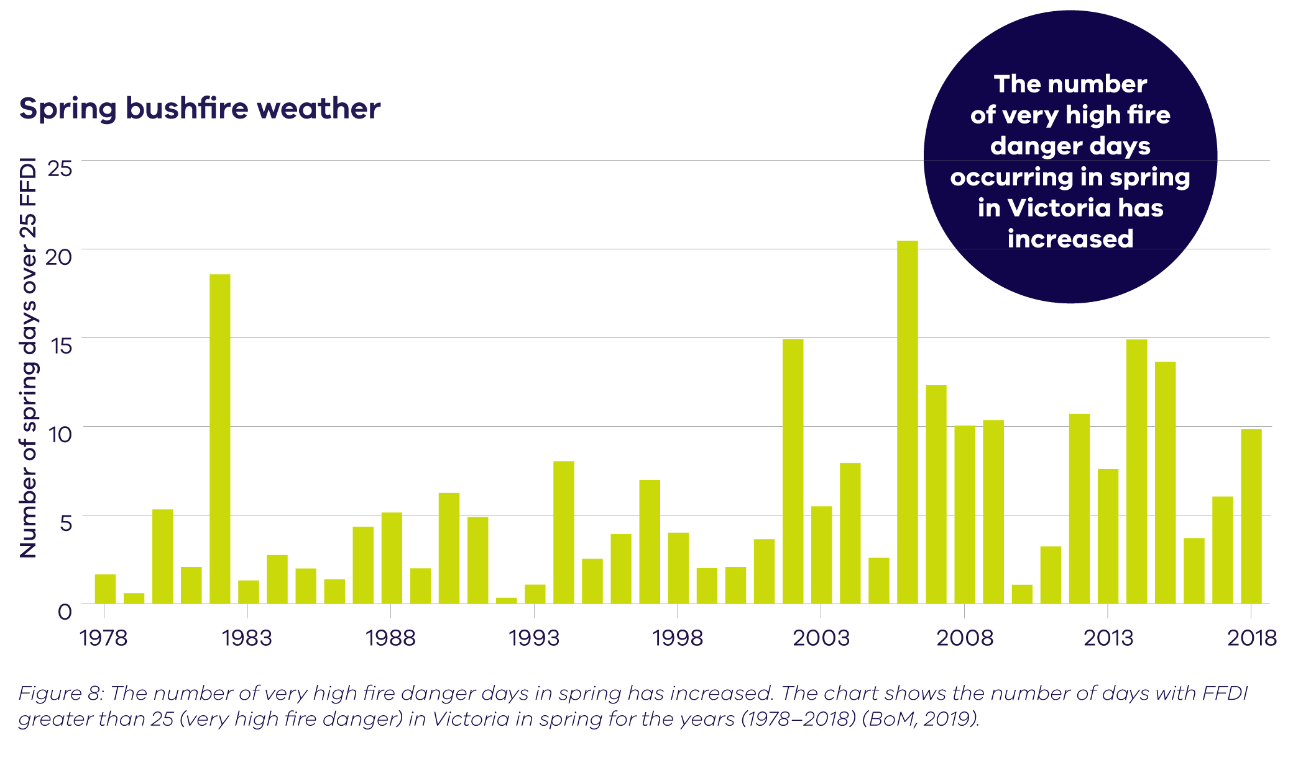
There has been an increase in dangerous fire weather and the length of the fire season across southern Australia since the 1950s (BoM and CSIRO, 2018). Fire weather in Victoria is largely measured using the Forest Fire Danger Index (FFDI). This index estimates the fire danger on a given day based on observations of temperature, humidity, wind speed and fuel (based on factors including recent temperature and rainfall). Although considerable year-to-year variability also occurs, there is a trend in more recent decades towards a greater number of very high fire danger days in spring (Figure 8).
2.3.5 Snow
A decline in snow accumulation and the extent
of snow cover has been observed since the 1950s across the Victorian Alps, with the largest declines during spring (Timbal et al., 2016). These changes are closely linked to increasing daily maximum temperatures in winter (Davis, 2013), which is projected to continue to increase in the future.

Impact of the changing climate on streamflow
Across the state, there have been significant reductions in streamflow. An analysis conducted in the Victorian Climate Initiative (VicCI) (Hope et al., 2017) found that the declines varied between about 25% and 75% (1997–2014 compared to 1975–1997), with relative declines typically larger in western Victoria, and smaller in the alpine areas. While the Millennium Drought was a large factor in the reduction in rainfall over the past 20 years, it was influenced by both natural variability and climate change.
3.0 Understanding climate science
In a changing climate, the climate experienced over the long-term past is no longer a good indicator of the climate we can expect in the future. Instead, we rely on climate models to project possible future climates.

Climate models help us to understand the
changes that are already happening and plan
for the changes to come. There is a high level
of consensus around the science underpinning
these models to provide robust projections
of the future climate.
3.1 Modelling the future climate
Climate scientists use climate models to create simulations of the Earth’s climate system to help
us understand our changing climate. The models
are a complex series of mathematical equations based on the fundamental laws of physics that simulate the dynamics of the atmosphere, oceans and ice. The simulations they produce indicate
how temperature, rainfall, wind and other
climate variables can change over a region, for different greenhouse gas concentrations.
3.1.1 Model resolution
Global climate models typically use a grid cell size
of 100–200 km, so they can adequately represent the national to regional scale changes in climate.
All locations within a grid cell are modelled as having the same climate, so large-scale features like fronts are represented, but the resolution is too coarse to represent individual thunderstorms, or to represent the interactions between weather and topography in mountainous regions.
To better represent local climate distinctions
and future weather, simulations from global
climate models can be downscaled to produce higher-resolution simulations for local areas. Downscaling can improve the representation
of extreme events and the influence of landscape features like mountains, coasts and urban heat islands on the local climate. There are two main types of downscaling: statistical and dynamical.
In statistical methods of downscaling, local climate is represented by establishing a statistical relationship between broader-scale and local-scale variables.
In dynamical downscaling, a regional climate model contains the same underlying physics as global climate models but can be processed at a higher spatial resolution in order to better resolve weather phenomena and regional influences over a smaller area (CSIRO, 2019).
This is demonstrated in Figure 9 where downscaling global climate model simulations to a 5 km x 5 km scale can better represent the mountains in the Victorian alpine regions (CSIRO, 2019).
3.1.2 Representing emissions
The concentration of greenhouse gas emissions
is an important component of climate modelling. Because we do not know what social, economic and technological pathways (which determine greenhouse gas emissions) will be followed over time, climate scientists use a set of four standard emissions scenarios (Representative Concentration Pathways or RCPs, see Table 1) to project
a reasonable range of possible future climates. Having consistent emissions scenarios allows comparison between studies and validation of results. Considering the results from multiple RCPs allows us to plan for a range of possible futures, making sure that our responses are robust across different future scenarios.
3.1.3 Global modelling efforts
The World Climate Research Programme’s Coupled Model Intercomparison Project (CMIP) is a global modelling experiment that facilitates the analysis of climate model performance. Simulations submitted to CMIP follow a standard framework, which allows the simulations to be compared. These simulations are used by climate scientists across the world.
Phase 5 of the project (CMIP5) incorporated over 40 global climate models that represent both oceanic and atmospheric processes. This modelling formed the basis for the Intergovernmental Panel on Climate Change (IPCC) Fifth Assessment Report (IPCC, 2013). A new global modelling effort, CMIP6, has seen improvement in the way the models represent the weather systems, clouds and aerosols. The results from these models will form the foundation of the IPCC’s Sixth Assessment Report due in 2021.
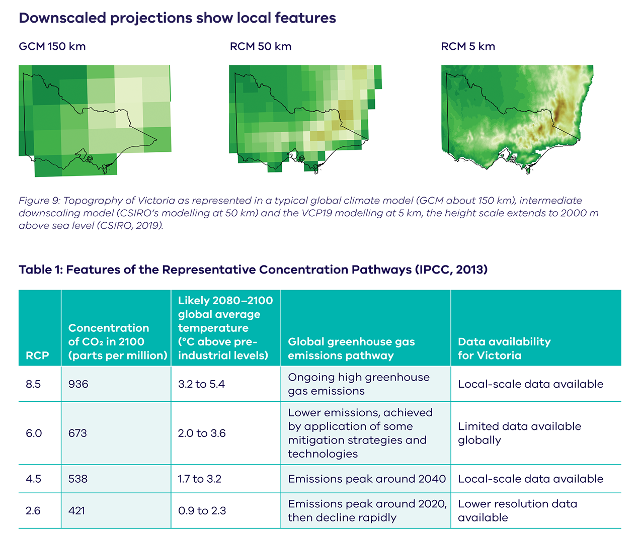
3.2 Climate science assessment
The IPCC is a United Nations body tasked with evaluating the global state of knowledge of the science and processes of climate change, the vulnerability of natural and human systems to climate change, options for reducing greenhouse gas emissions and adapting to the changes. IPCC assessment reports are drafted by large teams of leading scientists, drawing on the work of thousands of researchers, and extensively reviewed by 194 governments across the world before being published.
In 2013, the IPCC released its Fifth Assessment Report (IPCC, 2013) on the current and future state of the climate system, based on CMIP5 models. The report made several important conclusions:
- Greenhouse gas emissions have markedly increased because of human activity.
- Human influence has been detected in:
  - warming of the atmosphere and the ocean
  - changes in the global water cycle
  - reductions in snow and ice
  - global mean sea level rise
  - changes in some climate extremes.
- It is extremely likely that human influence has been the dominant cause of the observed warming since the mid-20th century.
- Continued emission of greenhouse gases will cause further warming and changes in all components of the climate system.
The IPCC also releases occasional special reports. The Special Report on the Impacts of Global Warming of 1.5°C above Pre-industrial Levels (IPCC, 2018) reported on the practical differences between 1.5°C and 2°C of global warming. The recent Special Report on Climate Change and Land (IPCC, 2019a) outlines the adverse effects of climate change on food security and terrestrial ecosystems, and the contribution of climate change to land degradation.
3.3 National climate projections
In 2015, following the release of the IPCC Fifth Assessment Report (IPCC, 2013), the Commonwealth Scientific and Industrial Research Organisation (CSIRO) and the Australian Bureau of Meteorology (BoM) released climate change projections for Australia which, like the IPCC Fifth Assessment report, used modelling from CMIP5. Victoria is represented in these national projections as part of the Murray Basin and Southern Slopes regions (CSIRO and BoM, 2015).
Every two years, CSIRO and BoM also publish a State of the Climate report that synthesises current climate observations and science. The 2018 report (BoM and CSIRO, 2018) notes:
- Australia’s average temperature has increased by more than 1°C since 1910.
- Extreme heat events have increased in frequency.
- Cool season rainfall (April to October) across southeastern Australia has declined since the late 1990s.
- Extreme fire weather has increased in frequency and duration.
- Sea levels have risen, leading to increased inundation risk for coastal areas.
The Earth Systems and Climate Change Hub, established in 2015 under the Australian Government’s National Environmental Science Program, is a partnership between CSIRO, BoM and universities. It aims to improve our understanding of how the Australian climate has changed and may change in the future, as well building the utility of climate change information and projections.
3.4 Climate science for Victoria
A major focus of Victorian Government support for climate science over the past decade has been to build our understanding of how climate change will affect Victorian water resources. In addition, to help support statewide adaptation planning, new local-scale future climate projections have also been produced for Victoria.
The Victorian Climate Initiative (VicCI), was a tailored program of water sector research, which built on earlier research including the South East Australian Climate Initiative (SEACI) and looked at past, present and future climate and hydrology. Future climate projections produced as part of the VicCI program are based on the CMIP5 models using statistical, empirical and dynamical methods of downscaling (e.g. Potter et al., 2016). To continue to provide the Victorian water sector with tailored climate and hydrology research and guidance, the Victorian Government is currently investing in the Victorian Water and Climate Initiative (VicWaCI) to gain further insights into the challenges that climate change poses to water resources. For more information, see https://www.water.vic.gov.au/climate-change.
In 2016, as part of the Victorian Government’s VicCI program, BoM released a summary of climate science for Victoria, presenting the state of knowledge on Victoria’s past, present and future climate (Timbal et al., 2016). The future climate information was based on the 2015 national-scale projections (CSIRO and BoM, 2015).
These projections were also the basis for the Victorian Government’s Climate-ready Victoria publications, released in 2016.
A new Victorian Government program has provided local-scale climate projections for Victoria. The Victorian Climate Projections 2019 (VCP19), developed by CSIRO’s Climate Science Centre, are statewide dynamically downscaled climate projections at a 5 km x 5 km spatial resolution to the 2090s.
High-resolution outputs are important for Victoria due to the state’s varied topography and long coastline, and allow us to better understand changes in our alpine regions, coastal areas and agriculture regions. Projections are available at short time intervals (e.g. hourly), which is important for understanding extreme weather events, such as localised intense rainfall. The VCP19 project describes how the climate of Victoria may respond to global warming under the IPCC’s medium and high emissions scenarios (RCP 4.5 and 8.5). The scenarios were chosen to provide a range of possible futures to assess the risks of climate change and inform appropriate adaptation decisions.
In VCP19, the new local-scale projections are presented alongside results from previous modelling work. In order to understand the full range of possible future climates, it is necessary to consider all available modelling for Victoria, and to regularly update our estimates with the newest generation of models (e.g. CMIP6).

4.0 Victoria’s future climate
Climate projections provide a representation of a possible future climate that can be used in planning and decision making when they are interpreted correctly. Projections for Victoria indicate the state is likely to become hotter and drier in the future, but the timing and extent of changes will vary across regions. Projections are always given as a range, so also provide detail about the less likely but still plausible scenarios.

This section explains how to interpret projections and presents a summary of the latest climate projections for Victoria out to the 2090s, including the VCP19 local-scale climate projections, results from VicCI research and national lower-resolution projections.
4.1 Interpreting projections
There is a lot of meaning wrapped up in projections statements. To use climate change projections appropriately, it is important that they are interpreted correctly.
Consider this example: By the 2090s, average maximum temperatures are projected to increase by 2.8 to 4.3°C compared to 1986–2005 (high confidence).
The first thing to be aware of is that climate projections are not predictions or forecasts. They cannot provide specific timing and sequences of changes, but instead provide a possible range for given climate variables.
Similarly, the future years given in climate projections (e.g. 2030, 2090) represent a period, centred on that year. The Victorian projections use a 20-year period. Looking at our example, ‘by the 2090s’ means the average maximum temperature for the period 2080 to 2099.
To measure a change, you need something to measure it against, so all projections are a change relative to a baseline period. Consistent with the IPCC, projections in this publication use 1986–2005 as the baseline, unless otherwise noted. It is difficult to define a baseline that represents the ‘current’ climate, so it is important to understand which period has been used as the reference (or baseline) from which to measure future changes.
The projected temperature increase is calculated by the difference between a climate model’s future and baseline values for a given emissions scenario.
What the given range of results represents may vary from study to study. It may represent the spread of results across all the models used, the 10th to 90th percentile result or another range entirely. Before using the range for policy and decision making it is important to be clear about what the range shows.
Confidence in projections is determined by how well we understand the physical climate processes, how well those processes are simulated in climate models, agreement between climate models and if projected changes are consistent with recent observed trends. Projections with higher confidence can inform choices more definitely.
4.2 Major climate influences
4.2.1 Weather systems
The westerly winds and associated weather systems, such as the subtropical jet, are projected to weaken over Australia and/or move further south (Grose et al., 2017a; Grose et al., 2019a).
Fewer blocking highs in the Tasman in winter are projected in the future (e.g. Grose et al., 2017) meaning less rainfall for eastern Victoria. The projection of blocking highs in summer is less clear (CSIRO, 2019).
These changes are expected to contribute to a decline in Victoria’s cool season rainfall, potentially leading to reduced runoff into rivers and dams, and less reliable filling of our water storages.
4.2.2 Climate drivers
ENSO and IOD will remain major factors affecting the climate of Victoria, including the possibility of more extreme El Niño and La Niña events (Cai et al., 2015), and a change to its influence on rainfall (Power et al., 2013; Power and Delage, 2018). However, the future of ENSO is unclear, partly because climate models cannot simulate it reliably (Cai et al., 2015).
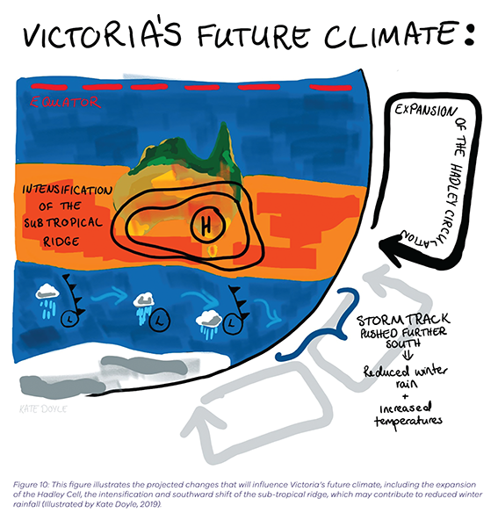
Similarly, the projected continuation of the current trend of SAM spending more time in the positive phase (especially in winter) may contribute to rainfall decline in Victoria (CSIRO, 2019).
As the Indian Ocean warms, the nature of the IOD and/or its influence on Victoria’s rainfall could change (CSIRO, 2019). A shift towards a more positive IOD (Cai et al., 2013) is also associated with a drier climate (CSIRO, 2019).

4.3 Temperature
4.3.1 Average temperature
Victoria’s climate will continue to warm, with maximum and minimum temperatures increasing over this century (very high confidence).
By the 2030s, average temperatures in Victoria are projected to increase by between 0.55°C and 1.3°C when compared to 1986–2005 (Figure 11), and changes under all RCPs are similar. The increase in average temperatures also translates to an increase in extreme temperatures (see section 4.3.2) and more frequent hot days (see section 4.5.1). Comparison of the recent observed warming and the projections suggests that Victoria is tracking towards the upper limit of the projections (see Figure 12).
Despite this overall warming trend, we will still experience cold days, cool months, and short-term trends of little warming or even cooling in the future due to natural variability.
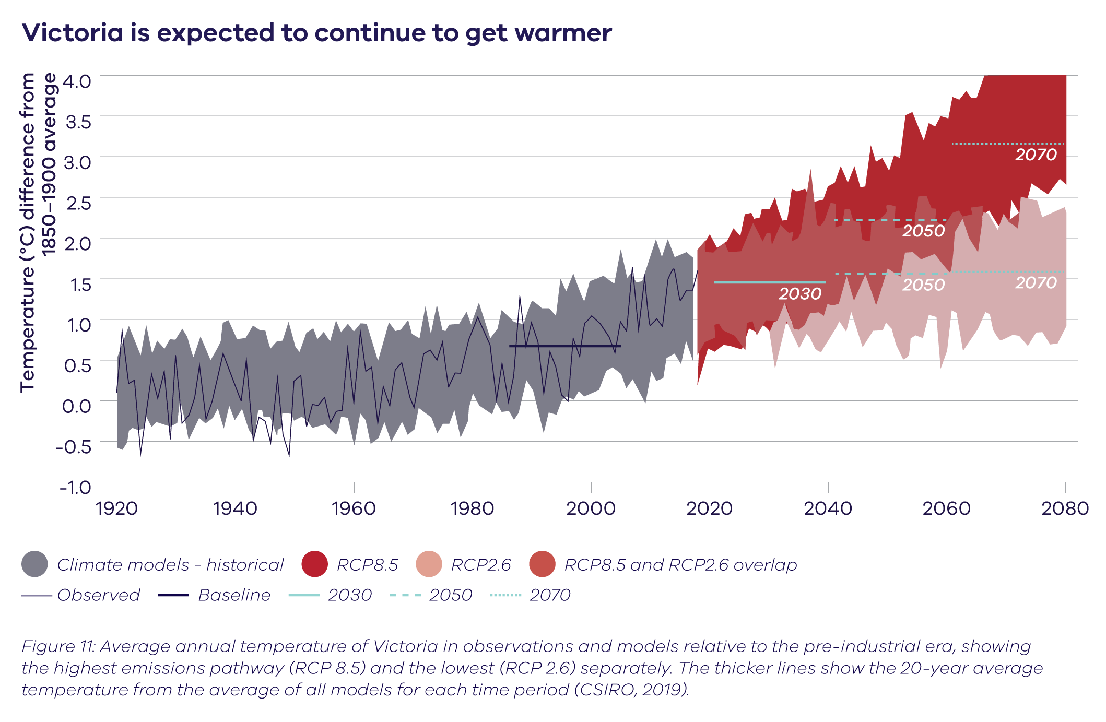
After 2030, the projected change in temperature depends strongly on the greenhouse gas emissions pathway that the world follows. By the 2050s, average temperatures in Victoria are projected to be 1.4 to 2.4°C warmer under a high emissions scenario (RCP 8.5) or 0.9 to 1.8°C warmer under a medium emissions scenario (RCP 4.5) compared to 1986–2005 (Figure 12). By the 2090s, average temperatures in Victoria are projected to be 2.8 to 4.3°C warmer under a high emissions scenario (RCP 8.5) or 1.3 to 2.2°C warmer under a medium emissions scenario (RCP 4.5) compared to 1986–2005 (high confidence). However, if the world succeeds in matching aspirations under the Paris Agreement to limit global warming to 2°C, then Victoria is also expected to warm by around 2°C in line with the global average. This is in contrast to other places in the world that will warm by much more (e.g. the Arctic) or less (e.g. the Southern Ocean) than the global average.
There are differences in projections between the local and global-scale models that demonstrate that there are important local-scale processes that act to affect temperature that cannot be captured by global models. For example, for Gippsland in spring, under a high emissions scenario by the 2090s, the upper range of average annual temperature change from global models was 3.9°C, but local-scale projections suggest the change could possibly reach 5.1°C. However, more analysis of this result needs to be done before we have high confidence in this projection.
4.3.2 Extreme temperatures
Changes to extreme temperatures are generally thought to increase by a similar magnitude as the average temperature, but with important regional exceptions where they can increase by more. For Victoria, new regional modelling suggests that under high emissions, extreme daily maximum temperatures could increase by as much as twice the rate of increase in the average maximum temperatures, and very large increases in high winter daytime and night-time temperatures are possible. This is found in climate model simulations with the greatest rainfall decrease, where a drier environment contributes to hotter extremes. For example, under high emissions by the 2090s, parts of Victoria could experience days of up to 55°C in summer and 33°C in winter (CSIRO, 2019).
While more work is needed to provide confidence in this result, it is in line with global projections that suggest an increased likelihood of “smashing” temperature records in the future (Power and Delage, 2019).
Very hot days can damage infrastructure and crops, and cause heat stress among vulnerable people and animals, as well as testing the resilience of health and emergency services and the provision of utilities.
An increased risk of frost is possible in some regions and seasons, such as spring, due to an increase in cold clear nights, at least in the short to medium term. In the long term, higher temperatures will tend to prevent frosts even on clear nights, leading to an overall decrease in their occurrence.
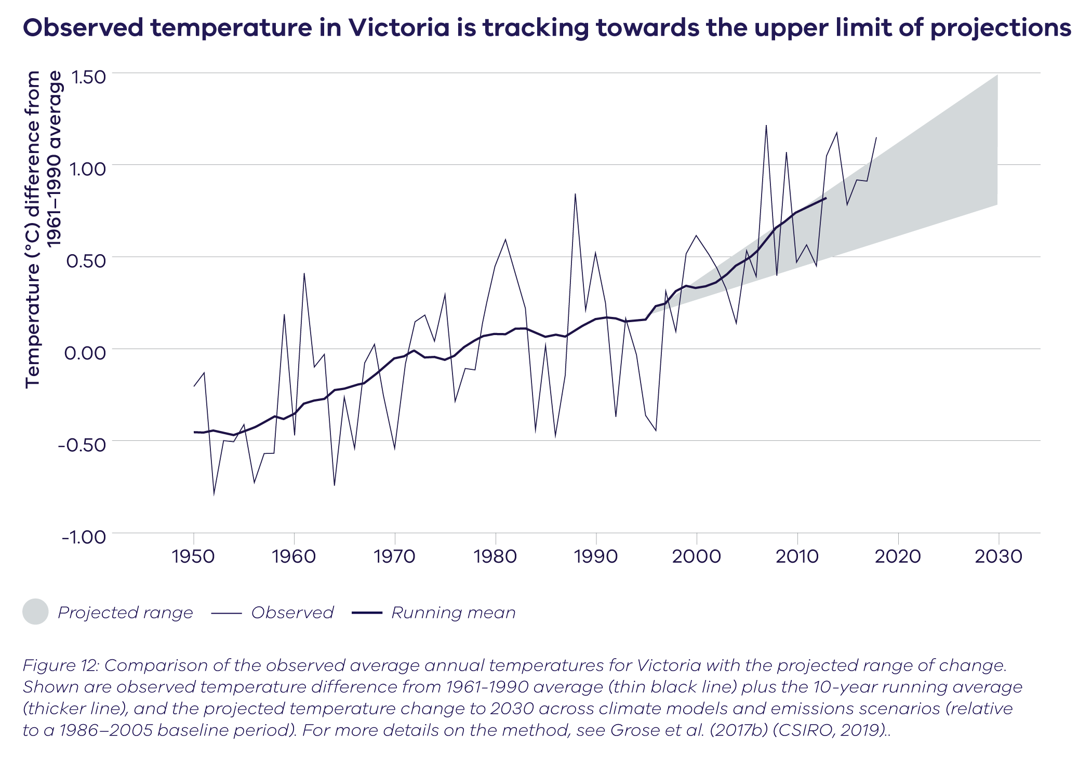
Climate extremes are by definition rare events, so accurately determining their current and future frequency and intensity is difficult and highly dependent on having a long record of climate observations.
4.4 Rainfall
4.4.1 Average rainfall
Victoria is likely to continue to get drier in the long term in all seasons except summer. The range of projections shows that little change, or an increase in rainfall is possible, however a drier future is most likely.
For short-term projections (to 2030s), observed winter rainfall declines are tracking at or below the dry end of the winter projections for many regions of southern Australia (Figure 13). This suggests either large decade-to-decade variability or that the projections underestimate the observed rainfall decline. Therefore, projections of a drier future seem to agree better with the recent observed rainfall trends in Victoria (see section 2.3.1). This is supported by our understanding of the changes to the large-scale climate drivers (Hope et al., 2017). Despite this overall reduction in rainfall,
Victoria will still experience some very wet years due to natural variability.
Rainfall is projected to continue to decline in winter and spring (medium to high confidence), and autumn (low to medium confidence).
Local-scale projections show greater reductions in rainfall on the windward (western) slopes of the Victorian Alps in autumn, winter and spring.
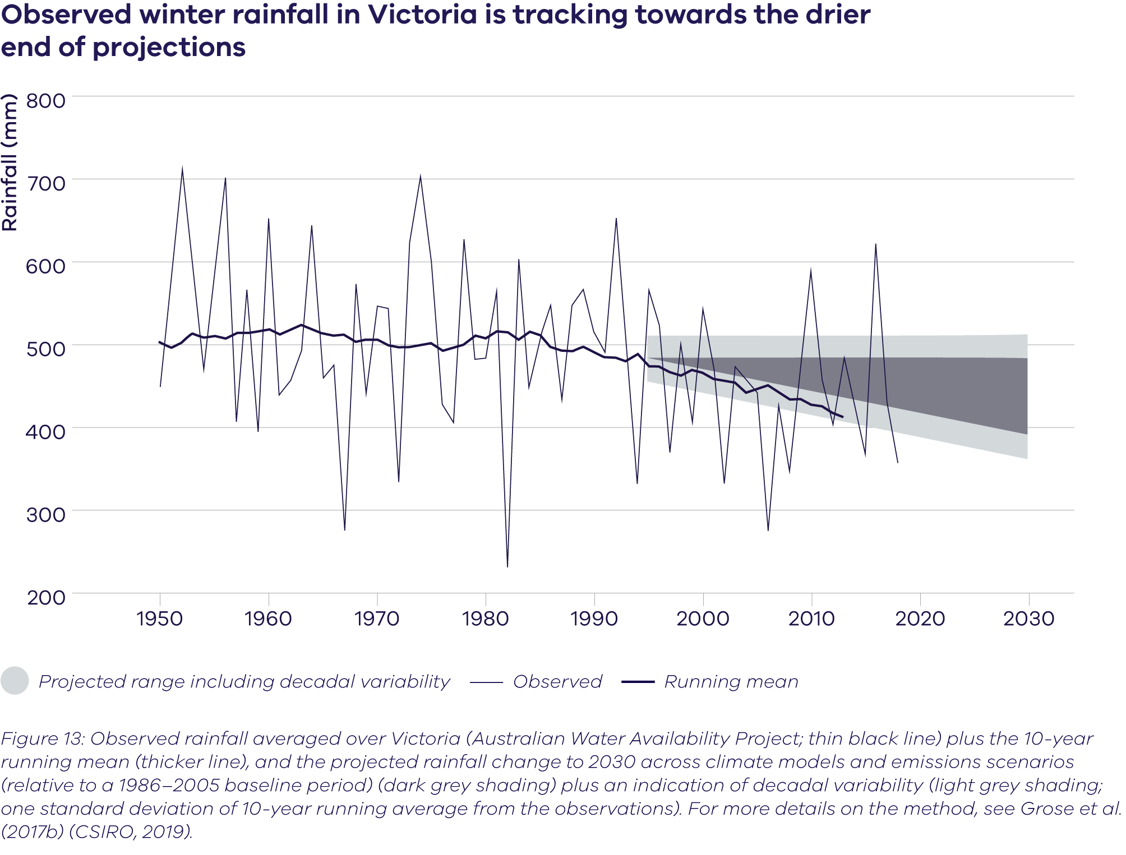
Rainfall projections are associated with very large uncertainties compared to temperature projections, because rainfall varies more in time and space than temperature. Rainfall also depends on more processes that are challenging to simulate reliably in models, such as atmospheric circulation and weather systems. This makes it difficult for climate models to accurately represent rainfall – even in local-scale modelling – and warrants a greater research focus. Therefore, it is important to assess the overall confidence in rainfall projections by considering the influence of changes to the large-scale drivers as well as the regional-scale influences.
4.4.2. Extreme rainfall
While Victoria is projected to likely receive less overall total rainfall in the future, extreme rainfall events are projected to increase (CSIRO, 2019).
Extreme rainfall events are expected to become more intense by the end of the century (high confidence) but when and where they will occur will remain highly variable.

Why will rainfall extremes get more extreme?
Even though a warming climate is leading to reduced annual rainfall totals in Victoria, extreme rainfall events, such as the flash floods north of Wangaratta in December 2018, are likely to get more extreme. The warmer the atmosphere, the more water vapour it can hold, and basic physics enables scientists to estimate that the intensity of extreme rainfall may increase by about 7% for each degree of warming.
Changes in atmospheric dynamics are also likely to cause heavier rainfall events when the conditions are right (Wasko et al., 2016). For example, extreme rainfall events have been associated with the combination of thunderstorms with other weather systems over Victoria (Dowdy and Catto, 2017). Together with a warmer atmosphere, this means that an increase of 14% has been observed in the most extreme short-duration rainfall extremes in Victoria (Guerreiro et al., 2018).
The processes that produce rainfall are highly complex and exactly how extreme rainfall is changing depends on the duration, place, season and the type of weather system bringing the rain. For example, rainfall during storms in summer is expected to become more intense, while rainfall associated with storms in autumn and winter may not change as much.
For more information, see https://www.water.vic.gov.au/climate-change

4.5 Regional changes in climate
It is important to understand how the climate is projected to change across the state, as it may not change in the same way in every region. Looking at projected changes regionally gives additional information that can be lost in statewide averages.
Regional summaries of the VCP19 projections and tables of key climate variables (annual and seasonal) are available at http://www.climatechange.vic.gov.au/vcp19.
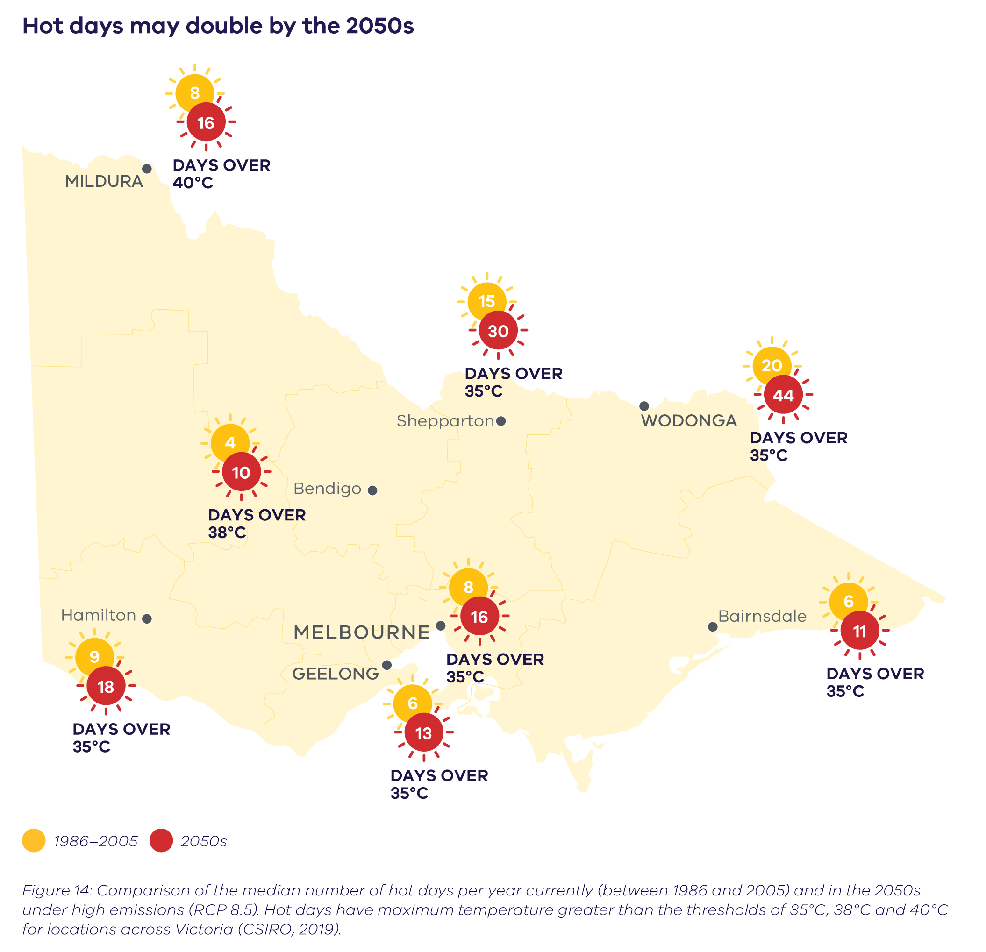
4.5.1 Regional temperature changes
The projected changes in temperature are higher inland compared to coastal regions: for example, the projected increase of maximum annual temperature for high emissions by the 2050s is 2.4°C (range of 1.6–3.1°C compared to 1986–2005), in the inland regions of Goulburn, Loddon Campaspe and Ovens Murray. In the coastal regions of Barwon, Greater Melbourne and Great South Coast, the projected increase of maximum annual temperature under high emissions is slightly lower, at 1.9°C (range of 1.4–2.6°C) by the 2050s (CSIRO, 2019).
While an average of 2°C increase may not sound like much of an impact, it can markedly increase the likelihood of hot days occurring. For example, between 1981 and 2010, Geelong experienced 6.4 days on average per year when the temperature was over 35°C. By the 2050s, this is expected to increase to 11 days on average per year (range of 8–13 days) for medium emissions and 13 days (range of 9–16 days) for high emissions. In Mildura, hot days over 40°C were experienced 8 days per year on average between 1981 and 2010. By the 2050s, this is expected to increase to 15 days on average per year (range of 12–16 days) for medium emissions and 16 days on average (range of 15–22 days) for high emissions (CSIRO, 2019).
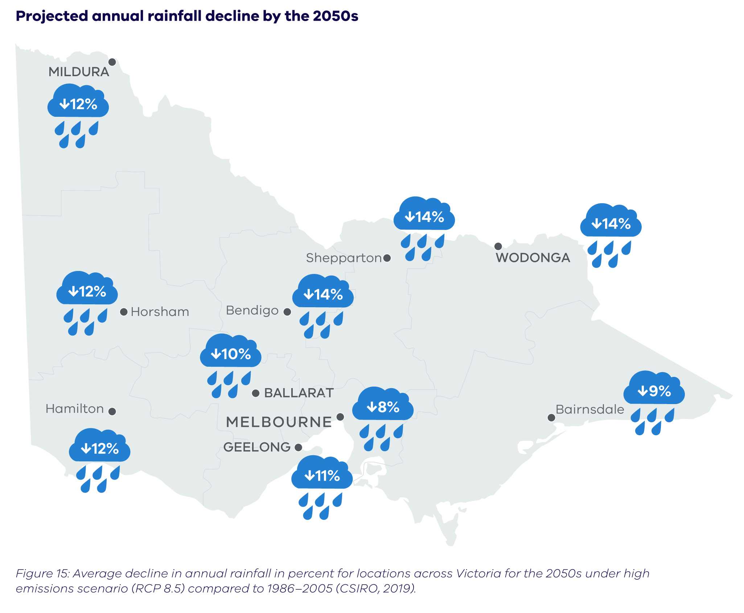
Figure 15 shows the results for hot days for other towns and cities across the state. The thresholds vary due to the differences in current climate: a 40°C day in the northwest currently occurs about as often as a 35°C day in Melbourne. Across the state, hot days are expected to approximately double between now and the 2050s under high emissions (Figure 14).
4.5.2 Regional rainfall changes
Annual rainfall is likely to decline across the state, with projected declines across autumn, winter and spring (CSIRO, 2019) (Figure 15). However, there will still be high year-to-year rainfall variability and the state is expected to see more extreme, short-duration rainfall despite this overall decrease in rainfall. The new local-scale projections suggest a greater decrease in the annual average rainfall on the windward (western) slopes of mountain ranges compared to the surrounding regions in autumn, winter and spring (see also Grose et al., 2019b). This is particularly noticeable in the projections for the Victorian Alps (CSIRO, 2019).
In response to the decline in rainfall, streamflow is also expected to decline. Future streamflow projections that take account of projected rainfall declines have been developed for the Victorian water sector (see section 5.1). Further research to better understand future streamflow projections is occurring through the VicWaCl.
Step-like changes in climate
Most climate projections presented here give a view of an ongoing climate change trend overlying natural climate variability. The climate change trend is presented as a smooth or incremental process, and climate variability is seen as a window or band where the climate varies around this baseline trend (CSIRO, 2019). However, climate variation and change can appear as steps and jumps, where temperature (or rainfall) changes by a relatively large amount in a short space of time (Jones and Ricketts, 2017). This is particularly important for considering the near-term climate to 2030: step-like changes may be much more notable and relevant than the smoother change associated with an underlying signal (CSIRO, 2019).
4.6 Fire danger
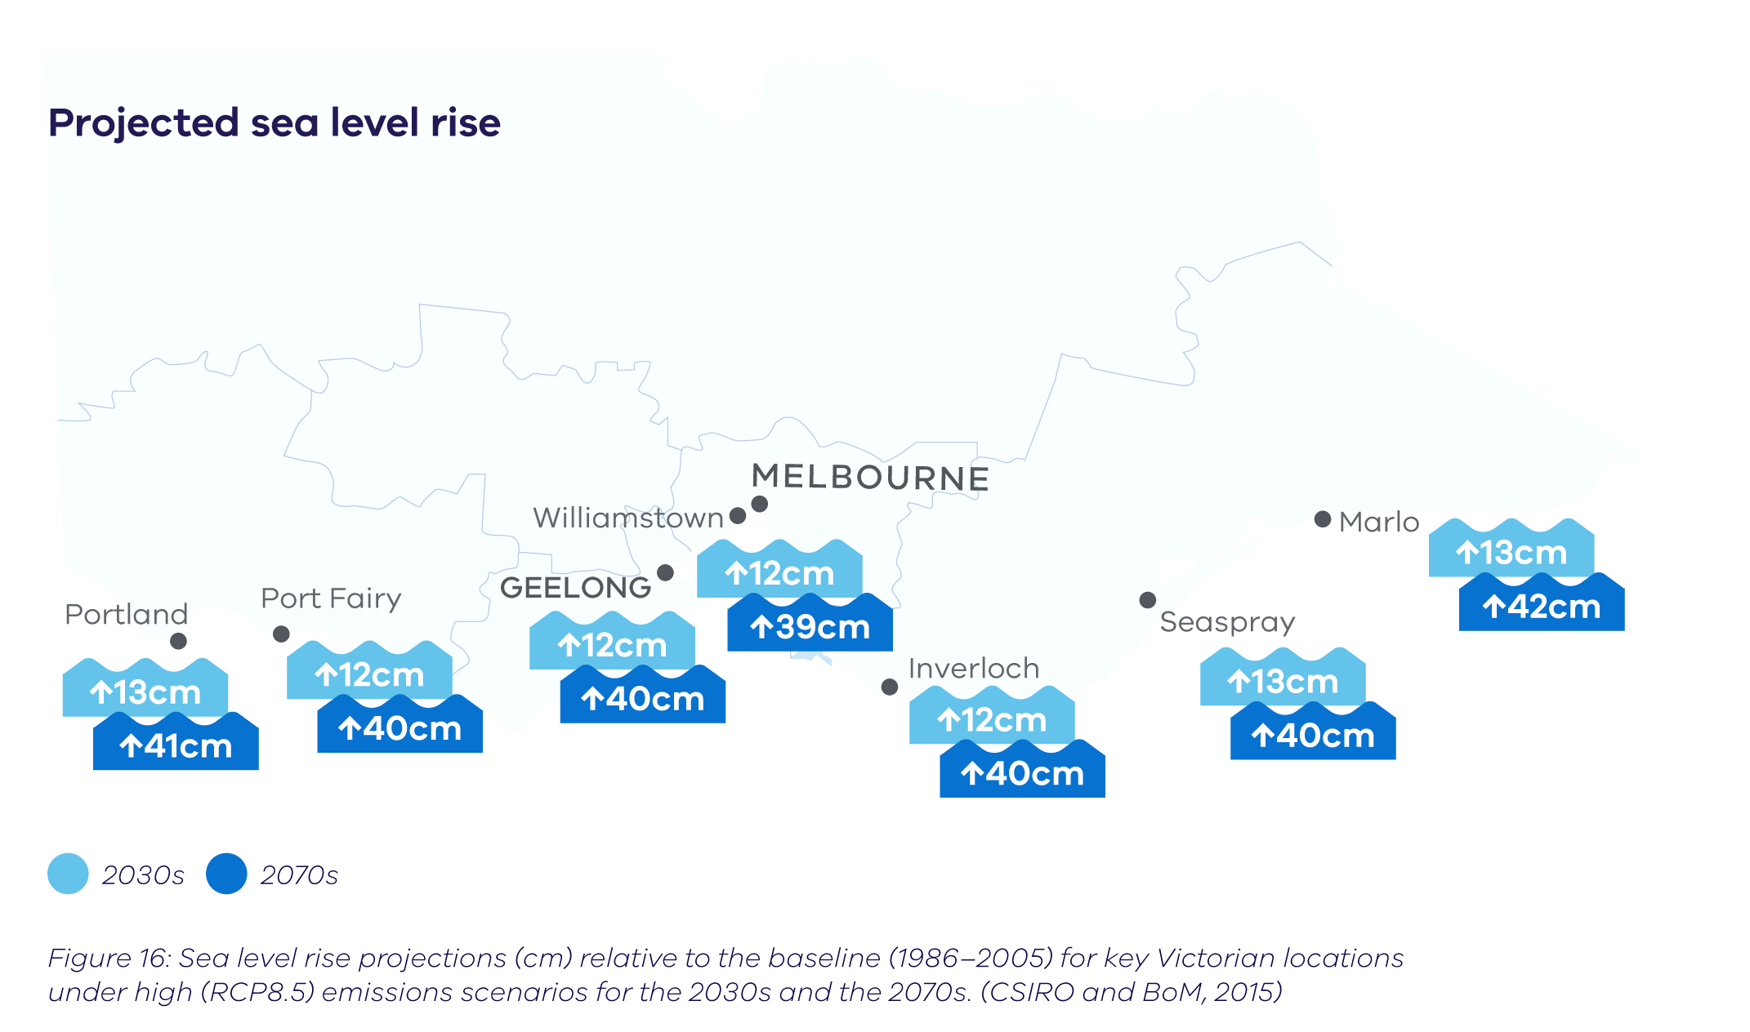
The number of high fire danger days in Victoria is expected to increase in the future, with a larger increase in fire days for alpine regions (CSIRO, 2019). By the 2050s under high emissions Bendigo, Ballarat and Shepparton show over a 60% increase in the projected number of high fire danger days compared to 1986–2005 (CSIRO, 2019). There may also be a greater occurrence of thunderstorms in the future. This is relevant as bushfires are often started by lightning.
It is important to note that these projections do not account for changes in fuel loads. Fuel loads are affected by rainfall and fire frequency.
The projections align with other studies (Dowdy et al., 2019) that show a clear trend towards more dangerous conditions for bushfires in Australia into the future. The risk of pyroconvection – where heat and moisture generated by bushfires creates clouds and thunderstorms – is projected to increase in some regions of southern Australia. In extreme cases, pyroconvection can lead to very dangerous bushfire conditions, such as occurred for Victoria’s Black Saturday fires of 2009 (Dowdy et al., 2019).
4.7 Snow
In the future, snow depths and snow extent are projected to continue to decrease (high confidence), due to reductions in snowfall and increases in snow melt due to projections of increasing maximum daily temperatures in winter (CSIRO, 2019; CSIRO and BoM, 2015). Snow depth is also influenced by large-scale drivers such as the ENSO and the IOD (Pepler et al., 2015) which may also be affected by global warming (Power et al., 2013; Cai et al., 2015). For more detailed analysis of the projected changes in snow, see the national climate projections and other previous studies (Nicholls, 2005; Harris et al., 2016; Bhend et al., 2012; Hennessy et al., 2008; CSIRO and BoM, 2015).
4.8 Sea level rise
4.8.1 Mean sea level
Future rises in sea level are projected with high confidence. Sea level rise projections for key areas in Victoria are based on the 2015 national sea level projections (CSIRO and BoM, 2015). By the 2030s, sea level is projected to rise by around 12 cm (7–18 cm) (relative to 1986–2005) under medium (RCP4.5) and high (RCP8.5) emissions scenarios. By the 2070s, the emissions scenario has greater impact, with increases of around 32 cm (20–46 cm) under RCP 4.5, but up to 42 cm (26–54 cm) under RCP 8.5. The projections for RCP 8.5 for the 2030s and the 2070s have been summarised in Figure 16.
Rising sea levels result in an increased risk of coastal erosion and inundation – threatening coastal ecosystems, local landscapes and crucial infrastructure.
Greater changes in sea level may occur. For example, if the West Antarctic ice sheet destabilises, the global average sea level could rise by an additional tens of centimetres this century (Grose et al., 2015a; IPCC, 2019b). In the much longer term, irreversible melting of ice sheets could lead to many metres of sea level rise (IPCC, 2019b). In the IPCC’s Special Report on the Ocean and Cryosphere in a Changing Climate (IPCC, 2019b), projections of global sea level rise by 2100 for high emissions are greater than in the previous Fifth Assessment Report due to a larger contribution from the Antarctic ice sheet (medium confidence).
4.8.2 Extreme sea level events
Sea level rise not only results in changes in mean sea level but can also change the frequency and intensity of extreme sea level events, such as storm tides that occur when high tides combine with strong winds and low-pressure systems. Even a 50 cm increase in mean sea level would contribute to a significant increase the hazards of extreme sea levels, such as coastal erosion and flooding. For example, a 1-in-100-year storm tide height in Geelong is likely to rise from 110 cm to 220 cm by the end of the century for a high emissions scenario (McInnes et al., 2013).
The Port Phillip Bay Coastal Hazard Assessment is investigating the extent of land expected to be threatened by the coastal processes of erosion, inundation, and groundwater change. The study will also model the impacts of sea level rises of 0.5 m, 0.8 m, 1.1 m and 1.4 m to account for extreme sea level events. The results of the study, available mid-2020, should provide insights and guidance for future coastal planning decisions. For more information: https://www.marineandcoasts.vic.gov.au/coastal-programs/port-phillip-bay-coastal-hazard-assessment.
4.8.3 Waves
Rising sea levels are not the only potential impact on our coasts. New wave modelling suggests that wave conditions may change for over 50% of the world’s coastlines (Morim et al., 2019).
Changes to the directions of waves can change current patterns of sand erosion and movement along the coast – an important consideration for coastal adaptation.
Compound extremes
Different climate or weather extremes occurring simultaneously or in succession can have greater impact than those extremes on their own. This might be an extreme storm surge coinciding with high rainfall to cause severe coastal inundation, (e.g. the flooding of the Yarra river in Melbourne in June 2014) or a heatwave occurring during a period of drought, exacerbating the impact (e.g. weather conditions leading up to Victoria’s Black Saturday bushfires in 2009).
Victoria’s Black Saturday bushfires occurred toward the end of the decade-long Millennium Drought, during one of the hottest and driest summers on record, and immediately following a record-breaking heatwave across Victoria (Commissioner for Environmental Sustainability, 2012). On Saturday 7 February 2009, the temperature in Melbourne peaked at 46.4°C. Melbourne had recorded no rainfall from 4 January to 7 February, and experienced three days above 43°C in the preceding week (including 45.1°C on 30 January). This, combined with high wind speeds and low humidity, created the conditions for an unprecedented natural disaster. The fires claimed 173 lives, destroyed more than 2000 properties, burnt nearly 400,000 ha and affected 78 communities. The estimated cost of the Black Saturday bushfires to Victoria was approximately $4.4 billion (Parliament of Victoria, 2010).
Climate change will affect the incidence of extremes in different climate variables, but also increase the chances of compound events. Projecting the occurrence and severity of future compound extreme events is important to understand future risks, however, modelling compound events is a large, complex and interdisciplinary undertaking (Leonard et al., 2013). Learning from past events is critical to understanding local risks and developing adaptation strategies.

5.0 Using climate science to support decision making
Climate change poses a serious risk for Victoria, so we will need to plan for and adapt to future climate change. The science underpinning this report currently provides the best representations of Victoria’s possible future climate. Using the full range of projections data provides a solid evidence base
to assess the potential impacts of climate change and plan
for a more resilient Victoria in the future.

The Victorian Government is committed to continually adding to the evidence base to improve our ability to plan for the future, and is working collaboratively with other jurisdictions to create a scientifically robust, consistent and coordinated approach to providing accessible climate science data and information. This is especially important as we prepare for the release of the IPCC Sixth Assessment Report in 2021 and then the development of new Australian projections based on the latest global climate models from CMIP6.
By continually improving models and regularly updating projections, we can better inform decision making by providing the best available data for Victoria. Nevertheless, uncertainties due to climate variability and emissions uncertainty will always remain, as will model-to-model differences. But uncertainty cannot stand in the way of action.
This means impact assessments will always have to deal with a range of possible future climates, and make sure that adaptation measures are robust across the range of potential futures. While climate projections provide a solid evidence base, they should be used as a guide to the future, and changes above or below the projected range should still be considered when managing risk.
Climate projections data are already being used to conduct impact and vulnerability assessments for a range of potential risks for Victoria. These assessments will identify how future climate will impact certain sectors or systems and enable targeted adaptation measures to be put in place to reduce the impacts. The following case studies are just some examples of how this is already happening in Victoria.
5.1 Climate change and water
resource management
Robust and up-to-date climate projections and science underpin many of the projects being implemented through Water for Victoria and Victoria’s Pilot Water Sector Climate Change Adaptation Action Plan. This includes projects to better understand the implications of more intense rainfall under climate change for flooding, incorporate climate change into emergency management planning and assess the impacts of climate change on Victoria’s sewerage systems.
Water sector research through the VicCI and VicWaCI programs includes a set of water sector hydroclimate projections (Potter et al., 2016). VicCI found that in light of the reductions in cool season rainfall over recent decades, it is likely that the climate experienced over recent decades provides a better representation of Victoria’s current climate than the full historical record extending back over the 20th century. The Guidelines for Assessing the Impact of Climate Change on Water Supplies in Victoria (DELWP, 2016) are used by the water sector and have adopted a current climate baseline defined as the period from 1975. The guidelines also consider a ‘step’ climate change scenario for planning purposes that is based on the climate and streamflow conditions experienced since 1997. The guidelines are currently being reviewed by DELWP in collaboration with water corporations.
Each of Victoria’s urban water corporations apply the guidelines when developing their urban water strategies, which map out what needs to be done to ensure secure urban water supplies over the coming 50 years. These strategies aim to manage the impacts of climate change on water availability, along with increasing pressures on water supplies, including population growth.
At a regional level, sustainable water strategies are a planning tool that considers the impact of climate change on all water users – urban, agriculture, Traditional Owners, the environment and recreational uses. The initial sustainable water strategies were completed between 2006 and 2011. They are now being reviewed and new sustainable water strategies are being developed that will consider the latest climate science and findings from the long-term water resource assessment.
5.2 Climate change and fire management
A dramatic increase in the number, size and severity of bushfires in Victoria over the past two decades has underscored a growing realisation by scientists, agencies and communities that climate change has already altered bushfire risk for the worse. There are clear links between climate, drought, increased fire activity, longer and earlier seasons, and more intense fire behaviour in Victoria.
To ensure that Victoria’s response to increasing fire risk is adaptive and scalable, climate data are being integrated into risk modelling. The Phoenix RapidFire simulation model (Tolhurst, 2008), developed at the University of Melbourne to characterise the behaviour of bushfires in response to changing fuels, weather and topography (among other variables), is currently being adapted to model fire behaviour and climate change scenarios at the local level.
5.3 Climate change and snow tourism
Changes to Victoria’s alpine environment under climate change will impact the region’s environmental, economic, social and cultural fabric. Animals already under threat include the Mountain Pygmy Possum, Baw Baw Frogs and the Powerful Owl (DELWP, 2017).
As natural snow declines, more snow would need to be made to cater for the current level of snow activities, with the added challenge of warmer conditions. Visitor numbers may decline, affecting the economic viability of resorts.
In 2016, the Alpine Resorts Co-ordinating Council commissioned the Antarctic Climate and Ecosystems Cooperative Research Centre to identify the potential impacts of climate change on Victorian alpine resorts (Harris et al., 2016). The study projected snow cover and volume would decline by 70 to 86% by the 2090s (under high emissions) compared to recent decades (1961–2010). Under those conditions only the highest peaks will get any snow. The northern resorts (Mt Buller, Mt Stirling, Mt Hotham and Falls Creek) are projected to have adequate snow to support winter snow activities in the short to medium term (20 to 30 years) with snow-making. The southern resorts (Mt Baw Baw and Lake Mountain) should have adequate snow to support winter snow activities in the short term (10 to 20 years).
These climate data informed the social and economic Alpine Resort Futures Vulnerability Assessment Report, which will in turn underpin the Alpine Resorts Strategic Plan that is currently under development. Climate data have also been used by alpine resorts to plan year-round activities and maximise economic sustainability in the future.
5.4 Climate change and agriculture
The North East Catchment Management Authority worked with the local agriculture industry, agriculture researchers, extension officers and local government to develop a mapping tool for agricultural producers to better understand the impacts of future climate change. The Embedding Climate Adaptation in Agriculture project was a collaboration between industry and the Australian Government to visualise both changes to the regional climate, and possible flow-on impacts for the local agriculture sector. The tool maps extreme heat and cold, changing rainfall patterns and evaporation projected for the region over the period 2020–2050. This information is invaluable for future planning by local industries such as viticulture, cherry, chestnut, forestry, dairy, grazing and cropping.
In northeastern Victoria, hot days can damage fruit, and a lack of cool days at certain times can impact fruit quality and yield. Producers are very experienced in applying historical climate data to business decisions and this tool provides a way to build climate projections into planning decisions in the future. For more information, see https://www.necma.vic.gov.au/ Solutions/Climate-Change/Embedding-Climate-Adaptation-in-Agriculture
5.5 Biodiversity conservation in a changing climate
Climate change will influence the future location, extent and availability of habitats, and the intensity and distribution of threats such as weeds and feral animals. This will influence how different types of management are targeted.
In 2017 the Victorian Government released Protecting Victoria’s Environment – Biodiversity 2037 (DELWP, 2017), a biodiversity plan that established new directions for biodiversity conservation in the state, with a changing climate embedded in management approaches. The approaches will range from 'letting nature take its course', to helping ecosystems build resilience to change or making intensive interventions.
Climate projections allow us to understand the likely impacts of climate change on key species and ecosystems, and trial management actions that will maximise their adaptive capacity. Tools such as EnSym, the Environmental Systems Modelling Platform, use climate projections to test the impact that interventions such as revegetation, weed control and riparian management could have on the landscape under different future scenarios.

Shortened forms

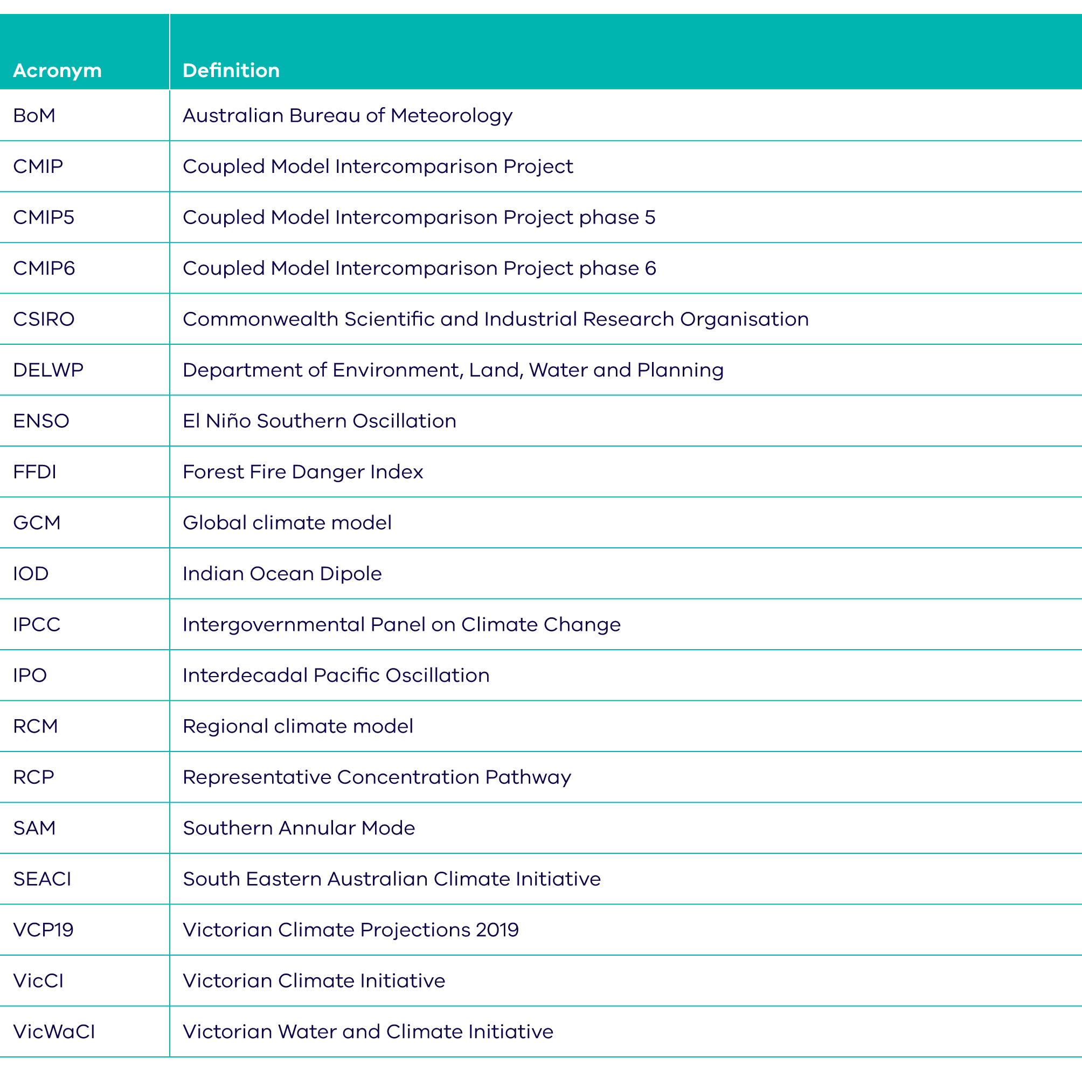

Glossary

Adaptation Changes made to natural or human systems to prepare for actual or expected changes in the climate in order to minimise harm, act on opportunities or cope with the consequences.
Atmosphere The gaseous envelope surrounding the Earth. The dry atmosphere consists almost entirely of nitrogen and oxygen with a number of trace gases (e.g. argon, helium) and greenhouse gases (e.g. carbon dioxide, methane, nitrous oxide). The atmosphere also contains aerosols and clouds.
Carbon dioxide (CO2) A naturally occurring gas, also a by-product of human actions such as burning fossil fuels or land use changes. It is the main human-generated greenhouse gas that affects the Earth’s atmosphere.
Climate The average weather experienced at
a site or region over a period of at least 30 years.
Climate change Changes in the state of the climate, including an increase in the occurrence of extreme weather events, long-term changes in weather patterns and sea level rise, attributed directly or indirectly to human activity. Distinct from climate variability as the changes persist for an extended period of time, typically decades or longer.
Climate driver Used in this report to describe the large-scale ocean and atmospheric processes and circulations that influence Victoria’s climate at seasonal to decadal timescales. These drivers can act alone, combine or contradict each other, influencing variability in the climate, particularly rainfall.
Climate projection The modelled response of the climate system to a scenario of future concentration of greenhouse gases and aerosols, generally derived using climate models. Climate projections are based on a specific emissions scenario, for examples RCPs.
Coupled Model Intercomparison Project (CMIP) A multiple-phase project that coordinates and archives climate model simulations based on shared model inputs by modelling groups from around the world. Models from Phase 5 (CMIP5) informed the Intergovernmental Panel on Climate Change's Fifth Assessment Report, while models from Phase 6 (CMIP6) will feed into the Sixth Assessment Report.
Compound extreme Different climate or weather extremes occurring simultaneously or in succession, which can have greater impact than those extremes on their own.
Cool season For Victoria, the cool season runs from April to October.
Confidence The validity of a finding based on how well the physical climate processes are understood and represented in climate models, and the level of agreement between results from different models.
Downscaling A method that produces local to regional-scale climate information from larger-scale models or data analyses. Different methods include dynamical, statistical and empirical downscaling.
East coast low Intense low-pressure system that occurs off the east coast of Australia, bringing storms, high waves and heavy rain. Generally occurs in autumn and winter off New South Wales, southern Queensland and eastern Victoria.
El Niño Southern Oscillation (ENSO) Year-to-year fluctuations in atmospheric pressure, ocean temperatures and rainfall associated with El Niño (the warming of the oceans in the equatorial eastern and central Pacific) and its opposite, La Niña. Over much of Australia, La Niña brings above average rainfall, and El Niño brings below-average rainfall.
Emissions scenario A plausible representation of the future development of greenhouse gas emissions (such as Representative Concentration Pathways, RCPs) based on a set of assumptions about factors such as demographic and socioeconomic development, and technological change.
Extreme sea level event Extremely high sea levels due to the combination of tides, storm surges and wind waves.
Extreme weather A weather event that is rare at a particular place and time of year. Definitions of rare vary, but an extreme weather event would normally occur less than 10% of the time.
Fire weather Weather conditions conducive to wildfires starting and continuing, usually based on a set of factors including temperature, soil moisture, humidity, and wind. Fire weather does not measure the presence or absence of fuel load.
Global climate model (GCM) A numerical representation of the climate system across the whole globe that is based on the physical, chemical and biological properties of its components, their interactions and feedback processes. Grid squares in global climate models are usually between 100 km and 200 km in size.
Global warming Global warming refers to the gradual increase, observed or projected, in global surface temperature.
Greenhouse gas Gaseous components of the atmosphere, both natural and human-generated, that absorb and emit solar radiation at specific wavelengths. Water vapour (H2O), carbon dioxide (CO2), nitrous oxide (N2O), methane (CH4) and ozone (O3) are the primary greenhouse gases in the Earth’s atmosphere.
Hadley Cell A large-scale atmospheric circulation pattern in which air rises at the Equator and sinks at about 30º latitude north or south. The Hadley Cell controls the position of the band of high-pressure systems (called the sub-tropical ridge).
Indian Ocean Dipole (IOD) A measure of the difference in sea surface temperature in the western and eastern equatorial Indian Ocean. When positive, there is cooler than normal water in the tropical eastern Indian Ocean and warmer than normal water in the tropical western Indian Ocean.
The Interdecadal Pacific Oscillation (IPO)
A lengthy interdecadal fluctuation in atmospheric pressure over periods of 20-30 years across the northern and southern Pacific Ocean.
Intergovernmental Panel on Climate Change (IPCC) An organisation established in 1988 by the World Meteorological Organization (WMO) and the United Nations Environment Programme (UNEP).
Jet stream Narrow and fast-moving westerly air currents related to the global circulation patterns.
Natural variability Variations in the climate (both its average state and the occurrence of extremes) that vary on scales from day to day, up to decade to decade, due to natural processes in weather systems. For example, consecutive summers will not all be the same, with some cooler and some warmer than the long-term average.
Palaeoclimate Indirect measurements of climate are referred to as palaeoclimate archives or proxies, which consist of geologic (e.g. sediment cores) and biologic (e.g. tree rings) materials that preserve evidence of past changes in climate. Palaeoclimate research provides the opportunity to look at changes in climate beyond the relatively short timeline of instrumental records.
Percentile A value on a scale of one hundred that indicates the percentage of the data set values that is equal to, or below it. For example, the 90th (or 10th) percentile may be used to refer to the threshold for the upper (or lower) extremes.
Pre-industrial Prior to the industrial revolution (i.e. pre-1750), when human activities such as the burning of fossil fuels increased the concentration of greenhouse gases in the atmosphere. Consistent with the IPCC, this report uses 1850–1900 as the pre-industrial baseline, as it is the earliest period with near-global temperature observations.
Pyroconvection Under the right conditions, heat
and moisture generated by bushfires creates
clouds and thunderstorms. In extreme cases, pyroconvection can lead to very dangerous bushfire conditions, such as occurred for Victoria’s Black Saturday fires of 2009.
Regional climate model (RCM) A climate model used to generate higher-resolution results from a GCM. Like a GCM, an RCM runs a numerical representation of the climate system that is based on the physical, chemical and biological properties of its components, their interactions and feedback processes to produce results at a regional or local scale.
Representative concentration pathway (RCP)
An emissions scenario that includes concentrations of the full suite of greenhouse gases and land use over time. These are used as inputs to climate models.
Risk The potential for consequences where something of value is at stake and where the outcome is uncertain. Risk is often represented as a probability of occurrence of hazardous events or trends multiplied by the consequences if these events occur.
Sea level rise An increase in the average level of the ocean. Relative sea level rise occurs where there is a local increase in the level of the ocean relative to land, which could be due to an increase in the volume of the ocean, or land level subsidence.
Sub-tropical ridge A belt of high pressure that encircles the globe in the middle latitudes. It is part of the global circulation of the atmosphere. The position of the sub-tropical ridge plays an important part in the way the weather in Australia varies from season to season.
Southern Annular Mode (SAM) Describes the north–south movement of the westerly wind belt that circles Antarctica. The changing position of the westerly wind belt influences the strength and position of cold fronts and mid-latitude storm systems, and is an important driver of rainfall variability in southern Australia.
Uncertainty A state of incomplete knowledge that can result from a lack of information or from disagreement about what is known or even knowable. It may have many types of sources, from imprecision in the data to ambiguously defined concepts or terminology, or uncertain projections of human behaviour. Uncertainty can be represented by qualitative statements
(e.g. reflecting the judgment of a team of experts).
Warm season For Victoria, the warm season runs from November to March.

References

Allen, K. J., Anchukaitis, K. J., Grose, M. G., Lee, E. R., Cook, J. S., Risby, J., O'Kane, D., Monselesan, A., O'Grady, S., Larsen, P. J. & Baker, P. 2019. Tree-ring reconstructions of cool season temperature for far southeastern Australia, 1731–2007. Clim Dyn, 53, 569.
Bhend, J., Bathols, J. M. & Hennessy, K. J. 2012. Climate change impacts on snow in Victoria. CAWCR Research Report. Centre for Australian Weather and Climate Research.
Bureau of Meteorology. 2019. Southern Annular Mode (SAM) [Online]. Available: http://www.bom.gov.au/climate/sam.
[Accessed August 2019].
Bureau of Meteorology & CSIRO 2018. State of the Climate 2018. Available: http://www.bom.gov.au/state-of-the-climate/index.shtml
Cai, W., Santoso, A., Wang, G., Yeh, S.-W., An, S.-I., Cobb, K. M., Collins, M., Guilyardi, E., Jin, F.-F., Kug, J.-S., Lengaigne, M., McPhaden, M. J., Takahashi, K., Timmermann, A., Vecchi, G., Watanabe, M. & Wu, L. 2015. ENSO and greenhouse warming. Nature Clim. Change, 5, 849-859.
Cai, W., Zheng, X.-T., Weller, E., Collins, M., Cowan, T., Lengaigne, M., Yu, W. & Yamagata, T. 2013. Projected response of the Indian Ocean Dipole to greenhouse warming. Nature Geoscience, 6, 999-1007.
Carbon Brief. 2019. Mapped: How climate change affects extreme weather around the world [Online]. Carbon Brief: Clear on Climate. Available: https://www.carbonbrief.org/mapped-how-climate-
change-affects-extreme-weather-around-the-
world [Accessed 11 March, 2019].
CSIRO. 2019. Victorian Climate Projections 2019: Technical Report. Available: www.climatechangeinaustralia.gov.au/vcp19
CSIRO & Bureau of Meteorology. 2015. Climate Change in Australia Projections for Australia's Natural Resource Management Regions: Technical Report. Melbourne, Australia. Available: www.climatechangeinaustralia.gov.au
DELWP. 2017. Protecting Victoria’s Environment – Biodiversity 2037. Department of Environment, Land, Water and Planning.
Dowdy, A. J. & Catto, J. L. 2017. Extreme weather caused by concurrent cyclone, front and thunderstorm occurrences. Scientific Reports, 7, 40359.
Dowdy, A. J., Ye, H., Pepler, A., Thatcher, M., Osbrough, S. L., Evans, J. P., Di Virgilio, G. & Mccarthy, N. 2019. Future changes in extreme weather and pyroconvection risk factors for Australian wildfires. Scientific Reports, 9, 10073.
Freund, M., Henley, B., Karoly, D., Allen, K. & Baker, P. 2017. Multi-century cool- and warm-season rainfall reconstructions for Australia's major climatic regions. Climate of the Past, 13, 1751-1770.
Global Carbon Project. 2018. Carbon budget and trends 2018. [Online]. Available: www.globalcarbonproject.org/carbonbudget
[Accessed May 2019].
Grose, M.R., Foster, S., Risbey, J.S., Osbrough, S.L.
and Wilson, L. 2019a. Using indices of atmospheric circulation to refine southern Australian winter rainfall climate projections. Climate Dynamics 10.1007/s00382-019-04880-4.
Grose, M.R., Syktus, J., Thatcher, M., Evans, J.P., Ji, F., Rafter,T. and Remenyi, T. 2019b. The role of topography on projected rainfall change in mid-latitude mountain regions. Climate Dynamics 10.1007/s00382-019-04736-x.
Grose, M. R., Abbs, D. J., Bhend, J., Chiew, F. H. S., Church, J. A., Ekström, M., Kirono, D. G. C., Lenton, A., Lucas, C., McInnes, K., Moise, A. F., Monselesan, D. P., Mpelasoka, F., Webb, L. & Whetton, P. H. 2015a. Southern Slopes Cluster Report. In: Ekström, M., Whetton, P. H., Gerbing, C., Grose, M. R., Webb, L. & Risbey, J. (eds.) Climate Change in Australia Projections for Australia’s Natural Resource Management Regions: Cluster Reports: CSIRO
and Bureau of Meteorology.
Grose, M. R., Risbey, J. S., Moise, A. F., Osbrough, S., Heady, C., Wilson, L. & Erwin, T. 2017. Constraints on Southern Australian Rainfall Change Based on Atmospheric Circulation in CMIP5 Simulations. Journal of Climate, 30, 225-242.
Grose, M. R., Timbal, B., Wilson, L., Bathols, J. & Kent, D. 2015b. The subtropical ridge in CMIP5 models, and implications for projections of rainfall in southeast Australia. Australian Meteorological and Oceanographic Journal, 65, 90-106.
Guerreiro, S. B., Fowler, H. J., Barbero, R., Westra, S., Lenderink, G., Blenkinsop, S., Lewis, E. & Li, X.-F. 2018. Detection of continental-scale intensification of hourly rainfall extremes. Nature Climate Change. 10.1038/s41558-018-0245-3.
Harris, R. M. B., Remenyi, T. & Bindoff, N. L. 2016. The Potential Impacts of Climate Change on Victorian Alpine Resorts. A Report to the Alpine Resorts Co-ordinating Council. Hobart, Australia: Antarctic Climate and Ecosystems Cooperative Research Centre.
Hennessy, K., Whetton, P., Walsh, K., Smith, I., Bathols, J., Hutchinson, M. & Sharples, J. 2008. Climate change effects on snow conditions in mainland Australia and adaptation at ski resorts through snowmaking. Climate Research, 255-270.
Hope, P., Timbal, B., Hendon, H. H., Ekström, M. & Potter, N. J. 2017. A Synthesis of Findings from the Victorian Climate Initiative (VicCI). Melbourne Australia: Bureau of Meteorology.
Hope, P. K., Grose, M. R., Timbal, B., Dowdy, A. J., Bhend, J., Katzfey, J. J., Bedin, T., Wilson, L. & Whetton, P. H. 2015. Seasonal and regional signature of the projected southern Australian rainfall reduction. Australian Meteorological and Oceanographic Journal, 65, 54-71.
IPCC 2013. Climate Change 2013: The Physical Science Basis, Cambridge, UK, and New York, NY, USA, Cambridge University Press.
IPCC, 2018: Global Warming of 1.5°C. An IPCC Special Report on the impacts of global warming of 1.5°C above pre-industrial levels and related global greenhouse gas emission pathways, in the context of strengthening the global response to the threat of climate change, sustainable development, and efforts to eradicate poverty [V. Masson-Delmotte, P. Zhai, H. O. Pörtner, D. Roberts, J. Skea, P.R. Shukla, A. Pirani, W. Moufouma-Okia, C. Péan, R. Pidcock, S. Connors, J. B. R. Matthews, Y. Chen, X. Zhou, M. I. Gomis, E. Lonnoy, T. Maycock, M. Tignor, T. Waterfield (eds.)].
IPCC 2019a. Summary for Policymakers. In: IPCC Special Report on climate change, desertification, land degradation, sustainable land management, food security, and greenhouse gas fluxes in terrestrial ecosystems.
IPCC 2019b. Summary for Policymakers. In: IPCC Special Report on the Ocean and Cryosphere in a Changing Climate. [H.-O. Pörtner, D. C. R., V. Masson-Delmotte, P. Zhai, M. Tignor, E. Poloczanska, K. Mintenbeck, M. Nicolai, A. Okem, J. Petzold, B. Rama, N. Weyer (eds.)].
Jones, R. N. & Ricketts, J. H. 2017. Reconciling the signal and noise of atmospheric warming on decadal timescales. Earth System Dynamics, 8, 177-210.
Leonard, M., Westra, S., Phatak, A., Lambert, M., Hurk, B., McInnes, K., Risby, J., Schuster, S., Jakob, D. & Stafford Smith, M. 2013. Understanding the role of compound events in climate extremes. WIREs Clim Change, 5,113-128. doi: 10.1002/wcc.252
McInnes, K. L., Macadam, I., Hubbert, G. & O'Grady, J. 2013. An assessment of current and future vulnerability to coastal inundation due to sea-level extremes in Victoria, southeast Australia. International Journal of Climatology, 33, 33-47.
Morim, J., Hemer, M., Wang, X. L., Cartwright, N., Trenham, C., Semedo, A., Young, I., Bricheno, L., Camus, P., Casas-Prat, M., Erikson, L., Mentaschi, L., Mori, N., Shimura, T., Timmermans, B., Aarnes, O., Breivik, Ø., Behrens, A., Dobrynin, M., Menendez, M., Staneva, J., Wehner, M., Wolf, J., Kamranzad, B., Webb, A., Stopa, J. & Andutta, F. 2019. Robustness and uncertainties in global multivariate wind-wave climate projections. Nature Climate Change, 9, 711–718. doi: 10.1038/s41558-019-0542-5.
Natural Capital Economics. 2018. Heatwaves in Victoria: a vulnerability assessment. Melbourne Australia: Natural Capital Economics.
Neukom, R., Barboza, L. A., Erb, M. P., Shi, F., Emile-Geay, J., Evans, M. N., Franke, J., Kaufman, D. S., Lücke, L., Rehfeld, K., Schurer, A., Zhu, F., Brönnimann, S., Hakim, G. J., Henley, B. J., Ljungqvist, F. C., McKay, N., Valler, V., Von Gunten, L. & Consortium, P. K. 2019a. Consistent multidecadal variability in global temperature reconstructions and simulations over the Common Era. Nature Geoscience, 12, 643–649.
Neukom, R., Steiger, N., Gómez-Navarro, J. J., Wang, J. & Werner, J. P. 2019b. No evidence for globally coherent warm and cold periods over the preindustrial Common Era. Nature, 571, 550-554.
Nguyen, H., Evans, A., Lucas, C., Smith, I., & Timbal, B. 2013. The Hadley Circulation in Reanalyses: Climatology, Variability, and Change. Journal of Climate, 26, 3357-3376.
Nguyen, H., Lucas, C., Evans, A., Timbal, B., & Hanson, L. 2015. Expansion of the Southern Hemisphere Hadley Cell in Response to Greenhouse Gas Forcing. Journal of Climate, 28 8067-8077.
Nicholls, N. 2005. Climate variability, climate change and the Australian snow season. Australian Meteorological Magazine, 54, 177-185.
Parliament of Victoria 2010. 2009 Bushfire Royal Commission. Melbourne: State of Victoria.
Pepler, A., Dowdy, A., & Hope, P. 2018. A global climatology of surface anticyclones, their variability, associated drivers and long-term trends. Climate Dynamics, 52: 9, 5397-5412 doi.org/10.1007/s00382-018-4451-5
Pepler, A., Trewin, B. & Ganter, C. 2015. The influence of climate drivers on the Australian snow season. Australian Meteorological and Oceanographic Journal, 65: 2.
Potter, N. J., Chiew, F. H. S., Zheng, H., Ekström, M. & Zhang, L. 2016. Hydroclimate projections for Victoria at 2040 and 2065. Canberra: CSIRO; 2016. doi.org/10.4225/08/5892224490e71
Power, S., Casey, T. & Folland, C. 1999a. Inter-decadal modulation of the impact of ENSO on Australia. Climate Dynamics 15, 319.
Power, S., Delage, F., Chung, C., Kociuba, G. & Keay, K. 2013. Robust twenty-first-century projections of El Nino and related precipitation variability. Nature, 502 (7472): 541-5. doi: 10.1038/nature12580.
Power, S., Tseitkin, F., Mehta, V., Lavery, B., Torok, S. & Holbrook, N. 1999b. Decadal climate variability in Australia during the twentieth century. International Journal of Climatology, 19, 169-184.
Power, S. B. & Delage, F. P. D. 2018. El Niño–Southern Oscillation and Associated Climatic Conditions around the World during the Latter Half of the Twenty-First Century. Journal of Climate, 31, 6189-6207.
Power, S. B. & Delage, F. P. D. 2019. Setting and smashing extreme temperature records over the coming century. Nature Climate Change. 9 (7): 529-534. doi: 10.1038/s41558-019-0498-5.
Risbey, J. S., Pook, M. J., McIntosh, P. C., Wheeler, M. C. & Hendon, H. H. 2009. On the remote drivers of rainfall variability in Australia. Monthly Weather Review, 137, 3233-3253.
Timbal, B., Ekström, M., Fiddes, S., Grose, M., Kirono, D., Lim, E., Lucas, C. & Wilson, L. 2016. Climate Change Science and Victoria, Melbourne, Victoria, Bureau of Meteorology.
Tolhurst, K. G. S., B., Chong, D. 2008. PHOENIX: Development and application of a bushfire risk management tool. Aust. J. Emerg. Manag., 23, 47-54.
Wasko, C., Sharma, A. & Westra, S. 2016. Reduced spatial extent of extreme storms at higher temperatures. Geophysical Research Letters, 43, 4026-4032.

1993 is chosen as a start point as this is the start date of the Bureau's Australian Baseline Sea Level Monitoring Program (ABSLMP). See: http://www.bom.gov.au/oceanography/projects/abslmp/abslmp.shtml. Data from non-ABSLMP gauges are held by the Bureau of Meteorology but operated by third parties.

