Briefing paper: Applying Climate Change Authority emissions targets to Victoria Frank Jotzo and Salim Mazouz, 7 March 2018

This briefing paper provides analysis on issues to consider when applying the Climate Change Authority’s recommendations for Australia’s emissions targets to Victoria.

Summary
- The CCA’s method for determining a range for future emissions targets for Australia remains valid today.
- Differences between Australia’s national and Victoria’s emissions profile, emissions intensity of the economy and emissions per capita are minor on the whole, implying that national targets derived on CCA methodologies are broadly applicable also to Victoria.
- There have been developments since 2014 on international climate policy, global and national emissions growth, and the cost of low-emissions technologies. Some of these changes may suggest changes to the recommended targets, however in our expert judgement the sum of these changes leaves the CCA’s findings broadly unchanged.
- Together these findings suggest that the CCA recommended targets for Australia – specifically the 40-60% reduction range at 2030 relative to 2000, equivalent to approximately a 45-65% reduction with 55% mid-point below 2005 – can be considered as by and large applicable to Victoria today.
- The Panel has requested separate work on global carbon budget. If this were to result in a revised global carbon budget, it would result in adjustments to the CCA’s recommended targets.
- Producing a recommendation for a future emissions targets involves large elements of judgement, as was the case for the CCA recommendations. The Panel will want to assess the CCA recommended targets in light of other information and considerations. This includes aspects such as the choice of a target range versus different scenarios for target.

CCA methods for determining emissions targets
The CCA applied a carbon budget approach to devise its medium and long term emissions target recommendations. This involved
- defining a budget that “might be considered Australia’s fair share in a global emissions budget” compatible with an anticipated below-two-degrees outcome (10.1 GtCO2equivalent between 2013 and 2050);
- defining a 2020 emissions target (15% reduction relative to 2000 or 19% after taking into account surplus Kyoto emissions units);
- assuming net annual emissions fall in a straight line from 2020 to zero by 2045; and
- defining a range around the central value for 2030, with the range chosen as a 40 to 60% reduction relative to 2000 levels (equivalent to approximately 45% to 65% relative to 2005).
This method for deriving emissions targets is based on scientific, economic and ethical principles and remains valid today.
Note that while the CCA did undertake analysis to estimate the cost of achieving emissions reductions, and this presumably informed their judgement calls, such analysis was not a primary determinant of emissions targets under the CCA’s method.
Recommendations for a future emissions target involve large elements of judgement, even if a specific quantitative framework like the CCA’s approach is used. In the case of the CCA recommendations, the following judgements had substantial impacts on the percentage targets recommended for 2030:
- assuming a specific global carbon budget that is in line with a 2-degree outcome;
- assuming a specific way of allocating a share of the carbon budget to Australia;
- assuming that the trajectory of emissions to meet the carbon budget determined for the period to 2050 (net of purchases of international emissions units) declines in a straight line from 2020 to 2045;
- basing the 2030 recommended target range on putting a +/- 10% band around the mid-point estimate (the upper and lower band loosely relate to higher and lower global temperature outcomes, p.126 of the CCA report).
The CCA’s target recommendations related to similar overall requirements as apply to Victoria’s interim emissions targets under the Climate Change Act 2017, specifically with regard to targets covering all GHGs and achieving net zero emissions by mid-century. Similar to the considerations required under the Act in determining Victoria’s interim targets, the CCA’s work included consideration of up-to-date climate science, technology and economic assessments, and existing and expected future national climate commitments. However, the CCA recommendations did not relate to many of the broader objectives as laid out in Section 22 of the Act.
The remainder of this briefing provides analysis and expert judgment about the applicability of the CCA’s recommended emissions targets to Victoria. Note, we use the term “target” as shorthand for recommended 2030 emissions targets.

Carbon budget
The crucial points of departure in the CCA’s analysis are the global carbon budget deemed to be in line with keeping global warming to below two degrees, and the apportioning of a share of this global budget to Australia.
The global carbon budget was taken to be 1,700 GtCO2-e for 2000 to 2050. This carbon budget may need to be revisited in light of latest scientific findings, and in light of updated global emissions levels (although we do not anticipate major changes). A new (lower) carbon budget could also be computed in light of the mention of the ambition for a 1.5 degrees outcome in the Paris Agreement. The CCA did state that the lower bound of their target (60%) may be appropriate as Australia’s contribution to keeping global warming to no more than 1.5 degrees. We would caution against making a 1.5 degree budget the basis for the mid-point of a target recommendations because the challenge is immense and seems unlikely to be achieved through emissions reductions before 2050, unless the world got on a “war footing” for its mitigation effort. In our expert judgement, informed by ongoing scientific work as synthesized by the IPCC, the only plausible scenario for the world achieving a 1.5 degree outcome is through substantial overshoot on emissions budgets, followed by negative emissions (‘draw-down’) in the second half of the century.
We do not provide carbon budget analysis here. If the global carbon budget was revised, this would – under the CCA’s methodology – result in a proportional change of allowable emissions in future years. Specifically, with a lower (higher) carbon budget, the rate of annual emissions reductions would be higher (lower), with a linear trajectory from present levels to zero net emissions by an earlier (later) point in time.
Apportioning the global carbon budget to nations – specifically Australia – was done according to a
‘modified contraction and convergence’ framework as proposed by the Garnaut Climate Change Review (2008): per-capita emissions in all countries converge to a common value over time from present-day starting points, and in the transition fast-growing developing countries are allowed extra headroom which is provided by faster reductions in emissions in developed countries. The choice of principles and parameters involves value judgments and as such is contestable. In our judgement, the CCA’s approach (and the Garnaut Review’s approach before it) was well justified on the basis of economic and ethical principles, and remains so today.
Updating the calculations today would yield a somewhat different share for Australia in the global carbon budget, on account of somewhat different starting points in per-capita emissions and percapita income. Our preliminary judgement is that these differences would be minor. In our view it is unlikely that shares in the global carbon budget would need to be re-calculated but a quantitative analysis to verify this judgement and provide evidence may be useful should the Panel wish to use the CCA targets to (in part) justify their recommended targets.

Victoria’s and Australia’s emissions profile and emissions intensity
Disaggregating a national target (or carbon budget) to subnational jurisdictions requires comparisons of key indicators, and possibly adjustments in line with observed differences and differences in future expected values.
We identify the following macro-level indicators that should be considered in disaggregating the CCA’s target recommendations to States:
- Emissions per capita: if emissions per capita in a State are higher than the national average, this implies faster reductions in per capita emissions, based on the logic of convergence to equal per capita emissions. Depending on parameters this likely means a higher overall share in a national carbon budget (as the starting point is higher) but faster annual percentage reductions. The converse is true for lower per capita emissions.
- Emissions intensity of the economy: if the emissions intensity of a State’s economy is higher than the national average, this implies greater opportunities to reduce emissions than in the national average, based on comparable effort across all States. The converse is true for lower emissions intensity. However, this may be tempered by differences in the emissions profile.
- Emissions profile: depending on which sectors and activities emissions in a State are concentrated in, reductions may be easier or harder to achieve, and the time profile of achievable emissions at a given level of effort will differ. This is a complex empirical issue that generally has no ready answer on the basis of high-level indicators.
The following sub-section provide an initial analysis of expected outcomes from changes to these indicators and their likely implications for translating the CCA target to Victoria.
Emissions per capita and emissions intensity:
The following Table shows Australia’s and Victoria’s per capita emissions and emissions intensity of GDP/GSP, for the year 2015 (data compiled by DELWP):
 | Australia | Victoria
Emissions per capita, tCO2e/person Emissions per unit of GDP or GSP, | 22.6 | 19.8
kgCO2/$ | 0.33 | 0.33

Emissions per capita are somewhat lower in Victoria than in Australia on average, implying that
Victoria’s per capita emissions would need to decline at a slightly lesser annual rate than in the Australian average. To make inferences about implications for absolute emissions levels, these starting points would need to be combined with projections of population growth rates. However, the difference in starting point is relatively small and differences in overall resulting emissions targets in a modified contraction-and-convergence framework would likely be minor.
The emissions intensity of Victoria’s economy was the same as the national average in 2015, so this aspect implies no differentiation between an Australian and a VIC target.

Emissions profile:
The following Table shows the share in Australia’s and Victoria’s total net greenhouse gas emissions, for the year 2015 (total values 534MtCO2-e for Australia, 120 MtCO2-e for Victoria; data compiled by DELWP):

 | Australia | Victoria
Electricity generation | 35% | 51%
Direct combustion (stat.) | 17% | 15%
Transport | 18% | 19%
Fugitive emissions | 8% | 2%
Industrial Processes | 6% | 3%
Agriculture | 13% | 12%
LULUCF | 1% | -5%
Waste | 2% | 2%

Material differences are: a significantly higher share of emissions from electricity generation in Victoria, though this difference has narrowed dramatically with the closure of Hazelwood; a lesser share of fugitive emissions; and Victoria’s forest estate as a net sink.
It is not possible on the basis of these differences to infer whether emissions reductions in Victoria at some point in time are easier or harder to achieve than in Australia overall. Such an analysis would require detailed comparative sector-based analysis.
Even if a difference in relative emissions reductions options was established, this would not necessarily result in different recommendations under the framework that underlies the CCA recommendations, because under that framework relative mitigation costs are used to underpin judgement calls made by the CCA and provide justification for the recommended targets rather than to directly determine them.

Overall assessment of AUS-VIC differences
Taken together, these data suggest that the CCA’s national target recommendations are by and large applicable to Victoria, and that any modifications on the basis of observed data and using CCA methodologies would be relatively small.

Developments since 2014
Developments in the four years since the CCA’s report may affect the analysis and recommendations on future targets. We identify international developments on climate change policy, global and national emissions growth, Victoria’s emissions growth and projections, and technological progress as relevant factors.

International developments
The 2015 Paris Agreement enshrined a ‘below 2 degrees’ goal, confirming the CCA’s starting point which was also a global ‘less than 2 degrees’ outcome.
The new United States administration has abandoned climate policy and signalled its intent to withdraw from the Paris agreement, however this has not led to any apparent widespread weakening of other countries’ resolve or commitment to their emissions reductions pledges.
China has confirmed its emissions goals, is strengthening its climate policies and is on track to meet or beat its 2020 emissions target.
Taken together these developments confirm that the relatively ambitious scenario chosen by the CCA is a justifiable point of departure. However, this is entirely a matter of judgment.

Developments in technology costs
Low-emissions technologies are and will be much cheaper than anticipated in 2014, making greater reductions easier to achieve (as we investigated in our earlier brief to the Panel).
These positive developments, and the opportunities they bring for Australia and Victoria, unambiguously suggest that relatively greater ambition could be supported.
Adjustments to target recommendations on the basis of lower mitigation costs would be consistent with the CCA’s considerations in recommending targets, including as a justification for a stronger target than the 5% by 2020 target that prevailed at the time (see eg p11 and p24 of the CCA report). As such, they could be used by the Panel to justify tighter targets or to provide a basis for underscoring that the unmodified application of CCA targets is conservative.

Emissions growth since 2014
Global greenhouse gas emissions did not grow between 2014 and 2017. This compares to the expectation that global emissions would continue to rise for several years even under a two-degree scenario, as they had until 2014. While not too much can be read into such short-term trends, this suggests a two-degree outcome remains in reach.
Australia’s emissions have seen moderate growth between 2014 and 2017, roughly in line with CCA’s “medium” scenario, far less than the CCA’s baseline scenario and only somewhat higher than the CCA’s “high” scenario for strong climate action.
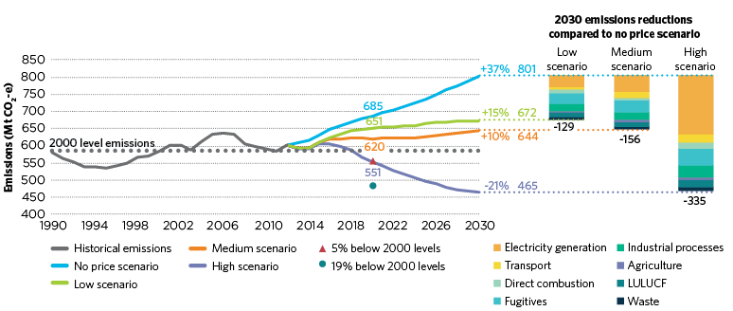
CCA report page 241, Figure D.3.
At the same time, the actual national emissions trajectory has been significantly higher than the CCA’s assumed straight-line reduction from 2013 to 2050. Note that the CCA assumed purchase of international emissions units, which explains the apparent discrepancy between the CCA’s “high” climate action scenario and the straight-line reduction.
Taken together these developments suggest that Australia by now has used up a somewhat greater share of its remaining carbon budget than assumed by the CCA, and hence would require somewhat faster annual reductions in the future. However, the difference up to this point is minor, and if spread over the period to 2050 it would make only a minor difference to 2030 targets.
Further quantitative analysis on this aspect may need to be undertaken should the Panel wish to use the CCA targets to (in part) justify their recommended targets (but, in our judgement, is unlikely to alter the target recommendations by a substantive extent).

Overall assessment of changes over time
Taken together, these observations suggest that the CCA’s target recommendations remain valid. If adjustments were made, our expectation is that these would result in a recommendation for somewhat stronger targets. This preliminary conclusion is drawn pending detailed analysis and does depend on contestable judgments about the outlook for global climate action today, compared to in 2014.
An analysis of expected developments (projections) of key parameters may yield further differences and could be undertaken should the Panel wish to use the CCA as a basis for their target recommendations.

Overall assessment of applicability of CCA targets to Victoria
Our initial assessment is that differences between relevant national parameters and those for Victoria are relatively minor, and that various developments since 2014 to a degree have cancelled each other out. The CCA’s method remains valid and the quantitative aspects of its calculations for national emissions targets remain similar.
The differences in relevant parameters in 2015 for Victoria and the Australian average on the whole are relatively minor, implying that recommendations for national emissions targets are broadly transferrable to Victoria.
More in-depth analysis would suggest somewhat different emissions targets for Australia and Victoria. Specifically, such further analysis could include a quantitative analysis of Victoria’s emissions budget under a contraction-and-convergence framework based on State-level per-capita emissions, which would yield somewhat different emissions targets within the CCA framework.
Further, detailed analysis could be undertaken of comparative emissions reduction potential in Victoria compared to the Australian average (for example by comparative technical-economic analyses with other States). This would provide some indication of whether achieving emissions reductions in Victoria may be easier or harder than in Australia on average, and provide guidance (outside of the CCA analytical framework) for adjusting a VIC target accordingly.
The analysis undertaken for this brief cannot determine whether such analysis would result in a VIC emissions target higher or lower than the CCA recommendation for Australia. However, we expect that the difference would be relatively minor and recent and expected technology cost developments beyond what was expected by the CCA would suggest that tighter targets may be justified.
Together these findings suggest that the CCA recommended targets for Australia are by and large applicable to Victoria today.
However, this is subject to any updating of the global carbon budget. Analysis of expected developments (projections) of key parameters may yield further differences and could be undertaken should the Panel wish to use the CCA as a basis for their target recommendations.
A final point for the Panel to consider is that the CCA’s recommended range for the 2030 national emissions target was derived from a 50% mid-point estimate with a +/- 10% range around the midpoint, without strong analysis to underpin the particular range was chosen. Providing a range is reasonable given the many other assumptions that shaped the point estimates for the CCA recommended targets, however it is not clear how broad such a range should be. The Panel could consider a narrower or wider range, or chose to provide different scenarios for targets rather than a range.

Summary Figure from Climate Change Authority’s 2014 report:
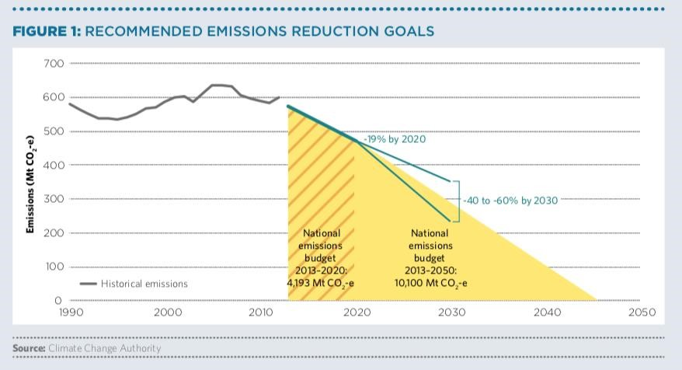

Summary of factors of influence of a VIC emissions target compared to CCA recommended targets for Australia
Aspect | Direction of change that would suggest a stronger target for VIC | Observed difference between VIC and  Australia overall | Observed change from 2014 to 2018 | Direction and magnitude of difference between VIC and AUS target | Adjustment of target within framework or just inform judgement  calls by CCA | Basis of conclusion
VIC-AUS comparison
Emissions per capita | Higher p.c. emissions would mean faster required emissions reductions | VIC per capita emissions somewhat lower | (not relevant) | VIC target somewhat weaker | within | Observed data
Emissions intensity of economy | Higher emissions intensity would imply greater reduction options | Same | (not relevant) | No difference | Affect judgement  calls | Observed data
Emissions profile | Greater concentration in sectors where emissions reductions are easy to achieve would imply greater reduction options | Some differences | (not relevant) | Indeterminate (would require further detailed analysis) | Affect judgement  calls | Observable data but analysis would be needed
Changes over time
International develpoments | Greater international commitment and action would imply stronger global, national and VIC targets | (not applicable) | Various developments that do not change the overall assessment | Suggests that CCA scenario remains valid – no change. | Within | Expert judgment only - contestable
Technology costs | Lower costs for clean technologies would imply greater reduction options | (not applicable) | Technology costs have fallen faster than anticipated | Suggests stronger target | Affect judgement  calls | Observed trends, expert judgment
Emissions growth since 2014 | Lower emissions growth than CCA target trajectory would imply more future headroom | (AUS-VIC differences reflected in per capita emissions levels) | Global emissions lower than projections but higher than CCA target trajectory | Suggests slightly stronger target | Within | Observed data

Climate Change Authority 2014, Reducing Australia’s Greenhouse Gas Emissions: Targets and Progress Review (final report).
Michaelowa, A., Allen, M. and Sha, F. 2018, Policy instruments for limiting global temperature rise to 1.5°C – can humanity rise to the challenge?, Climate Policy.

