Victoria’s Future Climate Tool

User Guide

  - An introduction and guidance for risk management

Contents
Victoria’s Future Climate Tool – an introduction and guidance for risk management 3
When do I need to use climate data and what data should I use? 3
What can I do with the data from Victoria’s Future Climate Tool? 5
What do I need to know about climate science to use the tool? 6
What do I need to understand about using climate projections as a risk management tool? 7
Factor in some uncertainty into your decision-making 7
Climate projections aren’t enough to consider extreme rainfall or flood risk 7
How to use Victoria’s Future Climate Tool 7
How do I choose which model to use? 7
Choosing models and emissions scenarios for different purposes 8
Choosing a future time period or projection horizon 9
Some common uses and layer selections 9
When Victoria’s Future Climate Tool won’t help 12

This User Guide has been developed and prepared by the Department of Environment, Land, Water and Planning and Victorian Managed Insurance Authority to support the delivery of the climate change risk management service.
Contact DELWP on climate.change@delwp.vic.gov.au for technical issues with Victoria’s Future Climate Tool.

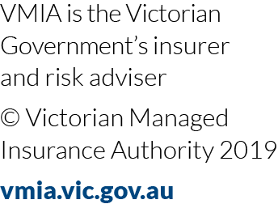 | 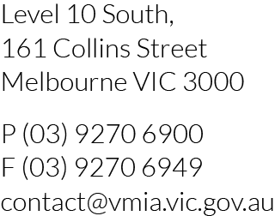 | Victorian Managed Insurance Authority (VMIA) acknowledges the Traditional Custodians of the  land on which we do business and we pay our  respects to their Elders, past, present and emerging. We acknowledge the important contribution that Aboriginal and Torres Strait Islander Peoples  make in creating a thriving Victoria.

Victoria’s Future Climate Tool – an introduction and guidance for risk management
There’s a new tool for risk practitioners to easily access future climate information, including some indicators of climate-related hazards, to help inform decision-making: Victoria’s Future Climate Tool.
This interactive online mapping tool will help you to visualise the future climate projections for Victoria. You can visualise an area of interest and choose your timescale – from the relatively near-term (2030s) to the distant future (2090s).
You don’t need to be a climate scientist or data scientist to use the data from this tool to inform your work. The tool is useful for:
• Risk practitioners (and project/policy staff to whom risk management is devolved)
• Environmental/sustainability officers
• Geospatial information system (GIS) users
• Specialists managing programs, services and infrastructure.
As a risk practitioner, you can explore how your organisation can use relevant data to inform decision-making and therefore better manage risk. You can also connect other people in your organisation with a reliable data source and information platform to help them do their work.
Any output from the tool represents a possible future and is defensible as long as the variables chosen are documented and it is recognised that there are multiple possible futures that need to be considered.

When do I need to use climate data and what data should I use?

As a risk manager, you may need to gain a general understanding of the physical risks of climate change to organisational function, strategy, or activities. You can use climate data to inform plans or projects to enable your organisation to prepare for and adapt to climate change and contribute to organisational resilience.

The decision tree below (Figure 1) asks you to consider the purpose for which information will be used to help you decide the best information to use.

If you only need high-level information or are doing a first-pass climate risk assessment, in most cases you’ll find the high-level information you need in:

• Victoria's Climate Science Report (state-level information), and/or

• The Victorian Climate Projections (VCP19) regional reports (information for each of DELWP’s ten regions).

In some cases, a mapping tool – like Victoria’s Future Climate Tool – will be more helpful (refer Table 1 below).

More often, Victoria’s Future Climate Tool will be useful if you’ve already done a first-pass climate risk assessment and now want to go into more detail. Being able to visualise the data at a local scale can help you explore potential impacts and risk treatment measures in more depth.

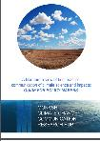
First ask: How will the information be used?
More technical information or data required?
VCP19 Publications (climatechangeinaustralia.gov.au)
Victoria’s Future Climate Tool
How to decide which information to use?
Looking for help communicating climate change?
Climate Science Communication Guide
Are there sector specific guidelines or products available?

Need more information on how the projections were developed and what it might mean?
Looking for Statewide information
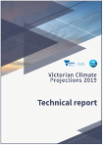
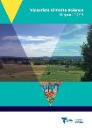
VCP19 technical report summary information
Climate Science Report

Looking for information to support regional or sector specific planning:
- Narrative scenarios
- Risk / vulnerability assessments
- Pathways Planning
- Regional of sector specific modeling
Summary information from the VCP19 regional reports

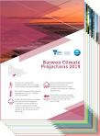
Need data for a more detailed hazard/impact study or to incorporate into existing systems or models?

GIS Data Formats
Change factor and application ready data: NetCDF format
Looking for local or asset-specific planning: Information at a specific geographic scale, temperature thresholds or heatwave projections and/or for GIS applications?

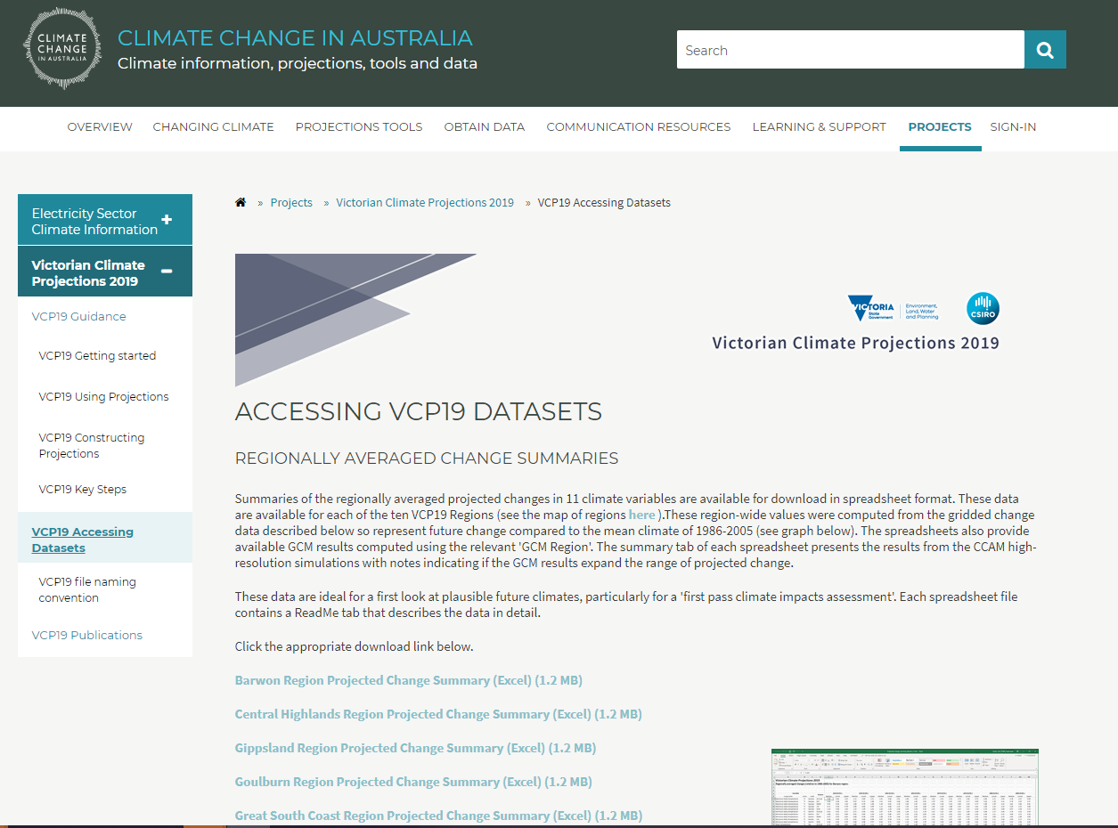
Climate Change in Australia website
Are there sector specific guidelines or products available?

Consider all available data .For example, the Water sector has: Guidelines for Assessing the Impact of Climate Change on Water Supplies in Victoria, Victorian Water and Climate Initiative products and ARR

Figure 1 Decision tree - deciding which climate information to use

Use the following table to help you work out when to use Victoria’s Future Climate Tool:
Table 1 When to use Victoria’s Future Climate Tool
I want to… | What the tool can do | Who might be most interested in this feature?
Compare the climate of the recent past for a particular area with the projected climate | Compare past climate (a 20-year average for the baseline period 1986-2005) for a particular area with the projected climate in the 2030s, 2050s, 2070s, 2090s | - Emergency management  - Those already experiencing climate impacts looking to better understand future change in relation to lived experience
Focus on a particular geographic area of interest | Display Local Government Areas, Catchment Management Authority areas, etc | - Local government  - Water sector  - Regional and community-based organisations.  - Organisations looking for geographically specific information at a scale not provided by existing reports
Find information about heatwave or temperature extremes | Display information about heatwave number duration and intensity.  [This is new information and is not in the VCP19 reports] | - Health and Natural environment  - Energy, transport, and water sectors  - Those systems with people or infrastructure/machinery/plant impacted by extreme heat or cold
Find information about projected climate extremes or thresholds in temperature or rainfall | Display information such as days over 35ºC or 40ºC or below 2ºC. Also, days with over 20mm rainfall or warm wet days with days over 25ºC and any rainfall | - Agriculture sector  - Natural environment  - Systems impacted by extreme heat or cold with known thresholds for health or productivity
Do a first-pass visual risk assessment – for example, identifying potential impacts for a particular asset | Display Google Street or satellite view to identify assets in the landscape | - Local government, regional and state-wide organisations  - Natural resource or infrastructure managers

What can I do with the data from Victoria’s Future Climate Tool?
You can view and access data for specific spatial areas including local government and Bureau of Meteorology forecast areas, or you can draft your own ‘polygon’ to identify a specific area of interest.
You can download the data in Excel tables or GIS formats and integrate these into your organisation’s existing spatial/GIS tools.
You can access additional data translating the climate projections into hazard and threshold information, e.g.:
• Heatwaves
• 1-in-20-year extreme heat and rainfall events
• Hot and cold thresholds (e.g. very cold nights, warm nights above 20⁰C, etc).

What do I need to know about climate science to use the tool?

Before using the tool, we recommend that you explore the background information on the Victorian Climate Projections to better understand the data and its potential use. Victoria’s Climate Science Report 2019 and the Victorian Climate Projections regional reports are a great place to start.

The tool contains information on climate models and emissions scenarios. You don’t need to know the detail of these to use the tool, but below is some basic information that might be helpful.

Climate models

Climate models help us to understand the changes that are already happening and plan for the changes to come. There’s a high level of consensus around the science underpinning these models to provide robust projections of the future climate. Climate scientists use climate models to create simulations of the Earth’s climate system to help us understand our changing climate. The models are a complex series of mathematical equations based on the fundamental laws of physics that simulate the dynamics of the atmosphere, oceans and ice. The simulations they produce indicate how temperature, rainfall and other climate variables can change over a region, for different greenhouse gas concentrations.

Emissions scenarios

Risk management is often about asking “what if?” Considering different, plausible scenarios based on the best available information can help you to answer this question. Victoria’s Future Climate Tool refers to two “emissions scenarios”, RCP4.5 (medium emissions) and RCP8.5 (high emissions), as well as a past climate baseline. Representative Concentration Pathways (RCPs) are related to the concentration of carbon dioxide in the atmosphere – refer Table 2 below.
Table 2 Representative Concentration Pathways (RCPs)
Representative Concentration Pathway (RCP) | Concentration of CO2 in 2100 (ppm) | Likely 2080-2100 global average temperature (°C above pre-industrial levels) | Emission scenario
4.5 | 538 | 1.7 to 3.2 | Medium emissions
8.5 | 936 | 3.2 to 5.4 | High emissions
Note: Representative Concentration Pathways (RCPs) and their temperature outcomes at 2100 are based on Climate Change in Australia (VCP19 Emissions Scenario).
See VCP19_EmissionsScenarios.pdf (climatechange.vic.gov.au) for more information

The past climate baseline period used for this calculation was the 20-year period, 1986–2005. This is consistent with the IPCC’s Fifth Assessment Report (IPCC 2013a) and CCIA projections (CSIRO and Bureau of Meteorology 2015).
Since the 2005 baseline is where the RCPs start, there was evidence that we were tracking at the highest or worst case scenario (RCP8.5), but a very recent slowdown in emissions growth suggests maybe we could be starting to track below this, although this is not certain yet. Regardless of which RCP we are tracking now, a range of scenarios should be considered when examining the future, rather than guessing a single scenario and using only that one.

What do I need to understand about using climate projections as a risk management tool?

Consider potential extremes that aren’t highlighted by the projections
While climate projections give us solid evidence for management, planning and policy decisions, they’re calculated as the average across a 20 or 30-year period. They don’t show the extremes possible within that period and may be too conservative for risk management. Testing your assumptions about the future may require you to consider the more extreme possibilities.
Some events and processes that aren’t perfectly understood could lead to unexpected climate change or shifts (e.g. melting of the Antarctic ice sheets; changes in the strength and timing of the El Niño Southern Oscillation). As such, it makes sense to use projections as a guide to the future, and not to discount changes above or below the projected range when managing risk.

Factor in some uncertainty into your decision-making
Uncertainty shouldn’t stand in the way of action. You may know the range of possibilities but you’re not sure exactly what will eventuate (the ‘known unknowns’), or you may not even be sure of what’s possible (the ‘unknown unknowns’). These factors must be honestly assessed to make decisions under uncertain future conditions. As a risk practitioner, you’re used to factoring uncertainty into decision making. Climate projections provide a solid evidence base to assess plausible ranges of future change, but given the deep uncertainty about the far future, you should make decisions that are robust across the range of possible futures, and don’t lock in one path of action.

Climate projections aren’t enough to consider extreme rainfall or flood risk
When it comes to rainfall, using climate projections is even more difficult. Although we know that extreme, short-duration rainfall events in Victoria are becoming more frequent and intense because of climate change, estimates of the most extreme rainfall events vary widely between different places and have high levels of uncertainty. As such, projections of extreme rainfall events cannot be estimated using the tool.
Further information on extreme rainfall is available from the Victorian Water and Climate Initiative:
VicWaCI-Fact-Sheet-Extreme-Rainfall.pdf (water.vic.gov.au)
ViCWaCI Victoria’s Water in a Changing Climate (PDF, 10.5 MB)

How to use Victoria’s Future Climate Tool
The tool is available from the DELWP website at https://www.climatechange.vic.gov.au/victorias-changing-climate. The tool is an interactive map with a series of climate change related layers which can be turned on and off to display possible future climates. Help and information buttons in the tool guide you through the selection of layers.
For further help and support contact DELWP’s Climate Science team: climate.science@delwp.vic.gov.au
The tool includes a range of information on the layers available, what they show and advice on how to select the layers and interpret the results.

How do I choose which model to use?
As each model represents a single possible future and no single model is ‘more likely’ than any other model, better practice is to use as many models as possible to fully explore the range of possible futures. If you are unable to use all the models you should think carefully about which model you choose based on the decision you are trying to inform. For example, to inform a first-pass risk assessment of the impacts of climate change on a health services agency, a hotter, drier climate may be considered the ’worst-case’ scenario and a future that is less hot and less dry is considered the ‘best-case’ climate scenario.

Table 3 Climate model descriptions
Climate Model | Description
ACCESS 1-0 | Maximum consensus (the most models agree, but not necessarily the ‘most likely future) for the whole state
CNRM-CM5 | Consistent with the consensus of GCM projections over Victoria
GFDL-ESM2M | A hot, dry model for Victoria
HadGEM2-CC | Comparatively hottest and driest climate future (least cool and wet) for Victoria
MIROC5 | A low warming, wet model for Australia and Victoria
NorESM1-M | Comparatively coolest and wettest climate future (least hot and dry) for Victoria
Multi Model Mean | Calculated as the mean of all six models

The “Multi Model Mean" option available within this tool is calculated as the mean of all six models. You many find this useful for a high-level assessment of your region when beginning to think about the impacts of climate change. It will give you an idea of the average climate projections from the models. However, it is not appropriate to use when assessing risk or adaptation options, when it is important to consider the full range of plausible changes, especially if worst-case or other ‘low probability, high impact’ cases are important to manage or mitigate.

Choosing models and emissions scenarios for different purposes
When choosing climate models and emissions scenarios, you are likely to want to compare the recent past with a “stress test” scenario AND either the “consensus” or “hopeful” scenario (or possibly both). The consensus and hopeful scenarios show the least amount of change you need to plan for.
As well as looking at the recent past (1986-2005), you should also consider events even further back that have impacted your organisation.
Table 4 Choosing climate models and emissions scenarios
Stress Test: High range Warming and Drying | Consensus: High to Mid-range Warming and Drying | Hopeful: Lower range Warming and Drying | Recent Past
A future with high levels of warming and drying:  - Climate Model: HadGEM2-CC  - Emissions Scenario: RCP8.5 (high emissions) | A mid-range future using the maximum consensus model and the high emissions scenario:  - Climate Model: ACCESS1-0  - Emissions Scenario: RCP8.5 (high emissions) | A more optimistic likely future reflecting some reduction in emissions:  - Climate Model: NorESM1-M  - Emissions Scenario: RCP4.5 (medium emissions) | Recent past to compare with the three future scenarios:  - Climate Model: N/A Observed Data  - Emissions Scenario: Past Climate Baseline (1986-2005)

The names of the climate models here are technical. You don’t need to be familiar with the model name or details; it should be sufficient just to select the relevant model in the tool.

Choosing a future time period or projection horizon

Data is available for four Projection Horizons:
2030s (2015 - 2044) | 2050s (2035 - 2064) | 2070s (2055 - 2084) | 2090s (2075 - 2104)

Climate is the long-term average of weather, typically over a period of at least 20-30 years. As such the data presented in the tool is calculated as the average across the 20/30-year projection time periods. The “Projected Climate: Change” layer uses 20-year projections, whereas the rest use 30 years. The future time-series data is the average and doesn’t show the extremes possible within that 30-year period.

For example, results for the 2030s period are the average results for the 30-year period from 2015 until 2044. This means that it shows change that we could already be experiencing. It’s clear that it doesn’t show the year to year variability that we’ve already seen and will continue to see. After all, climate is what we expect (the longer-term average), but the weather is what we get (including daily, seasonal and yearly variation).

When choosing a projection horizon, it important to think about the timelines being planned for but also a good idea to look as far ahead as possible (2090s) to get an idea of the far future and consider any actions that may need to be taken in advance to help prepare for longer term change.

Some common uses and layer selections
I want to… | How to do it
Compare the climate of the recent past for a particular area with the projected climate | When using the tool to look at any future climate, you can compare the results to the recent past by changing your choice under the Emissions Scenario dropdown to Past Climate Baseline (1986-2005).  Do check that your other selections haven’t changed back to the default.  If you want to begin by looking at the Past Climate Baseline:  - Select your “Region/Place Layer” in the dropdown and then click on the area of interest on the map.  - Under “Climate/Hazard Layer” select “Past Climate Baseline”.  - Choose a “Climate Variable” from the dropdown menu.  - Then go back to Climate/Hazard Layer and choose “Projected Climate: Values”.  - Once again choose your “Climate Variable” from the dropdown menu.  - Then an “Emission Scenario” − either “medium emissions”; or “high emissions”.  - Use the “Projection horizon” dropdown to choose the future timeframes for comparison.  Acree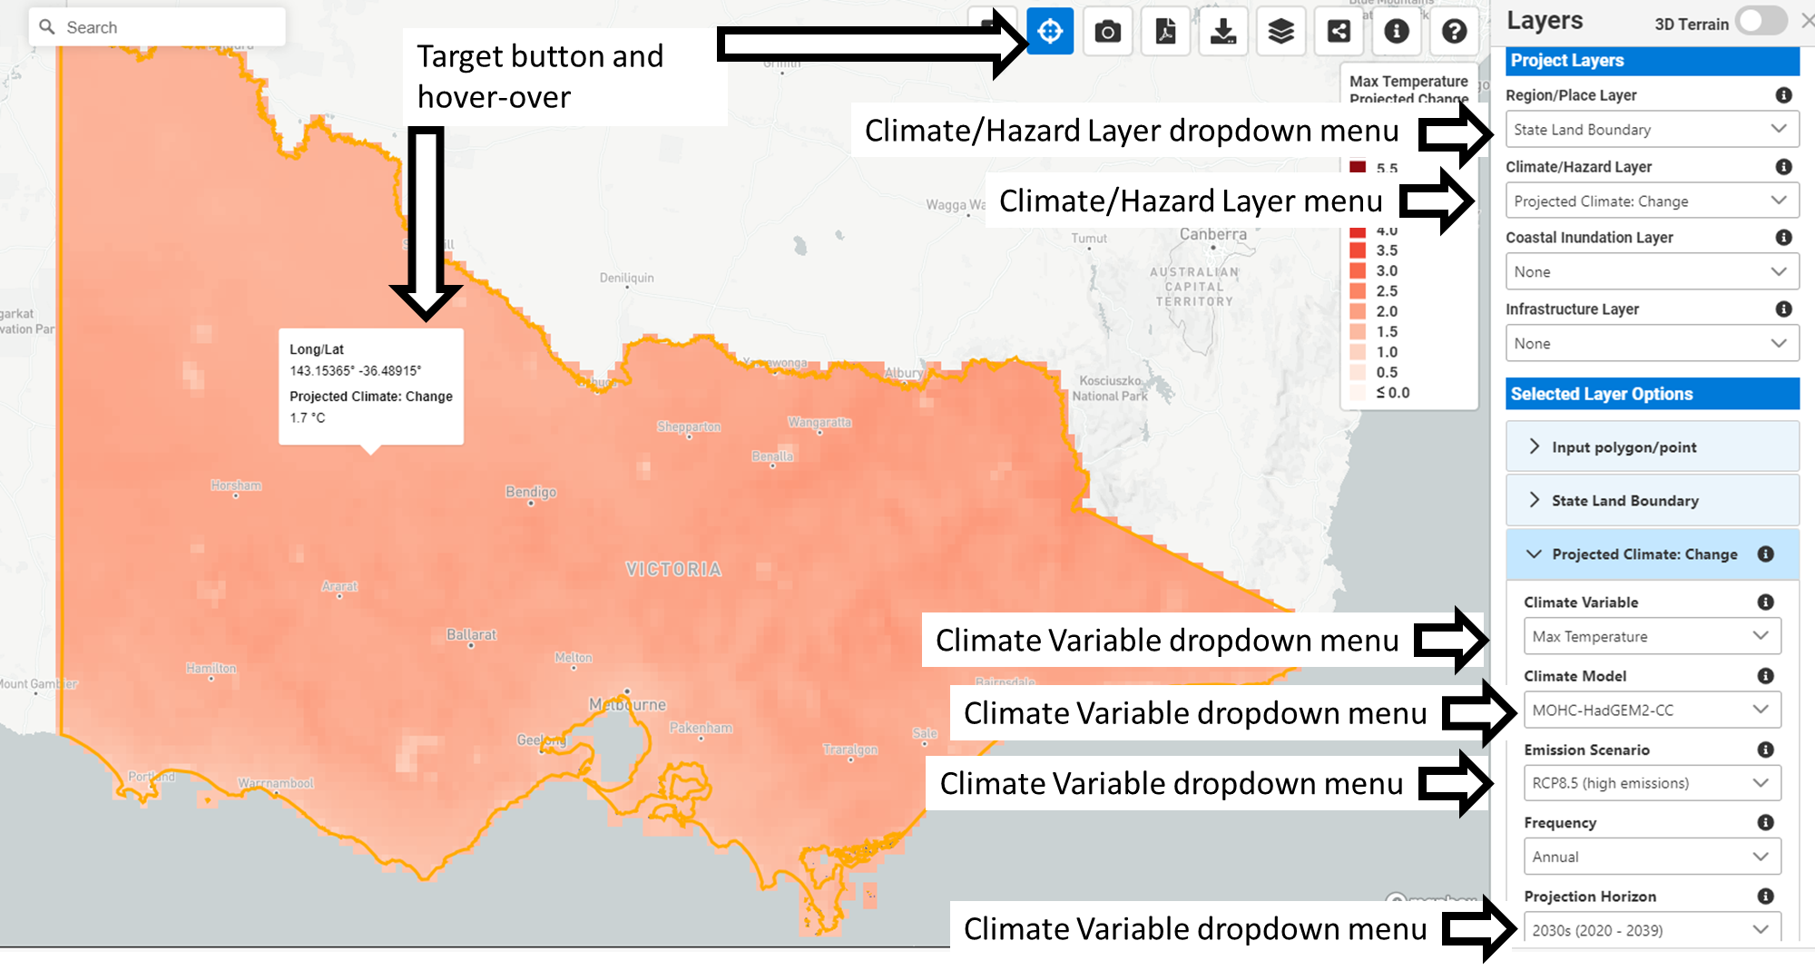
Focus on a particular geographic area of interest | - Use the “Region/Place Layer” dropdown menu to select the area of interest (i.e. Local Government Areas, Catchment Management Authority areas, etc).  - Or upload your own polygon using the input polygon/point option under the “Selected Layer Options” heading.  - Or use the draw polygon or add point tools on the bottom left of the screen.  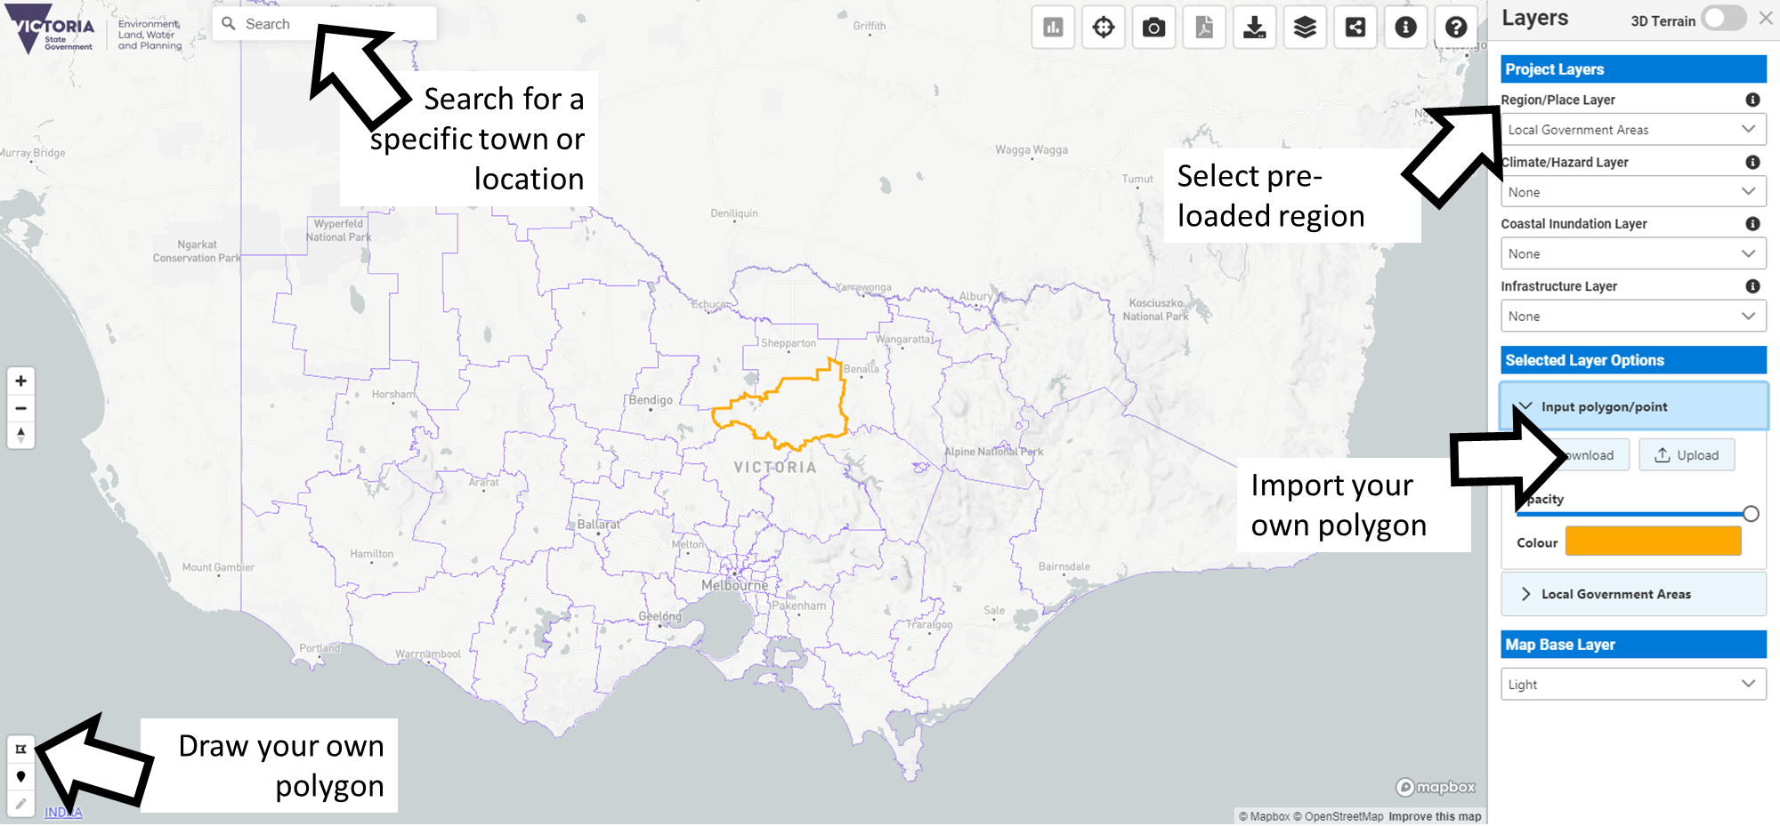  Example slides: Exploring reduced rainfall in a region using a stress test scenario: Reduction in rainfall for the Wimmera region using the driest model available under high emissions scenario for the 2070s
Find information about heatwave or temperature extremes | - In the “Climate/Hazard Layer” dropdown menu choose “Heatwaves”.  - This will then show a “Variables” dropdown from which you can choose Number, Duration, Amplitude or Frequency.  - Select a “Variable” and then a “Calculation Method”. The i-button and help document provide advice on what to select Excess heat Factor is the most commonly used.  - To explore the ‘worst case’ select Climate Model: MOHC-HadGEM2-CC and the Emissions Scenario RCP 8.5 (high emissions).  - You can also then use the “Emission Scenario” dropdown menu to select “Past Climate baseline” to see what extremes have been experienced in the recent past.  - Select the target button to hover over your area of interest and see the results.  For an example see this case study with Ambulance Victoria
Find information about projected climate extremes or thresholds in temperature or rainfall | - Choosing “Rainfall Extremes” or “Temperature Extremes” in the “Climate/Hazard Layer” dropdown menu allows you to explore a range of temperature thresholds and calculations for wet and warm moist days.  - You can also then use the “Emission Scenario” dropdown menu to select “Past Climate baseline” to see what extremes have been experienced in the recent past.  Example slides: Exploring extreme temperatures for a town: Days over 35ºC for Leongatha under a continuing high emissions scenario (RCP 8.5) in the 2030s

I want to… | How to do it
Do a first-pass visual risk assessment – for example, identifying potential impacts for a particular asset | Take a quick look at increases in maximum temperature and reductions in rainfall:  This will only give you a look at the average projected change and will not give an indication of extremes.  - Go to Climate/Hazard Layer and select Projected Climate: change.  - By clicking on the target button you can now hover over any area on the map to see the projected change in maximum temperature.  - If you look down the layers, you’ll see that the results shown are calculated using the multi model mean under the medium emissions scenario for the 2030s.  - A chart is also produced to show you the results for the whole of the area selected.  - At the bottom of the right-hand layer menu you can select the Google Street or satellite “Map Base Layer” to identify features of particular interest such as infrastructure or geographical features.  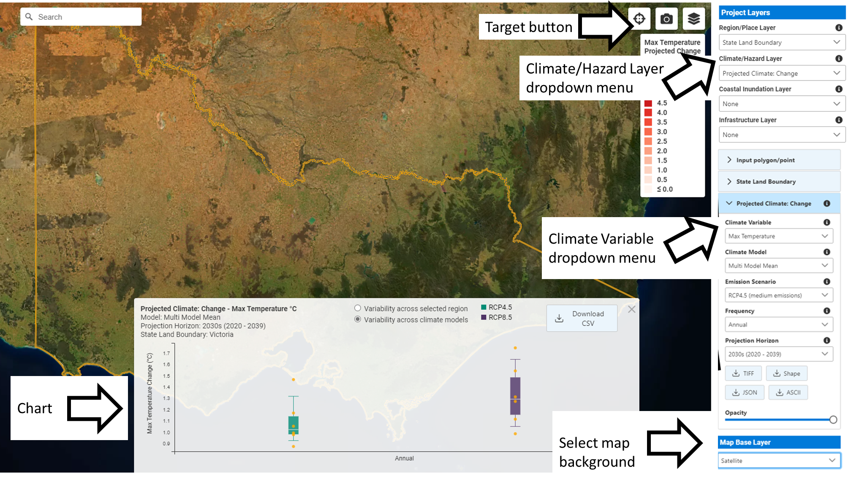

When Victoria’s Future Climate Tool won’t help

Victoria’s Future Climate Tool doesn’t provide data on every climate hazard you might be looking for information on. If you are seeking data on:

• flooding

• bushfire risk

• sea level rise and coastal erosion

• storm and wind, or

• compound events,

you won’t find it here yet, for reasons explained below. We’ve indicated where to look instead.
Table 5 A list of climate hazards, a summary of what is currently known, why it’s not covered in the tool and where to go for further information
Climate hazard | What we know about the impact of climate change on this hazard in Victoria | Why the tool doesn’t cover this | Where to go instead
Flooding | Extreme, short-duration rainfall events in Victoria are becoming more frequent and intense, particularly in the warm season.  However, the only extreme rainfall event represented in the tool at this stage is the Extreme Value Analysis for Rainfall - 20-year return period. This represents 1 in 20-year rainfall events, with a 5% chance of occurring in any one year. This does not indicate flooding. | Estimates of the most extreme precipitation events vary widely between different geographic locations and can have high levels of uncertainty. This makes representing them and the impact on flooding visually very difficult. | Further information on extreme rainfall and flooding is available from:  Victorian Water and Climate Initiative:  VicWaCI-Fact-Sheet-Extreme-Rainfall.pdf (water.vic.gov.au)  VICWACl_VictoriasWaterInAChangingClimate_FINAL.pdf
Bushfire risk (including Forest Fire Danger Index values) | The length and severity of the dangerous fire conditions across southern Australia has increased since the 1950s. Victoria has experienced a significant increase in very high fire danger days in spring in recent decades. This is likely to continue, with the severity of ongoing changes dependent on the emissions pathway that the world follows.  There’s high confidence that the number of fire days where the Forest Fire Danger Index is greater than the 95th percentile for 1986–2005 is projected to increase at Melbourne by a median value of 7.7 days per year by the 2050s under high emissions (or a 42% increase). It is important to note that these projections do not account for changes in fuel loads. Fuel loads are affected by rainfall and fire frequency. | The complexity and variability of what causes bushfires and how they behave mean that we are unable to represent them visually. | Forest Fire Danger Index values have been estimated for locations across Victoria in the Victorian Climate Projections 2019 Regional Reports.  For more information about how DELWP/Vic Govt is managing fire risk visit:  https://www.safertogether.vic.gov.au/
Sea level rise and coastal Erosion | Tide gauges show that Victoria’s mean sea level has been increasing, with average increases between 1.57 cm and 5.31 cm per decade between 19931 and 2017.  Projected Coastal Inundation layers are included in the tool, but these were not part of the VCP19 research, and provide only a simple interpretation of sea level rise which does not fully represent coastal erosion processes.  Sea level rise not only results in changes in mean sea level but can also change the frequency and intensity of extreme sea level events. Wave conditions may also change and could in turn change current patterns of erosion and sediment movement along the coast – an important consideration for coastal adaptation. | Coastal hazard modelling and assessments are complex and locally specific. Although some have been completed for small areas of the coast, state-wide climate change related coastal erosion data is not currently available in the tool. | - CoastKit has been developed by DELWP to provide an online data repository for the community to explore and use Victoria’s marine and coastal information. CoastKit promotes standardised data classification for collection, reporting, monitoring, assessment, and evaluation. To do this, DELWP is working with CSIRO to carry out a coastal hazard assessment for Port Phillip Bay. This assessment will look at the likely extent of inundation (flooding), groundwater change, and erosion for the Bay.  - The Port Phillip Bay Coastal Hazard Assessment will identify likely coastal hazard impacts around Port Phillip Bay through data analysis and modelling of a range of anticipated climate change scenarios. The data generated through the assessment will be shared with land managers and the community, to help them consider climate change in their future planning.
Storms and Wind | Interpreting changes in storms and lightning is a challenge for climate models. In broad terms, the new downscaled results suggest an increase in the favourable conditions for thunderstorm formation under global warming. | The impact of climate change on storms and wind is an ongoing area of research.  Trends in extreme wind events, including as caused by thunderstorms, are difficult to determine in Australia due to a lack of a long-term high-quality observations.  Future changes in thunderstorms are relatively uncertain for lightning, hail, tornados, and extreme wind gusts, with potentially large increases for short-duration rainfall extremes. Further research and additional downscaling experiments by different models will be required to better understand how thunderstorms will change in future. | Chapter 5.5.3 of the VCP19 Technical Report (https://www.climatechange.vic.gov.au/__data/assets/pdf_file/0022/435127/Ch.5-Vic-Climate-Projections-2019-Technical-Report_20200218.pdf) gives an overview of the projected changes in storms.
Compound events | This refers to the situation where two or more extreme weather events combine to produce impacts that are worse than the effects of each event independently (e.g. a heatwave during a drought period increasing the severity bushfires).  Climate change will affect the incidence of extremes in different climate variables, but also increase the chances of compound events. | Projecting the occurrence and severity of future compound extreme events is important to understand future risks, however, modelling compound events is a large, complex and interdisciplinary undertaking and the relevant data is not currently available. | In assessing the risk of compound events, it is important to look at the impact of past events and consider future scenarios where such events are more extreme and happen more frequently.
Climate analogues | Climate projections can be used to match the proposed future climate of a region of interest with the current climate experienced in another region using annual average rainfall and maximum temperature (within set tolerances). This approach was used to generate the analogue cases presented as examples in each of the regional reports – such as “By the 2050s, the climate of Geelong could be more like the current climate of Shepparton”. | Existing tool provides this information and is complementary. | Analogues Explorer (climatechangeinaustralia.gov.au)

