Water Cycle Climate Change Adaptation Action Plan 2022–2026

Acknowledgement of Aboriginal Victorians
Traditional Owners have a deep and living connection to Victoria’s land and waters that extend back tens of thousands of years. Over millennia, Traditional Owners have successfully adapted to historical changes in climate while caring for Country. We proudly acknowledge Victorian Traditional Owners as the original custodians of our land and waters and pay respect to their Elders past and present.
Traditional knowledge and wisdom has ensured the continuation of culture and traditional practices that have been negatively impacted by colonisation, dispossession and climate change. We are committed to genuinely partnering with Victoria’s Traditional Owners and Aboriginal communities to protect Country and heal water, embed cultural values into our climate change adaptation approach and empower Traditional Owners in future water management.
© Department of Environment, Land, Water and Planning (DELWP)

For more information
Refer to the transport website at delwp.vic.gov.au
Authorised by the Hon. Lisa Neville MP
Minister for Water and for Police and Emergency Services
Department of Environment, Land, Water and Planning (DELWP)
8 Nicholson Street, East Melbourne, 3000
Telephone 13 61 86
This work is licensed under a Creative Commons Attribution 4.0 International licence. You are free to re-use the work under that licence, on the condition that you credit the State of Victoria as author. The licence does not apply to any images, photographs or branding, including the Victorian Coat of Arms and the Victorian Government logo. To view a copy of this licence, visit http://creativecommons.org/licenses/by/4.0/

ISBN 978-1-76105-874-5 (pdf/online/MS word)

Disclaimer
This publication may be of assistance to you but the State of Victoria and its employees do not guarantee that the publication is without flaw of any kind or is wholly appropriate for your particular purposes and therefore disclaims all liability for any error, loss or other consequence which may arise from you relying on any information in this publication.

Accessibility
If you would like to receive this publication in an alternative format, please telephone the DELWP Customer Service Centre on 136 186, or email customer.service@delwp.vic.gov.au, or via the National Relay Service on 133 677, www.relayservice.com.au. This document is also available on the internet at www.delwp.vic.gov.au

Contents
From the Minister 3
Executive summary 4
1. Introduction 6
1.1. A systems approach to adaptation 6
1.2. Water Cycle AAP Objectives 8
1.3. Scope of the water cycle system 9
2. Governance, roles and responsibilities 13
3. Climate change and the water cycle system 19
3.1. Climate change in Victoria 19
3.2. Climate change impacts on the water cycle system 20
4. Key climate change risks and opportunities for the water cycle system 25
4.1. Risks specific to the water cycle system 27
4.2. Cross-system risks 29
4.3. Opportunities for the water cycle system 42
5. Existing climate change adaptation policies, programs and projects, and gap analysis 42
5.1. Addressing current impacts 43
6. Climate change adaptation actions: five-year plan 46
Outcome area 1 – Diverse water supplies 47
Outcome area 2 – Resilient infrastructure and natural assets 48
Outcome area 3 – Operational resilience and efficiency 50
Outcome area 4 – Engaged community 51
Outcome area 5 – Orderly transition 51
7. Monitoring, evaluation, reporting and improvement 71
8. Appendix 72
Appendix 1 - Development of the Water Cycle Climate Change Adaptation Action Plan 2022-2026 72
Appendix 2 - Policies, programs or legislation relevant to the water cycle system 73
Appendix 3 - Links to Victoria’s Climate Change Strategy 85
Appendix 4 - Implementation and effectiveness of the pilot AAP 85
9. Key terms and acronyms 88
10. References 93

From the Minister
Climate change is impacting our water cycle, increasing the threat of natural disasters, and lowering average rainfall, which is straining our natural water supply. The year 2019 marked Australia’s hottest year on record, and was followed by the devastating 2019-20 Black Summer bushfires, which burned more than 1.5 million hectares of land, impacting water quality and disrupting access to critical water supplies.
As our climate becomes hotter and drier, stream flows in some Victorian catchments are projected to drop approximately 50 per cent by 2065. Despite this, more intense short-duration rainfall events can increase risks of floods and sewer overflows. This plan represents just one of numerous strategies and frameworks in place to manage variable and changing water availability and water quality across Victoria.
The next five years present a critical window for climate change action – both in terms of adaptation and emission reduction efforts. The Victorian Government remains committed to action that limits global warming to well below 2°C above pre-industrial levels, and adequately preparing for a range of possible futures under climate change. The latest report from the Intergovernmental Panel on Climate Change has reiterated the sheer urgency of emission reductions and the need to adapt to climate impacts already happening.
The COVID-19 pandemic emphasised the need for affordable essential services like water, and to ensure adaptation does not cost future generations and amplify inequality. Appropriate planning and action today reduces long term costs and avoids the need for expensive retrofits or fixes later as the climate changes.
While this plan provides clear direction for adaptation over the next five years; Victoria’s water sector is responsible for nearly one quarter of government greenhouse gas emissions annually.
That’s more than our public schools, hospitals, universities or rail network. Adaptation measures must consider how we address the fundamental problem through emission reduction efforts and ensure we are well placed to take advantage of the opportunities arising from the transition to a net zero emission economy.
This is the first adaptation action plan for the water cycle system under the Climate Change Act 2017. Future plans will be completed every five years to drive progress as our adaptation journey evolves. We have worked collaboratively with other systems to provide comprehensive action on climate change.
Building on the strong foundations of Water for Victoria and the pilot Water Sector Adaptation Action Plan, the water sector had a valuable head start and relevant learnings have informed the development of this plan. This time, we are taking a broader systems-based approach in line with the other six adaptation action plans, guided by Victoria’s Climate Change Strategy.
Strong action is needed to ensure we make the most of our water resources to support liveability and important environmental, recreational, cultural and economic needs. Climate change adaptation is the responsibility of all Victorians to ensure the water cycle meets our differing needs and values. This plan helps everybody play a part in achieving our vision of a healthy environment, prosperous economy, and resilient communities under a changing climate.
The Hon. Lisa Neville MP
Minister for Water

Executive summary
Victoria’s water resources are under pressure from increasing demand and decreasing supply. As the fastest growing state in Australia, demand for water is growing while average annual rainfall across the state is projected to decline. Our catchments and much of our older infrastructure has not been built to withstand the increasing frequency and intensity of events under climate change, such as extreme rainfall, bushfires and heatwaves. This presents challenges as our water sector balances maintaining reliable services with affordability to customers.
Statewide climate change Adaptation Action Plans (AAPs) have been developed for seven different systems to prepare and respond to the current and future impacts of climate change. The Water Cycle Climate Change Adaptation Action Plan 2022-26 (Water Cycle AAP) is Victoria’s first legislated plan for the water cycle system.
Using the most up-to-date understanding of climate change and associated impacts, the Water Cycle AAP has identified priority climate change risks to the water cycle system. Some of these risks are exclusive to the water cycle system while many are shared with other AAP systems, highlighting the importance of whole-of-government action to address these complex challenges.
Guided by the adaptation priorities outlined in Victoria’s Climate Change Strategy, this plan outlines 21 actions to be implemented by 2026 to progress our adaptation journey in collaboration with stakeholders across the water cycle and other AAP systems. These actions complement existing policies and programs, including actions delivered through the Pilot Water Sector Adaptation Action Plan. They contribute towards building resilience to the impacts of climate change and proactively supporting the water sector to harness opportunities that may arise through effective climate action.
Diverse water supplies
- Investigate ways to enable greater uptake of stormwater and recycled water
- Consider all water supply options in updates to relevant water supply planning and use guidelines
- Deliver feasible water infrastructure projects in collaboration with community, water customers and government partners
- Investigate augmentation options to secure water supplies for greater Melbourne and surrounds
Resilient infrastructure and natural assets
- Enhance climate-related hazard and risk assessment capabilities to inform water infrastructure planning, design and investment
- Review Victoria’s emergency water supply point network every five years and clarify the responsibility of regional agencies to provide operations and maintenance of any new or upgraed emergency water supply points prior to state government investment
- Support the built environment system to reflect fit for purpose flood risk data across relevant planning mechanisms
- Consistently incorporate climate adaptation and land use planning into integrated water management plans
- Support the natural environment system to consider a climate adaptation lens in the renewal of the Victorian Waterway Management Strategy
Operational resilience and efficiency
- Identify opportunities to strengthen the water sector’s emergency capability, systems and processes for resource sharing
- Trial the application of a framework to understand future changes in algal risks across Victorian water bodies and centralise knowledge sharing to manage these risks
- Develop a framework to support the embedment of climate change within water sector decisions
- Define, benchmark and monitor resilience of the water sector over time
- Develop a monitoring, evaluation, reporting and improvement framework for the water cycle AAP program
Engaged community
- Support opportunities for Traditional Owner self-determination in climate adaptation planning and implementation across the water cycle system
- Develop an iterative climate change communication strategy for the water cycle system
- Continue researching climate change impacts on the water cycle system in collaboration with other AAP systems
Orderly transition
- Promote innovation and learning across the water cycle system that accelerates low-carbon adaptation and progresses Victoria’s transition to a circular economy
- Progress measures aimed at reducing energy and greenhouse gas emissions related to water use within households and businesses
- Review existing rainwater tank and water efficiency building and plumbing requirements
- Investigate a framework to better recognise complementary benefits in water sector adaptation projects

1. Introduction
Victoria’s highly variable rainfall and streamflow are now occurring against a backdrop of climate change. As Victoria becomes warmer and drier, there will be less runoff reaching rivers, streams and dams, and reduced groundwater recharge. Declining rainfall and water availability have serious consequences for everyone – to the way we live, work and connect with our natural surroundings. Victoria can expect more extreme events such as heatwaves, storms, bushfires, droughts and flood. These events threaten catchments, water quality and supply as well as test the resilience of our water infrastructure needed to provide essential services.
Victoria’s water sector has a long-standing history of effectively managing water resources. Under variable conditions it continues to learn from experiences such as the Millennium Drought (1997-2009), 2010-2011 floods, and more recently, the 2019-2020 Black Summer bushfires – the largest bushfires since 1939. Drawing on its strengths of innovation and collaboration, the water sector continues to plan for climate change guided by our long-term strategic plan, Water for Victoria.
Preparing for and responding to climate change is challenging. The degree of change will depend on future global emissions and flow-on effects to nature and society. Climate change sits alongside other pressures on water resources, such as population growth and changing economic conditions. Despite these complex considerations, it is critical that uncertainty does not translate to inaction.
Adaptation planning and decision making should consider multiple future scenarios. We should strive to keep as many options open as possible to avoid under or over-investing as circumstances unfold. This is known as an adaptive pathways approach. This Water Cycle AAP will guide statewide adaptation action over the next five years, based on our current scientific understanding, risk-informed needs and emerging opportunities. The development of these AAPs every five years allows us to reassess our assumptions, possible scenarios, climate change risks and priorities over time, to ensure that adaptation across the water cycle system remains both strategic and relevant.

1.1. A systems approach to adaptation
Victoria is taking strong and lasting action to reduce emissions to net zero by 2050, and build resilient communities prepared to deal with the impacts of climate change. Victoria was one of the first jurisdictions in the world to legislate a net-zero emissions target with the Climate Change Act 2017 and set a strong foundation for future climate resilience with action under Victoria’s Climate Change Adaptation Plan 2017–20.
The release of Victoria’s Climate Change Strategy sets out the Victorian Government’s current action on climate change and our next steps.
Reducing our emissions will help lessen the impact of climate change, but it will not prevent it – some degree of climate change is already locked in. Adapting to the impacts of climate change will reduce current and future risks, build social and economic resilience, and ensure Victoria is best placed to take advantage of opportunities.
Victoria’s Climate Change Strategy sets adaptation objectives for the next decade and priorities for the next five years. The adaptation priorities cover three focus areas, supported by four key enablers, for best-practice climate change adaptation.
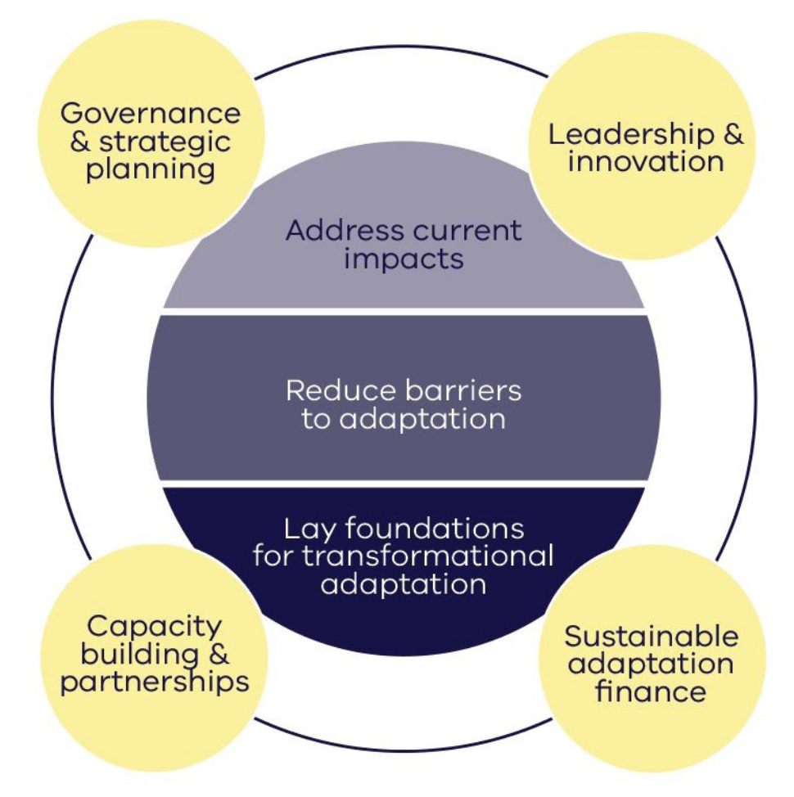
Figure 1: The basis for adaptation priorities outlined in Victoria’s Climate Change Strategy
The Victorian Government has prepared its first set of five-year AAPs for seven systems that are either vulnerable to climate change impacts, or are essential to ensure Victoria is prepared. These are the built environment, education and training, health and human services, natural environment, primary production, transport, and the water cycle systems.
This systems-based approach to climate change adaptation enables a targeted response to climate change, which focuses on the unique characteristics and needs of each system. It is complemented at a regional scale by the development of Regional Adaptation Strategies in partnership with regional communities to identify, prioritise and deliver place-based action informed by local knowledge and needs. These strategies have been developed for Greater Melbourne, Gippsland, Hume, Loddon Mallee, Grampians and Barwon South West.

The water cycle is unique
The Victorian Government released a Pilot Water Sector Adaptation Action Plan in 2018, outlining 20 unique actions to strengthen the sector’s ability to adapt effectively in the face of climate change. Actions included better understanding the implications of climate change for flood management, estimating resourcing needs to manage more frequent and complex emergency events, and identifying elements of successful adaptation business cases to guide the water sector. All actions have either been completed or are continued throughout this AAP.
The Water Cycle AAP looks beyond the scope of the water sector to iteratively guide system-wide adaptation effort over the next five years. It builds on strong foundations and seizes opportunities to accelerate adaptation. While adaptation is essential to meeting the current and future physical risks of climate change, there are indirect risks that might arise from not transitioning to a lower carbon economy.
Making up roughly one-quarter of the Victorian Government’s greenhouse gas emissions annually, water corporations are already acting to reduce their emissions in efficient and innovative ways. Water for Victoria commits water corporations to achieving net zero emissions by 2050, with Victoria’s four metropolitan water corporations exploring pathways to net zero by 2030. Ambitious interim emission reduction targets to 2025 have been formalised by the Minister for Water in the Statement of Obligations (Emissions Reduction) and represent a 42% reduction in collective emissions from a 2011–2016 average baseline.

1.2. Water Cycle AAP Objectives
This plan sets an overarching direction for long-term adaptation across Victoria’s water cycle system (see figure 2). It builds on objectives set through the Pilot Water Sector Adaptation Action Plan and Water for Victoria, as well as the guiding principles outlined in the Climate Change Act 2017.
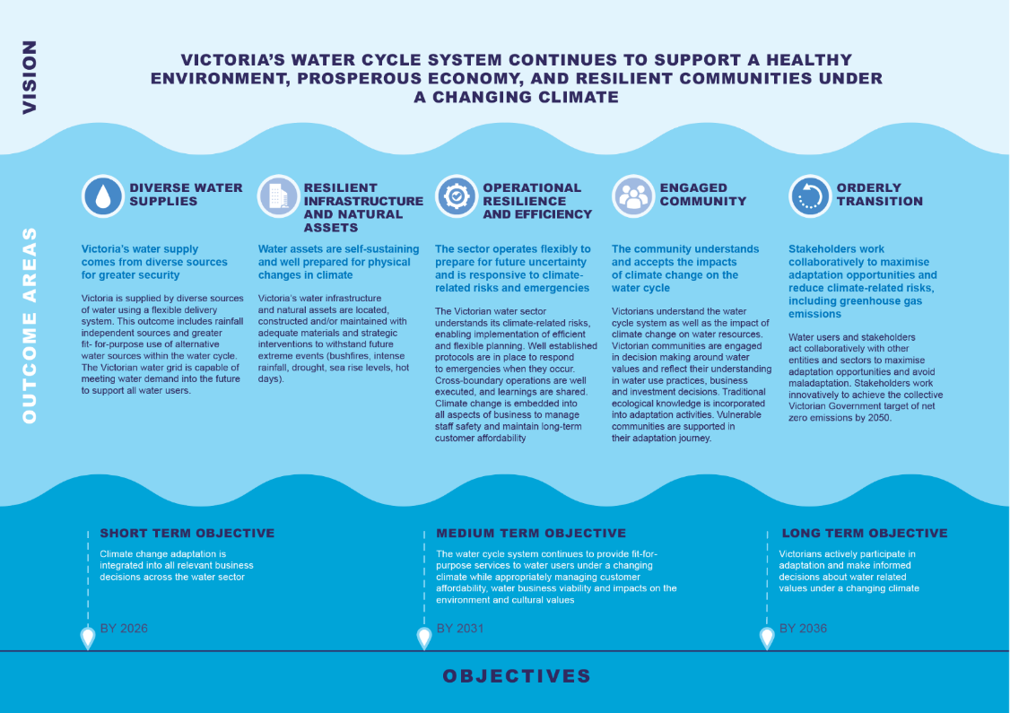
Figure 2: Strategic direction of the Water Cycle AAP

1.3. Scope of the water cycle system
As the name suggests, water continues to move through an endless cycle – for example between rivers, aquifers, oceans and clouds. These ongoing global processes mean water has been naturally recycled for millions of years. For the purposes of this AAP, the Climate Change Act 2017 defines the water cycle system as:

Water supply - the collection, storage, treatment, delivery and supply of water, including recycled water.
This includes availability, allocation and regulation of water supplies; managing water demand across different water users; the planning, operation and maintenance of water supply infrastructure; as well managing the quality of water supplied. Waterway health is within the scope of the Natural Environment AAP.

Sewerage - sewerage services, including the collection, treatment and disposal through sewerage systems and treatment plants.
This plan extends the definition to consider all wastewater sources. This includes planning, operation and maintenance of public wastewater infrastructure and treatment processes; wastewater discharge; and managing nutrient cycles including circular economy opportunities. Broader uses of wastewater continue to be investigated.

Drainage - drainage services including the operation of drainage systems.
This includes stormwater capture, treatment, storage and reuse opportunities; managing runoff in urban and rural environments; as well as nuisance inundation of drainage systems.

Flood management - flood management services including the operation and maintenance of infrastructure to mitigate floods.
While all AAPs must consider the impacts of sea level rise and intense rainfall events on their individual systems, the Water Cycle AAP considers the planning, construction, operation and management of flood mitigation assets; mapping of overland and riverine flood risks; as well as direct flood impacts to the water cycle system.
Integrated water management and systems-thinking highlights the overlaps between these four components of the water cycle. For example, drainage services and infrastructure can play an important role in flood management and also provide a fit-for-purpose water supply.

Connections with other systems
As an integral part of our human and natural surroundings, the water cycle system has many connections with the six other systems developing climate change AAPs under the Climate Change Act 2017. Connections can include ways in which water may rely on, or affect, other systems. While some connections may be well managed already through existing policies and programs, others may be amplified by the impacts of climate change. Figure 4 explores some of the connections between the water cycle and other AAP systems.
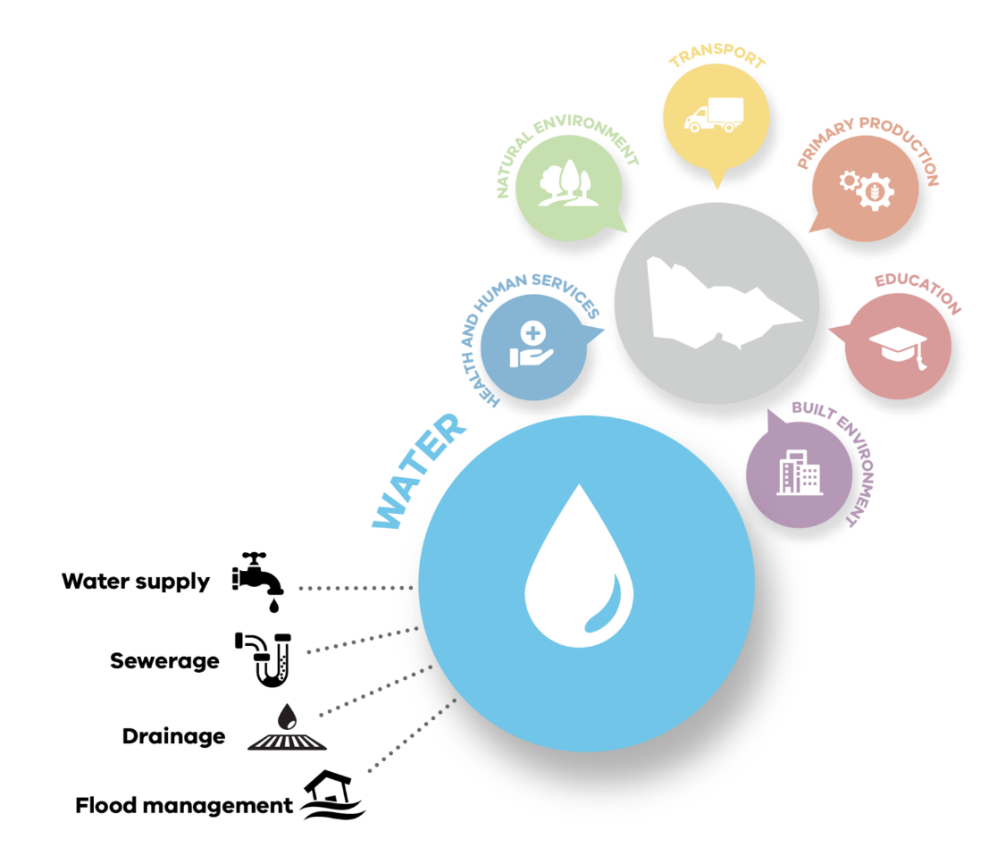
Figure 3: Scope of the Water Cycle AAP
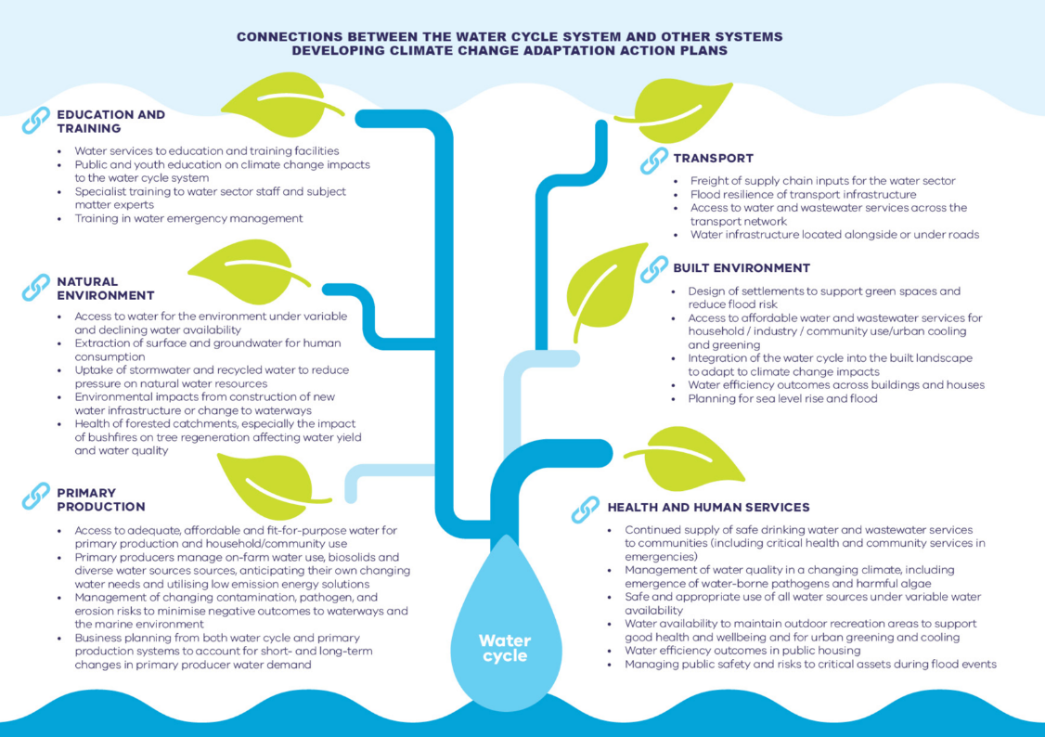
Figure 4: Connections between the water cycle system and other systems developing climate change AAPs
Key cross-cutting policy areas and stakeholders have also been identified that span across multiple AAP systems. Figure 4 outlines the ways these cross-cutting themes interact with the water cycle system.
Table 1. Connections between the water cycle system and cross-cutting policy areas and stakeholders
Cross-cutting policy areas and stakeholders identified across all AAPs | Interactions with the water cycle
Energy | - Secure and reliable energy supplies are needed to provide essential services such as pumping and treating water. Backup power may be employed at critical water assets in case of an emergency.  - The water sector participates in peak demand management programs and opportunities to generate local clean energy.  - Water is required to generate some forms of energy.  - There is water-related energy use throughout the water cycle system, for example heating water.  Energy is included within the scope of the Built Environment AAP.
Marine and coasts | - Some water infrastructure such as pipes, drains, outfalls and treatment plants are situated along the coastline and may be at risk of damage or inundation.  - Seawater incursion into groundwater supplies may reduce the quality of water available to coastal communities.  - Flood risks are exacerbated by sea level rise and storm surges.  Impacts on the health of the marine environment and productive fisheries is within the scope of the Natural Environment and Primary Production AAPs.
Emergency management | - The water sector has defined roles and responsibilities in Victoria’s coordinated emergency preparedness, response and recovery arrangements.  - Adaptation must consider the current and future capacity and capability of the water sector to address emergencies under climate change.  - Adaptation must consider the resilience of critical water assets during emergencies amplified by climate change.
Vulnerable communities | - Water plays an important role in urban greening and cooling to reduce heat stress, particularly targeting communities most exposed or sensitive to these conditions.  - Adaptation options must consider ongoing access and water affordability. Low-income households spend a greater proportion of their income on water bills and are therefore more vulnerable to price shocks.  - Reductions in water availability and water quality impact communities reliant on a single source of water or dependent on water security for their livelihoods.  - Disadvantaged communities are disproportionately impacted by emergencies amplified by climate change because they have less resources to prepare for, respond and recover from events.

2. Governance, roles and responsibilities
The Minister for Water is responsible for leading the development and implementation of this Water Cycle AAP. The Department of Environment, Land, Water and Planning (DELWP) is the key government agency that will work collaboratively with the Victorian water sector and community to deliver adaptation action.
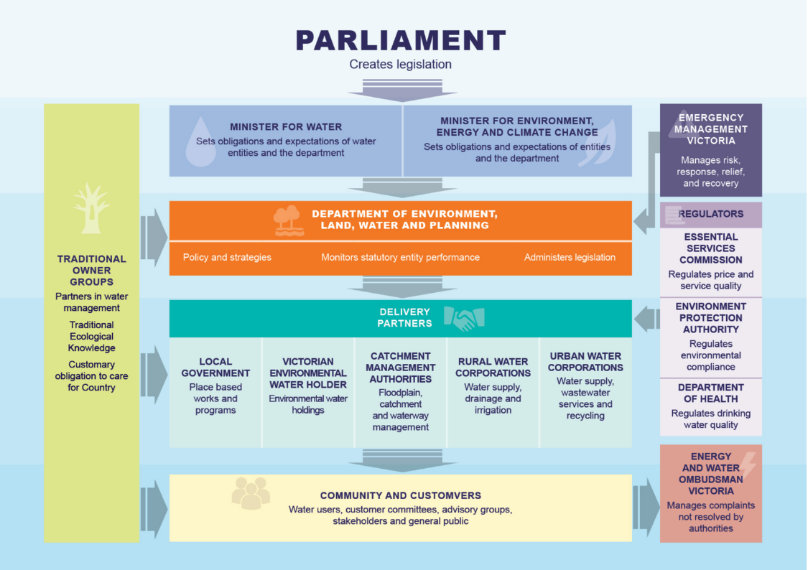
Figure 5: Governance and roles of the Victorian water sector
Climate change adaptation is a shared responsibility. Government, industry and communities all have important roles to play in effective adaptation across the water cycle system.

Community
Every single person uses water and therefore plays a role in climate adaptation. In fact, 95 per cent of Victorians believe that individuals should be acting on climate change. Communities and individuals have roles and responsibilities across the water cycle system to:
- Understand climate change impacts to the water cycle and how this influences their own risks.
- Appropriately manage water supply risks using available guidelines, frameworks and markets.
- Engage with government and authorities to determine adaptation needs and priorities, including willingness to pay to achieve desired water related outcomes.
- Reflect adaptation values in individual and collective water practices, investment and business decisions, including opportunities to reduce emissions.
Community groups and citizen science programs play an important role in connecting local communities to sustainable water management.

Australian Government
The Australian Government agrees on international obligations on climate change action, and supports adaptation across the water cycle by:
- Providing national climate science and investing in climate research for use by decision makers and the community.
- Setting national standards and advice for adaptation planning, drought policy and national water reform in consultation with states and territories.
- Assessing and prioritising federal investment in major water infrastructure projects delivered by Victorian water corporations to improve water security and resilience to climate change.
- Supporting Victoria and other jurisdictions reduce disaster risk and strengthen resilience, including funding for preparedness, relief and recovery.
- Implementing the National Climate Resilience and Adaptation Strategy as a roadmap to understand, monitor and respond to Australia’s changing climate.
Several departments play a role, including the Department of Agriculture, Water and the Environment; Bureau of Meteorology; Clean Energy Regulator; Murray-Darling Basin Authority; and Department of Industry, Science, Energy and Resources.

Victorian Government
The Victorian Government supports the water sector and Victorian water users prepare for and respond to a changing climate. To achieve this, it:
- Ensures policies and frameworks are in place for the planning and management of water resources to consider the impacts of climate change.
- Invests in research to understand how climate change is currently, and will continue to, impact the water cycle system across Victoria.
- Transparently communicates water availability, water use and water-related climate risks across the state.
- Addresses regulatory, financial, institutional, social and other barriers to encourage better use of all water sources under a warmer, drier future.
- Leads statewide emergency management arrangements, including preparing for, responding to, and recovering from, emergencies in partnership with communities, agencies and businesses. These include emergencies amplified by climate change.
- Works with water corporations to establish cost-effective pathways to achieving net zero emissions and contribute towards the emission reduction targets outlined in Victoria’s Climate Change Strategy (28-33% below 2005 levels by 2025 and 45-50% by 2030).
- Makes strategic and informed investment decisions based on changing water availability, demand and risks.
- Recognises and supports the self-determination of Traditional Owners and Aboriginal Victorians in deciding their roles and responsibilities for climate adaptation planning and provides resourcing.
- Works with critical infrastructure owners and operators to improve resilience, minimising shocks and outages during emergencies.
Victorian Government departments that play a role in adaptation across the water cycle system include DELWP, Agriculture Victoria, Emergency Management Victoria and the Department of Jobs, Precincts and Regions. Other statutory authorities such as Sustainability Victoria, Bushfire Recovery Victoria and the Victorian Planning Authority play a broader role in adaptation across the seven AAP systems.
Water sector delivery partners
Water sector delivery partners work collaboratively with government and each other to plan and manage water to optimise environmental, cultural and social benefits. Delivery partners play an important role in the management of water-related emergencies as well as identifying, prioritising and implementing integrated water management opportunities.
Victoria’s 18 water corporations provide a range of services to the community. They operate and maintain over $48 billion in infrastructure that have asset lives of up to 100 years. Water corporations:
- Consult with customers to identify local priorities, opportunities, potential risks and adaptation responses under different climate scenarios. This includes understanding customer willingness to pay for levels of service.
- Consider the financial and service delivery implications of climate change adaptation and articulate investment priorities to the Essential Services Commission when reviewing water prices.
- Fund and deliver projects to address climate change risks and incorporate climate change into asset planning and management.
- Consider opportunities to diversify water sources to increase resilience to climate change.
- Manage reservoirs to provide water services. Any flood mitigation from a water corporation dam is incidental and opportunistic.
- Work with government to establish a cost-effective pathway to achieving net zero emissions.
- Incorporate climate change into forecasting future water availability and ability to meet demand, including plans to manage water supplies during drought periods.
Water corporations each have specific obligations set out in a Statement of Obligations issued by the Minister for Water under the Water Industry Act 1994. Rural water corporations for example provide supplies for irrigation, domestic and stock use, drainage and water storage services. They also administer waterway diversions and groundwater extraction licences. Urban water corporations (metropolitan and regional water
corporations) plan and manage water resources, water supply and wastewater services within cities and towns. Melbourne Water provides wholesale water supplies, drainage, flood management and advisory services. Figure 6 shows the geographical boundaries between the 18 water corporations.
The Victorian Environmental Water Holder (VEWH) is responsible for holding and managing Victoria’s water for the environment. It plans when, where and how environmental water will be delivered to waterways across the state each year. This is done in consultation with catchment management authorities, the community, Traditional Owners, water corporations and other relevant agencies. The VEWH plans for a range of climatic scenarios each year, using a seasonally adaptive approach.
Victoria’s Catchment Management Authorities (CMAs) are responsible for the integrated planning of land, water and biodiversity management across 10 catchment regions. CMAs:
- Prepare, coordinate and monitor the implementation of strategies that promote sustainable use, conservation and rehabilitation of land, water and biodiversity resources while responding to climate change threats.
- Prepare and implement land and water management plans and irrigation development guidelines.
- Provide advice on flooding and development of controls including those subject to sea level rise.
- Conduct strategic assessments of flood management priorities for adapting to climate change.
- Provide advice to landholders developing dryland rural drainage management plans, and process applications for works on waterways.
- Work with water corporations to trial catchment works that deliver improved water quality and accredited carbon offsets that support emission reductions and climate change adaptation.
- Build community capacity through catchment stewardship and enable climate change adaptation pathways through an integrated approach to natural resource management.
Victoria’s 79 local government councils deliver a variety of place-based services to their community including planning, emergency management, public infrastructure provision, community services, waste and management of public spaces. Local government collectively manage approximately 35,000 kilometres of drainage pipes and 1.4 million stormwater pits across the state. They:
- Consider current and future flood risk when preparing planning schemes and land use planning decisions including coastal flooding.
- Manage public drainage, urban stormwater infrastructure and regulate onsite wastewater systems with a capacity of less than 5,000 litres per day.
- Provide and manage some flood mitigation infrastructure such as dams, levees and weirs.
- Provide and maintain public open space and streetscapes, which are essential to Victoria’s liveability. This includes adaptation to drought and other climate change impacts that threaten public spaces.
- Provide tools and information to private landholders to understand their options to manage dryland drainage where these have been agreed.
- Develop local communications and activities to support the community in managing the impacts of heatwaves and other emergency events.
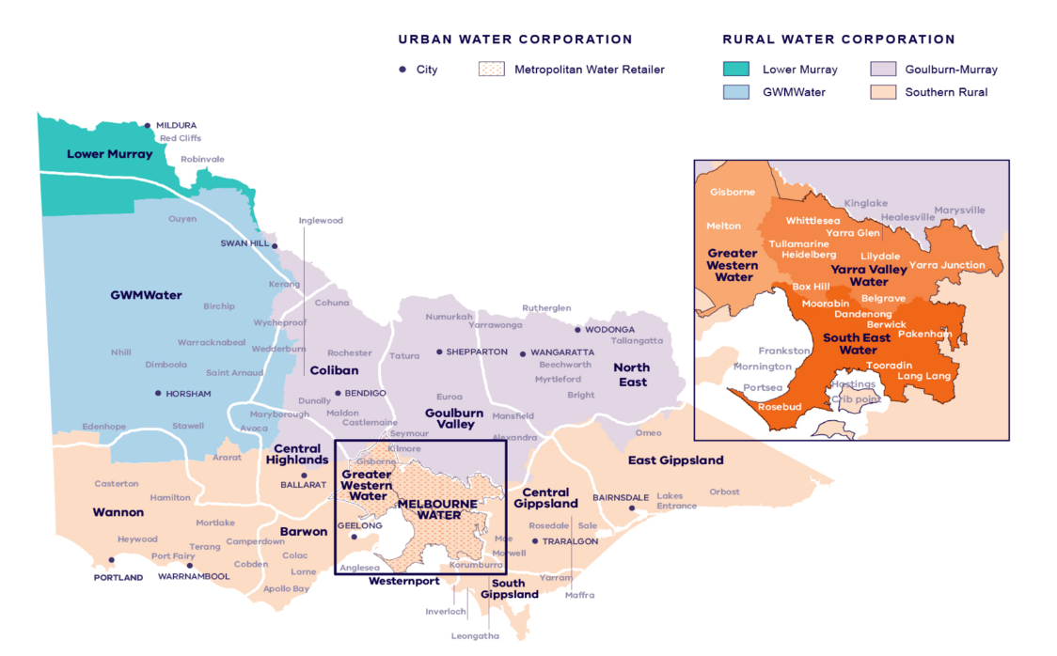
Figure 6: Map of water corporation boundaries across Victoria
Peak industry groups play a role in fostering the exchange of information between members. They discuss priority issues, identify industry best-practice and build networks to strengthen climate adaptation across the water sector. They also advocate the interests of their members when government policies are being developed, including those related to climate change. Peak industry groups include VicWater, Water Services Association of Australia, Vic Catchments and the Municipal Association of Victoria.
Aquasure operates and maintains the Victorian Desalination Plant as a rainfall-independent water supply, on behalf of the Victorian Government until 2039. The Victorian Desalination Plant delivers up to 150 billion litres of water annually to water corporations for distribution across Melbourne, Geelong and local regional communities. Aquasure provides 100 per cent renewable energy offsets for all electricity used to produce desalinated water at the plant.

Traditional Owners
Indigenous knowledge has developed over millennia and thoughout significant periods of environmental change. This means Traditional Owners and Aboriginal Victorians are important partners in adaptation across the water cycle for healthy waters and Country. The Water Cycle AAP will support Aboriginal self-determination and the respectful application of traditional ecological knowledge and caring for Country principles in the management of natural resources, including water, under climate change.
“Thousands of years of knowledge and how to work with the environment – climate change is not new to Aboriginal people. Aboriginal people know the land and how to manage it in traditional ways, intricate knowledge of weather patterns and spiritual entities and how they work together. The people could anticipate things – we could read the environment” – Djaara Elder Phyllis Harrison.
Traditional Owner groups play a role in:
- Considering climate change in Country plans, self-determination plans and Aboriginal waterway assessments.
- Reviewing local plans to protect Aboriginal cultural heritage and significant sites.
- Partnering with CMAs and other agencies in catchment management practices and decisions.
- Contributing to climate change adaptation strategies and plans throughout the Victorian water sector.

Regulators
The water sector is heavily regulated to ensure essential water services are affordable and safe, and that impacts on the environment are appropriately managed.
The Victorian Environment Protection Authority (EPA) is an independent statutory authority that operates under the Environment Protection Act 2017 to:
- Monitor and oversee environmental performance of Victorian businesses, government entities (including water corporations) and community in relation to wastewater discharge. The Environment Protection Act 2017 includes a general environmental duty which requires Victorians to take reasonable and practical steps to reduce risks to environmental and human health from their activities.
- Provide guidance to water corporations to support effective risk management of spills or leakage from sewerage systems.
- Provide permissions for large scale sewage treatment and the supply or use of reclaimed wastewater or biosolids.
- Consider the impacts of climate change on waterways when assessing licence or permit applications or reviewing of operating licences.
- Set and review environmental guidance relating to water management such as stormwater and recycled water based on best available science, knowledge and evidence.
The Essential Services Commission (ESC) is an independent regulator that promotes the long-term interests of Victorian consumers with respect to price, quality and reliability of essential services, including water. The ESC:
- Monitors and reports performance of water businesses against a range of customer service indicators that may be impacted by climate change.
- Regulates the water sector including assessing and approving proposed service levels as well as water and sewerage prices for customers.
- Reviews prudency and efficiency of water corporation expenditure forecasts in pricing submissions, including expenditure on climate change adaptation measures.
The Department of Health plays a role in delivering policies, services and regulatory functions throughout the water cycle system to:
- Regulate safe drinking water in accordance with the Safe Drinking Water Act 2003 and Safe Drinking Water Regulations 2015.
- Act as the control agency for drinking water contamination under the State Emergency Management Plan.
- Provide guidance and advice to manage risks associated with recreational water and private drinking water supplies.
- Inform policy as it relates to the public health aspects of water quality.
- Provide public health advice on harmful algal blooms to other agencies.

3. Climate change and the water cycle system

3.1. Climate change in Victoria
Long-term observed records show that Victoria’s climate is changing. Since official records began in 1910, Victoria has warmed by 1.2°C. With this amount of warming, Victoria has already experienced a decrease in average rainfall, especially in cooler months; an increase in the frequency of extreme heat events; and an increase in dangerous fire weather and the length of the bushfire season.
The climate trends and associated impacts Victoria has experienced over the last decades are expected to continue. For example, the latest climate projections for Victoria suggest that:
- By the 2050s, under a high emissions scenario, the state’s average annual temperature may increase by up to 2.4°C compared to the 1986–2005 average, with around double the number of very hot days.
- Across Victoria, annual rainfall is projected to decrease, especially in the cool season. However, due to natural variability, extreme rainfall events will still occur and will likely be more intense, potentially increasing the risk of flash flooding in some locations.
- The number of high fire-danger days in Victoria is expected to increase in the future.
- Sea levels will continue to rise. By the 2050s, under medium and high-emissions scenarios, sea level is projected to rise by about 24cm (relative to 1986–2005).
The magnitude of climate change impacts will depend on how quickly the international community reduces emissions. While reducing greenhouse gas emissions is the most effective strategy to reduce the impacts of climate change, even if emissions ceased today, the climate will continue to warm for decades due to historical emissions.
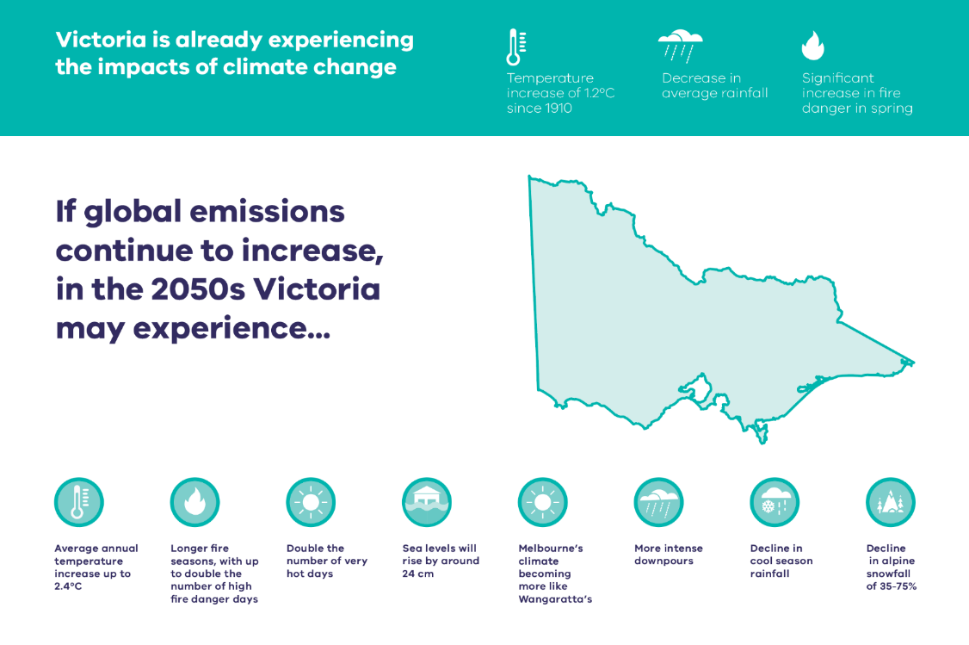
Figure 7: Current and projected climate change impacts for Victoria under high emissions, compared to 1986-2005

3.2. Climate change impacts on the water cycle system
Climate change is already impacting all aspects of the water cycle system, with the warming, drying trend of recent decades projected to continue in the future.

Observed changes
There has been a reduction in the frequency of rain-bearing low-pressure systems across Victoria.
The reduction in rainfall from these systems during cooler times of the year (April to November) contributes to the significant reductions observed in catchment runoff. Runoff is important for the water cycle system because it plays a large part in filling reservoirs, lakes, storages and farm dams across Victoria, as well as boosting flows in our waterways.
While observed warm season (November to March) rainfall has increased in northern parts of the state, this is not as effective at filling water storages. This is due to large proportions of rain being lost to evaporation, absorbed into dry soils, or taken up by vegetation.
Declines in streamflow across the state vary between about 25 per cent and 75 per cent compared to 1975–1997. The greatest reductions in streamflow have been typically recorded in the central and western parts of the state.
Long-term surface water availability across southern Victoria has declined by up to 21 per cent. The main cause of declines in surface water availability is drier conditions, however upstream interception of water by plantations and domestic and stock dams may also be contributing to the decline in surface water availability in some basins. An assessment of water resources in northern Victoria will commence in 2025.

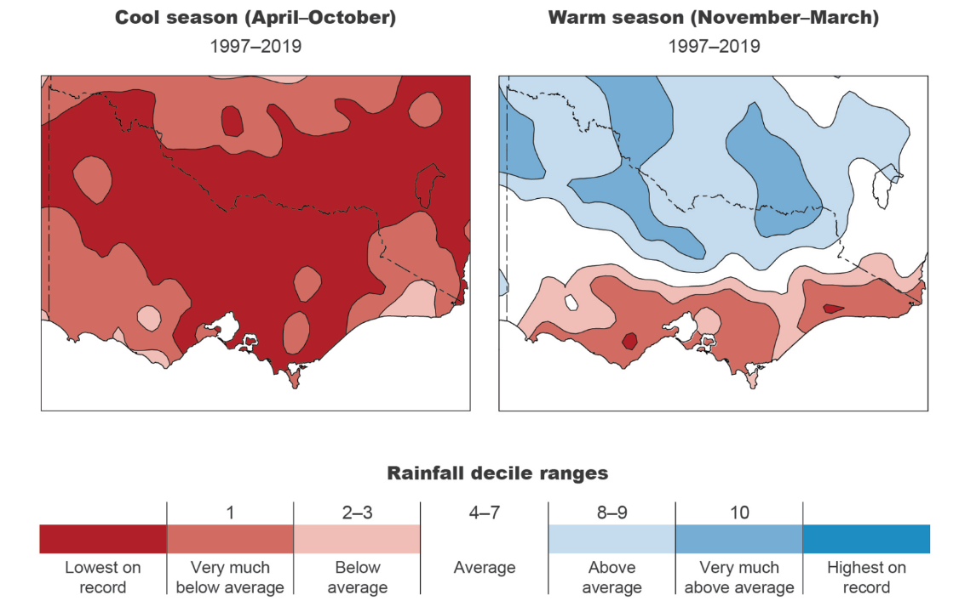
Figure 8: Rainfall declines for the cool season and warm season 1997-2019 relative to all other 23-year periods (source: Australian Gridded Climate Data)
CASE STUDY – MILLENNIUM DROUGHT
Between 1997 and 2009, Victoria experienced unprecedented dry conditions.
By 2007, after 10 years of below average rainfall and receiving the lowest annual inflows on record, 457 Victorian towns were on water restrictions. In some cases, water was carted to towns on stage four restrictions to meet essential needs when no other feasible supply options were available. Severe and prolonged water restrictions saw impacts on recreational areas, sports grounds and gardens as well as businesses such as nurseries, whose sales dropped as customers’ irrigation was restricted. Between 2007 and 2010, all northern Victorian regulated systems opened the irrigation season with zero allocations, highlighting the widespread strain to Victoria’s agriculture during this period. Inflows to river basins and reservoirs were just 26% of the long-term average, with most systems recording less than 20% of the long-term average streamflow.
The Millennium Drought posed water availability challenges more extreme than envisaged possible when water entitlements and sharing rules were developed. This sparked reforms across Victoria’s water management frameworks to improve our preparedness and response to these types of conditions. Although the Millennium Drought was the result of both natural variability and climate change, climate projections indicate we should expect longer and more frequent droughts in the future.
Despite an overall drying trend, historical observations are showing the intensity of extreme, short duration (hour long) rainfall events increasing by an average of 14 per cent per degree of warming. Short duration rainfall events are more likely to overwhelm stormwater systems, increasing the risk of flash floods and damage to surrounding properties and structures. For example, in December 2018, a month’s worth of rain fell in less than 24 hours resulting in at least 100 cars trapped by flash floods on the Hume Freeway north of Wangaratta.
Climate change amplifies deterioration of water quality through higher temperatures, drought, bushfires, floods and storms. Poor water quality poses threats to humans, livestock and ecosystems, as well as recreational and cultural values. Decreased water quality may include high turbidity and water-borne health risks (such as the presence of harmful algae and pathogenic microorganisms). In February 2016, a major blue green algae outbreak colonised 1,450 kilometres of the Murray River from the Hume Dam all the way to downstream of Wentworth, impacting many river communities for more than 12 weeks. The warmer average temperatures that year and low rainfall are thought to have contributed to this protracted outbreak.

Projected changes and impacts
Projections of future global trends in climate are wide ranging and affected by factors such as carbon emissions and feedback loops. Projected changes in runoff under a high climate change scenario suggest a possible average annual streamflow reduction of more than 50 per cent in some catchments by 2065. Reductions of this scale could have serious future consequences for water availability and water quality, particularly when coupled with higher average temperatures, heatwaves and bushfires that increase overall demand for water. Rainfall is expected to continue to decline in winter and spring. Local scale projections suggest a greater decrease in the annual average rainfall on the western slopes of the Victorian Alps compared to the surrounding regions in autumn, winter and spring11. Declining snowfall will also impact runoff amounts for alpine regions.
Victoria’s urban water corporations assess climatic factors that influence future water availability – such as changes to temperature, potential evaporation, rainfall, runoff and recharge – when developing potential future supply and demand scenarios. Even with Victoria’s existing desalination plant, Melbourne and surrounding regions are forecasting challenges in meeting existing levels of service to its increasing customer base over the next decade under a drying climate. New investments to the water grid and the uptake of diverse sources of water will be essential for future water security.
Based on our understanding of atmospheric processes, the intensity of future extreme rainfall events is expected to increase by at least 7 per cent for each degree of warming, noting historical observations are seeing increases double that amount on average17. Risks of flash flooding are an issue particularly in small catchments or urban environments where rainfall is directed from impervious surfaces into stormwater networks engineered for historical rainfall patterns.
Rising sea levels can inundate and damage coastal water infrastructure as well as cause seawater to infiltrate groundwater and other coastal water supplies used for agricultural, urban and environmental purposes. Flood mitigation and stormwater infrastructure may be less effective if partially filled with seawater.
The number of high fire-danger days in Victoria is expected to increase in the future. By the 2050s under high emissions, Bendigo, Ballarat and Shepparton could experience more than a 60 per cent increase in the number of high fire-danger days compared to 1986–2005¹¹. Fires can burn vegetation within water catchments and damage water infrastructure such as pumping stations, pipes, storages and treatment plants. Emergency water supplies may be damaged that assist in firefighting and provide immediate relief to affected communities. For many months after bushfire events, ash and sediment washed into reservoirs and waterways can affect the quality and quantity of water supplies, potentially rendering them unusable. Sediment loads have been reported up to 500 times the background level following fires and rainfall, with some reservoirs taking up to two years to return to pre-fire sediment levels. In some cases, water may continue to be supplied at a financial cost by the supplier and/or at a reduced quality.
Climate change may affect rates of recharge and the future availability of groundwater. The most vulnerable systems are those with shallow watertables and highly responsive systems. The variability and complexity of each groundwater system means individual modelling and assessment is required to understand the impacts of climate change over time13¹³.
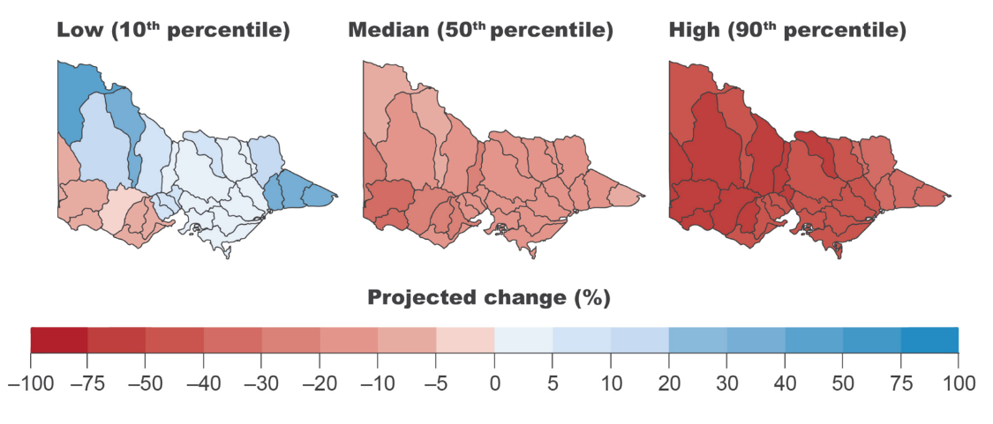
Figure 9: Median and range of projected changes in basin mean annual runoff by 2065 relative to post 1975 average under a high emissions scenario (RCP8.5)18
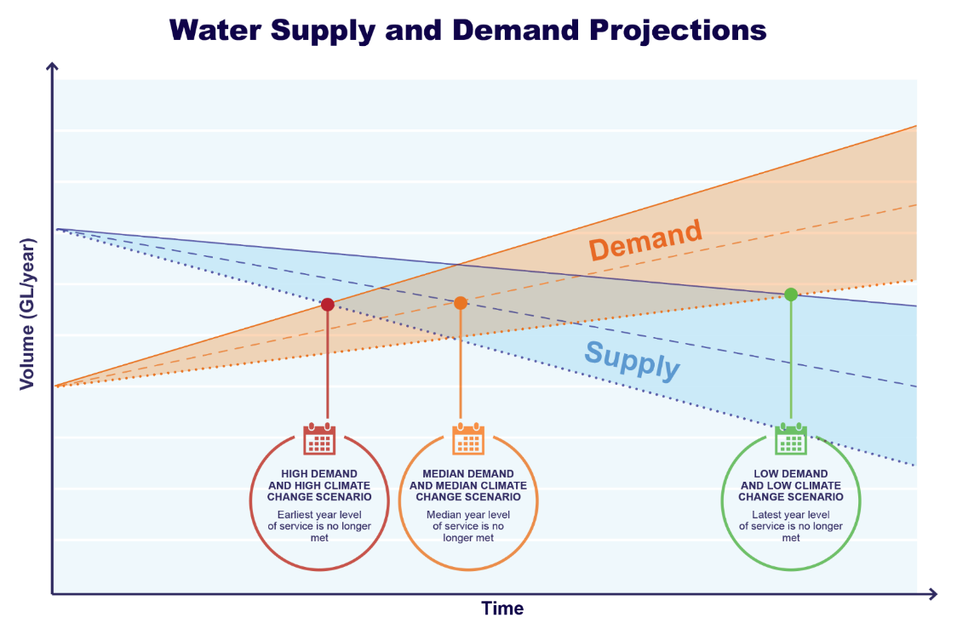
Figure 10: Projected water supply and demand for Melbourne and surrounds are indicating water supply shortfalls within the next 10 years. Urban water corporations are updating their supply and demand projections for 2022
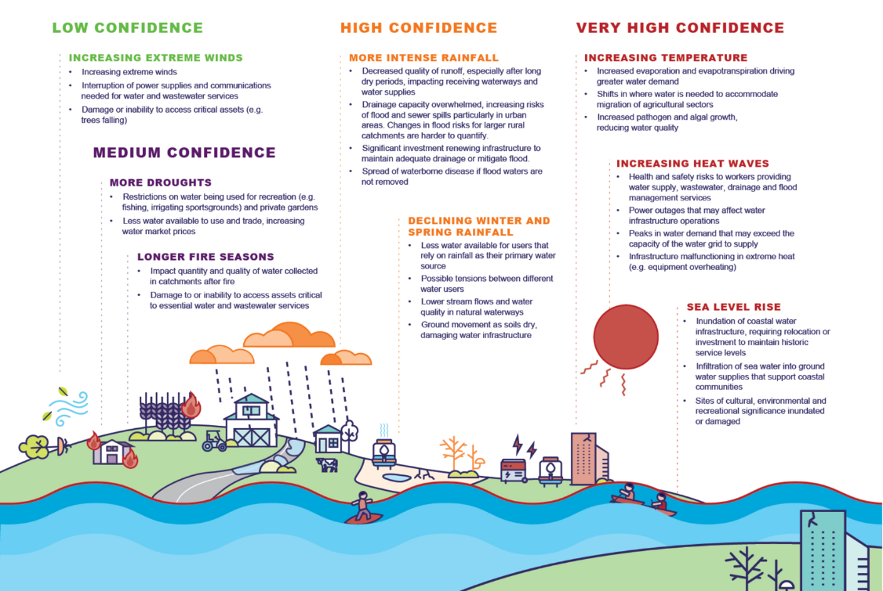
Figure 11: Summary of the potential implications for the water cycle system

4. Key climate change risks and opportunities for the water cycle system
This Water Cycle AAP follows the risk-based approach taken by the Intergovernmental Panel on Climate Change, focusing on how changes to the physical characteristics of the climate system (hazards) interact with our socioeconomic and biological systems (exposure and vulnerability).
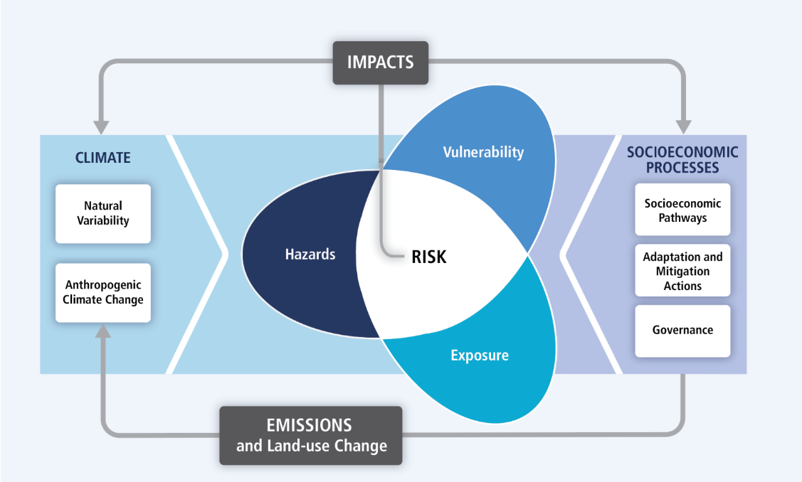
Figure 12: Fundamental concept of risk and vulnerability to climate change
A risk assessment is an integrated part of any adaptation planning and since we can never know with certainty what the future will look like, adaptation planning needs to consider a range of scenarios that explore different climate change and socio-economic pathways. Informed by best available information such as the Victorian Climate Change Projections 2019 and Victorian Water and Climate Initiative (VicWaCI), the Water Cycle AAP explored high-resolution projections under two representative concentration pathways: RCP4.5 (moderate) and RCP8.5 (high). Global emissions are currently tracking close to RCP8.5, which represents a future where emissions continue at current levels for the rest of the century. The RCP8.5 scenario is recommended for water supply planning across Victoria, consistent with a precautionary approach13.
Non-climate drivers also need to be considered in the context of future climate change risks. For example, population growth and the shifting distribution of communities and businesses throughout Victoria change future demand for water as well as the reliability and quality of water needed for different uses. Evolving community expectations are seeing a greater emphasis on diverse water sources to support healthy natural environments, green urban spaces, provide quality recreational areas and support Aboriginal cultural and spiritual connectedness with Country as well as economic aspirations. Changing economic condition influences our ability to access information and technology, as well as influence water needs across the state. COVID-19 is an example of non-climate drivers that have profound impacts on how we live in the short to medium-term.
Risk is never static and depends on how all three elements – hazard, exposure and vulnerability – and our understanding of them, change over time. It is important that potential risks to climate change are reviewed periodically to ensure our risk-based approach undertaken throughout the Water Cycle AAP is still appropriate and seeks to avoid maladaptation.
Climate change can present new risks to the water cycle system or, more commonly, exacerbate existing ones. While many organisations that manage water have their own specific risks relating to climate change, 13 priority risks were identified during the climate change risk assessment undertaken for the system at a statewide level. Many risks cannot be managed solely within the scope of the water cycle system and require collaboration with other systems to achieve a collective goal. These are termed ‘cross-system risks’ throughout the document.

4.1. Risks specific to the water cycle system

Damage to water infrastructure from soil movement
Victoria’s soils shrink and swell from drying and wetting cycles. This damages surface-level or underground infrastructure such as pipes, channels, foundations and dam walls. By 2030, Melbourne’s characteristic ground movement due to soil expansion is expected to increase 11 per cent from 1990 levels and a further 18 per cent by 2070.
Victoria is highly exposed to these soil conditions given its high proportion of older water infrastructure. Indirect damage can also occur as tree roots search for water in dry soil.
Replacing large amounts of water infrastructure before their intended life expectancy is cost-prohibitive. Victoria is therefore highly vulnerable to interrupted water, wastewater, drainage and flood management services as a result of infrastructure damaged from soil movement.
Existing measures: DELWP has explored the challenges of managing dams under climate change, presenting findings to conferences such as the Australian National Committee on Large Dams. The findings provide a strong case for the incorporation of climate change adaptation into dam safety management guidelines and design standards developed by relevant industry bodies. In collaboration with the water industry, DELWP is developing Guidelines for Assessing the Impact of Climate Change on Sewerage Systems in Victoria to provide comprehensive technical guidance on the design and operation of sewerage systems.
Risk assessment: There is a high risk of interruptions to water services due to damaged underground and surface infrastructure. This risk would likely result in medium to long-term increases in expenses to maintain, replace and repair this infrastructure. Infrastructure upgrades and/or repairs are reflected in customer prices, contributing to affordability risks for customers and financial pressure on water corporations and local government. Widespread short to medium-term disruptions to services would be expected while damaged infrastructure is being restored.

Water infrastructure malfunctioning during extreme heat events
Victoria is highly exposed to water infrastructure operating in conditions that exceed their safe functioning temperature. Infrastructure may fail under these conditions, leading to disrupted water supply and wastewater services.
Older water infrastructure is not designed to withstand extreme heat events. Most water infrastructure is long lived, with replacement not scheduled for decades. Hot days generally also coincide with large water demand and power use across a variety of users, exacerbating vulnerabilities for energy-dependent infrastructure such as pumps and treatment facilities.
Measures such as retrofitting parts most sensitive to heat, strategic shading, indoor cooling and back-up sources of power are possible. However, Victoria is still highly vulnerable to interrupted water and wastewater services from infrastructure malfunctioning during extreme heat events.
Existing measures: Victorian Climate Projections 2019 provides projected changes in hot days and heatwaves over different timeframes and climate change scenarios. This information helps infrastructure planners and operators across the water sector to incorporate possible heat events into its designs, standards and materials used when retrofitting or replacing infrastructure.

The Victorian water sector recognises that secure and reliable energy remains a key vulnerability to the water cycle system during extreme heat events and other emergencies. It has reviewed the opportunities to actively participate in energy demand response programs and embed response plans into business operations.
Risk assessment: There is a high risk that water infrastructure will malfunction during extreme heat events. This risk would likely result in communities losing essential water and wastewater services, which may be far-reaching due to the interconnectivity of the water grid. A lack of water to irrigators can threaten the survival or quality of products, even for a short period. Interrupted services can particularly impact vulnerable sections of the community, such as hospitals. This risk is compounded because water usage and the power needed to treat and transport water are both likely to be in high demand during extreme heat events.

Inadequate emergency response from the water sector
Across the state, projected increases in the frequency and intensity of extreme weather events under climate change will increase the likelihood of multiple emergencies occurring at the same time or in close succession. Longer high-risk weather seasons or more severe singular events require additional responses across the water sector to prepare, respond and recover from emergencies. The sector is moderately exposed to a shortage of resources, posing business continuity and capacity risks as well as issues with staff fatigue and safety. Historical reliance on sharing resources may be limited in the future as organisations are occupied responding to emergencies within their own region.
Organisations located in areas of higher bushfire, blue green algae and flood risk are considered moderately sensitive to human resource limitations due to redirection of staff from critical business tasks to emergency response roles. Emergencies can create cascading effects, which may require different concurrent responses from the water sector. For example, a drought followed by intense rainfall can increase the risk of erosion and flooding within catchments, which may impact water quality.
Given the opportunities for further training, capacity-building and improvements to mutual aid arrangements, Victoria has a moderate vulnerability to climate change impacting resourcing and emergency response capability across the Victorian water sector.
Existing measures: Victoria’s Water Sector Resilience Plan and Water Industry Risk Report are prepared annually. They assess risks and implement actions to mitigate identified risks through the DELWP water sector resilience program. The capability and capacity-building program trains approximately 200 water sector personnel annually in emergency management roles and facilitates upgrades of the Water Intelligence Platform.
Through the Pilot Water Sector Adaptation Action Plan, Victoria’s water sector emergency preparedness and response capacity was assessed, and considered future needs under climate change. Water corporations, government agencies and CMAs estimate that 40 per cent more personnel will be required for emergency response due to the amplifying effects of climate change. These results have informed strategies and priorities for future training and capability targets for the water sector. Exercises are undertaken regularly to test emergency management plans and build response capacity that prepares the water sector for different types of emergencies, including those exacerbated by climate change.
Victoria’s State Control Centre is the central point for intelligence, planning and response to an emergency. It uses a tiered approach to activate resources at the incident and align resourcing with the severity of the emergency and protection of critical assets. Mutual aid arrangements across Victoria’s water industry have been enacted for major emergencies, including during the 2019–2020 Black Summer Bushfires and during the COVID-19 pandemic. This allows resources to be shared between operators, such as equipment and personnel.
Risk assessment: There remains a high risk of inadequate emergency response across the water sector under future climate change. The risk includes possible disruptions to critical water supply and wastewater services, as well as low quality water. Inadequate emergency response across the water sector could exacerbate impacts felt by downstream sectors and agencies that rely on agreed emergency responses. Inadequate emergency response more broadly can have direct and indirect impacts on the physical and mental wellbeing of communities; costs to businesses and primary producers; damage to physical structures that support our everyday lives; and impacts to our natural environment that underpin a healthy economy and society.

4.2. Cross-system risks
The system-based adaptation approach taken through the AAP process plays a critical role in identifying cross-system climate change risks. These risks are particularly challenging as they may:
- be newly emerging risks (for example, sea level rise)
- occur during particular climatic and catchment conditions so may not be a priority at other times (for example, algal events)
- have accountability and oversight spread across multiple stakeholder groups due to size and complexity (for example, bushfires)
- raise inherent conflicts between the values or goals of different systems (for example, water availability).
Multiple AAP systems must work collaboratively to drive sustained change and address these cross-system climate change risks. ‘Risk champions’ have been designated for each risk based on their primary portfolio responsibilities, as well as policy or legislative levers available to drive action to address the risks (in partnership with other relevant APP systems). It is important to note, the departments associated with these lead systems will in many cases be different to those designated (in the State Emergency Management Plan) as control agencies for hazards or hazardous events. The water cycle system is nominated for five of the ten cross-system risks identified as the highest concern for this system.

Cross-system risks - water cycle as the risk champion

Reduced access and reliability of water supplies to various water users
A warmer, drier climate poses availability and reliability challenges for Victoria’s climate-dependent water resources such as surface water and groundwater. Reduced water availability increases competition for its use to support different community values. These include producing food, supporting jobs, maintaining a healthy natural environment, cooling and greening the urban environment, supplying places of recreation, Caring for Country, and providing essential services to maintain human health. Balancing supply with demand may require significant new investments, changes in practices and shifts in community mindset.
Associated AAP systems
Built Environment | Y
Natural Environment | Y
Primary Production | Y
Health and Human Services | Y
Transport | Y
Education and Training | Y

The water cycle system may experience increased pressure for affordable water options with risk of demand exceeding available supplies, including deliverability issues during peak demand periods. Without diversifying sources of supply revenue, the viability of water businesses may be challenged along with the possibility of stranded assets.
This is considered an extreme risk to the water cycle system.
Existing management strategies: The Victorian Government continues to support investment in water-climate research to inform long-term planning and policy decisions on water security. VicWaCI is an important contributor to our understanding of projected future water resources, including changes to rainfall and anticipated runoff. Research has resulted in tailored guidance to apply climate change in water sector planning, for example, the DELWP Guidelines for Assessing Climate Change Impacts on Water Availability in Victoria.
Victoria’s water entitlement and resource planning framework clearly defines how water is shared, held, used and traded to support diverse water needs. Using a robust resource assessment and planning program including sustainable water strategies and long-term water resource assessments, the Victorian Government works with different stakeholders to identify climate change impacts and risks to water resources. The aim is to understand and address disproportional impacts to particular water users over time.
Urban water corporations develop urban water strategies looking 50 years ahead, using scenario planning and adaptive management to meet water supply challenges. These are informed by best available climate science and trends for non-climate drivers of water demand. Water corporations are also required to develop drought preparedness plans in consultation with local government to protect priority parks, gardens and sporting fields during drier times.
Excluding the Victorian Desalination Plant, the Victorian Government has invested approximately $2.7 billion in water infrastructure projects during the last decade. This has expanded the state’s water grid and improved the delivery efficiency of irrigation infrastructure across regional Victoria. Future investments will be informed by the Water Grid Partnership, which has completed its first stress test of a portion of the grid under a severe but plausible scenario.
A network of emergency water supply points, operating since the 1960s, are used by the community during emergencies. Water carting from these emergency water supply points is not feasible for larger towns where large volumes are required, or when emergency water is needed for extended periods of time.
Victoria is already exploring the benefits of more climate-resilient sources such as recycled water and stormwater. In Victoria, new homes are required to install either a solar hot water system or rainwater tank plumbed to the toilet and for watering gardens. Across the state, integrated water management forums identify and prioritise projects to consider the entire water cycle in urban landscapes.
When planning for challenging conditions like droughts, government and the water industry’s first aim is to reduce the amount of water lost or wasted before looking to other approaches. For example, more than 9.1 billion litres of water has been saved through the Schools Water Efficiency Program. Improving the efficiency of how we use water is foundational to making the most of our water resources. Educational campaigns such as Target 155, Target Your Water Use and Permanent Water Saving Rules have helped raise awareness of water conservation. Where applicable, water efficiency labelling standards help consumers estimate how much water a product will use and apply a star rating to quickly compare the water efficiency of different products. Staged water restrictions are employed to address short term reductions in water availability when required.

Increased frequency and distribution of harmful and nuisance algal blooms
Algal blooms occur naturally in many of Victoria’s catchments and river systems. While some are harmless, others can make water unsafe for drinking or aesthetically unacceptable. Algal blooms can also pose health risks for people using waterbodies for recreation; impact the quality and useability of water for irrigation and stock; and affect our waterway ecosystems through toxicity, loss of oxygen, and fish deaths. Under climate change, harmful and nuisance algal blooms are becoming more common. They may occur in new waterbodies, and during cooler months of the year that have never seen outbreaks or similar species before. The likelihood, severity and impact of these algal blooms are linked to both climate and non-climate change factors.
Associated AAP systems
Built Environment | -
Natural Environment | Y
Primary Production | Y
Health and Human Services | Y
Transport | -
Education and Training | -
The water cycle system may experience reductions in available water of sufficient quality for its intended use. Apart from poor aquatic ecological outcomes, water-based tourism, recreation and cultural sites of significance are also disrupted during algal events.
The current process for treating blue green algae is expensive and, at high concentrations, poses a risk of damaging water treatment facilities. In rural areas, treatment is impractical due to the size of storages and waterways. As a result, the treatment process can only be used for essential drinking water within the community.
Agricultural and environmental water users remain at risk, with increases in algal outbreaks driving a need for greater knowledge on the risks of using algae tainted water and options to treat or prevent algal blooms. Long lasting blooms were recorded in the Goulburn system in 2019 and 2020, as well as sustained blooms of a previously unobserved algal species in the Macalister Irrigation District, indicating this risk is already occurring.
This is considered an extreme risk to the water cycle system.
Existing management strategies: Investment in irrigation modernisation projects and improved on-farm practices. These are reducing non-climate contributions to algal growth by limiting high nutrient runoff into nearby waterways. Waterway monitoring is undertaken where algal events are known to occur frequently to identify and respond to an event quickly. DELWP leads regular training exercises with the water sector and related agencies to prepare for algal events and test the roles and responsibilities outlined in Victoria’s Blue Green Algae Circular. Through the Pilot Water Sector Adaptation Action Plan, algal managers shared strategies to better manage blue green algae and understand the broad factors that may influence the likelihood, severity and prevalence of algal blooms under a changing climate.
The Safe Drinking Water Act 2003 and regulations includes a risk-based approach to regulating drinking water quality. It requires water suppliers and water storage managers to prepare and implement risk management plans, which include risks posed by harmful and nuisance algae. The Victorian Government supports research to understand costs of algal blooms to the water industry.

Decline in waterway quality and ecological health
Climate change may exacerbate declining water quality and ecological health either directly through changes in weather patterns and extreme events, or indirectly through greater need for the use of fertiliser and pest control chemicals that may subsequently enter waterways. Poor water quality can impact Aboriginal values and cultural sites of significance, irrigation, recreation, tourism and other activities that involve the use of waterways.
Associated AAP systems
Built Environment | -
Natural Environment | Y
Primary Production | Y
Health and Human Services | Y
Transport | -
Education and Training | -
The water cycle system may experience reductions in the volume of water with sufficient quality for its intended human consumptive use and diminished aquatic ecological outcomes. Poor water quality events may require rapid diversion of consumptive water supplies, additional treatment and health warnings to communities, primary producers and industry when water quality cannot be guaranteed. Water sector resources to manage water quality events may also be strained where emergency efforts are already allocated to a larger scale event (i.e. bushfire).
This is considered a high risk to the water cycle system.
Existing management strategies: Since 2016, $222 million has been invested towards waterway and catchment monitoring and restoration activities through Water for Victoria. A further $250 million allocated through the 2021–21 and 2021–22 State Budgets will see this work continue. Activities such as revegetation, weed and pest control through partnerships under Our Catchments Our Communities play an important role in strengthening a coordinated approach to improve the health and resilience of catchments to meet future challenges, including climate change. Victoria continues to contribute towards nationally significant environmental outcomes under the Murray-Darling Basin Plan. The water recovery and other complementary measures are socio-economically neutral or positive to regional communities. There is an established Environmental Water Reserve, with the VEWH, to manage environmental entitlement and prioritise its use of available water to achieve the best ecological outcomes. The Victorian Waterway Management Strategy provides direction for regional decision making and management issues for waterways, establishing an adaptive management framework to manage events exacerbated by climate change. The 2023 renewal of the Victorian Waterway Management Strategy is an action under the Natural Environment AAP to more explicitly address water quality and impacts of extreme events on waterways.
It is recognised there are complex trade-offs between population growth, higher wastewater volumes and a changing climate. Two water quality offset schemes have been approved by EPA Victoria that allow an increased volume of recycled water to be discharged into local waterways – if appropriate measures are taken to offset the resulting increase in nutrients and other pollutants. These offsetting measures may provide more cost-effective short-term solutions, reduce threats to catchment conditions from poor land management practices (via the offset), and enhance flows to local catchments stressed due to water extractions and climate change.
CASE STUDY – INTEGRATED CATCHMENT MANAGEMENT TO IMPROVE WATER QUALITY
The Regional Riparian Action Plan has accelerated the rate of on-ground works across Victoria to protect and restore vegetation around our waterways to reduce erosion, improve water quality and improve habitat for native birds, fish and other aquatic creatures. After five years of implementation (2015 to 2020), nearly 3,500km of land along rivers, creeks and wetlands have been protected and improved – that’s 140% of the plan’s original target. CMAs worked with more than 1500 landholders and about 600 Traditional Owner, Landcare, angling, school and other community groups to achieve these outcomes that were informed by the regional waterway strategies.

Increased risk of flash flooding damaging infrastructure, soils, and the natural environment
Flash flooding can occur if drainage or flood mitigation structures are overwhelmed. Concerns during floods include human health and safety near flood waters, sewage overflows, and runoff from farms entering the surrounding environment (including waterways). Flooding can interrupt critical services, transport routes and damage natural and built structures with cascading impacts on the community. Flooding may also cause the loss of valuable topsoil. Infrastructure may be increasingly difficult or expensive to insure in a future where flood risk is increasing under climate change.
Associated AAP systems
Built Environment | Y
Natural Environment | Y
Primary Production | Y
Health and Human Services | Y
Transport | Y
Education and Training | Y
Flooding can cause malfunctions, damage or hindered access to water and wastewater infrastructure that provide essential services to households, businesses and agriculture. Flash flooding impacts the quality of water in local catchments, storages and waterways, particularly if extreme rainfall creates sewer spills or occurs after bushfires that induce landslides. Flood events strain the emergency capacity and capability across Victoria’s water sector and partner agencies.
This is considered a high risk to the water cycle system.
Existing management strategies: The Victorian Floodplain Management Strategy (VFMS) was released in 2016 to increase appropriate preparedness and response in the event of a flood. This includes improvements to the communication of flood risks so relevant agencies can take more informed action to manage floods, including under climate change.
Since 2016, 57 flood mitigation works and warning system projects have commenced or been completed across the state through the VFMS. The VFMS is supported by regional floodplain management strategies developed for each catchment region. These strategies identify regional priorities and fund local flood studies that use best available rainfall projections to define the extent, depth and velocity of flooding. These studies inform land use planning (such as policies, zones and overlays) as well as building standards. Regular updates of the Australian Rainfall and Runoff (ARR) guidelines help water managers estimate flood characteristics and can inform the design, standards and materials used in future construction and maintenance of infrastructure, including drainage. The last update to the ARR guidelines was 2019 and considers future climate change scenarios for use by local governments, CMAs and water corporations.
Guidelines for Development in Flood Affected Areas assist floodplain managers with technical expertise, such as CMAs and Melbourne Water, in making decisions on proposed development in flood affected areas. These guidelines also help developers consider climate change when preparing their plans, rather than having to modify designs later. Specific planning advice is also available to local councils, which includes how to consider the impacts of climate change when applying flood overlays. Floodzoom provides a central platform for floodplain managers to access important information and data to inform planning and management decisions, including during emergencies.
Infrastructure such as levees, channel modifications, bypass floodways, retention basins, dams and floodgates all aim to reduce flood impacts on Victorians. Place-based investments in integrated water management projects across urban areas are supporting liveability and other important community assets and values that are under pressure from climate impacts including localised flooding from intense rainfall events. In rural areas, construction of drainage channels and removal of constraints in natural drainage lines aid effective drainage.

Appropriately managing diversification of water sources
Diversification of water sources such as stormwater and recycled water for appropriate uses will be increasingly needed to meet demands for food production, household use, recreation, urban cooling and other purposes. This must continue to be managed appropriately so community members are protected from pathogens and chemicals.
Associated AAP systems
Built Environment | Y
Natural Environment | -
Primary Production | Y
Health and Human Services | Y
Transport | -
Education and Training | -
Increasing the use of diverse water sources for appropriate uses must be supported by clear and up-to-date guidelines and frameworks that maximise benefits while protecting public health and the environment. Climate resilient water sources must be affordable to access and supported by educational programs and material that builds community knowledge about these important water resources.
This is considered a medium risk to the water cycle system.
Existing management strategies: EPA Victoria regulates the safe use of resources such as wastewater and recycled water. The Victorian Government invests in research to better understand and manage risks associated with the use of recycled water supplies, including research into emerging contaminants of concern. This will progress the water sector’s knowledge and build towards implementing practicable controls, to enable users of recycled water to fulfil their general environmental duty obligations under the Environment Protection Amendment Act 2018. The scheme is the first step in a long-term collaborative approach to dealing with the risk of emerging contaminants appropriately and proportionally.

Cross-system risks – water cycle as the supporting system

Heat impacts on community health and wellbeing
Extreme heat increases the incidence of illness, most commonly in the form of heat cramps, heat exhaustion, heat stroke and dehydration. Extreme heat can exacerbate pre-existing medical conditions, including heart and kidney disease, asthma and other respiratory illnesses. Heat conditions can significantly affect the comfort and productivity of outdoor work, restrict day-to-day activities such as recreation, shopping and active transport (walking, cycling, waiting at public transport hubs), and lead to infrastructure disruption. In addition to human health, extreme heat can negatively impact agricultural productivity and create animal welfare issues.
Associated AAP systems
Built Environment | Y
Natural Environment | -
Primary Production | Y
Health and Human Services | Y
Transport | Y
Education and Training | Y
Water Cycle | Y
Risk champion: Health and Human Services.
Implications for the water cycle system: Two key mechanisms to reduce heat are increasing tree canopy cover, and use of irrigation, in prioritised locations. Tree canopy can reduce the ‘feels like’ temperature by up to 15 degrees. Irrigation can not only reduce the temperature of grass by eight degrees, but also can result in trees having five times larger tree canopies. These existing strategies to combat heat stress through maintaining and enhancing greening and cooling will require water to support healthy trees, parks, public land and private backyards.
This exacerbates another cross-system risk relating to access and reliability of water supplies to meet demand across different water users.
Existing management strategies from water cycle system: A significant proportion of the water needed for greening and cooling can be sourced from non-potable water sources. This can include integrating water into the landscape, or supply of treated stormwater and recycled water through irrigation systems. Established integrated water management forums across the state identify and prioritise local stormwater, recycled water and rainwater projects to achieve multiple benefits, including greening and liveability outcomes. In areas that do not have access to cost-effective stormwater, recycled water or rainwater, the potable water network will need to provide an important baseline supply for irrigation.
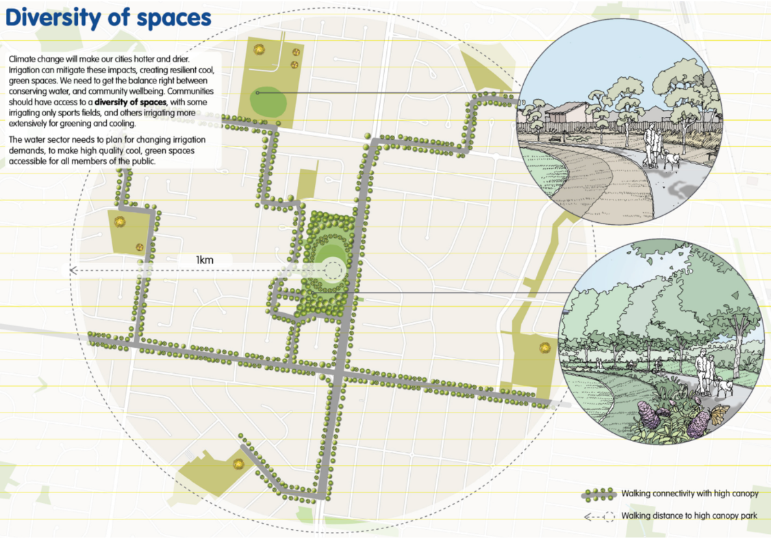
Figure 13: Creating a diversity of spaces will balance the need to conserve water, while preserving com-munity health and wellbeing (source: Melbourne Water)

Inundation and erosion of coastal assets and infrastructure
Flooding of low-lying coastal areas is projected to increase over coming decades, associated with sea level rise and changing weather patterns. Some coastal areas may also be increasingly prone to short or long-term erosion. This will affect future settlement patterns and require responses across existing suburbs and towns, to avoid and manage impacts. Inundation and erosion risk may increase for buildings and infrastructure located near the coast, such as roads and rail lines, drains and recreational assets such as boating infrastructure.
Associated AAP systems
Built Environment | Y
Natural Environment | Y
Primary Production | Y
Health and Human Services | Y
Transport | Y
Education and Training | Y
Water Cycle | Y
Risk champion: Built Environment.
Implications for the water cycle system: Malfunction or damage to coastal water infrastructure that provide essential services. There are limited alternatives for relocating water infrastructure away from populated coastlines, although there are some technology options available.
Seawater incursion into groundwater sources can reduce water quality for coastal communities, limiting how this more saline groundwater can be used in the future. Some services, infrastructure and land owned by the water sector may be permanently lost within the sea level rise impact zones.
This is considered a high risk to the water cycle system.
Existing management strategies from water cycle system: Victorian Flood Data and Mapping Guidelines require flood studies to consider coastal sources of flooding. In collaboration with the Victorian water industry, Guidelines for Assessing the Impact of Climate Change on Sewerage Systems in Victoria are under development to help people responsible for planning and managing our sewerage systems account for climate change, using the latest climate science including sea level rise.

Increased severity and frequency of bushfires
Climate change is likely to increase the risk of more severe and frequent bushfires. Bushfires damage settlements, threaten lives, interrupt essential services such as water, and have a financial impact on the community to rebuild. Large-scale changes to our ecosystem and the long-term viability of some settlements are likely to be affected. Smoke from bushfires and controlled burns present health impacts to humans and animals, and may reduce the quality of agricultural products, tourism experiences and visibility on roads.
Associated AAP systems
Built Environment | Y
Natural Environment | Y
Primary Production | Y
Health and Human Services | Y
Transport | Y
Education and Training | Y
Water Cycle | Y
Risk champion: Natural Environment.
Implications for the water cycle system: Malfunction, destruction or hindered access to infrastructure that provide essential services to Victorians and water for firefighting. Fire in catchments impacts the quality and yield of water in storages, with many of Victoria’s catchments and water assets located in bushfire prone areas. Periods when water assets are at threat from bushfire coincide with periods of high demand for water across the community to extinguish fires, protect individual properties and supply customers and industries with water. A lack of access by operators to critical water infrastructure, for example due to fire or road closures, creates a challenge in repairing damaged infrastructure and carting alternative water supplies by road.
This is considered a high risk to the water cycle system.
Existing management strategies from water cycle system: Victoria’s bushfire management strategies have been informed by world-leading bushfire behaviour modelling and place-based community values, including critical water assets and catchments. Fuel management programs including planned burning, slashing and other fuel reduction methods aim to reduce the scale of bushfires when they occur. These include fire breaks around catchments to control the spread of fire and minimise impact within catchments that would otherwise contribute to water quality issues.
Progressive changes to water infrastructure are helping the system become more resilient to bushfires. For example, regular firefighting water points are included in newly constructed pipelines to assist with rapid fire response, and the expansion of supervisory control and data acquisition (SCADA) technology enables infrastructure to be operated remotely (provided they are adequately protected from fire). A network of standpipes and emergency water supply points across Victoria provide alternative water sources. There is some flexibility in selected water supply systems to bypass or provide alternative supplies during poor water quality events.
Measures such as sedimentation traps and silt curtains can be used to prevent contamination of water when bushfire events occur. Bushfire risk modelling within the Phoenix platform is being developed to predict the locations where post-bushfire runoff, landslide or debris flows are more likely, and the locations that pose the greatest risk to water quality. This will better inform the strategic placement of sediment traps and silt curtains to reduce impacts when these events occur.

Impacts on drinking water quality
Various hazards exacerbated by climate change are expected to pose increasing challenges to drinking water treatment systems and increase the risk of poor drinking water quality and water supply interruptions. The expanded distribution and increased prevalence of harmful algal blooms and emerging waterborne pathogens in the Victorian environment due to warmer temperatures can impact the treatment of drinking water. Chemicals entering waterways have the potential to impact health.
Associated AAP systems
Built Environment | Y
Natural Environment | Y
Primary Production | -
Health and Human Services | Y
Transport | -
Education and Training | -
Water Cycle | Y
Risk champion: Health and Human Services.
Implications for the water cycle system: Reduction in water with sufficient quality for critical drinking needs. Poor drinking water quality events may require rapid diversion of supplies, additional treatment and public health warnings across private supplies or customers of the water grid. Adequate treatment requires significant resources from water suppliers, which may impact long-term costs. Water treatment chemicals need to be carefully administered during warmer conditions to be effective.
This exacerbates another cross-system risk relating to access and reliability of water supplies to meet demand across different water users.
Existing management strategies from water cycle system: The Department of Health regulates drinking water quality under The Safe Drinking Water Act 2003 and regulations, adopting a risk-based approach. The Victorian Government invests in research to support better understanding and management of risks posed by climate change to Victoria’s drinking water supplies. This includes supporting a collective research program managed by Water Research Australia focused on understanding drinking water quality risks under low and variable water levels. The outcomes of the research will guide future strategies for managing the water quality impacts of declining water levels in drinking water dams and reservoirs.

Loss or damage to sites culturally significant to Traditional Owners and Aboriginal Victorians
Traditional Owners and Aboriginal Victorians have cultural, spiritual and economic connections to land, water and resources through their associations and relationship with Country. As climate change increases the risks of extreme weather events, spiritually important species or objects (totems) may be lost, cultural sites of significance may be damaged and cultural practices may be impacted. All of these impacts may affect the health and wellbeing of Traditional Owners and Aboriginal Victorians.
Associated AAP systems
Built Environment | Y
Natural Environment | Y
Primary Production | Y
Health and Human Services | Y
Transport | Y
Education and Training | Y
Water Cycle | Y
Risk champion: Natural Environment.
Implications for the water cycle system: 95 per cent of the 35,000 Aboriginal places and sites recorded on the Victorian Aboriginal Heritage Register are within one kilometre of a waterway or water body. There is no explicit entitlement for cultural purposes in the existing water framework outside of section 8A of the Water Act 1989, making the Aboriginal community more vulnerable compared to other water users that have had long-standing opportunities to own and manage water. Allocating water resources to Traditional Owners for cultural and economic purposes is particularly challenging in water systems that are already fully allocated and under pressure from climate change.
This is considered a high risk to the water cycle system.
Existing management strategies from water cycle system: The Water and Catchment Legislation Amendment Act 2019 provides for greater recognition and inclusion of Traditional Owners and Aboriginal Victorians in the management and planning of waterways and catchments. Water corporations, CMAs and the VEWH must consider opportunities for Aboriginal cultural values and uses of waterways when carrying out their functions under the Water Act 1989.
The DELWP Aboriginal Water Unit has been in place since 2016 to deliver Water for Victoria actions on recognising Aboriginal values and aspirations for water and progressing self-determination. The program has provided funding for 23 Aboriginal Water Officers across the state and for the development of Aboriginal waterways assessments.
As part of the Pilot Water Sector Adaptation Action Plan, the Victorian Government partnered with Dja Dja Wurrung to collectively understand how cultural values can be embedded into climate adaptation thinking. Lessons from this case study will be shared with other Traditional Owner groups, government agencies and interested stakeholders to build greater awareness of climate impacts to cultural values and ways to incorporate cultural values and traditional ecological knowledge into adaptation approaches.
The DELWP Access to Water Roadmap project is seeking to identify the institutional barriers that exist in access to water for Traditional Owners and will provide a set of required policy reforms that will be directed by Traditional Owners and co-designed with government. The Central and Gippsland Region Sustainable Water Strategy is also exploring ways to return water for Traditional Owner use and management of water for any purpose they determine. Policies or actions developed at a regional level may have application across the state.

4.3. Opportunities for the water cycle system

Green recovery from the COVID-19 pandemic
Responses to COVID-19 represent an opportunity to stimulate economic growth in a way that accelerates an orderly transition to a low-carbon economy and improves climate change adaptation across the water cycle system. For example, stimulus investment in water infrastructure that creates jobs can also improve water-related outcomes for the community. Considering climate change in how we build things now will reduce embodied energy and avoid the need to retrofit changes later. It is estimated that every dollar invested towards adaptation saves around six dollars in avoided future costs.

Role of the water cycle system in a circular economy
Emerging technology is highlighting the role that the water cycle system can play in designing out waste, keeping products and materials in use as well as regenerating natural systems. Opportunities such as waste to energy projects that convert wastewater and other organic waste into valued commodities can change these products from a cost liability and business risk to a potential source of revenue. Additional revenue opportunities such as these can offset pressure on customer prices under a climate change future. Water’s role in the circular economy can provide benefits such as boosting clean, secure and reliable green energy supplies close to end-users, generating by-products that improve soil condition and agricultural productivity, as well as reduce waste and harmful contaminants released to the natural environment.

Improved community outcomes through greater use of climate resilient water
Reduction in climate dependent water sources is incentivising greater uptake of recycled water and stormwater that has traditionally not been viewed as a valuable resource. Uptake of these water sources diverts water from treatment plants and stormwater systems that would normally be discharged to waterways and oceans. Stormwater and recycled water is growing as a fit-for-purpose substitute for agricultural, industrial or urban greening purposes as well as an emerging area for energy production. Uptake of recycled water and stormwater reduces pressure on surface water and groundwater resources threatened by climate change. In partnership with other actions, this contributes to water being available to support other important values such as a resilient natural environment, high quality recreational areas and Caring for Country.

Adaptation measures that reduce greenhouse gas emissions
Some adaptation measures can reduce greenhouse gas emissions or provide carbon offsets for other areas of the system that are more challenging to reduce emissions, such as on-site treatment of our wastewater. An example of this includes planting vegetation that may reduce flood impacts, improve water quality and shade the surrounding environment (adaptation), while also sequestering carbon dioxide from the atmosphere. Strategic adaptation measures can also generate important complementary biodiversity, recreation and cultural benefits that contribute towards liveability.

5. Existing climate change adaptation policies, programs and projects, and gap analysis
The Victorian Government has existing strategies, policies and programs that contribute to addressing climate change risks and opportunities across the water cycle system (Appendix 2). Working alongside delivery partners, Traditional Owners, industry bodies and community organisations, progress is already happening in achieving adaptation priorities outlined in Victoria’s Climate Change Strategy.

5.1. Addressing current impacts
There are clearly defined roles and responsibilities across the water sector to prepare, respond and recover from emergencies, including those amplified by the impacts of climate change. Regular training exercises test skills against a range of scenarios, with specialised water emergency management training packages developed to improve the capability of staff. Existing materials and guidance supports planning and decision making across water supply, wastewater, drainage and flood management to embed climate risk management into water cycle services, operations and emergencies. These include both government and industry-led guidance such as Water Services Association of Australia’s Climate Change Adaptation Guidelines.
Recognising that climate change impacts local communities differently, place-based strategies such as regional catchment strategies, regional floodplain management strategies, urban water strategies and sustainable water strategies empower communities to contribute to, and shape, adaptation in a way that is tailored to their specific needs and values. Continued investment in water infrastructure improves water efficiency and security to regional communities that may be particularly vulnerable to climate change. These projects are guided by clear government investment principles.
The water sector owns infrastructure worth billions of dollars, with asset lives of up to 100 years. The sector regularly reviews its asset management plans to identify risks to service continuity and appropriate insurance. CMAs also play a key role in identifying land at greater risk of flooding. This information is provided to organisations and individual property owners on request, in addition to insurers.
Long-term drying trends as well as significant events such as the Millennium Drought have meant the water cycle system has adopted a suite of approaches to transparently communicate current changes to our water supplies, the long-term implications of climate change, and how water users can best manage their risks. Public resources such as the Victorian water accounts, Victorian water register and annual water outlook provide essential information on past and current water use as well as anticipated water availability that considers upcoming seasonal and catchment conditions.
CASE STUDY – TRARALGON FLOOD STUDY
The 2016 Traralgon flood study included a sensitivity analysis for potential climate change, including changes in rainfall intensity and bushfire extent within the catchment that has the potential to significantly alter flood behaviour. Four flood risk mitigation options were presented to the steering committee and community to prioritise next steps.
The flood study is being used to inform changes to the planning scheme to support appropriate development on land subject to inundation.
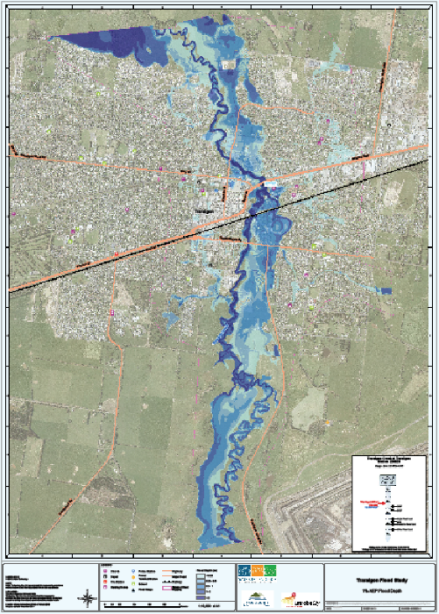
Figure 14: 1% Annual Exceedance Probability Maximum Flood Depth Map generated through the Traralgon flood study

Needs and opportunities
Strengthen alignment between water and planning systems – Through these AAPs, there are opportunities to strengthen the alignment between water and planning systems that improve integrated water management (IWM) outcomes and risk-based planning under climate change.
Tailor how climate change impacts are communicated to different water users, including vulnerable groups – Promoting greater understanding of water management in Victoria and the impact of climate change on the water cycle system is the critical basis for meaningful engagement with different water users about adaptation options and priorities. While the water sector has been conveying information to the community for some time, there are opportunities to centrally coordinate communication and education, adopting best-practice approaches.
Collaborate with other AAP systems to better understand shared climate risks – In addition to existing hydrological-focused research, such as through the Victorian Water and Climate Initiative, collaborative research with other AAP systems on shared climate change risks will accelerate our understanding of impacts and assess possible adaptation responses more holistically.
Emergency water supply points that reflect changes to our climate – As a key risk management strategy, we must regularly assess the adequacy of our emergency water supply network under possible climate projections to prepare for future emergencies. Clear arrangements for their ongoing operation and maintenance must be established to ensure these points are ready when needed.

Reducing barriers to adaptation
Successful climate risk management and transformational change depends on all Victorians having relevant knowledge, skills and capacity to take effective action. Collaborative networks across the Victorian water sector as well as extension support services such as the Sustainable Irrigation Program continue to build adaptation capacity across the water cycle system. Fit-for-purpose products that draw on the best available research and projections are improving access to water-related climate information that support decision making. As a sector that prides itself on innovation and collaboration, industry-led forums such as the Intelligent Water Network, Vic Catchments, Australian Water Association and Greenhouse Alliances facilitate learning within Victoria and nationally.
The National Water Initiative is an approach to best-practice water planning and management that has been described as ‘Australia’s enduring blueprint for water reform’. It represents a shared commitment by governments across the country to maximise water-use outcomes and deal with change responsively and fairly. In response to recommendations made by the Productivity Commission, Victoria is working alongside other states and territories to renew the National Water Initiative to better respond to climate change.
Adaptation leadership across all ages is being driven by citizen science programs like ‘Waterwatch” and water efficiency campaigns such as Target 155 and Target Your Water Use to promote community awareness about water behaviour. National Water Week is organised annually by the Australian Water Association to inspire communities, schools and industry organisations to build awareness around the value of water and a more sustainable water future. Educating younger generations about water resources is facilitated through the Schools Water Efficiency Program and readily available educational material that can be incorporated into the school curriculum.
Victoria’s water entitlement framework under the Water Act 1989 determines how available water resources are shared between various users and the environment now and into the future. It enables risk management through mechanisms such as trade and carryover provisions. The first statewide review of the effectiveness of Victoria’s water markets was completed in 2018 and will support market development and guide future policy. Victoria’s robust water resource assessment program regularly examines the availability, deliverability and other information to test augmentation options, interstate water management and sustainble sharing of water resouces in the longer term.

Needs and opportunities
Consider climate change across all relevant aspects of water business decisions – Organisations need to systematically examine which areas of their business appropriately consider climate change, and other areas where further work is needed. Our mindset must shift away from climate change being a standalone risk or task for a dedicated team. Instead, climate change should be contextualised and considered in all relevant decisions, governance frameworks and reporting.
Evaluate how successfully the system is adapting – A robust monitoring and evaluation framework must be established as part of this Water Cycle AAP. It will measure the effectiveness of these five-yearly actions, monitor long-term adaptation effectiveness, and incorporate learnings into future plans as part of the AAP program.
Address existing barriers to greater uptake of climate resilient water sources – The Parliamentary Inquiry into Tackling Climate Change in Victorian Communities highlighted issues such as insufficient water quality, affordability and infrastructure as barriers to greater uptake of stormwater and recycled water sources across the water sector, particularly in local government. Addressing these barriers presents an opportunity to enhance diversification of water supplies, where appropriate.
Increase climate risk assessment capabilities and sharing of comparable information – The translation of climate change data into information useful for decision makers can be time intensive and cost prohibitive, especially for smaller water corporations and local councils. There is a role for government to support capability-building across the water sector to better understand interdependencies, enhance consistency (where appropriate) and monitor state-level risks under climate change.
Justifying the value of adaptation – Adaptation often has longer-term future benefits across a range of areas that are difficult to quantify using traditional economic methods. In the case of regulated services such as water, the Essential Services Commission must be confident that investment decisions are prudent and represent value to customers. A whole of Victorian Government approach to support all sectors (including water) is needed to leverage economic tools and other opportunities that facilitate adaptation outcomes.

Laying foundations for transformational adaptation
Given the time, breadth and scale of adaptation required to meet future challenges, policies and programs must drive transformational adaptation that reduces the root causes of vulnerability and risk from climate change impacts. Water for Victoria remains the state’s strategic long-term plan for the water sector to meet the challenges of climate change and population growth. As of July 2020, 40 of the 69 actions were completed or undertaken as ‘business as usual’ and a further 25 were underway.
Changing climate conditions and extremes create demand for new skills across the water cycle system. Water industry capacity building programs such as Clearwater have led to the upskilling of more than 10,000 Victorian water practitioners since 2002. The annual Victorian Water Awards recognise leadership, innovative research, programs and infrastructure projects across members of the Australian Water Association to promote transformation across the sector.
Climate change has a unique impact on indigenous people due to their spiritual connections with Country and the impacts of colonial disposession. Climate change can have a devastating impact on cultural values and heritage sites. Country plans developed by Traditional Owner groups have highlighted the importance of empowering Traditional Owners in decision-making across the water cycle system. Guided by Water for Victoria, the water sector has made significant progress in partnering with Traditional Owners in the development and delivery of key strategies and resource plans. Amendments to the Water Act 1989 in 2019 now embed Aboriginal cultural values into water management, aided by resources such as the Aboriginal Water Program and Aboriginal Water Officer Network.

Needs and opportunities
Better integrate traditional ecological knowledge and Aboriginal cultural values into water adaptation planning and communication – Building stronger partnerships and empowering Traditional Owner groups in water resource planning remains an ongoing focus for the Victorian water sector and government. There are still many more opportunities to better understand and integrate traditional ecological knowledge into adaptation and the way we communicate climate change impacts on the water cycle system.
Focus on reducing water related emissions – The relationship between water and energy use remains relatively unexplored in Victoria. Early phases of research between DELWP, Victorian metropolitan water corporations and research academics have identified significant potential in reducing energy and associated greenhouse gas emissions by exploring the way water is used by different end users. This provides adaptation benefits by improving water efficiency across the water cycle system and reducing bills for customers, while also contributing towards Victoria’s legislated target of net zero emissions by 2050.

6. Climate change adaptation actions: five-year plan
A package of 21 actions will be delivered over the next five years. These actions will progress adaptation across the five outcome areas in the Water Cycle AAP:
- Diverse water supplies
- Resilient infrastructure and natural assets
- Operational resilience and efficiency
- Engaged community
- Orderly transition.

Outcome area 1 – Diverse water supplies
While demand for water is growing, average annual rainfall across the state is projected to decline between 14–24 per cent by 2065 under a high emission climate scenario, relative to 1975-201418. Diversifying our water supply is a critical way to meet the future needs of Victorians, including the use of climate resilient sources such as desalinated water, stormwater and recycled water where appropriate.
Recycled water, stormwater and rainwater have the potential to provide supplies that are fit-for-purpose while significantly reducing demand for potable water. Recycled water use over the last 10 years however, has remained static despite increasing wastewater volumes. On average 19 per cent of recycled water is repurposed for uses like agricultural production, watering parks and distribution through non-potable purple pipes in new and infill urban housing developments. Uptake of stormwater and rainwater is still comparatively small. The Victorian Government will investigate ways to enable greater uptake of recycled water and stormwater where feasible and where there are clear benefits to the community, Traditional Owners and/or the environment. Initiatives will build on recent progress such as updates to both the EPA Recycled Water Guidelines and EPA Urban Stormwater Management Guidance that simplify and streamline recycled water scheme approval processes.
As different sources of water become a greater part of our lives, water users must be aware of their obligations for the safe and appropriate use of diverse water supplies. To provide the most contemporary information to water users, future updates to relevant water supply planning and use guidelines will consider all water supply options so water users can better assess the risks and benefits of different water options under climate change scenarios. Updated documents will be user friendly, and where relevant, provide clear reference to other relevant guidelines and material to avoid duplication or inconsistent information.
Communities dependent on a single source of water (often rural and regional areas) are particularly vulnerable to the impacts of drought and declining rainfall. The Victorian Government has invested in infrastructure projects to improve water security for regional communities, agricultural businesses and supply chains. Recently completed projects include the South West Loddon Rural Water Pipeline, Lance Creek Water Supply Project and $2 billion Connections Project – the largest modernisation project in Australia.
The Victorian Government will continue to deliver feasible water infrastructure projects in collaboration with community, water customers and government partners that improve water security and socio-economic outcomes for regional communities. Projects include modernising existing irrigation districts to improve water efficiency, building water supply infrastructure to improve water security for rural users, connecting recycled water products to end users and reconfiguring water delivery systems to improve environmental outcomes and incorporate recreational and Aboriginal cultural values. Victorian Government investment will be guided by principles for public investment and subject to budget processes.
In 2017, a combined analysis across Melbourne’s water wholesaler and metropolitan retail water corporations identified demand for water could exceed the capacity of our existing sources of water as early as 2028, with potential shortfalls of more than 450 gigalitres annually by 2065. This was under a high water demand, high climate change scenario. To respond to this emerging challenge, the Victorian Government will investigate augmentation options to secure water for greater Melbourne and surrounds. Input from a variety of stakeholders across the water sector, Traditional Owner groups and community will be considered to determine the most appropriate means to ensure water supplies under future climate change scenarios and population growth.
CASE STUDY – CONTINUING MODERNISATION OF THE MACALISTER IRRIGATION DISTRICT
The Macalister Irrigation District (MID) is the largest irrigation district in southern Victoria, located around Maffra in central Gippsland. Building on previous phases of modernisation, co-investment across the Victorian Government, Australian Government, and Southern Rural Water’s irrigation customers will see the $62.6 million project modernise more than 90km of channel as well as upgrade and automate outlets to save around 10 gigalitres of water annually. Water recovered through the project will be used to support environmental flows in the Macalister River and increase water security for producers across the district. Modernisation of the public infrastructure enables irrigators to improve irrigation practices that use less water and reduce runoff, which contribute to water quality impacts in the Gippsland Lakes. Construction is due to finish in 2024.
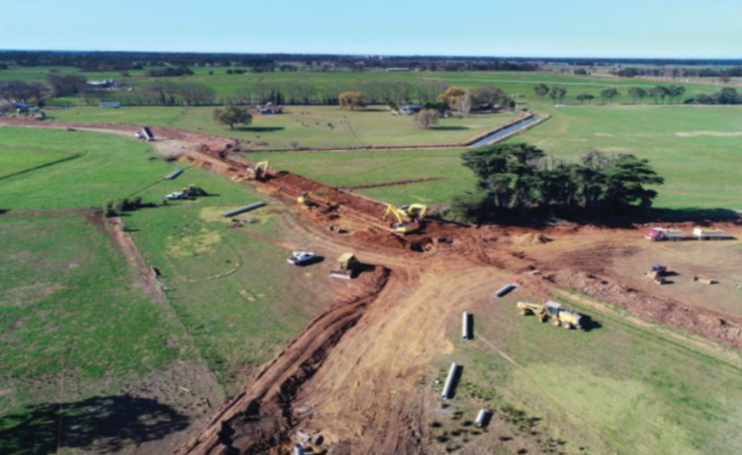
Figure 15: Modernisation works in the Macalister Irrigation District (courtesy of Southern Rural Water)

Outcome area 2 – Resilient infrastructure and natural assets
If water infrastructure is planned, delivered and maintained with climate change in mind, it will perform better under future possible conditions and the costs of adaptation may be reduced. Understanding how different climate-related hazards will impact our state’s built and natural assets is an important step to making informed adaptation decisions that best respond to these risks.
While many water corporations are already prioritising efforts to understand climate change risks to their infrastructure, differences in approaches make it difficult to share results that tell a comprehensive story of climate change risk at a state-level. The Victorian Government will work in collaboration with our water sector to enhance climate-related hazard and risk assessment capabilities to inform water infrastructure planning, design and investment decisions. Drawing on the most appropriate climate information for Victoria, this action will improve data access and capability support for the sector to undertake their own climate-related hazard and risk assessments. Addressing knowledge, process and capability gaps can enhance informed decision making and enable the sharing of comparable data and risk information between organisations to identify interdependencies under different climate scenarios. This action complements those being undertaken in the Built Environment AAP to adopt a more strategic approach to addressing mutual climate-related risks.
Victoria’s network of about 300 emergency water supply points plays an important role in providing rural communities with water for livestock and domestic use during dry periods and other year-round emergencies such as bushfire and water quality events. Since 2018, the Victorian Government has invested $2.4 million to expand the number of emergency water supply points across the state, reducing the distance for users to transport water at their own cost. Works also include upgrading existing supply points to ensure they are fit-for-purpose and can meet demand. For example, on-ground works after the 2019–2020 Black Summer Bushfires across the east of the state have repaired many and installed a further 14 emergency water supply points in fire impacted regions. The location of emergency water supply points across the state is available on the DELWP website.
With climate change projections of less rainfall and more bushfire weather, emergency water supply points will play an increasing role in providing regional parts of the state with access to adequate water supplies. The Victorian Government will undertake a review of the state’s emergency water supply point network every five years and clarify the responsibility of regional agencies to provide operations and maintenance of any new or upgraded emergency water supply points. This action will assess whether supply points sufficiently reflect current and future possible climatic conditions and ensure arrangements are in place so the network remains available and in working condition when needed.
Our understanding is evolving on the potential changes in flooding under climate change. A critical step in building flood resilience across communities is using the best available information to inform appropriate land use planning and development. Planning schemes are an important way to transparently communicate current and future flood information to help manage risk. Recognising the important interfaces between the water cycle and built environment AAPs, the water cycle system will support the built environment to reflect fit-for-purpose flood risk data across relevant planning mechanisms. For example, the water cycle system plays an essential role in developing flood studies for incorporation into planning schemes. Reducing the time between completion of flood studies and their translation into planning schemes can reduce vulnerability and risk to future township development.
Integrated water management is a collaborative approach to planning and managing all elements of the water cycle. IWM is an ongoing process that seeks to make smart investments and future-focused decisions to meet the challenges of a growing population and changing climate. In 2018, amendments to the Victoria Planning Provisions included an IWM clause into the Planning Policy Framework to embed the concepts of IWM objectives and strategies. Under these changes, the responsible authority (usually local councils) is responsible for determining if the standard has been met by proponents. To improve the identification and opportunities to achieve IWM outcomes, climate change and land use planning will be consistently incorporated into integrated water management plans across all scales.
While the scope of the Natural Environment AAP includes water bodies, natural assets such as catchments, rivers and wetlands underpin a healthy water cycle and water security across the state. As we continue to focus on maintaining and improving the condition of our natural assets, approaches must be flexible to manage the challenges of drought, flood, bushfire and the potential impacts of climate change. The water cycle system will support the natural environment to consider a climate adaptation lens in the renewal of the Victorian Waterway Management Strategy, due to be finalised in 2023.

Outcome area 3 – Operational resilience and efficiency
Events such as bushfire, drought and heatwaves are occurring at an increased frequency than historically, meaning there are fewer years in between extreme events to recover. Victoria’s water sector must be operationally prepared for changes in the diversity, intensity and scale of emergencies under climate change, to meet agreed service levels and protect the wellbeing and safety of staff and the community. The Victorian Government will identify opportunities to strengthen the water sector’s emergency capability, systems, and processes for resource sharing to better prepare for the frequency and intensity of emergency events under different climate scenarios. This includes responding to relevant recommendations from current and future reviews that may improve emergency management across the water sector. Examples of current reviews include the Inspector General for Emergency Management’s Inquiry into the 2019–20 Victorian fire season and Royal Commission into National Natural Disaster Arrangements.
The increasing incidence of nuisance and harmful algal blooms has been identified as a extreme risk to the water cycle system under climate change. An action completed under the Pilot Water Sector Adaptation Action Plan has improved our understanding of climate drivers of algae and developed a preliminary framework to assess algal risk associated with climate change. Building on this pilot work, we will trial the application of this framework to understand future changes in algal risks across Victorian water bodies and centralise knowledge sharing to manage these risks. Trialling this flexible and scalable algal management framework may help identify the likelihood, distribution, and frequency of algal blooms in waterways under future climate scenarios. This will assist algal managers prioritise preventative measures and response efforts when they occur. This action will also enhance collaboration and cross-agency understanding and response to algal outbreaks by centralising research and sharing experiences in applying different algal management solutions.
Recognising many facets of the water cycle system are impacted by climate change, there is an immediate need for adaptation to be integrated into all relevant business decisions across the water sector – from infrastructure planning to corporate governance. Decisions made now by the sector can have long lasting impacts on future generations. To encourage consistency in decision making, the Victorian Government will work with the sector to develop a framework to support embedding climate change within water sector decisions. Guided by the needs of the sector, this framework may include decision making principles that apply across different business functions and resources available to support best-practice adaptation decisions. The Victorian Government will also work collaboratively with the water sector to support improved disclosure of climate related risks within water businesses.
As climate change alters the way we operate parts of the water cycle system, business decisions within individual organisations may have broader implications for the state’s overall resilience. The Victorian Government will define, benchmark and monitor resilience of the water sector over time at a state level, leveraging existing reporting requirements from the sector. While resilience traditionally focuses on the ability to bounce back or recover quickly from a shock or stress, this action aims to improve the sector’s capability to bounce forward.
Monitoring and evaluation throughout the Pilot Water Sector Adaptation Action Plan has provided valuable learnings to inform this first legislated Water Cycle AAP (see Appendix 4). A long-term framework is necessary to examine adaptation progress as we continue to make decisions and investment over time. A monitoring, evaluation, reporting and improvement framework will be developed for the AAP program. It will focus on monitoring how well the five-yearly actions are achieving longer-term adaptation objectives and outcomes, and further inform future adaptation strategies. The monitoring, evaluation, reporting and improvement framework must navigate the challenges of achieving genuine adaptation against a background of population growth; changes in land use, economic activity and consumer behaviour; and an evolving landscape of policies at all levels of government. Where possible, the framework will consider alignment with monitoring and evaluation being undertaken by the broader Climate Change Strategy and across other AAP systems.

Outcome area 4 – Engaged community
The Victorian water sector remains committed to partnering with Traditional Owner groups in water management and reconnecting Aboriginal communities to water for cultural, economic, customary, and spiritual purposes. As part of the Pilot Water Sector Adaptation Action Plan, DELWP partnered with Djandak to build mutual knowledge about how Djaara cultural values can be embedded into adaptation thinking and how we can learn from Dja Dja Wurrung worldviews. Guided by the outcomes of this pilot project, the Victorian Government will support opportunities for Traditional Owner self-determination in climate adaptation planning and implementation across the water cycle system. Informed by the adaptation priorities across Traditional Owner groups (identified through Country plans and self-determination plans) this action will explore how policies and programs can support the application of traditional ecological knowledge in the context of climate adaptation across the system. In partnership with Traditional Owner groups, this initiative will also explore the delivery of next steps identified through the pilot project.
Social research shows 78 per cent of Victorian respondents were concerned about climate change, with the main area of concern focused on water shortage and drought5. Community engagement and participation is crucial to create change, either in responding to climate change risks or acting on opportunities to adapt. In collaboration with key stakeholders across the water cycle system and other relevant AAP systems, an iterative climate change communication strategy for the water cycle system will be developed to tailor the communications for different water users. This may include clarifying roles and responsibilities of different organisations that interact with water users; providing downscaled and locally relevant climate products that best meet the needs of different audiences; and encourage the integration of local values and traditional ecological knowledge in the climate change narrative. It is a priority to make information more accessible to water users most vulnerable to the impacts of climate change. The communications will change over time to reflect the latest global emission pathways, climate science and other drivers.
Research and knowledge-building continues to be a crucial component to evidence-based decision making and policy development. Continually improving our understanding of the risks and potential impacts of climate change enables the water sector and broader government to plan effectively and communicate this to stakeholders and the community. The Victorian Government will continue to research climate change impacts on the water cycle system in collaboration with other AAP systems. Research will be guided by industry needs and areas of mutual climate risks identified between water and other AAP systems. This action includes the forward program of research through VicWaCI, along with other climate change related activities undertaken by other institutions and research bodies.

Outcome area 5 – Orderly transition
As the water cycle system responds to climate change impacts, best-practice adaptation planning needs to leverage opportunities and consider potential unintended consequences. For example, how options contribute to the underlying climate change problem through greenhouse gas emissions. Through the Pilot Water Sector Adaptation Action Plan, guidance was provided to board members and executive of water corporations and CMAs in managing climate change risk, including indirect financial risks and opportunities that might arise from the transition to a lower carbon economy.
System-thinking across water sector organisations will see a greater integration of emission reduction, resource management and resilience as part of their climate adaptation journey. To support this systems approach to adaptation, we will promote innovation and learning across the water cycle system that accelerates low-carbon adaptation and progresses Victoria’s transition to a circular economy. This includes the exploration of emerging technologies and feasibility studies that build a strong evidence base to diversify water industry operations. The technologies will attract additional investment into areas that reduce climate impacts while creating new jobs and business opportunities in areas such as resource recovery and the circular economy. Equally important will be the sharing of learnings and successes across the water sector and other interested stakeholders to inform future technological applications, nature-based solutions, business models and investment decisions.
Approximately 1 per cent of Victoria’s total annual greenhouse gas emissions are generated directly by the water sector, associated mostly with pumping water supplies and treating wastewater. It is estimated however, that around seven times more emissions are generated from the heating of water within residential households, industry and businesses. Adaptation efforts that consider water related energy and associated emissions across the entire water cycle (rather than just the water sector) present an opportunity to make substantial progress towards Victoria’s ambition of net zero emissions. The Victorian Government will work collaboratively with research academics, water corporations and the energy industry to progress measures aimed at reducing energy and associated greenhouse gas emissions related to water use within households and businesses. This will involve identifying technical, behavioural and enabling factors that lead to sustainable reductions in Victoria’s water related energy, with particular focus on vulnerable demographic groups.
In 2019–20, 64 per cent of metered urban water use was supplied to residential households. With an extra 2.3 million Victorian households projected by 20561, small efficiencies in residential water use can generate substantial and cost-effective returns on managing growing water demand under a warmer, drier climate. The Victorian building regulations (under the National Construction Code) promote the use of tanks by requiring all new and freestanding homes and townhouses to install a rainwater tank or solar hot water system. The Victorian Government will review existing rainwater tank and water efficiency building and plumbing requirements to evaluate the costs and benefits of requiring a broader range of developments to install rainwater tanks and raising the water efficiency of water appliances and fixtures such as showers and toilets. Where applicable, the current requirement is a minimum 3-star rating as defined in the Water Efficiency Labelling Standard Act 2005.
As both stewards of the natural environment and critical service providers to customers and the broader community, the water sector has the unique ability to generate adaptation benefits both within and outside of its business boundaries. Water corporations must at the same time be able to justify prudent investments to both their customers and the Essential Services Commission. To navigate some of these challenges, the Victorian Government will investigate a framework to better recognise complementary benefits in water sector adaptation projects. The framework will seek centrally-agreed guidance on evaluating benefits commonly used across the water sector when assessing adaptation options. Greater recognition and valuation of complementary benefits creates a stronger basis for adaptation business cases and provides an avenue for co-investment and/or cooperation with other beneficiaries to achieve robust, high-value adaptation outcomes. As the water sector develops its pathway to net-zero emissions, understanding the associated emissions over the lifetime of different options is increasingly important and may have a cost implication in the longer term (if these emissions are needed to be offset later). Carbon valuation is an example of a well-established and practical tool to integrate climate-related risks into strategic planning and decisions across the water cycle system, and will be considered as part of this action.
Table 2. List of Water Cycle AAP actions to be implemented by 2026
Actions to be implemented by 2026 | Description | Links to other actions | Links to Water Cycle AAP |  |  |  |  | Links to Water Cycle AAP objectives
 |  |  | Diverse water supplies | Resilient infrastructure and natural assets | Operational resilience and efficiency | Engaged community | Orderly transition | Short | Medium | Long
1. Investigate ways to enable greater uptake of stormwater and recycled water | This action will investigate opportunities to streamline and update regulations, improve recycled water data and reporting, and develop policy that will support greater uptake of stormwater and recycled water across Victoria.  This action will be implemented as part of the Central and Gippsland Region Sustainable Water Strategy, due to be finalised in 2022, with statewide implications.  Desired outcome: Stormwater and recycled water use increases where it is safe and suitable. | 2  3  15  18  20 | Y | - | Y | Y | - | - | Y | -
2. Consider all water supply options in updates to relevant water supply planning and use guidelines | This action entails all water supply options being explicitly considered in any relevant updates to water supply planning and use guidelines and communications issued by DELWP and relevant sector agencies.  Updated documents should be clear, practical, and where relevant, provide clear signposting to other necessary guidelines or material to reduce inconsistency or duplication of advice to guideline users.  Desired outcome: Continue to provide contemporary advice for water users to consider diverse water supplies. | 1  3  4  21 | Y | - | - | Y | Y | - | Y | Y
3. Deliver feasible water infrastructure projects in collaboration with community, water customers and government partners | This action will deliver water infrastructure projects across the state that improve water security, deliver public benefit and build resilience by maximising socioeconomic outcomes for regional communities. This includes supporting the development of business cases and investigating co-investment opportunities with government partners and water customers.  Projects include modernising existing irrigation districts to improve water efficiency, building water supply infrastructure to improve water security for rural users, connecting recycled water products to end users and reconfiguring water delivery systems to improve environmental outcomes and incorporate cultural values. This action includes work to generate a pipeline of potential rural and peri-urban projects for the future.  Desired outcome: Provide public benefit and improve community resilience under climate change and variability through water infrastructure projects. | 1  2  4  5  15  16  21 | Y | Y | Y | Y | - | - | Y | Y
4. Investigate augmentation options to secure water supplies for greater Melbourne and surrounds | This action will investigate augmentation options for improving water security for greater Melbourne and surrounds in consultation with stakeholders.  This action will be implemented as part of the Melbourne Metropolitan Urban Water and System Strategy, which is focused on the supply of water for urban customers in Melbourne and surrounds, urban water strategies prepared by regional water corporations and the Central and Gippsland Region Sustainable Water Strategy which plans for the long-term water needs of all water users across this larger region. All strategies are currently under development and due to be finalised in 2022.  Desired outcome: Identify a process and possible options that will improve water security to Melbourne and surrounding regions long term. | 2  3  5  15 | Y | Y | Y | Y | - | - | Y | Y
5. Enhance climate-related hazard and risk assessment capabilities to inform water infrastructure planning, design and investment decisions | Working collaboratively with delivery partners, this action will build capabilities and improve hazard and risk assessment options available for the water sector to better inform water infrastructure planning, design and investment decisions.  Drawing on the most appropriate climate information for Victoria, this action aims to provide accessible data and capability support to strengthen business cases for adaptation action. | 3  4  6  8  12  17 | - | Y | Y | - | Y | Y | Y | -
6. Review Victoria’s emergency water supply point network every five years and clarify the responsibility of regional agencies to provide operations and maintenance of any new or upgraded emergency water supply points prior to state government investment | This action will review the state’s emergency water supply point (EWSP) network every five years so that the location and condition of emergency water supply points are current, accurate and clearly communicated to the water sector and broader community.  Prioritisation of future emergency water supply points will be investigated taking into consideration statewide and local climate change projections including average annual rainfall and fire weather conditions. This action will also clarify the responsibility of regional agencies or local governments to provide operations and maintenance of any new or upgraded EWSPs prior to state government investment.  Desired outcome: Identify areas of highest need for future EWSPs and determine arrangements so that they are operational when required. | 3  5  10  13 | Y | Y | Y | - | - | - | Y | -
7. Support the built environment system to reflect fit for purpose flood risk data across relevant planning mechanisms. | This action will support land use planning responses that reflect current and increased flood risk under climate change. The water cycle system will support floodplain management authorities to contribute towards the timely delivery of relevant actions under the Built Environment AAP.  Desired outcome: Flood risks that account for climate change are appropriately incorporated into land use planning in a timely manner. | 5  8  17 | - | Y | - | Y | Y | - | Y | Y
8. Consistently incorporate climate adaptation and land use planning into integrated water management plans | This action will incorporate climate adaptation and resilience into the development of IWM plans across all scales. These plans will improve identification of opportunities to achieve multiple IWM outcomes (such as waterway and marine health, water security, healthy urban landscapes and liveability). IWM plans will provide additional guidance and clarity needed by stakeholders to support IWM outcomes outlined in Victoria’s planning guidelines and documents.  Desired outcome: IWM plans continue to drive climate adaptation opportunities. | 1  2  3  7  15 | Y | Y | - | Y | Y | Y | Y | -
9. Support the natural environment system to consider a climate adaptation lens in the renewal of the Victorian Waterway Management Strategy | This action will support the natural environment to incorporate climate adaptation thinking into the renewal of the Victorian Waterway Management Strategy, due to be finalised in 2023.  Desired outcome: The renewed strategy appropriately considers the impacts of climate change to waterways and includes approaches to adapt. | 5  11  15  17 | - | Y | - | - | Y | - | Y | -
10. Identify opportunities to strengthen the water sector’s emergency capability, systems, and processes for resource sharing | This action will scan for innovative initiatives and opportunities to strengthen emergency human resource capability, as well as systems and processes for resource sharing to better consider the frequency and intensity of emergency events under different climate scenarios. This would include responding to relevant recommendations from current and future emergency management reviews.  Desired outcome: Steps have been identified and implemented to continue responding adequately to emergencies amplified by climate change. | 5  7  11  12 | - | - | Y | - | - | Y | Y | -
11. Trial the application of a framework to understand future changes in algal risks across Victorian water bodies and centralise knowledge sharing to manage these risks | This action will trial the application of a framework to understand the change in likelihood, distribution and frequency of algal blooms in Victorian waterways under future climate scenarios. Building on the work conducted under the Pilot Water Sector Adaptation Action Plan, the flexible, adaptable and scalable algal management framework would:  improve understanding of how algal risks may change in the future for algal managers  promote collaborative, cross-agency understanding of, and response to, algal outbreaks  centralise information on algal management research and development to avoid duplication of efforts where possible  share algal experiences across Victoria’s water sector with different algal management solutions.  Desired outcome: Share outcomes and lessons of applying the framework and support its use by algal managers more broadly. | 9  10  16  17 | - | Y | Y | - | - | Y | Y | -
12. Develop a framework to support the embedment of climate change within water sector decisions | This action will develop a framework to support climate change in decision-making across all levels of water sector organisations. Guided by the needs of the water sector, this framework will build on, and align with, existing climate change guidance already available and used across the sector. DELWP will also work collaboratively with the water sector to support improved disclosure of climate related risks within businesses.  Desired outcome: Climate change is incorporated into relevant decisions across water sector organisations. | All | Y | Y | Y | Y | Y | Y | Y | -
13. Define, benchmark and monitor resilience of the water sector over time | This action will develop a framework to define, benchmark and monitor resilience of the sector at a state level, leveraging existing reporting requirements.  Desired outcome: Statewide resilience metrics can be monitored over time to guide decision-making and priorities. | 10  14 | - | Y | Y | - | - | Y | Y | -
14. Develop a monitoring, evaluation, reporting and improvement framework for the water cycle AAP program | This action will develop and implement a robust monitoring, evaluation, reporting and improvement framework that includes indicators to monitor the implementation of the Water Cycle AAP over time, measure its progress towards its adaptation objectives and outcomes, and capture learnings to inform new adaptation action into the future.  Desired outcome: The success of adaptation across the water cycle system can be monitored over time and strategies adjusted accordingly. | All | Y | Y | Y | Y | Y | Y | Y | Y
15. Support opportunities for Traditional Owner self-determination in climate adaptation planning and implementation across the water cycle system | This action aims to share the outcomes and learnings from the Pilot Water Sector Adaptation Action Plan project with other Traditional Owner groups, government agencies and other interested stakeholders about embedding cultural values into adaptation thinking. It also seeks to support recommendations and next steps identified through the pilot.  Focusing on the adaptation priorities across Traditional Owner groups identified through country plans and self-determination plans, this action will explore how policies and programs can support traditional ecological knowledge being applied in the context of climate adaptation planning across the water cycle system.  Desired outcome: Increase awareness of climate change impacts to Aboriginal cultural values and strengthen partnerships with Traditional Owners in adaptation across the system. | All | - | - | - | Y | - | Y | Y | Y
16. Develop an iterative climate change communication strategy for the water cycle system | In collaboration with key stakeholders across the water cycle system and other relevant AAP systems, this action will develop an integrated water climate change communication strategy to:  clearly identify roles and responsibilities of different organisations in communicating water and climate related information  provide consistent, evidence-based messages relating to climate change risks and opportunities across the water cycle system  provide trusted and consistent data sources that enable downscaled and locally relevant water information to be used by communicators  provide climate information that best meets the needs of different audiences – encouraging the integration of local and traditional ecological knowledge as part of the climate change narrative  identify ways to make information more accessible to vulnerable community groups  plan for potential changes in messaging as circumstances change, ensuring there is a process to provide accurate and relevant information to the community as climate uncertainties unfold.  Desired outcome: Climate change information is targeted and tailored for different water user audiences to support informed decision making across the community. | 1  2  5  11  12  15  17  19 | - | - | - | Y | - | - | - | Y
17. Continue researching climate change impacts on the water cycle system in collaboration with other AAP systems | Research will be guided by industry priorities and mutually agreed areas of interest between water and other AAP systems. This action includes the forward program of research through VicWaCI, along with other climate change related activities undertaken by a range of other institutions and research bodies.  Desired outcome: Continue building knowledge of how climate change will impact the water cycle system and flow on impacts to other AAP systems. | 1  5  11  15  16  18 | - | Y | Y | Y | Y | Y | Y | Y
18. Promote innovation and learning across the water cycle system that accelerates low-carbon adaptation and progresses Victoria’s transition to a circular economy | This multi-faceted action will include exploration of emerging technologies and feasibility studies that build a strong evidence base to diversify water corporation operations and attract additional investment into areas that reduce climate impacts while creating new jobs and business opportunities in areas such as resource recovery and the circular economy.  This action also focuses on supporting the sharing of learnings and successes across the water sector and other interested stakeholders to inform future technological applications, business models and investment decisions. | 1  15  17  19  21 | - | - | Y | - | Y | Y | Y | -
19. Progress measures aimed at reducing energy and associated greenhouse gas emissions related to water use within households and businesses | This action will progress efforts that lead to sustainable reductions in Victoria’s water-related emissions across households and businesses in collaboration with research academics, water corporations and the energy industry.  Monitoring and evaluation will be undertaken to understand the success and potential upscaling of interventions that reduce water-related energy consumption, associated greenhouse gas emissions and savings on customer bills. This action will particularly focus on representing vulnerable groups.  Desired outcome: Water corporations understand their role and are better equipped to drive emission reductions at an end user level. | 16  18  20  21 | - | - | - | Y | Y | - | Y | Y
20. Review existing rainwater tank and water efficiency building and plumbing requirements | This action, through a Regulatory Impact Statement, evaluate the costs and benefits of:  Requiring a broader range of developments to install rainwater tanks  Raising the water efficiency of water appliances and fixtures  This action will be implemented as part of the Central and Gippsland Region Sustainable Water Strategy due to be finalised in 2022, with statewide implications  Desired outcome: Victorians are progressively using less reticulated water per capita. | 1  16  19  21 | - | - | Y | Y | Y | - | Y | -
21. Investigate a framework to better recognise complementary benefits in water sector adaptation projects | This action will investigate a framework to better recognise complementary benefits that are commonly difficult to acknowledge across water sector projects. This framework would seek to identify centrally agreed guidance to evaluating benefits such as emission reductions and other benefits that are consistently used across the water sector for assessing possible adaptation interventions and attracting co-investment opportunities.  Desired outcome: Business cases for adaptation projects can more readily consider complementary benefits and attract co-investment. | 1  3  4  5  8  17  18  19  20 | - | - | - | - | Y | Y | Y | -

7. Monitoring, evaluation, reporting and improvement
Monitoring and evaluating climate change adaptation is complex. There can be significant time lags between an intervention and any measurable impacts, making it difficult to assess the effectiveness of an adaptation action compared to other types of projects. It can also be difficult to attribute outcomes to a particular adaptation action alongside societal, technological, and economic changes that may be happening at the same time. There can also be interdependencies where an action is dependent on another implemented by a third party.
There is no off-the-shelf approach to monitoring and evaluating climate change adaptation. As the first action to be delivered under this plan, the monitoring, evaluation, reporting and improvement framework is drawing on best-practice principles and alignment with the other AAP systems. The framework considers how adaptation actions contribute towards the system’s identified objectives and key evaluation questions, utilising a mixture of quantitative and qualitative data. Indicators of maladaptation have also been identified to monitor whether actions are creating unintended negative impacts on other aspects of climate adaptation and resilience. The ongoing process of monitoring and evaluation will guide progress over time and inform new actions under future iterations of the Water Cycle AAP to 2050.

8. Appendix

Appendix 1 - Development of the Water Cycle Climate Change Adaptation Action Plan 2022-2026
The development of the Water Cycle AAP included:
- A review of the Pilot Water Sector Adaptation Action Plan’s policy gap analysis and rapid international review of best practice adaptation. Learnings captured from the development and implementation of the pilot were also considered (Appendix 4).
- A statewide assessment of Victoria’s climate change risks across the water cycle system.
- A comprehensive stocktake of existing policies and programs that relate to adaptation across the water cycle system.
- A discussion paper testing with key stakeholders areas for further consideration through the Water Cycle AAP. Written submissions on behalf of 25 different organisations were received.
- Development of draft adaptation actions in consultation with representatives from water sector stakeholders, other AAP systems and identified cross-cutting policy areas and stakeholders.
- Public consultation through Engage Victoria. A total of 33 contributions to the water cycle survey were received in addition to 133 contributors to the broader AAP survey across the seven systems, many of which included references to the water cycle. DELWP also received 26 written submissions relevant to water.
Adhering to COVID-19 restrictions, development and engagement for the Water Cycle AAP was undertaken entirely virtually. The development of the Water Cycle AAP has been guided by an advisory committee made up of representatives from:
- Melbourne Water
- Goulburn-Murray Water
- Barwon Water
- MAV
- Goulburn Broken CMA
- Melbourne City Council
- DELWP Aboriginal Water Unit
- DELWP Hydrology Climate Science
- DELWP Climate Change Policy
- DELWP Sector Resilience
DELWP would like to thank the advisory committee for their insights and guidance throughout the development of the Water Cycle AAP.
Many water sector organisations have their own climate change resilience plans that focus primarily on their operations, assets, business and how they work with their local communities and stakeholders. This Water Cycle AAP seeks to provide an overarching direction to complement place-based measures and/or strategies focused on particular elements of the water cycle system. This includes measures undertaken through the suite of regional adaptation strategies.

Appendix 2 - Policies, programs or legislation relevant to the water cycle system
Name | Status | Description
LEGISLATION
Water Industry Act 1994 | Current | A Statement of Obligations (SOO) was issued to all water corporations in 2015 by the Minister for Water under the Water Industry Act 1994. Among other things, the SOO outlines how water corporations should plan for future climate change, provide educational material about sustainable resource management, and manage risks. The requirements under the SOO differ between water corporations to reflect their specific roles and responsibilities as a bulk wholesaler (Melbourne Water), rural or urban water corporation.
The Water Act 1989 | Current | Provides the basis of Victoria’s water entitlement framework and long-term planning arrangements. It acknowledges and caters for regional variability in water availability and provides the tools for stakeholders to make the most effective decisions about their water resources. The framework establishes water entitlements, annual processes to allocate water to entitlements, and ability to trade between users. Under the framework, entitlement holders are responsible for managing their own water security and risks including during drought.  A Statement of Obligations (SOO) was issued to all CMAs in 2018 by the Minister for Water under the Water Act 1989. Among other things, the SOO outlines how CMAs should recognise climate change as a challenge to the management of natural assets and prepare key documents such as regional waterway strategies and regional floodplain management strategies.
Catchment and Land Protection Act 1994 | Current | Establishes Victoria’s framework for the coordinated management of land, water and biodiversity resources based on catchment areas.  A Statement of Obligations (SOO) was issued to all CMAs in 2018 by the Minister for Water under the Catchment and Land Protection Act 1994. Among other things, the SOO outlines how CMAs should develop and coordinate the implementation of regional catchment strategies, land and water management plans and participate in improvements to key documents including land use planning.
The Environment Protection Act 2017  Act amendments in force now:  Environment Protection Amendment Act 2018 | Current | The Environment Protect Act 1970 was repealed by the enactment of the Environment Protection Act 2017. The Environment Protection Act 2017 includes a new approach to environmental issues, focusing on preventing waste and pollution impacts rather than managing those impacts after they have occurred. One of the objects of the Act is to facilitate and promote activities related to climate change including the adaptation and adjustment to climate change.
Local Government Act 2020 | Current | Strengthens the mandate for climate change risks and relevant state and national plans to be considered in council decision-making processes and strategic planning. There is a clear expectation that decision-making is supported by robust and transparent practices, and that the long-term adverse consequences of climate change for future generations are incorporated into council planning, decisions, and actions.
Safe Water Drinking Act 2003 | Current | Regulates drinking water quality and places obligations on water suppliers and water storage managers to provide safe, high-quality drinking water. It provides a regulatory framework that takes a risk-based approach for managing public health, including risks that may be posed by climate change.
Essential Services Commission Act 2001 | Current | Establishes the Essential Services Commission as an independent economic regulator for essential service sectors, including water.
Emergency Management Act 2013 | Current | Outlines the responsibilities of control and support agencies for various water emergencies. It also outlines responsibilities for businesses with ‘vital’ critical infrastructure including emergency risk management planning, exercises, audits and assurance reporting. Climate change considerations are part of risk, emergency and business continuity planning in the water sector.
STRATEGIES
Water for Victoria | Released 2016  Actions underway | Sets a long-term direction for the Victorian water sector and managing our water resources. It includes 69 actions that partner with water corporations, CMAs, the VEWH, Traditional Owner groups, local government and community partners to delivery priority outcomes across the system, including action on climate change.
Biodiversity 2037 | Released 2017  Next updated 2022 | The Victorian Government’s ambitious plan to stop the decline of our biodiversity and achieve overall biodiversity improvement over the next 20 years. As a critical part of the ecosystem, water agencies have been contributing its implementation, identifying climate adaptation priorities, undertaking statewide projects and helping communicate information to the community.
Sustainable water strategies (SWS) | Reviewed every 10 years  Actions underway | Long-term plans to address water security across four regions (central, northern, western and Gippsland). The strategies identify and manage threats to supply and quality of the state’s water resources and identify ways to improve waterway health over the next 50 years. DELWP is working to have the Central and Gippsland Region SWS ready for publication in 2022.
Urban water strategies | Updated every 5 years (urban water corporations only).  Next updated 2022 | Plan water supplies over the following 50 years, using different scenarios of population growth, climate change and climate variability. Each strategy must identify adaptation measures to ensure secure water and wastewater services as well as encourage sustainable use of water resources.  Drought preparedness plans are prepared as part of an urban water strategy and sets out actions needed to prepare for and respond to water shortages if they arise in the immediate and short-term. The plan includes how the community, local government and urban water corporations will protect the health of priority parks, gardens and sporting fields during an extreme dry period and/or water quality event.
Victorian Floodplain Management Strategy | Victorian Floodplain Management Strategy Released 2016  Actions underway | Guides appropriate response and action in the event of a flood. It sets out accountabilities and aims to improve communication of flood risks so communities and relevant agencies can take better informed action to manage floods, including under climate change. Regional floodplain management strategies provide regionally set priorities around flood. An independent audit undertaken in 2020 confirmed that 43 out of the strategy’s 56 actions are complete and/or embedded as part of business as usual.
Victorian Rural Drainage Strategy | Released in 2018  Actions underway | Sets out rules, protocols and support mechanisms to enable landholders and government agencies to overcome past barriers to the repair and management of degraded dryland rural drainage systems. Restoring the functionality of rural drains is important to ensure adequate removal of excess water during high rainfall events to support agricultural production. As part of the strategy, landholders will be provided with guidance materials to help them take account of climate change and climate variability when making decisions regarding investment in dryland rural drainage management.
Victorian Waterway Management Strategy | Reviewed every 8 years  Next updated 2023 | Provides direction for regional decision-making, investment and management issues for waterways, as well as the roles and responsibilities of management agencies. The strategy establishes an adaptive management framework and flexible approach to manage through the challenges of drought, flood, bushfire and the potential impacts of climate change. Regional waterway strategies are developed in each region to drive implementation of the approach outlined in the Victorian Waterway Management Strategy.
Regional catchment strategies (RCS) | Reviewed every 6 years  In development. Expected to be released early 2022 | Provides an overarching strategic document for managing land, water and biodiversity in each catchment region. Prepared by each CMA, it outlines community values and interactions with the landscape, management challenges as well as agreed directions for natural resource management.  As part of the RCS, climate change adaptation plans or strategies are developed to help integrate climate change into regional natural resource and waterway management. Drawing on spatial tools, adaptation pathways planning, extensive engagement with the community and key stakeholders, the documents provide comprehensive natural resource management plans for climate change adaptation.
Regional Natural Resource Management Climate Change Adaptation Strategies and Plans | Reviewed every 8 years  Next updated 2023 | Integrates climate change planning into regional natural resource and waterway management. Developed by each CMA, these strategies draw on spatial tools, adaptation pathway planning, extensive engagement with the community and key stakeholders to provide a comprehensive natural resource management plan for climate change adaptation.
Aboriginal Access to Water Roadmap | Under development | Set of policy reforms developed and designed by Traditional Owners to gain access, management and ownership of water for economic, cultural and spiritual purposes.
Bushfire Management Strategies | Released in 2020 | Developed for each of the six Victorian Government regions, these strategies bring together land and fire managers, communities and stakeholders to develop a common understanding of bushfire risk and determine strategies and actions to reduce that risk.
POLICIES AND FRAMEWORKS
State Environment Protection Policy (Waters) | Released 2018 | Guides water quality management in Victoria and improves protection of our waterways, bays and coastal waters. It provides water quality objectives based on the latest monitoring, scientific understanding that consider climate change and relevant national standards. It identifies rules for decision makers and obligations on industry to protect surface water and groundwater quality, for example instructions around sewer spills.
Long-term water resource assessments | Reviewed every 15 years  Underway | Monitor the state’s water resources to determine if long-term water availability has changed, and if so, whether there are disproportionate impacts to certain water users or the environment. The assessments also assess whether waterway health has declined for flow-related reasons. A long-term water resource assessment for southern Victoria was completed in 2020 and will be reviewed every 15 years. An assessment for northern Victoria will start in 2025 to align with the Murray Darling Basin Plan review.
Seasonal watering plans | Released annually | Developed annually by the VEWH to guide environmental watering decisions in Victoria. These are based on seasonal watering proposals submitted each year by CMAs and include details such as environmental values, watering objectives, priority watering events to occur under a range of climate, and seasonal outlooks – drought, dry, average and wet.
Drought Preparedness and Response Framework | Established 2015 and updated 2018 | Establishes three stages of drought response that recognises additional support may be required as drought continues and impacts more widely on farmers, families and the surrounding community. It provides clear principles and priority focus areas to guide support that is well-planned, fair and strategic.
Waterways and Drainage Investment Plan | Reviewed every 5 years (Melbourne Water only)  Updated 2021 | Sets out the responsibilities, goals, levels of service and program of work for waterway management, flood management and drainage. The plan must use scenario planning and have regard to future risk and uncertainty associated with climate change.
Principles for public investment in rural infrastructure | Released 2016 | Principles for how government will consider future investment in rural water infrastructure, which recognises climate change. Strategic investment in rural infrastructure provides communities access to the water grid and deliver wider community benefits.
Blue-green Algae Circular and State Response Plan | Released 2018 | A statewide coordination plan to manage blue-green algae blooms, including roles and responsibilities in response to events. It identifies mandatory notification triggers, incident management and reporting relationships across Victorian government agencies and stakeholders.
Water Sector Critical Infrastructure Resilience Plan | Reviewed annually | Scans across all hazards, including those amplified by climate change, to undertake focused risk management planning for infrastructure identified as vital and their dependencies with other sectors.
Emergency Relief Drinking Water Policy and Procedure | Established 2019 | Provides relief drinking water for people in non-reticulated households whose tanks have been polluted by bushfire ash and other materials. The water tanks are drained, cleaned and then refilled with fresh potable water.
PROGRAMS AND NETWORKS
Water Grid Partnership | Established 2018 | Ensures Victoria is well placed to deal with challenges of climate change and population growth in collaboration with key players across the water industry. The partnership will publish a statement every two years about future water availability and proposals to augment the grid to ensure water security (latest released in 2021).
Integrated Water Management Program | Established 2017 | A collaborative approach to plan and manage all elements of the water cycle. Forums have been created to maximise opportunities for greater integrated water management across Victoria’s cities and towns. Place based IWM plans are developed, these are being led at various scales by water corporations and in some cases local government. The IWM Program also contains related policy or strategic investigations looking at adaptive water service planning and delivery of assets.
Aboriginal Water Program | Established 2016 | Aims to better include Aboriginal people in the way water is managed in Victoria and to reconnect community to water for cultural, economic, customary and spiritual purposes. This program includes Aboriginal waterway assessments across the state to better understand and incorporate cultural values into Victoria water management and planning. Recognising that partnership requires resources, the program funds 23 Aboriginal water officers across the state.
Water Sector Capability and Capacity Building Program | Established 2016 | DELWP’s operational training program, that accommodates additional needs due to climate change. This program includes DELWP water emergency role specific training, training programs developed collaboratively for water corporation emergency management and has been expanded to include CMAs and municipal councils.  In 2019-2020 the program reviewed future capability requirements across the sector, taking into account climate-related emergencies.
Intelligent Water Network | Established 2010 | A collaborative network between 16 Victorian water corporations, VicWater and DELWP to enhance knowledge sharing and efficiencies to meet the challenges facing the water industry such as population growth, changing customer expectations and climate change.
Post-Emergency Rapid Risk Assessment Teams (RRAT) | Established 2010 | Assesses risks to assets caused by post fire hydrology processes such as debris flow, poor water quality events, flash flood and reductions in water yield. The RRAT’s use a suite of tools and models co-developed between DELWP, University of Melbourne and Melbourne Water.
Replacement of Essential Water Used During Bushfire Operations Policy | Established 2016 | Recognising bushfire risk is a shared responsibility between government, community and individual landholders, CFA and DELWP are empowered under legislation to take water from private properties during emergencies. This policy recognises that water taken is to be replaced as soon as practical to sustain the health of impacted residents, their stock and/or productivity of agricultural activities
Victorian Water and Climate Initiative (VicWaCI) | Established 2017 | Supports research into the impact of climate change and variability on Victoria’s water sources (predecessor was the Victorian Climate Initiative VicCI, established in 2014).  VicWaCI develops a range of communications products (reports, fact sheets, newsletters, webinars) to share the science and implications with the water sector and broader community.
Integrated Forest Ecosystem Research program | Established 2012 | A long-term research program, led by DELWP, looking at forest science and forest values. Outcomes from this research has been used in various decision-making activities and communications, such as assessing the risks of post-fire hazards including water contamination, debris flows and flash flooding.
Community Rebate and Housing Retrofit Program | Established 2015 | Offers rebates and retrofits to customers in vulnerable and hardship situations to help reduce their water consumption and water bills by improving water efficiency of appliances and fixing leaks around the property. Since 2015 the programs have assisted around 14,500 customers across Victoria, saving $1.4 million annually in water bills and around 348 megalitres of water. The program is expected to assist an additional 2,375 customers over the next two years.
Target 155/Target Your Water Use | Reactivated 2016 | A water efficiency program encouraging Victorians to use water more efficiently. Target 155 promotes the daily target of 155 litres per person within Melbourne. Target Your Water Use is tailored to regional areas and is implemented locally by each urban water corporation.
Schools Water Efficiency Program | Established 2012  Earlier version ran between 2006 and 2010 providing audits and retrofits to schools. | Teaches schools about water consumption to help them save water and money. It allows Victorian schools to access their own water usage information using data loggers. Access to this information enables improved water efficiency by identifying high water usage and leaks. More than 1,260 schools across Victoria have registered for the program. The program has saved schools 9.1 billion litres of water and more than $28.4 million in water and wastewater charges.
Sustainable Irrigation Program | Variations of the program have been in place for the past 30 years | Provides district farmers with independent advice and incentives to plan for their future business needs, improve their water use efficiency and manage the impacts of irrigation.
DHHS Water Program | Ongoing | Aims to improve water quality and protect Victorians from waterborne illness by administering drinking water regulations, informing state and national policy and raising awareness.
PROJECTS AND TOOLS TO GUIDE ADAPTATION
South Central Market Trial | Completed 2021 | A five-year trial to understand the barriers and opportunities to developing a south-central water market. The trial could provide opportunities to delay or avoid costly additions to the water grid and free up water trading between urban users, southern irrigation districts and the environment. Balancing economic, environmental and water security values during long periods of drought will be core considerations when evaluating the trial.
Water infrastructure projects | Ongoing | The Victorian Government makes case by case investment in water infrastructure, investing around $2.7 billion over the last decade (not including the Victorian Desalination Plant) to expand the water grid or improve the efficiency of existing infrastructure. Projects include the South West Loddon Rural Pipeline, Lance Creek Water Connection Project and modernisation of the Goulburn Murray, Macalister, Sunraysia, Bacchus Marsh and Werribee irrigation districts. A significant volume of water has been recovered by irrigation modernisation projects in Victoria and has been used to boost environmental flows or returned to productive use.
Pilot Water Sector Climate Change Adaptation Action Plan | Released 2018 | A Pilot Water Sector Climate Change Adaptation Action Plan was released three years ahead of this first legislated plan under the Climate Change Act 2017. The pilot outlined 20 unique actions to further strengthen the sector’s ability to adapt. Key outputs from the pilot are outlined below.
Action 20: Guidelines for assessing the impact of climate change on sewerage systems in Victoria |  | In collaboration with the water sector, sewerage planners and operators will have guidance to better prepare for the impacts of climate change based on best practice science and engineering. The guidelines are due to be completed late 2021.
Action 18: A guide to developing adaptation business cases in the Victorian water sector |  | Outlines the key challenges faced by the water sector in undertaking adaptation business cases and provides further guidance on six specific economic assessment techniques that can be used to undertake an economic analysis of adaptation investments.
Action 17: Managing Climate Change Risk – Guidance for Board Members and Executives of Water Corporations and Catchment Management Authorities |  | Provides guidance to boards and executives across the water sector in understanding their responsibilities in relation to climate change. The document describes steps for effective decision making to discharge their responsibilities.
Action 9: Guidelines for Assessing the Impact of Climate Change on Water Availability in Victoria |  | Sets out climate change scenarios for temperature, potential evapotranspiration, rainfall, runoff and groundwater recharge for assessing the impact of climate change on water availability, supply and demand across Victoria. The guidelines also include information on changes to climate variability associated with climate change, and information on stress and sensitivity testing. The guidelines can be adapted to suit a range of climate change impact assessments for water supply, demand and availability. They were last updated in 2020.
Action 12: Scenario use and embedding climate change into decision making |  | Presents principles for the use of scenarios in adaptive planning across the Victorian water sector. These principles are informed by research findings on current approaches and needs in using scenarios in water sector climate change planning and current best practice.
Victorian Climate Projections 2019 | Released 2019 | Local-scale climate projections data for Victoria at a 5km by 5km scale.  As outlined in the VCP report, water sector users should consider using the VCP projections as a stress-test, but should consider primarily using VicWaCI projections, which are developed for the water sector and use the full suite of global climate models.
EPA Sewerage management guidelines | Released 2019 | Provides suitable approaches for water corporations to effectively manage sewer overflow risks and leakages when considering various influences including altered rainfall scenarios associated with climate change. The guidelines are consistent with the Environmental Reference Standards and the general environmental duty in the Environment Protection Act 2017.
EPA urban stormwater management guidance | Released 2021 | Aims to improve management of urban stormwater in Victoria by recognising current science and the risk of harm from urban stormwater flows. This guidance targets developers who create new impervious surfaces such as roads and subdivisions as well as parties who inform infrastructure planning and design.
FloodZoom | Established 2015 | A web-based tool that is a single location for accessing pertinent flood information and data. The resource provides up to date data before, during and after floods that assists regional and state flood response agencies monitor floods as well as their potential impacts. This information will assist flood prone communities with more accurate and up to date flood warnings as well as better informed planning decisions.  In 2017 DELWP added an algal blooms module to the FloodZoom platform. This module provides up to date information before, during and after algal events that assists regional and state managers monitor algal levels, trends in algal events and their potential impacts.
Guidelines for Development in Flood Affected Areas | Released 2019 | Provides a transparent and consistent assessment framework to assist floodplain managers make decisions on proposed developments in flood affected areas. The guidelines outline the impacts of climate change on flood behaviour and key resources to support informed development decisions. In principle, development should not intensify the harmful impacts of flooding.
Victorian Coastal Inundation Dataset | Established 2013 | Digital dataset consisting of eight spatial layers modelling the extent of land subject to coastal inundation due to projected sea level rise from 2009 to 2100. This dataset is not suitable for inundation assessments at a property level but provides information that water corporations could use to assess the impacts of sea level rise on larger assets.
Guidelines for Developing a Coastal Hazard Assessment | Released 2017 | Help plan and deliver inundation and erosion coastal hazard assessments. Coastal hazard assessments identify likely impacts through data analysis and modelling across a range of climate change scenarios. The data is shared with land managers and the community to help them consider climate change in future planning. Four pilot coastal hazard assessments were undertaken at Port Fairy, Bellarine Peninsula/Corio Bay and Gippsland Lakes/90 Mile Beach between 2011 and 2016. The Port Phillip Bay Coastal Hazard Assessment is expected to be completed in 2021.
Risk 2.0 Project | Underway | Aims to improve data and models that underpin the calculation of bushfire risk, including the incorporation of climate change projections. The project will consider risk to assets including critical infrastructure and water catchments to assist the sector in preparing and managing bushfire risks.
Victorian water accounts | Released annually | An annual summary of Victoria's water resources, reporting on water availability and use at the catchment scale.
Annual water outlook | Released annually | From December each year, a summary of the water corporations’ outlooks for water supplies over the coming year is published. It informs Victorians how water corporations will manage water for drinking, commercial and agricultural uses under forecast weather and catchment conditions. The outlook also summarises the key challenges for ensuring safe, secure water for communities.
Water Measurement Information System (WMIS) | Program | A public interface for surface water, groundwater and water quality data across Victoria, largely collected under the Regional Water Monitoring Partnership. Both continuous, and monthly on-site spot and laboratory data is included under the partnership and displayed in WMIS. WMIS is currently undergoing a major review to improve its data accessibility and increase analytical content.
Victorian Water Register | Established 2007 | Provides water users with essential information about water entitlements, seasonal allocations, trade and transfers. The water register is the authoritative record of water entitlements and facilitates the transactions that are the basis of Victoria’s water markets.
Essential Services Commission Water Performance Indicator Definitions | Established 2005  Reissued annually | Describes a range of performance indicators which water businesses are responsible for providing performance data against. While these performance indicators do not specifically refer to climate change impacts, indicators such as sewerage network reliability and efficiency, customer responsiveness and services, water conservation, reuse, recycling, and usage, price trends and payment management are particularly relevant to effective climate adaptation.
Australian Rainfall and Runoff | Last updated 2019 | A national guideline document, data and software suite that can be used for the estimation of design flood characteristics in Australia, including guidance on the estimated of design flood characteristics under projected climate change.

Appendix 3 - Links to Victoria’s Climate Change Strategy
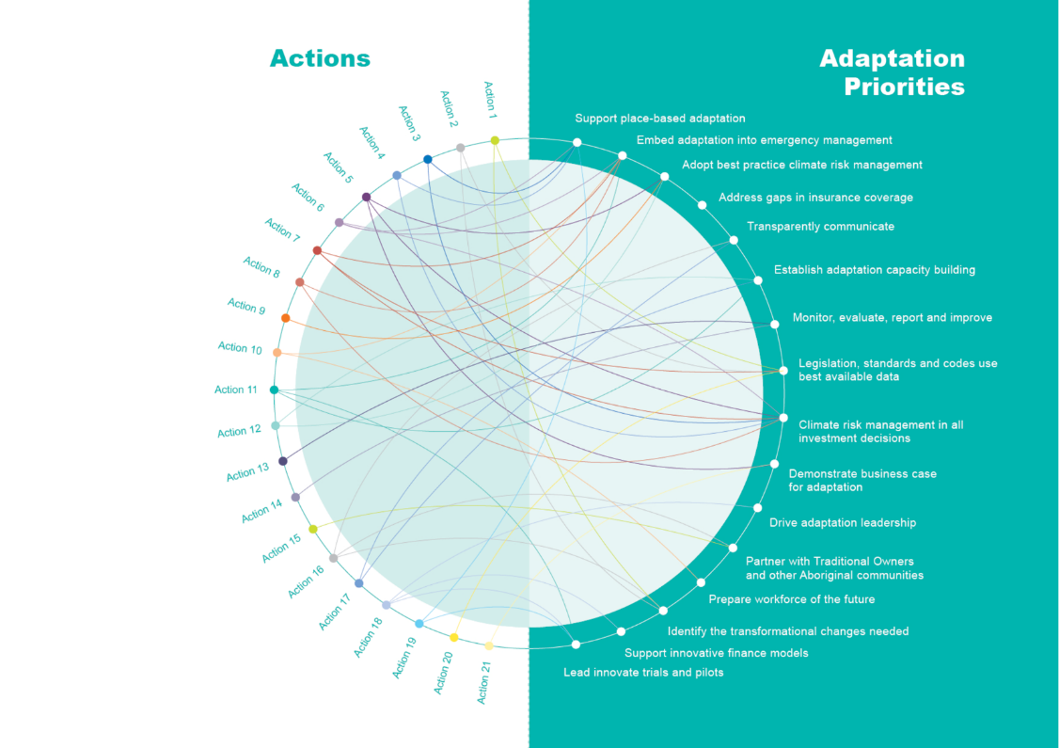
Figure 16: Links between the actions from the Water Cycle AAP and adaptation priorities outlined in Vic-toria’s Climate Change Strategy

Appendix 4 - Implementation and effectiveness of the pilot AAP
Pilot WSAAP short term objectives
Build knowledge | Develop frameworks, policy and tools | Enhance the capability and capacity of water sector staff

Pilot WSAAP purpose
Consolidate lessons learnt from development and implementation phases | Inform development of the Water Cycle AAP 2022-26
Impact and effectiveness - Actions provided tangible outcomes to help build capacity of water sector staff; were relevant to current challenges, opportunities and gaps; and enabled knowledge building to inform the medium and long term actions
- Impacts: The degree to which the problem/need has been addressed, i.e. Changes to resource condition, stakeholder behaviour, management activities or institutions. Effectiveness: The extent to which outputs achieve desired outcomes or objectives.
- Legacy: The likelihood that impacts will continue over time after the program ceases, i.e. Institutional changes, changed capacity or mechanisms that enable further ongoing change.
- Appropriateness: The extent to which the program’s objectives and methods align with the driving priorities, values and needs.
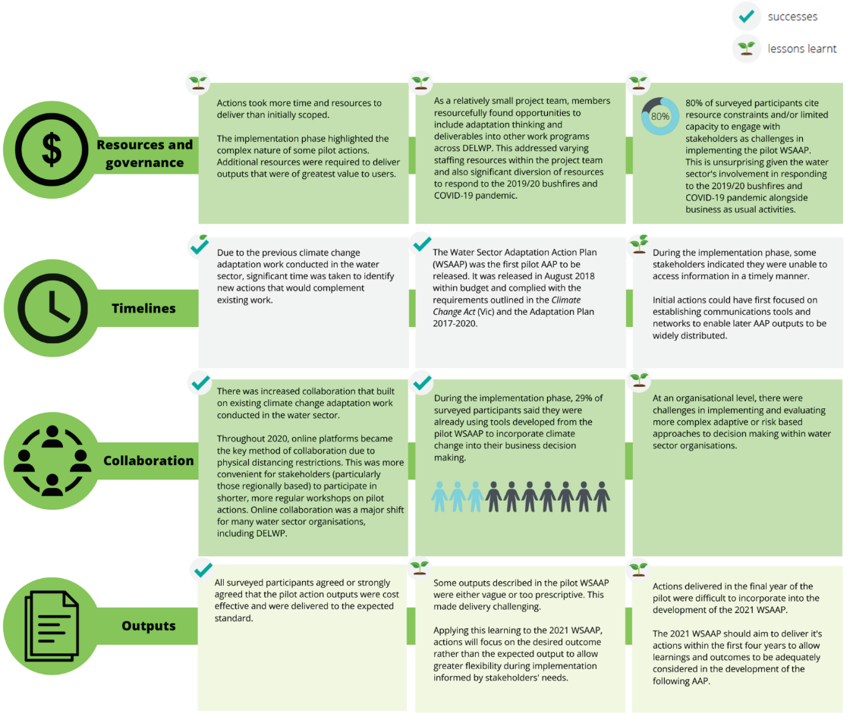
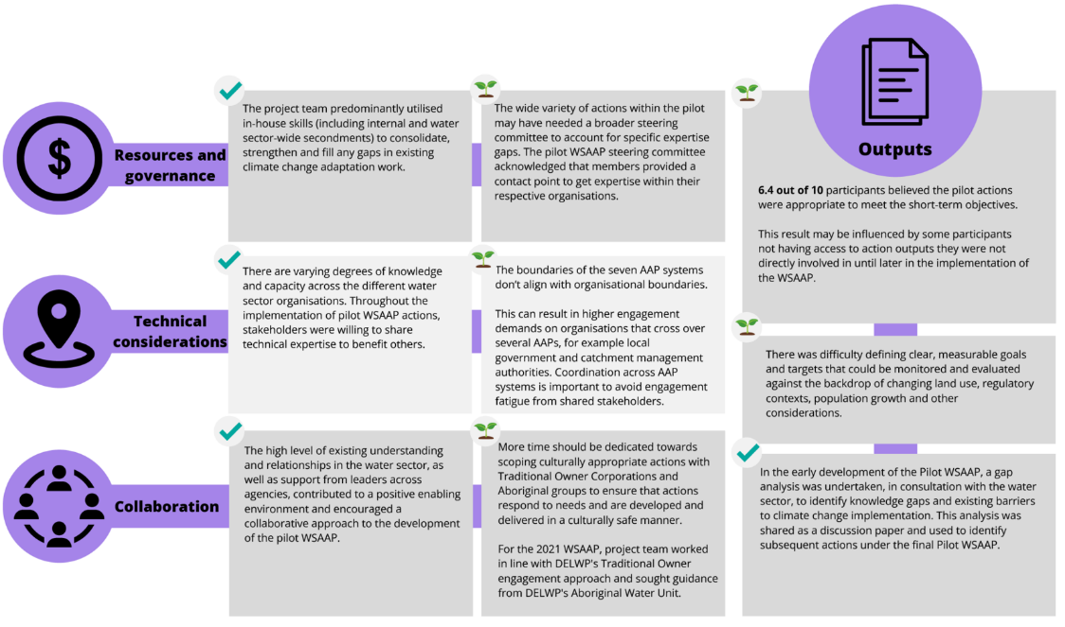
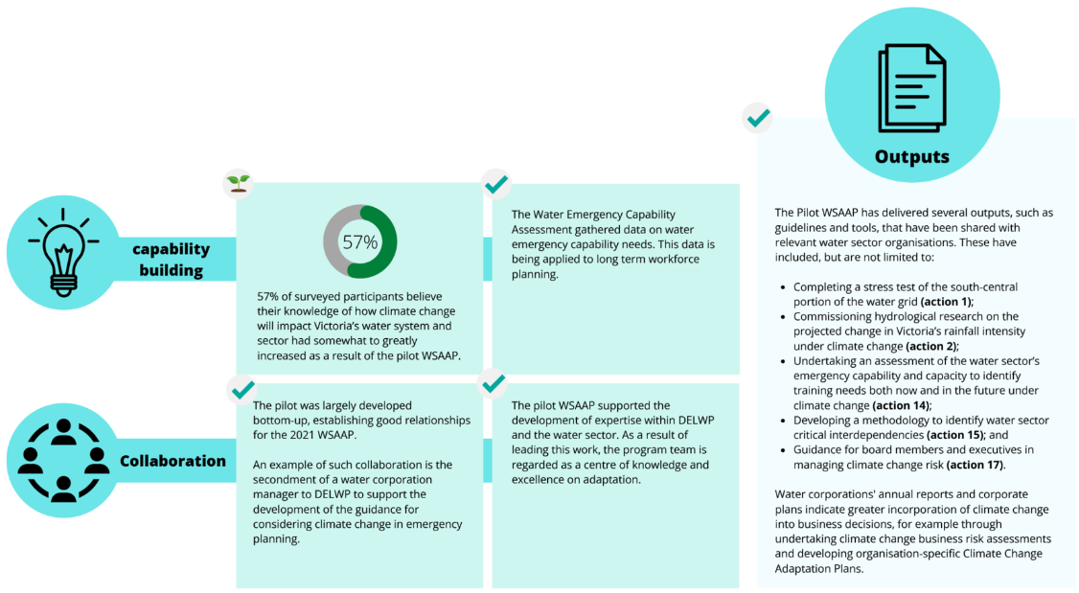

9. Key terms and acronyms
Term | Definition
AAP system | One of the seven systems defined under the Climate Change Act 2017 required to develop an adaptation action plan. The seven systems are Primary Production, Natural Environment, Built Environment, Transport, Health and Human Services, Education and Training and the Water Cycle.
Adaptation | Any process of adjusting to actual or expected climate and its effects that (a) in human systems, seek to moderate or avoid harm or exploit beneficial opportunities and (b) in natural systems, may be facilitated by human interventions.
Adaptive capacity | The ability of systems, institutions, humans and other organisms to adjust to potential damage, to take advantage of opportunities, or to respond to consequences.
Adaptive management | A process of iteratively planning, implementing and modifying strategies for managing resources in the face of uncertainty and change. Adaptive management involves adjusting approaches in response to observations of their effect and changes in the system brought on by resulting feedback effects and other variables.
Assets | Resources that provide benefit, including infrastructure such as treatment plants, pipes and pumps; water assets such as dams, bores and wetlands; and community assets such as sporting facilities, public gardens and street trees. Natural assets are assets of the natural environment, for example waterways and vegetation.
Capacity building | The practice of enhancing the strengths and attributes of, and resources available to, an individual, community, society, or organisation to respond to change.
Circular economy | An economic system based on the principles of designing out waste and pollution, keeping products and materials in use, and regenerating natural systems.
Climate change | A change of climate which is attributed directly or indirectly to human activity that alters the composition of the global atmosphere and which is in addition to natural climate variability observed over comparable time periods.
Climate resilient water | Sources of water that are less affected by climate variability and climate change. These include recycled water and desalinated water that have an indirect or no reliance on rainfall.
Climate scenario | A plausible and often simplified representation of the future climate, based on an internally consistent set of climatological relationships that has been constructed for explicit use in investigating the potential consequences of anthropogenic climate change, often serving as input to impact models. Climate projections often serve as the raw material for constructing climate scenarios, but climate scenarios usually require additional information such as the observed current climate.
Climate variability | Climate variability refers to variations in the mean state and other statistics (such as standard deviations, the occurrence of extremes etc) of the climate and all spatial and temporal scales beyond that of individual weather events. Variability may be due to natural internal processes within the climate system (internal variability) or due to natural or anthropogenic external forcing (external variability).
CMA | Catchment Management Authority.
Co-benefits | The positive effects that a policy or measure aimed at one objective might have on other objectives, irrespective of the net effect on overall social welfare. Co-benefits are often subject to uncertainty and depend on local circumstances and implementation practices, among other factors.
Country | Aboriginal culture revolves around relationships to the land and water. For Traditional Owners, Country is a part of who they are, just as they are a part of it. Traditional Owners are authorised to speak for Country and its heritage.
COVID-19 | Coronavirus disease 2019 (SARS-CoV-2).
Cross-cutting policy areas and stakeholders | Policy areas and stakeholders that cut across the scope of multiple AAP systems. Marine and coasts, energy, emergency management and vulnerable communities are the four cross-cutting policy areas and stakeholders considered by each AAP system.
Cross-system risk | These risks impact more than one AAP system and/or require action across more than one system to mitigate the risk.
DELWP | Department of Environment, Land, Water and Planning.
Diverse water | Water supplied from a variety of sources. These may include stormwater, rainwater tanks, groundwater, river water, fit-for-purpose recycled water and desalination.
Drought | May refer to meteorological drought (rainfall well below average), hydrological drought (low river flows and water levels in rivers, lakes and groundwater), agricultural drought (low soil moisture), and environmental drought (a combination of the above).
EMV | Emergency Management Victoria.
EPA Victoria | Environmental Protection Authority Victoria.
Exposure | The presence of people, livelihoods, species or ecosystems, environmental functions, services, and resources, infrastructure, or economic, social or cultural assets in places and settings that could be adversely affected.
Fit-for-purpose water | Water of a quality that is appropriate for its intended use
Floodplain | Low lying land adjacent to a river or stream with unique ecosystems dependent on inundation from flood events.
Gigalitre (GL) | Equivalent to one billion litres.
Greenhouse gas emissions | Emissions of (a) carbon dioxide, methane, nitrous oxide or sulphur hexafluoride or (b) a hydrofluorocarbon or perfluorocarbon that is specified in regulations under the National Greenhouse and Energy Reporting Act 2007 of the Commonwealth.
Hazard | The potential occurrence of a natural or human-induced physical event or trend of physical impact that may cause loss of life, injury, or other health impacts, as well as damage and loss to property, infrastructure, livelihoods, service provision, ecosystems and environment resources. In this Water Cycle AAP, the term hazard usually refers to climate related physical events or trends or their physical impacts, for example bushfire, flooding or heatwaves.
Heatwaves | Three or more days of unusually high day and night time temperatures.
Hot days | Days with a maximum temperature greater than the thresholds of 35°C, 38°C or 40°C for locations across Victoria.
IWM | Integrated Water Management.
Likelihood | The chance of a specific outcome occurring, where this might be estimated probabilistically.
Maladaptation | Actions that may lead to increased risk of adverse climate-related outcomes, increased vulnerability to climate change, or diminished welfare, now or in the future.
MAV | Municipal Association of Victoria
Mitigation (of risk) | Measures taken in advance of an emergency aimed at decreasing or eliminating its impact on society and the environment.
Pilot Water Sector Adaptation Action Plan | Pilot Water Sector Adaptation Action Plan released by the Victorian Government in 2018 containing 20 unique actions to (a) build knowledge, (b) develop frameworks, policy and tools and (c) enhance staff capability and capacity.
Potable | Water of suitable quality for drinking
RCP | Representative Concentration Pathway, referring to the concentration of greenhouse gases in the atmosphere by 2100.
Recycled water | Wastewater that has been collected and treated to a higher standard so that it can be used for a variety of purposes.
Resilience | The capacity of social, economic, and environmental systems to cope with a hazardous event or trend or disturbance, responding or reorganising in ways that maintain their essential function, identity and structure, while also maintain the capacity for adaptation, learning and transformation.
Risk | The potential for consequences where something of value is at stake and where the outcome is uncertain, recognising the diversity of values. Risk is often represented as probability of occurrence of hazardous events or trends multiplied by the impacts if these events or trends occur. Risk results from the interaction of vulnerability, exposure and [climate change] hazard.
Runoff | The amount of rainfall that drains into the surface drainage network to become stream flow, also known as rainfall excess.
Sewerage | The network of pipes, pumps and equipment that transfers all our wastewater from our homes and businesses to a treatment plant.
Stormwater | Runoff from urban areas. There is a net increase in runoff from urban development due to water not being able to seep into the ground because of impervious surfaces, such as roads and roofs.
SWS | Sustainable Water Strategy.
Traditional ecological knowledge | Knowledge that incorporates the concept of biocultural diversity – the diversity of life in all its manifestations: biological, cultural and linguistic – which are interrelated in a complex socio-ecological adaptive system.
Traditional Owners | People who, through membership of a descent group or clan, are responsible for caring for particular Country. A Traditional Owner is authoritised to speak for Country and its heritage.
Transformational adaptation | Adaptation that changes the fundamental attributes of a system in response to climate and its effects.
Wastewater | Water that has had its quality affected by human influence, deriving from industrial, domestic, agricultural or commercial activities.
Water cycle | The cycle of processes by which water circulates between the earth’s oceans, atmosphere and land, involving precipitation as rain and snow, drainage in streams and rivers, and return to the atmosphere by evaporation and transpiration.
Water industry | The collective term for Victoria’s water corporations.
Water sector | The broad range of entities with a stake or role in water management. For example, water corporations, catchment management authorities, local government, and environmental water holders.
Waterway health | The overall state of the main features and processes underpinning a functioing waterway ecosystem (such as species and communities, habitat, connectivity, water quality, riparian vegetation, physical form and ecosystem processes such as nutrient cycling and carbon storage).
WSAA | Water Services Association of Australia.
VCOSS | Victorian Council of Social Service.
VEWH | Victorian Environmental Water Holder.
Vulnerability | The propensity or predisposition to be adversely affected. Vulnerability encompasses a variety of concepts and elements including sensitivity or susceptibility to harm and lack of capacity to cope and adapt.

10. References

DELWP (2019). Victoria in Future 2019. Melbourne, Victoria.
Huf, B. and McLean, H. (2020). Parliament of Victoria, 2019-20 Bushfires, Research Note No. 1, February 2020, pp.1–2
DELWP (2018). Pilot Water Sector Climate Change Adaptation Action Plan, Melbourne, Victoria.
DELWP (2016). Water for Victoria, Melbourne, Victoria.
Sustainability Victoria (2017). Summary of key findings – climate change social research. Melbourne, Victoria.
DELWP (2021). Victoria’s Climate Change Strategy. Melbourne, Victoria.
VicWater (2020). VicWater Policy Platform. Accessed March 2021.
Municipal Association of Victoria (2020). Submission to the Draft EPA Urban Stormwater Management Guidance, Victoria.
Dja Dja Wurrung Enterprises (2021). Climate change: activating cultural values to inform effective policy and strategy development. Victoria.
CSIRO (2019). Victorian Climate Projections 2019 Technical Report. CSIRO, Melbourne, Victoria.
DELWP (2019). Victoria’s Climate Science Report 2019, Melbourne, Victoria.
DELWP, Bureau of Meteorology, Commonwealth Scientific and Industrial Research Organisation, the University of Melbourne (2020). Victoria’s Water in a Changing Climate, Melbourne, Victoria.
DELWP (2020). Guidelines for Assessing the Impact of Climate Change on Water Availability in Victoria, Melbourne, Victoria.
DELWP (2020). Long-Term Water Resource Assessment for Southern Victoria, Melbourne, Victoria
Evans A., Jones D., Smalley R. and Lellyett S. (2020). An enhanced gridded rainfall analysis scheme for Australia Bureau Research Report – BRR041, pp. 39.
DELWP (2016). Managing extreme water shortage in Victoria – lessons from the Millennium Drought. Melbourne, Victoria.
DELWP (2019). ‘Rainfall Extremes are getting more extreme’ – are they? Prepared through the Victorian Climate Change Initiative, Melbourne, Victoria.
Potter NJ, Chiew FHS, Zheng H, Ekström M and Zhang L (2016). Hydroclimate projections for Victoria at 2040 and 2065, CSIRO, Australia.
Water Services Association of Australia and Arran Canning, WaterFutures (2020). Bushfire management: National good practice operational guidelines for the Australian water industry.
IPCC (Intergovernmental Panel on Climate Change) Fifth Assessment Report (2014). Summary for Policymakers. In: Climate Change 2014: Impacts, Adaptation and Vulnerability. Part A: Global and Sectoral Aspects. Contributions of working Group II to the Fifth Assessment Report of the Intergovernmental Panel on Climate Change. IPCC, Geneva, Switzerland.
Sun, X., Li, J. and Zhou, A. (2017). Assessment of the impact of climate change on expansive soil movements and site classification. Australian Geomechanics Journal, 52(3), 39-50.
Karunaratne, T., Fagan, J. and Adikari, G. (2018). Integrating Climate Change into Dams Management Practices. Paper presented at the Australian National Committee on Large Dams conference in Melbourne, Victoria.
Emergency Management Victoria (2021). Victoria’s Critical Infrastructure All Sectors Resilience Report 2020. Victoria, Australia.
Victorian Building Authority (2018). Residential Sustainability Measures. Practice note 55-2018.
HydroNumerics (2020). Developing a new framework for future blue-green algae assessment and management. Final Report. Prepared on behalf of DELWP.
Environment Protection Authority (2018). Water quality offsets: Goulburn Valley Water Kilmore case study, publication 1690, Victoria.
DELWP (2020). Victorian Floodplain Management Strategy Implementation Snapshot, Melbourne, Victoria.
Ennos, R. (2015). Can trees really cool our cities down? The Conversation
Broadbent, A., Coutts, A., Tapper, N., Demuzere, M., and Beringer, J. (2018). The microscale cooling effects of water sensitive urban design and irrigation in a suburban environment. Theoretical and Applied Climatology 134(1), 1-23.
Bath, A., Middleton, D., Smith, F., Khan, S. and Williamson, S. (2020). Drought, deluges and disinfection: managing water quality in an environment of climate change. Australian Water Association.
Martinez-Diaz (2018). Investing in resilience today to prepare for tomorrow’s climate change, Bulletin of Atomic Scientists, 74(2), 66-72.
Water Technology (2016). Traralgon Flood Study Summary Report. Prepared for West Gippsland Catchment Management Authority.
DELWP (2020). Water for Victoria Action Status Report July 2020, Melbourne, Victoria.
Melbourne Water, City West Water, Yarra Valley Water, South East Water (2017). Water for a future-thriving Melbourne, Melbourne, Victoria.
Bors, J., Kenway, S., Satur, P., Skinner, R., Smith, L. and Lam., K.L (2021). Phase 1 final report: drivers for energy reduction in the use of water in residential households – opportunities. Monash Sustainable Development Institute and the University of Queensland, Australia.

