Victorian Greenhouse Gas Emissions Report 2019

Acknowledgment
We acknowledge and respect Victorian Traditional Owners as the original custodians of Victoria’s land and waters, their unique ability to care for Country and deep spiritual connection to it. We honour Elders past and present whose knowledge and wisdom has ensured the continuation of culture and traditional practices.
We are committed to genuinely partner, and meaningfully engage, with Victoria’s Traditional Owners and Aboriginal communities to support the protection of Country, the maintenance of spiritual and cultural practices and their broader aspirations in the 21st century and beyond.
© The State of Victoria Department of Environment, Land, Water and Planning 2021
This work is licensed under a Creative Commons Attribution 4.0 International licence. You are free to re-use the work under that licence, on the condition that you credit the State of Victoria as author. The licence does not apply to any images, photographs or branding, including the Victorian Coat of Arms, the Victorian Government logo and the Department of Environment, Land, Water and Planning (DELWP) logo. To view a copy of this licence, visit http://creativecommons.org/licenses/by/4.0/
ISSN 2652-8495 (online PDF/Word)
ISSN 2652-8932 (print)

Disclaimer
This publication may be of assistance to you but the State of Victoria and its employees do not guarantee that the publication is without flaw of any kind or is wholly appropriate for your particular purposes and therefore disclaims all liability for any error, loss or other consequence which may arise from you relying on any information in this publication.

Accessibility
If you would like to receive this publication in an alternative format, please telephone the DELWP Customer Service Centre on 136186, email customer.service@delwp.vic.gov.au , or via the National Relay Service on 133 677 www.relayservice.com.au. This document is also available on the internet at www.delwp.vic.gov.au.

Content
Minister’s foreword 3
Summary 4
Introduction 7
1. Victorian emissions and indicators – 1990 to 2019 9
1.1 Emissions 1990 to 2019 9
1.2 Change in emissions – 2005 to 2019 9
1.3 Victoria’s contribution to national emissions 10
1.4 Per capita emissions 12
1.5 Emissions and Gross State Product 14
2. Emissions by sector (IPCC categories) 16
2.1 Energy 19
2.2 Industrial processes and product use (IPPU) 34
2.3 Waste 36
2.4 Agriculture 39
2.5 Land Use, Land-Use Change and Forestry (LULUCF) 43
3. Emissions by economic sector – 2019 51
3.1 Direct (Scope 1) emissions by economic sector 51
3.2 Allocation of Scope 2 emissions from electricity generation to end-users 52
3.3 Scope 1 plus Scope 2 emissions by economic sector 53
Appendix A 55
Revision of historical greenhouse gas emissions data 55
A.1 – Further detail on revisions to historical LULUCF data 57
Abbreviations and acronyms 60
Reference List 61

Minister’s foreword
The Victorian Greenhouse Gas Emissions Report 2019 is the fourth in an annual series of reports that are prepared in accordance with the requirements of the Climate Change Act 2017.
Annual emissions reports provide the Victorian community with detailed information on the sources of – and trends in – Victoria’s emissions. They also provide important insights to assist the Government in framing climate change policy and enable the effectiveness of policy to be monitored and reviewed over time.
This year’s report shows that in 2019, Victoria’s emissions were 30.1 Mt CO₂-e (24.8 per cent) below 2005 levels. This means the Government’s target to reduce emissions by 15 to 20 per cent below 2005 levels by 2020 was met and exceeded ahead of time. It also shows we are tracking towards meeting Victoria’s interim emissions reduction targets of 28 to 33 per cent below 2005 levels by 2025 and 45 to 50 per cent below 2005 levels by 2030.
These interim targets – and the actions the Victorian Government is taking to meet them – are set out in Victoria’s Climate Change Strategy which was released in May this year. The Strategy will ensure Victoria remains on track to achieving net zero emissions by 2050 while also seizing opportunities to advance clean and innovative technologies, invest in new industries and create jobs and cost savings for all Victorians.
I trust you will find this report informative in understanding the diversity of activities across the economy that give rise to greenhouse gas emissions; and how these are evolving over time as we transition towards net zero emissions.
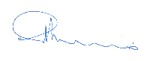
The Hon. Lily D’Ambrosio MP
Minister for Energy, Environment and Climate Change
Minister for Solar Homes

Summary
The Victorian Greenhouse Gas Emissions Report 2019 is the fourth in a series of annual emissions reports required by Victoria’s Climate Change Act 2017 (the Act). It provides:
- an overview of the state’s greenhouse gas emissions from 1990 to 2019 with a focus on trends since 2005 (the reference year for interim emissions reduction targets under the Act); and
- an explanation of sources of emissions and trends over time, including likely drivers of those trends.
Key points include:
- Victoria’s total net emissions in 2019 were 91.3 million tonnes (Mt) of carbon dioxide equivalent (CO₂-e)
- This comprises emissions from electricity generation (48.0% of total net emissions), transport (24.8%), direct combustion (19.1%), agriculture (17.1%), industrial processes and product use (3.7%), fugitive emissions from fuels (3.3%) and waste (3.1%).
- Land use, land-use change and forestry (LULUCF) provided net sequestration of 17.4 Mt CO₂-e (-19.1% of net emissions) – that is, the sector removed (sequestered) more greenhouse gases than it generated.
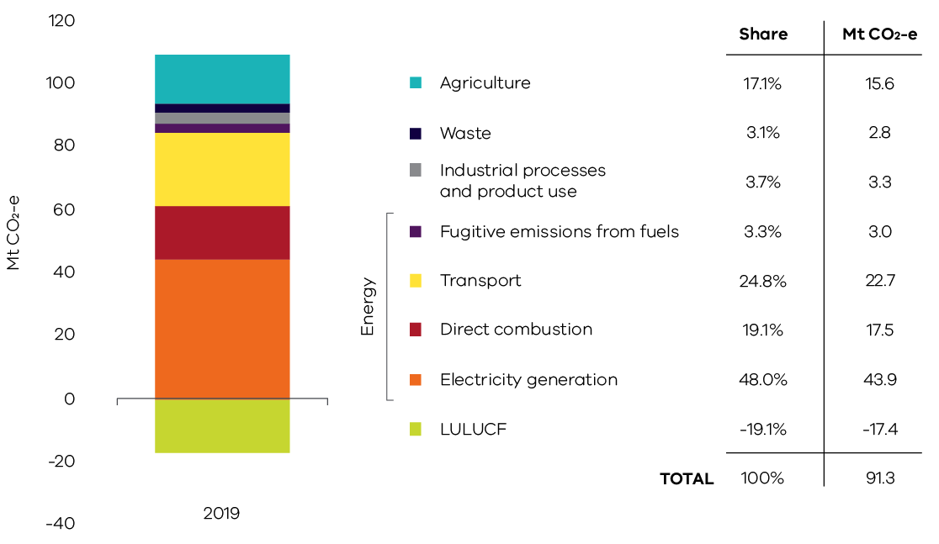
Figure 1. Victorian emissions by sector and energy sub-sector, 2019
Source: Australian Greenhouse Emissions Information System (DISER 2021b)
Note – numbers may not sum due to rounding
- Victoria’s total net emissions fell by 30.1 Mt CO₂-e (24.8%) between 2005 and 2019
- Key contributors to this reduction were electricity generation, which saw emissions fall by 19.6 Mt CO₂-e (65% of the change in total net emissions) and the LULUCF sector, which increased net sequestration by 8.8 Mt CO₂-e (29% of the change in Victoria’s total net emissions).
- Reductions in emissions also occurred in agriculture (2.5 Mt CO₂-e), waste (1.5 Mt CO₂-e) and direct combustion (1.0 Mt CO₂-e).
- Emissions increased in transport (2.5 Mt CO₂-e), fugitive emissions from fuels (0.6 Mt CO₂-e) and industrial processes and product use (0.3 Mt CO₂-e).
- Between 2005 and 2019, the emissions intensity of Victoria’s economy declined by 48% from 0.38 to 0.20 kilograms (kg) CO₂-e per dollar of Gross State Product. Per capita emissions decreased by 43% from 24.3 to 13.8 tonnes (t) CO₂-e per person.
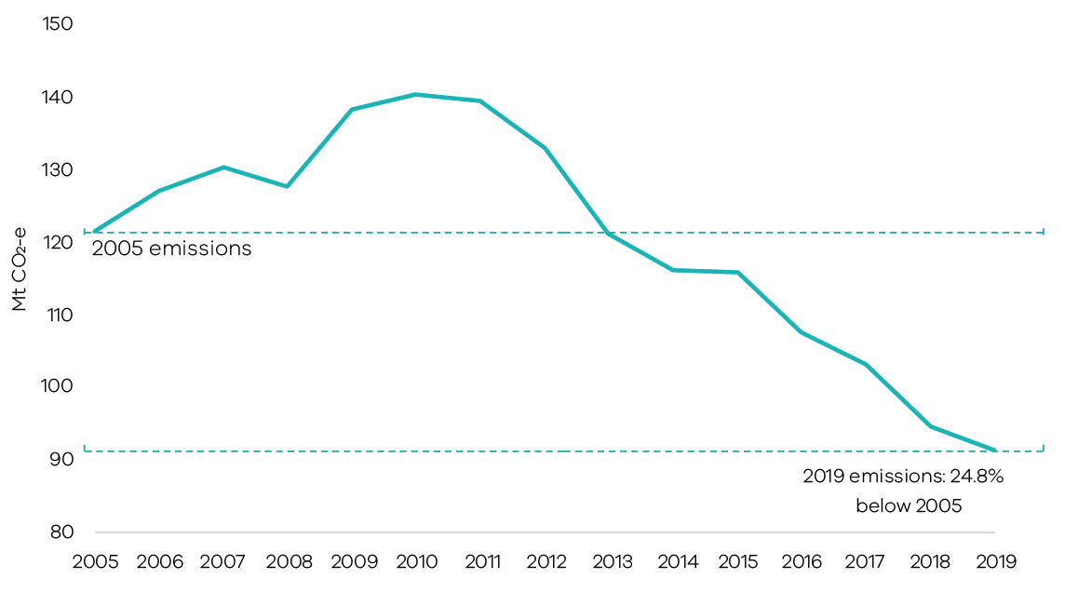
Figure 2. Victoria’s total net emissions, 2005-2019
Source: Australian Greenhouse Emissions Information System (DISER 2021b)
- Carbon dioxide contributed 74% of Victoria’s 2019 total net emissions
- At 67.4 Mt CO₂-e (73.8%), carbon dioxide (CO₂) was the largest contributor to total net emissions in 2019, followed by methane (CH₄) at 17.7 Mt CO₂-e (19.4%), nitrous oxide (N₂O) at 3.6 Mt CO₂-e (3.9%) and hydrofluorocarbons (HFCs) at 2.6 Mt CO₂-e (2.8%). Other gases included perfluorocarbons (PFCs) at 0.05 Mt CO₂-e (0.05%) and sulphur hexafluorides (SF₆) at 0.04 Mt CO₂-e (0.04%).
- The major source of CO₂ gas emissions was fuel combustion associated with electricity generation, direct combustion and transport.
- Agriculture was the main source of methane emissions – predominantly from livestock digestive processes – with small contributions from waste and fugitive emissions.
- Agriculture was also the main source of N₂O emissions which arose from agricultural soils due to microbial and chemical transformations associated with nitrogen fertiliser.
- HFCs, PFCs and SF₆ emissions resulted from the industrial processes and product use sector, including – for example, HFC emissions from air conditioning and refrigeration units, PFC emissions from aluminium smelting and SF₆ emissions from electricity supply and distribution network.
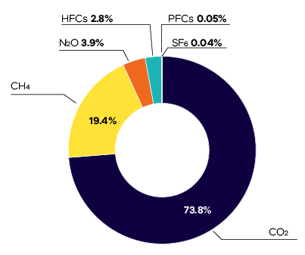
Figure 3. Victoria’s greenhouse gases emissions by gas, 2019
Source: Australian Greenhouse Emissions Information System (DISER 2021b)

Introduction
Section 52 of the Climate Change Act 2017
(the Act) requires the Minister administering the Act to prepare annual greenhouse gas emissions reports for Victoria. The Act requires that the reports include an overview and collation of the best practicably available information about Victoria’s greenhouse gas emissions; and the extent to which emissions have been reduced compared with 2005 levels (the reference year for interim emissions reduction targets under the Act).
The Victorian Greenhouse Gas Emissions Report 2019 presents information on Victoria’s emissions in two forms:
- presentation of emissions data in accordance with sectors defined by the Intergovernmental Panel on Climate Change (IPCC) reporting framework for national greenhouse gas inventories – with disaggregation of data in the energy sector; and
- presentation of emissions data by sectors of the economy categorised according to the Australian and New Zealand Standard Industrial Classification (ANZSIC).
Data for the report is sourced from State and Territory Greenhouse Gas Inventories released in April 2021 by the Commonwealth Department of Industry, Science, Energy and Resources (DISER); and the Australian Greenhouse Emissions Information System online database. Both sources provide data at a state and territory level over the period 1990 to 2019. This is the most recent official data on annual greenhouse gas emissions.
Victoria’s Climate Change Strategy
The Victorian Government released Victoria’s Climate Change Strategy in May 2021. The Strategy is a roadmap to net-zero emissions and a climate-resilient Victoria by 2050; and includes Victoria’s interim targets for a reduction in emissions by 28-33% below 2005 levels by 2025 and 45-50% by 2030.
The Strategy is available at https://www.climatechange.vic.gov.au/victorias-climate-change-strategy
Updated historical data
DISER reviews and, where necessary, revises greenhouse gas data annually to ensure the data is produced in a manner consistent with international methodologies; and to reflect improved estimation methods and new sources of information as they become available.
This review process has resulted in updated historical emissions data for Victoria for 1990 to 2018. Consequently, data over this period in this year’s report differs from that presented in the Victorian Greenhouse Gas Emissions Report 2018.
This is discussed further in Chapter 2 and Appendix A.
The data relates to production-based rather than consumption-based emissions in Victoria – that is, it accounts for emissions from goods and services produced in Victoria. This is in accordance with United Nations Framework Convention on Climate Change’s (UNFCCC) emissions accounting provisions.
Economic and population statistics for Victoria were used to calculate emissions intensity measures and to obtain insights into trends in the state’s emissions.
Note that, throughout the report, numbers may not sum precisely to the totals due to rounding.
The report is structured as follows:
- Chapter 1 presents the trend in Victoria’s emissions from 1990 to 2019; its contribution to national emissions and emissions per capita and per unit of Gross State Product (GSP).
- Chapter 2 presents Victoria’s emissions by sector based on IPCC sector categories. It describes historical trends in emissions in each sector and the key drivers of those trends.
- Chapter 3 presents Victoria’s emissions by economic sector based on ANZSIC sector categories.

Victorian emissions and indicators – 1990 to 2019

Emissions 1990 to 2019
Victoria’s total net emissions declined between 1990 and 1996 before trending upwards to a peak in 2010 and then declining through to 2019 (Figure 4). In 2019, total net greenhouse gas emissions were 91.3 Mt CO₂-e, or 19.0% below 1990 levels. Emissions decreased by 3.3 Mt CO₂-e (3.5%) between 2018 and 2019.
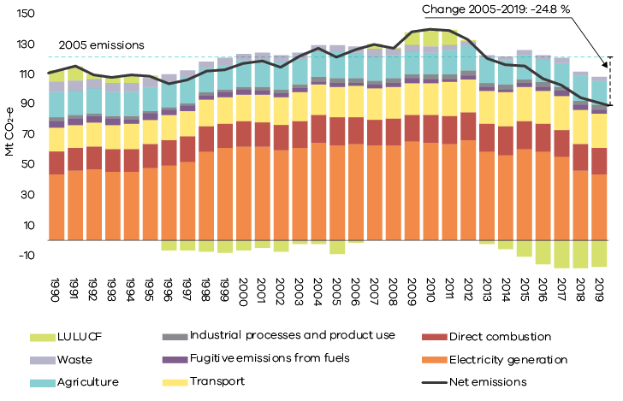
Figure 4. Total net emissions and emissions by sector – Victoria, 1990 to 2019
Source: Australian Greenhouse Emissions Information System (DISER 2021b)
Chapter 2 discusses the trends in sectoral emissions, including the key factors driving these trends.

Change in emissions – 2005 to 2019
The Act specifies that Victoria’s greenhouse gas emissions reduction targets are set with 2005 as the reference year. In 2019, Victoria’s total net emissions of 91.3 Mt CO₂-e were 30.1 Mt CO₂-e (24.8%) below their level of 121.4 Mt CO₂-e in 2005 (Figure 5). The 24.8% reduction means the Victorian Government’s target to reduce emissions by 15-20% below 2005 levels by 2020 has been met and exceeded ahead of time.

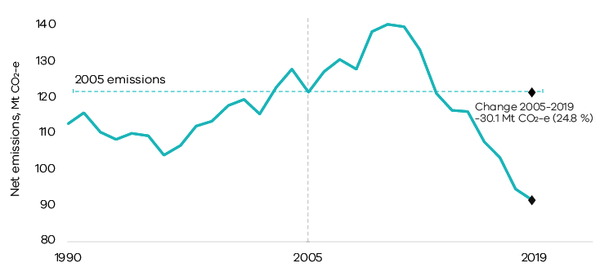
Figure 5. Trend in net emissions – Victoria, 1990 to 2019 – highlighting change between 2005 and 2019
Source: Australian Greenhouse Emissions Information System (DISER 2021b)

Victoria’s contribution to national emissions
Figure 6 shows that in 2019, Victoria was the fourth largest contributor to Australia’s total net emissions (17.3%), behind Queensland (31.1%), New South Wales (25.8%) and Western Australia (17.4%).
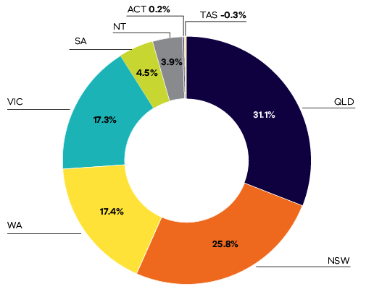
Figure 6. Contribution to national emissions by state and territory, 2019
Source: State and Territory Greenhouse Gas Inventories 2019 (DISER 2021e)
Note: Tasmania’s share of -0.3% reflects the fact that net sequestration in the LULUCF sector in that state exceeded emissions in other sectors with the result that Tasmania had negative total net emissions in 2019.
Figure 7 shows that Victoria’s share of Australia’s total net emissions increased from 17.9% in 1990 to a peak of 23.9% in 2011, before declining to 17.3% in 2019.
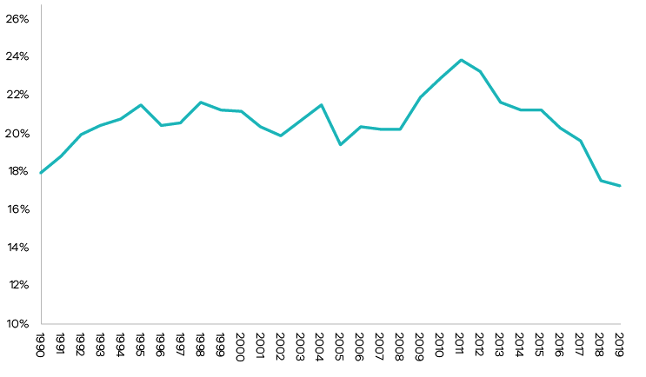
Figure 7. Contribution to national emissions – Victoria, 1990 to 2019
Source: State and Territory Greenhouse Gas Inventories 2019 (DISER 2021e)

Per capita emissions
Victoria’s per capita emissions of 13.8 tonnes (t) CO₂-e in 2019 was less than the national average (20.9 t CO₂-e), lower than the Northern Territory, Western Australia, Queensland and New South Wales; but higher than Tasmania, the Australian Capital Territory (ACT) and South Australia (Figure 8).
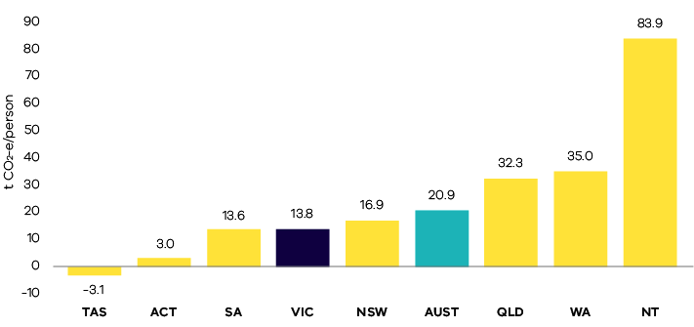
Figure 8. Per capita emissions in Australia and by state and territory, 2019
Source: Analysis based on State and Territory Greenhouse Gas Inventories 2019 (DISER 2021e) and Australian Demographic Statistics 2020 (ABS 2021a)
Note: Tasmania’s figure of -3.1 t CO₂-e per capita reflects the fact that net sequestration in the LULUCF sector in that state exceeded emissions in other sectors with the result that Tasmania had negative total net emissions in 2019.
Victoria’s per capita emissions decreased from 25.8 to 13.8 t CO₂-e between 1990 and 2019. As shown in Figure 9, the rate of reduction was particularly marked after 2011.
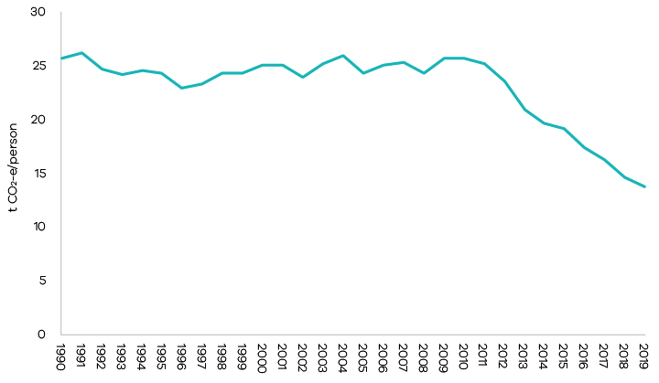
Figure 9. Trend in per capita emissions – Victoria, 1990 to 2019
Source: Analysis based on State and Territory Greenhouse Gas Inventories 2019 (DISER 2021e) and Australian Demographic Statistics 2020 (ABS 2021a)

Emissions and Gross State Product
Between 1990 and 2019, real Gross State Product (GSP) increased by 126% while emissions fell by 19% (Figure 10), resulting in a decline in the emissions intensity of the Victorian economy from 0.55 to 0.20 kg CO₂-e per $GSP – a reduction of 64% (see Figure 11).
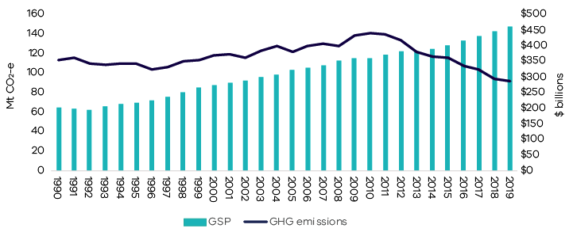
Figure 10. Greenhouse gas emissions and real GSP – Victoria, 1990 to 2019
Source: Analysis based on State and Territory Greenhouse Gas Inventories 2019 (DISER 2021e) and Australian National Accounts: State Accounts, 2019-20 (ABS 2021b).
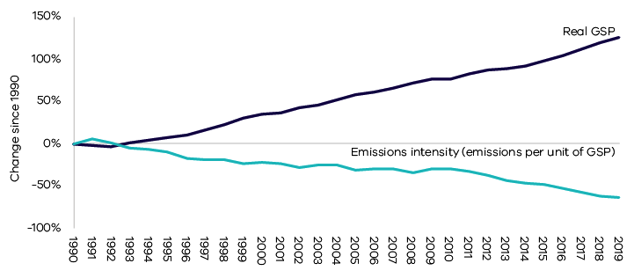
Figure 11. Percentage change in real GSP and emissions intensity – Victoria, 1990 to 2019
Source: Analysis based on State and Territory Greenhouse Gas Inventories 2019 (DISER 2021e) and Australian National Accounts: State Accounts, 2019-20 (ABS 2021b).

Emissions by sector (IPCC categories)
This chapter presents information on Victoria’s greenhouse gas emissions by sector, the activities that drive these emissions and the key factors influencing emissions trends. Sectors are based on the five categories identified in Intergovernmental Panel on Climate Change (IPCC) international guidelines, namely:
- Energy
- Industrial processes and product use (IPPU)
- Agriculture
- Land use, land-use change and forestry (LULUCF)
- Waste.
Due to its significance in Victoria, the energy sector is disaggregated into four sub-sectors: electricity generation, direct combustion from stationary sources, transport and fugitive emissions from fuels.
The National Inventory Report 2019 (DISER 2021d) is the primary source of information for the activities that drive sectoral emissions. Commonwealth Government statistics for Victoria, academic and Victorian Government publications and consultation with experts were used to obtain additional insights into the factors that influenced sectoral emissions trends over the period 1990 to 2019.
Figure 12 presents the share of Victoria’s net emissions in 2019 by sector and energy sub-sectors.
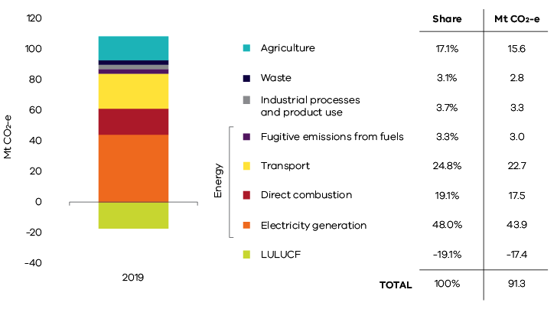
Figure 12. Victorian emissions by sector and energy sub-sectors, 2019
Source: Australian Greenhouse Emissions Information System (DISER 2021b)
*Note – numbers may not sum due to rounding
Figure 13 presents emissions by sector in 1990, 2005 and 2019. Key points to note include:
- emissions from electricity generation, direct combustion and agriculture increased between 1990 and 2005, but declined between 2005 and 2019;
- emissions from transport and IPPU increased between 1990 and 2005 – and continued to increase to 2019;
- LULUCF was a net source of emissions in 1990 but sequestered more emissions than it generated in both 2005 and 2019 (i.e. the sector provided net sequestration in both years); and
- emissions from the waste sector declined between 1990 and 2005 and continued to do so to 2019.
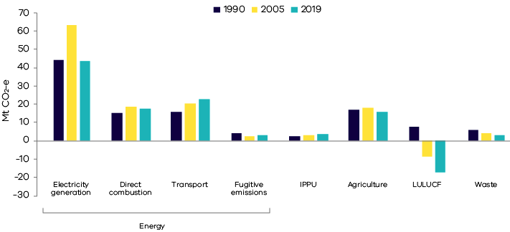
Figure 13. Emissions by sector and energy sub-sectors – 1990, 2005 and 2019
Source: Australian Greenhouse Emissions Information System (DISER 2021b)
Table 1 and Figure 14 provide further details on the scale of changes in sectoral emissions between 2005 and 2019. The electricity generation sub-sector experienced the largest reduction in net emissions, followed by LULUCF, agriculture, waste and direct combustion.
Table 1. Change in emissions by sector and energy sub-sector between 2005 and 2019, Victoria
Sector | 2005  (Mt CO₂-e) | 2019  (Mt CO₂-e) | Change 2005 to 2019  (Mt CO₂-e)
Electricity generation | 63.5 | 43.9 | -19.6 | ↓
Direct combustion | 18.5 | 17.5 | -1.0 | ↓
Transport | 20.2 | 22.7 | 2.5 | ↑
Fugitive emissions | 2.4 | 3.0 | 0.6 | ↑
IPPU | 3.1 | 3.3 | 0.3 | ↑
Agriculture | 18.1 | 15.6 | -2.5 | ↓
LULUCF | -8.6 | -17.4 | -8.8 | ↓
Waste | 4.4 | 2.8 | -1.5 | ↓
Total (net emissions) | 121.4 | 91.3 | -30.1 | ↓

Source: Australian Greenhouse Emissions Information System (DISER 2021b)
*Note – numbers may not sum due to rounding
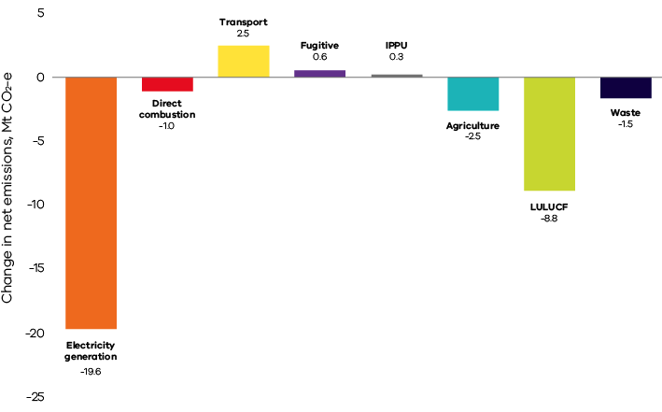
Figure 14. Change in net emissions between 2005 and 2019 by sector and energy sub-sector, Victoria
Source: Australian Greenhouse Emissions Information System (DISER 2021b)

Energy
The energy sector comprises sub-sectors including electricity generation, direct combustion, transport and fugitive emissions from fuels. Figure 15 shows the contribution of each sub-sector to Victoria’s total net emissions in 2019 – collectively, the energy sector was responsible for 95.3% of Victoria’s total net emissions in that year.
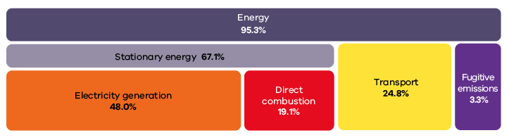
Figure 15. Energy sub-sectors and their contributions to total net emissions in Victoria, 2019
Source: Australian Greenhouse Emissions Information System (DISER 2021b)
Note – numbers may not sum to totals due to rounding
The following sections discuss emissions trends for each energy sub-sector.

Electricity generation

Sources of emissions
Emissions from electricity generation arise from the combustion of fuels to generate power supplied to the electricity grid.
International emissions accounting requires that emissions data are production rather than consumption-based. Consistent with these provisions, this sub-sector includes emissions released from electricity generated in Victoria, some of which is exported for consumption in other states. Emissions associated with electricity imported by Victoria from other states are not included as part of Victoria’s net emissions but instead are included in the emissions inventories of those states where the electricity is generated.

Electricity generation in Victoria
In 2019, emissions from electricity generation accounted for almost half of Victoria’s total net emissions. Approximately 71% of the state’s electricity was generated by brown coal-fired power stations, slightly down from 73% in 2018 (DISER 2021a). Three brown coal-fired power stations were operating in 2019, all located in the Latrobe Valley: Yallourn, Loy Yang A and Loy Yang B. These power stations were responsible for 45.3% of Victoria’s total net emissions in 2019 (Table 2).
Gas-powered generation (GPG) contributed 6.8% of total electricity generation in Victoria in 2019 – emissions from large and medium GPGs took the contribution of electricity generation to 47.0% of total net emissions (Table 2 and Figure 16).
Figure 15 indicates electricity generation was responsible for 48.0% of Victoria’s total net emissions – the difference between this number and the total of 47.0% presented in Table 2 is because emissions from small electricity generators are not captured in the data in Table 2 due to those generators falling below emissions reporting thresholds.
In 2019, renewables accounted for 21.9% of Victorian electricity generation – renewable electricity produces no emissions.
Table 2. Electricity production and emissions from Victorian brown coal-fired power stations and large and medium GPG in 2019
Facility |  | Electricity production (MWh) | Total direct emissions  (Mt CO₂-e) | Share of Victoria’s net greenhouse gas emissions
Brown coal power stations | Loy Yang A | 15,959,544 | 18.5 | 20.3%
 | Yallourn | 10,133,040 | 13.3 | 14.6%
 | Loy Yang B | 8,443,824 | 9.6 | 10.5%
 | Sub-total | 34,536,408 | 41.4 | 45.3%
Large and medium GPG# |  | 2,612,066 | 1.5 | 1.7%
TOTAL |  | 37,148,474 | 42.9 | 47.0%*

Source: Analysis based on Greenhouse and energy information for designated generation facilities 2018-19 (CER 2020)
* Total of 47% varies from the total of 48% presented in Figure 15 due to the exclusion of small electricity generators in Table 2 (e.g. generation from liquid fuels).
# Excludes small-scale GPG which is below the threshold for NGER reporting
Note – numbers may not sum to totals due to rounding

Emissions trends and drivers
Figure 16 shows the trend in emissions from electricity generation since 1990.

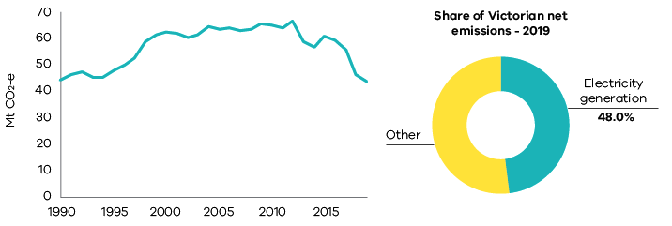
Figure 16. Emissions from electricity generation – Victoria, 1990 to 2019
Source: Australian Greenhouse Emissions Information System (DISER 2021b)
Emissions from electricity generation increased from 1990 to a peak in 2012. After falling from this peak to 2014, they rose again in 2015 before declining significantly through to 2019. This decline was associated with the closure of Hazelwood Power Station in March 2017 (which contributed emissions of 14.4 Mt CO₂-e in 2016) (Australian Energy Regulator 2020 and CER 2020); and increased renewable electricity generation (with renewable producing record output in 2019).
As illustrated in Box 1, between 2016 and 2019:
- Emissions from the remaining coal-fired power stations decreased by 1.7 Mt CO₂-e due to outages at the stations.
- GPG output increased significantly in 2019 to help meet electricity demand during a high number of unplanned coal-fired generation outages. As a result, direct emissions from large and medium GPG doubled from around 0.7 Mt CO2-e to around 1.5 Mt CO2-e between 2016 and 2019 (CER 2020, CER 2018) – GPG nonetheless remained a relatively small share of Victoria’s overall electricity generation mix (see Table 2).
- The share of renewable electricity in Victoria’s electricity generation increased from 14.8% to 21.9% (DISER 2021a).

Box 1: Key events and drivers of trends in emissions from electricity generation
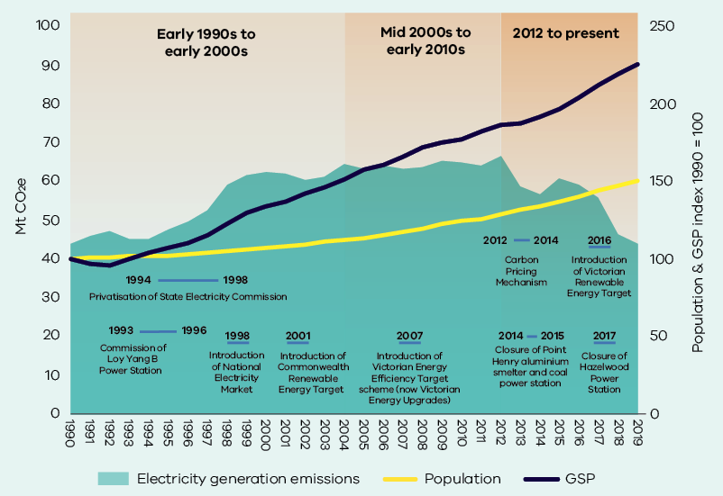
1990 to early 2000s
The increase in emissions from electricity generation reflected the underlying growth in Victoria’s economy and population. It also reflected the privatisation of the Victorian electricity industry in the mid- to late-1990s and the introduction of the National Electricity Market (NEM), which boosted the competitiveness of Victorian generators and saw an increase in generation volumes – including for export to other states. Loy Yang B Power Station was commissioned in the mid-1990s. The Commonwealth Government’s Renewable Energy Target was introduced in 2001 to incentivise investment in large-scale renewable energy projects.
Mid 2000s to early 2010s
Despite continued strong growth in GSP, emissions from electricity generation plateaued due to:
- policies and programs to drive increased energy efficiency (e.g. Minimum Energy Performance Standards for appliances, energy efficiency standards in building regulations and the Victorian Energy Efficiency Target scheme which later became the Victorian Energy Upgrades program) and the uptake of small-scale renewable energy (e.g. rooftop solar). These policies and programs had a significant impact on residential consumption of electricity from the national grid (Sustainability Victoria n.d);
- a reduction in Victorian manufacturing;
- consumer responses to rising electricity prices; and
- an increase in the installed capacity of renewables in Victoria which grew from 668 megawatts (MW) to 1419 MW over the decade to 2010 (Sustainability Victoria 2011).
2012 to present
Between 2012 and 2014, Victoria generated less electricity from brown coal, although this was partially offset by an increase in GPG (DISER 2021a). The reasons for this included:
- operation of the Australian Carbon Pricing Mechanism, which commenced in July 2012 and was repealed in July 2014; and
- Yallourn Power Station generating less electricity due to factors including flooding of the neighbouring Yallourn coal mine (Morton 2012).
Brown coal-fired electricity emissions increased in 2015 following the repeal of the Carbon Pricing Mechanism and as Yallourn returned to full operational capacity.
Emissions fell in 2016 and continued to decline to 2019 due to:
- closure of Alcoa’s Point Henry aluminium smelter in 2014, which was followed by closure of the brown coal-fired Anglesea Power Station in August 2015;
- closure of Hazelwood Power Station in March 2017; and
- continued growth in renewable electricity generation.

Direct combustion

Sources of emissions
Direct combustion emissions arise from burning fuels for activities such as the production of fuels (such as oil and gas extraction and refining); generating heat, steam or pressure for manufacturing operations; and burning gas for heating, hot water and cooking in households and businesses.
Direct combustion does not include emissions from fuel combustion for electricity generation or transport – emissions from these activities are accounted for in the electricity generation and transport sub-sectors respectively.

Direct combustion in Victoria
Residential activities are the largest source of emissions from direct combustion in Victoria, followed by manufacturing industries and construction and fuel production (Figure 17).
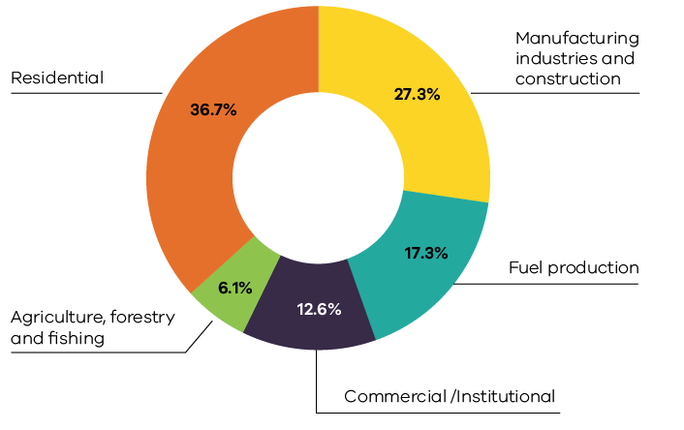
Figure 17. Direct combustion emissions by activity sub-categories – Victoria, 2019
Source: Australian Greenhouse Emissions Information System (DISER 2021b)
Natural gas is the major fuel used for direct combustion in Victoria, representing 61% of the total fuels used in 2019. In that year, Victoria consumed a total of 236 petajoules (PJ) of natural gas in direct combustion activities, with the highest consumption in the residential (47%), manufacturing (24%) and commercial (16%) activity sub-categories (DISER 2020a).
Other fuels contributing to direct combustion include on-site use of diesel, liquified petroleum gas (LPG) and various petroleum-based oils.

Emissions trends and drivers
Direct combustion accounted for 19.1% of Victoria’s total net emissions in 2019 – the third largest share of total net emissions behind electricity generation and transport. Direct combustion emissions grew from 15.3 Mt CO₂-e in 1990 to 17.5 Mt CO₂-e in 2019, with interannual variability in emissions for the sub-sector as a whole (Figure 18) and its activity sub-categories (Figures 19 and 20).
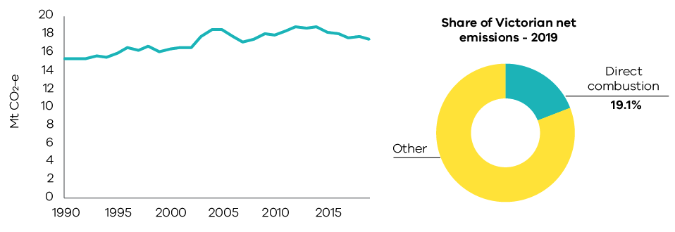
Figure 18. Emissions from direct combustion – Victoria, 1990 to 2019
Source: Australian Greenhouse Emissions Information System (DISER 2021b)
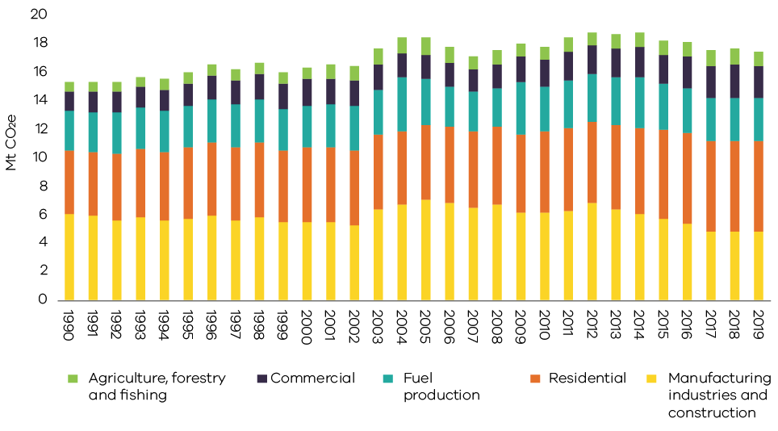
Figure 19. Emissions by direct combustion sub-categories – Victoria, 1990 to 2019
Source: Australian Greenhouse Emissions Information System (DISER 2021b)
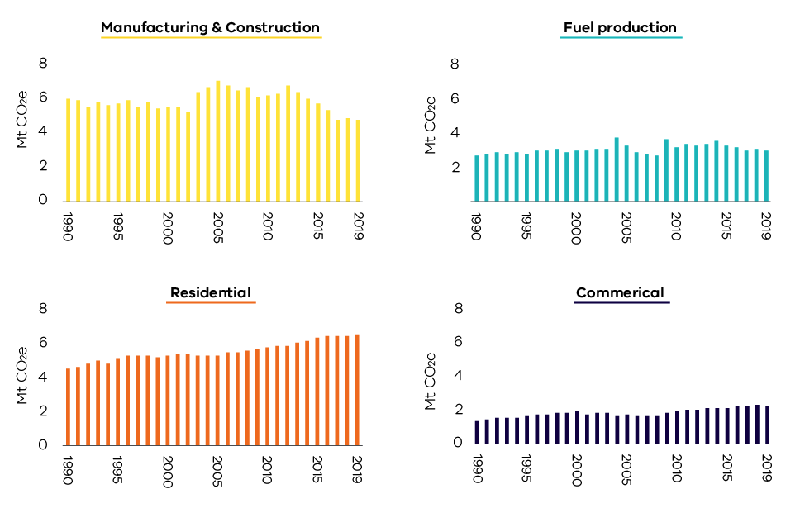
Figure 20. Trends in emissions in the four major direct combustion sub-categories – Victoria, 1990 to 2019
Source: Australian Greenhouse Emissions Information System (DISER 2021b)
Factors explaining the trends presented in Figures 18 to 20 include:
- Growth in population and economic activity in Victoria contributed to direct combustion emissions being higher in 2019 than 1990.
- Interannual variability in emissions was associated with variability in the rate of economic growth and seasonal variations in demand for residential heating (i.e. colder versus milder winters over the 20-year period).
- Direct combustion emissions from manufacturing and construction generally declined between 1990 and 2002 before increasing sharply in 2003 due to growth in the output of metal and mineral production and food processing. Following a peak in 2005, emissions from this sub-category reduced in line with the overall decline in manufacturing activity in the state.
- Victoria’s total annual consumption of natural gas was relatively stable after 2012, with declining industrial gas use offsetting increasing residential gas consumption in winter. The residential sub-category surpassed manufacturing as the major user of gas in Victoria in 2006 (DISER 2020a). Figure 21 shows that the increase in residential gas consumption was driven largely by population growth.
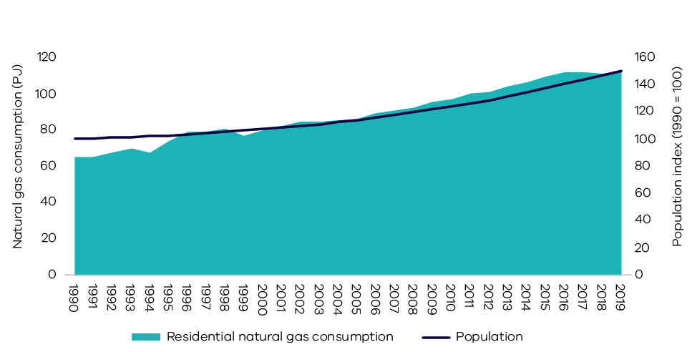
Figure 21. Trends in residential natural gas consumption and population – Victoria, 1990 to 2019
Source: Australian Energy Statistics, Table F (DISER 2020a) and Australian Demographic Statistics (ABS 2021a)

Transport

Sources of emissions
Emissions from transport arise from the combustion of fuels such as petrol, diesel and LPG in passenger and commercial motor vehicles, railways, domestic aviation and navigation (i.e. shipping).
Emissions from electricity used to power public transport (i.e. metropolitan trains and trams) and to drive electric vehicles are not included as they are accounted for in electricity generation.

Transport in Victoria
Figure 22 shows that road transportation was responsible for the vast majority (87.5%) of emissions from this sub-sector in 2019, with the major contributors being cars (49.4%), heavy-duty trucks and buses (20.5%) and light commercial vehicles (16.7%).
In 2019, the transport sub-sector consumed 337 petajoules (PJ) of energy, with the main fuels being petrol (45%), diesel (42%), domestic aviation fuel (7%) and LPG (3%) (DISER 2020a).
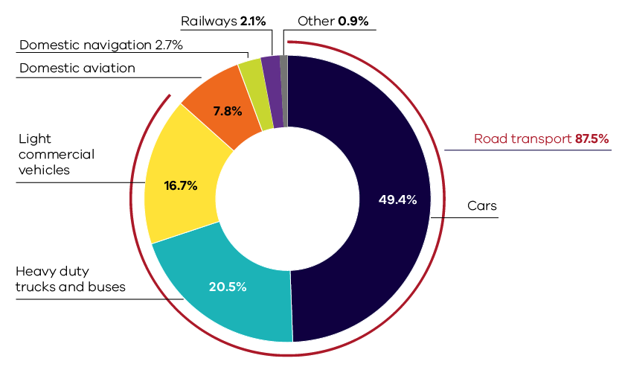
Figure 22. Transport emissions by sub-categories – Victoria, 2019
Source: Australian Greenhouse Emissions Information System (DISER 2021b)
Despite an increase in public transport use (heavy and light rail and buses) since 1990, cars remain the dominant mode of transport in Melbourne (Figure 23).
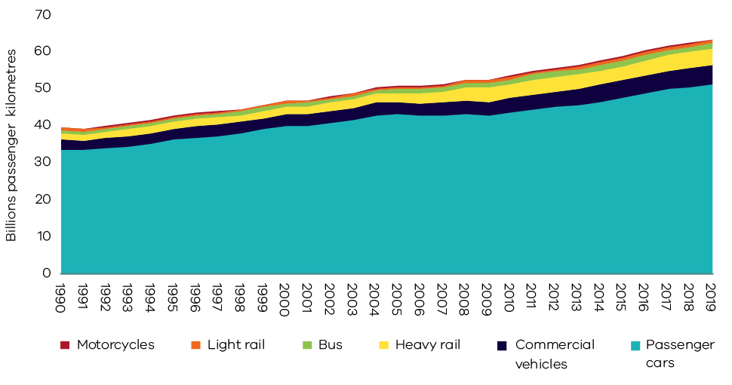
Figure 23. Total passenger kilometres travelled – Melbourne, 1990 to 2019
Source: Australian Infrastructure Statistics (BITRE 2020)

Emissions trends and drivers
Transport emissions grew by 6.8 Mt CO₂-e (42.6%) between 1990 and 2019 – the largest growth in emissions from any sector/sub-sector over this period (Figure 24). Transport contributed 24.8% of Victoria’s net emissions in 2019 – the second largest share behind electricity generation.
Trends in emissions by transport activity sub-category are presented in Figure 25, with further detail on the four major sub-categories presented in Figure 26.
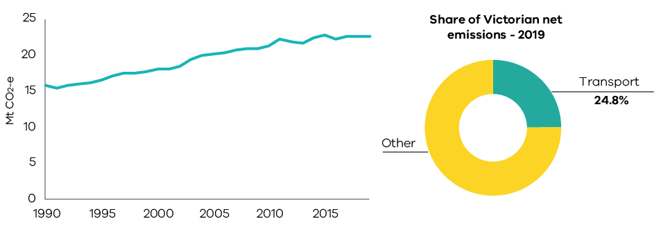
Figure 24. Emissions from transport – Victoria, 1990 to 2019
Source: Australian Greenhouse Emissions Information System (DISER 2021b)

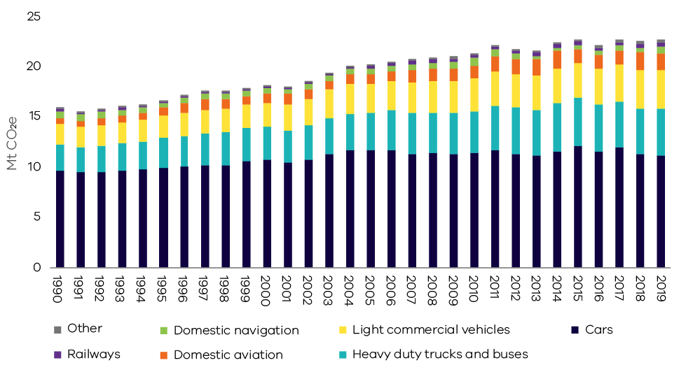
Figure 25. Emissions by transport sub-categories – Victoria, 1990 to 2019
Source: Australian Greenhouse Emissions Information System (DISER 2021b)
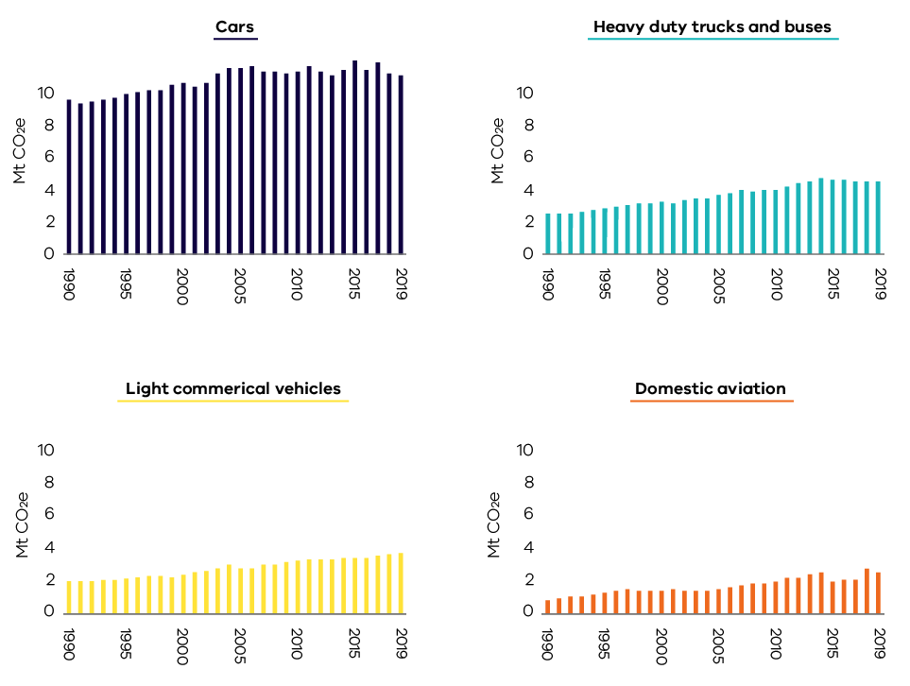
Figure 26. Trends in emissions from the four major transport sub-categories – Victoria, 1990 to 2019
Source: Australian Greenhouse Emissions Information System (DISER 2021b)
Factors explaining the trends presented in Figures 24 to 26 include:
- Emissions from cars increased by 15.9% between 1990 and 2019 due to strong population growth which led to increased passenger vehicle registrations and total passenger vehicle kilometres travelled (see Figure 27).
- Strong economic growth between 1990 and 2019 led to large increases in emissions from heavy and light commercial vehicles of 77.3% and 84.4% respectively (see Figure 28).
- From 2015 to 2019, the number of diesel-fuelled vehicles increased by 42% while the number of petrol vehicles grew by only 5%. The increase in diesel vehicles was associated with both the growth in freight transport and a shift in consumer preferences toward diesel passenger cars.
- Between 2002 and 2019, the average emissions intensity of new passenger and light commercial vehicles sold in Australia reduced from 252.4 g CO2 per km to 180.5 g CO2 per km (NTC 2020). However, improvements in vehicle emissions efficiency were partially offset by increasing consumer preferences for larger vehicles, particularly sports utility vehicles (SUVs) (BITRE 2021a and NTC 2020).
- The domestic aviation sub-category experienced the largest growth, with emissions increasing by 254.8% between 1990 and 2019 – in 2019 it contributed 7.8% of transport emissions. This reflects growth in business- and tourism-related air travel, with the number of domestic passengers at Melbourne Airport increasing from 4.8 million in 1990 to 25.7 million in 2019 (BITRE 2021b).
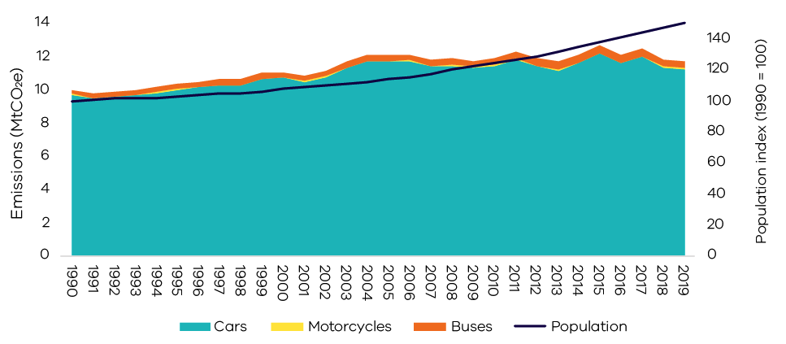
Figure 27. Trends in passenger motor vehicle emissions and population – Victoria, 1990 to 2019
Source: Analysis based on Australian Greenhouse Emissions Information System (DISER 2021b) and Australian Bureau of Statistics (ABS 2021a)
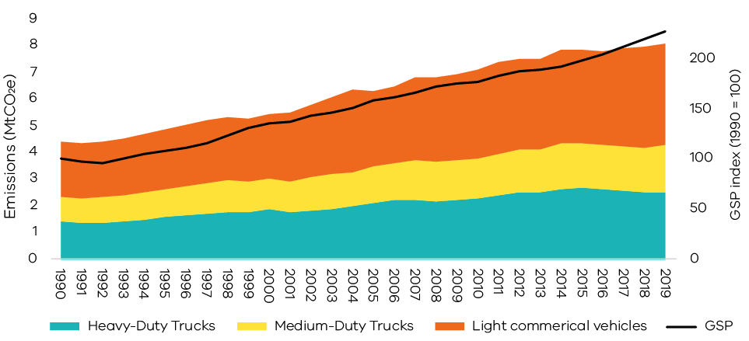
Figure 28. Trends in freight vehicle emissions and GSP – Victoria, 1990 to 2019
Source: Analysis based on Australian Greenhouse Emissions Information System (DISER 2021b) and Australian Bureau of Statistics (ABS 2021b)

Fugitive emissions from fuels

Sources of emissions
Fugitive emissions result from leaks or the venting and flaring of gases during the exploration, extraction, production, processing, storage, transmission and distribution of fossil fuels including coal, oil and natural gas. Emissions from decommissioned coal mines are also included.
Fugitive emissions do not include emissions from the combustion of fuels in activities such as electricity generation, the operation of mining plants and equipment or the transportation of fossil fuels by road, rail or sea. These are accounted for in the electricity generation, direct combustion and transport sub-sectors.

Fugitive emissions from fuels in Victoria
55.3% of fugitive emissions in Victoria arise from leakages during the exploration, production, transmission, storage and distribution of natural gas.
Most of the remaining fugitive emissions are associated with flaring and venting as part of oil and natural gas production and processing, with some additional emissions also arising from leakage during the exploration, production, storage and distribution of oil and flaring in Victoria’s petroleum industry which is concentrated in the offshore regions of the Otway and Gippsland basins.
A small contribution to Victoria’s total fugitive emissions (less than 1%) arises from the extraction of solid fuels, particularly from brown coal mines.
A description of the key Victorian petroleum and gas infrastructure associated with these emissions is provided in Box 2.
Box 2: Victoria’s petroleum and gas production and transmission infrastructure
Crude oil and gas are transported via pipeline from offshore facilities to stabilisation and gas processing plants where they are separated into wet gas, LPG and stabilised crude oil for distribution within Victoria, interstate or internationally. Stabilised crude oil is processed at refineries in Altona and Geelong into a range of refined petroleum products such as petrol, diesel, jet fuel, bitumen and solvents.
Natural gas is transmitted in Victoria through the Principal Transmission System (PTS) – a 2,000 km pipe network covering Melbourne and central Victoria. The system also utilises storage facilities to help meet demand peaks.
Victoria’s fugitive emissions (3.0 Mt CO₂-e) are significantly lower than those of New South Wales (12.7 Mt CO₂-e), Western Australia (12.8 Mt CO₂-e) and Queensland (18.2 Mt CO₂-e) due to the greater volumes and types of coal and natural gas production in those states.

Emissions trends and drivers
Victoria’s fugitive emissions rose from 4.0 Mt CO₂-e in 1990 to a peak of 4.1 Mt in 1995. Emissions then declined to a low of 2.0 Mt CO₂-e in 2015 before increasing again – with interannual variability – to reach 3.0 Mt CO₂-e in 2019 (Figure 29). In 2019 the sub-sector accounted for 3.3% of Victoria’s total net emissions.
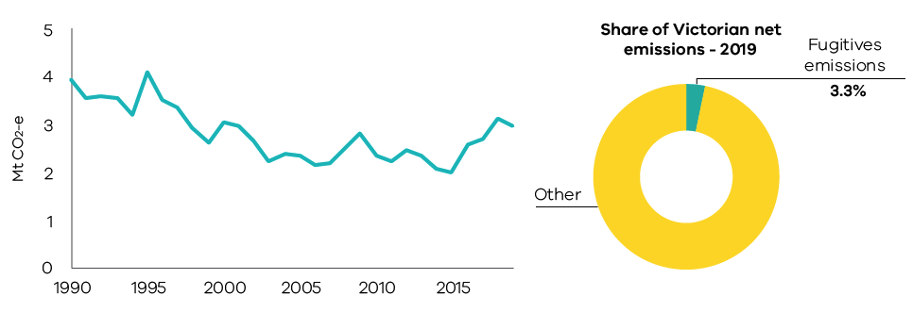
Figure 29. Emissions from fugitives – Victoria, 1990 to 2019
Source: Australian Greenhouse Emissions Information System (DISER 2021b)
Factors explaining the trends presented in Figure 29 include:
- Crude oil production in Victoria fell by 91% between 1990 and 2019 (DISER 2020b).
- The annual volume of natural gas consumption varied significantly between 1990 (259 PJ) and 2019 (284 PJ), with the highest rate of consumption being 291 PJ in 2018 (DISER 2020a). Key factors influencing this interannual variability included seasonal variation in the demand for gas for heating and variation in annual levels of GPG to help meet electricity demand. The level of fugitive emissions associated with natural gas consumption has moderated over time due to improvements in transmission, storage and distribution resulting in reduced natural gas leakages.
- Natural gas production was generally stable between 1990 and 2002, after which production increased significantly – in 2019, production levels were 213% higher than in 1990 (DISER 2020b). Increased emissions from flaring during oil and gas production and processing contributed to increased fugitive emissions after 2016.

Industrial processes and product use (IPPU)

Sources of emissions
Industrial processes include emissions generated from a range of production processes involving, for example:
- the use of carbonates (e.g. limestone, dolomite, magnesite, etc.);
- carbon when used as a chemical reductant (e.g. iron and steel or aluminium production); and
- chemical industry processes (e.g. ammonia and nitric acid production).
Product use includes emissions associated with the use of synthetic gases such as:
- hydrofluorocarbons (HFCs) in refrigeration and air conditioning, foam blowing, fire extinguishers, aerosols/metered dose inhalers and solvents;
- sulphur hexafluoride (SF6) in electrical equipment; and
- perfluorocarbons (PFCs) arising from primary aluminium production process.
Emissions associated with the consumption of electricity or combustion of fuels in industrial production are accounted for in the electricity generation and direct combustion sub-sectors.

IPPU emissions in Victoria
In 2019, 77.1% of Victoria’s IPPU emissions resulted from the use of synthetic greenhouse gases (mainly HFCs) for refrigeration and air conditioning in commercial, residential and transport activities.
The remaining 22.9% of IPPU emissions resulted from processes in activities such as metals and chemicals production.

Emissions trends and drivers
Victoria’s IPPU emissions fell between 1990 and 1995, before rising through to 2019 with some interannual variability. In 2019 the sector accounted for 3.7% of Victoria’s total net emissions (Figure 30).
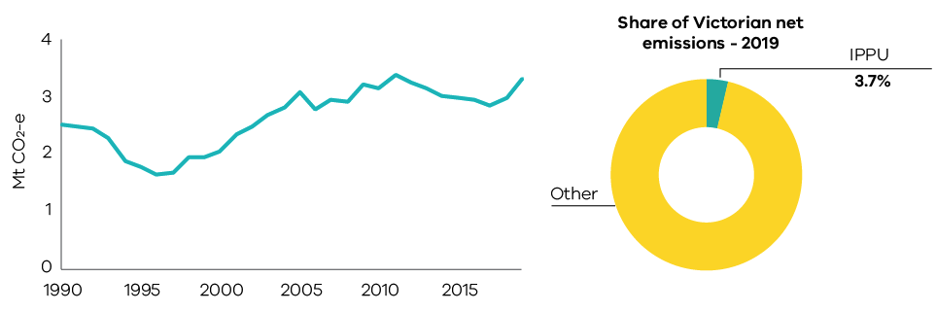
Figure 30. Emissions from industrial processes and product use (IPPU) – Victoria, 1990 to 2019
Source: Australian Greenhouse Emissions Information System (DISER 2021b)
Increasing use of HFCs was a major driver of growth in IPPU emissions after the mid-1990s (see Figure 31). A phase out of ozone depleting hydrochlorofluorocarbons (HCFCs) commenced in the mid-1990s, with HFCs being introduced in 1994 as the primary substitute for HCFCs. The phase out was largely completed by 2018. HFCs themselves are now subject to a phase out with their replacement by alternative substances with lower climate impacts (Brodribb and McCann 2020). Both phase outs are driven by the Montreal Protocol on Substances that Deplete the Ozone Layer.
Population growth and associated demand for services provided by equipment and appliances that use HFCs fuelled growth in emissions. Between 1990 and 2019, Victoria’s population grew by 51% and IPPU emissions increased by 32.5%.
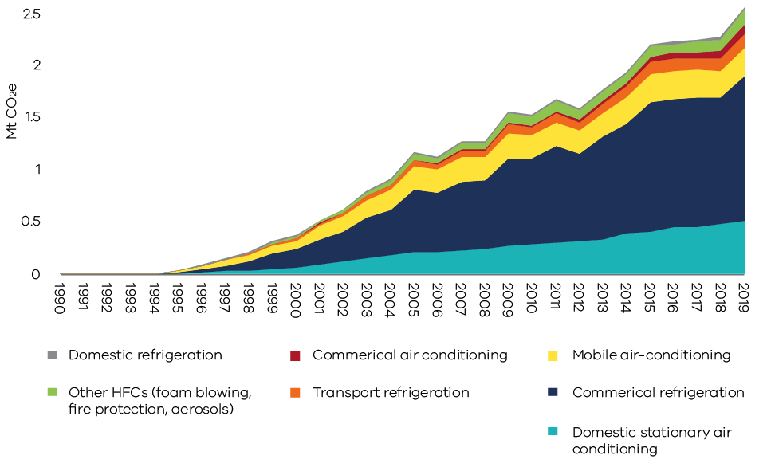
Figure 31. Emissions from HFC use by activity – Victoria, 1990 to 2019
Source: Australian Greenhouse Emissions Information System (DISER 2021b)
The growth in emissions associated with HFC use offset a reduction in other IPPU emissions associated with a decline in industrial activity in Victoria. Emissions from the chemicals industry dropped substantially after 1995 due to the closure of several chemical production facilities in Victoria. A reduction in economic growth in the early 1990s is also likely to have contributed to the fall in IPPU emissions between 1990 and 1995.
Emissions from the minerals industry declined in 2014 and beyond due to the closure of facilities producing clinker and lime.

Waste

Sources of emissions
Emissions from the waste sector arise from the decomposition of organic waste in landfills and from the direct release of greenhouse gases during wastewater treatment. Emissions include:
- methane – which results from the anaerobic decomposition of organic matter from solid waste in landfills and wastewater treatment plants; and
- nitrous oxide – which results from the nitrification and denitrification of urea and ammonia in wastewater treatment plants.
Carbon dioxide (CO₂) emissions from the combustion of methane captured from landfills and wastewater treatment plants, and the combustion of biomass for electricity generation, are reported in the energy sector. Emissions associated with energy used for managing and transporting waste are accounted for in the electricity generation, direct combustion and transport sub-sectors.
CO₂ emissions from carbon stock transfers of harvested wood products (e.g. paper, wood) to landfill are reported in the LULUCF sector. However, methane emissions from the decomposition of wood and paper in landfill are reported in the waste sector.

Waste emissions in Victoria
The main sources of waste sector emissions are the disposal of solid waste to landfill (66.2% of total waste sector emissions) and the treatment of domestic, commercial and industrial wastewater (30.6%). Most landfills in Victoria operate in accordance with best practice in greenhouse gas management, such as capturing and combusting landfill gas. This significantly reduces greenhouse gas emissions from this sector.

Emissions trends and drivers
Victoria’s waste sector emissions declined between 1990 and 2013 before increasing through to 2017 and declining again in 2018. In 2019, the waste sector was responsible for 3.1% of Victoria’s total net emissions – emissions from the sector in 2019 were 2.8 Mt CO₂-e, significantly below the 6.0 Mt CO₂-e emitted in 1990 (Figure 32).
Figures 33 and 34 present trends in emissions from waste sector sub-categories – solid waste disposal; wastewater treatment and discharge; biological treatment of solid waste; and incineration and open burning of waste.
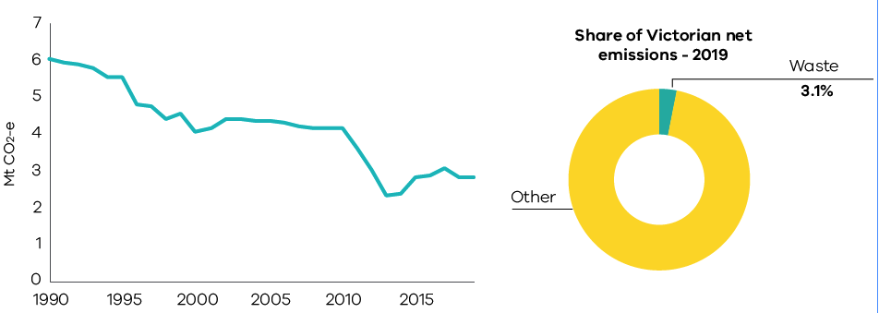
Figure 32. Emissions from waste – Victoria, 1990 to 2019
Source: Australian Greenhouse Emissions Information System (DISER 2021b)
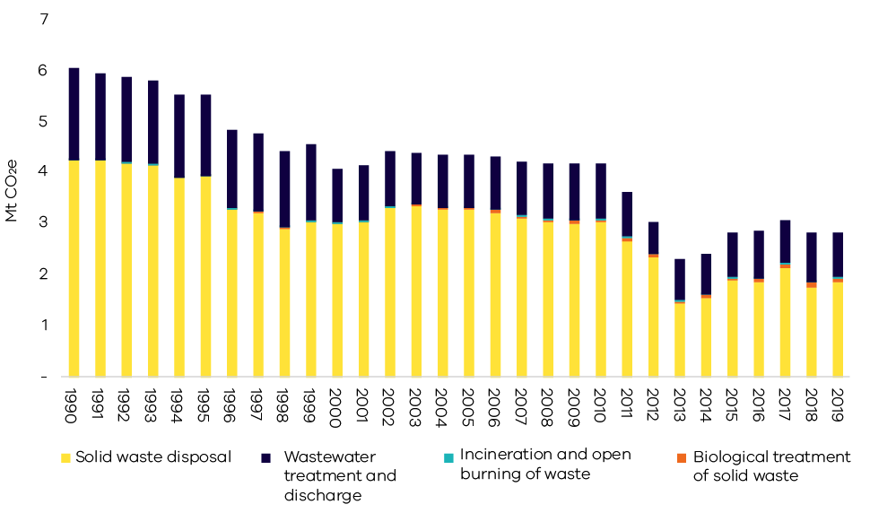
Figure 33. Emissions by waste sector sub-categories - Victoria, 1990 to 2019
Source: Australian Greenhouse Emissions Information System (DISER 2021b)
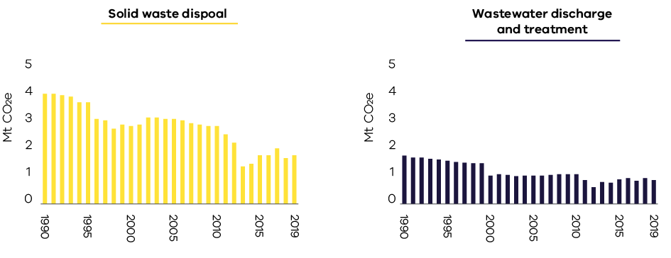
Figure 34. Trends in emissions by the major waste sub-categories – Victoria, 1990 to 2019
Source: Australian Greenhouse Emissions Information System (DISER 2021b)
Factors explaining the trends in Figures 33 to 34 include:
- Emissions associated with management of solid waste fell by 55.9% between 1990 and 2019 despite increased volumes of solid waste driven by population growth. This was due to increased landfill gas capture and combustion; improved landfill management practices reducing methane leakage; greater levels of materials recycling; and increased diversion of organics from the waste stream to composting and electricity generation.
- Emissions from wastewater decreased by 51.1% between 1990 and 2019. These decreases were due to more efficient wastewater treatment processes and increased methane capture from wastewater treatment plants. Factors influencing interannual variability in wastewater emissions include changing volumes of wastewater discharged by large industry and changes in the operational management and efficiencies of wastewater treatment plants.

Agriculture

Sources of emissions
Agriculture sector emissions result from:
- enteric fermentation – this is part of the digestive processes of ruminants (eg. cattle, sheep) through which microbes decompose and ferment food in the animals’ digestive tract or rumen and which produces methane emissions;
- manure management – emissions result from the anaerobic decomposition of organic matter contained in manure;
- the release of nitrous oxide from cropping and pasture land – emissions result from processes in the soil following the application of fertilisers, crop residues and animal waste; and
- emissions from burning agricultural residues.
Emissions associated with the use of electricity, fuel consumption to operate equipment and transport are accounted for in the energy sector. Carbon sequestration associated with tree planting and vegetation or agroforestry activities are accounted for in the land use, land use change and forestry sector.

Agriculture emissions in Victoria
Livestock enteric fermentation was the main source of agriculture sector emissions in Victoria in 2019 (69.7%), followed by the release of nitrous oxide from cropping and pastures (16.7%).
A description of the Victorian agricultural sector by farm type and commodities is presented in Box 3.
Box 3: Overview of Victoria’s agricultural sector
Agriculture occupies around 50% of Victoria’s land mass (Agriculture Victoria 2021). The most prevalent land use by area is livestock grazing which occupies 54% of the total agriculture land. In 2018-19 there were 21,900 farms in Victoria, representing 24% of all farm businesses in Australia. Of these, the majority of farm businesses produce beef (9,600 farms), sheep meat/wool (8,200), grains (5,900), and dairy (3,700) – with some farms producing multiple commodities (ABS 2020a).
The most important commodities in Victoria based on the gross value of agricultural production were horticulture for human consumption – which includes fruit, nuts, vegetables and grapes (table and wine) – followed by milk, beef, sheep meat and wool (ABS 2020b).
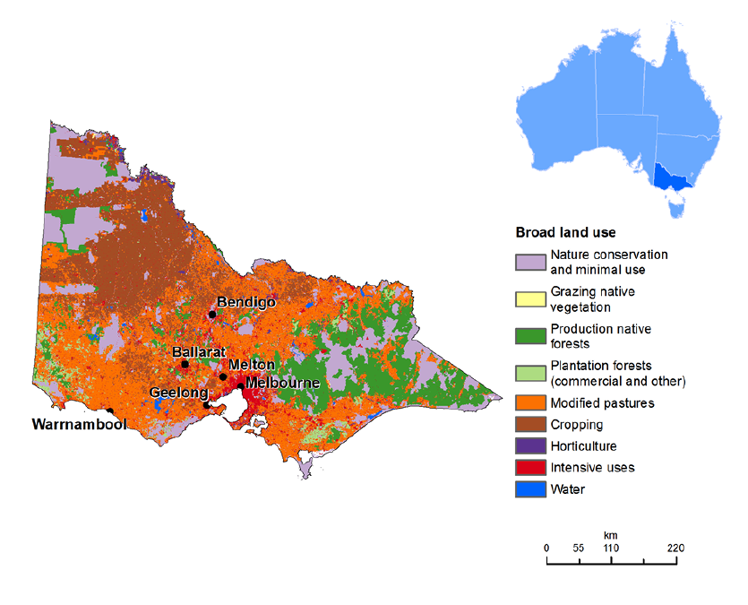
Source: Australian Bureau of Agricultural and Resource Economics (ABARES 2021)

Emissions trends and drivers
Victoria’s agriculture emissions fluctuated significantly between 1990 and 2019. The sector accounted for 17.1% of Victoria’s net emissions in 2019 – the fourth largest share of total emissions behind electricity generation, transport and direct combustion (Figure 35).
Figure 36 presents the trend in agriculture emissions by activity sub-categories.
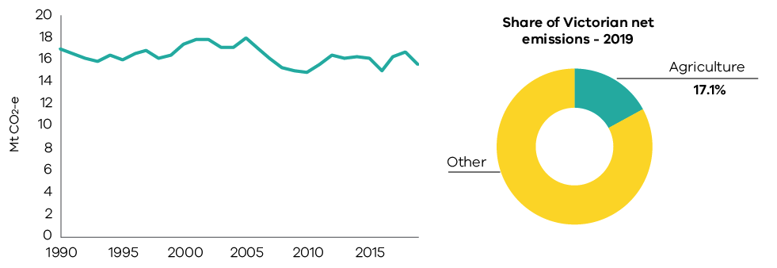
Figure 35. Emissions from agriculture – Victoria, 1990 to 2019
Source: Australian Greenhouse Emissions Information System (DISER 2021b)
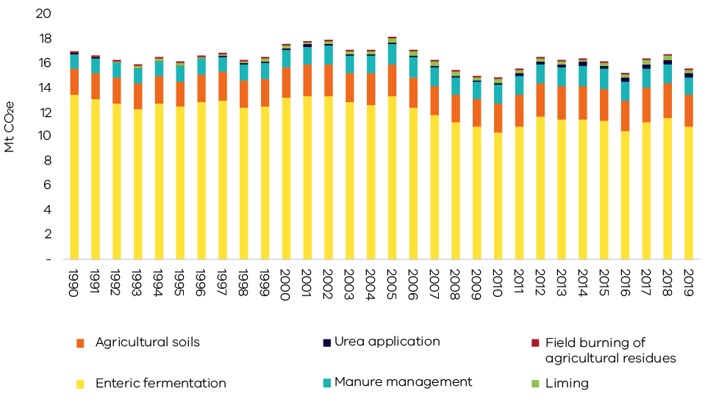
Figure 36. Emissions by agriculture sector sub-category – Victoria, 1990 to 2019
Source: Australian Greenhouse Emissions Information System (DISER 2021b)
Figure 37 presents trends in the four sub-categories with the greatest contributions to emissions from agriculture.
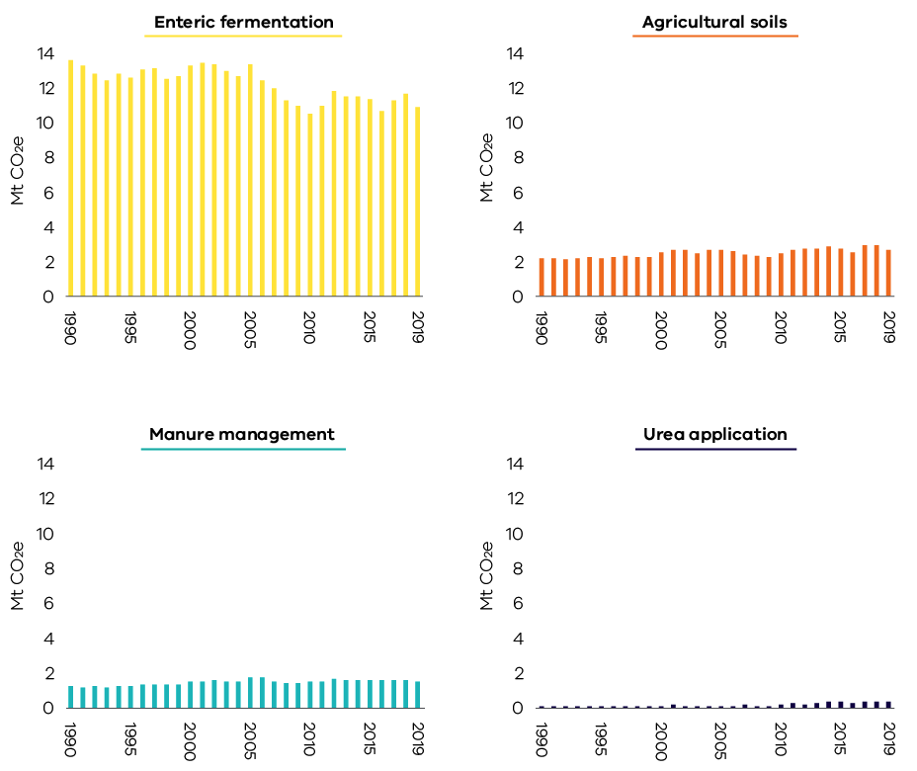
Figure 37. Trends in emissions for the four major agriculture sub-categories – Victoria, 1990 to 2019
Source: Australian Greenhouse Emissions Information System (DISER 2021b)
Factors explaining the trends presented in Figures 36 to 37 include:
- The interannual variation in total agriculture emissions was driven mainly by seasonal conditions and by domestic food demand and exports.
- Emissions from sheep grazing fell by 53.2% between 1990 and 2019 which is reflected in the overall decline in enteric fermentation emissions (Figure 37). This was due primarily to the overall decline in sheep numbers over this period (Figure 38) due to falling wool prices. Victoria’s sheep population fluctuated during both drought and non-drought conditions.
- Emissions from cattle were 9.8% higher in 2019 compared with 1990 – however, interannual fluctuations occurred throughout the period reflecting variation in cattle numbers. Victoria’s cattle population was particularly influenced by the millennium drought that affected Victoria from 1997 to 2009. Cattle numbers initially remained steady, then declined rapidly towards the end of the drought in the late 2000s. Numbers increased with the return to more favourable conditions in 2010 and 2011 (Figure 38).
- Despite the decline in the sheep population since 1990, there were nearly four times as many sheep as cattle in Victoria in 2019 (Figure 38). Nonetheless, cattle emissions were just over three times higher than sheep emissions in 2019 due to the higher emissions intensity of cattle compared with sheep.
- Emissions from agricultural soils increased (with interannual variability) between 1990 and 2019. This increase resulted from an increase in the total area of crop cultivation – particularly for wheat, barley and canola – and associated increases in the application of nitrogen fertilisers, crop residue and animal wastes. The total area of crop cultivation grew from 1.8 to 3.4 million hectares (87%) between 1990 and 2019, while the application of fertilisers increased from 50,000 to 283,000 tonnes of nitrogen (an increase of 470%) over this period (DISER 2021b).
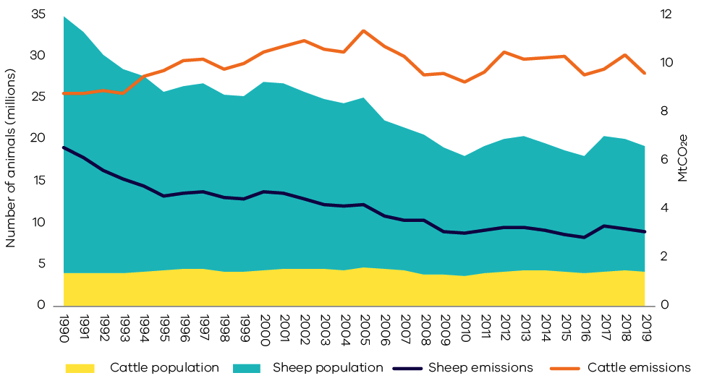
Figure 38. Sheep and cattle populations and emissions – Victoria, 1990 to 2019
Source: Analysis based on Australian Greenhouse Emissions Information System (DISER 2021b)
Note – Figure 38 includes all the mechanisms that give rise to emissions from livestock, including enteric fermentation, manure management, urine and faeces on grazing land and atmospheric deposition of nitrous oxide

Land Use, Land-Use Change and Forestry (LULUCF)

Sources of emissions
The land use, land-use change and forestry (LULUCF) sector includes emissions and the removal (sequestration) of greenhouse gases resulting from direct human-induced land use, land-use change and forestry activities. This includes emissions and removals from the clearance of forested land and conversion to other land uses; from new forests planted on previously unforested land; and from other practices that change emissions and removals (forest management, cropland management and grazing land management).
Fossil fuel combustion associated with forestry and land management activities – such as diesel used in logging machinery – is accounted for in the direct combustion sub-sector. Emissions from burning agricultural residues, and non-CO₂ emissions associated with land use such as the application of fertilisers, are accounted for in the agriculture sector.

Emissions in Victoria
The main sources of Victoria’s LULUCF emissions and removals are forest lands, specifically from land classified as:
- Forest land remaining forest land – comprising changes in the native forest estate and harvesting from that estate and pre-1990 plantations.
- Land converted to forest land – comprising plantations established since 1990 and regeneration of previously cleared land.
- Grassland remaining grassland – includes all areas of grassland not reported under land converted to grassland, comprising grasslands and shrublands (woody areas that do not meet the definition of forest).
- Forest land converted to cropland, grassland, wetlands and settlements – comprising primary and secondary clearing of forest land since 1972 to enable a change in land use and changes in soil carbon and other emissions resulting from land use change.

Emissions trends and drivers
Victoria’s LULUCF emissions fluctuated significantly between 1990 and 2019 (Figure 39). LULUCF was a net sink (sequestration exceeded emissions) from 1996 to 2006 and from 2013 to 2019, and a net source of emissions (emissions exceeded sequestration) from 1990 to 1995 and from 2007 to 2012. Over the period 1990 to 2019, LULUCF provided a cumulative net sink of approximately -80.4 Mt CO₂-e. In 2019, in net terms, the LULUCF sector sequestered 17.4 Mt CO₂-e of emissions, equivalent to 19.1% of total Victorian emissions.
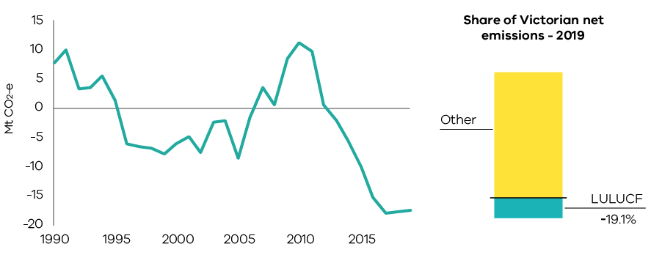
Figure 39. LULUCF net emissions – Victoria, 1990 to 2019
Source: Australian Greenhouse Emissions Information System (DISER 2021b)
Figure 40 summarises net emissions across all LULUCF sub-categories; with further details for individual sub-categories presented in Figures 41 to 44.
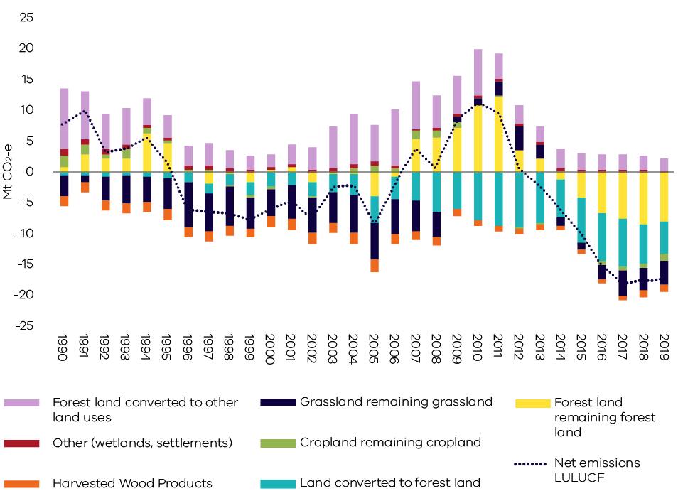
Figure 40. Emissions from LULUCF sub-categories – Victoria, 1990 to 2019
Source: Analysis based on Australian Greenhouse Emissions Information System (DISER 2021b) and LULUCF data by subcategory provided by DISER (DISER 2021c)

a. Forest land remaining forest land
This sub-category includes emissions/removals derived from modelled changes in carbon pools in:
- harvested native forests;
- other native forests; and
- plantations established before 1990.
Figure 41 shows net emissions from forest land remaining forest land resulting from activities such as wildfire and prescribed burning; and other sources of emissions including changes in living biomass, dead organic matter and soil carbon in harvested native forest and other native and pre-1990 plantation forests. The years where wildfire and prescribed burning are net emissions sinks (e.g. 2015 to 2019) indicates that carbon removed through vegetation regrowth after fires outweighed carbon released during fires in those years.
Forest land remaining forest land was a net sink of 8.1 Mt CO₂-e in 2019. Net emissions varied between 1990 and 2019 – it was a net sink from 1997 to 1999, 2002 to 2006 and from 2014 to 2019; but a net source of emissions from 1990 to 1996, 2000 to 2001 and 2007 to 2013.
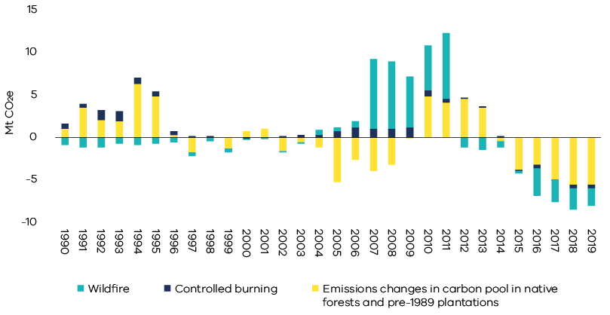
Figure 41. Net emissions from fire (wildfire and controlled burning) and other sources – Victoria, 1990 to 2019
Source: Analysis based on Australian Greenhouse Emissions Information System (DISER 2021b) and LULUCF data by subcategory provided by DISER (DISER 2021c)
Note – non-anthropogenic natural disturbances – including some but not all wildfires – are reported as a long run trend in emissions, reflecting the balance of carbon lost and later re-absorbed by future regrowth. This approach is in accordance with the ‘natural disturbance’ provision of IPCC accounting rules and leaves anthropogenic emissions and removals as the main drivers.

b. Land converted to forest land
- This sub-category includes net emissions/removals from:
- for-harvest plantations established since 1990, which are mainly hardwood;
- environmental plantings established since 1990;
- regrowth of forest on land cleared for cropping or grazing; and
- regeneration of areas cleared of forest since 1972 from natural seed stocks. This may be a combination of regeneration for environmental purposes on protected land or on land that is maintained by the landowner. Regeneration on land cleared prior to 1990 is also captured in this sub-category.
Land converted to forest land was a net sink of 5.2 Mt CO₂-e in 2019. As shown in Figure 42, removals by this sub-category increased in scale from 1990 to a peak in 2012 before declining slightly – it nonetheless remained a substantial net sink from 2013 to 2019.
A key driver of sequestration in this sub-category was plantations. The area of hardwood plantations expanded rapidly in response to the Commonwealth Government’s Managed Investment Act 1998 which increased the finance available for plantation establishment. The Managed Investment Act was repealed in 2016 and the rate of plantation establishment in Victoria has been close to zero since 2013. The scale of sequestration from plantations also declined after 2012 as short-rotation hardwood plantations were harvested.
Sequestration through regrowth on cleared land generally increased after 1990, and particularly so after 2012. Natural regeneration has been a small but material source of both emissions and removals between 1990 and 2019 – the years where natural regeneration was a net emissions source was due to the impacts of disturbances such as temporary forest dieback.
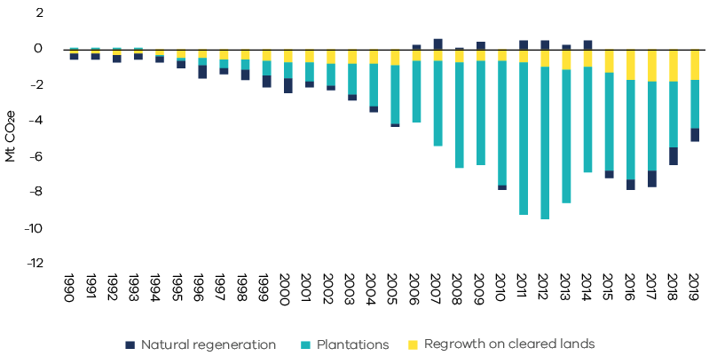
Figure 42. Net emissions from land converted to forest land – Victoria, 1990 to 2019
Source: Analysis based on Australian Greenhouse Emissions Information System (DISER 2021b) and LULUCF data by subcategory provided by DISER (DISER 2021c)

c. Grassland remaining grassland
In Victoria, grassland remaining grassland includes:
- herbaceous grassland (soil carbon);
- changes in sparse woody or shrubland extent (i.e. increases or losses of woody vegetation not categorised as forest); and
- biomass burning.
Changes in carbon stocks in this sub-category are largely driven by changes in land management practices (particularly from changes in pasture, grazing and fire management) and climate. These factors determine the amount of live biomass and dead organic matter, as well as the amount of residues, root and manure inputs to soil carbon.
Figure 43 shows that in 2019, grassland remaining grassland was a net sink of 4.0 Mt CO₂-e predominantly due to grassland soils (96.4%). Throughout 1990s and early 2000s, this sub-category provided a net sink, but became a net source of emissions between 2009 and 2013 before again providing a net sink from 2014 to 2019.
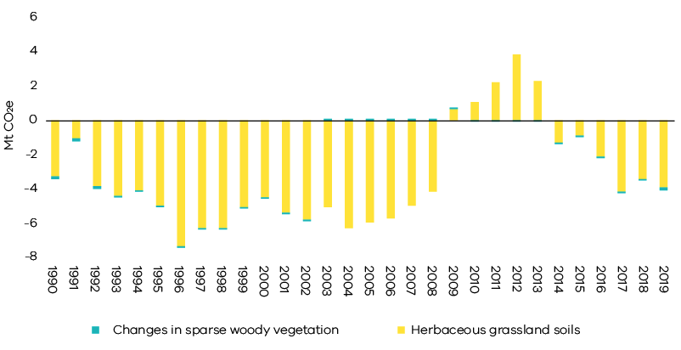
Figure 43. Net emissions from grassland remaining grassland – Victoria, 1990 to 2019
Source: Analysis based on Australian Greenhouse Emissions Information System (DISER 2021b)

d. Forest land converted to cropland, grassland, wetlands and settlements
This sub-category includes:
- emissions from the primary conversion of land that was forested in 1972;
- emissions from secondary or re-clearance of forest which has regrown on cleared land – where forest regrows on converted lands, the sequestration is included in the sub-category land converted to forest; and
- indirect emissions from loss of soil carbon and other emissions and removals associated with the new land use. Indirect emissions are highest in the two years after clearing and then decline. Non-CO₂ emissions associated with application of fertilisers and the management of crops are accounted for in the agriculture sector.
Figure 44 shows that emissions from forest land converted to other uses fluctuated significantly between 1990 and 2019. Emissions fell substantially from 1990 to 2000 before increasing on average between 2001 and 2010, then declining to relatively low levels over the period 2011 to 2019. Most of the fluctuation in emissions was due to primary forest clearing. Primary land clearing in Victoria is constrained by land clearing regulations introduced in the 1980s. Australia-wide, the area of both primary and secondary clearing is also influenced by changes in farmers’ terms of trade and weather conditions.
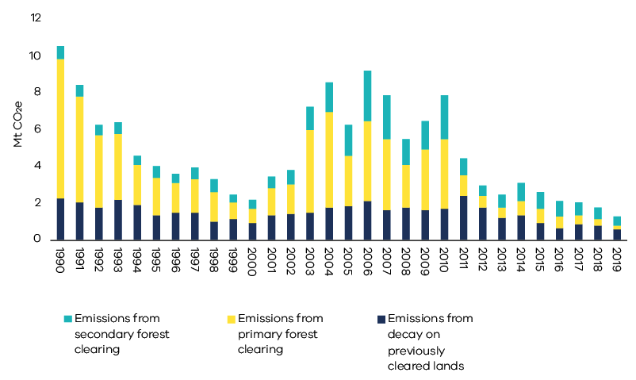
Figure 44. Sources of emissions and removals from forest land converted to cropland, grassland, wetlands and settlements – Victoria, 1990 to 2019
Source: Analysis based on Australian Greenhouse Emissions Information System (DISER 2021b) and LULUCF data by subcategory provided by DISER (DISER 2021c)

Uncertainty in LULUCF emissions estimates
Uncertainty is a characteristic of any estimation process. According to Australia’s National Greenhouse Gas Inventory 2019 (NGGI), the estimated uncertainties for total net emissions in 2019 emissions are:
- +/- 3.1% excluding net emissions from LULUCF; and
- +/- 4.2% when LULUCF is included.
The higher uncertainty associated with LULUCF is due to the complexity of biological processes, the measurement and data collection techniques and the challenges of representing biological processes in mathematical models.
It is not practicable to directly measure emissions and sequestration in the LULUCF sector. Instead, the Full Carbon Accounting Model (FullCAM) is used to estimate emissions and removals arising from changes in above and below ground biomass, dead organic matter, soil carbon and changes in land use and management techniques.
FullCAM uses data on climate, soils and land management practices, as well as land use changes observed from satellite imagery and is supplemented by additional data and models as appropriate.
The overarching approach to estimating net emissions in the LULUCF sector is continually reviewed by the DISER, with changes being made to both the assumptions in FullCAM as knowledge advances; and to data as improved information becomes available.
When changes are made, these are applied to the historical data series back to 1990. Appendix A describes the main methodological changes between the Victorian Greenhouse Gas Emissions Report 2018 and the current (2019) report and the impact they have had on LULUCF emissions data between 1990 and 2018.
Changes will continue to occur in future years as further improvements in estimation methods occur.
Updated historical LULUCF data
The LULUCF emissions presented in this report for the years 1990 to 2018 differ from those in the Victorian Greenhouse Gas Emissions Report 2018 due to improvements in data and emissions estimation methodologies. These include:
- Soil carbon – historical data has been revised due to improved modelling of soil carbon processes; improved information on factors such as the decomposition rate of carboniferous matter in soils; and a move to smooth data over 5 rather than 10 years in all relevant LULUCF categories other than grassland and agriculture for which no change was made; and
- Harvested native forests – historical data has been revised in light of more accurate spatial modelling of forests and improved historical harvesting data from VicForests that more accurately reflect tree characteristics (species and age) – a smoothing change is also applied to be consistent with the 5-year smoothing period for other non-forest soils.
Information on the recalculations involved is presented in Appendix A.

Emissions by economic sector – 2019
Chapter 2 presented emissions data based on sectors defined in accordance with IPCC guidelines. This chapter presents information on Victoria’s emissions by economic sector defined in accordance with the following Australian and New Zealand Standard Industry Classification (ANZSIC) divisions:
- electricity, gas, water and waste services
- manufacturing
- commercial services
- agriculture, forestry and fishing
- transport, postal and warehousing
- mining
- construction
- residential.

Direct (Scope 1) emissions by economic sector
Direct emissions (also known as Scope 1 emissions) result from an activity within an entity’s own operational boundary – for example:
- Direct emissions from manufacturing include emissions resulting from combustion of fuels, transport, waste management and greenhouse gas leakage from industrial processes directly related to manufacturing processes such as the production of food, paper, textiles and chemicals.
- Direct emissions from agriculture, forestry and fishing include emissions from activities such as the application of fertilisers, livestock management and the combustion of fuels. It also includes emissions and sequestration of CO₂ from forest and grassland management.
- Direct emissions from the residential sector include emissions from transport activities, the consumption of gas for heating and cooking and emissions associated with the use of waste and wastewater services.
Figure 45 shows that in 2019, the electricity, gas and water supply sector (53%) was responsible for the largest share of direct emissions, followed by the residential sector (22%), manufacturing (8%) and transport, postal and warehousing (7%).
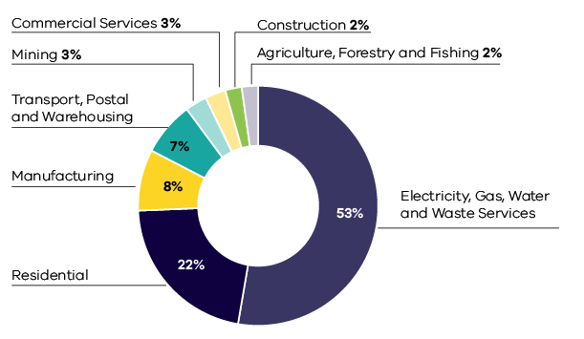
Figure 45. Share of Scope 1 emissions by economic sector – Victoria, 2019
Source: Australian Greenhouse Emissions Information System (DISER 2021b)

Allocation of Scope 2 emissions from electricity generation to end-users
In this section, emissions resulting from electricity generation are allocated to economic sectors according to the volume of electricity consumed by each sector. The emissions attributable to electricity consumption are referred to as indirect or Scope 2 emissions.
Information on sectoral responsibility for Scope 2 emissions enables a deeper understanding of the demand drivers responsible for electricity sector emissions.
Figure 46 shows that in 2019, commercial services (37%) was responsible for the largest share of Scope 2 emissions, followed by the residential (23%) and manufacturing (22%) sectors. The electricity, gas, water and waste services sector (14%) includes emissions associated with electricity consumed by this sector for its own use.
Note – unlike the emissions accounting reflected in Chapter 2 in which emissions from electricity generation are accounted for in the state or territory where generation takes place, the approach to allocating Scope 2 emissions to end-use economic sectors takes into account net imports and exports of electricity between jurisdictions through the National Electricity Market. Scope 2 emissions factors reflect data on electricity generation and emissions in each state or territory.
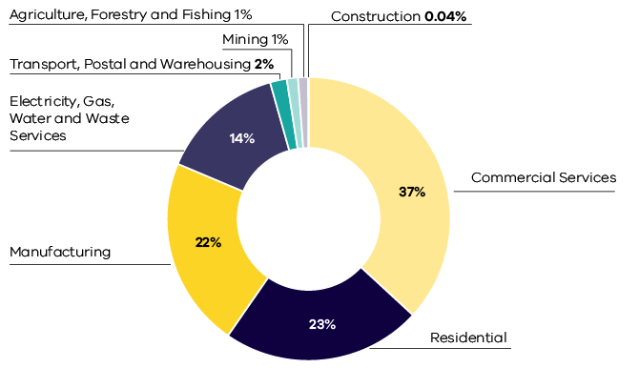
Figure 46. Share of Scope 2 emissions by economic sector – Victoria, 2019
Source: Australian Greenhouse Emissions Information System (DISER 2021b)

Scope 1 plus Scope 2 emissions by economic sector
This section combines the analysis in the previous two sections to allocate Scope 1 plus Scope 2 emissions to each economic sector.
Consistent with DISER’s approach to the National Greenhouse Gas Inventory, the electricity, gas, water and waste services sector is excluded from this allocation process to avoid double counting of Scope 1 emissions from electricity generation which are fully allocated to other sectors that consume the electricity.
Figure 47 shows that, in 2019, the residential sector was responsible for the largest share of Scope 1 plus Scope 2 emissions (29.2 Mt CO₂-e, 37%), followed by commercial services (17.8 Mt CO₂-e, 23%) and manufacturing (16.5 Mt CO₂-e, 21%).
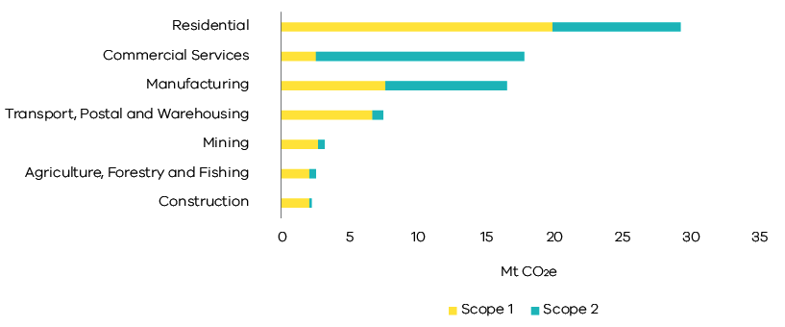
Figure 47. Scope 1 plus 2 emissions by economic sector – Victoria, 2019
Source: Australian Greenhouse Emissions Information System (DISER 2021b)

Appendix A

Revision of historical greenhouse gas emissions data
DISER reviews and, as necessary, revises national and state/territory greenhouse gas data annually to ensure the data is produced in a manner consistent with the latest international methodologies; and to reflect improved estimation methods and new sources of information as these become available. To maintain consistency of data series across time, when revisions occur, past emissions estimates are recalculated for all years in the historical record to 1990.
This review process has resulted in revised emissions data for Victoria for the years 1990 to 2018 – particularly for the LULUCF and IPPU sectors. Consequently, data for 1990 to 2018 in this year’s report differ from those presented in the Victorian Greenhouse Gas Emissions Report 2018.
A summary of these recalculations by sector, together with an explanation of the changes, is presented in section 10.1 of the National Inventory Report 2019 – Volume 2 (DISER 2021d).
The most significant points to note in relation to Victoria are:
- Soil carbon (LULUCF sector) – changes reflect:
  - New spatial modelling of Victoria’s forests that help better estimate the true quantity of soil carbon, both stored and released from soils.
  - Improved information on the decomposition rate of carboniferous matter in soils which shows that decomposition of soil carbon to carbon dioxide is slower than previously estimated resulting in lower estimated emissions.
  - Soil carbon emissions are averaged to smooth data variability. For previous inventories, a 10-year averaging period was used. This has been changed to a 5-year averaging period. In recent years, soil carbon emissions have been lower than earlier in the decade of the 2010’s – consequently, the move to a shorter averaging period means lower emissions being reported for 2019.
- Harvested native forests (LULUCF sector) – changes reflect the use of more accurate spatial modelling and integration of VicForests historical harvesting data which more accurately reflects tree characteristics (species and age) to better capture the relatively carbon dense nature of Victoria’s forests.
- HFCs refrigerants (IPPU sector) – changes reflect improved data on the rates of HFC leakage from equipment and appliances; and improved information on retirement rates of equipment and appliances. Improvements in data/information have resulted from the calibration of atmospheric data on HFC concentrations based on analysis and inverse modelling conducted by CSIRO on air samples collected at Cape Grim station to determine concentrations of greenhouse and ozone-depleting gases, as well as other air pollutants. Fluctuations in the atmospheric data were used to adjust the annual leakage rate to ensure the trend in atmospheric observations is reflected in the inventory. This has resulted in lower emissions estimates as atmospheric analysis suggests refrigeration and air conditioning units leak less greenhouse gases than previously assumed.
- Global warming potentials (GWP) are used to convert non-CO₂ greenhouse gases such as methane, nitrous oxide and HFCs to a common unit (known as CO₂ equivalent or CO₂-e) which shows the relative contribution of each gas to global warming. The GWP values have been updated to those published in the IPCC’s Fifth Assessment Report for a 100-year time horizon, reflecting emissions estimation rules agreed by parties to Paris Agreement. Overall, this has resulted in an increase in the level of CO₂-e emissions reported in Victoria’s emissions inventory. However, because the impact on reported emissions was similar in 2005 and 2019, there was minimal effect on the trend in emissions between these years.
Figure 48 shows the trend in Victoria’s total net emissions between 1990 and 2018 as presented in the Victorian Greenhouse Gas Emissions Report 2018 and the current (2019) report.
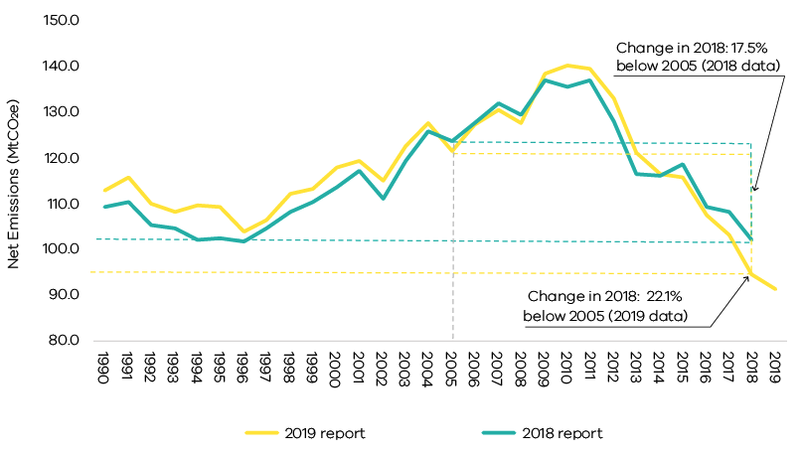
Figure 48. Change in trends in Victoria’s total net emission between 1990 and 2018 in the 2019 v 2018 emissions reports
Source: State and Territory Greenhouse Gas Inventories 2019 (DISER 2021e) and State and Territory Greenhouse Gas Inventories 2018 (DISER 2020c)
Table 3 focuses on impact of these changes in 2005 and 2018 – it shows that:
- total net emissions in 2005 has been revised from 123.8 Mt CO₂-e to 121.4 Mt CO₂-e (a reduction of 2.4 Mt CO₂-e); and
- total net emissions in 2018 has been revised from 102.2 Mt CO₂-e to 94.6 Mt CO₂-e (a reduction of 7.6 Mt CO₂-e).
As a consequence, the Victorian Greenhouse Gas Emissions Report 2019 shows Victoria’s total net emissions in 2018 were 22.1% below 2005 levels – the Victorian Greenhouse Gas Emissions Report 2018 showed the reduction between 2005 and 2018 as being 17.5%.

Table 3. Change in emissions by sector between 2005 and 2018 as reported in 2019 v 2018 Victorian Greenhouse Gas Emissions Reports
Sector/sub-sector | Change in emissions  (Mt CO₂e)
 | 2005 | 2018
Electricity generation | -0.03 | -0.01
Direct combustion | 0.03 | -0.02
Transport | -0.04 | -0.90
Fugitive emissions | -0.08 | -0.75
IPPU | -0.11 | -0.86
Agriculture | 1.26 | 1.00
LULUCF | -3.84 | -6.28
Waste | 0.44 | 0.23
Total | -2.37 | -7.58
Source: State and Territory Greenhouse Gas Inventories 2019 (DISER 2021e) and State and Territory Greenhouse Gas Inventories 2018 (DISER 2020c)
While there have been minor changes in historical data in most sectors and sub-sectors, the most significant change is in the LULUCF sector which has seen estimated net sequestration increase by 3.84 Mt CO₂-e in 2005 and 6.28 Mt CO₂-e in 2018 in the 2019 emissions report compared with the 2018 report.
Further detail on the changes in LULUCF data is presented in section A.1.

A.1 – Further detail on revisions to historical LULUCF data
Figure 49 shows the trend in LULUCF emissions between 1990 and 2018 as presented in the 2018 and 2019 reports.
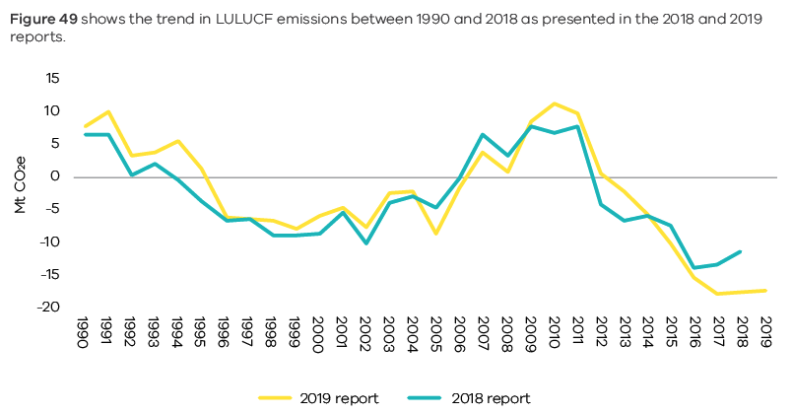
Figure 49. Change in trends in LULUCF emissions between 1990 and 2018 in the 2019 v 2018 emissions reports
Source: State and Territory Greenhouse Gas Inventories 2019 (DISER 2021e) and State and Territory Greenhouse Gas Inventories 2018 (DISER 2020c)

Changes by LULUCF sub-category
Figure 50 disaggregates the data in Figure 49 according to major LULUCF sub-categories:
- Forest land remaining forest land – changes in this sub-category contributed significantly to the revised trends in LULUCF data between 1990 and 2018. Key factors contributing to the changes include: updated spatial simulation of prescribed fires using FullCAM to include carbon stock changes from the combustion and subsequent recovery of live biomass from prescribed fires; updated spatial observations of forest cover change and revised weather and climate data using improved methodology for pre-1990 plantations; new data and a spatially-explicit methodology for harvested native forests; and changes reflecting the use of more accurate spatial modelling and integration of VicForests historical harvesting data which more accurately reflects tree characteristics (species and age) to better capture the relatively carbon dense nature of Victoria’s forests.
- Grassland remaining grassland – changes in this sub-category also contributed significantly to the revised trends in LULUCF data between 1990 and 2018. The changes result from a revision of land areas and land-use allocations across the LULUCF sectors; a periodic update to fire spatial data; soil cover factor improvements in timing and scope of events relating to agricultural plant cover; and updated resistant fractions for unimproved grasses.
- Land converted to forest land – changes in this sub-category had a minor impact on historical data between 1990 and 2000. After 2000, the changes were discernible but had less impact on LULUCF emissions than the previous two sub-categories. Factors that contributed to changes in historical emissions data for this sub-category include: updated spatial observations of forest cover change; improvements in understanding of the timing and scope of events determining agricultural plant cover; an update to agricultural parameters to ensure consistency with croplands/grassland remaining croplands/grassland; and a periodic update to fire spatial data.
- Cropland remaining cropland – changes in this sub-category had a minor impact on historical data between 2008 and 2018, but had a small yet discernible impact in the period prior to 2008. Changes reflect: a revision of land areas and land-use allocations across LULUCF sectors; and improvements in understanding of the timing and scope of events determining agricultural plant cover.
- Forest land converted to other uses – changes in this sub-category had a minor impact on historical data across 1990 to 2018 – sequestration across the timeseries has been reduced by an average of 0.1 Mt CO₂-e p.a. Contributions to changes include: updated spatial observations of forest cover change; improvements in understanding of the timing and scope of events determining agricultural plant cover; an update to agricultural parameters to ensure consistency with croplands/grassland remaining croplands/grassland; and a periodic update to fire spatial data.
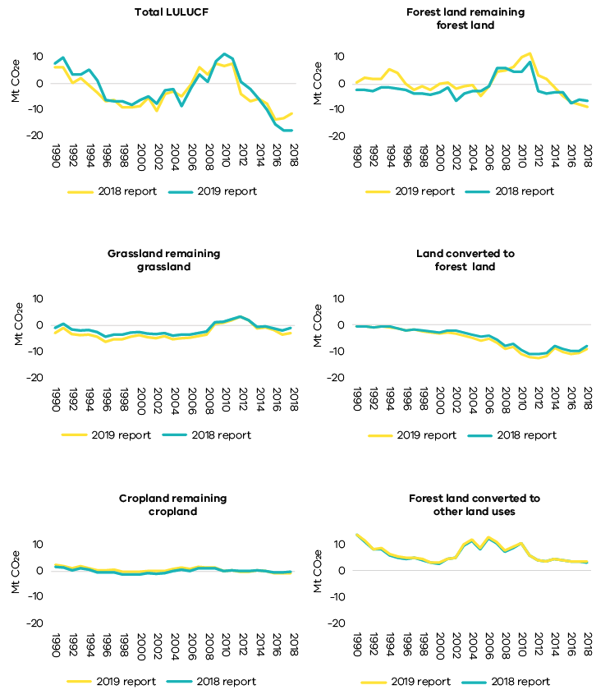
Figure 50. Emissions from Victoria’s main LULUCF sub-categories – Comparison of 2018 and 2019 reports
Source: State and Territory Greenhouse Gas Inventories 2019 (DISER 2021e) and State and Territory Greenhouse Gas Inventories 2018 (DISER 2020c)

Abbreviations and acronyms
AEMO Australian Energy Market Operator
The Act Climate Change Act 2017
ANZSIC Australian and New Zealand Standard Industrial Classification
CH₄ Methane
CO₂ Carbon dioxide
CO₂-e Carbon dioxide equivalent
DISER Commonwealth Department of Industry, Science, Energy and Resources
DOM Dead Organic Matter
FullCAM Full Carbon Accounting Model
GSP Gross State Product
HCFCs Hydrochlorofluorocarbons
HFCs Hydrofluorocarbons
HWP Harvested Wood Products
IPCC Intergovernmental Panel on Climate Change
IPPU Industrial Processes and Product Use
KP Kyoto Protocol
LULUCF Land use, land-use change and forestry
N₂O Nitrous oxide
Mt Million tonnes
MW Megawatt
MWh Megawatt hours
NEM National Electricity Market
PFCs Perfluorocarbons
PJ Petajoules
SF₆ Sulphur hexafluorides
UNFCCC United Nations Framework Convention on Climate Change

Reference List
Agriculture Victoria. 2021. “Victorian Agriculture Industry Overview – March 2021”. Food and Fibre Factsheet_March 2021-detailed.pdf (agriculture.vic.gov.au)
Australian Bureau of Agricultural and Resource Economics and Sciences (ABARES). 2021. ‘About my region – Victoria’, Canberra. Commonwealth of Australia Accessed 21 June. https://www.agriculture.gov.au/abares/research-topics/aboutmyregion/vic#regional-overview.
Australian Bureau of Statistics (ABS). 2020a. “Agricultural Commodities, Australia 2018-19”. Canberra. Commonwealth of Australia
———. 2020b. “Value of Agricultural Commodities Produced, Australia 2018-19”. Canberra. Commonwealth of Australia
———. 2021a. “3101.0 - Australian Demographic Statistics, Mar 2021.” Canberra. Commonwealth of Australia
———. 2021b. “5220.0 - Australian National Accounts: State Accounts, 2019-20.” Canberra. Commonwealth of Australia
Australian Energy Market Operator (AEMO). 2020. “Victorian Gas Planning Report Update.” Gas Transmission Network Planning for Victoria. Australian Energy Market Operator Limited.
Australian Energy Regulator. 2020. “State of the Energy Market 2020.” Melbourne. Commonwealth of Australia

Bureau of Infrastructure and Transport Research Economics (BITRE). 2020. “Australian infrastructure statistics Yearbook 2020.” In Table T 3.3b Total passenger kilometres travelled by capital city—Melbourne. Canberra. Commonwealth of Australia
———. 2021a. “ Australia’s light vehicle fleet – some insights” Canberra. Commonwealth of Australia.
———. 2021b. “Airport Traffic Data 1985–86 to 2019–20.” Canberra. Commonwealth of Australia
Brodribb and McCann. 2020. “Cold hard facts “ In, edited by Expert Group. Canberra Commonwealth of Australia
Clean Energy Regulator (CER). 2020. “Greenhouse and energy information for designated generation facilities 2018-19.” Canberra. Commonwealth of Australia
———. 2018. “Greenhouse and energy information for designated generation facilities 2015-16.” Canberra. Commonwealth of Australia
Department of Industry, Science, Energy and Resources (DISER). 2020a. “Australian Energy Statistics, Table F.” In Australian energy consumption, by state and territory, by industry and fuel type, energy units Canberra. Commonwealth of Australia
———. 2020b. “Australian Energy Statistics, Table I“ In Australian production of primary fuels, by state and territory, physical units. Canberra. Commonwealth of Australia
———. 2020c. “State and Territory Greenhouse Gas Inventories 2018.” In. Canberra Commonwealth of Australia
———. 2021a. “Australian Energy Statistics, Table O, May 2021 “ Canberra. Commonwealth of Australia
———. 2021b. “Australian Greenhouse Emissions Information System.” Canberra. Commonwealth of Australia
———. 2021c. “LULUCF historical emissions provided on 22 April 2021.”
———. 2021d. “National Greenhouse Gas Inventory Report: 2019.” Canberra. Commonwealth of Australia
———. 2021e. “State and Territory Greenhouse Gas Inventories 2019.” Canberra. Commonwealth of Australia
Morton 2012. ‘Yallourn coal mine flood worsens’, Fairfax, Accessed 27 July https://www.theage.com.au/national/victoria/yallourn-coal-mine-flood-worsens-20120715-224ef.html.
National Transport Commission (NTC). 2020. “Carbon Dioxide Emissions Intensity for New Australian Light Vehicles 2019.” Melbourne. Commonwealth of Australia
Sustainabilty Victoria. 2011. “Electricity from Renewable Energy in Victoria “ In. Melbourne. Victorian Government
———. n.d. “Victorian Energy Consumption Update – to 2016/17 “

2019 is the latest year for which official emissions data, published by the Commonwealth Government, is available.
Percentage contributions of each sector are calculated in terms of sectors’ shares of total net emissions (which takes into account net sequestration by the LULUCF sector).
DISER prepares National Greenhouse Accounts that include a series of annual publications to meet Australia’s international obligations under the UNFCCC and Kyoto Protocol (KP). These include State and Territory Greenhouse Gas Inventories and the National Inventory Report. Victoria’s Greenhouse Gas Emissions reports apply UNFCCC accounting provisions rather than KP accounting because the former includes a more comprehensive set of land categories and the identification of emissions from land clearing events. UNFCCC reporting rules and guidelines are those adopted under decision 24/CP.19 – known as the Revision of the UNFCCC reporting guidelines on annual inventories for Parties included in Annex I to the Convention; and the Intergovernmental Panel on Climate Change (IPCC) 2006 Guidelines for National Greenhouse Gas Inventories (IPCC 2006).
Financial years to June 30 – for example, the year 2012 refers to the Australian financial year from 1 July 2011 to 30 June 2012.
DISER produces LULUCF emissions data under the rules for reporting applicable to both the UNFCCC and the Kyoto Protocol. Victorian Greenhouse Gas Emissions reports apply UNFCCC emissions accounting provisions.
Percentage contributions of each sector are presented as a share of total net emissions (i.e. they take into account sequestration in the LULUCF sector).
Sections 2.1 to 2.5 of this report discuss the interannual variability of emissions trends by sector between 1990 and 2019.
Data is collected from power stations through the National Greenhouse and Energy Reporting (NGER) scheme. Under NGER, facilities over certain thresholds are required to submit to the Clean Energy Regulator annual data on fuel consumption, fuel energy content, fuel emissions factors (incorporating oxidation factors), emission estimates and the amount of electricity generated and sent out. NGER data is received from all large and medium sized power stations in Australia. This data is currently available for around 140 fossil fuel-based power stations in Australia. The energy use of small power stations that do not meet the NGERS reporting thresholds are estimated as the difference between the total of reported values under NGER and Australian Energy Statistics for ANZSIC subdivision 26 (Electricity Generation).
Excluding gas consumption for electricity generation
Fuel consumption data sourced from Australian Energy Statistics and adjusted to exclude international aviation fuel. This is consistent with the UNFCCC accounting framework which excludes international aviation and shipping for national inventories.
Also includes emissions from flaring during exploration.
These emissions are from equipment operating as designed, as opposed to leakages.
Also known as the Victorian Transmission System (VTS), the Declared Transmission System (DTS) or APA GasNet System.
DISER estimates state/territory IPPU emissions by dividing national IPPU emissions by the population of each state/territory.
Biogenic CO2 from paper, wood, garden, food or other biomass is assumed to experience uptake and release within 100 years through photosynthesis. As per 2006 IPCC Guidelines, biogenic CO2 is assumed to have a neutral global warming potential and, as such, is reported as a memo item in the National Inventory Report.
Principles of conversion of carbon and mass are respected when estimating rates of decomposition - consequently, no double counting of carbon occurs.
DISER produces LULUCF emissions data under the rules for reporting applicable to both the UNFCCC and under the Kyoto Protocol. The Victorian Greenhouse Gas Emissions Report 2019 uses LULUCF data following the UNFCCC emission accounting provisions. The definition of the land relating to each LULUCF sub-category and the principal sources of emissions and removals are available in National Inventory Report 2019 Volume 2 Chapter 6.
These four sub-categories account for more than 80% of total emissions from the LULUCF sector. While emissions from other sub-categories are not described in this section of the Report, their net emissions are accounted for in the total net LULUCF emissions presented in Figures 39 and 40.
The electricity, gas, water and waste services sector’s Scope 2 emissions include own use by electricity generators that does not necessarily meet the National Greenhouse Accounts (NGA) Factors 2019 definition of scope 2 emissions.

