Victorian climate change data and information
for local government
This factsheet provides a snapshot of the climate information and data available for Victorian councils to use,
and a decision-tree to help determine which resource might be best suited for a particular decision or action.
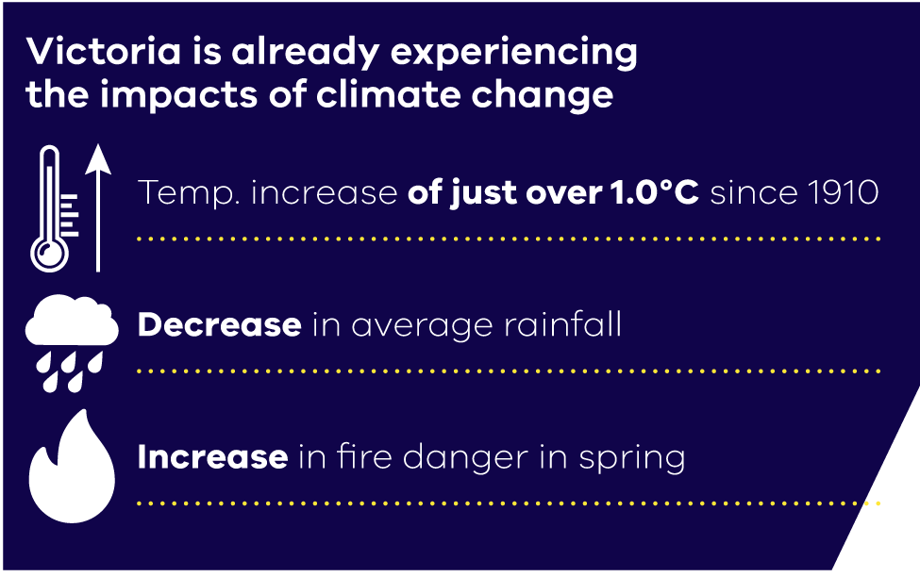
Understanding and managing the risks of climate change to council assets, services and local communities are critical responsibilities of local governments.
When making decisions in a changing climate, councils can no longer rely on the historical climate trends as a good indicator of the climate we can expect in the future.
Instead, we must draw on climate models to project possible future climates and plan in ways that allow
for uncertainty.
The Victorian Government partnered with CSIRO’s Climate Science Centre to develop new local scale climate projections for Victoria at a 5 km grid. The projections cover average and extreme temperature
and rainfall, relative humidity and evaporation to the 2090s for moderate and high emissions scenarios.
Based on the best available climate science, Victorian Climate Projections 2019 provides a solid evidence base for management, planning and policy decisions that will result in a more resilient Victoria.
Victoria’s Changing Climate
Climate projections for Victoria indicate the state is likely to become hotter and drier in the future, and the timing and extent of these changes will vary across regions. These snapshots show what the projections indicate for each of Victoria’s regions for the 2050s (compared to 1986–2005) under high global greenhouse gas emissions.
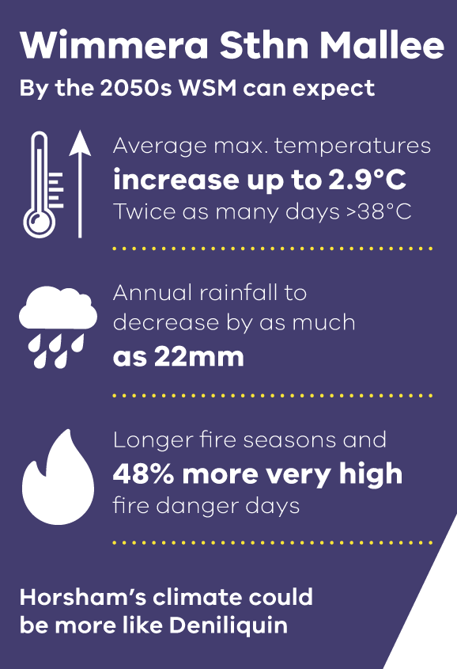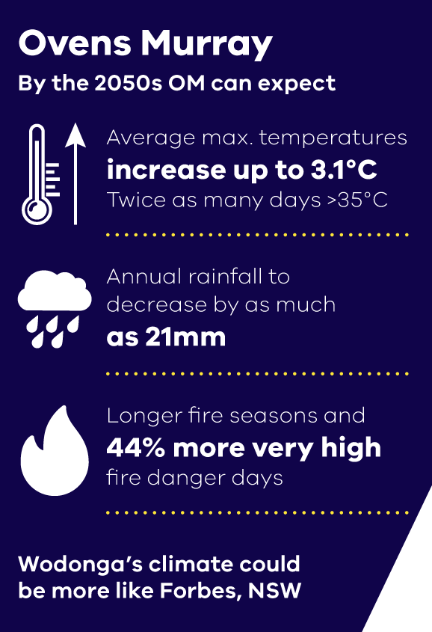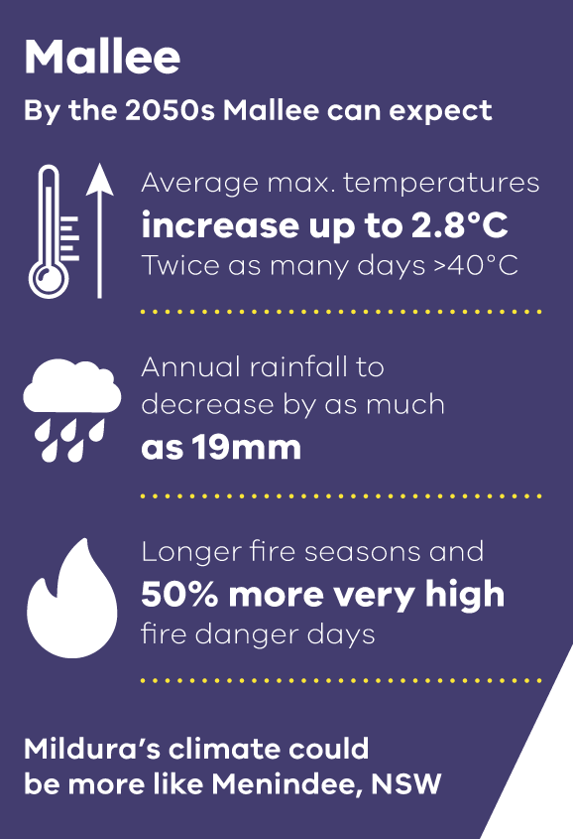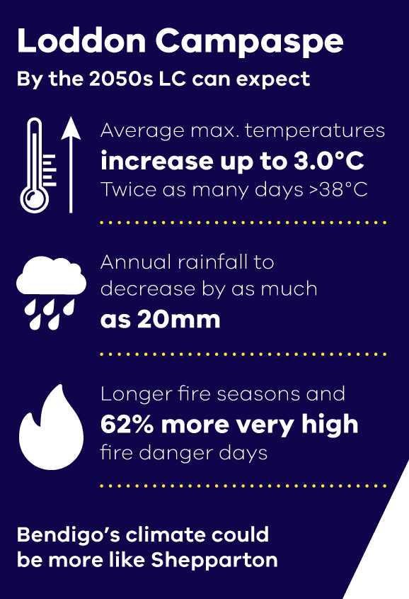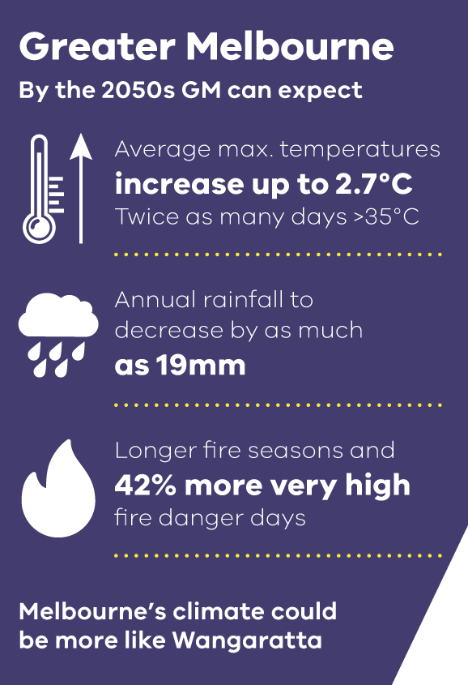

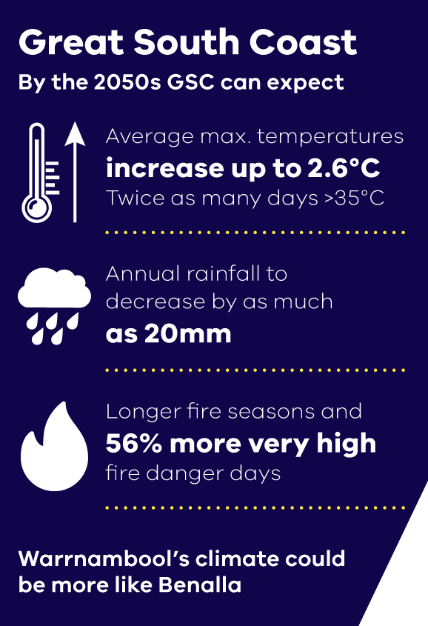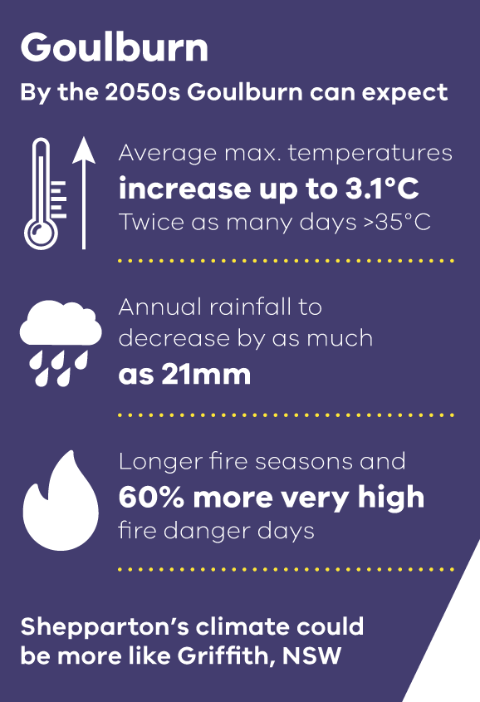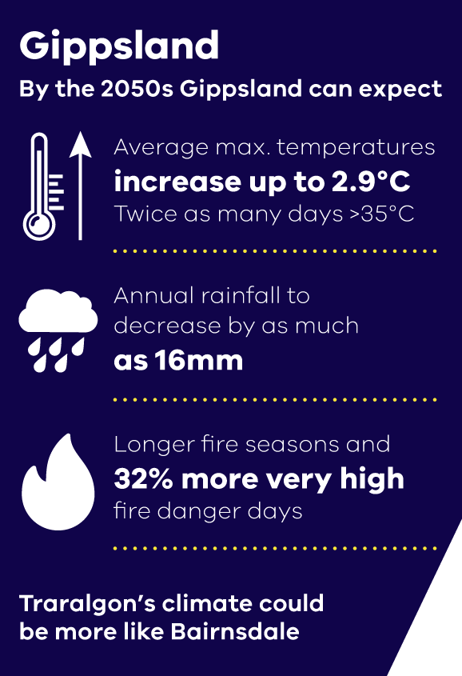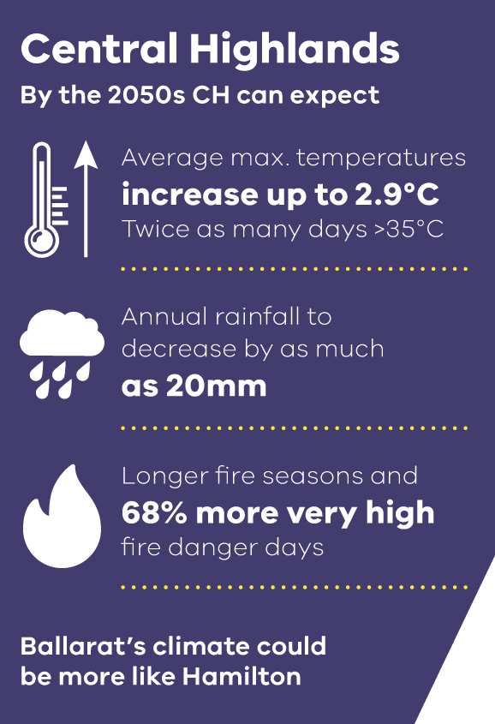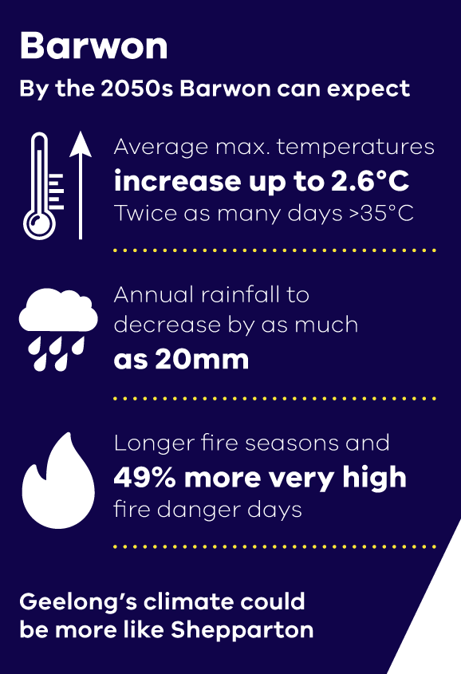

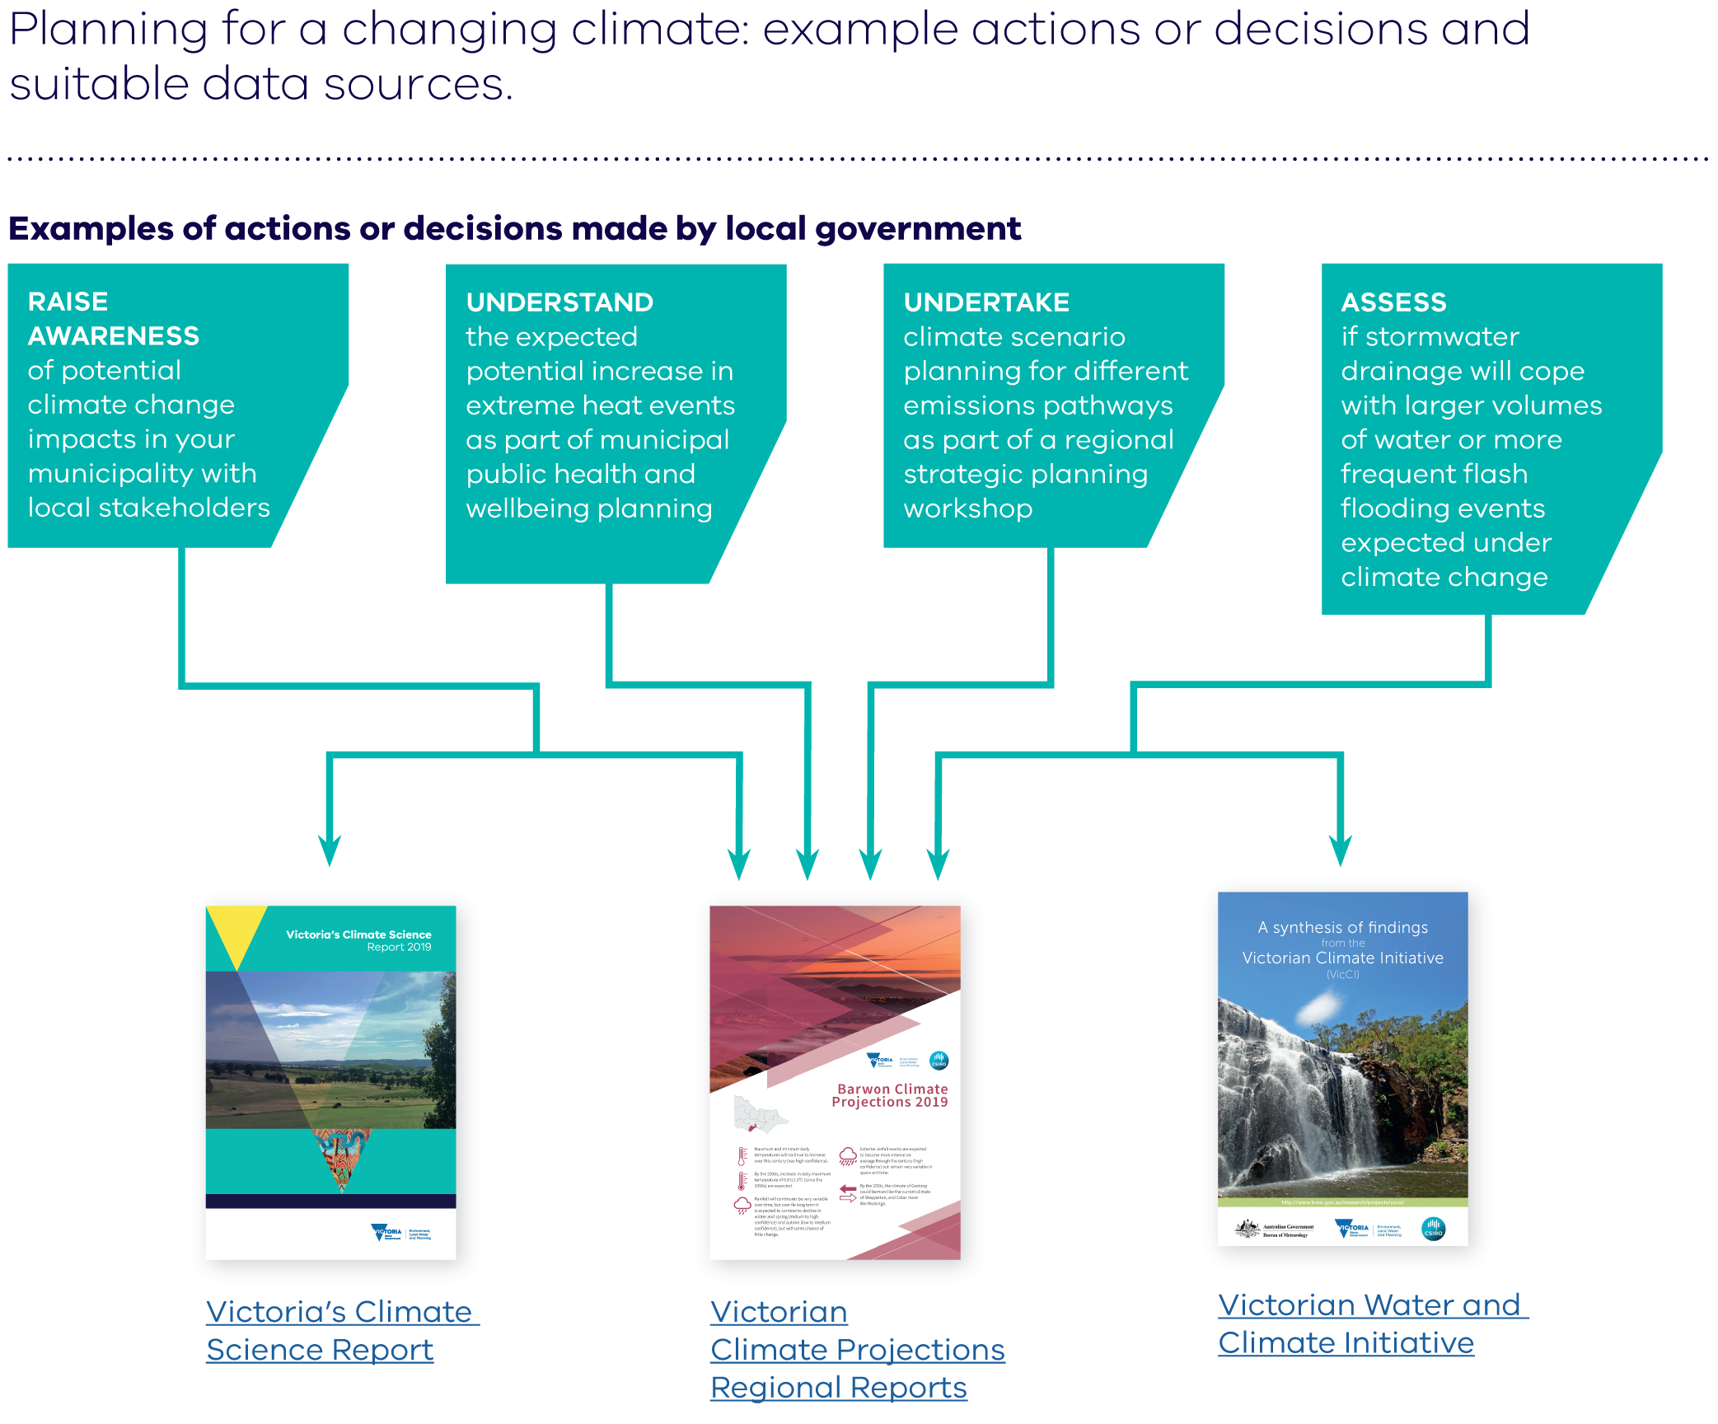
Victorian climate change information and data
products available
DELWP have worked with CSIRO and the
Bureau of Meteorology to produce a range
of resources to help plan for a changing
climate. These include:
Victoria’s Climate
Science Report 2019
A summary of the best available scientific
evidence on current and future climate
for our state, including observed changes
over recent decades.
Understanding the drivers and impacts
of these changes, as well as what we
can expect in the future, will help us to
plan and adapt.
Regional Reports
A selection of the Victorian Climate
Projections findings for each of
Victoria’s Regional Partnership regions
and Greater Melbourne to help you
understand how the climate will change
in your region.
Technical datasets
Can be used by technical specialists
for use in climate risk assessments
and impact modelling to understand how
particular systems may respond to
climate change.
Choosing the climate information or data product for your needs
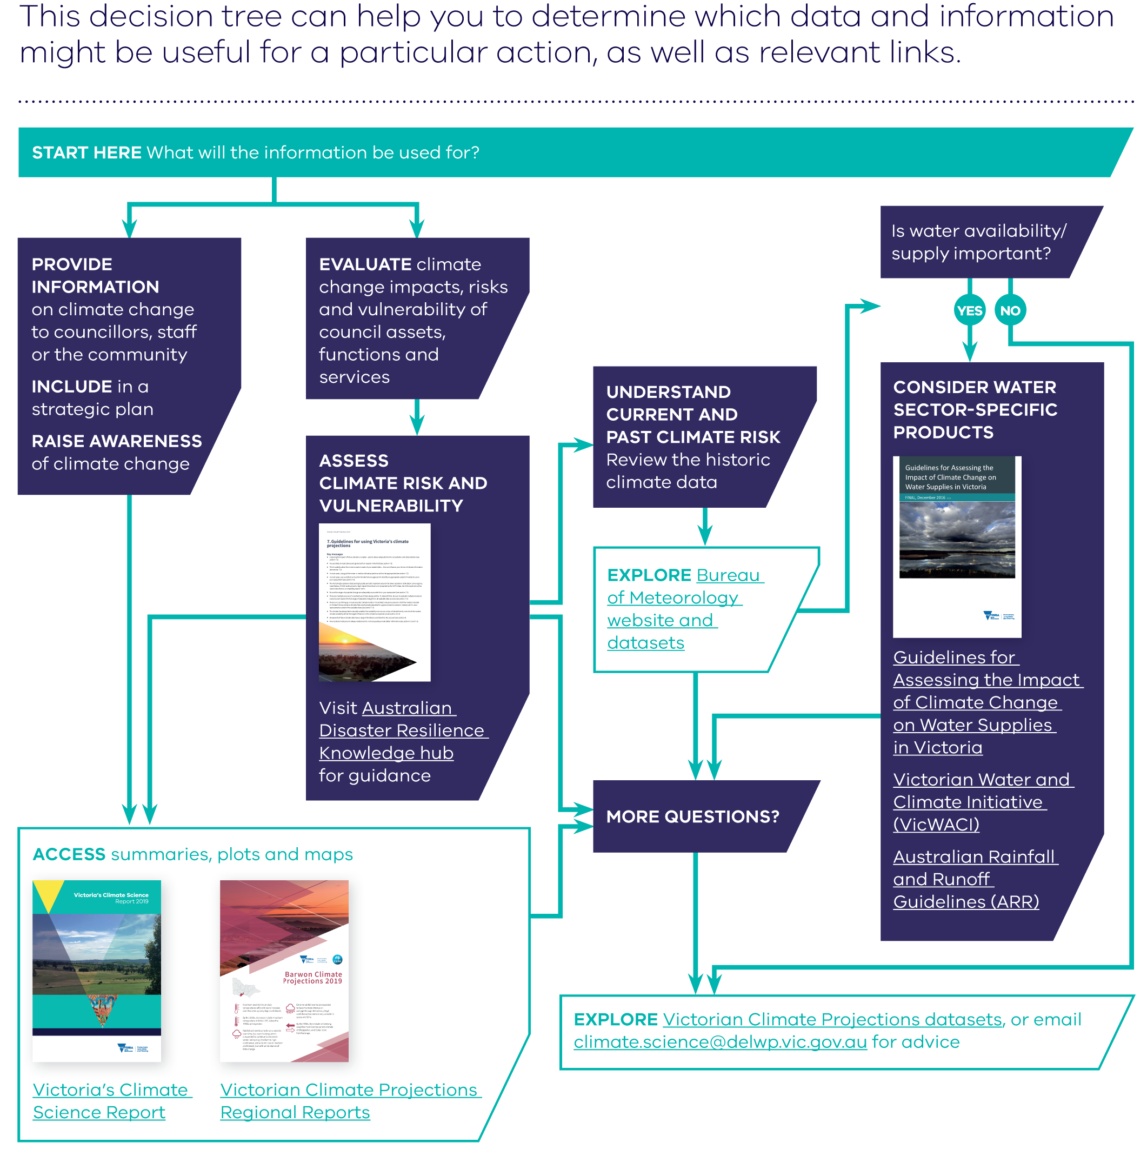
Different questions or decisions need information
and data at various levels of detail and complexity.
It is important to consider the level of detail of the
information you need, as not all decisions will require
detailed data analysis. Some assessment and scenario planning can be done on basic information about trends,
which can be easily found in the Regional Reports
and Victoria’s Climate Science Report 2019. It is also
always important to consider the impact of climate
change alongside the impact of other changes, such
as population, economic and technology changes.
The Victorian Climate Projections 2019 Technical Report (chapter 7) provides guidance on how to incorporate
the projections information into adaptation, vulnerability
or impact assessments and the decision tree presented
here is a simplified summary of that guidance.

