Gippsland Regional

Climate Change

Adaptation Strategy

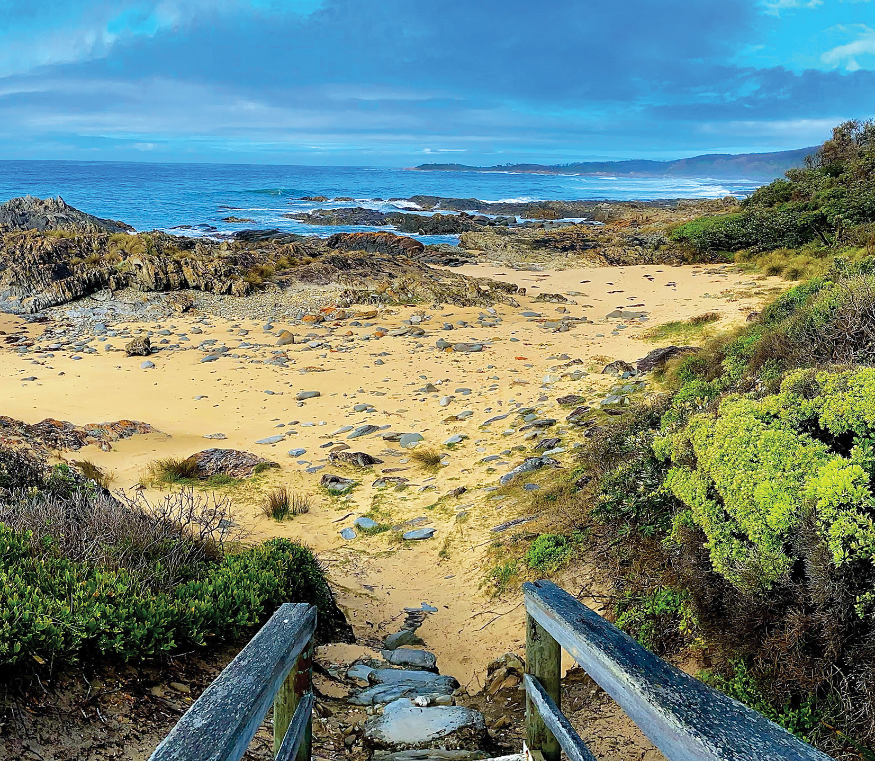

Traditional Owners Acknowledgement
We acknowledge and respect Gippsland’s Traditional Owners as the original custodians of Victoria’s land and waters, their unique ability to care for Country and deep spiritual connection to it. We honour Elders past and present whose knowledge and wisdom has ensured the continuation of culture and traditional practices.
We are committed to genuinely partner, and meaningfully engage, with Gippsland’s Traditional Owners and Aboriginal communities to support the protection of Country, the maintenance of spiritual and cultural practices and their broader aspirations in the 21st century and beyond.
Acknowledgements
This work is licensed under a Creative Commons Attribution 4.0 International licence. You are free to re-use the work under that licence, on the condition that you credit the State of Victoria as author. The licence does not apply to any images, photographs or branding, including the Victorian Coat of Arms, the Victorian Government logo and the Department of Environment, Land, Water and Planning (DELWP) logo. To view a copy of this licence, visit
www.creativecommons.org/licenses/ by/4.0/
ISBN 978-1-76105-619-2 (pdf/online/MS word
This publication was developed during a global pandemic (COVID-19) and may be of assistance to you but the State of Victoria and its employees do not guarantee that the publication is without flaw of any kind or is wholly appropriate for your particular purposes and therefore disclaims all liability for any error, loss or other consequence which may arise from you relying on any information in this publication.

Thank you
We acknowledge and thank the member organisations of the Gippsland Climate Change Adaptation Working Group for their leadership and contributions in preparing the Gippsland Regional Climate Change Adaptation Strategy
- Gippsland Climate Change Network
- Bass Coast Shire Council
- East Gippsland Shire Council
- Gunaikurnai Land and Waters Aboriginal Corporation
- Bunurong Land Council Aboriginal Corporation
- Regional Development Victoria
- Central West Gippsland Primary Care Partnership
- Destination Gippsland
- West Gippsland Catchment Management Authority
- Federation University
- Food and Fibre Gippsland
- Gippsland Water
- Agriculture Victoria
- Department of Environment, Land, Water and Planning
Accessibility
If you would like to receive this publication in an alternative format, please telephone the DELWP Customer Service Centre on 136 186, email customer.service@delwp.vic.gov.au or via the National Relay Service on 133 677 or at www.relayservice.com.au. This document is also available on the internet at www.delwp.vic.gov.au.
The development of the Gippsland Regional Climate Change Adaptation Strategy was supported by the Victorian Government and funded through the Sustainability Fund – Supporting Our Regions to Adapt program.

Table of Contents
Gippsland Regional 1
Climate Change 1
Adaptation Strategy 1
Table of Contents 4
Introduction 5
Natural Environment 16
Water 24
Cultural Heritage and Cultural Values 29
Emergencies and Emergency Management 31
Agriculture 36
Health and Human Services 42
Built Environment and Transport 46
Community 49
Knowledge 53
Regional Economy 57

Introduction

Supporting regional climate change adaptation
The Supporting our Regions to Adapt (SORAd) program, funded through the Sustainability Fund, is a four-year program that has provided Victoria’s regions with support to:
- strengthen their resilience to climate change by building adaptive capacity
- deliver targeted adaptation action.
As part of the SORAd program, DELWP is supporting each of the six regions – Loddon-Mallee, Hume, Gippsland, Port Phillip, Barwon South West and Grampians to take a place-based approach and develop their own Regional Adaptation Strategy (RAS). Each RAS will be a community owned document, where regional stakeholders have the opportunity to identify and prioritise strategic adaptation action within their region. The RAS will serve as a tool for each region to use in guiding collaboration and planning future adaptation needs.
This five-year strategy is supported by initial implementation funding that will support localised projects and initiatives that build regional capacity and create working examples of adaptation action within Gippsland.
The development of the RAS and finalisation of the initial implementation funding was overseen by a Regional Climate Change Adaptation Stakeholder Working Group and supported by the DELWP regional project team.

Climate adaptation Vision for Gippsland
For Gippslanders to be aware of the effects of climate change on community and Country, be flexible to adapt and be supported in adapting.
- Ensuring our communities and people are climate ready and capable of coping with climate change challenges and impacts, with support available for the most vulnerable.
- Ensuring our landscapes of built and natural environments can support our people, our wildlife, our businesses and our producers.
- Our regional economy is prepared to cope with the impacts and challenges of climate change and can continue to provide both economic and employment security and opportunities.

Adaptation and mitigation
Figure 1: Adaptation and Mitigation actions
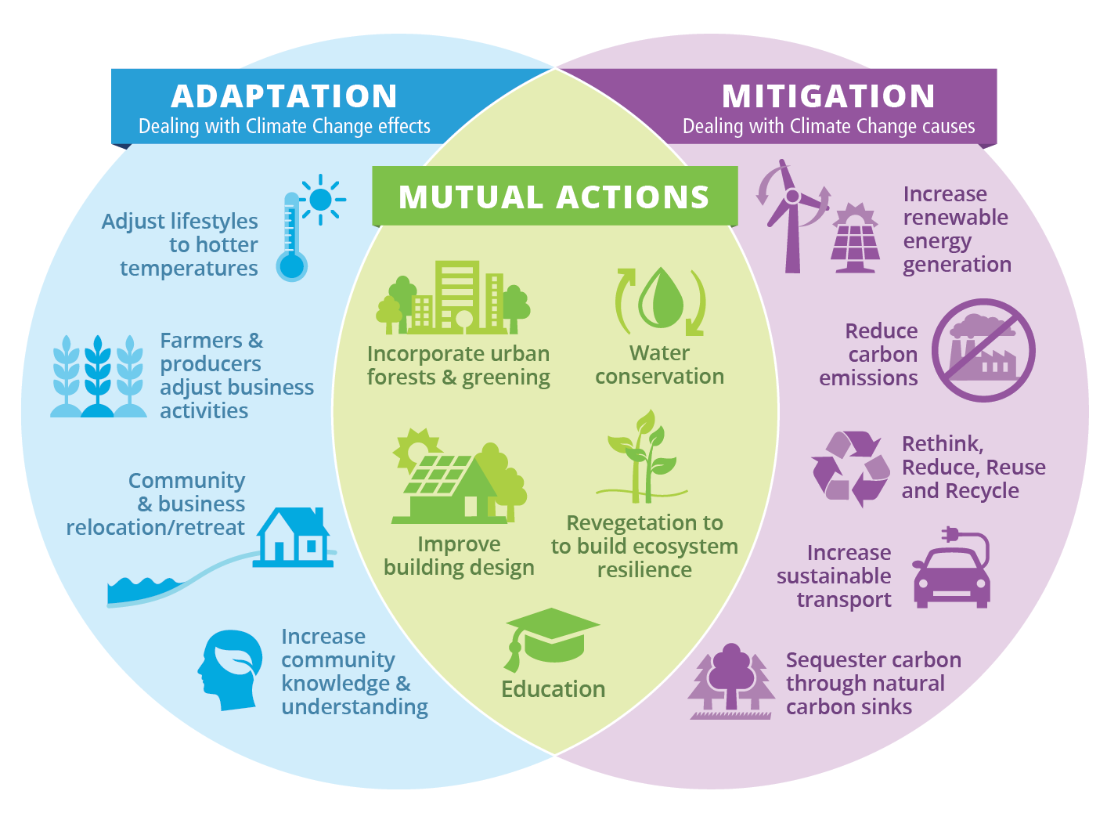
Climate change action is typically divided into two categories: adaptation and mitigation.
Adaptation focuses on living and coping with the impacts of climate change.
Mitigation focuses on dealing with the causes of climate change by reducing global greenhouse gas emissions.
Importantly, some climate change actions involve both adaptation and mitigation activities.
As an adaptation strategy, this document focuses on those actions that will help the community, business, industry and environment to better adapt to the changing climate. Because there are other plans and strategies dedicated towards mitigation actions, such as renewable energy and emissions reductions, this strategy does not actively outline specific mitigation priorities or actions. It must be noted that actions to mitigate climate change are critically important to reduce or limit the impacts of climate change. It is recommended that this occurs alongside and in conjunction with adaptation activities.

Where climate change actions can achieve both mitigation and adaptation outcomes they have been considered and incorporated into this strategy.
For further details on Victorian and regional climate mitigation actions, please refer to the documents and links listed below.
- Download Victoria’s Climate Change Strategy
- Download Victoria’s Renewable Energy Roadmap (plus regional roadmaps)

Snapshot of the region
Gippsland’s diverse mix of native forests, major rivers, beautiful coastlines, ready resources and rich food production make the region an attractive place to live, work, study and invest. The region stretches from Longwarry in the west, to the state’s border with New South Wales in the east. Its northern and southern borders feature natural boundaries of mountains and coasts. The Gippsland region includes the six local government areas of Bass Coast, Baw Baw, South Gippsland, Latrobe, Wellington and East Gippsland. For thousands of years, the land now known as the Gippsland region has been, and continues to be, the traditional lands of the Gunaikurnai, Monero, Ngarigo, Bidwal (Bidwell), Wurundjeri, Jaithmathang, Taungurung and Bunurong Peoples.
The region is well-renowned for its many natural attractions such as the Gippsland Lakes, Wilsons Promontory, snowfields and alpine areas, Tarra Bulga National Park and Phillip Island. The Gippsland coastal areas provide a diverse range of habitats that support the high biodiversity values of the region, including a significant portion of the state’s important habitat for migratory and native bird species. In addition, the region encompasses Mt Baw Baw, one of the five major Victorian snowfields, and part of the Alpine National Park.
These vast areas of crown land within the region are managed for a range of important community and biodiversity values including recreational, cultural, forestry, conservation and tourism.
In addition to supplying its own water needs, catchments within Gippsland supply over half of Melbourne’s water. The Thomson Reservoir is fundamental to Melbourne’s water supply and the desalination plant at Wonthaggi provides future water security for an expanding city and suburban population.
Gippsland is a major contributor to the state’s food and fibre economy with the region’s farms collectively producing billion dollar outputs annually. The region is also home to a well-established and high-value food processing sector that specialises in dairy, meat and vegetables.
Gippsland has a long and proud history in energy production with ready access to regional coal, gas and oil reserves. The energy and resources industry has provided employment opportunities and built up a skilled workforce since the early 20th century. The shift away from traditional sources of energy has already started within Gippsland and will continue over the coming decades.
Approximately 270,000 people live in Gippsland, with the population expected to grow to over 386,000 by 2041. Gippsland has a long-established trend of school leavers migrating out of the region in search of education and employment, and young families and those close to retirement, moving into the region. This contributes to an aging population within the region. Currently, around 40% of the region’s population live in towns and settlements of less than 500 people.
Figure 2: Map of Gippsland Region
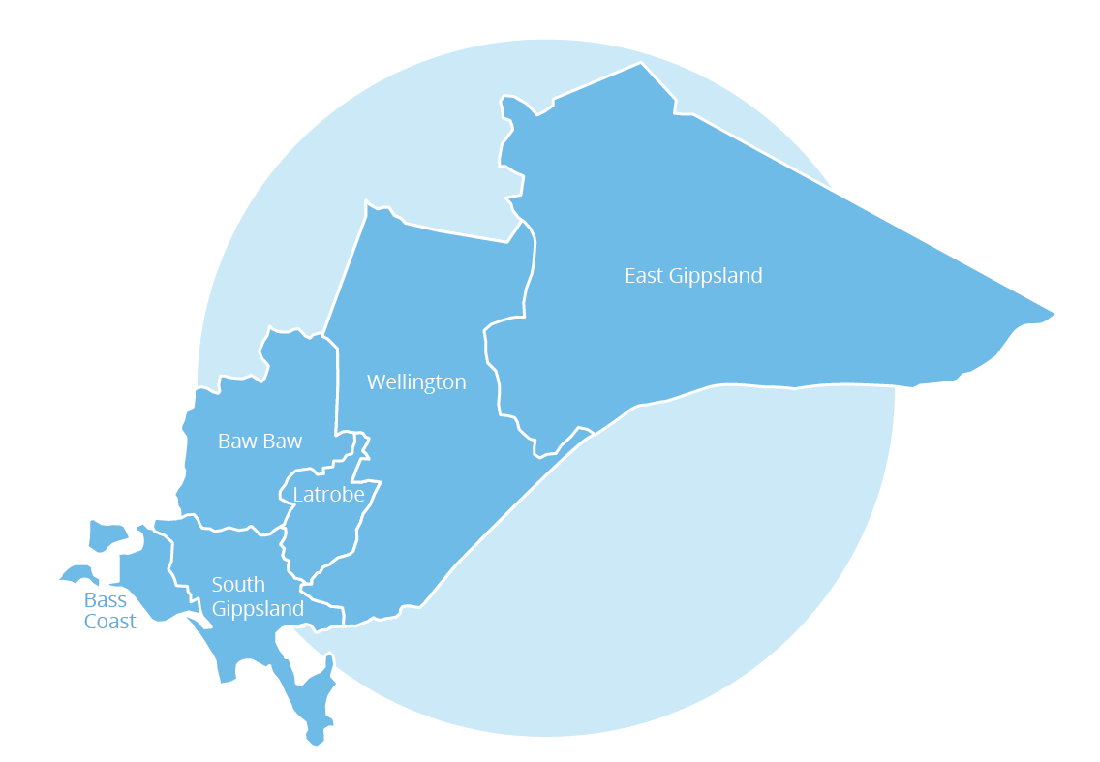

Climate change has and will continue to pose challenges for the communities and landscapes of Gippsland. Without immediate adjustment and adaptation there would be great risks to the health and livelihoods of our people, irreparable impacts on our diverse natural environment, impacts to our built environment and ramifications for our economic outlook and employment levels.
Adaptation will present opportunities to innovate, collaborate and diversify as well as embrace practice and behavioural change.
The Gippsland Regional Climate Change Adaptation Strategy (RAS) outlines both short-term goals and initiatives that will support immediate adaptation action as well as planning that is necessary for preparing the region beyond its five-year timeframe.

Developing this strategy
The impacts of climate change are evident across Gippsland. Current projections show that the impacts will increase in frequency and severity over the coming decades and we’ll face more challenging conditions. Without immediate planning and action, we’ll face significant impacts upon our built and natural environment, increased costs to build resilience and threats to our regional economy.
The five-year timeframe of this strategy is an important opportunity to communicate these threats within the region, build understanding, collaborate, implement action and continue planning for the future.
The formation of the Gippsland Regional Climate Change Adaptation Strategy has been guided by the Gippsland Climate Change Adaptation Working Group. The Working Group has collaborated closely with a DELWP project team to develop this strategy and then select regional adaptation action initiatives to receive implementation funding support. The Working Group and the project team have worked with current sector knowledge, priorities outlined within the Regional Gap Analysis and stakeholder input from DELWP-led Climate Change Adaptation Workshops and engagement to help shape the strategy.
Further input from stakeholders and the community during the final consultation phase during April and May 2021 was used to refine and finalise the strategy.

Using this strategy
Climate change will impact each part of Gippsland differently. All parts of the community, business, government and industry will need to be involved in some way to best prepare, respond and adapt. These impacts will be experienced differently by each sector, system, community and individual. Just as approaches and planning will need to be place-based, so they are specific to each region, there is a need to tailor climate change adaptation actions within each household, business, community and sector.
The development of this strategy has given the region the opportunity to highlight its current priorities and future adaptation directions and options that will provide greater support to the people of Gippsland. This strategy provides a summary of actions that the community, organisations, agencies and government can draw from, align to and collaborate around to achieve climate adaptation goals and priorities.
Importantly, adaptation action is already underway within the region. There are many champions of change who have been working on adapting to a changing climate for years. Many agencies and organisations have already implemented, or are currently developing, their own individual climate change adaptation action plans across the region. This strategy does not seek to replace those other plans, nor will it be able to capture and address the full detail of all of the adaptation needs across the region.
Instead, the aim of this strategy is to support existing plans by capturing a high level overview of their main themes, directions and priorities to aid knowledge sharing, networking, planning, collaboration, the leveraging of support and identifying existing or future gaps. It is intended that this strategy be used alongside other regional plans to provide accompanying adaptation support. One example is the Gippsland Regional Plan 2020 – 2025, which outlines a strategic vision for Gippsland in 2040. Both documents outline goals across the region’s sectors. The RAS can also be used to support the climate action goals within the Gippsland Regional Plan 2020 – 2025.
The planning and implementation of adaptation actions will benefit from collaboration, consultation, communication and co-design between regional partners and stakeholders, as well as necessary input from those outside of the region who can either enable or remove blockages.
Coordination of this collaboration into the next five years and beyond will be critical in ensuring cross-sectoral agreement, commitment and implementation of the options outlined within this strategy.
Options listed in this strategy are based on current knowledge and information. The paths, networks and resources required to complete some actions are yet to be established. Additionally, leads for some actions and the advocacy roles required will need to be confirmed. Collaboration, consultation and planning will be required between sectors and organisations within the region to ensure that they progress to an implementation stage.
This strategy will also be used to:
- build knowledge, capture, collate and share broad adaptation priorities
- support strategic engagement, establishing networks across sectors, systems and organisations
- signpost, guiding sectors and organisations to identify and connect with relevant broader adaptation needs and actions
- foster collaboration, on actions of shared interest and responsibility
- support business planning, and the inclusion and implementation of adaptation action
- leverage, secure support and resources required to plan for or implement action.
Some of the focus areas within this strategy align directly with a single sector within the region, while others may involve the interests and priorities of multiple sectors. Throughout the strategy there are examples of priorities that apply to multiple sectors and focus areas. In some places, priorities have been listed in multiple locations as they are important in establishing cross-sector understanding, collaboration and action.
Please note that focus areas and actions featured in this strategy have not been listed in any order of priority for support or implementation.

The strategic directions and actions outlined here have been divided into the following 10 focus areas.
- Natural Environment
- Water
- Cultural Heritage and Cultural Values
- Emergencies and Emergency Management
- Agriculture
- Health and Human Services
- Built Environment
- Community
- Knowledge
- Regional Economy
The focus areas within this strategy have links to existing plans and strategy documents that provide more specific detail about implementation.
While the focus areas align closely with existing sectors and systems, it is acknowledged that there are many crossover points. It is recommended that impacts, priorities and opportunities are not considered in isolation and consideration is given to connecting focus areas and other relevant sectors.

Emerging themes

Leadership
The need for strong leadership, at both the regional and community level, has been a consistent theme in the development of this strategy. Feedback and input from stakeholders and the community asserts that leadership on climate adaptation action is necessary across the region, from government to business, industry, agencies and individuals to drive progress and ensure participation and commitment.
Leadership on climate adaptation in Gippsland is seen as the willingness to recognise the risks, opportunities and priorities then work to plan, act and empower others to build their capacity and resilience.

Collaboration
Collaboration has been highlighted as an important aspect of planning and implementing adaptation action. This collaboration will need to occur across sectors and systems, as many risks and priorities are likely to have direct and indirect impacts on multiple sectors. Collaboration within sectors and across the region is seen as a way to prevent duplication of effort as well as avoid maladaptation¹.
While the strategy’s directions and action have been divided into 10 focus areas, it is important that stakeholders, businesses and communities consider how all areas will either impact them or provide opportunities to collaborate and work towards better and more effective ways to adapt.
Within this strategy it has been highlighted that there will be times when the adaptation priorities and objectives across multiple sectors may not align. As these circumstances emerge, cross-sectoral consultation and collaboration will be essential to work through and explore how to reach collective benefit.

Planning for multiple possible futures
Planning for climate change involves exploring multiple possible futures, as it is difficult to know the exact scale and rate of climate change. This plan refers to and encourages planning on regional and local scales, by government, organisations and communities as well as across sectors to prepare for possible impacts and changes. There are numerous ways that adaptation planning can explore a range of potential futures and outcomes. These include methods such as adaptation pathways and scenario planning.
Adaption pathways help to address the challenges and uncertainty involved in climate change decision making. They allow the consideration of multiple possible futures and provide an opportunity to explore and analyse the strengths and flexibility of the various options within each possible future. Detailed information on the adaptation pathways concept can be found via the CoastAdapt website, https://coastadapt.com.au/pathways-approach.
Scenario planning can help to:
- explore how different futures might look
- identify and understand the local risks and/or vulnerabilities
- explore the opportunities that could reduce these risks and/or vulnerabilities.

The use of scenarios can also help to analyse current practices and decisions, identify assumptions about the future and explore ‘what if’ questions. There are multiple methods for conducting scenario planning. Further information and references can be found via DELWP’s Regional Climate Change Adaptation Strategy Guidance Note 5, visit https://www.climatechange.vic.gov.au/__data/assets/pdf_file/0041/489686/RAS-GN5_-Exploring-Multiple-Futures-.pdf

Advocacy
This strategy captures and highlights the opportunities and actions across the region that will help Gippsland adapt to climate change. However, not all adaptation action can be organised or implemented at a regional level. Some responsibilities and authority sit at higher state or national levels. In these circumstances, advocacy will be necessary to influence and lead action. Collaboration and cooperation across sectors and systems within the region will be necessary where decision making is out of our power.

Gippsland’s possible future climate
Gippsland’s climate has changed along with the rest of Victoria. Expected further changes have been outlined in the Gippsland Climate Projections 2019 report that was compiled as part of the Victorian Climate Projections 2019 (VCP19). Future climate change scenarios are possible futures and not predictions. Climate projections can help guide our decisions on identifying and preparing for future risks.
Access the Gippsland Climate Projections 2019 information

Figure 3: Climate change projections
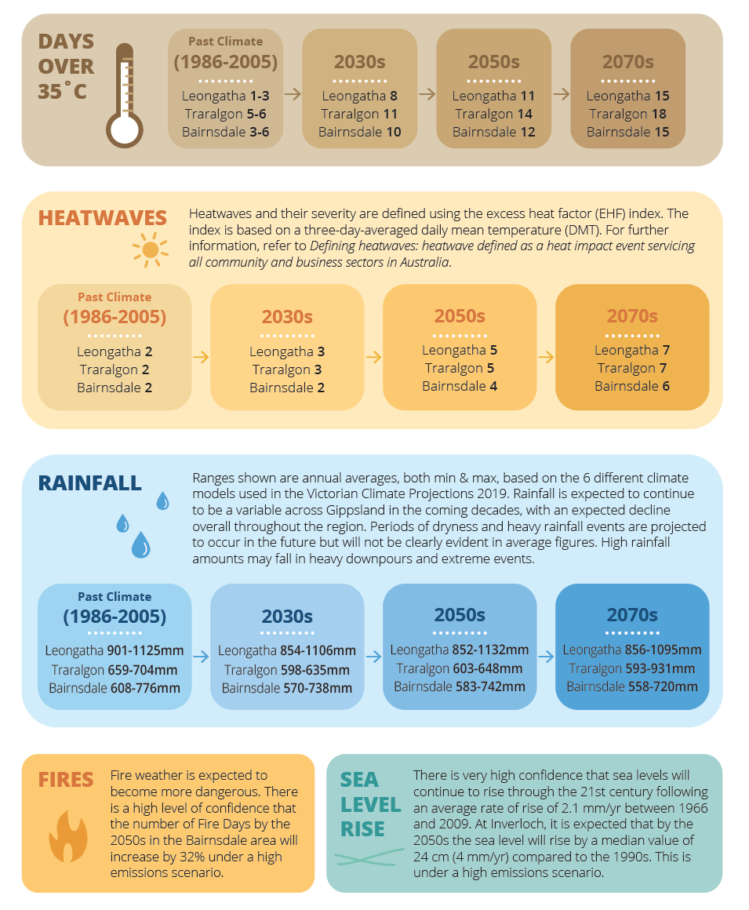

Projection data extracted from the Victorian Climate Projections 2019 (VCP19) and Victoria’s Future Climate Tool, based on VCP19 data.
Data for Days over 35°C, Heatwaves and Rainfall is the average annual for each location using the multi-model mean under a continued high emissions scenario (RCP8.5).
While climate projections give us solid evidence for management, planning and policy decisions, they are calculated as the average across a 30-year period and do not show the extremes possible within that period. As such, in some cases, projections may be too conservative for risk management. Climate is what we expect in longer-term trends, but the weather is what we get on a daily, seasonal, and yearly bases and can vary greatly from that average.

Natural Environment
Gippsland’s diverse landscapes host a range of significant ecosystems that include native forest, major river systems, wetlands, alpine and coastal environments, and sea grass meadows. This range of habitats supports both high biodiversity values and Traditional Owner cultural values throughout the region.
Our natural environment will experience significant impacts through climate change. Flora and fauna species that are currently under the threat of extinction will face further pressure to survive. Over the coming decades, it is expected that some species will not survive the projected changes and continued loss of habitat.
The gradual changes to the climate can have various and significant impacts on the natural environment, including intensifying existing detrimental processes such as vegetation and soil loss, habitat fragmentation and increasing numbers of weeds and pest animals. Many of the impacts on flora and fauna are difficult to predict exactly, although it is expected that gradual changes in the composition of vegetation communities will occur as more resilient species cope in a warmer and drier climate. Fauna species may experience changes in behaviour, abundance and distribution as well as potential shifts in regular cycles such as migration or breeding. Habitats in areas where retreat is not possible, such as alpine and coastal, will face significant permanent changes.
More dramatic events such as large-scale bushfires are likely to occur more frequently and with greater severity. These events have the potential to trigger devastating and long-term impacts on the natural environment, as well as on nearby communities. Storms and flooding, in conjunction with fires, can contribute to impacts on receiving waters such as our lakes, estuaries and wetlands. The expansive Gippsland coast features areas and habitats that are highly vulnerable to impacts and erosion triggered by sea level rise and storm surge events.
Traditional Owners seek to be embedded in the process of healing and caring for Country as they acknowledge that climate change will impact their tangible and intangible cultural heritage. They wish to protect their cultural values, which include:
- the health of waterways
- place-based dependency
- cultural landscape considerations (such as spiritual connection, wellbeing, connectivity including aesthetically)
- obligations to care for Country
- Traditional Owner Community connection, including the historical and traditional past, and the present.
Helping the natural environment to build its adaptive capacity is a resilience approach that assists a landscape or species to adjust to climate change, either by taking advantage of opportunities or coping with the impacts.
This can include the ability to modify behaviour or characteristics to adjust and better cope with changing climate conditions.
Pictured: Blue Skipper Butterfly, photo by Faye Bedford
Pictured: Karkalla (Native Pigface) – Carpobrotus rossi at Wilson’s Promontory National Park, photo by David Hood.

Strong interconnection occurs between the natural environment and other systems such as water management and the agriculture sector, which presents a range of cross-cutting issues for climate adaptation. The natural environment space within the Gippsland region involves multiple land managers, as well as responsible authorities and agencies.
Most of the directions and actions within this strategy involve multiple partners and stakeholders. There will need to be strong collaboration between multiple land managers and other sectors to work towards providing best protection for natural environment values in adaptation.
Potential also exists for issues to emerge where multiple sector objectives may not be complementary. For example, clearing native vegetation to allow for expansion and development of the built environment, or to reduce fire risk, would not support ecosystems in building their resilience to climate change impacts. With projections of lower rainfall in future, it is expected that the competing demands for water use in a drier climate will become more critical. Collaboration will be essential to achieve collective benefit where these issues emerge.
An opportunity within this focus area is to help and encourage the community to increase their knowledge of climate change impacts on the natural environment. Part of this could include encouraging individuals and groups to join existing programs and initiatives that protect and enhance natural environment values on both private and public land. These include programs such as Landcare, voluntary committees of management, citizen science, Friends of National Park groups and community gardens. This action would need to be accompanied by an assessment of the level of support required to ensure these programs have the capacity to attract and manage additional volunteers and activities.
Protection and preservation of the natural environment also has strong links to increasing and maintaining positive health and well-being within the community, as it provides space and opportunities for passive and active recreation, cultural connection and social engagement. This shows that the natural environment has strong links and crossover with the focus areas centring on Health, the Community and Regional Economy.

Relevant Regional Plans/Strategies
- Read the West Gippsland Regional Natural Resource Management (NRM) Climate Change Strategy
- Read the East Gippsland Regional Catchment Strategy: Climate Change Adaptation and Mitigation Plan
- Read the West Gippsland Regional Catchment Strategy (renewal due late 2021)
- Read the East Gippsland Regional Catchment Strategy (renewal due late 2021)

Steps toward adaptation
Strategic Direction 1
Understand likely scenarios and associated risks that inform actions to minimise impacts.
Initiative / action
- Improve knowledge, through research and investigation, to understand implications of climate change impacts on:
- groundwater dependent systems
- drought refuges
- rivers and streams
- wetlands
- key ecological vegetation classes
- Traditional Owner cultural values, including significant species, and cultural landscapes
- alpine biodiversity.
B. Actively monitor and document the impacts of climate change on different ecosystems to understand how they respond and use this information to inform best management options.
Strategic Direction 2
Actively support and improve the adaptive capacity of landscapes and vegetation communities.
Initiative / action
A. Explore options to implement active restoration, threat management and future impact mitigation to support key environmental and Traditional Owner cultural landscape areas, including:
- remnant vegetation
- alpine peatlands
- waterways
- floodplain and fringing wetlands
- coastal environments; seagrass and saltmarshes.
- Improve vegetation connectivity between existing environmental areas to support landscape resilience and adaptation (with consideration given to future species migration needs).

Strategic Direction 3
Monitor and manage the impacts on coastal and estuarine environments.
Initiative / action
- Establish short, medium and long-term goals for the understanding, and management of, coastal and estuarine impacts. Where applicable, include adaptation and mitigation programs that consider Traditional Owner, environmental and recreational expectations.
B. Establish a knowledge sharing system for information gained from projects focussed on coastal and estuarine impacts including:
- inundation mapping
- impacts on sea walls
- impacts on water quality
- impacts on tangible and intangible cultural heritage and possible mitigation
- considerations for future land use
- coastal/waterway management planning.
- Support land managers of coastal and marine areas to plan for adaptation, retreat and future land use options in response to areas being impacted by sea level rise and storm surge events.
Strategic Direction 4
Empowering Traditional Owners to care for Country.
Initiative / action
A. Embed Traditional Owners in the policy, planning and implementation of healing and caring for Country.
Strategic Direction 5
Effectively resolve competing sector issues.
Initiative / action
- Support and allow partner organisations to identify, collaborate on and resolve cross-sector issues to deliver positive climate change adaptation outcomes for natural environment values.

Strategic Direction 6
Maximise community participation and connection to nature.
Initiative / action
A. Determine capacity levels and support required for programs and groups that provide community connection to nature and climate action opportunities.
B. Support programs that connect the community with nature as well as boost their awareness of and participation in climate change adaptation and mitigation programs.
Strategic Direction 7
Identify opportunities to protect Gippsland’s natural environment from increased bushfire frequency and intensity.
Initiative / action
A. Determine opportunities and programs to protect vulnerable species, such as the capture and release of vulnerable species ahead of areas to be impacted by fire.
B. Identify implications on vulnerable habitat (rainforest, Ash forests) and the options to mitigate impacts.
C. Assess implications of pest plants and animals on fire impacted areas and proactive opportunities in post fire recovery.
Strategic Direction 8
Increase carbon sequestration within the landscape to build adaptive capacity.
Initiative / action
A. Support carbon sequestration through the establishment of targeted biodiverse plantings in areas that address priorities for biodiversity, land and waterway health.
B. Support carbon sequestration through the protection and enhancement of blue carbon environments including saltmarsh, mangrove and seagrass habitats.
C. Support carbon sequestration through the protection and enhancement of teal carbon environments including freshwater and brackish wetlands.

Key organisations
- Department of Environment, Land, Water and Planning
- Parks Victoria
- Catchment Management Authorities (all within Gippsland)
- Landcare Networks
- Local Government (all within Gippsland)
- Gunaikurnai Land and Waters Aboriginal Corporation
- Bunurong Land Council Aboriginal Corporation
- Other Gippsland Traditional Custodians
- VicForests

Case Study - Alpine Ash vulnerability
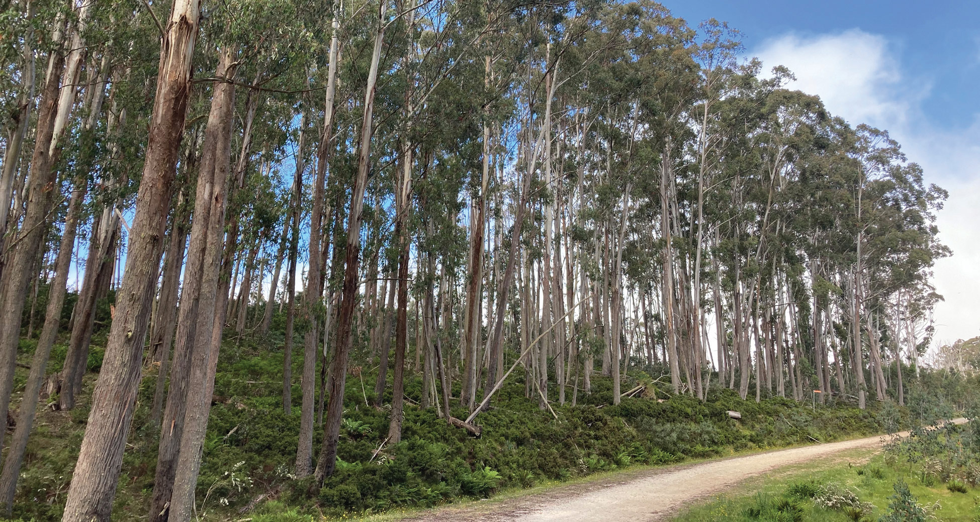
Alpine ash (Eucalyptus delegatensis) forests occur in wet subalpine areas at high altitudes. They are obligate seeders, meaning that while a high intensity fire kills most trees, forests regenerate via seed held in the canopy that’s released after the fire. However, if the regenerating forests are burnt again before the trees reach reproductive age, they will not regenerate naturally.
In the 150 years to the year 2000, populations of alpine ash across the Australian Alps have been impacted by bushfires, most notably in 1939. However, in the last 20 years, the severity and frequency of bushfire has dramatically increased. Between 2002 and 2013, high-severity fires occurred across 43% of mainland alpine ash forests¹. Between 2003 and 2009, more than 87% of Victorian Alpine ash forests were burnt, with some areas burnt multiple times within a decade². Studies demonstrate that the futures of alpine ash populations are threatened by these unprecedented increased fire frequencies.
Around 18,000ha of ash forest considered to be reproductively immature was killed in the 2019-20, bushfires. Post-fire studies however have shown that fortunately, much of the Alpine Ash regrowth from the 2003 bushfires, held a small seed crop, which, augmented by the aerial re-seeding of 11500ha, is hoped will contribute to successful regeneration of these forests.
Under rapid global warming, extreme fire events will be experienced more frequently, potentially interrupting any expected species migration to high altitudes^{3, 4}. Given the well-known sensitivity of alpine and the similar mountain ash (Eucalyptus regnans) forest communities to fire, many researchers and forest managers are deeply concerned about their long-term survival.
¹ David M. J. S. Bowman, Brett P. Murphy, Dominic L. J. Neyland, Grant J. Williamson, Lynda D. Prior, Abrupt fire regime change may cause landscape-wide loss of mature obligate seeder forests, Global Change Biology, Volume20, Issue3, March 2014, Pages 1008-1015, https://doi.org/10.1111/gcb.12433, accessed 03/06/2021
² Owen D. Bassett, Lynda D. Prior, Carolyn M. Slijkerman, Daniel Jamieson, Aerial sowing stopped the loss of alpine ash (Eucalyptus delegatensis) forests burnt by three short-interval fires in the Alpine National Park, Victoria, Australia, April 2015, Forest Ecology and Management 342, DOI:10.1016/j.foreco.2015.01.008 https://www.researchgate.net/publication/272297806_Aerial_sowing_stopped_the_loss_of_alpine_ash_Eucalyptus_delegatensis_forests_burnt_by_three_short-interval_fires_in_the_Alpine_National_Park_Victoria_Australia, accessed 04/06/2021
³ Hasson AEA, Mills GA, Timbal B, Walsh K (2009) Assessing the impact of climate change on extreme fire weather events over southeastern Australia. Clim Res 39:159-172. https://doi.org/10.3354/cr00817, accessed 04/06/2021
⁴ David et. al., 2014

Water
This focus area includes both waterways and the water sector in the region, which covers the collection, storage, treatment, delivery and supply of water, as well as recycled water. Within Gippsland this involves our water storages, domestic, commercial and stock water supplies, irrigation, industry (including power generation) and recreational use. It has also been acknowledged that, since the Victorian Government released its Water for Victoria policy in 2016, water is integral to the cultural values and uses of Traditional Owners.
Research conducted by the Victorian Water and Climate Initiative (VicWaCI) shows that the large variability in rainfall and streamflow that we currently experience is expected to continue in the coming years and challenge our region’s future water management. Other reports, such as The Long-Term Water Resource Assessment for Southern Victoria found that long-term surface water availability has already declined in all Gippsland water basins. The levels of decline vary between basins, however the continued reduction in stream flows and decrease in water availability will have broad impacts across the region and will be noticeable during periods of drought. Other impacts, such as the increased risk of storm events, flooding, rising sea levels and algal blooms will present additional challenges to the water sector, the natural environment and local communities.
Further challenges posed by climate change will include an increase in user demand during longer and hotter periods and drought, vulnerability of water treatment and sewerage systems with higher intensity rainfall events, and damage to critical infrastructure and built assets due to bushfires. There will also be added pressures on the ecosystems within critical water catchments with expected impacts including vegetation loss, habitat fragmentation, weeds and pest animals, damage to the environment and impacts of flooding following bushfire.
Water supply considerations such as security, quality and yield are reliant on the condition of the land and environment health within each of the catchments, as well as water-related infrastructure. Protecting infrastructure and building resilience to ensure the adaptive capacity of the ecosystems in our catchments is a high priority to secure future water quality and yield.
The risks that climate change poses to water quality will add pressure to the supply of water, with risks including blue green algal blooms, nutrient loads, pollution and emerging contaminants.
The security of a clean and readily available supply of water is critical during emergency events, not only for supporting emergency services in their response efforts, but for maintaining services to communities within the impacted areas during and after the event. Preparation and collaboration between sectors, as well as water corporations, has proved crucial in the past and will continue to have critical importance as the climate continues to change.

Multiple pieces of work, led at a state-wide level, are either in development or have been released to assist regional water management in a changing climate. The 2020 edition of the Guidelines for Assessing the Impact of Climate Change on Water Availability in Victoria includes updated climate projections and more tailored guidance on applying climate science to assist its primary audience of water corporations and other water resource managers. The guidelines are available at: https://www.water.vic.gov.au/climate-change/adaptation/guidelines.
Work is also progressing on developing the Central and Gippsland Sustainable Water Strategy, which will update and build on the previous Gippsland strategy released in 2011. This strategy will be used to manage threats to the quality and supply of water resources to better protect environmental, economic, cultural and recreational values. Further information on the development of the strategy can be found via the following link, Central and Gippsland Sustainable Water Strategy.
The future of Gippsland’s water availability is another important consideration for future coal mine rehabilitation options within the Latrobe Valley as there is further transition from traditional forms of power generation. The Latrobe Valley Regional Rehabilitation Strategy has been developed to provide guidance on mine rehabilitation issues and factors in the implications of a drying climate. Further information on the strategy, the implementation actions and the development of further guidance can be found via the following link, Latrobe Valley Regional Rehabilitation Strategy.

Relevant Regional Plans/Strategies
- Read the Pilot Water Sector Climate Change Adaptation Action Plan
- Read the West Gippsland Regional Natural Resource Management (NRM) Climate Change Strategy
- Read the East Gippsland Regional Catchment Strategy: Climate Change Adaptation and Mitigation Plan
- Read the West Gippsland Regional Catchment Strategy (renewal due late 2021)
- Read the East Gippsland Regional Catchment Strategy (renewal due late 2021)
- Southern Rural Water – Climate Change Adaptation Plan (not available online)

Steps toward adaptation
Strategic Direction 1
Determine water supply options for sectors and systems in a changing climate.
Initiative / action
A. Identify water availability in the region and how water supply and demand may change under future climate and population circumstances.
B. Determine needs and options, through existing planning processes, for achieving water security balance for domestic and industrial supply, the environment and Traditional Owner cultural values in Gippsland.
Strategic Direction 2
Secure environmental water for high-value waterways and wetlands.
Initiative / action
A. Identify priorities and develop a plan of works to improve the hydrological regime of floodplain wetlands and fringing wetlands.
B. Investigate alternate delivery methods such as the use of irrigation infrastructure to provide environmental water to high-value waterways and wetlands.
C. Investigate partial re-engagement of old river meanders to increase riverine wetland habitat.
Strategic Direction 3
Enhance land health and ecosystem resilience within water supply catchments.
Initiative / action
A. Build the adaptive capacity and resilience of the natural ecosystems within catchments to secure future water quality and yield.
B. Improve soil health and moisture-holding capacity on actively managed private land.
Strategic Direction 4
Protect critical catchment areas and water quality in the event of bushfires.
Initiative / action
A. Identify areas vulnerable to erosion and the control measures available to minimise the impacts of excess and contaminated water runoff, such as low impact, engineered solutions.
B. Continue monitoring and evaluation research of protection measures following bushfire events to assess impacts and implement continual improvement.

Strategic Direction 5
Protect water infrastructure in a changing climate.
Initiative / action
A. Identify critical infrastructure and assess its vulnerability to climate change impacts and significant events, including:
- bushfire
- flooding
- sea level rise
- algal blooms
Strategic Direction 6
Protect water infrastructure in a changing climate.
Initiative / action
A. Develop strategic plans, involving collaboration between Gippsland water corporations, to mitigate climate change threats, including retro-fitting existing assets and decentralised back-up emergency systems.
Strategic Direction 7
Manage the impacts of flooding on waterways, flood-plains and agricultural land.
Initiative / action
- Explore opportunities across freehold and public land to manage and address the impacts of flooding.
Strategic Direction 8
Understand the impacts of climate change and increased demand on recycled water options.
Initiative / action
A. Identify how climate change may impact on the use of recycled water for agriculture and industry. This would include possible effects on quality, availability, and susceptibility to being impacted by other climate-related impacts.

Key organisations
- Regional Water Corporations (all within Gippsland)
- Southern Rural Water
- Melbourne Water
- Local Government (all within Gippsland)
- Catchment Management Authorities (all within Gippsland)
- Gunaikurnai Land and Waters Aboriginal Corporation
- Bunurong Land Council Aboriginal Corporation
- Other Gippsland Traditional Custodians
- Department of Environment, Land, Water and Planning

Case Study - Macalister Irrigation District
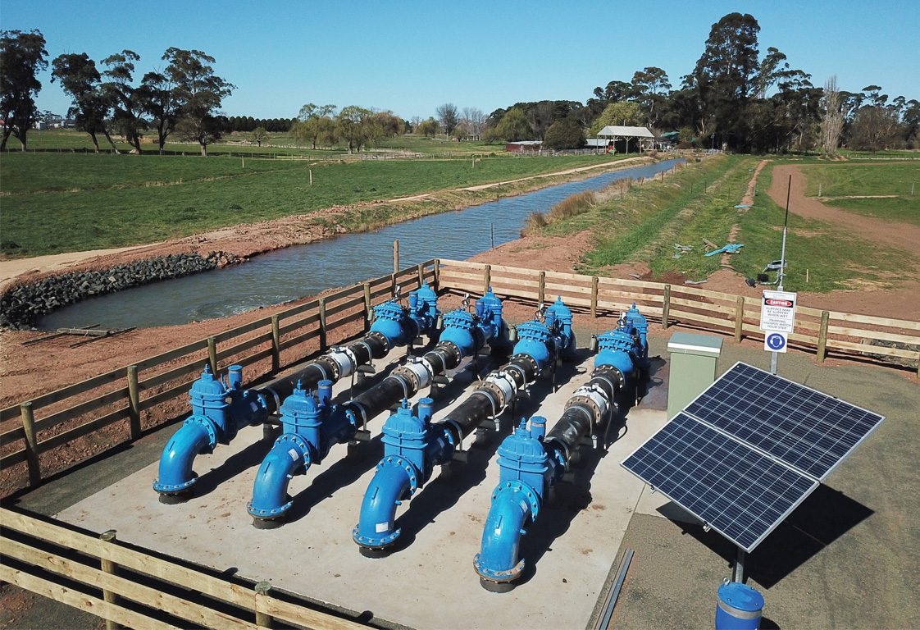
The Macalister Irrigation District (MID) is one of the largest of its kind in southern Victoria and plays a crucial role in the sustainability of the environmental, economic and social systems of Gippsland. The Victorian Government has committed to modernising Gippsland’s irrigation system to prepare for hotter, dryer conditions in the landscape brought on by climate change. These upgrades began in 2013 and are due for completion by 2030.
The MID2030 project will generate significant water savings by implementing more efficient water infrastructure. It will allow farmers to implement best-practice water use and more to improve their farm’s productivity, as well as helping to ensure the region is better prepared for the future impacts of climate change. As rainfall is projected to decrease, the MID2030 project has and will continue to modernise Macalister’s critical irrigation infrastructure to maximise the amount of water retained in the delivery system and optimise the quantity of water available for farmers’ use. So far, the project has provided regional farmers with an additional 22,000 megalitres of water with a further 10,300 megalitres worth of water savings expected by the final stage of the project, due in 2030.

Cultural Heritage and Cultural Values
Climate change will impact on Traditional Owners’ tangible and intangible cultural heritage. Impacts will include changes on Country to plants and wildlife, reduced stream flows, coastal impacts on cultural heritage sites of significance through inundation and erosion, as well as significant and severe events such as fires and flooding.
Traditional Owners have a cultural obligation to care for Country, but do not feel empowered to properly care for Country through current legislative tools and instruments. In a changing climate this is particularly disempowering as the rate of change can mean irreversible outcomes.
A key challenge for Traditional Owners is having the resourcing and the authorising environment to assess, monitor and respond to climate change threats on Country. To work towards this, it will be critical for existing collaboration and partnerships between Traditional Owner groups and natural resource managers to continue to grow. Further opportunities for ongoing employment, resourcing and empowerment should also be explored to meet this need.
With threats to cultural sites including coastal inundation and other significant natural events, there is a greater sense of urgency to identify and record these sites, and examine possible mitigation. This process would also include capturing the stories that each of these sites can tell before they are impacted.
Traditional Owner groups have a deep obligation to care for and heal Country, and have traditional ecological knowledge and customs built over thousands of years of practice. These practices are critical in helping Traditional Owners to remain connected with Country and be empowered to care for Country, which will take on great importance during a changing climate.

Relevant Regional Plans/Strategies
- Read the Gunaikurnai Whole-of-Country Plan

Steps toward adaptation
Strategic Direction 1
Understand the impacts of climate change on Country, cultural values and cultural heritage.
Initiative / action
A. Build knowledge and awareness, for agencies and the community, of the impacts that a changing climate will have on cultural landscapes, and tangible and intangible cultural heritage.
B. Monitor and respond to the impacts of climate change on Country through close collaboration between Traditional Owner groups and natural resource managers.
Strategic Direction 2
Understand how to best care for Country within a changing climate.
Initiative / action
A. Identify and implement options to manage and protect cultural sites where possible.
B. Secure resources to capture stories and archaeological information from sites that cannot be adequately protected.
C. Implement traditional practices to care for Country, such as using cultural fire on Country.

Key organisations
- Gunaikurnai Land and Waters Aboriginal Corporation
- Bunurong Land Council Aboriginal Corporation
- Other Gippsland Traditional Custodians
- First Peoples – State Relations (formerly Aboriginal Victoria)
- See Victoria’s current Registered Aboriginal Parties

Emergencies and Emergency Management
As a region, Gippsland has always been at significant risk from the impacts of emergency events due to its natural features and the spread of the built environment and population centres throughout the landscape.
The key areas of emergency response in Gippsland as we adapt to a changing climate are:
- increasing risk of bushfires due to an increase in hot days, more days of severe fire weather and longer fire seasons
- flooding caused by extreme rainfall events, sea level rise, storm surge and coastal inundation
- an increase in potential for algal blooms on waterways, which could be triggered by storm events, combined with nutrient release from fires and higher average temperatures.
The types of events already cause disruption within the region and pose significant risks to life and livelihoods of the Gippsland community. As well as causing devastation to the natural environment, these events also affect the region by:
- damaging critical infrastructure including roads, bridges and buildings
- isolating communities (from other communities, goods and services)
- directly impacting catchments and water quality
- damaging cultural heritage
- decreasing agriculture production
- impacting tourism during peak periods.
Agencies currently work with communities to provide them with education and information on the risks of natural events and how to best prepare themselves for an emergency. The future needs for informing and preparing the communities and people of Gippsland will have to consider changes in risk profiles across our landscape and each possible emergency scenario.
The bushfires of summer 2019/20 serve as a recent example that our fire danger periods are projected to lengthen and start earlier. The devastation was widespread and had significant impact on both communities and the environment. More than 1.1 million hectares were burnt within the region; houses and lives were lost in multiple communities and major transport corridors were cut off for extended periods. The scale and spread of the fires placed a strain on our existing critical infrastructure such as roads, telecommunications and supply lines.

Many of the impacts that were felt within the region during the 2019/20 fires have been experienced during previous major fires and incidents. In a new circumstance for many, authorities took the step of ordering an evacuation of a large geographic area in East Gippsland prior to a day of extreme fire and weather conditions. With three significant fires already in the landscape and worsening conditions forecast, authorities advised both residents and holiday makers to leave the area as impacts were expected on communities, recreations sites and major transport routes. This decision was made in peak holiday period and was a sign of the measures required to protect communities and visitors during extreme conditions.
Recovery has been an important focus within Gippsland following recent fire seasons. Recovery can happen on multiple levels, sometime simultaneously, including landscape and road network rehabilitation as well as at the community level. Community Recovery Committees are actively working to assist individuals and communities to connect with each other, as well as agencies, and rebuild their lives following the Black Summer fires.
Adaptation is not a new practice for emergency service agencies within Gippsland and Victoria, as they have been adapting to the impacts of climate change for many years already. Over the last few decades, various agency-wide innovations and response measures have helped emergency service agencies respond to events such as bushfires. However, with fire seasons extending in length and more frequent large-scale fire-fighting campaigns, there will be a continued need to adapt to future changes. These changes bring challenges to resourcing and fatigue management for personnel (including volunteers) as well as the community. With fire seasons overlapping with other states and areas, it provides additional strain on receiving assistance, resources and equipment from external agencies.
Emergency management planning in Victoria happens at three tiers. Plans at each tier reflect the appropriate level of Emergency Management responsibilities and actions for that tier. At the municipal tier the Emergency Management Plan is locally led and informs the priorities. In this way, the State, Regional and Municipal plans, in conjunction with any community plans, form a holistic planning landscape to mitigate, plan and prepare for, respond to and recover from emergencies (Figure 4).

Figure 4: Framework for emergency management planning
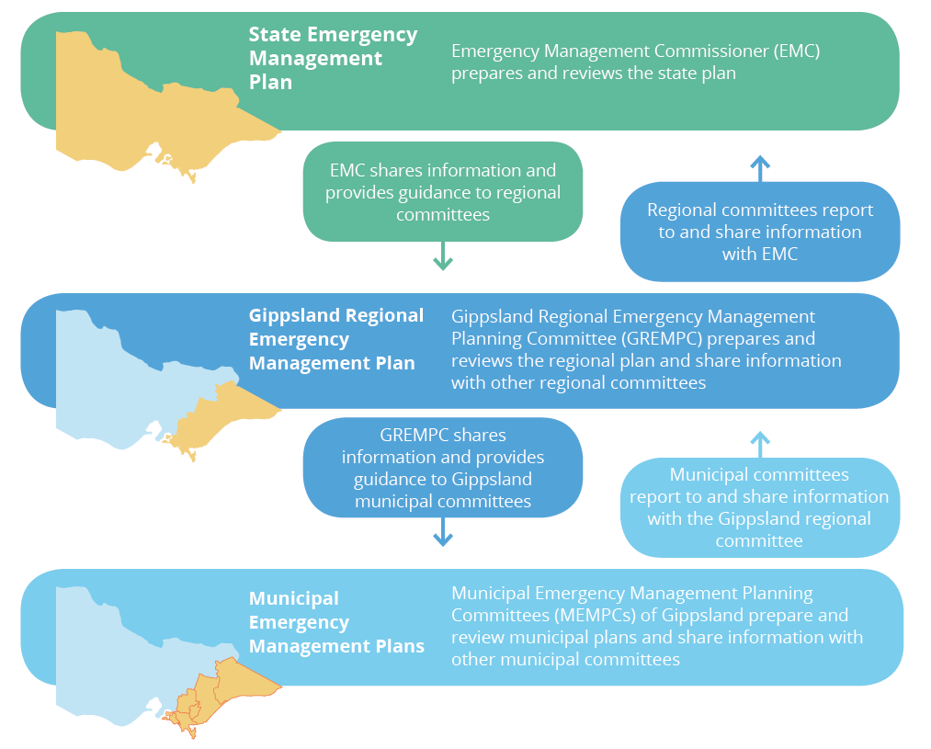

Relevant Regional Plans/Strategies
- Read the Victorian State Emergency Management Plan

Steps toward adaptation
Strategic Direction 1
Understand how climate change will influence natural disasters in Gippsland.
Initiative / action
A. Identify the changing risk profiles across the region, including:
- landscapes (natural environment)
- built environment (towns and communities)
- interface areas
- visitors to the region.
B. Determine the most appropriate fuel management techniques, accounting for vegetation communities, biodiversity values, topography and proximity to interface areas.
C. Further understand limitations on responders and support agencies (heat, extreme weather, no-go zones [remote areas]).
D. Explore opportunities across private and public land to manage and address the impacts of flooding.
Strategic Direction 2
Increase critical infrastructure resilience to the impacts of significant events.
Initiative / action
A. Enhance protection and establish reliable back-ups for essential infrastructure in emergency situations, such as:
- transport and access (road) network (for responders and the community)
- water supplies
- communications
- community relief centres
- power/emergency generators.
Strategic Direction 3
Increase community resilience during significant events and emergencies.
Initiative / action
A. Identify the opportunities and requirements to establish self-sufficient community facilities to protect and support rural and remote communities if they become isolated.
B. Provide community/health service organisations with the resources to map vulnerability across the region and develop emergency plans with clients at risk or without the resources to adapt.
Strategic Direction 4
Build back better following significant natural events.
Initiative / action
A. Identify and maximise opportunities to replace impacted infrastructure with designs more resilient and fit for purpose.
Strategic Direction 5
Prepare Gippsland emergency service agencies for response requirements in a changing climate.
Initiative / action
A. Understand and plan for longer duration events and fire danger periods and the impacts on responders and relevant agencies, including factors such as:
- resource requirements
- fatigue management.

Key organisations
- Forest Fire Management Victoria
- Emergency Management Victoria
- Victoria Police
- Country Fire Authority
- Fire Services Victoria
- State Emergency Service
- Local Government (all within Gippsland)
- Department of Environment, Land, Water and Planning
- Catchment Management Authorities (all within Gippsland)

Agriculture
Gippsland’s agriculture sector is a key component of the region’s economic and employment base. Farmers within Gippsland supply significant amounts of dairy, beef and vegetable produce to Victoria and are multi-billion-dollar contributors to the region and state’s economy. With an agriculture and food processing sector that is well renowned for high-quality and quality assured produce, Gippsland is also well-located to access Victoria’s major export hubs.
The projected further changes to the climate have the potential to affect Gippsland agriculture in multiple ways. The increase in average temperature, coupled with reduced rainfall will greatly impact upon the cropping, pasture, vegetable and fruit varieties that farmers can produce. The Victorian Climate Projections 2019 also suggest that in the short term, there is an increased possibility of frosts in some areas with clearer night skies. Projected increases in severe weather events (heat, storms, wind) will also have a significant effect on horticulture and dairy production, as well as threats posed by bushfires.
Government agriculture departments, at both state and federal level, recognise the impact that climate change will have on the sector and have adopted adaptation priorities into their respective plans. Ensuring that Gippsland’s agricultural climate change response and actions are aligned with these plans and supporting programs is an important step in our region’s successful adaptation. The release of Victoria’s Climate Change Strategy in conjunction with the Agriculture sector pledge outline the aims for the agriculture sector in responding and adapting to climate change.
The agriculture sector has many links with other sectors and systems throughout the region. Close relationships already exist between the systems and sectors of primary production, the natural environment, water and transport. The need for ongoing and effective collaboration between these sectors and all organisations, businesses and individuals is vital to ensure that primary producers can continue to be supported as they provide for and support the region.
Gippsland’s expansive geographic footprint poses challenges and opportunities when developing adaptation solutions. The various weather influencers and drivers across Gippsland will be affected differently by climate change with multiple solutions needed across the region, in both irrigated and dryland farming areas. This offers opportunities to develop climate resilient diversification in the agricultural sector across Gippsland. Matching land capacity and capability with the pasture and cropping varieties that will suit current and future climate conditions will work towards identifying diversification and adaptation options for producers.
A part of increasing agricultural diversification opportunities will include improving and maximising land health for local producers. Achieving good land health involves using best practices in farm planning, creating healthy soils, effective farm water management, soil conservation, grazing/ pasture management and sustainable cropping. Some of the elements of land health, such as minimum tillage, improving ground cover, increasing soil organic matter/carbon and water holding capacity are also commonly referred to as aspects of regenerative agriculture.
Work has been underway within the agricultural sector in Gippsland on adapting to climate change for many years. From previous research to early adopters of changed practices, there are some great existing examples of adaptation within the region. Gippsland is home to the AgVic Smart Farm at Ellinbank, Australia’s leading dairy innovation and research facility.
Important and beneficial research into the impacts of extreme heat events on the dairy industry and trialling innovation and technology to create a carbon-neutral farm is exciting work that is happening within the region. Work is underway to open the AgVic Smart Farm at Ellinbank research centre to visitors by late 2021 to allow farmers to see new technology in operation. The Gippsland Agricultural Group Inc is a volunteer not for profit organisation that is conducting trials and demonstrations on a dryland farm located in Bairnsdale. The group is focusing on four key areas of dry-land agriculture, including healthy soils, productive pastures, future grain and fodder, and premium livestock. Viable practices that are proven at the Gippsland Research Farm will be moved to satellite farms on a larger scale for further research.
Opportunities to improve and shorten supply chains allowing Gippsland agriculture products to reach local markets is an option that can be explored within the region. Where possible, these initiatives could provide better access to local markets, reduce the food miles for local produce and add further value to the region.
The challenge is often finding the most effective way to share, support and encourage widespread uptake of adaptation methods and techniques. Ensuring that Gippsland farmers and producers can plan, prepare and respond to seasonal variability and further climate change is key to the successful adaptation of the agricultural industry within the region. Achieving this will rely heavily on farmers receiving the support of service providers and the agriculture industry. Extension officers with the appropriate levels of technical and practice change knowledge will be best placed to deliver this support effectively, and be available to interpret the range of existing information and how it can be implemented on individual farming properties.
Gippsland’s producers will be encouraged to embrace technology and innovation as well as research and development in their own individual adaptation planning and action. While new practices and technology will be useful, effective business management skills will be critical for producers to remain viable during the toughest years.

Relevant Regional Plans/Strategies
- Read the Strong, Innovative, Sustainable: A New Strategy For Agriculture In Victoria
- Read the Agriculture sector pledge

Steps toward adaptation
Strategic Direction 1
Understand the agricultural needs and potential of Gippsland in current and future climate scenarios.
Initiative / action
A. Collate and review existing research on climate change and primary production. Identify which gaps may exist for Gippsland produce and markets.
B. Identify pasture and cropping species/varieties that will suit projected Gippsland climatic conditions.
C. Match land capability and capacity with land use and management (linking with action 1b).
Strategic Direction 2
Utilise engaged networks and knowledge channels to upskill producers and provide them with critical adaptation practice information.
Initiative / action
A. Support the delivery of practice change and adaptation knowledge through:
- producer level demonstration
- training
- education
- coaching and mentoring.
B. Work with producers to develop their natural resource management skills and create individual farm plans implementing adaptation best management practice.
C. Equip producers with business management information and practices to endure variable years and income.
D. Provide capability development for the next generation of farm managers, ensuring that they have the adaptation skills required for the future.
Strategic Direction 3
Maximise profit and adaptation through innovation.
Initiative / action
- Support primary producers to embrace innovative approaches by utilising modern technology (with the aim to becoming carbon neutral), and research and development to maximise income.
Strategic Direction 4
Provide adaptation assistance by improving and maximising land and soil health.
Initiative / action
A. Support the adoption of best practice land management (examples outlined on page 22) that improves land and soil health, and production outcomes.
B. Provide adaptation support to producers and agricultural enterprises through extension, incentives and trials.
Strategic Direction 5
Recognise agriculture needs in land-use planning.
Initiative / action
A. Support strategic approaches to land-use planning that account for the needs of the agricultural sector:
- match land capability, climate requirements and changing land-use under climate change
- recognise competing priorities, such as urban expansion.
Strategic Direction 6
Implement best practice to protect environmental values.
Initiative / action
A. Greater enhancement and protection for riparian buffers and remnant vegetation on private land.
B. Encourage increased reuse and recycling of water by agriculture and industry (linking with action 8a in the Water focus area).
C. Promote and encourage the integration of local native species in plantings for shade and shelter with landholders.
D. Encourage landholders in peri-urban areas to undertake biodiverse plantings and allow natural regeneration to occur (with consideration to fire risk).
Strategic Direction 7
Support local supply chains.
Initiative / action
A. Identify and support opportunities to improve and shorten supply chains allowing Gippsland agriculture producers to reach local markets.
Strategic Direction 8
Increase carbon sequestration to improve land and soil health.
Initiative / action
A. Support carbon sequestration through the establishment of targeted biodiverse plantings in areas of private land that address priorities for biodiversity, land and waterway health.
B. Support carbon sequestration through the establishment of targeted farm forestry plantings on private land.
C. Support carbon sequestration through the protection and enhancement of teal carbon environments including freshwater and brackish wetlands on private land.

Key organisations
- Department of Jobs, Precincts and Regions
- Agriculture Victoria
- Food and Fibre Gippsland
- Gippsland Agricultural Group
- Catchment Management Authorities
- Southern Rural Water
- Landcare Networks

Case Study - Growing Southern Gippsland
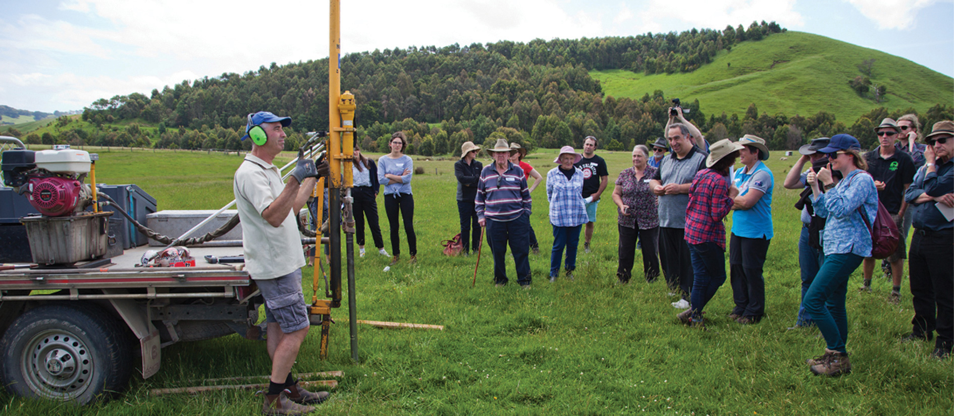
A collaboration between the Bass Coast Landcare Network, the South Gippsland Landcare Network, Federation University Australia, RMIT University and the Bass Coast Shire Council, the Growing Southern Gippsland (GSG) web portal is an enabling tool for South Gippsland farmers. Bringing together regionally specific climate change information and agriculture best practices, GSG seeks to connect like-minded South Gippsland farmers and help them with climate change planning and adaptation. GSG is designed to encourage the public to identify and target their own knowledge gaps. The portal hosts several case studies that have been developed to provide the public with local stories of positive change that farmers can identify with and potentially implement on their own land.

Primarily GSG is a host for several resources that local farmers can use to inform the path they choose to make in preparing for a hotter, dryer climate in the future. Among the resources that GSG provides farmers is the opportunity to create their very own Climate Action Plan (CAP). This template has been tailor made to assist farmers to further investigate potential new methods of farming that are climate friendly and can be easily implemented on their land. Another key feature of the portal are the future climate projections, dedicated to how the changing climate will affect South Gippsland. This resource lays out the facts in a clear and simple manner to inform local farmers about how their business will be affected in the coming years. From there, it directs them to resources such as the CAP that can help them to accomplish their plan.
GSG aims to connect South Gippsland farmers to resources that can help prepare them for the changing climate, allowing them to continue in their industry long into the future. Visit Growing Southern Gippsland.
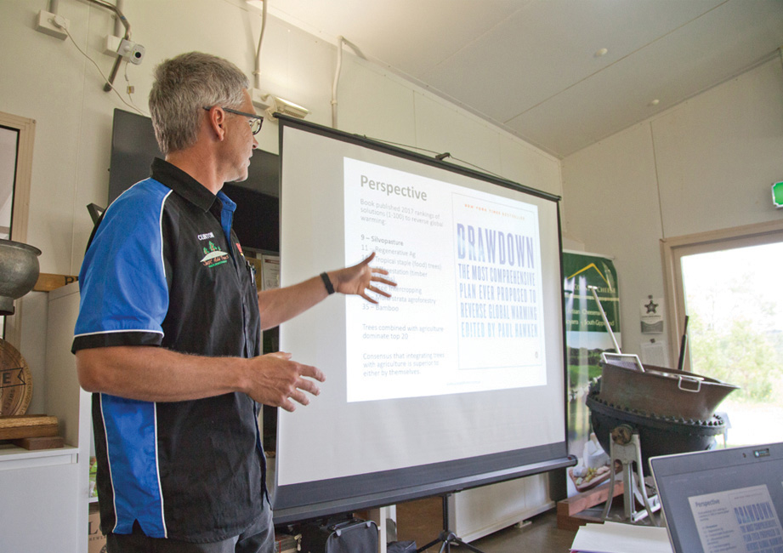
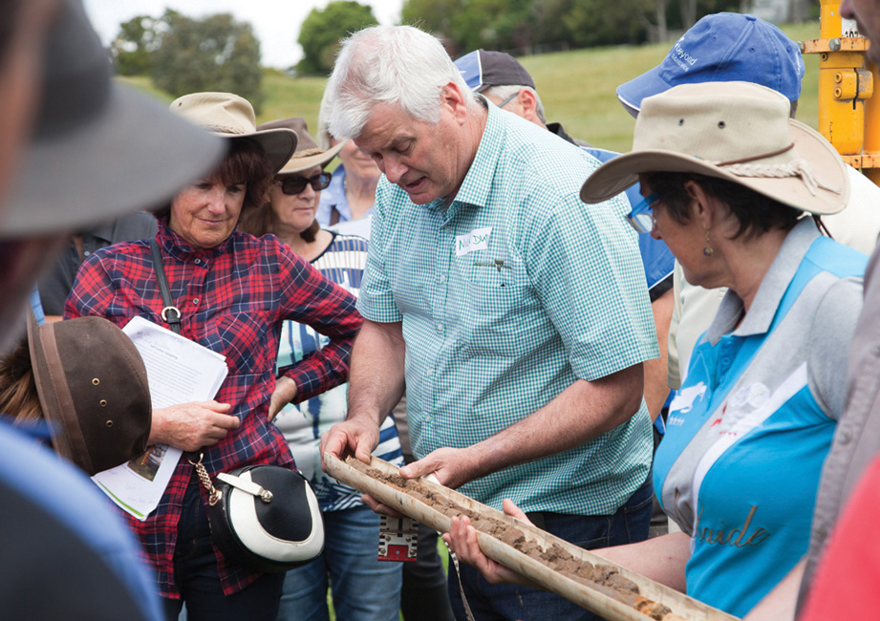

Health and Human Services
Adaptation to the impacts of climate change in the areas of health and human services will be a critical factor in the continued health and well-being of the Gippsland community. The 2019 climate projections indicate that Victoria will experience increases in both intensity and frequency of extreme weather. Both outcomes will aggravate existing health risks and increase the pressure on our health services.
The combination of gradual climactic changes and extreme events will create both direct and indirect impacts on human health. The direct impacts on human health can include:
- heat stress
- trauma
- injury
- death
- negative mental health impacts
Indirect impacts on human health can include:
- water-borne diseases (affecting drinking water, water supplied for domestic and agricultural use and recreation water)
- air pollution arising from bushfires
- food-borne diseases from rising temperatures
- airborne pollen impacting thunderstorm asthma risk
- vector-borne diseases (e.g. transmitted from mosquitos to humans) arising from changes to mosquito breeding habitat and environmental conditions.
These projected impacts will also affect our health system’s ability to deliver services. Additional strain and pressure will be placed on multiple aspects of service and delivery, including:
- more frequent surges in client demand
- disruption of supply chains
- damage to infrastructure (from significant events such as fire, flood or storms)
- disruption to service access or delivery, including access to remotely located clients.
A common concern is that there is a gap in the community’s knowledge and awareness of the health impacts of climate change, both current and into the future. Existing resources in the form of information and advice are readily available through the Better Health Channel website. The challenge is to effectively promote these messages and information to the community through all available options including health services and the established support networks within the region.

Further changes to the climate and the impacts of extreme events have the potential to exacerbate existing health issues in the community, as well as increase the risks to people’s mental health. Preparing communities and individuals with the appropriate knowledge, skills and confidence is seen as an effective way of preparing people to respond to arising mental health challenges. This can be achieved through formal training, such as in the following examples:
- Mental Health First Aid (MHFA) https://mhfa.com.au/
- Applied Suicide Intervention Skills Training (ASIST) https://www.livingworks.com.au/
- Minds Community Trauma Toolkit https://emergingminds.com.au/resources/toolkits/community-trauma-toolkit/
This training was delivered in East Gippsland following the impacts of the fires in 2019/20, however local mental health practitioners strongly advocate for this training and preparation to be more available for individuals and communities prior to extreme events. This would better equip communities with the ability to respond to mental health and psychological distress in a prepared and confident way.
Supporting the adaptation of Gippsland’s health and human services, and that of the community, will require collaboration and actions across a range of sectors. Responsibility and action will extend beyond regional health service providers.
Examples include:
- meeting the needs of the vulnerable and disadvantaged members of the community who are more likely to experience negative health affects due to climate change
- advocating to ensure public housing properties are thermally safe to protect vulnerable residents from the effects of extreme heat
- Local Government Municipal Public Health and Wellbeing planning incorporating actions related to climate change and health, and work to strengthen community connections
- owners of community social infrastructure in small towns such as halls, community centres and neighbourhood houses supporting work to ensure they can be places of refuge from extreme heat and smoke events
- residents and businesses taking action to improve the security and safety of private drinking water supplies (non-reticulated supplies such as rainwater, bores, dams etc.)
- communication and collaboration between health authorities, water corporations and other relevant authorities to address potential risks for water supplies (with planning to identify emerging risks and future needs).

Relevant Regional Plans/Strategies
- Read the Pilot health and human services climate change adaptation action plan 2019–21

Steps toward adaptation
Strategic Direction 1
Health services vulnerability to climate change is understood and managed.
Initiative / action
A. Advise Health Service Boards to ensure they understand risk and consider vulnerability assessments in the development of Strategic Plans.
Strategic Direction 2
Health services understand climate change impacts on delivery and the community’s health.
Initiative / action
A. Share climate change information among regional health services and practitioners, with connections to necessary data sources.
B. Source and disseminate existing examples of prevention strategies and communication tools among regional health services so that they are readily and easily implemented.
Strategic Direction 3
Minimise heat-related illness and death.
Initiative / action
A. Support implementation of Victoria’s Heat Health Alert system by encouraging the general community to prepare for extreme heat to protect themselves and those in their care, particularly those most at risk.
B. Utilise heatwave planning guides available for local government and residential aged care facilities to ensure heat health plans are in place.
Strategic Direction 4
Increase community awareness of how climate change can impact physical and mental health.
Initiative / action
A. Promote existing education materials⁴ to the community, that translate broad climate change risks and threats into meaningful examples.
B. Establish partnerships with the community sector to co-design and communicate this information due to organisations’ understanding of local vulnerability.
C. Explore options for communications to be accessible, translated, and communicated through a range of channels so all parts of the community can benefit.
Strategic Direction 5
Support collaboration between health services and non-health related sectors to prepare for climate change impacts.

Initiative / action
A. Collaboration between health services and local government to incorporate climate change impacts and adaptation considerations into the Municipal Public Health and Wellbeing Plans (MPHWP).
B. Ensure effective collaboration and information sharing between health services and non-health services providers (such as essential service providers) in the region to identify future needs and allow for necessary planning.
Strategic Direction 6
Support and promote positive mental health and wellbeing within the Gippsland community.
Initiative / action
A. Provide mental health training for communities and individuals to prepare them for the sudden and gradual impacts of climate change.
B. Determine the best methods for providing mental health support for communities and individuals during and following the impacts of large-scale events and impacts.
Strategic Direction 7
Support residences and businesses on private water supplies to adapt to climate change threats, including security of supply and changing environmental water quality.
Initiative / action
A. Complete an assessment of:
- the extent of reliance on private water supplies
- the predicted impacts of climate change on private water supply, security and quality.
B. Develop proposals for government consideration of how to address climate risks to private water supplies.

Key organisations
- Department of Health
- Department of Families, Fairness and Housing
- Gippsland Primary Health Network
- Hospitals (all within Gippsland)
- Local Government (all within Gippsland)
- Red Cross
- General Practitioners
- Bush Nursing Centres
- Aboriginal Community Controlled Health Organisations

Built Environment and Transport
Within this strategy, this focus area incorporates both built environment and transport. This includes domestic housing, public, commercial and industrial built assets, infrastructure for transport networks (roads and rail), utilities and broader residential/urban settings, commercial and private ports, as well as fishing and boating infrastructure.
As with most of the focus areas in this strategy, the need for adaptation to the impacts of climate change within the built environment extends across multiple sectors. For instance: housing impacts on health; transport infrastructure on industry/regional economy; and utilities and critical infrastructure service multiple sectors.
Some specific challenges include:
- high levels of poor quality private and public housing in the region which becomes thermally unsafe in extreme weather, and expensive to run for often lower income households
- increased number and severity of bushfires, storms and floods which can impact on community and health of built assets.
Continued sea level rise and storm intensity, coupled with the subsequent coastal erosion and coastal inundation, will impact private and public assets including surf life-saving clubs, ports and jetties as well as roads and transport networks, and utilities infrastructure such as for sewerage, water and gas. Planning for current and future land use as well as asset adaptation, or a managed retreat, is necessary in the immediate future to ensure that action can respond in time to emerging threats.
The majority of the housing, public, educational and commercial building stock within Gippsland has not been designed or constructed to withstand the projected increase in temperatures or extreme heat. Many homes currently lack existing thermal comfort features which can create health and wellbeing issues during both winter and summer. Those most affected are the vulnerable and disadvantaged within the community who have less capability to address and resolve the issues.
The protection and integrity of our transport network is crucial to the region’s connectivity. Significant natural events in the past 20 years have caused the closure of major highways, cutting off communities and blocking supply chains. These situations have the potential to prevent people from accessing essential services as well as creating economic interruptions to the region. Ongoing coastal impacts will add challenges to port and waterway-based transport, with challenges placed on maintaining safe passage through channels with ongoing sand movement.
Urban areas will face potential impacts from both increasing temperatures and intense rainfall events. Urban heat island effects in central business districts and residential areas have the potential to increase temperatures which can have a negative impact upon human health. Intense rain events have the potential to create localised flooding within urban areas which will add pressure to existing stormwater networks.
While both pose challenges and risks, adaptation opportunities exist with the implementation of green-blue infrastructure which can either in part or fully mitigate the impacts. This type of design successfully incorporates natural systems that provide urban greening and cooling (trees, parks, gardens) as well as stormwater management to manage intense rain events (drainage areas, flood storage).
Key assets that provide services such as communications and supply of power can be cut during major incidents or impacted during extreme heat. Ensuring that the supply of these services can remain uninterrupted or that back up options are in place is a critical part of ensuring our successful adaptation.
Population and associated industry and services may grow in relation to other regions, as the relatively milder climate of Gippsland attracts those seeking refuge from harsher climates on mainland Australia.
Future financial implications include increased insurance costs associated and ultimately non-insurable building stock due to risk of fire, floods, storms and coastal inundation.
The overarching aim is to prepare the built environment to deal with climate change impacts and provide ongoing adaptation functions. This applies to both modifying aspects of the existing built environment as required, as well as incorporating adaptation principles into new additions to the built environment.

Steps toward adaptation
Strategic Direction 1
Assess key infrastructure vulnerability to inform adaptation planning.
Initiative / action
A. Assess vulnerability of key regional infrastructure and the impacts of failure (responsible agencies and asset owners).
B. Agencies to collaboratively develop an understanding of asset interdependence and the impacts of failure/s on surrounding and dependent infrastructure and systems.
C. Responsible agencies to develop a greater understanding of higher risk areas and implement adaptation measures to reduce risk.
Strategic Direction 2
Build understanding of coastal asset vulnerability.
Initiative / action
A. Support land owners, land managers and asset owners along the coast to adapt or make a planned retreat in areas impacted by sea level rise and storm surge.
B. Assess the level of impacts likely on Gippsland coastal assets (ports, sea walls, jetties, boat ramps) to enable effective adaptation planning.
Strategic Direction 3
Provide connected and resilient transport networks.
Initiative / action
A. Assess where changes to transport networks will enable the provision of robust and efficient connection of industries, communities and markets into, within and out of Gippsland.
Strategic Direction 4
Promote and encourage adaptation and resilience measures within urban environments.
Initiative / action
A. Investigate blue-green infrastructure opportunities, such as integrating urban forestry and stormwater management, to enhance and implement new green spaces and mitigate urban heat island effects.
B. Support and encourage the improvement of thermal efficiency of public, rental and owner occupied current (retrofit) and new housing stock. Priority to be given to the vulnerable and disadvantaged members of the community.
C. Investigate and support opportunities to provide climate safe spaces within the community.
Strategic Direction 5
Enable agents of change such as government, community groups, organisations and industry to implement effective adaptation.
Initiative / action
A. Define and clarify regional responsibilities and identify practicalities related to adaptations regarding responsibility for public and private spaces.
B. Provide support for local government and community adaptation activities and projects.

Key organisations
- Local Government (all within Gippsland)
- Department of Environment, Land, Water and Planning
- Regional Roads Victoria
- V/Line
- Gippsland Ports
- Catchment Management Authorities (all within Gippsland)

Community
The increased reach of climate change influences on the community will be driven by the projected impacts on health and wellbeing, the economy and lifestyles. The current and further impacts of climate change are and will be felt differently across the region, as well as experienced differently according to each individual and their circumstances.
With such variation across the region, adaptation at a community level will need to be place-based. Preparing and informing communities will be essential in empowering them to take appropriate adaptation action. While the most severe of the scenarios listed above may not occur within the immediate decades, boosting awareness and making incremental changes, in line with local conditions and influences, will allow future generations to be better prepared. Providing communities with opportunities to implement adaptation on an individual and community level, as well as within the natural environment, could remove a sense of disempowerment or lack of control that can be associated with the enormity of climate change.
Health and social wellbeing is affected by the ability to move freely around the built and natural environment, as communities experience the exposure to heat, heat islands in urban areas and other extremes, disrupted operation of public transport, and diminished access to roads that may be affected by fires, flood or storms. Increases in disease and disease vectors and water quality issues due to increased temperatures and potentially compromised water and waste infrastructure will add to stressors on communities.
If farmers and primary producers cannot adapt or diversify fast enough, the agricultural sector is at risk of further compounding financial hardship and a diminished ability to afford upgrades that would help to prepare for continued changes to the climate. The flow on effects impact the rest of the community though less expenditure, job losses, and potentially food insecurity. A continued long-term decline in rainfall and increased variability during the seasons, crop pests and disease may also impact food production and security.
Lifestyle and leisure are fundamental influences on the overall health of communities, individuals and the visitor economy. Impacts are expected upon recreational and lifestyle opportunities as climate change will affect natural areas such as beaches and snow fields, and extreme weather also impacts on the use of recreational sites. Impacts on water quality will affect access to and the appeal of water-based sports. Water availability and use will affect surfaces such as playing fields, and extreme heat or flooding may damage constructed surfaces. Gradual increases to temperature, as well as extreme conditions, will also influence and impact play schedules for organised sports, and participation in informal sport and recreation.
Community and social service organisations are likely to experience a higher demand for services as they look to support clients who are further impacted by the effects of climate change. Organisations will need support to build their resilience as well as protect staff members and prevent disruptions to service delivery.
Possibility for changes in regional population, employment and business opportunities in the decades to come exist as people and businesses may elect to move to a more moderate climate, with southern Victoria the most likely option on mainland Australia. This may result in positive economic development; however timely, proactive and adaptation-aware planning will be needed to ensure that increased housing, industry and employment options are developed in ways that are adaptive to climate changes, and without loss to valuable natural and agricultural lands.
Adequate household insurance is widely accepted as a positive contributor to a household’s and community’s recovery after an emergency. Research⁵ has found that more than half of Victorian households either have no insurance or have inadequate insurance. Home and contents insurance builds resilience to more frequent and more extreme emergency events occurring because of climate change. A continued focus is to lift the prevalence of home and contents insurance, particularly for low-income households living in high risk areas with little or no home and contents insurance.
Similar to the Natural Environment focus area, opportunities exist to encourage the public and communities to build their knowledge and awareness of the climate change impacts that will influence their lifestyles. As is suggested in the Natural Environment focus area, this can include the opportunity to empower people to implement action at an individual or community level.

Relevant Regional Plans/Strategies
- Read the document - A climate of fairness - Victorian Council of Social Service

Steps toward adaptation
Strategic Direction 1
Inform the community about the impacts of climate change on practical aspects of lifestyle.
Initiative / action
A. Provide the community with relevant information on how climate change will impact lifestyle, health and wellbeing.
B. Provide the community with practical options on how to be involved and implement adaptation on an individual and community level.
C. Determine how regional agencies and service providers can support the community with building adaptation capacity and resilience. Identify the best support network opportunities.
Strategic Direction 2
Protect people from extreme heat in urbanised and rural areas.

Initiative / action
A. Prepare outdoor spaces in urban areas to be temperature proof for commuting, work and leisure.
B. Support Gippsland employers with tools, options and examples to assist with preparing working environments that are suitable and safe in the event of extreme temperatures and adverse weather.
Strategic Direction 3
Ensure community facilities are more resilient to a changing climate and safer during more frequent emergency events.
Initiative / action
A. Support the owners/managers of social community infrastructure to:
- improve their thermal safety and comfort so they can provide respite during heatwaves
- improve indoor air quality at the facilities when there is extremely poor air quality due to bushfire smoke.
Strategic Direction 4
Enable communities to continue to participate in outdoor recreation within natural landscapes and built sites.
Initiative / action
A. Increase flexibility to conduct outdoor recreation outside of extreme temperatures.
B. Prepare outdoor sporting fields and recreation areas with climate appropriate plantings and maintenance. Utilise alternate water sources where possible (reused stormwater or treated wastewater).
Strategic Direction 5
Ensure future population changes will enhance or not detract from the natural and built environment.
Initiative / action
A. Provide for large population changes in planning new housing developments and individual builds.
B. Plan for employment and new industry that supports a changed population to achieve positive impact on the wellbeing of the community, economy, and natural and built environments.

Strategic Direction 6
Maximise community action, participation and connection to nature.
Initiative / action
A. Support health and well-being programs that boost community awareness and participation in implementing climate change adaptation and mitigation actions at both individual and community levels.
B. Promote the importance of adequately protecting and insuring personal assets and possessions through the ‘Insure it, it’s worth it’ Toolkit⁶.
C. Use a variety of regional and local communication channels to deliver the ‘Insure it, it’s worth is’ campaign messages⁷.
⁵ Essence Communications, DHHS Underinsurance Research, Topline Findings, October 2016
⁶ http://goodshepherdmicrofinance.org.au/researchreports/insurance-toolkit/
⁷ https://www.betterhealth.vic.gov.au/insure-it-its-worth-it

Key organisations
- Local Government (all within Gippsland)
- Department of Health
- Department of Families, Fairness and Housing
- Victorian Council of Social Service
- Gippsland Climate Change Network
- Local Climate Action Groups
- Community Service Organisations
- Local Health Services

Knowledge
The focus area of Knowledge, which encompasses education, training, awareness and research, has priorities that differ slightly from the other areas within this strategy. The directions and actions within this area focus on how to effectively reach into, and influence, communities and sectors to contribute towards effective regional adaptation.
Research is a critical part of the Knowledge focus area to increase understanding of needs, options and effectiveness of adaptation strategies and actions. Research impacts on all areas within this strategy including health, biodiversity, water management, social research on behaviour change, visitor economy, animal and human health, community and environmental education. Gippsland based researchers and institutions, as well as those outside the region, have provided expertise and have already been involved in climate-based research and projects. Opportunities exist to continue research of climate change impacts and adaptation opportunities within the region. The Gap analysis of 2018 emphasised the need for research institutions and their work to partner closely with local organisations and authorities to increase the level of influence of their work.
Building adaptation awareness and providing education for the community outside of the formal education structure is an opportunity within the Knowledge focus area. Providing readily available, regionally specific climate change adaptation information and resources will assist the community to better understand the concepts of adaptation. These would be complemented by providing examples of existing adaptation actions and research. Benefits to the community would include boosting knowledge of how climate change could impact people personally and the actions that individuals, the community, businesses and organisations can make to take ownership and adapt to climate change. This also relates to the Community focus area within this strategy.
Through the education sector there is an opportunity to address the general lack of understanding between climate change, climate mitigation and climate adaptation. The advantage of increasing the profile of adaptation knowledge and opportunities is providing positive actions that can increase our resilience to changing circumstances and limit harmful impacts. To achieve this, it has been highlighted that educators would benefit from professional development opportunities as well as having educational materials focused on climate change adaptation.
Gippsland has a comprehensive network of formal and informal knowledge structures that could be used to deliver adaptation information to the broader community. With the development and increase in the capability of flexible, digital and remote learning opportunities during the 2020 COVID-19 pandemic, this has further increased the opportunities to reach the community through all available structures.

To support a broadly diverse informed community, the strategic directions are to:
- support formal education programs
- encourage research partnerships with industry business and academia
- support industry and lifelong learning organisations to understand and educate about adaptation needs and options
- educate leaders to increase and diversify the knowledge base.

Steps toward adaptation
Strategic Direction 1
Develop formal education curricula to engage and incorporate adaptation knowledge and actions.
Initiative / action
A. Develop and circulate educational materials about climate change adaptation (with Gippsland context) that align with current curricula.
B. Provide climate change adaptation professional development for teachers and educators.
C. Support local tertiary education providers to identify opportunities to develop and deliver courses or subjects to provide adaptation knowledge and skills for current and future requirements.
Strategic Direction 2
Promote and encourage interdisciplinary research and partnerships.
Initiative / action
A. Identify and encourage partnerships between research organisations and industry that combine industry insights and access with research expertise and methodology.
B. Promote data sharing and access to Intellectual Property across sectors and throughout the region to develop region-specific resource materials.
C. Establish evaluation frameworks for industry research partnerships to assure return on investment from any joint programs.
Strategic Direction 3
Actively share adaptation education and awareness within and through industry, community educational and training networks.
Initiative / action
A. Develop resources (based on best management practices) that support non-formal education networks to present adaptation awareness and education. Include frameworks that assess vulnerabilities and suggest adaptation measures and practice change options.
B. Utilise established networks to promote adaptation planning and climate change risk assessments within the community, industry and business.
Strategic Direction 4
Equip and educate leaders with climate adaptation knowledge.
Initiative / action
A. Build upon the adaptation momentum created by the COVID-19 pandemic and explore the parallels with climate change impacts and adaptation opportunities.
B. Identify existing and encourage new communities of practice to develop leadership in adaptation.
C. Analyse and evaluate existing programs to adopt and translate successful models of leadership, action and education to other sectors.

Key organisations
- Department of Education and Training
- Primary and Secondary schools
- Federation University
- TAFE Gippsland
- Neighbourhood Learning Houses
- Resource Smart Schools Gippsland

Case Study - Gippsland Community Leadership Program
The 2018 Gippsland Climate Change Gap Analysis identified a lack of knowledge and leadership within the community around action on climate change in the Gippsland region. This program was developed to fill this gap by connecting with and educating key members of the Gippsland community so that they can in turn spread this knowledge within their own networks.
The approach taken was to hold a one-day workshop that was a mixture of presentations and activities. To achieve this, a training module was developed that covered:
- the science of climate change and how it is impacting Gippsland
- building climate change vulnerability and risk assessment literacy
- how to incorporate climate vulnerability risk assessment into business planning and reporting (scorecard)
- Bass Coast Shire’s Climate Action Plan
- resources on sustainability auditing for business (energy, water, transport and supply chain, waste) – include in resource materials.

The workshop saw the desired outcome of a higher degree of knowledge and awareness surrounding the risks and impacts of climate change amongst the program participants. It was noted that participants responded well to the worked example highlighted in the Bass Coast Shire’s Climate Action Plan.
The success of this program has seen it endorsed to become an annual event on the Gippsland Community Leadership Program’s calendar, whilst the method has been recommended for similar programs across the state.

Regional Economy
Gippsland’s economy has been built upon the region’s ready access to natural resources and fertile land which currently supports industries such as power generation in the Latrobe Valley, agriculture, timber production and a visitor economy that benefits from our diverse landscapes, local produce and the hospitality industry. Supporting industries and sectors that provide major economic contribution or significant employment within the region include manufacturing, construction, health care, retail, and education and training.
Potential threats to the regional economy are broad, including costs associated with installing, upgrading or adapting infrastructure to withstand climate change impacts, population relocation, loss of work capacity due to extreme heat, diminishing harvest yields and increases in the price of food items and consumer goods.
Although the most severe and full extent of these threats may be decades away, it will be important to communicate these threats, build understanding and commence appropriate planning over the five-year timeframe of this strategy and beyond. Strong collaboration between all sectors will be essential to complete adequate adaptation planning and preparation.
The impacts of climate change threaten to impact the Gippsland economy in many of our places of current advantage. As one example, the bushfires during the summer of 2019/20 laid waste to significant tracts of forest, farmland and tourism assets. The bushfires also impacted local transport networks and, with increased attention and warnings, many people cancelled their visits to the region, even in areas unaffected by fire.
The tourism industry faces multiple challenges with a further changing climate. Tourism operators have experienced difficulty in attracting visitors following events such as bushfires, even those areas that have not been impacted by fire. Days of higher fire danger also impact the tourism sector as some operators implement planned closures or visitors choose not to travel if it isn’t essential.
Further changes in natural snowfall will affect snow-based tourism within the region, with shorter seasons and less reliable snow cover. The impacts of rising sea levels and destructive storms place the attractions and communities along our region’s coastline at risk and could heavily affect visitation throughout holiday and summer periods. Many operators and communities that have previously relied heavily on seasonal visitation are working towards the opportunities available by making changes and planning to provide year-round products and attractions. Further support and assistance will be required by many others for successful adaptation to be achieved.

The adaptation of our regional economy will also involve responding to changes outside of the impacts of climate change. The current transition away from some of Gippsland’s traditional economic and employment sources, such as fossil fuel power generation and native timber harvesting, will require the attraction of new industries and investments. Job retention and workforce retraining has been, and will continue to be, a focus for the region. Other strategies, such as the Gippsland Regional Plan 2020-2025 and the Grow Gippsland Regional Action Plan, focus on the challenges and opportunities of this employment and industry transition, as well as attracting new investment.
Importantly, implementing climate adaptation action does provide opportunities for Gippsland to diversify our regional knowledge, workforce and skillsets.
Other economic risks from the changing climate include potential loss of infrastructure and interruptions to supply chains, challenges to transport and land-use changes.
Sectors will rely on receiving detailed information about successfully adapting to climate change impacts. This will need to be accompanied by details of the risks and costs of inaction. Business continuity planning will be crucial when preparing for potential impacts on infrastructure, services and supply chains during natural events. This will assist businesses to continue operating if there are ongoing delays in re-establishing services, supply chains or repairing infrastructure.
Both the COVID-19 pandemic and climate change increase the potential for people to consider a move from metropolitan areas to live, invest in and support businesses within the regions. Such changes would create an opportunity for new businesses to be attuned to the need for and potential of climate change adaptations from the start, so leadership, information and education to new and existing businesses becomes an important focus. The ability to be agile and find the most effective ways to continue to operate amidst interruptions or climate change impacts will be advantageous for Gippsland businesses and our regional economy.
Pursuing opportunities that can deliver both adaptation and mitigation outcomes do provide a chance for innovation and economic diversification within the region. This provides space to maximise existing and emerging opportunities, with examples including agroforestry, ecotourism and a circular economy.

Relevant Regional Plans/Strategies
- Read the document - Towards 2030 Destination Gippsland Management Plan
- Read the Gippsland Regional Plan 2020-2025
- Read the Grow Gippsland Regional Action Plan

Steps toward adaptation
Strategic Direction 1
Equip all levels of business with the knowledge and skills to take adaptation action.
Initiative / action
A. Build business awareness of the local changes, impacts and risks associated with climate change, including identifying potential economic impacts and opportunities.
B. Support and inform the business community enabling them to plan and maintain continuity during and following extreme events.
Strategic Direction 2
Understand existing and likely future impacts on tourism products and attractions to guide flexibility and cross-seasonal appeal.
Initiative / action
A. Support the tourism industry to plan and develop year-round, resilient tourism products and projects.
B. Provide support for the tourism sector to plan for business continuity in extreme events.
C. Understand and factor impacts for seasonal tourism attractions (alpine/snow based, coastal) and plan for diversification by developing alternative all-seasons attractions.
D. Embed climate change adaptation planning into new and existing tourism products and assets.
Strategic Direction 3
Enable communities to support regional economic activity .
Initiative / action
A. Prioritise and promote the rebuilding of businesses and garnering of local support after a significant natural event (flood, fire).
B. Anticipate any likely increase in population growth in regions due to comparatively more attractive climate and conditions, which may result in a community positioned to create and support tourism enterprises.
Strategic Direction 4
Develop industry readiness for impacts to supply chain security.
Initiative / action
A. Prepare and plan for potential interruptions to transport networks and connectivity.
B. Prepare and plan for potential business/industry impacts due to climate change, including:
- changes to demand levels for products
- availability and supply of goods.

Key organisations
- Regional Development Victoria
- Department of Jobs, Precincts and Regions
- Latrobe Valley Authority
- Local Government (all within Gippsland)
- One Gippsland
- Committee for Gippsland
- Destination Gippsland
- Chambers of Commerce and Industry (all within Gippsland)
- Local tourism associations (all within Gippsland)

Case Study - Mt Baw Baw Alpine Resort transitioning to being an all seasons attraction

Mt Baw Baw Alpine Resort has been active in developing itself as an all year-round destination that places less reliance on winter and snow-based visitation. With decreasing natural snowfalls and a less reliable snow cover, the resort has been increasing the options for family and adventure-based activities including short walks, extended walks into the adjoining Baw Baw National Park, mountain biking, photography and interpretive activities and tours.
Visitation is boosted by the resort hosting mountain biking, adventure racing, trail running and motorsport events, as well as attracting non-traditional user groups to the mountain. The current investments and offerings have seen a significant increase in visitation and revenue over the green season period. To further support this the resort will significant upgrade its family and adaptive mountain biking trails and infrastructure over the next two years.
The resort continues to support winter visitation and the surrounding tourism economy. By maximising snowmaking activities in the lead up to and during winter, the resort can ensure snow sports and snow play areas have a more reliable snow cover throughout the white season. The resort is also committed to adapting to climate change by further developing its year-round operations and renewal of inefficient and ageing infrastructure.

Maladaptation is an action that is taken to reduce or avoid vulnerability to climate change that then negatively impacts or increases the vulnerability of other sectors and systems.
Teal carbon environments are known as freshwater (non-tidal) wetlands
Water found on the surface of the land in waterways (such as in rivers, wetlands and estuaries) and in bodies of water (such as lakes, dams and reservoirs).

