Victorian Greenhouse Gas Emissions Report
  - 2016
© The State of Victoria Department of Environment, Land, Water and Planning 2018
This work is licensed under a Creative Commons Attribution 4.0 International licence. You are free to re-use the work under that licence, on the condition that you credit the State of Victoria as author. The licence does not apply to any images, photographs or branding, including the Victorian Coat of Arms, the Victorian Government logo and the Department of Environment, Land, Water and Planning (DELWP) logo. To view a copy of this licence, visit http://creativecommons.org/licenses/by/4.0/
ISSN 2652-8495 (Online PDF/Word)

Disclaimer
This publication may be of assistance to you but the State of Victoria and its employees do not guarantee that the publication is without flaw of any kind or is wholly appropriate for your particular purposes and therefore disclaims all liability for any error, loss or other consequence which may arise from you relying on any information in this publication.

Accessibility
If you would like to receive this publication in an alternative format, please telephone the DELWP Customer Service Centre on 136186, email customer.service@delwp.vic.gov.au, or via the National Relay Service on 133 677 www.relayservice.com.au. This document is also available on the internet at www.delwp.vic.gov.au.

Contents
Context: Victorian Climate Change Act 2017 4
Summary 5
Introduction 6
1. Victorian emissions and indicators – 1990 to 2016 7
1.1 Emissions 1990 to 2016 7
1.2 Change in emissions since 2005 8
1.3 Victoria’s contribution to national emissions 8
1.4 Per capita emissions 10
1.5 Emissions and Gross State Product (GSP) 10
2. Emissions by sector (IPCC categories) 11
2.1 Energy 14
2.1.1 Electricity generation 14
2.1.2 Direct combustion 16
2.1.3 Transport 18
2.1.4 Fugitive emissions from fuels 20
2.2 Industrial processes and product use (IPPU) 21
Sources of emissions 21
IPPU emissions in Victoria 21
Emissions trends and drivers 21
2.3 Waste 22
Sources of emissions 22
Waste sector in Victoria 22
Emissions trends and drivers 22
Reducing waste sector emissions 24
2.4 Agriculture 25
Sources of emissions 25
Emissions trends and drivers 26
2.5 Land Use, Land Use Change, and Forestry (LULUCF) 27
Sources of emissions 27
Emissions in Victoria 27
Emissions trends and drivers 27
3. Emissions by economic sector – 2016 31
3.1 Direct emissions by ANZSIC sector 31
3.2 Allocation of emissions from electricity generation to end-users 32
3.3 Direct plus indirect emissions by ANZSIC sector 33
4. Projected emissions to 2020 34
4.1 Progress towards Victoria’s 2020 target 35
4.2 Sectoral trends 35
Appendices 37
Appendix A LULUCF definitions, sources and removals 37
Appendix B 2020 projections method and assumptions 39
LULUCF 43
Abbreviations and acronyms 45
Reference list 45

Context: Victorian Climate Change Act 2017
The Victorian Greenhouse Gas Emissions Report 2016 is one of a range of requirements of the Climate Change Act 2017 (the Act). Major deliverables and their statutory due dates under the Act from 2018-2021 are outlined in Figure 1.
Figure 1: Timeline of requirements under the Climate Change Act 2017
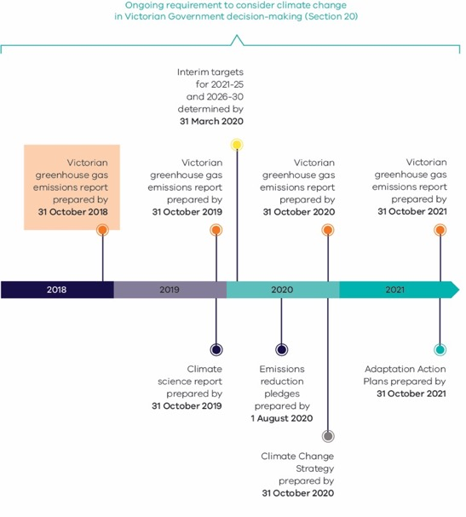
- Long-term emissions reduction target: The Act legislates for a target of net zero greenhouse gas emissions by 2050 and a duty on the Premier and the Minister for Energy Environment and Climate Change to ensure it is met.
- Requirement to consider climate change in government decision making (Section 20): The government must endeavour to ensure that any decision made, and any policy, program or process of government, appropriately takes account of climate change, having regard to the principles and objectives of the Act.
- Victorian greenhouse gas emissions reports: Annual reports will present an overview and collation of the best available information on state emissions and set out the extent to which emissions have reduced relative to 2005.
- Climate science reports: Climate science reports will be prepared every five years setting out a synthesis of the best available climate change science, its implications for the state and regions of the state and data on observed changes in climate in the state.
- Interim targets: The Premier and the Minister for Energy, Environment and Climate Change will set five yearly interim targets to ensure that Victoria remains on track to meet its long-term target. Interim targets will commence from the 2021-25 period.
- Pledges: Pledges will be prepared every five years to identify policies and programs to reduce emissions from key emitting sectors of the economy (for example, energy, transport, agriculture, waste and land use) as well as the state government’s own operations. Pledges will commence in the 2021-25 period.
- Climate Change Strategy: A Victorian Climate Change Strategy will be prepared every five years to set out how Victoria will meet its emissions reduction targets, adapt to the impacts of climate change, and transition to a net zero emissions future. Climate Change Strategies will commence from the 2021-25 period.
- Adaptation Action Plans: System-based Adaptation Action Plans (AAPs) will be prepared every five years for key systems (for example, primary production, transport, water cycle) that are either vulnerable to the inevitable impacts of climate change, or critical to ensure Victoria is better prepared for the impacts of climate change. AAPs will commence from the 2022-26 period.

Summary
This Victorian Greenhouse Gas Emissions Report 2016 is the first in a series of annual emission reports required by Victoria’s Climate Change Act 2017 (the Act). It contains:
- An overview of the state’s greenhouse gas emissions from 1990 to 2016 (the latest year for which official emissions data, published by the Commonwealth Government, is available) with a focus on the change since 2005 (the reference year for interim emissions reduction targets under the Act).
- An explanation of sources of emissions and trends over time, including likely drivers for those trends.
- A projection of Victoria’s emissions to 2020.
Key points are:
- Victoria’s net emissions in 2016 were 114 megatonnes (Mt) of carbon dioxide equivalent (CO₂-e)
  - These consisted of emissions from electricity generation (52% of net emissions), transport (19.5%), direct combustion (16.2%), agriculture (12.2%), industrial processes and product use (3.6%), fugitive emissions (2.8%) and waste (2.2%).
  - Land Use, Land Use Change and Forestry (LULUCF) provided net sequestration of emissions amounting to 9.7 Mt CO₂-e (-8.5% of net emissions).
Figure 2: Victorian emissions by sector and energy sub-sectors, 2016
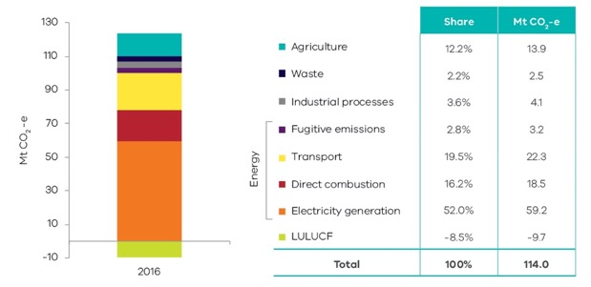
Source: State and Territory Greenhouse Gas Inventories 2016 (Commonwealth of Australia 2018a)
- Victoria’s emissions fell by 13.8 Mt CO₂-e (10.8%) between 2005 and 2016
  - Key contributors to this reduction were the LULUCF sector, which increased sequestration by 9.3 Mt CO₂-e (67% of the change in the state’s total net emissions), and electricity generation, which saw emissions fall by 4.3 Mt CO₂-e (31% of the change in net emissions).
  - Reductions in emissions occurred in agriculture (2.4 Mt CO₂-e) and waste (1.4 Mt CO₂-e).
  - Sectors that experienced increases in emissions over this period were transport (1.8 Mt CO₂-e), industrial processes (0.9 Mt CO₂-e), fugitives (0.8 Mt CO₂-e) and direct combustion (0.03 Mt CO₂-e).
  - From 2005 to 2016, the emissions intensity of the Victorian economy declined from 0.43 to 0.30 kilotonnes (kt) CO₂-e per million dollars ($m) of Gross State Product (31%). Per capita emissions decreased from 26 to 18 t CO₂-e (28%) despite population growth of 24%.
- Victoria’s 2020 emissions are projected to be 104.5 Mt CO₂-e, a fall of 18.2% below 2005 levels
  - Victoria is well on track to achieving its 2020 emissions reduction target of 15-20% below 2005 levels
by 2020.
  - The projected reduction in emissions in 2020 is primarily due to a projected 14.9 Mt CO₂-e reduction in electricity generation emissions.
  - Small reductions in emissions are also projected for fugitive emissions (0.5 Mt CO₂-e), direct combustion (0.2 Mt CO₂-e) and waste (0.1 Mt CO₂-e).
  - Increased emissions are projected for LULUCF (2.5 Mt CO₂-e), transport (2.3 Mt CO₂-e), agriculture (1.4 Mt CO₂-e) and industrial processes (0.1 Mt CO₂-e).
Figure 3: Victoria’s historical and projected emissions
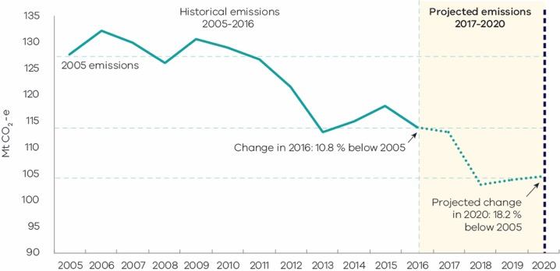
Source: State and Territory Greenhouse Gas Inventories 2016 (Commonwealth of Australia 2018a) and DELWP analysis on projections

Introduction
Section 52 of the Climate Change Act 2017 (the Act) requires the Minister administering the Act to prepare annual greenhouse gas emissions reports for Victoria, with the first report to be prepared by 31 October 2018. The Act requires the annual reports to include an overview and collation of the best practicably available information about Victoria’s greenhouse gas emissions, and the extent to which greenhouse gas emissions have been reduced compared with 2005 levels (the reference year for emissions reduction targets under the Act).
This Victorian greenhouse gas emissions report presents information on Victoria’s emissions in two forms:
    - Reporting of emissions in accordance with sectors defined by the Intergovernmental Panel on Climate Change (IPCC) reporting framework for national greenhouse gas inventories, with disaggregation of data in the energy sector.
    - Reporting of emissions by sectors of the economy categorised under the Australian and New Zealand Standard Industrial Classification (ANZSIC).
Data for the report was sourced from State and Territory Greenhouse Gas Inventories released in February 2018 by the Commonwealth Department of the Environment and Energy (DoEE), and the Australian Greenhouse Emissions Information System database. Both sources provide data at a state and territory level over the period 1990 to 2016. This is the most recent official data in Australia on annual greenhouse gas emissions. The data relates to production-based rather than consumption-based emissions in Victoria – that is, it accounts for emissions from goods and services produced in, and exported from, Victoria. This is in accordance with the United Nations Framework Convention on Climate Change (UNFCCC)’s emissions accounting provisions.
Economic and population statistics for Victoria were used to calculate emissions intensity measures and to obtain insights into trends in the state’s emissions.
The report also provides a projection of Victoria’s greenhouse gas emissions to 2020. This projection indicates that Victoria is well on track to meeting the Victorian Government’s target to reduce greenhouse gas emissions by 15 to 20% below 2005 levels by 2020.
This report is structured as follows:
Chapter 1 presents the trend in Victoria’s emissions over the period 1990 to 2016, Victoria’s contribution to national emissions, and Victorian emissions per capita and per unit of Gross State Product (GSP).
Chapter 2 presents Victorian emissions by sector using IPCC sector categories. It describes historical trends in emissions in each sector and the key drivers of these trends.
Chapter 3 presents Victorian emissions by economic sector based on the Australian and New Zealand Standard Industry Classification (ANZSIC).
Chapter 4 presents emissions projections for Victoria to 2020.

1. Victorian emissions and indicators – 1990 to 2016

1.1 Emissions 1990 to 2016
Figure 4 presents Victoria’s annual greenhouse gas emissions over the period 1990 to 2016. Total net greenhouse gas emissions increased by 7.8 megatonnes (Mt) of carbon dioxide equivalent (CO₂-e) (7.3%) between 1990 and 2016. Emissions decreased by 4.2 Mt CO₂-e (3.5%) between 2015 and 2016.
Chapter 2 discusses the trends in sectoral emissions including the key factors driving these trends.
Figure 4: Total net emissions and emissions by sector – Victoria, 1990 to 2016
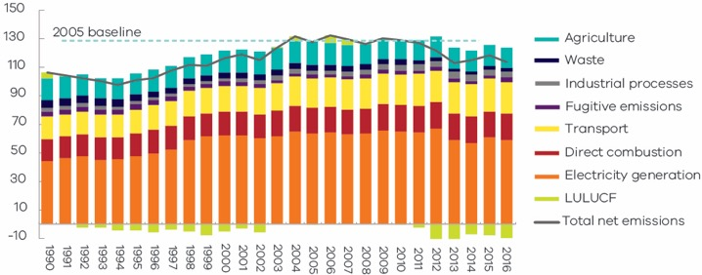
Source: State and Territory Greenhouse Gas Inventories 2016 (Commonwealth of Australia 2018a)

1.2 Change in emissions since 2005
Victoria’s greenhouse gas emissions reduction targets are set relative to the 2005 reference year. Emissions fell by 10.8% from 127.8 Mt CO₂-e in 2005 to 114.0 Mt CO₂-e in 2016 (Figure 5).
Figure 5: Trend in net emissions – Victoria, 2005 to 2016
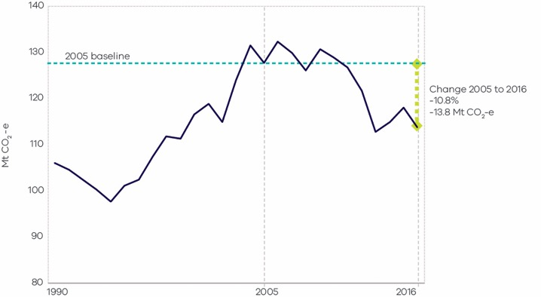
Source: State and Territory Greenhouse Gas Inventories 2016 (Commonwealth of Australia 2018a)

1.3 Victoria’s contribution to national emissions
Figure 6 shows that in 2016, Victoria – with a 22% share – was the third largest contributor to Australia’s total emissions (525 Mt), behind Queensland (29%) and New South Wales (25%).
Figure 6: Contribution to national emissions by State and Territory, 2016
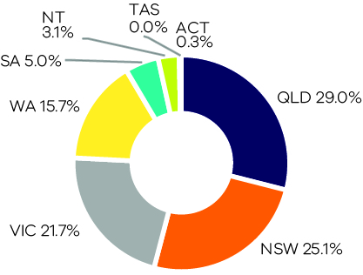
Source: State and Territory Greenhouse Gas Inventories 2016 (Commonwealth of Australia 2018a)
Figure 7 shows that Victoria’s share of Australia’s total emissions has grown since 1990. In the years 1990 and 2005, Victoria’s contributions were 18% and 21% respectively.
Figure 7: Contribution to national emissions – Victoria, 1990 to 2016
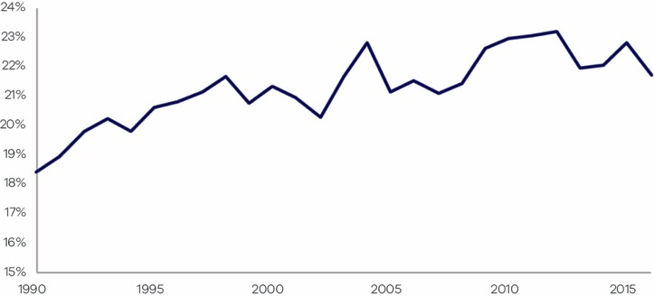
Source: Analysis based on State and Territory Greenhouse Gas Inventories 2016 (Commonwealth of Australia 2018a)

1.4 Per capita emissions
Victoria’s per capita emissions of 18.4 tonnes (t) CO₂-e in 2016 were less than the national average (21.7 t CO₂-e), lower than Western Australia, Queensland and the Northern Territory, but higher than Tasmania, the ACT, SA and NSW (Figure 8).
Figure 8: Per capita emissions in Australia and by State/Territory, 2016
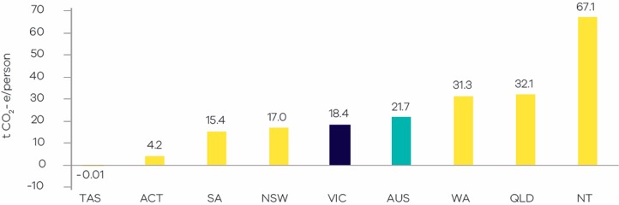
Source: Analysis based on State and Territory Greenhouse Gas Inventories 2016 (Commonwealth of Australia 2018a) and Australian Demographic Statistics 2016 (Australian Bureau of Statistics 2017a)
Victoria’s per capita emissions decreased from 24 to 18.4 t CO₂-e between 1990 and 2016, a period during which the state’s population grew by 41%. In the period from 2005 to 2016, per capita emissions fell from 26 to 18.4 t CO₂-e (28%) despite population growing by 24% – see Figure 9.
Figure 9 Trend in per capita emissions – Victoria, 1990 to 2016
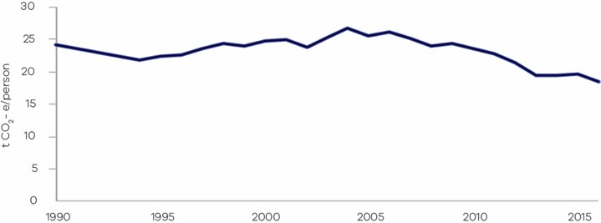
Source: Analysis based on State and Territory Greenhouse Gas Inventories 2016 (Commonwealth of Australia 2018a) and Australian Demographic Statistics 2016 (Australian Bureau of Statistics 2017a)

1.5 Emissions and Gross State Product (GSP)
Figure 10 presents the trends in Victorian emissions and real GSP (in 2016 $A) over the period 1990 to 2016. Over this period, real GSP grew by 105% while the emissions intensity of the Victorian economy declined from 0.56 to 0.30 kilotonnes (kt) CO₂-e per $m GSP – a reduction of 48% (see Figure 11).
From 2005 to 2016, real GSP grew 29% while emissions fell by 11%. This resulted in a reduction in emissions intensity from 0.43 to 0.30 kt CO₂-e per $m GSP (31%), indicating that Victoria is transitioning to a less carbon intensive economy.
Figure 10: Greenhouse gas emissions and real GSP (in 2016 $A) – Victoria, 1990 to 2016
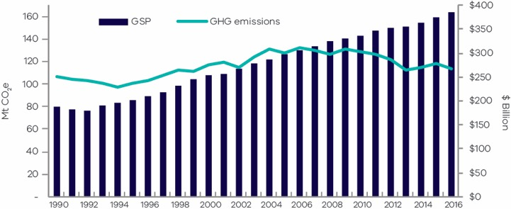
Source: Analysis based on State and Territory Greenhouse Gas Inventories 2016 (Commonwealth of Australia 2018a) and Australian National Accounts: State Accounts, 2015-16-17 (Australian Bureau of Statistics 2017b).
Figure 11: Percentage change in real GSP and emissions intensity – Victoria, 1990 to 2016
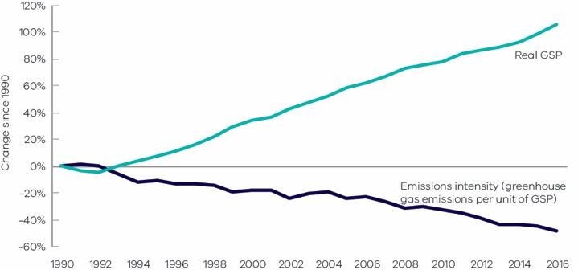
Source: Analysis based on State and Territory Greenhouse Gas Inventories 2016 (Commonwealth of Australia 2018a) and Australian National Accounts: State Accounts, 2015-16-17 (Australian Bureau of Statistics 2017b).

2. Emissions by sector (IPCC categories)
This chapter presents information on Victoria’s greenhouse gas emissions by sector, the activities that drive these emissions, and the key factors that have influenced emissions trends in each sector. Sectors are based on the five categories identified in Intergovernmental Panel on Climate Change (IPCC) international guidelines, namely: Energy; Industrial Processes and Product Use; Agriculture; Land Use, Land Use Change and Forestry (LULUCF); and Waste. Due to the significance of the energy sector in Victoria, this sector is disaggregated into four sub-sectors: electricity generation; direct combustion from stationary sources; transport; and fugitive emissions from fuels.
The National Inventory Report (Commonwealth of Australia 2018b) is the primary source of information for the activities that drive sectoral emissions. Commonwealth Government statistics for Victoria, academic and Victorian Government publications and consultation with experts were used to augment the National Inventory Report to obtain insights into the factors that influenced sectoral emissions trends over the period 1990 to 2016.
Figure 12 presents the share of Victoria’s net emissions in 2016 by sector and energy sub-sectors.
Figure 12: Victorian emissions by sector and energy sub-sectors, 2016
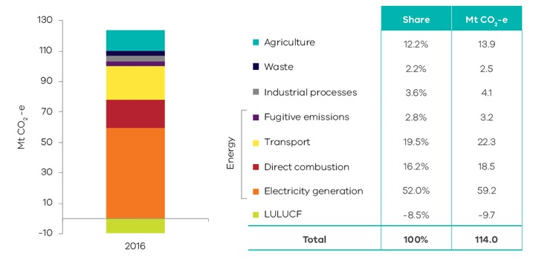
Source: State and Territory Greenhouse Gas Inventories 2016 (Commonwealth of Australia 2018a)
Figure 13 presents emissions by sector in 1990, 2005 and 2016. Key points of note include:
- Emissions from electricity generation and agriculture increased between 1990 and 2005, but declined between 2005 and 2016.
- Emissions from transport, industrial processes and direct combustion increased between 1990 and 2005 and continued to increase to 2016.
- Emissions from the LULUCF and waste sectors declined between 1990 and 2005 and continued to do so
to 2016.
Figure 13: Emissions by sector – 1990, 2005 and 2016
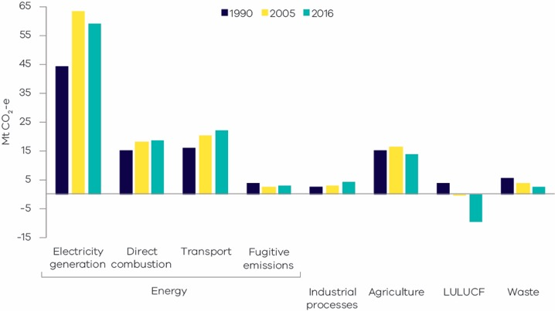
Source: State and Territory Greenhouse Gas Inventories 2016 (Commonwealth of Australia 2018a)
Table 1 and Figure 14 provide further details on the scale of change in sectoral emissions between 2005 and 2016. The LULUCF sector experienced the largest reduction in net emissions, followed by electricity generation, agriculture and waste.
Table 1: Change in emissions by sector / sub-sector between 2005 and 2016, Victoria
Sector/ sub-sector | 2005 Mt CO₂-e | 2016 Mt CO₂-e | Change 2005 to 2016* Mt CO₂-e
Electricity generation | 63.5 | 59.2 | -4.3 | ↓
Direct combustion | 18.4 | 18.5 | 0.03 | ↑
Transport | 20.4 | 22.3 | 1.8 | ↑
Fugitive emissions | 2.4 | 3.2 | 0.8 | ↑
Industrial processes | 3.2 | 4.1 | 0.9 | ↑
Agriculture | 16.3 | 13.9 | -2.4 | ↓
LULUCF | - 0.5 | - 9.7 | -9.3 | ↓
Waste | 3.9 | 2.5 | -1.4 | ↓
Total (net emissions) | 127.8 | 114.0 | -13.8 | ↓
Source: State and Territory Greenhouse Gas Inventories 2016 (Commonwealth of Australia 2018a)
*Note – numbers may not add up to the total due to rounding.
Figure 14: Change in emissions between 2005 and 2016 by sector / sub-sector, Victoria
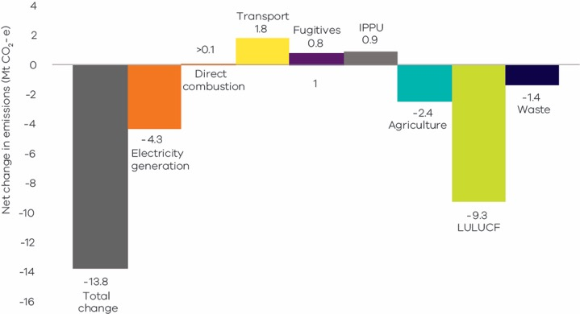
Source: State and Territory Greenhouse Gas Inventories 2016 (Commonwealth of Australia 2018a)

2.1 Energy
The energy sector – which comprises electricity generation, direct combustion, transport and fugitive emissions – was responsible for 91% of total net emissions in Victoria in 2016. Figure 15 provides a breakdown of emission by each energy sub-sector.
Figure 15: Energy sub-sectors and their contributions to total net emissions in Victoria, 2016
Energy ( 91% )
Stationary energy |  | Transport  20% | Fugitive emissions  3%
Electricity generation  52% | Direct combustion  16%
Source: Australian Greenhouse Emissions Information System (Department of Environment and Energy 2018a)
A discussion of emissions trends for each energy sub-sector follows.

2.1.1 Electricity generation

Sources of emissions
Emissions from electricity generation arise from the combustion of fuels to generate power that is supplied to the electricity grid.
Consistent with a production-based approach, this sub-sector covers emissions released from the electricity that is generated in Victoria, some of which is exported for consumption in other states. Emissions from electricity imported from other states are not accounted for in this sub-sector.

Electricity generation in Victoria
In 2016, emissions from electricity generation accounted for more than half of Victoria’s total net emissions. In that year, around 83% of the state’s electricity was generated by brown coal-fired power stations (NEM-Review6, 2018). Four brown coal-fired power plants were operating in 2016, all located in the Latrobe Valley: Hazelwood, Yallourn, Loy Yang A and Loy Yang B. Table 2 presents production and emissions statistics for these plants in 2016 – this shows that 50.5% of Victoria’s total net emissions arose from brown coal-fired electricity generation (emissions also arose from gas-fired generation, bringing the total contribution of electricity generation to 52% – see Figure 16).
Table 2: Electricity production and emissions from Victorian brown coal-fired power plants in 2016
Facility | Electricity production (MWh) | Total direct emissions (Mt CO₂-e) | Share of Victoria's net greenhouse gas emissions
Loy Yang Power Station and Mine | 15,715,547 | 18.1 | 15.9%
Yallourn Power Station | 11,588,110 | 15.3 | 13.4%
Hazelwood Power Station | 10,325,778 | 14.4 | 12.7%
Loy Yang B Power Station | 8,451,503 | 9.7 | 8.5%
Total | 46,080,938 | 57.5 | 50.5%
Source: Analysis based on Clean Energy Regulator 2015-16 greenhouse and energy information for designated generation facilities (Clean Energy Regulator 2017)

Emissions trends and drivers
The trend in emissions from electricity generation in Victoria is presented in Figure 16.
Figure 16: Emissions from electricity generation – Victoria, 1990 to 2016
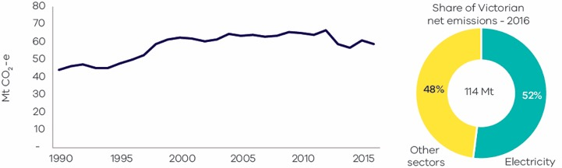
Source: Australian Greenhouse Emissions Information System (Department of Environment and Energy 2018a)
Figure 16 shows that electricity generation emissions increased significantly between 1990 and 2004. Emissions were relatively steady from 2005 through to their peak in 2012, before falling in 2013 and 2014, increasing in 2015 and falling again in 2016. Factors that contributed to the trends include:
- The general trend of increased emissions through the 1990s into the early part of the 2000s reflected the underlying growth in Victoria’s economy and population. It also reflected the privatisation of the Victorian electricity sector in the mid-to-late 1990s and the introduction of the National Electricity Market (NEM), which boosted the competitiveness of Victorian generators and saw an increase in generation volumes, including for export to other states.
- The flattening of emissions growth from the mid-2000s was due to a range of factors, including a reduction in electricity demand after 2009, both in Victoria and across the NEM, as well as increased renewable electricity generation. The flattening and reduction in demand stemmed from improvements in energy efficiency (due to policies including appliance Minimum Energy Performance Standards, energy efficiency standards in building regulations and the Victorian Energy Upgrades program, formerly the VEET scheme), a decline in Victorian manufacturing and consumer responses to higher electricity prices. Energy efficiency and small scale renewable energy policies and programs put in place from the early to mid-2000s had a significant impact on residential energy consumption.
- Over the period 2012 to 2014, Victoria generated less electricity from brown coal with an increase in generation from gas-fired power stations resulting in lower greenhouse gas emissions in these years (NEM-Review6, 2018). The reasons for the fall included:
  - Operation of the Australian Carbon Pricing Mechanism, which commenced in July 2012 and was repealed in July 2014.
  - Yallourn power station generating less electricity from 2012 to 2014 due to factors including flooding of the neighbouring Yallourn coal mine (Morton 2012).
  - Closure of the Point Henry aluminium smelter in 2014, which resulted in closure of Alcoa’s brown coal-fired Anglesea Power Station in August 2015.
The increasing use of renewable energy also influenced trends in electricity generation emissions. The Commonwealth Government’s Renewable Energy Target, introduced in 2001, drove investment in large-scale renewable energy projects in Victoria, primarily wind farms located in Western Victoria. Around 1,200 MW of wind projects were constructed in Victoria between 2001 and 2016 (Australian Energy Market Operator 2018a). Growth also occurred in the number of small (household) solar photovoltaic systems installed per year in Victoria. After relatively slow growth between 2001 and 2009, around 35,000 systems were installed during 2010, reaching a peak of 66,000 systems during 2012. From 2013 to 2015, the number of systems installed averaged 34,000 per year (Clean Energy Regulator 2018).

2.1.2 Direct combustion

Sources of emissions
Direct combustion emissions arise from burning fuels for a wide range of stationary energy activities, such as generating heat, steam or pressure for major industrial operations, and burning gas for household heating and cooking.
The activities giving rise to these emissions include the production of fuels (such as oil and gas extraction and refining), manufacturing, construction, agriculture, residential, and commercial activities.
The direct combustion sector does not include emissions associated with electricity consumption or emissions from fuel combustion in transport activities – these emissions are accounted for in the electricity generation and transport sub-sectors respectively.

Direct combustion in Victoria
Figure 17 shows that residential activities are the largest source of emissions from direct combustion in Victoria, followed by manufacturing industries and construction, and fuel production.
Figure 17: Direct combustion emissions by sub-categories – Victoria, 2016
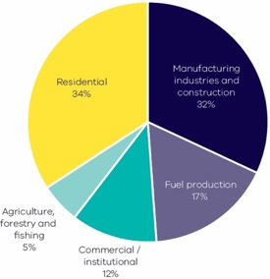
Source: Australian Greenhouse Emissions Information System (Department of Environment and Energy, 2018b)
Natural gas is the major fuel used for direct combustion in Victorian industrial, commercial and residential sub-categories, representing 65% of the total fuels used in 2016. In that year, Victoria consumed a total of 284 petajoules (PJ) of natural gas, with the highest consumption in residential activities (39%), followed by manufacturing (27%) and commercial (12%) activities.

Emissions trends and drivers
The trend in emissions from direct combustion in Victoria over the period 1990 to 2016 is presented in
Figure 18. Direct combustion contributed 16% of Victoria’s net emissions in 2016 – the third largest share of total emissions behind electricity generation and transport.
Figure 19 shows the trend in emissions from direct combustion by activity sub-categories.
Figure 18: Emissions from direct combustion – Victoria, 1990 to 2016
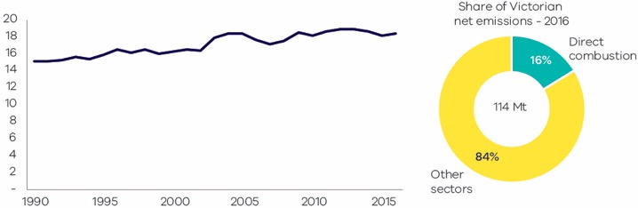
Source: State and Territory Greenhouse Gas Inventories 2016 (Commonwealth of Australia 2018a)
Figure 19: Emissions from direct combustion sub-categories – Victoria, 1990 to 2016
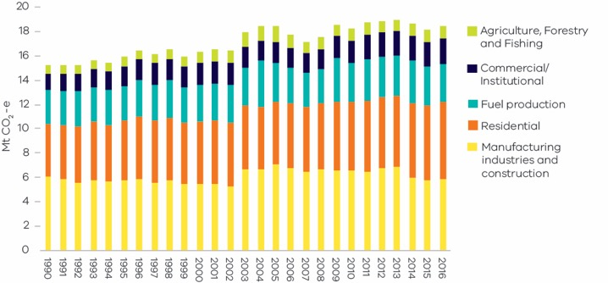
Source: State and Territory Greenhouse Gas Inventories 2016 (Commonwealth of Australia 2018a)
Direct combustion emissions grew from 15 Mt CO₂-e in 1990 to 18.5 Mt CO₂-e in 2016, with interannual variability. Factors that contributed to the trends include:
- The overall growth between 1990 and 2016 was associated with growth of population and economic activity in Victoria. Interannual variability in emissions was associated with changes in the rate of economic growth and variations in seasonal demand.
- Annual consumption of natural gas was relatively stable from 2013, with declining industrial gas use offset by increasing residential consumption in winter (Australian Energy Market Operator 2018b). Manufacturing was the largest user of natural gas in Victoria from 1990 to 2005, but its consumption steadily decreased over that time. The residential sector steadily increased its consumption and, from 2006, was the major user of natural gas in Victoria.
- Direct emissions from manufacturing fell between 1990 and 2002 before experiencing a notable increase in 2003 due to growth in the output of food processing. Emissions from manufacturing peaked in 2005 then declined gradually due to the overall decline in manufacturing activity in the state.

2.1.3 Transport

Sources of emissions
Emissions from the transport sub-sector are produced by the consumption of fuels such as petrol, diesel and LPG in passenger and commercial motor vehicles, railways, domestic aviation and shipping.
Emissions from electricity used to power public transport (e.g. metropolitan trains and trams) and to drive electric vehicles are not included here but are accounted for in the electricity generation sub-sector.

Transport in Victoria
Figure 20 shows that road transportation was responsible for the vast majority (~90%) of emissions from transport in 2016. The major contributor to emissions from road transport was cars (56%) followed by heavy-duty trucks (25%) and light commercial vehicles (19%).
In 2016, the transport sub-sector consumed 367 petajoules (PJ) of energy with petrol representing the highest share (41%), followed by diesel (34%), aviation fuel (16%) and LPG (7%).
Figure 20: Transport emissions by mode and road transport sub-categories – Victoria, 2016
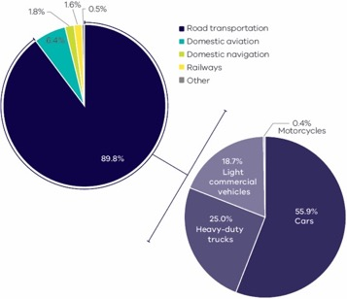
Source: Australian Greenhouse Emissions Information System (Department of Environment and Energy, 2018a)

Emissions trends and drivers
The trend in transport emissions over the period 1990 to 2016 is presented in Figure 21. Transport contributed 20% of Victoria’s net emissions in 2016 – the second largest share behind electricity generation.
Figure 22 presents the trend in emissions from transport by activity sub-categories.
Figure 21: Transport emissions – Victoria, 1990 to 2016
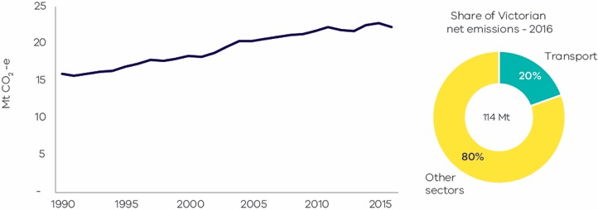
Source: Australian Greenhouse Emissions Information System (Department of Environment and Energy, 2018a)
Figure 22: Emissions from transport sub-categories – Victoria, 1990 to 2016
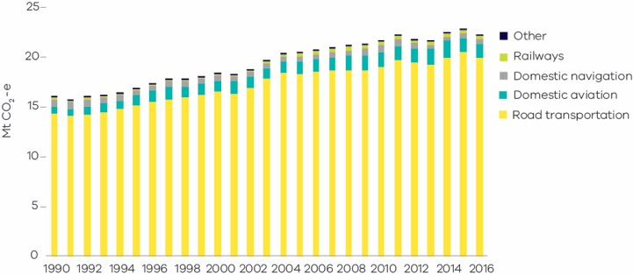
Source: Australian Greenhouse Emissions Information System (Department of Environment and Energy 2018a)
Transport emissions grew by 6.2 Mt CO₂-e (39%) between 1990 and 2016 – the largest growth in emissions from any sector/sub-sector over this period. Contributing factors include:
- Growth in passenger vehicle emissions (which increased by 13.3% between 1990 and 2016) was driven by growth in the number of passenger vehicles and in the total passenger vehicle kilometres travelled, which reflected Victoria’s strong population growth. For example, the number of registered passenger vehicles in Victoria increased by approximately 73,000 each year from 2012 to 2016.
- Growth in emissions from heavy and light commercial vehicles (which increased by 47.5% and 45.1% respectively between 1990 and 2016) reflected strong growth in freight transport.
The volume of petrol consumed in road transport activities was relatively stable between 1990 and 2016 despite the substantial growth in vehicle registration. This was due to improvements in the average fuel efficiency of the passenger vehicle fleet and an increase in the share of diesel vehicles, which nearly tripled in number over this period. From 2012 to 2017, the number of petrol vehicles grew by 6.5% while diesel-fuelled vehicle numbers increased by 65.5%. Substantial growth in the number of diesel vehicles was also associated with growth in freight transport.

2.1.4 Fugitive emissions from fuels

Sources of emissions
Fugitive emissions result from leaks or venting gases during the extraction, production, processing, storage, transmission and distribution of fossil fuels including coal, oil and natural gas. Emissions from decommissioned coal mines are also included.
Fugitive emissions do not include emissions from the combustion of fuels in activities such as electricity generation, the operation of mining plant and equipment or the transportation of fossil fuels by road, rail
or sea.

Fugitive emissions from fuels in Victoria
Almost 60% of fugitive emissions in Victoria arise from losses involved in the transmission, storage and distribution of natural gas. Natural gas is transmitted in Victoria through the Principal Transmission System (PTS), a 1,900 km pipe network covering Melbourne and central Victoria. The system also utilises storage facilities to help meet demand peaks.
Victoria’s petroleum industry, which involves the exploration and production of oil and gas, contributes around 26% of total fugitive emissions. These emissions arise throughout the production chain, including exploration and development drilling when gas or liquid hydrocarbons are encountered. The industry’s activities are concentrated in the offshore regions of the Otway and Gippsland basins.
Crude oil and gas are transported via pipeline from offshore facilities to stabilisation and gas processing plants where they are separated into wet gas, LPG and stabilised crude oil for distribution within the state, interstate or internationally (Department of Economic Development, Jobs, Transport and Resources 2015). Stabilised crude oil is processed at refineries in Altona and Geelong into a range of refined petroleum products such as petrol, diesel, jet fuel, bitumen and solvents.
A small contribution to Victoria’s total fugitive emissions (less than 1%) arises from the extraction of solid fuels, particularly from brown coal mines. This contrasts with New South Wales and Queensland where 94% and 72% of their total fugitive emissions respectively in 2016 were from the extraction of solid fuels (black coal), and the total fugitive emissions in those states are around double those in Victoria.

Emissions trends and drivers
The trend in fugitive emissions from fuels over the period 1990 to 2016 is presented in Figure 23. In 2016, the sub-sector contributed 3% of Victoria’s total net emissions.
Figure 23: Fugitive emissions – Victoria, 1990 to 2016
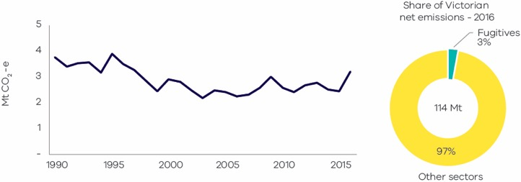
Source: Australian Greenhouse Emissions Information System (Department of Environment and Energy 2018a)
Fugitive emissions rose from 3.8 Mt CO₂-e in 1990 to a peak of 3.9 Mt CO₂-e in 1995. Emissions then declined through to the latter half of the 1990s and first half of the 2000s, reaching a low of 2.2 Mt CO₂-e in 2003
before increasing again – with interannual variability – to 3.2 Mt CO₂-e in 2016. Factors influencing these trends included:
- A reduction in oil and natural gas production from 1995 to 2003. In the mid-1980s, Victoria produced around 178 million barrels of crude oil annually (~90% of total Australian crude oil output). By 2014, Victorian crude oil production had declined to 11.7 million barrels (Department of Economic Development, Job, Transport and Resources 2015).
- Changes in the volume of natural gas consumption, which fluctuated between 230 and 285 PJ per year between 1990 and 2016 (with peaks in 1995 and 2009). The scale of fugitive emissions associated with natural gas consumption was, however, moderated by improvements in transmission, storage and distribution, which reduced natural gas leakages.

2.2 Industrial processes and product use (IPPU)

Sources of emissions
The industrial processes and product use (IPPU) sector includes emissions generated from a range of production processes involving, for example, the use of carbonates (i.e. limestone, dolomite, magnesite, etc.), carbon when used as a chemical reductant (e.g. iron and steel or aluminium production), chemical industry processes (e.g. ammonia and nitric acid production) and the production and use of synthetic gases such as:
- Hydrofluorocarbons (HFCs) in refrigeration and air conditioning, foam blowing, fire extinguishers, aerosols/metered dose inhalers and solvents.
- Sulphur hexafluoride (SF₆) in electrical equipment.
Emissions associated with the consumption of electricity or combustion of fuels required by industrial production processes are accounted for in the electricity generation and direct combustion sub-sectors.

IPPU emissions in Victoria
In Victoria in 2016, 82% of IPPU emissions arose from the use of synthetic greenhouse gases. The remaining 18% of IPPU emissions resulted from processes in activities such as metals and chemicals production.

Emissions trends and drivers
The trend in IPPU emissions over the period 1990 to 2016 is presented in Figure 24. In 2016, the sub-sector contributed 4% of Victoria’s total net emissions.
Figure 24: Industrial processes and product use emissions – Victoria, 1990 to 2016
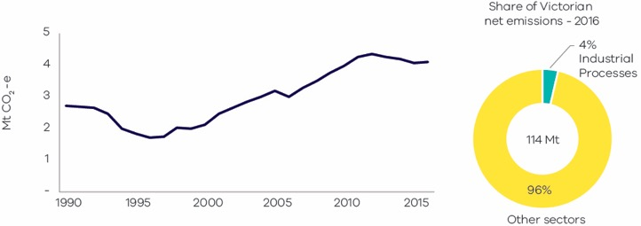
Source: Australian Greenhouse Emissions Information System (Department of Environment and Energy 2018a)
A major driver of emissions trends in this sector is the increase of HFCs due to population growth. Between
1990 and 2016, Victoria’s population grew by 41% and IPPU emissions increased by 52%. The growth in product use-related emissions offset the reduction in emissions associated with a decline in industrial processing.
Emissions from the chemicals industry dropped substantially after 1995 due to the closure of several chemical production facilities in Victoria. A reduction in economic growth in the early 1990s is likely to have contributed to the fall in IPPU emissions between 1990 and 1995.
Emissions from the minerals industry declined in 2014 and subsequent years due to the closure of facilities associated with the production of clinker and lime.

2.3 Waste

Sources of emissions
Emissions from the waste sector arise from the decomposition of organic waste in landfills and from the release of greenhouse gases during the treatment of wastewater. Methane is produced from the anaerobic decomposition of organic matter from solid waste in landfills and from wastewater treatment plants. Nitrous oxide emissions are produced from the nitrification and denitrification of urea and ammonia in wastewater treatment plants.
Emissions produced from the combustion of methane arising from landfills and wastewater treatment plants for electricity generation are reported in the electricity generation sub-sector. Emissions associated with the electricity and energy use required for the management and transportation of waste are accounted for in the electricity generation, direct combustion and transport sub-sectors.

Waste sector in Victoria
The main sources of waste sector emissions are the disposal of solid waste to landfill (64.7% of total waste sector emissions) and the treatment of wastewater from domestic, commercial and industrial sources (31.9% of total waste sector emissions).
Most landfills in Victoria operate in accordance with best practice in greenhouse gas management. This resulted in a significant reduction of greenhouse gas emissions from this sector.
Victoria's water sector comprises 19 water corporations, of which 16 provide water supply and sewage services to urban Victoria. Water for Victoria, the state’s water plan, commits water corporations to demonstrate a pathway to net-zero emissions and to pledge an interim emission reduction target to be achieved by 2025 (Neville 2018). Water corporations have developed emission reduction pathways with proposals to reduce both energy-related emissions and direct emissions associated with treatment processes.

Emissions trends and drivers
The trend in waste sector emissions over the period 1990 to 2016 is presented in Figure 25. In 2016, waste was responsible for 2% of Victoria’s total net emissions.
Figure 26 presents the trend in emissions from waste sector sub-categories – solid waste disposal; wastewater treatment and discharge; biological treatment of solid waste; and incineration and open burning of waste.
Figure 25: Waste emissions – Victoria, 1990 to 2016
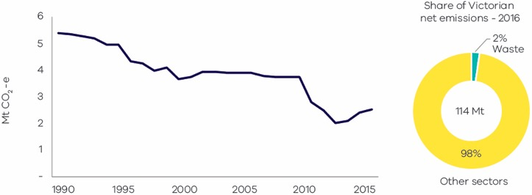
Source: Australian Greenhouse Emissions Information System (Department of Environment and Energy 2018a)
Figure 26: Emissions from waste sub-categories – Victoria, 1990 to 2016
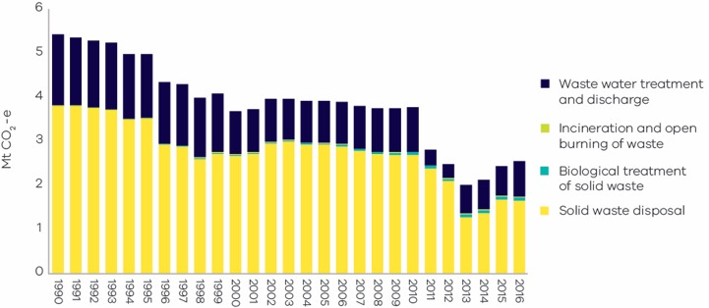
Source: Australian Greenhouse Emissions Information System (Department of Environment and Energy 2018a)
While the production of waste is strongly correlated with population growth, and Victoria’s population grew strongly between 1990 and 2016, emissions from solid waste fell by around 65% over this period. The reduction was due to increased landfill gas capture and conversion to energy; improved landfill management practices reducing methane leakage; greater levels of materials recycling; and increased diversion of organics from the waste stream to composting or energy generation.
Emissions from wastewater decreased by 32% from 1990 to 2016, with steep decreases in 2000 and in 2010-11. These decreases corresponded with the implementation of more efficient wastewater treatment processes and increased capture of methane from wastewater treatment plants.

Reducing waste sector emissions
Between 2006 and 2016, waste generation in Victoria increased by 14%. However, a 37% increase in materials recovery led to the diversion of a significant volume of waste from landfills. 8.5 million tonnes of waste were diverted from landfills in Victoria in 2016. Waste diversion reduces direct greenhouse gas emissions by avoiding methane release from the decomposition of organics. Recovery of inorganic materials also indirectly reduces emissions associated with the extraction of raw materials, and the use of water and energy in production processes.
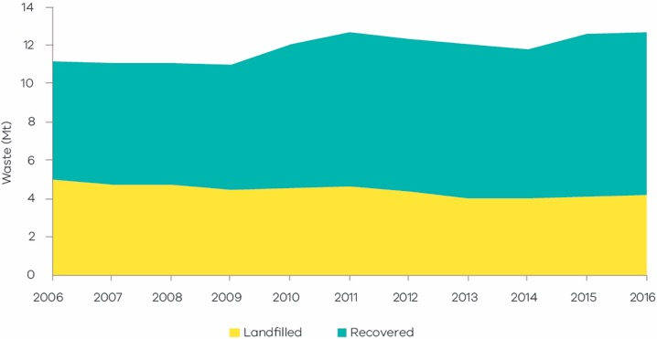
In Victoria, best practice landfill gas management is well established for large putrescible waste landfills, where landfill gas is combusted to generate electricity that is fed into the grid. Nine large landfills in operation or recently closed are connected to landfill gas power generation infrastructure. Additionally, nearly half of the medium-size landfills with volumes insufficient for power generation have flaring management equipment that reduces greenhouse gas emissions through the conversion of methane to carbon dioxide. While smaller landfills without such technology contribute a significant amount of emissions per tonne of waste deposited, collectively these landfills only manage a small percentage of Victoria’s waste.
The maturity of different waste to energy technologies in Victoria is variable. However, small-scale examples of food and farm waste in agricultural and food manufacturing settings being converted to energy are increasing.

Yarra Valley water waste to energy facility
In June 2017, Yarra Valley Water opened a waste to energy facility in Wollert. This facility is located next to
an existing Yarra Valley Water sewage treatment plant and generates enough biogas to run both sites with surplus energy to be exported to the grid. The site can process up to 33,000 tonnes of organic waste annually.

Melbourne Water anaerobic lagoons
Sewage at Melbourne Water’s treatment plant flows through two covered anaerobic lagoons, where solids are captured and methane is produced for renewable energy. Improvement works completed in 2017 ensure that 100% of the energy demand of the plant is now met. An 18-month co-digestion trial was launched in 2017 to add organic waste into the anaerobic section. Co-digestion offers multiple benefits, including an increase in renewable energy generated from biogas, and reduced waste to landfill.

2.4 Agriculture

Sources of emissions
Agriculture sector emissions arise from livestock digestion (enteric fermentation), manure management, the release of nitrous oxide from cropping and pasture land, and the burning of agricultural residues.
Enteric fermentation of plant material that is digested by animals results in emissions. Manure management produces emissions through the anaerobic decomposition of the organic matter contained in manure, especially when a considerable number of animals are confined (e.g. piggeries).
Emissions associated with the use of electricity, fuel consumption from operating equipment and fuel consumption in transport are accounted for in the energy sector.
Agriculture emissions in Victoria
Emissions from livestock enteric fermentation are the main contributor (68%) to agriculture sector emissions in Victoria.
Another activity contributing significantly to agriculture emissions in Victoria (20%) is the release of nitrous oxide through the application of fertilisers to soils.
Agricultural land occupies around 56% of Victoria’s surface (Department of Agriculture and Water Resources 2018a). The most prevalent land use by area is grazing of modified pasture, which occupies 32% of the state as shown in Figure 27.
Figure 27: Broad land use in Victoria
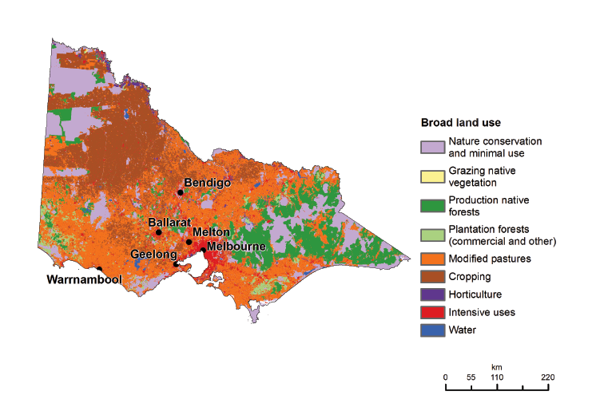
Source: Australian Bureau of Agricultural and Resource Economics and Sciences, ABARES 2016 (Department of Agriculture and Water Resources 2018a)
In 2015-16 there were 20,532 farms in Victoria (24% of all farm businesses in Australia). Of these, the most common farm types were dairy cattle (21.0%), beef cattle (20.9%), sheep (13.6%), and ‘other’ grain growing (10.1%). The most important commodities in Victoria based on the gross value of agricultural production
were milk, followed by cattle and calves, and sheep and lambs (Department of Agriculture and Water Resources, 2018b).

Emissions trends and drivers
The trend in agricultural emissions over the period 1990 to 2016 is presented in Figure 28. The sector contributed 12% of Victoria’s net emissions in 2016 – the fourth largest share of total emissions behind electricity generation, transport and direct combustion.
Figure 29 presents the trend in emissions from agriculture sub-categories.
Figure 28: Agriculture emissions – Victoria, 1990 to 2016
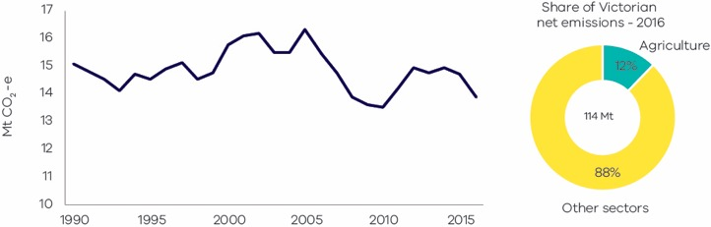
Source: Australian Greenhouse Emissions Information System (Department of Environment and Energy 2018a)
Figure 29: Emissions from agriculture sub-categories – Victoria, 1990 to 2016
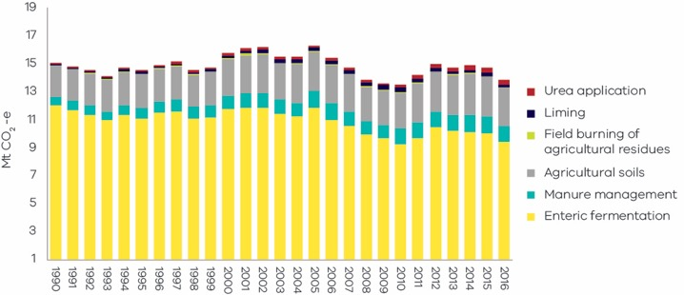
Source: Australian Greenhouse Emissions Information System (Department of Environment and Energy, 2018a)
Emissions from the agriculture sector varied significantly over the period 1990 to 2016, driven mainly by seasonal conditions and by food demand due to domestic population growth and exports. Factors that influenced the trend include:
- Sheep population fluctuated during both drought and non-drought conditions. However, the overall
trend was one of a decline in numbers between 1990 and 2016. Emissions from sheep grazing fell by 56% over this period.
- Cattle population also fluctuated, especially through the millennium drought that hit Australia from 1997 to 2009. Livestock numbers initially remained steady, then rapidly declined towards the end of the drought. Numbers then rebounded with the return of wetter conditions in 2010 and 2011. Emissions from beef cattle were only slightly higher in 2016 compared with 1990. However, interannual fluctuations occurred throughout the period due to interannual variation in cattle numbers.

2.5 Land Use, Land Use Change, and Forestry (LULUCF)

Sources of emissions
The LULUCF sector includes emissions and sequestration (removal) of greenhouse gases resulting from direct human-induced land use, land-use change and forestry activities. This includes emissions and sequestration associated with the clearance of forested land and conversion to other land uses, from new forests planted on previously unforested land and from other practices that change emissions and sequestration (forest management, cropland management and grazing land management).
Combustion of fossil fuels associated with forestry and land management activities – such as diesel used in logging machinery – are accounted for in the direct combustion sub-sector. Emissions from livestock, manure management, nitrous oxide emissions from cropping and pastureland soils, and burning of agricultural residues are accounted for in the agriculture sector.

Emissions in Victoria
The main sources of Victoria’s LULUCF emissions and removals – and of variations in these emissions – are forest lands, specifically from land classified as:
    - Forest land remaining forest – comprising changes in the native forest estate and harvesting from that estate, and pre-1989 plantations.
    - Land converted to forest land – comprising plantations established since 1990, and regeneration of previously cleared land.
    - Forest land converted to cropland, grasslands, wetlands and settlements – comprising primary and secondary clearing of forest land since 1990 to enable a change in land use, and changes in soil carbon and other emissions resulting from land use change.
Other sources of LULUCF emissions make a smaller contribution to total emissions from the sector and were relatively stable between 1990 and 2016. These other sources include net emissions from grasslands, croplands, wetlands and settlements. Australia reports storage of carbon by durable wood products from forest harvesting under the sub-category Harvested Wood Products. This sub-category also was relatively stable in Victoria between 1990 and 2016.
The definition of the land captured in each sub-category, and the principal sources of emissions and removals, are set out in Appendix A.

Emissions trends and drivers
Victoria’s net LULUCF emissions between 1990 and 2016 are presented in Figure 30. Figure 31 presents net emissions by LULUCF sub-category.
LULUCF emissions fluctuated significantly between 1990 and 2016. LULUCF was a net sink between 1992 and 2002, and from 2010 to 2016, but a net source of emissions between 1990 and 1991 and from 2003 to 2009. Net LULUCF emissions averaged around -9 Mt CO₂-e between 2012 and 2016. In 2016, the LULUCF sector sequestered emissions equivalent to 9% of total Victorian emissions.
Figure 30: LULUCF emissions – Victoria, 1990 to 2016
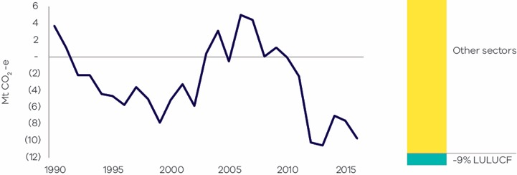
Source: State and Territory Greenhouse Gas Inventories 2016 (Commonwealth of Australia, 2018a)
Figure 31: Emissions from LULUCF sub-categories – Victoria, 1990 to 2016
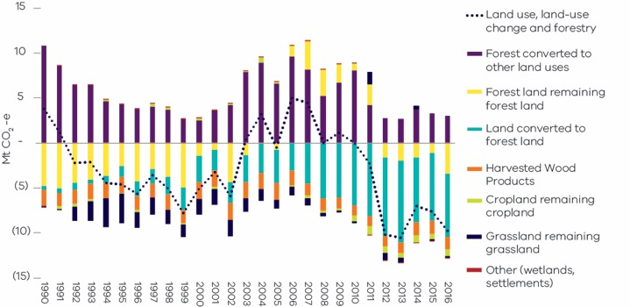
Source: State and Territory Greenhouse Gas Inventories 2016 (Commonwealth of Australia 2018a)

A. Forest land remaining forest land
This sub-category includes emissions from changes in carbon pools in:
- harvested native forests
- other native forests
- plantations established before 1989.
‘Forest land remaining forest land’ was a net sink of 3.4 Mt CO₂-e in 2016. As shown in Figure 31, emissions from this sub-category varied significantly between 1990 and 2016: a net sink between 1990 and 2003, a net source of emissions from 2006 to 2011, and a net sink from 2012 to 2016.
A key driver of emissions from ‘forest land remaining forest land’ is wildfire and fire management practices. Combined emissions from prescribed burning and wildfires fell steeply between 2010 and 2016 – this may have been in part due to a reduction in fuel load following the drought and major bushfires of the 2000s.
Figure 32 shows the total emissions from ‘forest land remaining forest land’. It distinguishes between total emissions from wildfire and prescribed burning and other sources of emissions (including changes in living biomass, dead organic matter [DOM] and soil) in harvested native forest and other native and pre-1989 plantation forests.
Figure 32: Emissions from fire (wildfire and prescribed burnings) and other sources – Victoria, 1990 to 2016
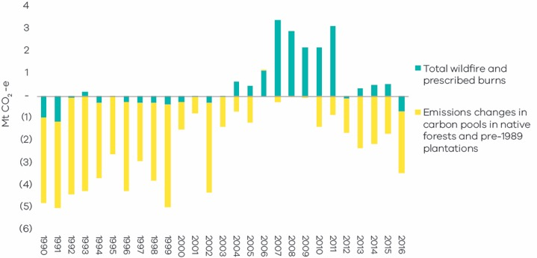
Source: State and Territory Greenhouse Gas Inventories 2016 (Commonwealth of Australia 2018a)

B. Land converted to forest land
This sub-category includes net emissions/removals from:
- For-harvest plantations established since 1990, which are mainly hardwood.
- Environmental plantings established since 1990.
Revegetation of areas cleared of forest since 1972 from natural seed stocks. This may be a combination of intended revegetation for environmental purposes that will be maintained by the landowner, and unintended regeneration of previously cleared land that may be re-cleared. Revegetation of land cleared prior to 1990 is also captured in this sub-category.
‘Land converted to forest land’ was a net sink of 7.0 Mt CO₂-e in 2016. As shown in Figure 31, sequestration from this sub-category increased in scale from 1990 to a peak in 2013 before declining slightly – it nonetheless remained a substantial source of sequestration from 2014 to 2016.
The area of hardwood plantations expanded rapidly in response to the Commonwealth Government’s Managed Investment Act 1998, which increased the finance available for plantation establishment. The Act was subsequently repealed. Harvest volumes have been increasing as short-rotation hardwood plantations are harvested.
The net sink provided by regrowth on deforested land increased between 2007 and 2016 is shown in Figure 33. Sequestration from reforestation on previously cleared land is a function of the area of land on which regrowth is occurring and the rate of regrowth, which depends in part on weather and the type of vegetation.
Figure 33: Net emissions from land converted to forest land – Victoria, 1990 to 2016
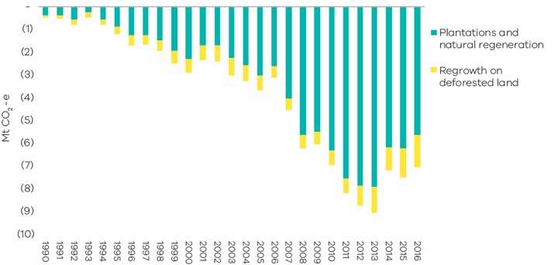
Source: State and Territory Greenhouse Gas Inventories 2016 (Commonwealth of Australia 2018a)

C. Forest land converted to other land uses
This sub-category includes, in roughly equal proportions as at 2016:
- Emissions from the primary conversion of land that was forested in 1972.
- Emissions from secondary or re-clearance of forest which has regrown on cleared land.
- Indirect emissions from loss of soil carbon and other emissions and removals associated with the new land use. Non-CO₂ emissions (for example, associated with application of fertilisers) are accounted for under agriculture sector emissions.
Figure 34: Sources of emissions and removals from ‘forest land converted to other land uses’ – Victoria, 1990 to 2016
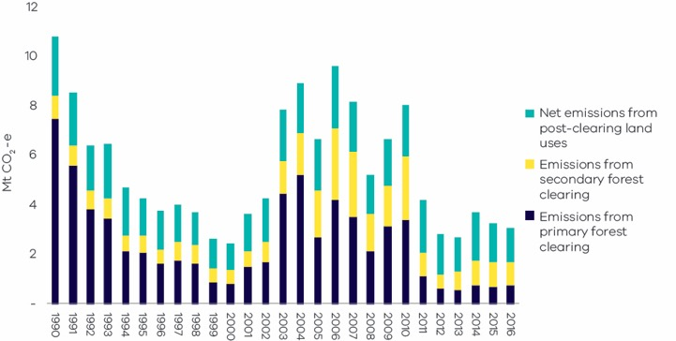
Source: State and Territory Greenhouse Gas Inventories 2016 (Commonwealth of Australia 2018a)
Figure 34 shows that emissions arising from ‘forest land converted to other land uses’ fluctuated significantly over the period 1990 to 2016. Emissions – particularly from primary forest clearing, which correlate with the area of land cleared – fell substantially from 1990 to 2000 before increasing on average between 2001 and 2010, then declining to low levels over the period 2011 to 2016.
Historically, Australia-wide, the area of both primary and secondary clearing has been influenced by changes in farmers’ terms of trade and weather conditions. However, primary clearing is now significantly constrained by land clearing regulations introduced in Victoria in the late 1980s.
The greatest contribution of indirect emissions from clearing occurs within the first two years. However, emissions continue beyond that period.

3. Emissions by economic sector – 2016
Chapter 2 presented emissions data and analysis of emissions trends based on a set of sectors defined in accordance with IPCC guidelines. This chapter provides information on Victorian emissions presented in accordance with various Australian and New Zealand Standard Industry Classification (ANZSIC) sectors, including:
- electricity, gas and water supply
- manufacturing
- commercial services
- agriculture, forestry and fishing
- transport, postal and warehousing
- mining
- construction
- residential.

3.1 Direct emissions by ANZSIC sector
This section presents data on the direct emissions attributable to each ANZSIC sector. Direct (also known as Scope 1) emissions are released to the atmosphere as a direct result of an activity within an organisation’s boundary (i.e. fuel use, energy use, manufacturing process activity, mining activity, on-site waste disposal, etc.). The following examples illustrate the scope of direct emissions for selected ANZSIC sectors:
- Direct emissions from the residential sector include emissions from transport activities, the consumption of gas for heating and cooking, and emissions associated with the use of waste and wastewater services.
- Direct emissions from agriculture, forestry and fishing include emissions from activities such as the application of fertilisers, livestock management, and the combustion of fuels required for agriculture and forestry activities. It also includes emissions and sequestration of carbon from forest and grassland management.
- Direct emissions from manufacturing include emissions related to the direct combustion of fuels, transport, the use of waste management services and leaks from industrial processes that are directly related to manufacturing processes such as the production of food, paper, textiles and chemicals.
Figure 35 presents the result of this process. It shows that the electricity, gas and water supply sector (54%) produces the largest share of direct emissions, followed by the residential sector (16%) and manufacturing (8%).
Figure 35: Scope 1 emissions by ANZSIC sector – Victoria, 2016
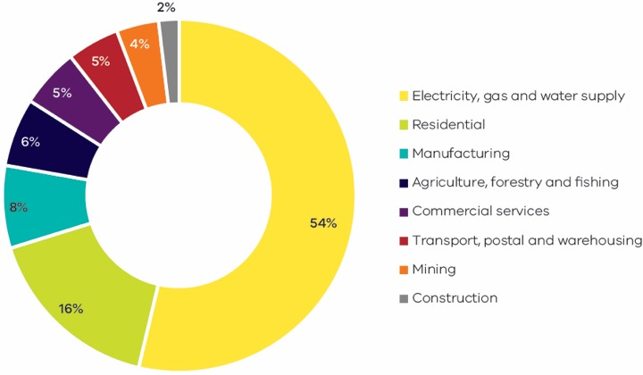
Source: Australian Greenhouse Emissions Information System (Department of Environment and Energy 2018b)

3.2 Allocation of emissions from electricity generation to end-users
In this section, emissions associated with the generation of electricity are allocated to the end-users of electricity in each ANZSIC sector. The emissions attributable to electricity consumption are known as indirect or Scope 2 emissions.
Analysis of the emissions attributable to electricity consumption enables a deeper understanding of the demand drivers that contribute to emissions from the electricity sector.
Figure 36 presents the results of this process. The economic sector responsible for the largest share of Scope 2 emissions is commercial services (34%) followed by manufacturing (23%) and residential (22%). The ‘electricity, gas and water supply’ sector (17%) includes emissions associated with electricity that is consumed by this sector for its own use.
It should be noted that the data in Figure 36 relates only to electricity that is generated in Victoria and to the share of this generation that is consumed by ANZSIC sectors in Victoria. Net exports of electricity between jurisdictions in the National Electricity Market are not accounted for in the calculations.
Figure 36: Scope 2 emissions by ANZSIC sector – Victoria, 2016
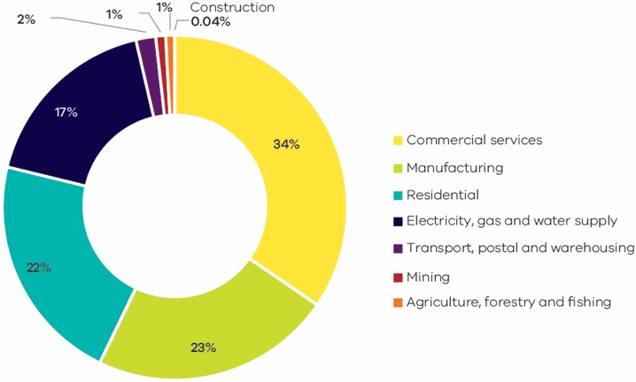
Source: Australian Greenhouse Emissions Information System (Department of Environment and Energy 2018b)

3.3 Direct plus indirect emissions by ANZSIC sector
This section combines the analysis in the previous two sections to allocate direct (Scope 1) plus indirect (Scope 2) emissions to each ANZSIC sector.
The results are presented in Figure 37. The residential sector is responsible for the largest share of direct plus indirect emissions in Victoria (30.1 Mt CO₂-e or 26.1%), followed by commercial services (23.9 Mt CO₂-e or 20.7%) and manufacturing (20.3 Mt CO₂-e or 17.6%).
Figure 37: Scope 1 + 2 emissions by ANZSIC sector* – Victoria, 2016
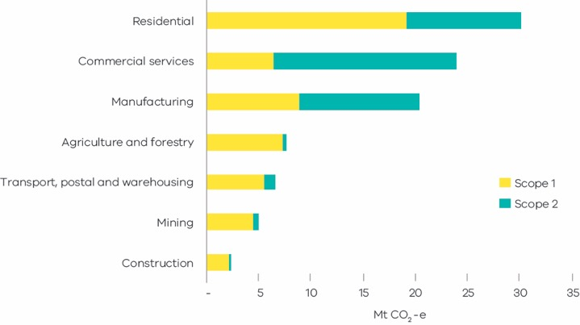
Source: analysis based on Australian Greenhouse Emissions Information System (Department of Environment and Energy 2018b), (Department of Environment and Energy 2018c)
*Note – consistent with the approach adopted by the Commonwealth, emissions from electricity generation consumed by the electricity, gas and water sector are not included in this figure as this electricity use includes ‘own use’ of generators and does not necessarily meet the National Greenhouse Accounts Factors 2017 definition of Scope 2 emissions. Direct emissions from agriculture and forestry also include sequestration from forest and grassland management.

4. Projected emissions to 2020
The Victorian Government has a target to reduce Victoria’s greenhouse gas emissions by 15-20% below
2005 levels by 2020 (Department of Environment, Land, Water and Planning, 2018). This chapter presents
a projection of Victorian emissions to 2020, providing information on how Victoria is tracking towards
this target.
The 2020 emissions projection is based on the approach used by the Commonwealth Department of the Environment and Energy (DoEE) for preparing the 2017 national emissions projections (Department of Environment and Energy, 2017e) as set out in Appendix B.
Projections for electricity generation, transport and agriculture are based on the 2017 DoEE emissions projections, disaggregated to a state level. The electricity generation projections also take account of estimated emissions based on actual electricity generation for 2017 and 2018.
Projections for direct combustion, fugitive emissions from fuels, industrial processes and product use, and waste are based on proxy indicators that aim to replicate the DoEE projections methods when disaggregated data for Victoria is not available. This estimates the projected change in emissions based on trends in the activities that drive emissions in these sectors/sub-sectors.
LULUCF emissions were projected by analysing the historical trend in emissions for LULUCF each sub-category, identifying the drivers and anticipating the most representative trend.
The 2020 projections include the:
- Expected reductions in greenhouse gas emissions due to existing government policies and programs – they do not incorporate the impact of any possible new policy initiatives at the national or state level.
- Estimated impact on Victoria’s emissions of the closure of the Hazelwood Power Station in 2017.

4.1 Progress towards Victoria’s 2020 target
The results of this analysis are shown in Figure 38. Victoria’s total emissions in 2020 are projected to be 104.5 Mt CO₂-e. This represents a reduction of 23.2 Mt CO₂-e (18.2%) from 2005 emissions. The projections indicate that Victoria is on track to achieve the 2020 emissions reduction target of 15-20% below 2005 levels.
The trend in emissions from 2017 to 2020 shows total emissions falling in 2017 and 2018 due to emissions reduction policies and the closure of the Hazelwood Power Station in March 2017. Electricity emissions are projected to remain flat over 2019 to 2020. However, total emissions in these years are projected to increase slightly due to growth in emissions from transport and agriculture.
Figure 38: Victoria’s historical and projected emissions
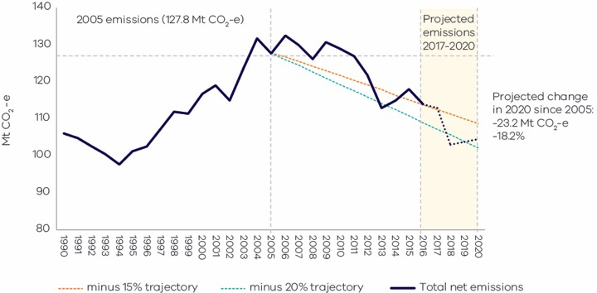
Source: State and Territory Greenhouse Gas Inventories 2016 (Commonwealth of Australia 2018a) and DELWP analysis on projections

4.2 Sectoral trends
Table 3 presents the projected change in emissions by IPCC sector/sub-sector between 2016 and 2020. This is followed by an explanation of the anticipated drivers of these changes. Because 2016 is the latest year for which official emissions data is available, it was necessary to project emissions for 2017-2020.
The discussion of sectoral projections below indicates that population growth is an important driver of emissions trends in a number of sectors/sub-sectors. However, it is not the only driver. This is reflected in per capita emissions numbers, which are projected to fall from 18t CO₂-e per person in 2016 to 16t CO₂-e per person in 2020.
Table 3: Projected change in emissions by IPCC sector/sub-sector – Victoria, 2016 to 2020
Sector/sub-sector | 2016 actual  Mt CO₂-e | 2020 projected  Mt CO₂-e | Change 2016 to 2020  Mt CO₂-e | Change 2016 to 2020 (%)
Electricity generation | 59.2 | 44.3 | -14.9 | -25.2% | ↓
Direct combustion | 18.5 | 18.3 | -0.2 | -0.9% | ↓
Transport | 22.3 | 24.6 | 2.3 | 10.5% | ↑
Fugitive emissions | 3.2 | 2.7 | -0.5 | -15.6% | ↓
Industrial processes and product use | 4.1 | 4.2 | 0.1 | 2.0% | ↑
Agriculture | 13.9 | 15.3 | 1.4 | 10.1% | ↑
Waste | 2.5 | 2.4 | -0.1 | -3.9% | ↓
LULUCF | -9.7 | -7.3 | 2.5 | 25.3% | ↑
Total (net emissions) | 114.0 | 104.5 | -9.4 | -8.2% | ↓
Source: State and Territory Greenhouse Gas Inventories 2016 (Commonwealth of Australia 2018a) and DELWP analysis on projections
Table 4: Drivers of projected emissions by IPCC sector/sub-sector – Victoria, 2016 to 2020
Emission source | Anticipated drivers of change in emissions to 2020
Electricity generation | Electricity emissions are projected to decrease by 25.2% between 2016 and 2020. In 2016, Hazelwood Power Station generated emissions of 14.4 Mt CO₂-e. Following its closure, most of Hazelwood’s output was replaced by generation in other states, reducing Victoria’s net electricity exports. In Victoria, there was some additional gas-fired generation and a small increase in output from other brown coal generators. Considering this market response in the 12 months following the closure, it is estimated that the net impact of Hazelwood’s retirement was a reduction in Victoria’s emissions of 11.8 Mt of CO₂-e (NEM-Review6 2018). In 2020, electricity generation emissions in Victoria are projected to be 14.9 Mt CO₂-e lower than in 2016. The reduction in emissions over and above the impact of the closure of Hazelwood largely reflects the projected impact of existing Victorian and Commonwealth government policies including those bringing new renewable generation into the National Electricity Market.
Direct combustion | Direct combustion emissions are projected to decrease by 0.9% between 2016 and 2020 driven by a reduction of natural gas consumption. AEMO forecasts that natural gas consumption will decline slightly to 2020 due to ongoing reductions in industrial load, inner city residential users switching from gas to electrical appliances, and improvements in energy efficiency (Australian Energy Market Operator, 2018b). Continuing population growth will only partly offset these reductions.
Transport | Transport emissions are projected to increase by 10.5% between 2016 and 2020 mainly due to population and economic growth leading to greater transport use.
Fugitive emissions | Fugitive emissions are projected to decrease by 15.6% between 2016 and 2020 mainly driven by reduced losses of natural gas from distribution activities associated with a decrease in natural gas consumption. In addition, AEMO forecasts a slight decrease in natural gas production resulting from an earlier than anticipated depletion of gas fields (Australian Energy Market Operator, 2018b).
Industrial processes and product use | IPPU emissions are projected to increase by 2.0% between 2016 and 2020 mainly driven by increasing usage of HFCs due to population and economic growth. Emissions reductions from the national legislative phase-down of HFCs are not expected to occur until after 2020.
Agriculture | Agriculture emissions are projected to increase by 10.1% between 2016 and 2020 mainly due to rising food demand. Beef cattle is projected to continue to be the biggest contributor, followed by sheep and pigs.
Waste | Waste emissions are projected to decline by 3.9% between 2016 and 2020 mainly driven by the diversion of waste from landfills in line with the 30-year roadmap set out in the Statewide Waste and Resource Recovery Infrastructure Plan (2018). Domestic wastewater emissions are also projected to fall due to emission reductions required by the Water Sector Statement of Obligations (Neville 2018).
LULUCF | LULUCF is projected to continue to be a net sink between 2016 and 2020, but the scale of sequestration is anticipated to decline by 25.3% due to:  Harvesting of commercial plantations, which has been increasing in recent years as short rotation hardwood plantations mature and are harvested. At the same time, rates of plantation establishment have been close to zero since 2013. This trend is likely to continue to 2020 in the absence of new policy initiatives.  A return to average levels of net removals of carbon from the sub-category of forest land remaining forest land. Sequestration levels in 2016 were more than double the average over the previous four years.

Appendices

Appendix A LULUCF definitions, sources and removals
Category | Land areas | Sources of anthropogenic emissions and removals
Forest land
Forest land remaining forest land | Includes:  - Harvested native forests – multiple-use public forests as at 2008, and private native forests subject to harvest or regrowing from prior harvest.  - Other native forests – forests of endemic species that are not harvested native forests or plantations. It includes protected areas such as wilderness areas and national parks.  - For-harvest plantations established up to the end of 1989. | Sources of anthropogenic emissions and removals include:  - Annual change in carbon pools due to forest growth and losses due to harvesting. Living biomass (above and below ground) changes due to forest growth, and losses due to harvesting. Dead organic matter (DOM) and soils are affected by turnover and decay, and harvest residues. Biomass removals as roundwood from harvesting are reflected in inputs to the Harvested Wood Product category. Emissions from wildfires and fire management practices. Non-anthropogenic natural disturbances, including some but not all wildfires, are modelled to average out over time, leaving anthropogenic emissions and removals as the main drivers.  - Annual change in carbon pools from plantation establishment and harvesting on land that was plantation land in 1989. Carbon pools include above and below-ground biomass, DOM and soil. Harvested wood products from plantations are reported under the Harvested Wood Products category.
Land converted to forest land | - This includes land on which forest has been established that was not forested as of 1972. It includes grassland, croplands, settlements and wetlands on which forest has been identified as emerging.  - Grassland converted to forest land includes for-harvest and environmental plantations, forest that has regrown on land that had been cleared for other uses, and regeneration of forest from in situ seed sources on land that had been cleared (including land where some regeneration had begun prior to 1990).  - Wetlands converted to forest land includes mangrove forests that have emerged on tidal marshes. | Sources of anthropogenic emissions and removals include: annual change in living biomass (above and below ground) on new and existing land in this category, losses due to harvesting, and DOM and changes in soil carbon.
Forest land converted to cropland, grasslands, wetlands and settlements
Land converted to cropland | This includes forest and wetlands converted to cropland since 1972. | Sources of anthropogenic emissions and removals include changes in all carbon pools (living biomass, DOM and soil) from:  - Primary clearing – arising when forest is cleared and maintained as cropland  - Secondary clearing – arising when forest is cleared for cropland but then regrows and is re-cleared. The regrowth is now reported as land converted to forest land  - Post-clearing land use – primarily changes in soil carbon.  In Victoria’s LULUCF emissions discussed in Chapter 2, all forest land converted to other uses (cropland, grassland, wetland and settlements) is reported in one sub-category – Forest Land Converted to Other Land Uses.
Land converted to grassland | This includes forest land and wetlands converted to grassland since 1972. | Sources of anthropogenic emissions and removals include changes in all carbon pools (living biomass, DOM, and soil) associated with:  - Primary clearing – arising when forest is cleared and maintained as grassland  - Secondary clearing – arising when forest is cleared for grassland but then regrows and is re-cleared. The regrowth is now reported as land converted to forest land  - Post-clearing land use – primarily changes in soil carbon.  In Victoria’s LULUCF emissions discussed in Chapter 2, all forest land converted to other uses (cropland, grassland, wetland and settlements) is reported in one sub-category – Forest Land Converted to Other Land Uses.
Land converted to wetland | This includes forests cleared as part of the construction of reservoirs and other land classified as flooded land. | CO₂ emissions from cleared biomass consistent with Vol 4 Sub‑section 7.3.2 of IPCC 2006 Guidelines.
Land converted to settlements | Includes forest land and wetlands converted to settlements. This includes mangrove forests cleared for commercial developments such as marinas. | Sources of anthropogenic emissions and removals include changes in all carbon pools associated with the clearing.

Appendix B 2020 projections method and assumptions
DELWP liaised with the DoEE on the approach to developing the 2020 emissions projections, including the method, sources of data, and assumptions. The projections are that of DELWP and are not official projections of the Commonwealth. DELWP also engaged an independent expert to conduct a peer review of the method and initial results of the projections.
Electricity generation
Method and rationale | Emissions for the years 2016-17 and 2017-18 were sourced from NEM Review data (NEM-Review6, 2018), which estimates greenhouse gas emissions for these years on the basis of actual generation volumes reported by AEMO and publicly available emissions factors.  Projected emissions for the years 2018-19 and 2019-20 were obtained from data provided by DoEE, which projects electricity output using an electricity market simulation model.
Inclusions | Inclusions – estimated impacts of:  closure of the Hazelwood Power Station  Victorian Renewable Energy Target and energy efficiency measures  Commonwealth Large-scale Renewable Energy Target  COAG agreed National Energy Productivity Plan  growth in electricity consumption by electric vehicles  gas to electricity fuel switching.
Source of information | DoEE produces its sectoral projections consistent with international guidelines and includes data disaggregated to the state level. The method for the 2017 national projections is available at: http://www.environment.gov.au/climate-change/publications/emissions-projections-2017

Direct combustion
Method and rationale | Proxy indicator using natural gas consumption  Historical trends indicate that there is a strong correlation between emissions from this sub-sector and the consumption of natural gas. Natural gas contributes more than 65% to emissions from this sub-sector in Victoria.  Projected emissions were estimated using a proxy indicator that considers the annual change in natural gas consumption in Victoria for residential, commercial and industrial activities, and direct combustion emissions from the previous year.
Assumptions and justification | It was assumed that other fuels used in direct combustion follow the same trend as natural gas consumption.  In 2015-16, approximately 258 PJ of natural gas was consumed in direct combustion in Victoria (excluding electricity generation and transport) (Department of Environment and Energy, 2017a). The fuel with the second largest share of direct combustion in Victoria, excluding electricity and transport, is petroleum products. The Australian Energy Statistics do not include the quantities of miscellaneous petroleum products consumed to provide stationary energy at Victoria’s two oil refineries and at petrochemical manufacturing facilities. Publicly available data is not sufficient to allow these quantities to be estimated, but they are certainly much smaller than quantities of natural gas consumption. The Australian Energy Statistics further indicate that consumption of brown coal briquettes is negligible.
Source of information | AEMO’s forecast of natural gas consumption for residential, commercial and industrial activities in Victoria is available at: http://forecasting.aemo.com.au/Gas/AnnualConsumption/Total

Transport
Method and rationale | Projected emissions were obtained from Victorian data provided by DoEE using an integrated bottom-up and top-down modelling approach called the Energy Sector Model (ESM).
Exclusions | Possible measures to improve the fuel efficiency of Australia’s vehicle fleet – these are currently under consideration by the Ministerial Forum on Vehicle Emissions.
Source of information | DoEE prepared projections for this sub-sector consistent with international guidelines and with data disaggregated at the state level. The method for the 2017 national projections is available at: http://www.environment.gov.au/climate-change/publications/emissions-projections-2017

Fugitive emissions from fuels
Method and rationale | Proxy indicator using natural gas losses  Historical trends indicate that there is a strong correlation between consumption and production of natural gas and fugitive emissions. 74% of fugitive emissions in Victoria come from the consumption and production of natural gas, of which 80% is associated with losses in natural gas distribution, transmission and storage.  Projected fugitive emissions from the transmission, storage and distribution of natural gas were estimated using a proxy indicator that considers the annual change of gas losses in Victoria and fugitive emissions of these sub-categories from the previous year.  Proxy indicator using natural gas production  For sources of fugitive emissions from the natural gas supply system other than gas distribution, transmission and storage, projected emissions were estimated using a proxy indicator that considers the annual changes of gas production in Victoria and fugitive emissions of these sub-categories from the previous year20.
Assumptions and justification | All other oil and gas fugitives, including venting and flaring, account for 28.5% of emissions from this sub-sector. Data collected by the Commonwealth relating to these sources of emissions is commercial-in-confidence and therefore cannot be reported or projected in a disaggregated manner for Victoria. Consequently, it was assumed that emissions from these other sources follow the same trend as fugitive emissions associated with natural gas production.  Fugitive emissions from solid fuels are negligible – they account for only 0.51% of fugitive emissions. It is assumed that these emissions will remain constant between 2016 and 2020 because material changes in the production of solid fuels are not anticipated before 2020.
Source of information | AEMO’s forecast on gas consumption in Victoria is available at: http://forecasting.aemo.com.au/Gas/AnnualConsumption/Total  AEMO’s forecast on gas production in Victoria is available at: https://aemo.com.au/-/media/Files/Gas/National_Planning_and_Forecasting/VGPR/2017/2018---Victorian-Gas-Planning-Report-Update.pdf  Historical Australian Energy Statistics for natural gas production in Victoria is available at:  https://www.energy.gov.au/publications/australian-energy-update-2017

Industrial processes and product use (IPPU)
Method and rationale | National projected change of HFCs applied to Victoria  IPPU emissions were projected by applying the projected annual change in national emissions of synthetic gases from the use of halocarbons in refrigeration and air conditioning (HFCs) obtained from DoEE data, and applying these projected rates of change to Victoria.  There is a strong correlation between the use of HFCs and emissions from this sector. This is mainly due to the multiple sources of emissions caused by using air-conditioning and refrigerant gases in commercial, domestic and industrial activities accounting for 82% of IPPU emissions  in Victoria.
Assumptions and justification | The remaining 18% of emissions from this sector are associated with manufacturing industries such as chemical and metal manufacturing (of which aluminium smelting is the major source in Victoria). Data collected by the Commonwealth relating to these sources of emissions is commercial-in-confidence and therefore cannot be reported or projected in a disaggregated manner for Victoria.  It is assumed that emissions from these sources in Victoria will remain constant between 2016 and 2020 because no material changes in these industries are anticipated.
Source of information | DoEE provided HFCs projected emissions at the national level based on models used in the preparation of the National Inventory Report.

Waste
Method and rationale | Proxy indicator using waste landfill projections  Solid waste emissions, which contribute 65% of emissions from this sector, were projected using a proxy indicator that considers the annual change in the volume of waste sent to landfills and solid waste emissions from the previous year.  Projected emissions from water corporations  Wastewater emissions from municipal treatment plants, which contribute 18% of emissions from this sector, were projected by analysing underlying data on emissions projections developed by water corporations as part of emissions reduction pledges and provided to DELWP.
Assumptions and justification | It was assumed that the remaining 17% of emissions from this sector, which are associated mainly with private industrial wastewater treatment plants, remain constant between 2016 and 2020 because material changes in industrial activity is not anticipated before 2020.
Source of information | Source of information for solid waste proxy  Victorian waste projections maintained by Sustainability Victoria are available at:http://www.sustainability.vic.gov.au/Government/Victorian-Waste-data-portal/Interactive-waste-data-mapping/Waste-projection-model#  Source of information for municipal wastewater treatment plants  Scope 1 emissions analysis was based on emissions reduction pledges provided by water corporations. Estimates were made of the emissions reductions anticipated up to 2020 from the implementation of actions by the water sector to reduce wastewater-related emissions.

Agriculture
Method and rationale | Projected emissions were obtained from Victorian data provided by DoEE using a bottom-up model developed and maintained by DoEE. Projections are based on the projected level of agricultural activity in each year estimated by drawing on external data sources that contain activity levels and growth rates.  Where projected activity data was not available for particular commodities, an appropriate proxy such as production (quantity of end product), or a relevant driver such as growth in another connected commodity (as informed by historical comparisons) was used.
Inclusion | The projected impact on emissions associated with the Emissions Reduction Fund (ERF).
Source of information | DoEE prepared sectoral projections consistent with international guidelines and provides data disaggregated at the state level. The method for the 2017 national projections is available at:  http://www.environment.gov.au/climate-change/publications/emissions-projections-2017

LULUCF
Separate projections were prepared for each LULUCF sub-category.
This was done by analysing the trend in emissions for each sub-category between 1990 and 2016 to identify the factors that drove the trends in emissions at different stages over this period.
Based on this analysis, the sub-stages in the 1990-2016 period that are anticipated to be most representative of the projection period (2017-2020) were identified. Emissions projections for 2017-2020 were then made by:
- Extrapolating a linear trend from a sub-period between 1990 and 2016 – this approach was adopted when the data over the sub-period was relatively stable and, therefore, a linear trend could be established; or
- Extrapolating the average emissions from a sub-period between 1990 and 2016 – this approach was adopted when the data over the sub-period involved fluctuations so that a linear trend would not be reasonable to establish.
The specific approach for each sub-category is presented below.
Sub-category and emissions source |  | Basis for projecting emissions trends 2017-2020 |  | Rationale
Forest land remaining forest land
Changes in carbon pools in native forests and pre-1989 plantations | Average emissions 2012 to 2016 |  | Emissions from changes in carbon pools in native forests and pre-1989 plantations from 2017 to 2020 were projected by extrapolating the average net removals from this sub-category between 2012 and 2016. The period after 2012 reflects lower volumes of harvesting from the native forest estate. It should be noted that the projections were not adjusted to account for VicForest’s forecast of still lower harvest volumes between 2018 and 2020 – projected emissions for this sub-category are likely to be conservative (high) as a result.
Wildfire and fire management | Average emissions 1990 to 2016 |  | Combined emissions from prescribed burning and wildfires fell steeply between 2010 and 2016. This may have been due, in part, to the reduction in fuel load following the drought and major bushfires of the 2000s. There is ongoing consideration in Victoria regarding the optimal level and approach to prescribed burning. The Victorian Government’s Reducing Bushfire Risk Program was implemented in late 2017. It will focus on effective fuel management through a combination of planned burning, slashing and mulching. It is unclear what impact this will have on overall emissions from prescribed burning or wildfire in the context of the increased risk of extreme weather resulting from climate change. Given the variability over time of emissions from wildfire and fire management, the most appropriate basis for projecting emissions from this sub-category is the long-term average.
Land converted to forest land
Plantations and natural regeneration | Trend line for 2014 to 2016 |  | The trend rate of change in emissions from plantations between 2014 and 2016 reflects recent low rates of plantation establishment and harvesting rates that are representative of anticipated activity levels over the period 2017 to 2020. Consequently, emissions were projected by extrapolating the trend line for emissions between 2014 and 2016 to the projection period.
Regrowth on deforested land | Trend line for 2002 to 2016 |  | Rates of sequestration from regrowth on deforested land increased in the current decade relative to the 2000s. While it is anticipated that these higher rates will continue into the projection period, regrowth can be affected by variations in the weather and variations in farmers’ terms of trade. Consequently, a conservative approach was adopted with a trend line established for the 15-year period from 2002 to 2016 rather than only for the post-2010 period – projections were made by extrapolating this 15-year trend to 2017-2020.
Forest land converted to other land uses
Primary and secondary land clearing | Trend line for 2011 to 2016 |  | Rates of primary and secondary clearance of forest land to other land uses in Victoria fell sharply in 2010 and have remained at lower rates since then. This resulted in substantial reductions in the direct emissions arising from the primary conversion of land and emissions associated with secondary (or re-clearance) of forest which regrows on cleared land. Indirect emissions from loss of soil carbon and other emissions and removals (sequestration) associated with the new land use (e.g. agricultural activity) fluctuated over this period. It is anticipated that trends established since 2010 will continue over the projection period – as such, emissions for 2017 to 2020 were projected by extrapolating the trend line for emissions between 2010 and 2016.
Indirect emissions from loss of soil carbon | Trend line for 2011 to 2016

Abbreviations and acronyms
AEMO – Australian Energy Market Operator
AAP– Action Adaptation Plan
The Act–The Climate Change Act 2017
ANZSIC–Australian and New Zealand Standard Industrial Classification
CO₂–Carbon dioxide, a greenhouse gas
CO₂-e–Carbon dioxide equivalent
DoEE–Commonwealth Department of Environment and Energy
GSP–Gross State Product
HFCs–Hydrofluorocarbons, a greenhouse gas
IPCC–Intergovernmental Panel for Climate Change
KP–Kyoto Protocol
kt–Kilo tonnes
LULUCF–Land Use, Land Use Change and Forestry
Mt–Mega tonnes
Mw–Mega watt
NEM–National Electricity Market
PJ–Petajoule
UNFCCC–United Nations Framework Convention on Climate Change

Reference list
Australian Bureau of Statistics 2016, Australian National Accounts: State Accounts, 2015-16, Cat. No. 5220.0,ABS, Canberra, viewed 20 July. 2018.http://www.abs.gov.au/AUSSTATS/abs@.nsf/DetailsPage/5220.02015-16?OpenDocument
Australian Bureau of Statistics 2017a, Australian Demographic Statistics 2016, Cat. No. 3101.0, ABS, Canberra, viewed 20 July 2018. http://www.abs.gov.au/AUSSTATS/abs@.nsf/DetailsPage/3101.0Dec%202016?OpenDocument
Australian Bureau of Statistics 2017b, Australian National Accounts: State Accounts, 2016-17, Cat. No. 5220.0, ABS, Canberra, viewed 20 July 2018. http://www.abs.gov.au/AUSSTATS/abs@.nsf/DetailsPage/5220.02016-17?OpenDocument
Australian Bureau of Statistics 2017c, Motor Vehicle Census, Australia, Cat. No. 9309.0, ABS, Canberra, 31 Jan 2017, viewed 27 July 2018. http://www.abs.gov.au/AUSSTATS/abs@.nsf/allprimarymainfeatures/AFE43252F544460ACA2582D60014CB0F?opendocument
Australian Energy Market Operator 2018a, Electricity – Generation Information Page, NEM Regional Generation Information Pages, AEMO, viewed 27 July 2018. https://www.aemo.com.au/Electricity/National-Electricity-Market-NEM/Planning-and-forecasting/Generation-information
Australian Energy Market Operator 2018b, Victorian Gas Planning Report Update, Gas Transmission Network Planning for Victoria, March 2018, viewed 27 July 2018. https://aemo.com.au/-/media/Files/Gas/National_Planning_and_Forecasting/VGPR/2017/2018---Victorian-Gas-Planning-Report-Update.pdf
Clean Energy Regulator 2017, Electricity sector emissions and generation data 2015-16, Designated Generation Facility Data 2015 – 2016, published 27 October 2017, viewed 27 July 2018. http://www.cleanenergyregulator.gov.au/NGER/National%20greenhouse%20and%20energy%20reporting%20data/electricity-sector-emissions-and-generation-data/electricity-sector-emissions-and-generation-data-2015-16#Designated-generation-facility-data-201516
Clean Energy Regulator 2018, Postcode data for small-scale installations, Summary of postcode data, Small generation unit – solar (deemed), viewed 27 July 2018. http://www.cleanenergyregulator.gov.au/RET/Forms-and-resources/Postcode-data-for-small-scale-installations#Smallscale-installations-by-installation-year
Commonwealth of Australia 2018a, State and Territory Greenhouse Gas Inventories 2016, Department of the Environment and Energy (Australian National Greenhouse Accounts, 2018), viewed 22 June 2018. http://www.environment.gov.au/climate-change/climate-science-data/greenhouse-gas-measurement/publications/state-and-territory-greenhouse-gas-inventories-2016
Commonwealth of Australia 2018b, National Inventory Report 2016, Department of Environment and Energy, published April 2018, viewed 22 June 2018. http://www.environment.gov.au/climate-change/climate-science-data/greenhouse-gas-measurement/publications/national-inventory-report-2016
Department of Agriculture and Water Resources 2018a, About My Region – Victoria – Regional Overview, ABARES, 11 July 2018, viewed July 2018. http://www.agriculture.gov.au/abares/research-topics/aboutmyregion/vic#regional-overview
Department of Agriculture and Water Resources 2018b, About My Region – Victoria – Agricultural Sector, ABARES, 11 July 2018, viewed July 2018. http://www.agriculture.gov.au/abares/research-topics/aboutmyregion/vic#agricultural-sector
Department of Economic Development, Jobs, Transport and Resources 2014, Sheep Industry Profile, Agriculture Victoria, 24 December 2014, viewed 27 July 2018. http://agriculture.vic.gov.au/__data/assets/pdf_file/0007/292174/2-Sheep-Industry-Profile_December-2014-Update_MASTER1.pdf
Department of Economic Development, Jobs, Transport and Resources 2015, Petroleum, published 28 October 2015, viewed 27 July 2018. http://earthresources.vic.gov.au/earth-resources/victorias-earth-resources/petroleum
Department of Environment and Energy 2017a, Australian Energy Update 2017, Table F – Australian Energy Consumption by State, by industry, by fuel, energy units, published September 2017, viewed 27 July 2018. https://www.energy.gov.au/publications/australian-energy-update-2017
Department of Environment and Energy 2017b, Australian Energy Update 2017, Table Q: Australian consumption and production of natural gas, by state, physical units, published September 2017, viewed 27 July 2018. https://www.energy.gov.au/sites/g/files/net3411/f/table-q-2017.xlsx
Department of Environment and Energy 2017e, Australia’s emissions projections 2017- Methodology for the 2017 Projections, DoEE, 2017, viewed 27 July 2018. http://www.environment.gov.au/system/files/resources/eb62f30f-3e0f-4bfa-bb7a-c87818160fcf/files/2017-projections-methodology.pdf
Department of Environment and Energy 2018a, Australian Greenhouse Emissions Information System - National Greenhouse Gas Inventory Trend, Victoria, sourced July 2017. http://ageis.climatechange.gov.au/NGGITrend.aspx
Department of Environment and Energy 2018b, Australian Greenhouse Emissions Information System - National Inventory by Economic Sector, Victoria, sourced 27 July 2018. http://ageis.climatechange.gov.au/ANZSIC.aspx
Department of Environment and Energy 2018c, Australian Greenhouse Emissions Information System -– Scope 2 Emissions, Indirect emissions from purchased electricity – Victoria, sourced 27 July 2018. http://ageis.climatechange.gov.au/Electricity.aspx
Department of Environment, Land, Water and Planning 2018, Victoria's Climate Change Framework, viewed 1 August 2018. https://www.climatechange.vic.gov.au/victorias-climate-change-framework
NEM-Review6 2018, Metered Generation (As Generated), sourced July 2018. http://v6.nem-review.info/use/index.aspx
Neville, L 2018, Water Industry Act; Statement of Obligations (Emission Reduction), 14 March 2018, viewed 27 July 2018. https://www.water.vic.gov.au/__data/assets/pdf_file/0017/120671/Statement-of-Obligations-Emission-Reduction.pdf
Morton, A 2012, ‘Yallourn coal mine flood worsens’, The Age, 16 July 2012, viewed 27 July 2018. https://www.theage.com.au/national/victoria/yallourn-coal-mine-flood-worsens-20120715-224ef.html

The Victorian Government may deliver the products before the statutory due date.
Percentage contributions of each sector are presented as net emissions (i.e. they take into account sequestration in the LULUCF sector).
DoEE prepares National Greenhouse Accounts that include a series of annual publications to meet Australia’s international obligations under the United Nations Framework Convention on Climate Change (UNFCCC) and Kyoto Protocol (KP). These include State and Territory Greenhouse Gas Inventories and the National Inventory Report.
Financial years to 30 June – for example, the year 2012 refers to the Australian financial year from 1 July 2011 to 30 June 2012.
UNFCCC accounting was used rather than Kyoto Protocol (KP) accounting because it includes a more comprehensive set of land categories and the identification of emissions from land clearing events. It is also expected to be more widely used in the future than the KP provisions. Total net Victorian emissions in 2016 estimated under UNFCCC rules were 1.2 Mt CO₂-e lower than those estimated using KP rules.
DoEE produces LULUCF emissions data under the rules for reporting applicable to both the UNFCCC and under the Kyoto Protocol. The Victorian Greenhouse Gas Emissions Report uses LULUCF data following the UNFCCC emission accounting provisions.
Percentage contributions of each sector are presented as net emissions (i.e. take into account sequestration in the LULUCF sector)
Sustainability Victoria’s analysis based on 2017 Australian Energy Statistics, Table F - Australian energy consumption, by industry and fuel type, energy units (Department of Environment and Energy 2017a).
Natural gas analysis based on Australian Energy Statistics (Department of Environment and Energy 2017a)
Natural gas analysis based on Australian Energy Statistics (Department of Environment and Energy 2017a)
Natural gas analysis based on Australian Energy Statistics (Department of Environment and Energy 2017a)
Analysis based on 2017 Motor Vehicle Census (Australian Bureau of Statistics 2017c)
Transport fuel analysis based on Victorian energy consumption (Department of Environment and Energy 2017a)
Enteric fermentation is a natural part of the digestive process of ruminants where microbes decompose and ferment food present in the digestive tract or rumen.
DoEE produces LULUCF emissions data under the rules for reporting applicable to both the UNFCCC and under the Kyoto Protocol. The Victorian Greenhouse Gas Emissions Report uses LULUCF data following the UNFCCC emission accounting provisions.
ABS projects that Victoria’s population in 2020 will be 6.55 million (Australian Bureau of Statistics, 2017a)
IPCC defines carbon pool as a reservoir. A system which has the capacity to accumulate or release carbon. Examples of carbon pools are forest biomass, wood products, soils, and atmosphere.
National Inventory Report 2016, s6.4.1.3, consistent with IPPC 2006 Volume 4.1.5 (Commonwealth of Australia, 2018d)
The following proxy indicator formula is used. It is applied in the methodology for DoEE 2017 projections when facility level data is not available for modelling (Department of Environment and Energy, 2017e). Et = Et-1*At/At-1 Et = emissions in year t Et-1 = emissions in year t-1 At = activity in year t At-1 = activity in year t-1
The following proxy indicator formula is used. It is applied in the methodology for DoEE 2017 projections when facility level data is not available for modelling (Department of Environment and Energy, 2017e). Et = Et-1*At/At-1 Et = emissions in year t Et-1 = emissions in year t-1 At = activity in year t At-1 = activity in year t-1
The following proxy indicator formula is used. It is applied in the methodology for DoEE 2017 projections when facility level data is not available for modelling (Department of Environment and Energy, 2017e) Et = Et-1*At/At-1 Et = emissions in year t Et-1 = emissions in year t-1 At = activity in year t At-1 = activity in year t-1

