Victoria's 2035 Emissions Reduction Target Supporting Analysis
Acknowledgement
We acknowledge and respect Victorian Traditional Owners as the original custodians of Victoria’s land and waters, their unique ability to care for Country and deep spiritual connection to it.
We honour Elders past and present whose knowledge and wisdom has ensured the continuation of culture and traditional practices.
The Department of Energy, Environment and Climate Action is committed to genuinely partnering with Victorian Traditional Owners and Victoria’s Aboriginal community to progress their aspirations.
© The State of Victoria Department of Energy, Environment and Climate Action May 2023.
Creative Commons
This work is licensed under a Creative Commons Attribution 4.0 International licence, visit the Creative Commons website (http://creativecommons.org/licenses/by/4.0/). You are free to re-use the work under that licence, on the condition that you credit the State of Victoria as author. The licence does not apply to any images, photographs or branding, including the Victorian Coat of Arms, and the Victorian Government and Department logos.
ISBN 978-1-76136-268-2 (pdf/online/MS word)
Disclaimer
This publication may be of assistance to you but the State of Victoria and its employees do not guarantee that the publication is without flaw of any kind or is wholly appropriate for your particular purposes and therefore disclaims all liability for any error, loss or other consequence which may arise from you relying on any information in this publication.
Accessibility
To receive this document in an alternative format, phone the Customer Service Centre on 136 186, email customer.service@delwp.vic.gov.au, or contact National Relay Service on 133 677. Available at DEECA website (www.deeca.vic.gov.au).
Contents
1. Introduction 3
2. Reducing emissions and growing Victoria’s economy 5
3. Creating new jobs and supporting new industries 8
4. Savings for households and businesses 9
5. Improved health and environment 11
6. Maintaining a prosperous, competitive economy 13
7. Progress in cutting Victoria’s emissions 15
8. Achieving Victoria’s 2035 target 17
Appendix A. Climate-economy modelling 21
Appendix B. Quantification of non-market benefits 27
Appendix C. Modelling pathways to net zero emissions 30

1. Introduction
The Victorian Government is continuing to take ambitious climate action by setting a world-leading greenhouse gas emissions reduction target of 75 to 80 per cent below 2005 levels by 2035. This target marks the next step in Victoria’s pathway to net zero emissions by 2045. It builds on Victoria’s targets of 28 to 33 per cent below 2005 levels by 2025 and 45 to 50 per cent by 2030.
These targets send a clear, long-term signal to guide the transition of Victoria’s economy to net zero emissions. They provide clarity and certainty to communities, businesses, investors and policy makers to prepare for and implement this transition. By setting ambitious targets, Victorians will experience the benefits from strong climate action sooner – new jobs, new industries, lower energy bills and cleaner air. By being an early mover, Victoria is positioning itself to have a competitive advantage in a global economy that is also transitioning to net zero emissions.
As required by Victoria’s Climate Change Act 2017, the Government considered a broad range of factors when determining the 2035 emissions reduction target, including the:
- economic, social and environmental benefits and impacts of reducing Victoria’s emissions;
- opportunities available now and in the future to reduce Victoria’s emissions;
- pathways for Victoria to reach net zero emissions by 2045;
- impacts of climate change and action required to limit future climate change; and
advice of the Independent Expert Panel for the Victorian 2035 Emissions Reduction Target.
This report sets out the evidence on the first three factors. It shows that:
- climate action can deliver significant benefits to Victorian communities – including better health outcomes and lower energy bills; and for the environment – including increased vegetation cover and enhanced biodiversity;
- the Victorian economy, employment and wages will continue to grow strongly while meeting the 2035 target;
- the 2035 target is achievable and a range of emissions reduction options are available to meet the target; and
the target will drive sufficient transition by 2035 to keep Victoria on track to reach net zero emissions by 2045.
Information on other factors considered in determining the 2035 can be found in the following documents:
- Advice from the Independent Expert Panel appointed by the Minister for Climate Action to provide advice on Victoria’s 2035 target: the Panel’s final report is available at https://www.climatechange.vic.gov.au/climate-action-targets/Independent-Expert-Panel_Victorias-2035-Climate-Action-Target_Driving-Growth-and-Prosperity.pdf.
- Impacts of climate change: primarily drawn from The Intergovernmental Panel on Climate Change’s (IPCC’s) Sixth Assessment Report and Victoria’s Climate Science Report 2019. Further narrative can also be found in the Independent Expert Panel’s report.
Action required to limit future climate change: drawn from emissions budgets developed for the Independent Expert Panel by international climate experts. These enabled consideration of how Victoria’s 2035 target relates to Victoria’s share of global action to achieve the Paris Agreement goals to limit global temperature rise to well-below 2°C above pre-industrial levels and to pursue efforts to limit global temperature rise to 1.5°C.

2. Reducing emissions and growing Victoria’s economy
Victoria’s track record shows that climate action and a strong economy go hand-in-hand. As we continue to cut emissions to meet our 2035 target, the Victorian economy, jobs and wages will continue to grow strongly.
Victoria’s emissions have fallen significantly while our economy has grown substantially. According to the latest available data, emissions fell by 32 per cent between 2005 and 2021, while the economy grew by 43 per cent and jobs grew by 38 per cent (Figure 1).
Figure 1. Changes to Victorian Gross State Product (GSP), jobs and greenhouse gas emissions 2005-2021
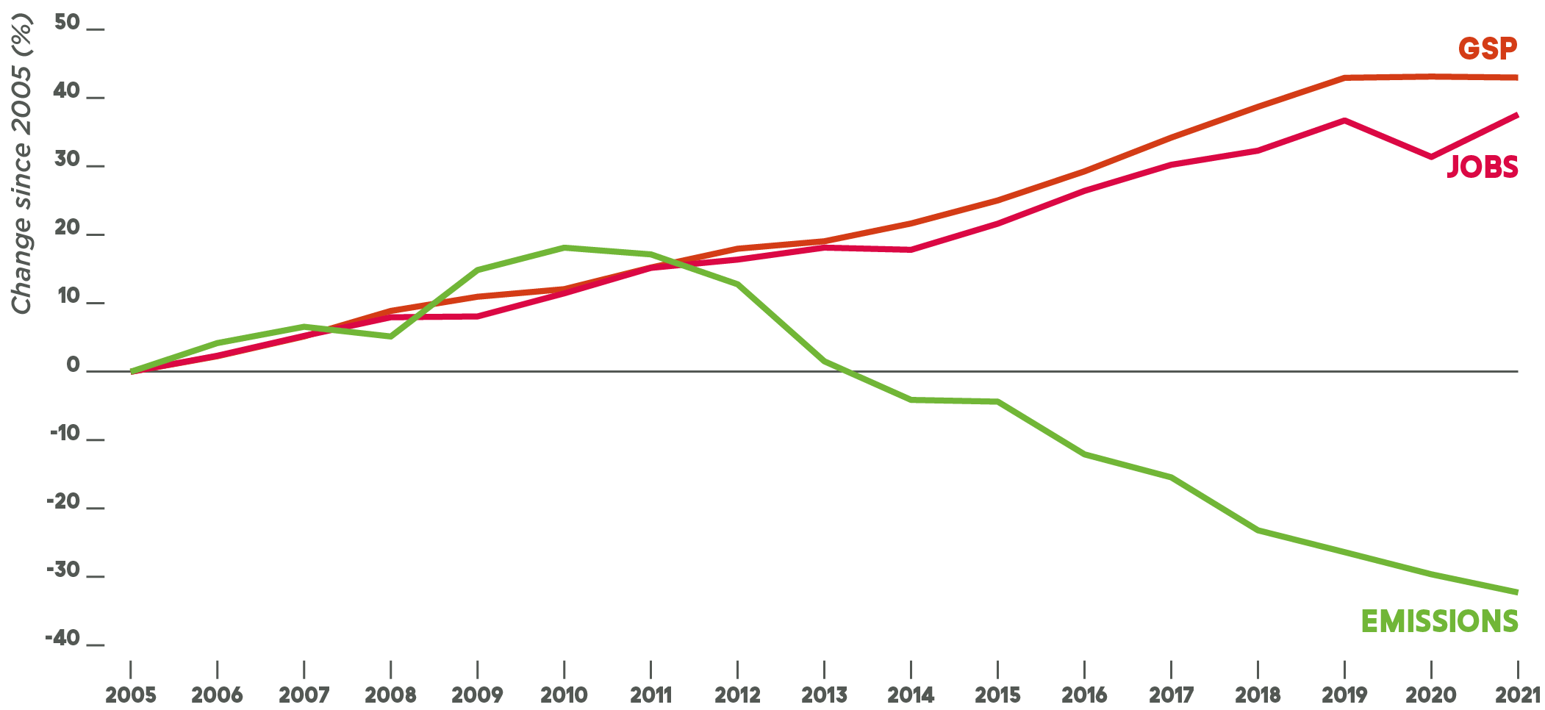
Source: Australian Greenhouse Emissions Information System, Australian Bureau of Statistics (ABS) Gross State Product Table 1, ABS Labour Force Victoria Table 5.
Note: During the period 2019 to 2021, economic growth levelled, and jobs dipped then rebounded, due to the significant impacts of the COVID-19 pandemic on the way Victorians live and work.
The Victorian Government commissioned climate-economy modelling to estimate the economic impacts of reducing emissions to meet Victoria’s 2035 target (Appendix A). Consistent with past trends, the modelling projects that Victoria’s economy, employment and wages will continue to grow strongly while meeting the 2035 target.
Victorian Gross State Product (GSP) is projected to be $63 billion higher overall (Net Present Value (NPV) 2022–2070) if Victoria meets the 2035 target and there is strong global action than if neither act. However, this is likely to be an underestimate of the full benefits of the 2035 target to the Victorian economy. This is because, while the model accounted for many key factors and used best practice approaches, it has limitations that mean it likely overstates the costs of transition and does not fully capture all the benefits of acting. These are discussed further in Appendix A.
This finding that failing to act on climate change is more costly than taking decisive action is consistent with many previous well-respected economic studies such as the international Stern Review (2007) and the Australian-focused Garnaut Review (2008). A recent global survey of economists who have published climate-related research in leading academic journals confirmed this conclusion. These findings reflect the fact that the benefits of growth in low emissions industries, stronger trade and lower climate impacts outweigh the costs of action to reduce emissions. Indeed, climate impacts on the economy are already being felt and without further action in Victoria and the rest of the world, these will worsen significantly (Box 1).

Box 1. Climate change is already costing Victoria
Victoria is already experiencing the costs of climate-related impacts such heatwaves, droughts, floods and an increase in the length and severity of dangerous fire conditions. Examples of climate-related events with high economic impacts include:
- The Black Saturday bushfires in 2009, estimated to have cost the state economy $7 billion.
- The 2010–11 Victorian floods, estimated to have cost the Victorian economy $1.3 billion.
- Australia’s 2019–20 bushfires, estimated to have cost around $100 billion in tangible costs, and around $230 billion if intangible costs are also included. Smoke-related health costs from these fires are estimated to have cost $486 million for Victoria alone.
- Heatwaves, estimated in a 2018 study to currently cost the Victorian economy an average of $87 million per year.
Drought and climate variability, estimated to have reduced Victorian broadacre farm profits over the last 20 years by 37 per cent, compared to what they would have been if earlier climate conditions had persisted.
While identifying causes for these types of events is complex, a global study has shown that more than two-thirds of extreme weather events are made more likely or more severe by climate change.

3. Creating new jobs and supporting new industries
The economic transition to meet Victoria’s 2035 target and net zero emissions will continue to create thousands of new jobs and support the development of new industries. We are already seeing this in Victoria’s rapidly-growing renewable energy sector. Communities and workers can be supported as fossil fuel-related industries are replaced by cleaner alternatives.
The climate-economy modelling commissioned by the Victorian Government projects most industries in Victoria will continue to grow strongly under the 2035 target and global transition. Industries projected to experience the strongest improvement in employment growth compared to a world without continued emissions reductions are clean electricity, renewable hydrogen, forestry and zero-emissions biofuels. Manufacturing jobs are projected to be boosted over the longer term.
We are already seeing jobs created in these fields. Wind and solar projects delivered under the first Victorian Renewable Energy Target (VRET) auction, held in 2017, have supported more than 800 construction jobs. The second VRET auction, held in 2022, is expected to support at least 920 direct jobs. The Victorian Energy Upgrades program supports over 2,200 ongoing jobs. Victoria’s new VRET and energy storage targets for 2030 and 2035 are anticipated to deliver around 59,000 jobs in Victoria’s economy over the period 2023 to 2035.
While most industries are projected to grow, fossil fuel industries are projected to decline as they are replaced by clean energy, renewable hydrogen and biofuel industries.
The climate-economy modelling shows that when government policies are put in place to support growth in lower emissions sectors, this can significantly reduce the economic impacts of the transition in the most affected areas. The Latrobe Valley Authority is an example of how this support can be provided. Established in 2016, the Authority is dedicated to supporting long-term economic transition in the region, including support for reskilling and establishment of new businesses. More broadly, the Victorian Government’s Clean Economy Workforce Development Strategy is guiding investment in clean economy skills and training to support Victorian workers to benefit from and deliver Victoria’s emissions reduction targets. The Commonwealth Government’s Powering Australia framework also commits support to communities and workers as part of the energy transition, including through the Powering the Regions fund and the New Energy Skills program.

4. Savings for households and businesses
Victorians can save money and cut emissions through improved energy efficiency and transitioning to renewable electricity.
Many Victorians will benefit from the energy system transition required to meet the 2035 greenhouse gas emissions target. As Victoria achieves its 95 per cent renewable energy target by 2035, high-cost, high emissions fossil fuel electricity will continue to be replaced by low-cost renewable electricity generation.
Electrification and energy efficiency improvements will allow households and businesses to save on their energy bills:
- Modelling indicates that converting an existing home from using fossil gas for heating, hot water and cooking to using efficient electric appliances could reduce a household’s average energy bill by over $1000 per year.
- Requirements for new homes to be more energy efficient can deliver household cost savings from $300 to over $1,000 a year.
- Households and businesses who switch to more efficient appliances and equipment through the Victorian Energy Upgrades program have saved an average of $110 and $3,700 respectively per year.
Upgrades through the Solar Homes program deliver average annual savings per household of $1,000 for solar panel (PV) installations, $100–$400 for solar hot water or heat pump systems and $640 for a typical solar battery installation.
As adoption of zero emissions vehicles (ZEVs) accelerates, consumers and businesses will benefit from substantially lower vehicle running costs:
- Households switching from an internal combustion engine vehicle (ICEV) to a battery electric vehicle can save over $1,300 per annum on fuel.
ZEVs have fewer moving parts and are simpler to repair compared to ICEVs, meaning annual maintenance and servicing costs are estimated to be 35 per cent lower than for an equivalent ICEV.
Additionally, the electrification of vehicles, heating and appliances will reduce Victorians’ exposure to volatile fossil gas and petrol prices, helping to keep energy costs more predictable and affordable.

5. Improved health and environment
Climate action brings significant health and environmental benefits to all Victorians
Climate action provides benefits beyond reducing greenhouse gas emissions – including cleaner air both outdoors and indoors, buildings that perform better in hot and cold weather, protection and restoration of natural landscapes, and benefits to Victorians and the wider global community of limiting the impacts of climate change.
The large-scale uptake of renewable energy and ZEVs can deliver significant health benefits. The combustion of fossil fuels in electricity generation and transport creates local outdoor air pollutants including nitrous oxides (NO_{x}), sulphur dioxide (SO₂), carbon monoxide (CO) and fine particulate matter (PM₁₀, PM_{2.5}) that contribute to serious health impacts such as increasing the risk of cardiovascular and respiratory illnesses., Analysis commissioned by the Victorian Government estimates that the reduction in pollutants from transport and electricity generation from meeting the 2035 target will lead to health improvements worth an estimated $5.7 billion (net present value) over 2022 to 2070 (see Appendix B).
Electrification of homes is also expected to bring significant health benefits. Burning gas in homes for cooking, heating and hot water creates indoor air pollutants which can exacerbate the risk of illnesses such as childhood asthma. One study estimates that Australia-wide, transitioning away from home gas appliances would avoid $2.6 billion in healthcare costs associated with pollution-related respiratory illnesses in 2035.
Finally, improving the energy efficiency of buildings can bring significant health benefits to their occupants, particularly if they do not have the income for adequate heating and cooling. For example, a study of the Victorian Healthy Homes Program – which funded energy efficiency improvements for low-income elderly households – found the financial value of the health system savings was ten times greater than the energy savings.
Meeting the 2035 target will likely involve more carbon being absorbed in Victoria’s landscapes (see Chapter 8). Protecting and increasing vegetation can produce a broad range of benefits, including improved air and water quality, reduced soil erosion, increased biodiversity and strengthened nature-based tourism. There are also potential economic benefits for Victoria’s farmers and Traditional Owner Groups through the creation of additional and alternative income streams and flow-on impacts to regional economies, including through agri-services and plant nurseries.
In addition to providing benefits to the Victorian community, meeting the 2035 target of 75–80 per cent will benefit the rest of the world as fewer Victorian emissions contribute to limiting climate change. The climate-economy modelling estimates this to be worth around $140 billion globally (NPV 2022–2070).

6. Maintaining a prosperous, competitive economy
The global economy is also transitioning to net zero emissions. Victoria’s 2035 target will protect Victoria’s competitiveness, attract investment and help us take advantage of these global changes.
As of September 2022, 88 parties representing around 80 per cent per cent of global emissions and around 90 per cent of global GDP have net zero emissions commitments. The global transition to net zero emissions will change demand patterns for goods and services and the competitive context for Victorian industry. The strong, early signal sent by the 2035 target and Victoria’s 2045 net zero emissions commitment will help drive a well-planned transition that will help Victoria respond to and capitalise on the opportunities arising from these changes, including:
- Attracting foreign and domestic private investment. Establishing a stable policy environment for climate action reduces the risks associated with long-term investments. This can make Victoria an attractive destination for foreign and domestic investment, including in zero-emissions infrastructure and technology and emerging nature positive investment. As such, Victoria’s targets will help attract a share of the $US130 trillion of global private capital available for the net zero transition. Stable policy settings also send an important signal to help secure the materials and skilled labour needed for the transition to a strong and resilient net-zero emissions economy.
- Positioning Victoria as a destination of choice for low emissions industries. A world-leading 2035 target of 75 to 80 per cent, backed by emissions reduction policies, can position Victoria to become a hub for new industries and services required for the global transition to net zero emissions. Victoria can build on its traditional strengths – especially in education, manufacturing and innovation – to attract new nascent industries looking for an Australian base.
Protecting competitiveness. Greenhouse gas emissions and climate ambition are becoming an increasingly important trade consideration. Seventeen of Victoria’s top 20 export markets have net zero commitments. Momentum is also building to tax the carbon content of imports in key jurisdictions such as the European Union, United States, the United Kingdom and Canada. A sensitivity analysis carried out as part of the Victorian Government’s climate-economy modelling shows such a tax would impose a material cost on the Victorian economy. Victoria’s 2035 target sends a clear signal to Victorian industries to decarbonise and this will at a minimum, help them avoid these trade penalties and remain globally competitive in the future. If Victorian industries produce low-emissions goods and services sooner than international competitors, this could increase the competitiveness and profitability of Victorian exports.

7. Progress in cutting Victoria’s emissions
Victoria’s emissions have already been cut by a third. We are on track under current policies to meet our 2025 target and deliver an almost 60 per cent cut on 2005 levels by 2035. Our ambitious 2030 and 2035 targets will drive further action and even greater emissions cuts to meet these targets.
Victoria has already reduced its greenhouse gas emissions by 32 per cent since 2005 (Figure 1). This has been primarily driven by:
- a significant increase in renewable electricity generation, from 5% of Victoria’s electricity generation in 2009 to 35 per cent in 2022, driven by the Victorian Renewable Energy Targets and programs such as Solar Homes;
- reductions in emissions from coal-fired electricity generation;
- continued improvements in energy efficiency through programs such as the Victorian Energy Upgrades Program;
- growth in Victoria’s forests and a decline in of native timber harvesting; and
changes in the composition of Victoria’s economy, with relatively less economic output from emissions-intensive sectors such as manufacturing and construction.
These declines have been partly offset by smaller increases in emissions from transport and refrigerants.
Further information on Victoria’s historical emissions trends are provided in annual Victorian Greenhouse Gas Emissions Reports.
To inform the 2035 target decision, the Victorian Government commissioned modelling of Victoria’s projected emissions under current policies and market conditions (the ‘reference case’). This modelling projects the downward trend in Victoria’s emissions continuing to 2035. The key drivers of this continued decline include:
- a continued increase in renewable electricity generation in Victoria to meet the Government’s commitment to 95 per cent renewable energy by 2035 and across the rest of the National Energy Market;
- the closure of Yallourn Power Station in 2028 and Loy Yang A Power Station by 2035;
- a reduction in fuel combustion, mostly fossil gas use by households, businesses and industry due to improved energy efficiency and switching equipment and appliances to electricity;
- a reduction in fugitive emissions from fossil gas extraction, due to a depletion of Victoria’s fossil gas reserves;
- a plateau then reduction in transport emissions, as ZEVs become more cost-competitive and buyers shift away from petrol and diesel vehicles; and
a reduction in emissions from refrigerant gases, as Commonwealth legislation continues to phase down imports of high climate impact refrigerant gases.
The modelling projects Victoria remains on track to meet its 2025 target despite a rebound in population and economic growth as Victoria recovers from the coronavirus (COVID-19) pandemic.
If the Government took no further action, the projections shows Victoria’s emissions would fall to around 59 per cent below 2005 levels by 2035. This demonstrates that the ambitious target of 75-80 per cent will drive action over the next 12 years to further reduce Victoria’s emissions and track towards net zero emissions by 2045, as intended. The Victorian Government will continue to take action to reduce emissions further.
The five-yearly sectoral emissions reduction pledges required under the Climate Change Act 2017 provide a framework for additional policy development to meet Victoria’s targets. The next set of pledges, for 2026-2030, are due in 2025. Actions in these pledges to meet Victoria’s 2030 target, as well as Commonwealth action to meet national emissions reduction targets, will also create momentum and stimulate market responses, including changes in supply chains, and labour force skills and knowledge that will contribute to meeting Victoria’s 2035 target.

8. Achieving Victoria’s 2035 target
Victoria’s 75-80 per cent target for 2035 is ambitious but achievable and builds on trends and actions already underway. Cost effective emissions reductions are available across the economy to meet the target. A cut of 75-80 per cent below 2005 levels by 2035 will keep Victoria on track to net-zero emissions, with the remaining transition manageable by 2045.
Emissions reduction scenario modelling shows that the 2035 target is achievable with known technologies and solutions. There are multiple pathways Victoria can take. The Victorian Government will continue to work with communities and business to meet the 2035 target.
Figure 2. Illustrative emissions reductions across the Victorian economy from today to achieve the 2035 target
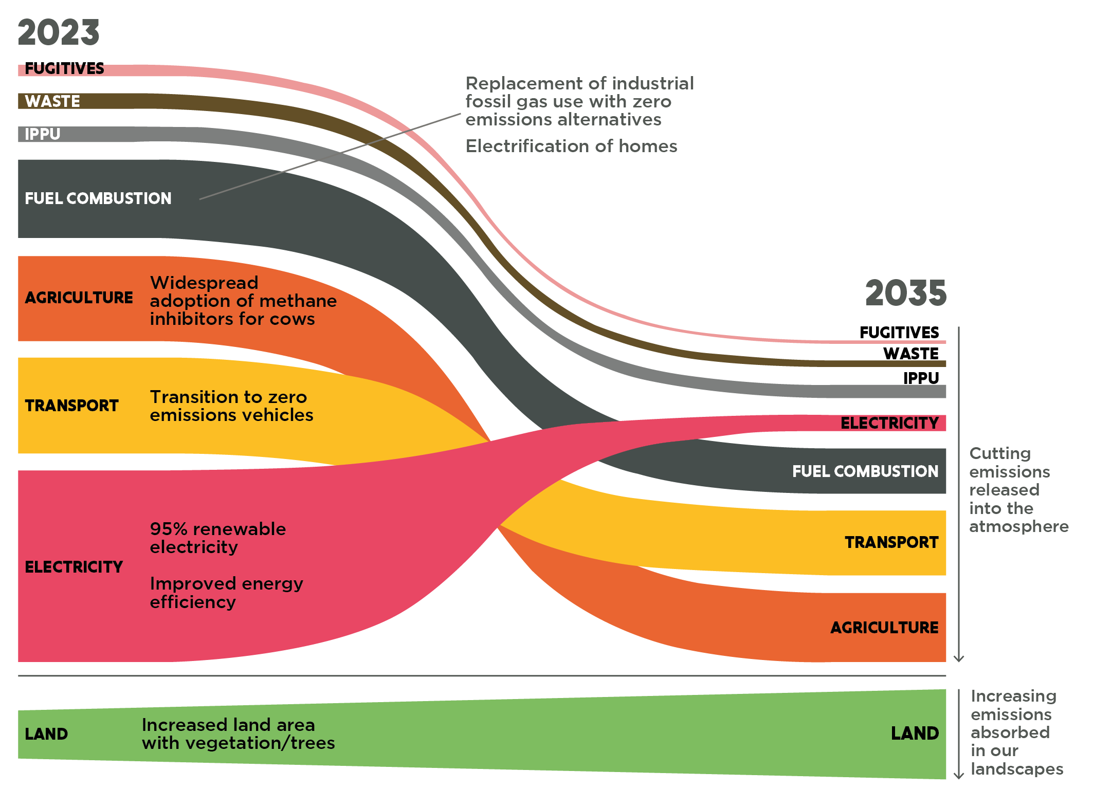
IPPU = Industrial Processes and Product Use; Land = Land Use, Land Use Change and Forestry
Source: Jacobs for the Department of Energy, Environment and Climate Action (2023)
Note: This figure depicts emissions reductions from Scenario 3 below which sees emissions reach 78 per cent below 2005 levels in 2035. It is neither the only pathway for achieving the target, nor a prescription for how to achieve it. More details on the scenario modelling are provided below and in Appendix C.
Meeting the Victorian Government’s commitment to 95 per cent renewable electricity generation by 2035 will make a substantial contribution to meeting the 2035 emissions reduction target and will mean that electricity generation shifts from being one of Victoria’s largest emissions sources today to one of the smallest by 2035 (Figure 2).
Beyond electricity, emissions reductions options are available across all sectors of Victoria’s economy to contribute to meeting the 2035 target. Three scenarios were modelled that achieved the 2035 target range. In all three, the following technological shifts make the largest contributions to meeting the target:
- A renewables-dominated electricity grid: In all three scenarios, coal-fired power generation is progressively replaced by renewable electricity sources such as solar, onshore and offshore wind, supported by storage capacity and transmission build. This is in line with the announced closure dates of some of Victoria’s aging coal-fired electricity generators, the falling cost of renewable electricity and Victoria’s commitment to reach 95 per cent renewable electricity by 2035. Victoria had already reached 35 per cent renewable electricity in 2022, and further work is underway to develop Victoria’s offshore wind resources, grid-scale battery storage and transmission infrastructure.
- All new road passenger vehicles are zero emissions vehicles (ZEVs): Victoria’s target to increase the share of ZEVs in light vehicle sales to 50 per cent by 2030, establish a fast-charging network on major highways, and trial electric buses on the way to purchasing only ZEV public buses from 2025 will further support a shift that has already begun in the state’s transport fleet. Building on this, in all three scenarios, ZEVs reach 100 per cent of new passenger vehicle sales by 2035, supported by a significant expansion in charging infrastructure and sufficient electricity supply to meet increased demand. In the scenarios, by 2035 around one-third of the diesel bus fleet is replaced by electric or hydrogen vehicles, with only ZEV buses purchased by 2035.
- Increasing substitution of fossil gas use in buildings and industry: The Victorian Government has begun to transition the state away from fossil gas. The three scenarios show a more rapid uptake of electric space heating, hot water heating and cooking appliances in the residential and commercial sectors by 2035, compared to the reference case. These technologies are cost effective replacements when fossil gas appliances reach the end of their lives, and are readily available today.
- Significant deployment of methane inhibitors for livestock: Agriculture is currently Victoria’s third largest emitting sector – and almost 70 per cent of the sector’s emissions come from methane emissions from livestock. Methane-inhibiting feed supplements and vaccines, and selective breeding, are considered the most likely solutions to tackle these emissions. Across the three scenarios, between 65 and 100 per cent of intensive livestock (dairy and feedlot cattle) and 30 to 100 per cent of extensive livestock (pasture-fed beef and sheep) are modelled as being treated by 2035. Action is underway to further develop these solutions and make them more widely available.
Reforestation of Victoria’s landscapes: All three scenarios see significant increases in carbon sequestration in Victoria’s land sector, a process supported by policies such as the cessation of native timber harvesting by 2030, and implementation of the Victorian Carbon Farming Program and the Government’s target to revegetate 200,000 hectares for improved habitat connectivity by 2037. The modelled scenarios have environmental plantings and expansions of plantations and agroforestry of around 390,000 to 445,000 hectares cumulatively by 2035. While some plantings can take place on public land, achieving plantings on these scales would involve substantial participation by private land holders. In some cases, vegetation could exist alongside or even increase the productivity, of existing land uses such as livestock farming; in other cases land use would change.
Independent analyses of net zero emissions pathways for Australia by ClimateWorks Centre and Net Zero Australia have also identified these technological shifts as being central to the transition that will occur at the national level by 2035 on the way to the Commonwealth’s target of net zero emissions by 2050.
While the above technological shifts are present across the three scenarios, there is a degree of flexibility in their relative contribution to meeting the 2035 target (Figure 3). For example, in Scenario 1, relatively more action takes place to reduce fuel combustion emissions than in the other two scenarios, while in Scenario 3, agriculture emissions contribute more to achieving the 2035 target than in the other two scenarios.
Figure 3. Victoria’s remaining 2035 emissions under three modelled scenarios that meet a target of 75–80 per cent below 2005 levels
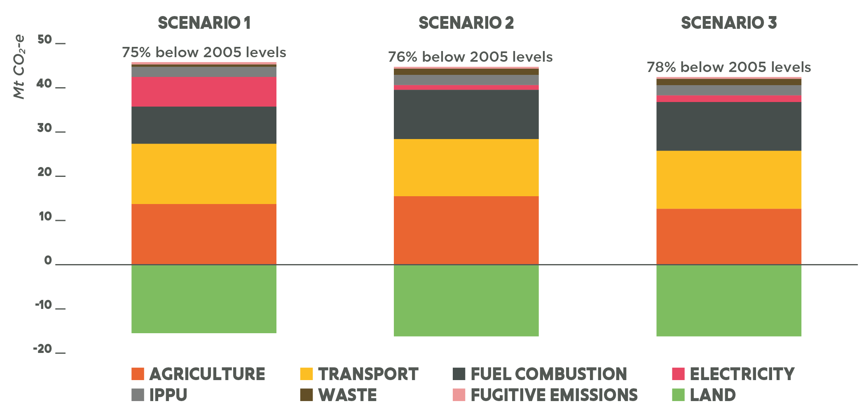
Source: Jacobs for the Department of Energy, Environment and Climate Action (2023)
After meeting the 2035 target, Victoria’s remaining emissions are expected to primarily come from (Figure 3):
- Agriculture: treatment of cows and sheep with methane inhibitors will not eliminate all methane emissions from digestion; and nitrous oxide emissions from fertiliser remain harder to abate;
- Transport: some petrol and diesel road vehicles remain while the fleet continues to switch to ZEVs and emissions from ships and planes remain harder or more costly to abate;
- Non-transport fuel combustion: some fossil gas use remains in households, business and industry; and
Industrial processes and product use (IPPU): fridges and air conditioners will remain an emissions source as low climate impact refrigerant gases do not eliminate all emissions.
The modelling suggests that by achieving the 2035 target, it will be manageable to reach net zero emissions a decade later. In other words, the 2035 target of 75 to 80 per cent drives sufficient transition by 2035 to keep Victoria on track to net zero emissions by 2045.

Appendix A. Climate-economy modelling
The Victorian Government commissioned Deloitte Access Economics (Deloitte) to conduct climate-economy modelling of the 2035 target. The modelling estimated the economic impacts of Victorian emissions reduction to reach the 2035 target and subsequently net zero emissions. This included impacts on Gross State Product, employment and income, in the context of physical damages and trade effects experienced by Victoria under different global emissions reduction pathways from 2022 to 2070.

A.1 D.Climate
Deloitte’s D.Climate climate-economy model consists of two interacting modules (Figure 4).
- A Computable General Equilibrium (CGE) economy module, which models activity in the Victorian economy as a whole, by sector and by region. CGE models are commonly used to estimate the economic impacts of emissions reduction policy in Australia and globally. The CGE module takes into account interactions between the Victorian economy, the economies of other states and the global economy. It also accounts for interactions between sectors and regions within Victoria. For a particular scenario, the model estimates the equilibrium state of the economy – the point where supply and demand are balanced. The economic impact of reducing emissions is estimated by comparing economic metrics in the 2035 target scenario to those in a “reference case” (or business-as-usual) scenario.
A climate module, which accounts for greenhouse gas emissions, emissions reduction in Victoria and the rest of the world and physical damages from climate change.
To account for the cost of climate inaction, these two modules are linked, capturing the effects of rising global temperatures on the productivity of capital, labour and land, varying by region and industry, which subsequently reduces economic output. Conversely, as economies reduce greenhouse gas emissions and limit warming, these damage impacts are reduced within the model.
Figure 4. Deloitte’s D.Climate climate-economy model
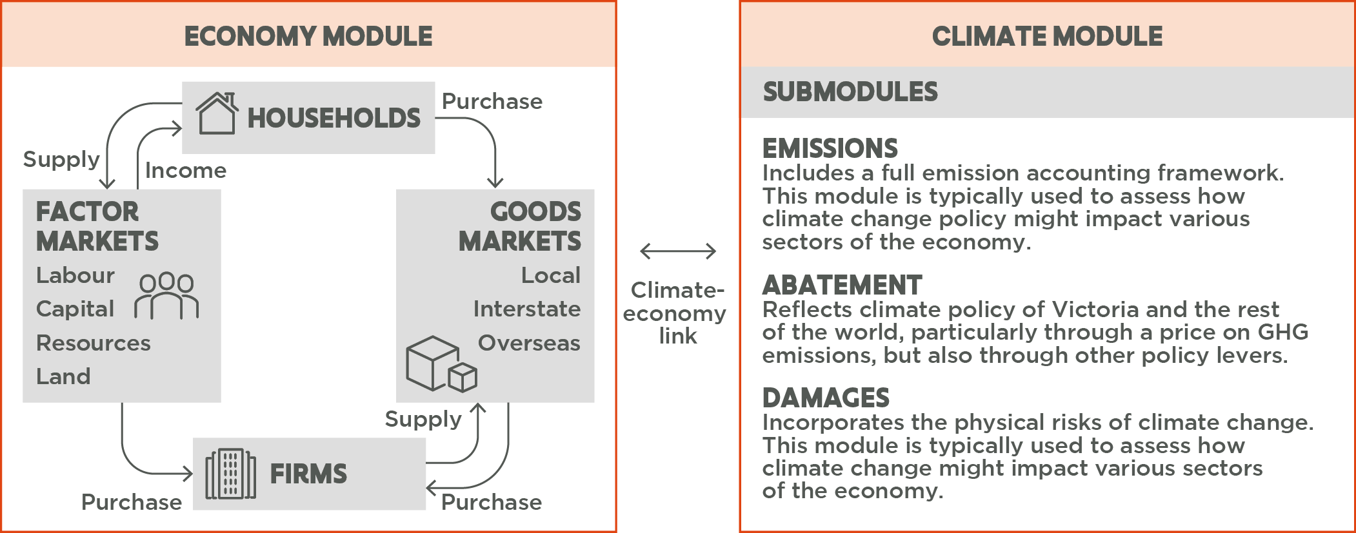
Source: Deloitte Access Economics
Emissions reductions were modelled through the implementation of a notional price on greenhouse gas emissions to represent a suite of possible climate action policies. D.Climate reduces greenhouse gas emissions by implementing emissions reduction measures, from least-cost to highest-cost, then applying increased costs to the remaining, unabated emissions. As this increasing price of greenhouse gas emissions results in processes with emissions becoming more expensive, relative price changes lead to behavioural changes, such as firms switching from fossil fuel-based electricity generation to renewable electricity.
While each of these steps could be achieved by various policy mechanisms (e.g. subsidies, regulation, marketing, direct delivery), D.Climate used a single mechanism of a notional price on all greenhouse gas emissions. This is a methodologically tractable and well-established way of modelling greenhouse gas emissions reduction and does not imply judgement about which policies are likely to be implemented in reality.

A.2 Assumptions
The climate-economy modelling drew on the insights and outputs from the scenarios in Jacobs’ Sectoral Emissions and Abatement Model (SEAM) analysis (Appendix C). Abatement technology costs, baseline Victorian GSP and population growth rates were aligned with assumptions used in SEAM, while global Gross Domestic Product (GDP) and population growth rates, as well as greenhouse gas emissions from industry output, were sourced from IIASA SSP projections, IMF forecasts and the GTAP 10 database. Assumptions were tested with subject matter experts and reflect best available information.
Present values in this report are discounted using a 2 per cent annual rate. This is the preferred rate of economists who are experts in long term discounting. Discounting is necessary for climate change analysis as the impacts of climate change occur over very long time horizons.

A.3 Scenarios
The climate-economy modelling results in this report compare:
- a reference case which assumes that Victoria does not take further action beyond meeting its 2030 target and
a 2035 target scenario in which Victoria reduces its emissions to 78 per cent below 2005 levels in 2035 and net zero by 2045.
These two scenarios are differentiated by two key variables: the level of Victorian climate action and the level of global climate action (Table 1).
Table 1. Description of the key variables and assumptions in the reference case and the 2035 target scenario
 | Global climate action | Victorian climate action
Reference Case | Global current policies – the world does not take further action beyond current policies and global emissions continue to rise. This scenario aligns with IPCC AR6 Scenario Pathway SSP2-4.5 and results in global temperatures rising to approximately 2.7°C above pre-industrial levels by 2100 | Victoria:  - meets its 2025 and 2030 interim targets; but  - implements no further climate policies, therefore not reaching net zero emissions within the modelling period.
2035 target scenario | Global Well-Below 2°C – the world shifts to a declining emissions trajectory and global action is in line with the IPCC AR6 Scenario Pathway SSP1-2.6, with global temperatures rising to approximately 1.8°C above pre-industrial levels by 2100 | Victoria:  - meets its 2025 and 2030 interim targets;  - achieves emissions reductions of 78% below 2005 levels in 2035 (approximately the mid-point of the Government’s commitment to a 2035 target 75–80% below 2005 levels); and  - meets the Victorian Government’s commitment to net zero emissions by 2045.

A.4 Regional/sectoral analysis
In addition to estimating macroeconomic impacts across the whole of the Victorian economy, the model produced results by sub-region and by industry. This provided indicative estimates of potential regional and industry impacts of climate action although, in practice, impacts may vary depending on the specifics of the policies implemented.

A.5 Interpretation of results
This analysis compared the combined effect of Victoria meeting a 2035 target and the world shifting to a declining emissions trajectory to a notional reference case that assumed little further Victorian emissions reductions and higher global emissions (and therefore higher climate change-induced economic damages). As climate change is a global issue, with Victoria’s actions delivering benefits for others and other jurisdictions’ actions benefiting Victoria, it is appropriate for economic evaluation to consider this collective global response rather than Victoria’s action in isolation.

A.6 Limitations
The modelling provides useful estimates of the economic impacts of emissions reductions but, as with any modelling exercise, it remains subject to limitations and uncertainty.
- The modelling used an ‘indicative’ scenario and reference case, not ‘most likely’ estimates of greenhouse gas emissions policies and their impacts. The modelling provides insights into the trade-offs and direction of change in key indicators for the Victorian economy but should not be interpreted as the planned pathway to net zero emissions.
- The precise economic impacts of Victoria meeting a 2035 emissions target will depend heavily on the mix of policies used to achieve the target. Therefore, relative differences in economic metrics between the 2035 target scenario and reference case are more meaningful than the absolute values in any scenario.
- Climate-economy modelling has tended to underestimate the rate at which economies can decouple emissions from economic growth. The costs of emissions reduction technologies have historically fallen faster than projected and unexpected technological breakthroughs have broadened the emission reduction options available. These effects may lead to lower economic costs than estimated. The climate-economy modelling also didn’t capture cost reductions that will be realised through ‘learning by doing’ – which may be significant – or the efficiencies of investment being brought forward by a stable climate policy environment.
- The climate-economy modelling cannot capture all the benefits of action. It is not able to fully capture economic opportunities that represent a significant change from the past, including development of new industries. It also does not capture benefits outside of the market economy, such as improved health outcomes for Victorians and benefits to Victoria’s environment and ecosystems – instead these have been analysed separately (see Appendix B). The benefits of a more stable climate are likely to be understated due to both the limited types of damages that can be captured in the model and the risk of more severe outcomes than assumed.
There is also a range of factors that may increase the cost of transition, such as supply chain constraints, resistance to change and slower-than-expected development of zero-emissions technologies. However, experience has shown that the instances of higher-than-expected costs or other difficulties have not outweighed the trends for emissions reductions to take place more cheaply and easily than projected.

A.7 Sensitivity testing
Sensitivity testing was undertaken to assess the impact of key uncertainties on the modelled results. The core conclusions of the climate-economy modelling were found to remain valid under these sensitivity tests – i.e. the conclusions were not sensitive to key uncertainties.
- A sensitivity test with differing levels of global climate ambition found that a higher pace of global action resulted in improved economic outcomes for a given mitigation case due to fewer climate impacts, more rapid technology cost reductions and improved trading conditions. In the opposite simulation, with weaker global action but the same Victorian target, GSP growth is still positive but is slower. Under current expectations, a strengthening of global action is more likely than a weakening.
- A sensitivity with stylised investment programmes targeted at industries and communities negatively impacted by the transition, such as the work of the Latrobe Valley Authority, found that investment at sufficient levels offset the structural adjustment costs of reducing greenhouse gas emissions.
A simulation of key jurisdictions introducing a Carbon Border Adjustment Mechanism (CBAM) – in line with current proposals of the European Union and the United States – tested the impacts of trade sanctions if Victoria does not continue to reduce its emissions. In the reference case, this sensitivity analysis indicates that Victorian export industries would be adversely affected by a CBAM (since they would not be subject to sufficient domestic constraints on emissions and therefore would face trade sanctions). The sensitivity analysis resulted in a reduction in the value of reference case exports. The estimated reduction in the value of exports in 2035 under a CBAM was of a similar magnitude to the reduction in export value in the 2035 target scenario but without the benefits gained in the 2035 target scenario when Victoria reduces its emissions.

Appendix B. Quantification of non-market benefits
As noted in Appendix A, a limitation of climate-economy modelling is its inability to fully include the benefits of Victorian emissions reduction not captured in economic markets. These ‘non-market’ benefits include, but are not limited to, reduced air pollution, improved water and soil quality, improved diet, food security, biodiversity protection and preservation, reduced noise pollution and improved physical activity.
Many of these benefits are difficult to quantify in monetary terms (compared with traditional economic metrics) due to limitations in empirical evidence or because they are highly contingent on the broader policy environment. The analysis of non-market benefits for the 2035 target decision analysis focused on those benefits that were most relevant to Victoria’s emissions and could be more robustly quantified and ‘monetised’ – namely the health benefits of reduced air pollution associated with cutting emissions in the transport and electricity sectors.
In Victoria, the main sources of air pollution are motor-vehicles, electricity generation and smoke from bushfires, planned burns and wood heaters. Electricity generation and transport are Victoria’s two largest greenhouse gas emitting sectors – respectively contributing 52 per cent and 23 per cent of total Victorian greenhouse gas emissions in 2021.

B.1 Reduced air pollution impacts from electricity generation
This analysis used a damage costs methodology for reduced air pollution impacts from electricity generation utilising the framework developed by Ward and Power (2015), which applies estimates of damage costs from USA coal-fired power stations to a Victorian context. This methodology was first identified as appropriate in 2018 by the Department of Environment, Land, Water and Planning (DELWP), and was also used in developing Victoria’s 2021 Climate Change Strategy, including the interim emissions reduction targets for 2025 and 2030. A literature review in 2022 confirmed that Ward and Power (2015) remained the best available source on which to base an estimate.
This methodology estimated the health cost of air pollution from Victorian power stations at $15 million per megatonne of carbon dioxide equivalent (Mt CO₂-e). Ward and Power’s estimate is limited, however, by incomplete data on background air pollutant concentration rates and health complications in Gippsland. The estimates also only account for SO₂, NO_{X}, PM₁₀ and PM_{2.5} (not including other pollutants such as mercury, lead, arsenic, ozone or volatile organic compounds (VOCs)) – Ward and Power suggest this makes it likely that this damage cost underestimates the full cost of air pollution.

Air pollution impacts from reduced transport emissions
The impacts of air pollution from transport have been calculated based on estimated average environmental unit costs per kilometre for different modes of travel and different locations in the Australian Transport Assessment and Planning (ATAP)’s Guidelines. The total vehicle kilometres travelled in Victoria and total CO₂-e emissions from the transport sector within Victoria were then used to derive a damage cost estimate of $37 million per Mt CO₂-e of transport emissions.
There are limitations with this approach, including that it draws upon Australia-wide unit costs, assumes the costs of air pollution from road transportation can be applied to the broader transport sector (noting that around 90 per cent of Victoria’s current transport emissions are from road transportation) and that other transport-emissions related costs (including building damage and crop loss) are captured alongside health costs.

B.2 Estimated total health benefits from reduced electricity and transport emissions
To calculate total health benefits from the 2035 target, the avoided health costs per Mt CO₂-e of electricity and transport emissions were applied to the difference between emissions pathways in the 2035 target scenario and the reference case for the electricity and transport sectors respectively, based on the climate-economy modelling described in Appendix A. Using this methodology, these total health benefits are estimated to be worth $5.7 billion (NPV 2022–2070).

B.3 Global benefits of Victorian emissions reduction
A social cost of carbon (SCC) is an estimate of the value that should be placed on each tonne of greenhouse gas emissions that is avoided, based on the additional damages that would result globally if that tonne were emitted. While the climate-economy modelling provided estimates of how Victoria might experience differing climate damages under different global climate action scenarios, the SCC captures the reverse effect – it estimates the benefits that Victorian emissions reduction provides to the rest of the world.
This analysis used a SCC estimate produced by the USA Environmental Protection Agency, converted to Australian dollars and adjusted to present values. This estimate incorporates the value of a wide array of empirically grounded climate change impacts, including changes in health (heat- and cold-related mortality), energy demand, labour productivity, net agricultural productivity, and coastal inundation (from sea level rise). The SCC value was applied to the difference in emissions between the 2035 target scenario and the reference case. The global benefit derived from this is estimated at around $140 billion (NPV 2022–2070).

Appendix C. Modelling pathways to net zero emissions
The Victorian Government commissioned Jacobs Group Australia (Jacobs) to model Victoria’s projected future emissions under current policies and expected market trends (the ‘reference case’), and three emissions reduction scenarios showing possible pathways for Victoria to reach net zero emissions that also met Victoria’s existing emissions reduction targets in 2025 and 2030 and new target for 2035. The modelling was used to understand future possibilities and to identify the likely key areas of change between today and 2035, on the way to net zero emissions. The modelling does not predict the future, nor determine what Victoria’s future sectoral emissions reduction pathways should be.

C.1 The Sectoral Emissions and Abatement Model (SEAM)
Jacobs uses a microeconomic model of emissions and abatement called SEAM to model Victoria’s future emissions under various scenarios, calibrated to historical data from the 2020 State and Territory Greenhouse Gas Inventories.
Emissions are modelled as a function of activity levels (e.g. head of cattle or vehicle kilometres travelled). The activity levels are linked to exogenous macroeconomic variables (i.e., Gross State Product and commodity projections) and social-demographic variables (i.e., population and household formation projections) that form trends out to 2050. The model manages interactions between activities where these have an impact on emissions elsewhere in the economy. For example, an increase in the number of electric space and hot water heaters increases demand for electricity, resulting extra electricity generation. The model then accounts for the emissions impact of changes in generation.
Abatement options – i.e. technologies and actions – for all sectors of the economy are included in the model. While these abatement options are comprehensive, they are not exhaustive, meaning some technologies or behavioural changes which may play a role in the transition to a net-zero emissions Victoria were not included. Abatement options were included primarily based on materiality, with options that would likely have a larger abatement impact – such as renewable energy, ZEVs, tree planting and methane inhibitors for livestock – being prioritised. Some abatement options are widely available today, while others are known but not yet fully commercialised and represent the likelihood of further technology progress over coming decades. Information was drawn from authoritative Australian sources including CSIRO, the Australian Energy Market Operator and, where these were not available, robust international sources such as the International Energy Agency. All abatement options have been assessed by Jacobs as plausible on technical grounds, using best-available evidence on physical limits to technologies or resources and/or behavioural factors.
The model determines the timing and level of adoption of abatement options by ranking options from lowest to highest cost to generate a least-cost combination of emissions reduction options to meet the emissions constraints and policy objectives each year.
Figure 5. Overview of the Sectoral Emissions and Abatement Model
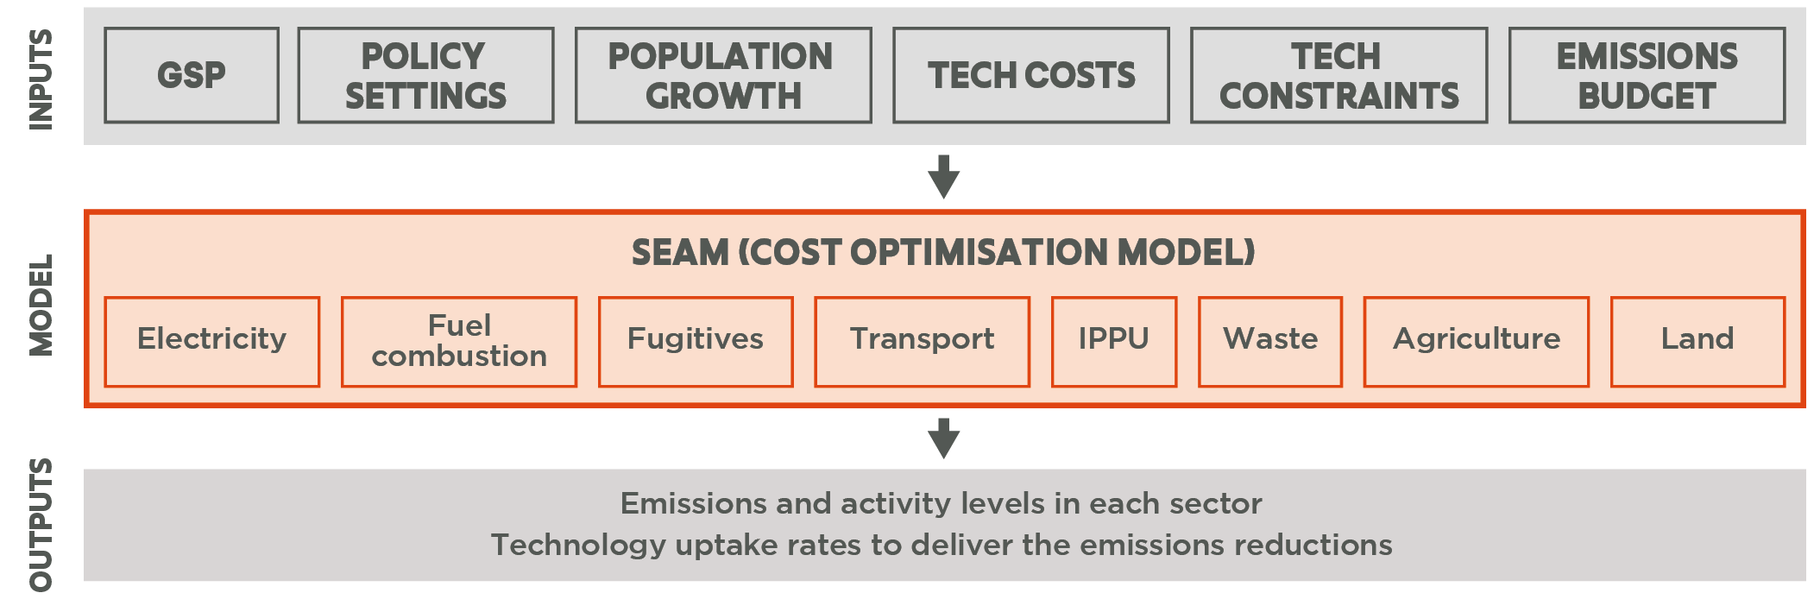
IPPU = Industrial Processes and Product Use; Land = Land use, Land use change and Forestry

C.2 Uncertainties and limitations in the modelling
This modelling comprehensively represents the Victorian economy and key available abatement options, and is based on standard optimisation techniques. While it provides an illustration of what Victoria’s emissions may be under a given set of assumptions, it is not a forecast of the future, and it remains subject to limitations and uncertainty.
One of the main uncertainties surrounds technology costs and the pace at which they are likely to decline. Where possible, Victorian or Australian cost projections were used, such as those produced by CSIRO for the capital cost reductions of ZEVs. Where local costing or projections were not available, robust global sources were used, such as from the International Energy Agency. Some of the most sensitive technology costs used in the model are those for renewable electricity generation, electric and hydrogen fuel cell vehicles, hydrogen electrolysers, hydrogen/electric equipment and appliances and methane inhibitors in agriculture.
Another uncertainty, which could result in differences between future real-world emissions and modelled scenarios, is deployment challenges. A global transition to more sustainable supply chains, manufacturing methods and technologies at small and large scales will require considerable changes to global markets to support global net zero ambitions. In practice, there may be physical (materials), workforce and behavioural challenges associated with deployment of abatement opportunities which are not accounted for in the model, such as skills shortages and supply chain bottlenecks. While efforts have been made to account for these challenges, deployment challenges specific to each technology have not been individually modelled.
Additionally, the model does not account for the following factors:
- Economic structure – in the future, new manufacturing industries may develop (including both zero-emission industries and industries that emit some greenhouse gases as part of production). The modelling has not considered any change in Victoria’s economic structure and has not attempted to estimate future changes and development of new industries in Victoria.
The downstream effects of climate change – changes in seasonal and extreme temperature are expected to influence activities across the economy from energy consumption associated with heating and cooling buildings, to agricultural productivity and disturbances and growth of Victoria’s forests and vegetation. The modelling did not incorporate changes from historic climate conditions due to data and modelling limitations.

Independent Expert Panel for the Victorian 2035 Emissions Reduction Target (2023) Victoria’s 2035 Climate Action Target: Driving Growth and Prosperity. Accessed: https://www.climatechange.vic.gov.au/climate-action-targets/Independent-Expert-Panel_Victorias-2035-Climate-Action-Target_Driving-Growth-and-Prosperity.pdf
Intergovernmental Panel on Climate Change (2021 - 2023) Sixth Assessment Report. Accessed: https://www.ipcc.ch/assessment-report/ar6/
Victorian Government Department of Environment, Land, Water and Planning (2019), Victoria’s Climate Science Report 2019. Accessed: https://www.climatechange.vic.gov.au/__data/assets/pdf_file/0029/442964/Victorias-Climate-Science-Report-2019.pdf
Climate Resource (2023) Victorian emissions budgets. Accessed: https://www.climatechange.vic.gov.au/climate-action-targets/Victorian-emissions-budgets.pdf
Garnaut, R (2008), The Garnaut Climate Change Review: Final report, Cambridge University Press. Accessed: https://library.bsl.org.au/jspui/bitstream/1/1002/1/Garnaut%20Climate%20Change%20Review%20-%20Final%20Report2008.pdf; Stern, N (2007), The Economics of Climate Change: The Stern Review, Cambridge University Press. Accessed: http://www.cambridge.org/core/books/economics-of-climate-change/A1E0BBF2F0ED8E2E4142A9C878052204
Howard, P, Sylvan, D (2021), Gauging Economic Consensus on Climate Change, New York University Institute of Policy Integrity. Accessed: https://policyintegrity.org/files/publications/Issue_Brief_Economic_Consensus_on_Climate.pdf.
Deloitte Access Economics (2016), The economic cost of the social impact of natural disasters. Accessed: http://australianbusinessroundtable.com.au/assets/documents/Report%20-%20Social%20costs/Report%20-%20The%20economic%20cost%20of%20the%20social%20impact%20of%20natural%20disasters.pdf.
Comrie, N (2011), Review of the 2010-11 Flood Warnings and Responses Victorian Floods Review. Accessed: http://floodsreview.archive.vic.gov.au/images/stories/documents/review_201011_flood_warnings_and_response_final_report_cp1to3.pdf.
Read, P and Denniss, R (2020), With costs approaching $100 billion, the fires are Australia’s costliest natural disaster, The Conversation. Accessed: https://theconversation.com/with-costs-approaching-100-billion-the-fires-are-australias-costliest-natural-disaster-129433.
Johnston, FH et al (2020), Unprecedented health costs of smoke-related PM2.5 from the 2019–20 Australian megafires, Nature Sustainability, vol. 4, pp 42-47. Accessed: http://www.nature.com/articles/s41893-020-00610-5
Natural Capital Economics for DELWP (2018), Heatwaves in Victoria: a vulnerability assessment. Accessed: https://www.climatechange.vic.gov.au/__data/assets/pdf_file/0029/399440/Heatwaves_VulnerabilityAssessment_2018.pdf
Australian Bureau of Agricultural and Resource Economics and Sciences (2019), The effects of drought and climate variability on Australian farms. Accessed: https://www.agriculture.gov.au/sites/default/files/documents/EffectsOfDroughtAndClimateVariabilityOnAustralianFarms_v1.0.0.pdf
Carbon Brief (2019), Mapped: How climate change affects extreme weather around the world [Online]. Carbon Brief: Clear on Climate. Accessed: https://www.carbonbrief.org/mapped-how-climate-change-affects-extreme-weather-around-the-world
Victorian Government (2022), Victoria’s Gas Substitution Roadmap. Accessed: http://www.energy.vic.gov.au/gas/victorias-gas-substitution-roadmap
ACIL Allen for Australian Building Codes board (2022), NCC 2022 Residential Energy Efficiency – Final Decision RIS. Accessed: https://abcb.gov.au/ncc-2022-residential-energy-efficiency-final-decision-ris. Renew (2021), Households Better Off: Lowering energy bills with the 2022 National Construction Code. Accessed: https://renew.org.au/wp-content/uploads/2021/10/Households-Better-Off-full-report.pdf
Victorian Government (2021), Zero Emissions Vehicle Roadmap. Accessed: https://www.energy.vic.gov.au/__data/assets/pdf_file/0036/575676/Zero-Emission-Vehicle-ZEV-Roadmap.pdf.
KPMG for Infrastructure Victoria (2018), Vehicles Advice – financial analysis. Accessed: https://www.infrastructurevictoria.com.au/document/vehicle-advice-financial-analysis-9-july-2018/vehicles_advice_-_financial_analysis/.
Konduracka,E and Rostoff,P. (2022), Links between chronic exposure to outdoor air pollution and cardiovascular diseases: a review. Environmental Chemistry Letters (online). Accessed: https://link.springer.com/article/10.1007/s10311-022-01450-9
Environment Protection Authority Victoria (2018), Air Pollution in Victoria – A summary of the state of knowledge. Accessed: https://www.epa.vic.gov.au/about-epa/publications/1709
Knibbs, L et al (2018) Damp housing, gas stoves, and the burden of childhood asthma in Australia. Medical Journal of Australia 208: 299-302. Accessed: www.mja.com.au/journal/2018/208/7/damp-housing-gas-stoves-and-burden-childhood-asthma-australia
Accenture (2022), System Value Analysis – Australia, October 2022.
Sustainability Victoria and University of Technology Sydney (2022), The Victorian Healthy Homes Program Research Findings. Accessed: https://www.sustainability.vic.gov.au/research-data-and-insights/research/research-reports/the-victorian-healthy-homes-program-research-findings.
United Nations Environment Programme (UNEP). (2022), Emissions Gap Report 2022. Accessed: https://www.unep.org/resources/emissions-gap-report-2022.
Energy and Climate Intelligence Unit, Oxford Net Zero, Data-Driven EnviroLab, and NewClimate Institute (2022), Net Zero Stocktake 2022. Accessed: https://zerotracker.net/insights/pr-net-zero-stocktake-2022.
The Glasgow Financial Alliance for Net Zero (2022), Amount of finance committed to achieving 1.5°C now at scale needed to deliver the transition. Accessed: https://www.gfanzero.com/press/amount-of-finance-committed-to-achieving-1-5c-now-at-scale-needed-to-deliver-the-transition/
Victorian Government (2022), Victoria’s Greenhouse Gas Emissions Report 2020. Accessed: https://www.climatechange.vic.gov.au/victorias-greenhouse-gas-emissions-and-targets.
As forecast by Australian Energy Market Operator (2023) Gas Statement of Opportunities. Accessed: https://aemo.com.au/-/media/files/gas/national_planning_and_forecasting/gsoo/2023/2023-gas-statement-of-opportunities.pdf?la=en
See Climate Change Act 2017, Division 3 – Emissions reduction pledges. Accessed: https://www.legislation.vic.gov.au/in-force/acts/climate-change-act-2017/008.
Victorian Government (2023), Offshore wind energy, Accessed: https://www.energy.vic.gov.au/renewable-energy/offshore-wind-energy.
Victorian Government (2022), Batteries and energy storage projects, Accessed: https://www.energy.vic.gov.au/renewable-energy/batteries-energy-storage-projects.
Victorian Government (2023), Transmission and grid upgrades, Accessed: https://www.energy.vic.gov.au/renewable-energy/transmission-and-grid-upgrades.
Victorian Government (2023), Zero emissions vehicles. Accessed: https://www.energy.vic.gov.au/renewable-energy/zero-emission-vehicles
Victorian Government (2022), Victoria’s Gas Substitution Roadmap. Accessed: https://www.energy.vic.gov.au/renewable-energy/victorias-gas-substitution-roadmap.
While feed supplement trials are already underway in Victoria, the progress in commercialising these supplements varies between specific products. In the model it is assumed that feed supplements will become available from 2026 and vaccines will become available from 2031. The timing and ramping up to the modelled adoption rates takes account of the need for further technology development, industry application, and training and education programs to assist farmers to adopt these new practices.
The level of sequestration modelled per hectare varies based on the type of planting activity and the geographic region where local conditions such as climate and water are relevant. Annual limits on plantings were factored in to reflect plausible limits on potential program capacities and labour and plantings were only taken up in the model where it was economic to do so.
Fritsch and Hudson (2008) Whole Farm Financials and Environmental Returns Under Farm Forestry. Accessed: https://agrifutures.com.au/wp-content/uploads/publications/08-146.pdf.
Agriculture Victoria (2022) Making cents of carbon and emissions on-farm. Accessed: https://agriculture.vic.gov.au/climate-andweather/understanding-carbon-and-emissions/making-cents-of-carbon-and-emissions-on-farm
Climateworks Centre (2020), Solutions, actions and benchmarks for a net zero emissions Australia. Accessed: https://www.climateworkscentre.org/resource/decarbonisation-futures-solutions-actions-and-benchmarks-for-a-net-zero-emissions-australia/.
For more information see Net Zero Australia, Accessed: https://www.netzeroaustralia.net.au/.
IIASA (2022), Shared Socioeconomic Pathways (SSPs). Accessed: https://iiasa.ac.at/models-tools-data/ssp
IMF (2023), World Economic Outlook (WEO) Database. Accessed: https://www.imf.org/en/Publications/WEO
GTAP (2022), GTAP Database, version 10. Accessed: https://www.gtap.agecon.purdue.edu/databases/v10/index.aspx
Drupp et al (2018), Discounting Disentangled. American Economic Journal: Economic Policy, 10(4): 109-34.
Stern, Stiglitz and Taylor (2022), The economics of immense risk, urgent action and radical change: towards new approaches to the economics of climate change, National Bureau of Economic Research. Working Paper 28472. Accessed: http://www.nber.org/papers/w28472
Way, R. et al. (2022), Empirically grounded technology forecasts and the energy transition, Joule 6, 2057-2082. Accessed: www.cell.com/joule/pdf/S2542-4351(22)00410-X.pdf
See, for example, the International Energy Agency consistently underestimating projected uptake of solar photovoltaic panels, as illustrated on p.66 of the Independent Expert Panel’s advice on Interim Emissions Reduction Target for Victoria for 2021-2030 (March 2019): www.climatechange.vic.gov.au/__data/assets/pdf_file/0016/420370/Final-Report_Interim-Emissions-Reduction-Targets.pdf
Karlsson et al. (2020). Climate policy co-benefits: a review. Climate Policy, 3(20). doi: 10.1080/14693062.2020.1724070; Helgenberger, S., Jänicke, M. and Gürtler, K. (2019). Co-benefits of climate change mitigation. Climate Action, 327-339
EPA Victoria (2021), 2016 Victorian air pollution inventory report. Accessed: https://www.epa.vic.gov.au/about-epa/publications/2028
Victorian Government (2022), Victoria’s Greenhouse gas Emissions Report 2020. Accessed: https://www.climatechange.vic.gov.au/victorias-greenhouse-gas-emissions-and-targets.
Ward, J. and Power, M. (2015). Cleaning up Victoria’s Power Sector: the full social cost of Hazelwood power station. Harvard Kennedy School of Government. Accessed: https://environmentvictoria.org.au/wp-content/uploads/2016/06/Hazelwood-Report-Social-cost-of-carbon.pdf
DELWP. (2018). Estimating the health costs of air pollution in Victoria. State Government of Victoria. Accessed at: https://www.climatechange.vic.gov.au/__data/assets/pdf_file/0022/421717/Final_Health-costs-of-air-pollution-in-Victoria.pdf. A literature review in 2022 found no new studies more relevant to the Victorian context nor more robust than the sources used to develop the original 2018 methodology.
DELWP (2021) Victoria's Climate Change Strategy: Economic analysis. Accessed at: https://www.climatechange.vic.gov.au/__data/assets/pdf_file/0023/521357/Victorias-Climate-Change-Strategy-Economic-Analysis.pdf
Australian Transport Assessment and Planning Guidelines Steering Committee. (2021). Australian Transport Assessment and Planning Guidelines: PV5 Environmental parameter values. Accessed: https://www.atap.gov.au/sites/default/files/documents/pv5-multi-modal-update.pdf
Victorian Government (2022), Victoria’s Greenhouse Gas Emissions Report 2020. Accessed: https://www.climatechange.vic.gov.au/victorias-greenhouse-gas-emissions-and-targets.
To avoid double counting, the damages to Victoria from global climate action scenarios were the same regardless of Victoria’s projected emissions. Victoria’s share of global greenhouse gas emissions is small enough that this is methodologically valid.
USA Environmental Protection Agency (2022). Report on the Social Cost of Greenhouse gases: Estimates Incorporating Recent Scientific Advances. Accessed: https://www.epa.gov/system/files/documents/2022-11/epa_scghg_report_draft_0.pdf
While not specifically accounted for, where there was particular uncertainty about the timeframe for abatement options’ deployment due to factors such as labour force or supply chain constraints etc., this uncertainty was accounted for by imposing minimum deployment year constraints, adjusting technology costs or elasticity of demand functions.

