Victorian Greenhouse
Gas Emissions Report 2023
Table of Contents
Minister’s foreword 3
Victoria’s greenhouse gas emissions report 5
Victoria has cut emissions by almost a third since 2005 6
Unpacking emissions reporting 6
Victorians emit fewer greenhouse gases than the national average 7
Victoria’s population and economy are growing, yet emissions are falling 8
The sources of Victoria’s emissions 10
Emissions sectors 11
Energy: Electricity generation 12
Energy: Fuel combustion 12
Energy: Transport 13
Industrial processes and product use (IPPU) 13
Energy: Fugitive emissions from fuels 13
Waste 14
Agriculture 14
Land Use, Land Use Change and Forestry (LULUCF) 14
Trends in Victoria’s emissions 16
Victoria’s shift to renewable energy continues to drive emissions down 16
Businesses and households have reduced their fossil fuel use 17
Transport emissions have increased as post-pandemic recovery continued, despite growing electric vehicle sales 17
Victoria’s forests are absorbing more carbon 18
Where Victoria’s emissions data comes from 20
Recalculating historical emissions 21
Abbreviations and acronyms 23
Publication information 24
Acknowledgements 24
Copyright 24
Creative Commons 24
Disclaimer 24
Accessibility 25

Minister’s foreword
Victoria leads the nation in climate action. We’ve set some of the most ambitious climate targets in the world: net zero emissions by 2045 and strong interim targets along the way – 28–33% below 2005 levels by 2025, 45–50% by 2030, and 75–80% by 2035.
And we’re seeing results. The Victorian Greenhouse Gas Emissions Report 2023 measures Victoria’s progress towards these targets and shows that Victoria has reduced its net emissions by 31.4% below 2005 levels – within the range of our 2025 target.
We’ve proven we can take world-leading climate action and continue to grow our economy and create thousands of jobs in the process. Between 2005 and 2023, while Victoria’s greenhouse emissions fell by 31.4%, our economy grew by 57.5%.
Our transition to renewable energy is driving this progress. We’re leading the nation with our renewable energy targets: 65% renewable energy by 2030 and 95% by 2035, and energy storage targets of 2.6 gigawatts (GW) by 2030, and 6.3 GW of storage by 2035.
We've brought back the State Electricity Commission (SEC), to put power back in the hands of the people. The SEC is leading our transition to renewable energy, and helping families upgrade their homes to efficient electric energy and slash their bills.
We will continue to reduce emissions in a way that helps Victorians who are doing it tough in the face of rising cost of living, and safeguard a better future for all Victorians.
The Hon. Lily D’Ambrosio MP
Minister for Climate Action
Minister for Energy and Resources
Minister for the State Electricity Commission

Victoria’s greenhouse gas emissions report
The Victorian Government is committed to playing its part in limiting global warming to 1.5°C. The Climate Action Act 2017 (the Act) sets out Victoria’s emissions reduction targets.
Figure 1: Victoria's emissions reduction targets
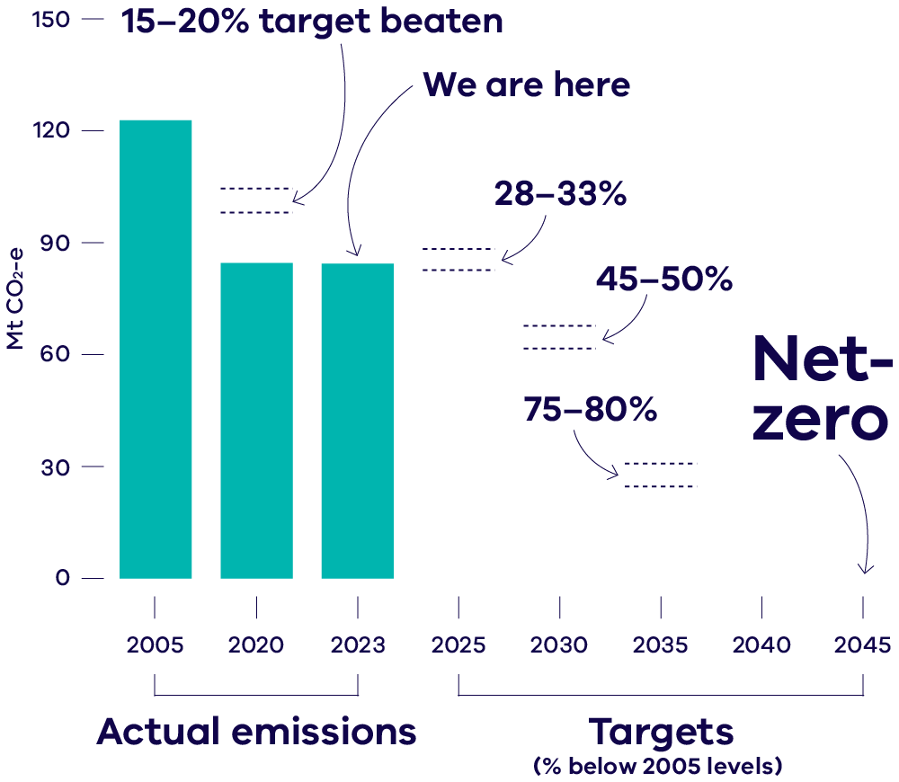
This report is the eighth in a series of annual emissions reports required under the Act. It helps track progress being made towards these emissions reduction targets. The report provides an overview of the state’s greenhouse gas emissions in 2023 – the most recent year with available data. It explains emissions sources and trends over time, including some likely drivers of those trends.

Victoria has cut emissions by almost a third since 2005
Victoria’s net greenhouse gas emissions for 2023 were 84.2 Mt CO₂-e. This is 31.4% below 2005 emissions – within range of Victoria’s 2025 emissions reduction target to reduce emissions by 28–33% below 2005 levels.
Figure 2: Victoria’s total net emissions, 2005 to 2023
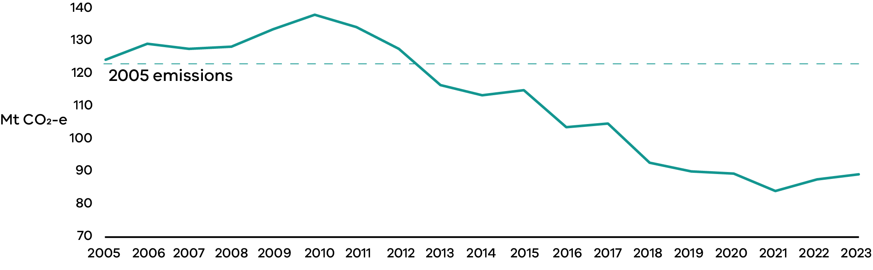
Victoria’s 2023 emissions increased by a small amount (1.7 Mt CO₂-e or 2%) compared to 2022. This was partly due to natural causes such as wet weather conditions in both 2022 and 2023, which increased emissions from soil carbon in forests – these short-term natural fluctuations are expected to even out over time. Transport emissions also contributed to the increase as the sector continued to rebound following the end of COVID-19 restrictions.
Importantly, in 2023, emissions from burning fossil fuels in Victoria have continued to decline. This is a result of the transition from coal-fired electricity generation to renewable sources, and Victorians using less fossil gas in homes and industry.

Unpacking emissions reporting
Net emissions represent the difference between the greenhouse gases released into the atmosphere and those removed from it. There are many types of greenhouse gases, including carbon dioxide, methane, and nitrous oxide. To simplify comparisons across various greenhouse gases, they are expressed in terms of millions of tonnes of carbon dioxide equivalent (Mt CO₂-e), indicating the amount of carbon dioxide that would cause the same amount of global warming as a particular greenhouse gas over a 100-year period.
This report covers financial years, with 2023 referring to the period from 1 July 2022 to 30 June 2023. 2023 is the latest year for which official emissions data is available. This data was published by the Commonwealth Government in May 2025.

Victorians emit fewer greenhouse gases than the national average
Victoria’s emissions account for 18.6% of Australia’s total emissions. This makes Victoria the fourth largest contributor to national emissions (Figure 3).
Figure 3: Contribution to national emissions by state and territory, 2023
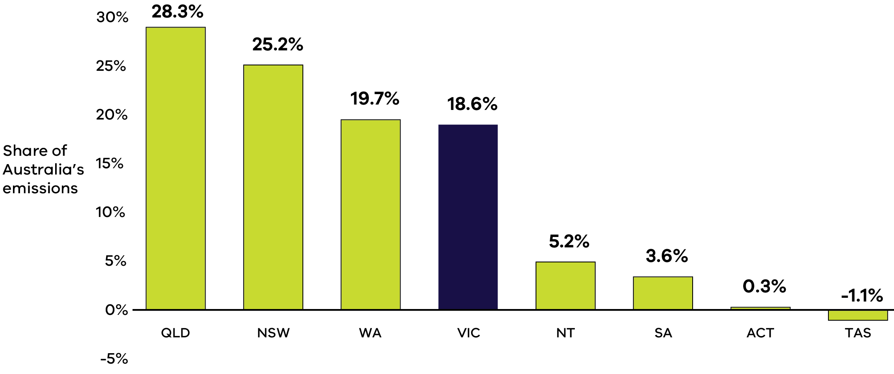
On average, Victorians emitted 12.3 tonnes of CO2-e per person in 2023, down from 12.4 tonnes in 2022. This is lower than the national average and places Victoria below all states and territories except Tasmania, South Australia and the Australian Capital Territory (Figure 4). Compared to Victoria, these states and territory rely more heavily on renewable energy, meaning they produce less emissions from fossil fuel-based electricity. Tasmania also has extensive forest cover that absorbs carbon, contributing to its negative emissions.
Figure 4: Per capita emissions in Australia by state and territory, 2023
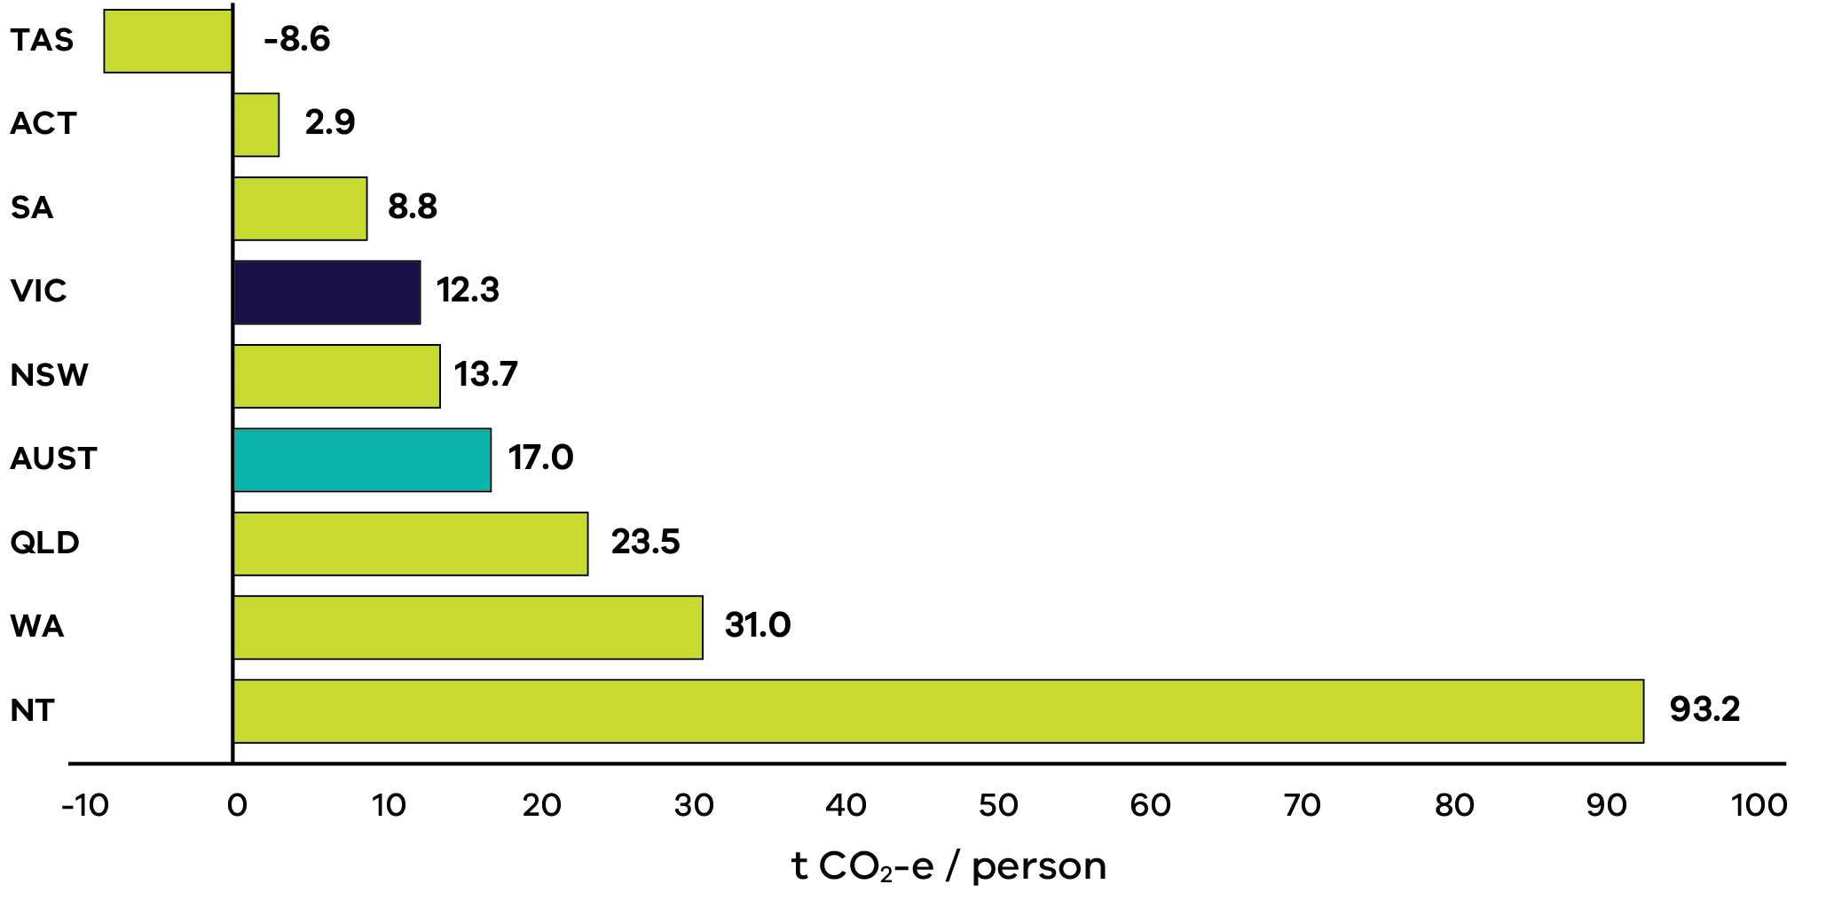

Victoria’s population and economy are growing, yet emissions are falling
In the past, as Victoria’s population and economy grew, so did emissions. However, in the last decade or so, our emissions have started to decrease, even though Victoria’s population and economy have continued to grow.
This is shown by the emissions intensity of Victoria’s economy, which measures the amount of emissions that are produced for every dollar the state’s economy generates. Since 1990, this has dropped by 69%, meaning that for every dollar of economic activity, we’re releasing far less emissions.
Figure 5: Changes in emissions, population and economic growth (represented by Gross State Product, GSP) – Victoria, 1990 to 2023
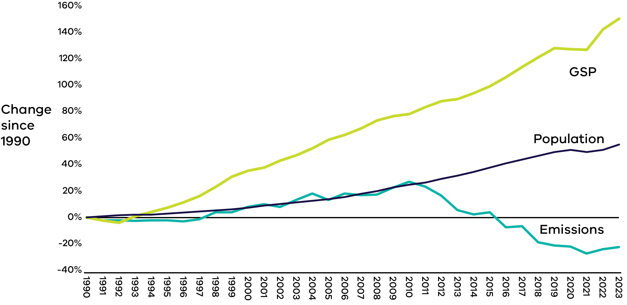

The sources of Victoria’s emissions
Figure 6: Victorian net emissions by sector and energy subsector, 2023
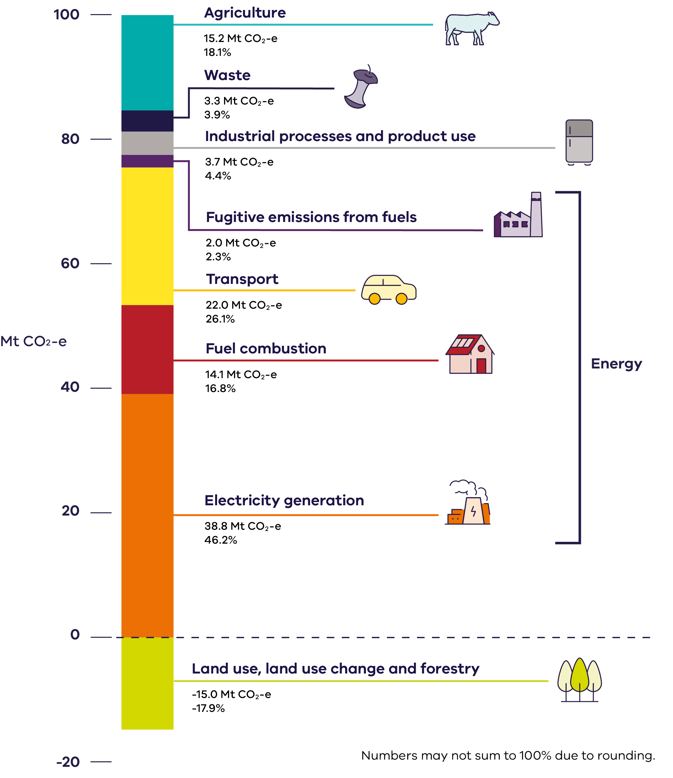

Emissions sectors
The Intergovernmental Panel on Climate Change (IPCC) is the United Nations body for assessing the science related to climate change. They set the standards for international emissions reporting. The reporting uses standard ‘IPCC emissions sectors’ to categorise where emissions come from. These sectors are based on the processes which generate emissions. This makes reports from different countries easier to compare and reduces double-counting of emissions. The emissions sectors are not the same as economic sectors. For example, fuels burned on farms are categorised as fuel combustion emissions, not agriculture emissions.
Around 90% of Victoria’s net greenhouse gas emissions come from burning fossil fuels to make energy. This energy is used for electricity generation, transport and fuel combustion. Electricity generation accounts for the majority of fossil fuel emissions and makes almost half (46%) of the state’s total emissions. The use of fossil fuels in cars, trucks and other transport contributes 26% of total emissions. Burning fossil fuels in homes, businesses and industry contributes 17%.
Emissions from agriculture are the next most significant source of Victoria’s emissions, making up 18% of net emissions. Industrial processes and product use, referring to emissions from human-made chemicals, contribute 4% of the state’s net emissions. Emissions from waste, particularly methane released from landfills and wastewater treatment plants, account for 4% of net emissions.
The land sector reduced Victoria’s net emissions by 18% in 2023 as forests and other vegetation absorb carbon dioxide.

Energy: Electricity generation
Total emissions from electricity generation contributed to almost half of Victoria’s net emissions in 2023.
Almost all (96%) of these emissions come from burning brown coal to create electricity, which occurs at Victoria’s three brown coal power plants: Loy Yang A, Loy Yang B, and Yallourn.
Burning fossil gas to generate electricity accounts for around 2% of Victoria’s electricity emissions. This is produced at eight major gas power plants across the state.

Energy: Fuel combustion
Total emissions from fuel combustion contributed around 17% of Victoria’s net emissions in 2023.
Almost 40% of fuel combustion emissions come from burning fossil fuels for heating, hot water and cooking in homes.
One third of fuel combustion emissions come from industry burning fossil fuels to operate machinery or provide heat, steam or pressure to manufacture goods.
The most common fuel burned is fossil gas, which accounts for around 70% of Victoria’s fuel combustion emissions. Other common fuels include diesel and LPG.

Energy: Transport
Transport emissions contributed to over one quarter of Victoria’s net emissions in 2023.
Transport emissions come from burning fossil fuels in vehicles including cars, buses, vans, trucks, trains, aircraft, and watercraft. The most common fossil fuels used in Victorian transport are petrol and diesel.
In 2023, about 85% of transport emissions came from road vehicles, of which 55% come from passenger cars, 24% from trucks and buses and 21% from light commercial vehicles (LCVs) such as utes and vans. Air transport accounted for 11% of total transport emissions.

Industrial processes and product use (IPPU)
In 2023, IPPU made up 4% of Victoria’s net emissions.
The majority (78%) of these emissions come from leaks of synthetic greenhouses gases – specifically hydrofluorocarbons – used in refrigeration and air conditioning equipment.
The remaining IPPU emissions are from industrial processes. For example, the production of steel, cement, aluminium and various chemicals involve chemical reactions that directly release greenhouse gases.

Energy: Fugitive emissions from fuels
Fugitive emissions contributed 2% to Victoria’s net emissions in 2023.
These emissions occur when greenhouse gases (often methane) are released or leaked during various stages of fossil fuel production and delivery. In Victoria, almost all stem from processes involving fossil gas – its extraction, processing and distribution to end users. Coal mines also release fugitive emissions.

Waste
In 2023, waste made up 4% of Victoria’s net emissions.
Of this, 72% came from the release of methane due to the breakdown of solid waste in landfills.
Another 26% of waste emissions came from the treatment of wastewater, which releases methane and nitrous oxide.

Agriculture
In 2023, agriculture contributed around 18% of Victoria’s net emissions.
Agriculture emissions arise from livestock and crop farming processes. As cows and sheep digest food, they release methane – a type of greenhouse gas. This process is called enteric fermentation. It accounts for around 70% of agriculture emissions in Victoria, and mostly comes from cattle.
Other sources of agriculture emissions in Victoria include the use of fertiliser in crop production and soil management practices.

Land Use, Land Use Change and Forestry (LULUCF)
The LULUCF sector includes vegetation and soil that can either emit or absorb carbon dioxide. When it absorbs and stores carbon dioxide this is called sequestration.
Because trees, vegetation and soil can sequester carbon dioxide, the LULUCF sector as a whole can be a net sink of emissions (meaning it absorbs and stores more than it emits). This is based on how land is managed. Planting more trees and encouraging plant life sequesters more carbon dioxide. This can be achieved through actions like starting a commercial plantation, or doing environmental planting to improve biodiversity.
In Victoria, the LULUCF sector sequesters almost one fifth of Victoria’s net emissions.
Victoria’s forests contribute the most sequestration, representing around 70% of the sector. Other LULUCF sub-sectors that contribute to sequestering Victoria’s emissions include croplands and grasslands.

Trends in Victoria’s emissions
The sectoral breakdown of Victoria’s emissions has changed over time. This reflects targeted policy action, as well as broader economic and social trends (Figure 7).
Figure 7: Total net emissions and emissions by sector – Victoria, 1990 to 2023
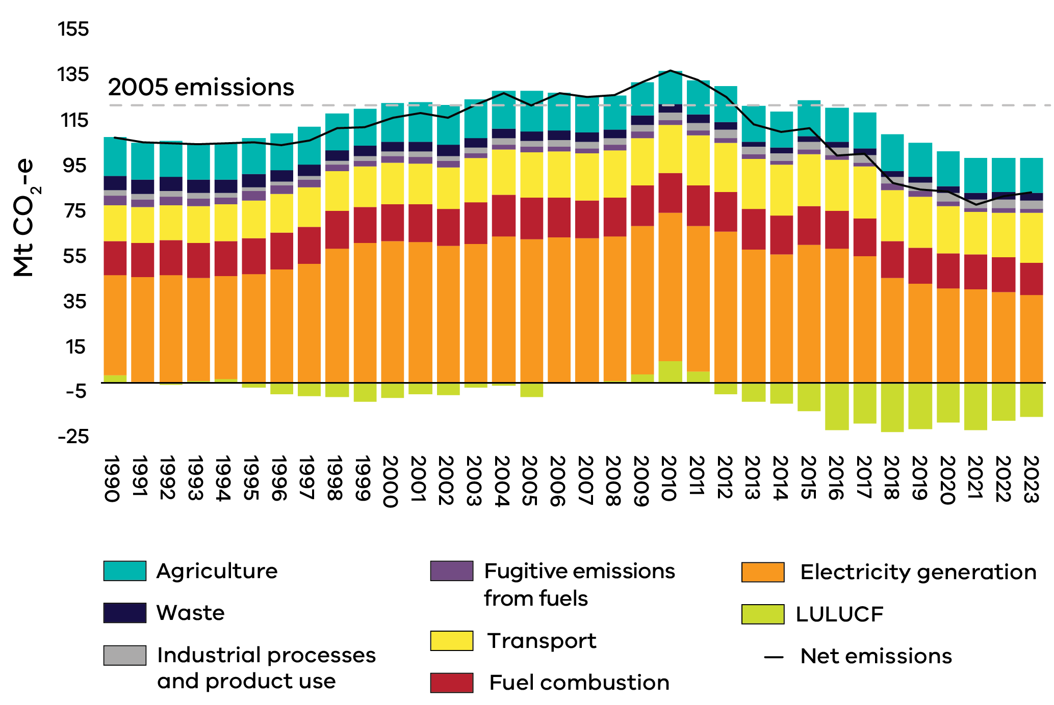

Victoria’s shift to renewable energy continues to drive emissions down
Electricity generation remains the largest contributor to Victoria’s emissions reduction, having fallen by 39% (24.6 Mt CO₂-e) since 2005. This has been driven by the transition from coal-fired electricity to renewable sources. In 2023, renewable sources supplied 38% of Victoria’s electricity generation – doubling their share in the last five years.

Businesses and households have reduced their fossil fuel use
Emissions from fossil fuel combustion in Victoria have decreased by 22% since 2005. The biggest contributor has been the reduction in energy intensive manufacturing in Victoria as the economy has shifted towards service industries.
Historically, Victorian household emissions from burning fossil fuels (mainly fossil gas) grew in line with population growth. However, in 2023, Victorian households are using less fossil gas – with residential emissions returning to around 2005 levels. This reflects the growing trend toward use of electric appliances (particularly for heating and hot water), improved energy efficiency of Victorian homes, and dual fuel homes increasingly using their electric heating.
The extraction and production of fossil fuels has also decreased, reducing Victoria’s fugitive emissions by 17% since 2005.

Transport emissions have increased as post-pandemic recovery continued, despite growing electric vehicle sales
In 2023 transport emissions were 3% lower than pre-pandemic levels, despite steadily rising over the past two years. This reflects a mixed trend: a strong rebound in emissions following COVID-19 restrictions, tempered by ongoing shifts in travel habits and vehicle choices.
During COVID-19 restrictions in 2020 and 2021, transport emissions dropped by around 10% each year. As restrictions eased, transport emissions rebounded, increasing by an average of 9% each year in 2022 and 2023. Still, in 2023, emissions had not fully returned to pre-pandemic levels.
The continued trend of hybrid work has contributed to this by reducing car travel. Passenger cars travelled an estimated 5% fewer kilometres overall in 2023 nationwide, compared with 2019.
Electric vehicle sales have also continued to grow. In 2023, battery electric vehicles made up 7.5% of passenger vehicle sales in Victoria, more than double the percentage of sales compared to 2022. Despite this sales growth, battery electric vehicles currently make up less than 1% of all passenger vehicles in Victoria.⁹
While reduced car travel and growing electric vehicle sales cause emissions to decrease, this was counterbalanced by the increasing popularity of larger vehicles like sport utility vehicles (SUVs), and light commercial vehicles (LCVs). SUVs represented 59% of all national vehicle sales in 2023 – double their share compared to 2013 – and are more fuel intensive and emissions intensive than smaller vehicles⁹.

Victoria’s forests are absorbing more carbon
Historically, there have been periods when the land sector was a source of Victoria’s emissions. However, since 2012, the sector has absorbed more carbon dioxide than it emits, making it an important carbon sink. This is largely due to a reduction in land clearing and native forest harvesting, as well as growth in the plantation forest industry.
Land and forest emissions belong to the LULUCF sector. This sector changed from emitting 3% of Victoria’s emissions in 1990 to absorbing 18% in 2023.
Short-term weather variation causes fluctuations in LULUCF emissions around long-term trends. Wetter than normal conditions cause microbes in forest soil to become more active and release more carbon dioxide. Lower levels of sequestration in 2022 and 2023 can be explained by wetter than usual conditions.

Where Victoria’s emissions data comes from
In accordance with the Act, data used for this report comes from the State and Territory Greenhouse Gas Inventory (STGGI). The STGGI is Australia’s national inventory disaggregated by state and territory. The national inventory and the STGGI are developed by the Commonwealth Department of Climate Change, Energy, the Environment and Water (DCCEEW) as part of the National Greenhouse Gas Accounts.
You can access data from the National Greenhouse Gas Accounts, including the STGGI, by going to http://www.greenhouseaccounts.climatechange.gov.au/. The National Inventory Report provides a detailed explanation of the methods used to calculate the inventory. The National Inventory Report 2023 can be found at https://www.dcceew.gov.au/climate-change/publications/national-inventory-report-2023.
DCCEEW uses the inventory to report Australia’s emissions to the United Nations, which fulfills Australia’s obligations under the United Nations Framework Convention on Climate Change (UNFCCC) and the Paris Agreement.
The 2023 STGGI was released by DCCEEW in May 2025. This is the most recent official data on annual state and territory greenhouse gas emissions. The release of data two years after the year to which they pertain is standard for national greenhouse accounts, reflecting the time taken to develop and verify a complex national inventory to international standards.
The STGGI data is prepared following a rigorous annual process which includes planning; methodology improvements; data collection and entry; quality control and assurance measures; estimating emissions; and preparing, reviewing, and publishing reports and emissions data. The full description of this process can be found in Section 1 (page 12–32) of the National Inventory Report 2023, Volume 1.
In addition to the STGGI, the Australian National Greenhouse Accounts (ANGA) include the National Inventory by Economic Sector, and the National Quarterly Update. This data can be found on the ANGA website at https://greenhouseaccounts.climatechange.gov.au/, along with projections of national future emissions to 2040.

Recalculating historical emissions
DCCEEW makes improvements to their methods for estimating emissions in response to new data, improved science, and review by international experts. New methods must then be used to estimate all emissions dating back to 1990, so previously published figures may be recalculated and replaced with new figures. This means method improvements can change Victoria’s emissions in 2005, which is the baseline year used to calculate Victoria’s interim emissions reduction targets.
This year’s recalculations have changed the state’s greenhouse gas emissions for the year 2005 from 123.2 Mt CO₂-e to 122.7 Mt CO₂-e, a 0.5% decrease.
In their 2023 report, DCCEEW’s main method updates included:
- Agriculture, with new calculations for agricultural soils and enteric fermentation; and
Fuel combustion, with new data from the National Greenhouse and Energy Reporting Scheme (NGERS).
While there have been no method updates for LULUCF in the National Inventory Report 2023, recalculations are also applied to LULUCF emissions each time a new set of data is published. This needs to be done regardless of method updates because the sector can experience large year on year fluctuations due to natural conditions, including weather conditions and some fires. These recalculations apply multi-year averaging to the sources of emissions that are most impacted by natural fluctuations, helping smooth them out over time.
Figure 8: Comparing historical emissions data published in the Victorian Greenhouse Gas Report 2022 with updated historical emissions data published in this report for 2023
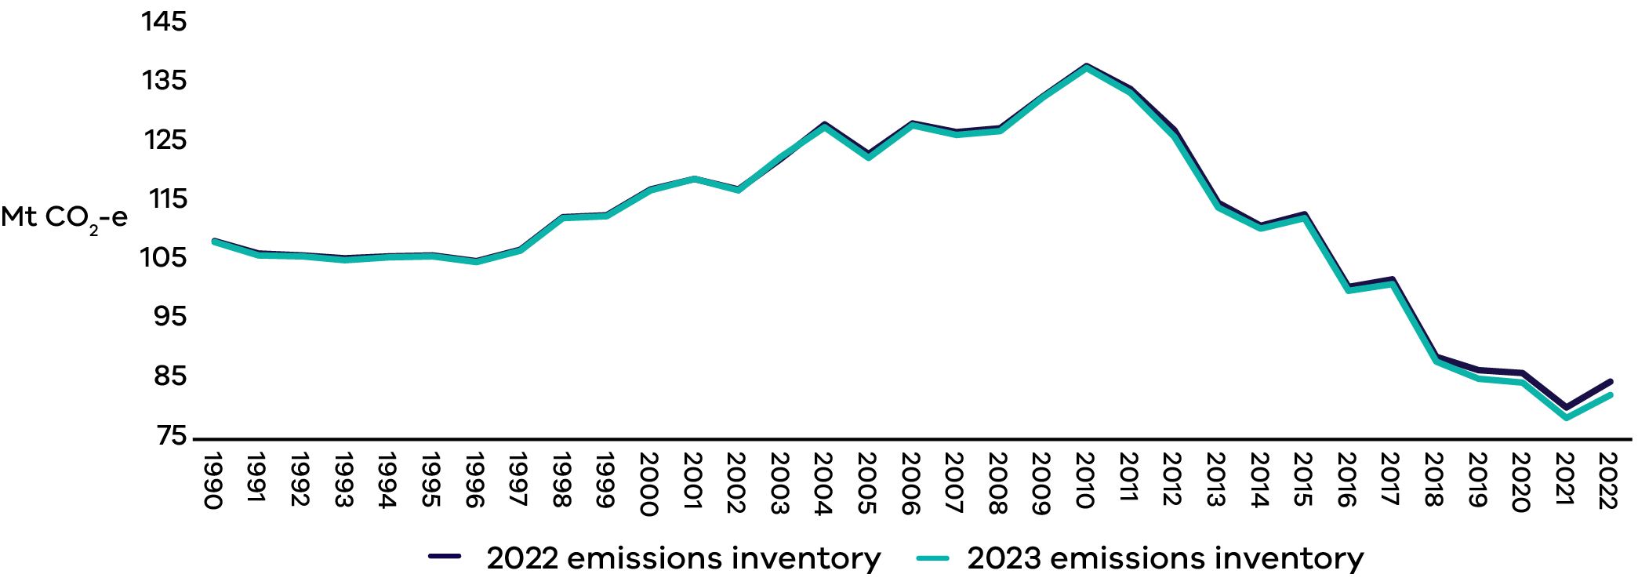

Abbreviations and acronyms
Table 1: Abbreviations and acronyms and their definitions
Abbreviation | Definition
The Act | Climate Action Act 2017
CO₂-e | Carbon dioxide equivalent
DCCEEW | Commonwealth Department of Climate Change, Energy, the Environment and Water
DEECA | Department of Energy, Environment and Climate Action
EV | Electric vehicle
GSP | Gross State Product
GW | Gigawatts
HFC | Hydrofluorocarbons
IPCC | Intergovernmental Panel on Climate Change
IPPU | Industrial processes and product use
LCV | Light Commercial Vehicle
LPG | Liquefied petroleum gas
LULUCF | Land use, land use change and forestry
Mt | Million tonnes
NGERS | National Greenhouse and Energy Reporting Scheme
SEC | State Electricity Commission Victoria
STGGI | State and Territory Greenhouse Gas Inventories
UNFCCC | United Nations Framework Convention on Climate Change

Publication information

Acknowledgements
We acknowledge and respect Victorian Traditional Owners as the original custodians of Victoria’s land and waters, their unique ability to care for Country and deep spiritual connection to it.
We honour Elders past and present whose knowledge and wisdom has ensured the continuation of culture and traditional practices.
DEECA is committed to genuinely partnering with Victorian Traditional Owners and Victoria’s Aboriginal community to progress their aspirations.

Copyright
© The State of Victoria Department of Energy, Environment and Climate Action, 2025.

Creative Commons
This work is licensed under a Creative Commons Attribution 4.0 International licence, visit the Creative Commons website (http://creativecommons.org/licenses/by/4.0/).
You are free to re-use the work under that licence, on the condition that you credit the State of Victoria as author. The licence does not apply to any images, photographs or branding, including the Victorian Coat of Arms, and the Victorian Government and Department logos.
ISSN 2652-8495 (online PDF/Word)
ISSN 2652-8932 (print)

Disclaimer
This publication may be of assistance to you but the State of Victoria and its employees do not guarantee that the publication is without flaw of any kind or is wholly appropriate for your particular purposes and therefore disclaims all liability for any error, loss or other consequence which may arise from you relying on any information in this publication.

Accessibility
To receive this document in an alternative format, phone the Customer Service Centre on 136 186, email customer.service@delwp.vic.gov.au, or contact National Relay Service on 133 677. Available at DEECA website (www.deeca.vic.gov.au).
End of document.

In this report, shares of emissions from each sector are compared against Victoria's total net emissions. This includes negative emissions from sequestration in the land sector. Using this approach, the shares of emissions from non-land sectors add up to more than 100%. When sequestration from the land sector is excluded, burning fossil fuels to make energy contributed to almost 80% of Victoria's emissions.
Only those emissions generating activities that occur in Victoria are counted in the state’s emissions inventory. This means that the electricity sector accounts for emissions from electricity generation in Victoria, including any electricity that is exported to other states. Emissions from electricity that is imported to Victoria is not included in the state’s emissions.
Electricity emissions from the use of electric vehicles (e.g. electric cars, trains, and trams) are counted in the electricity sector.
DEECA, 2023, Victorian Renewable Energy Target 2022/23 Progress Report
DJSIR, 2025, Summary of Victorian economic data.
AEMO, 2025, Gas-Electricity Meter Data Linking Project Report.
Bureau of Infrastructure and Transport Research Economics, 2025, Australian Infrastructure and Transport Statistics Yearbook 2024
Department of Treasury and Finance, 2024, Victoria’s Economic Bulletin: A region-based examination of electric vehicle take-up rates in Australia
National Transport Commission, 2024, Light vehicle emissions intensity in Australia: trends over time
The National Quarterly Update presents a summarised version of Australia’s most up-to-date emissions, and is supplemented with estimates where complete data is not yet available

