Victorian Greenhouse Gas Emissions Report
  - 2020
Victoria State Government
Environment, Land, Water and Planning
Acknowledgment
We acknowledge and respect Victorian Traditional Owners as the original custodians of Victoria's land and waters, their unique ability to care for Country and deep spiritual connection to it. We honour Elders past and present whose knowledge and wisdom has ensured the continuation of culture and traditional practices.
We are committed to genuinely partner, and meaningfully engage, with Victoria's Traditional Owners and Aboriginal communities to support the protection of Country, the maintenance of spiritual and cultural practices and their broader aspirations in the 21st century and beyond.
© The State of Victoria Department of Environment, Land, Water and Planning 2022
This work is licensed under a Creative Commons Attribution 4.0 International licence. You are free to re-use the work under that licence, on the condition that you credit the State of Victoria as author. The licence does not apply to any images, photographs or branding, including the Victorian Coat of Arms, the Victorian Government logo and the Department of Environment, Land, Water and Planning (DELWP) logo. To view a copy of this licence, visit creativecommons.org/licenses/by/4.0/
Printed by Finsbury Green, Port Melbourne
ISSN 2652-8495 (online PDF/Word)
ISSN 2652-8932 (print)
Disclaimer
This publication may be of assistance to you but the State of Victoria and its employees do not guarantee that the publication is without flaw of any kind or is wholly appropriate for your particular purposes and therefore disclaims all liability for any error, loss or other consequence which may arise from you relying on any information in this publication.

Contents
Minister’s foreword 3
Summary 4
Introduction 6
1 Victorian emissions and indicators – 1990 to 2020 8
1.1 Emissions 1990 to 2020 8
1.2 Change in emissions – 2005 to 2020 8
1.3 Change in emissions – 2019 to 2020 9
1.4 Victoria’s contribution to national emissions 10
1.5 Per capita emissions 10
1.6 Emissions and Gross State Product 12
1.7 Emissions by greenhouse gas type 12
2 Emissions by sector (IPCC categories) 13
2.1 Energy 16
2.1.1 Electricity generation 17
2.1.2 Fuel combustion 20
2.1.3 Transport 23
2.1.4 Fugitive emissions from fuels 29
2.2 Industrial processes and product use (IPPU) 31
2.3 Waste 33
2.4 Agriculture 35
2.5 Land Use, Land-Use Change and Forestry 38
3 Emissions by economic sector – 2020 46
3.1 Direct (Scope 1) emissions by economic sector 46
3.2 Allocation of Scope 2 emissions from electricity generation to end-users 47
3.3 Scope 1 plus Scope 2 emissions by economic sector 48
Appendix A: Revision of historical greenhouse gas emissions data 49
Abbreviations and acronyms 54
References 55

Minister’s foreword
Victoria demonstrated global leadership when we legislated a net zero target for 2050 under the Climate Change Act 2017, in line with the Paris Agreement to limit warming to well below 2°C. The Act also provides for a series of five-yearly, science-based targets, providing clarity and certainty about the pathway to net zero.
We have set targets to reduce Victoria’s emissions for 2020, 2025 and 2030. Our 2030 target – to halve Victoria’s emissions from 2005 levels – puts Victoria alongside international climate leaders such as the United States, Canada and the European Union. In 2023 we will set the 2035 emissions reduction target for Victoria, following receipt of advice from an independent expert panel.
The Victorian Greenhouse Gas Emissions Report 2020 allows us to measure Victoria’s progress in achieving our targets. This report shows that we have exceeded our target for 2020, to reduce emissions by 15-20% below 2005 levels, slashing Victoria’s emissions by 29.8% below 2005 levels.
Victoria is now firmly on the path to reducing our emissions to net zero. The historical emissions data in this report show that getting to this point was a multi-decadal process, reflecting economic, demographic, and technological changes, action from the Victorian community, as well as the impact of policies to support the clean energy transition.
The data also show that Victoria has made these significant reductions in emissions while our population and economy have grown over the past 30 years. In 2020 Victorians were responsible for fewer emissions per person than Australians in all States and Territories other than Tasmania and the Australian Capital Territory (ACT).
Changes to the way we generate electricity in this state were responsible for almost two-thirds of the cut to Victoria’s emissions between 2005 and 2020. Shifting Victoria’s energy system towards renewables as fossil-fuelled electricity generators retire has had a significant impact on our emissions. Our strong targets to bring online more renewable energy – including Australia’s first offshore wind targets – will help us to keep moving toward our 2030 target to halve Victoria’s emissions.
We invite you to use this resource in the same way that government will – to make decisions for a net zero emissions, climate resilient future based on the best available data.
The Hon. Lily D’Ambrosio MP
Minister for Energy
Minister for Environment and Climate Action
Minister for Solar Homes

Summary
The Victorian Greenhouse Gas Emissions Report 2020 (the report) is the fifth in a series of annual emissions reports required under Victoria’s Climate Change Act 2017 (the Act). The report provides an overview of the state’s greenhouse gas emissions from 1990 to 2020 with a focus on trends since 2005 (the reference year for interim emissions reduction targets under the Act). It also explains emissions sources and trends over time, including the likely drivers of those trends.
The key findings in this report include:
Victoria’s population and economy have grown, while emissions have declined
Victoria’s emissions declined by 24.7% between 1990 and 2020, as the population increased by 52.9% and the economy grew by 127% (Figure 1). Victoria’s per capita emissions in 2020 — a measure of the state’s total net emissions divided by its population — were well below the national average, and lower than all States and Territories’ other than Tasmania and the Australian Capital Territory (ACT).
Figure 1: Change in Gross State Product (GSP), population and emissions – Victoria, 1990 to 2020
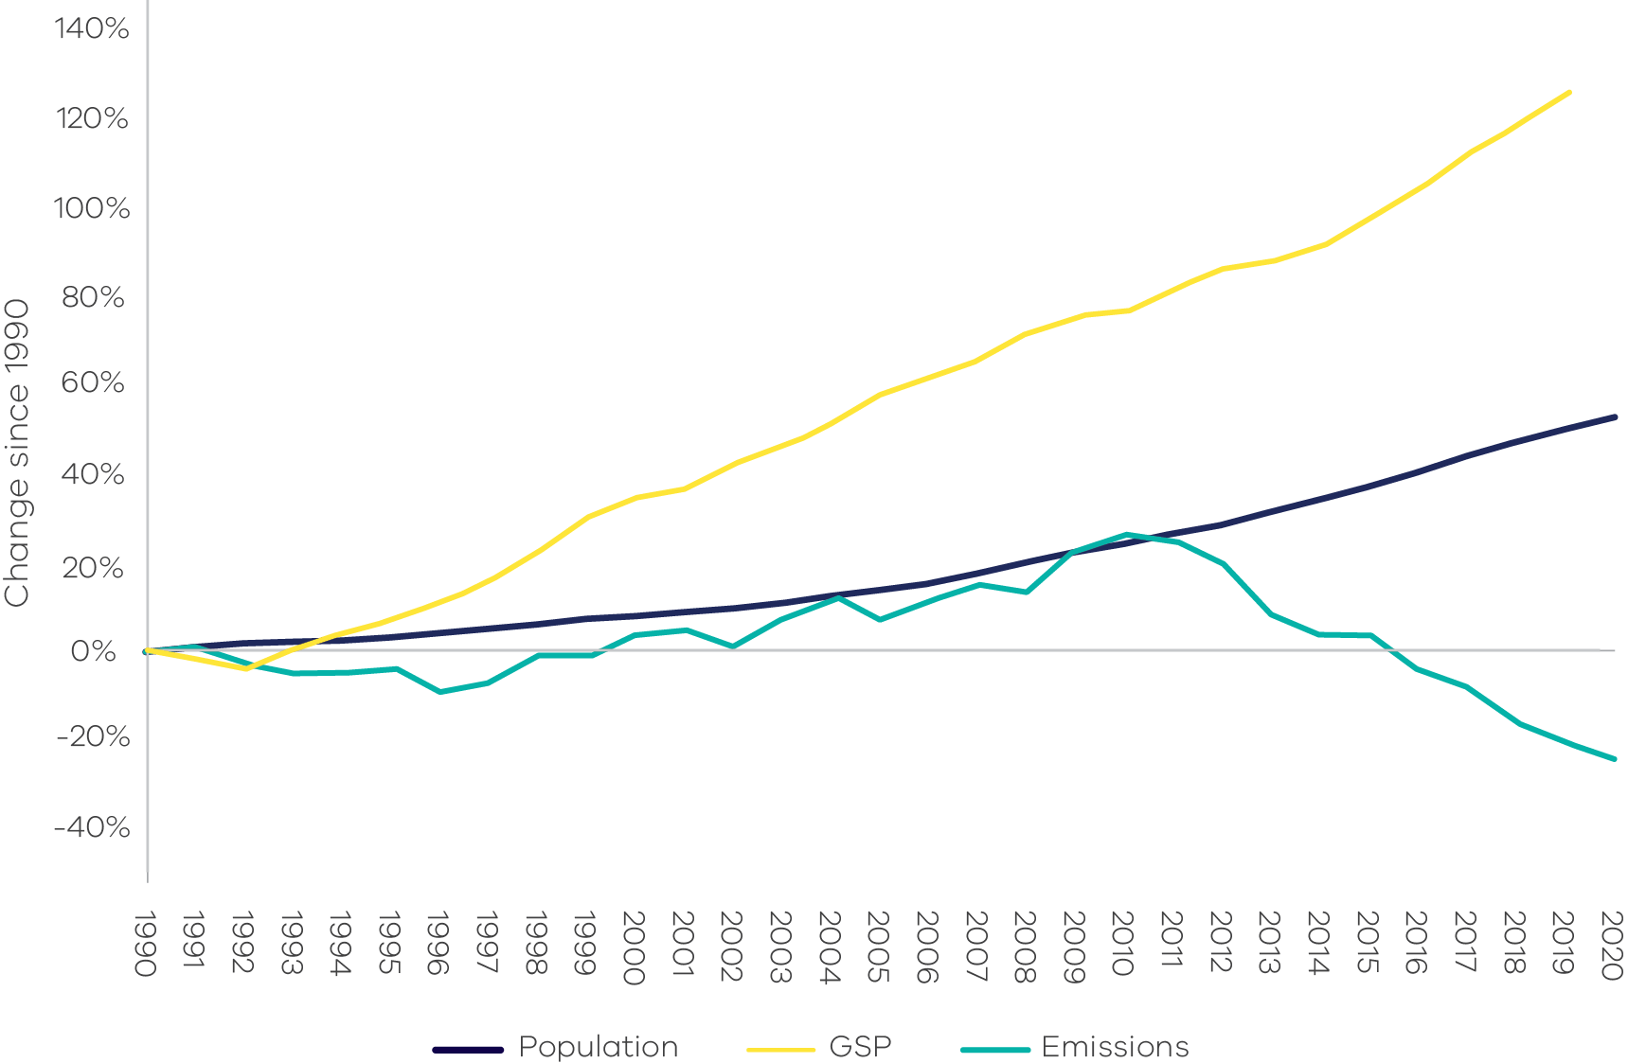
Source: Analysis based on Australian Greenhouse Emissions Information System (DCCEEW 2022a), Australian National Accounts: State Accounts 2020-21 (ABS 2021a) and Australian Demographic Statistics 2021 (ABS 2022a)
Victoria has cut emissions by almost 30% since 2005
Victoria’s total net emissions fell by 29.8% between 2005 and 2020, to a total of 83.3 million tonnes (Mt) of carbon dioxide equivalent (CO₂-e). The state has significantly exceeded its target to reduce emissions by 15-20% below 2005 levels by 2020 (Figure 2).
Figure 2: Victoria’s total net emissions, 2005-2020
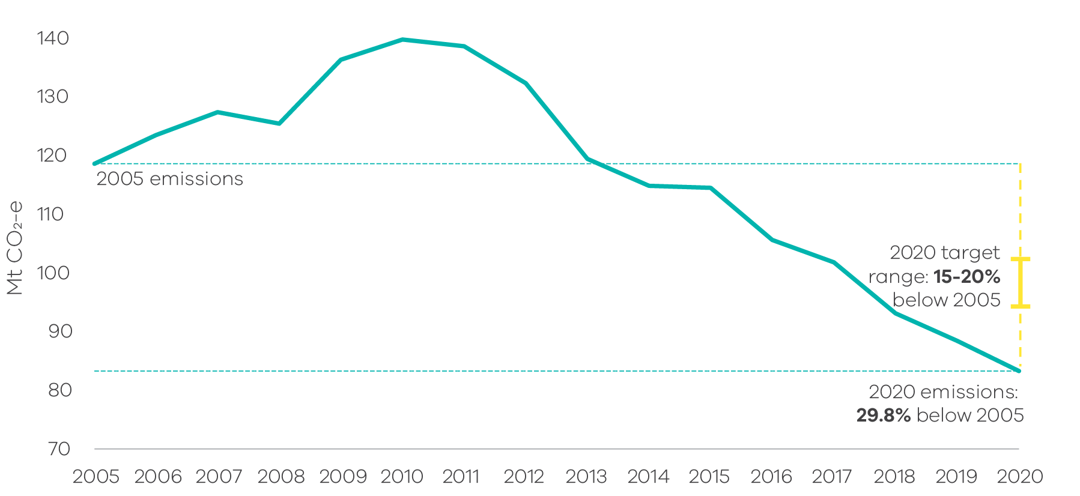
Source: Australian Greenhouse Emissions Information System (DCCEEW 2022a)
The electricity sector continues to be Victoria’s largest source of emissions but also leads the state’s emissions reduction efforts
The electricity sector was responsible for 50.1% of Victoria’s total net emissions in 2020. Other sources of state emissions were transport (25%), fuel combustion (20.8%), agriculture (19.3%), industrial processes and product use (IPPU, 4.3%), waste (3.4%) and fugitive emissions from fuels (2.4%) (Figure 3).
Figure 3: Victorian emissions by sector and energy sub-sector, 2020
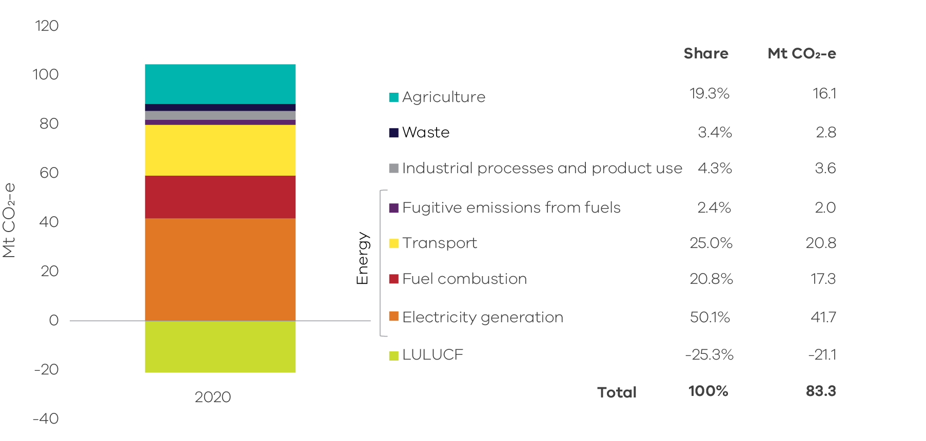
Source: Australian Greenhouse Emissions Information System (DCCEEW 2022a). Note: numbers may not sum due to rounding
Between 2019 and 2020 significant decreases in emissions were observed in the electricity generation (4.9%), transport (8.4%), fuel combustion (1.2%) and fugitive emissions from fuels (8.7%) sectors. These changes are mostly due to a 15.8% increase in renewable electricity production combined with a 2.4% reduction in the output of coal-fired electricity generators and changes in activity related to the coronavirus (COVID-19) pandemic.
The electricity generation sector is responsible for almost two-thirds of the change (reduction) in Victoria’s total net emissions between 2005 and 2020.
Emissions have declined for all sectors but Transport and Industrial Processes and Product Use since 2005
Transport emissions increased steadily with population growth since 2005, contributing 25% of Victoria’s net emissions in 2020. With road transportation responsible for most of the sector’s emissions, pandemic-related changes to human movement saw transport activity decrease in 2020 for the first time since 1990. Despite that, transport emissions still grew between 2005 and 2020 by 0.6 Mt CO₂-e.
IPPU sector emissions also increased between 2005 and 2020 (by 0.8 Mt CO₂-e), driven mainly by the growth in the stock of air-conditioning and refrigeration systems.
The Victorian land sector’s role in absorbing emissions continued to grow over 2019-2020
Victoria’s forests and natural systems – the Land Use, Land-use Change and Forestry (LULUCF) sector – absorbed over a quarter of Victoria’s emissions in 2020. Forest land remaining forest land was the largest contributor to emissions reductions in Victoria, despite the summer 2019-20 bushfires having burnt over 1.5 million hectares of land. The emissions impact of the 2019-20 bushfires will be spread across several years, because of the way forests regenerate after a bushfire and internationally agreed carbon accounting rules for extreme bushfires (see Box 3: Accounting for emissions from the 2019-2020 Eastern Victorian bushfires).

Introduction
Section 52 of the Climate Change Act 2017 (the Act) requires the Minister administering the Act to prepare annual greenhouse gas emissions reports for Victoria. The Act requires that the reports include an overview and collation of the best practicably available information about Victoria’s greenhouse gas emissions; and the extent to which emissions have been reduced compared with 2005 levels (the reference year for interim emissions reduction targets under the Act).
The Victorian Greenhouse Gas Emissions Report 2020 presents information on Victoria’s emissions in two forms:
- presentation of emissions data in accordance with sectors defined by the Intergovernmental Panel on Climate Change (IPCC) reporting framework for national greenhouse gas inventories – with disaggregation of data in the energy sector; and
- presentation of emissions data by sectors of the economy categorised according to the Australian and New Zealand Standard Industrial Classification (ANZSIC).
Data for the report is sourced from State and Territory Greenhouse Gas Inventories released in June 2022 by the Commonwealth Department of Climate Change, Energy, the Environment and Water (DCCEEW); and the Australian Greenhouse Emissions Information System online database. Both sources provide data at a state and territory level over the period 1990 to 2020⁷. This is the most recent official data on annual greenhouse gas emissions.
The data relate to production-based rather than consumption-based emissions in Victoria – that is, it accounts for emissions from goods and services produced in Victoria. This is in accordance with the United Nations Framework Convention on Climate Change’s (UNFCCC) emissions accounting provisions.
Economic and population statistics for Victoria have been used to calculate emissions intensity measures and to obtain insights into trends in the state’s emissions.
Unless otherwise specified, data in this report follows DCCEEW’s convention of being based on financial years. Numbers also may not sum precisely to the totals due to rounding.
Updated historical data
DCCEEW reviews, and, where necessary, revises greenhouse gas data annually to ensure the data are produced in a manner consistent with international methodologies; and to reflect improved estimation methods and new sources of information as they become available.
This review process has resulted in updated historical emissions data for Victoria for 1990 to 2019. Consequently, data over this period in this year’s report differs from that presented in the Victorian Greenhouse Gas Emissions Report 2019.
This is discussed further in Chapter 2 and Appendix A.
Victoria’s emissions reduction targets
Victoria’s Climate Change Act 2017 sets a target of net zero greenhouse gas emissions by 2050 and requires the Government to set 5-yearly interim targets to establish the pathway to net zero.
To date the government has set interim emissions reduction targets for:
- 2020 of 15 – 20% below 2005 levels
- 2025 of 28 – 33 % below 2005 levels
2030 of 50% below 2005 levels
The Minister for Energy, Environment and Climate Action has established an independent expert panel to provide advice on the next target, for 2035. The government will set the 2035 target in 2023.
This report is structured as follows:
Chapter 1: Presents the trend in Victoria’s emissions from 1990 to 2020; its contribution to national emissions and emissions per capita and per unit of Gross State Product (GSP).
Chapter 2: Presents Victoria’s emissions by sector based on IPCC sector categories. It describes historical trends in emissions in each sector and the key drivers of those trends.
Chapter 3: Presents Victoria’s emissions by economic sector based on ANZSIC sector categories.
- Victorian emissions and indicators – 1990 to 2020
  - Emissions 1990 to 2020
Victoria’s total net emissions decreased between 1990 to 1996, before increasing to a peak in 2010 before falling over the period to 2020 (Figure 4). In 2020, total net greenhouse gas emissions were 83.3 Mt CO₂-e, or 24.7% below 1990 levels.
Chapter 2 discusses the trends in sectoral emissions and key factors driving these trends.
Figure 4: Total net emissions and emissions by sector – Victoria, 1990 to 2020
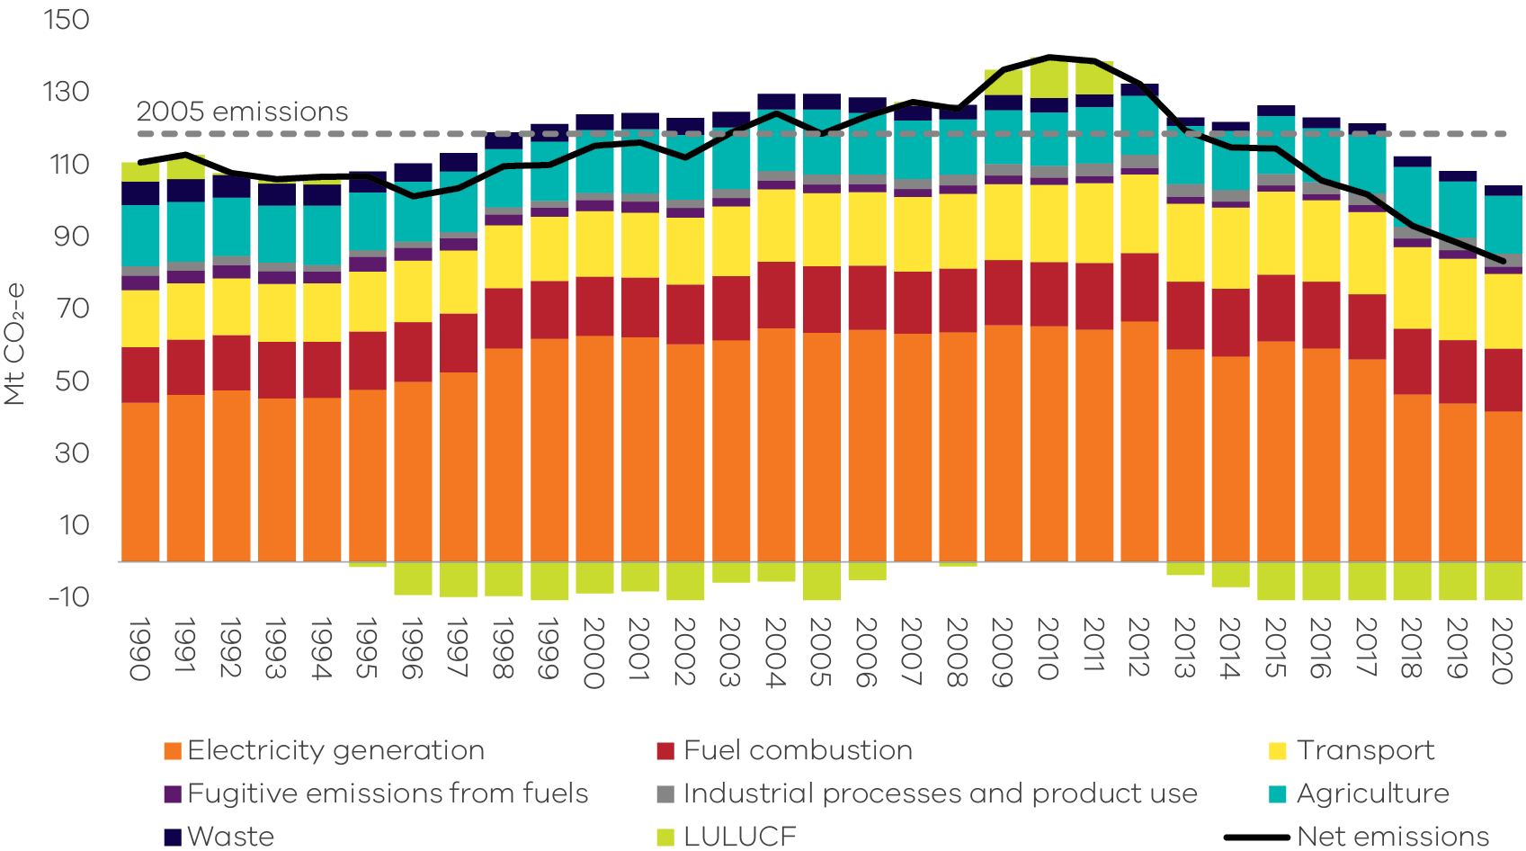
Source: Australian Greenhouse Emissions Information System (DCCEEW 2022a)
  - Change in emissions – 2005 to 2020
Victoria’s greenhouse gas emissions reduction targets use 2005 as the baseline year as stipulated by the Act. In 2020, Victoria’s total net emissions of 83.3 Mt CO₂-e were 35.3 Mt CO₂-e (29.8%) below the baseline level of 118.6 Mt CO₂-e in 2005 (Figure 5). The 29.8% reduction means Victoria has significantly exceeded its target to reduce emissions by 15-20% below 2005 levels by 2020.
Figure 5: Trend in net emissions – Victoria, 1990 to 2020 – highlighting change between 2005 and 2020
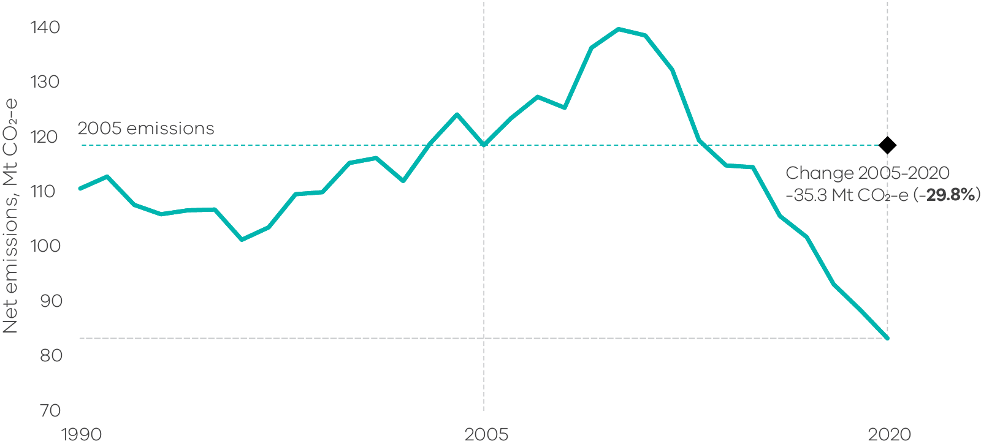
Source: Australian Greenhouse Emissions Information System (DCCEEW 2022a)
  - Change in emissions – 2019 to 2020
Between 2019 and 2020, Victoria’s emissions declined by 5.8%. This was mainly driven by falling emissions in electricity generation (2.2 Mt CO₂-e), transport (1.9 Mt CO₂-e), fuel combustion (0.2 Mt CO₂-e), fugitive emissions from fuels (0.2 Mt CO₂-e) and increased sequestration from the LULUCF sector (1.2 Mt CO₂-e) (Figure 6). The main drivers behind these reductions were a decrease in coal-fired generation, an increase in renewable electricity production (from 21.7% of total electricity generation in 2019 to 24.8% in 2020) (DELWP 2021) and reduced transport activity due to the COVID-19 pandemic.
Figure 6: Change in emissions between 2019 and 2020 by sector, Victoria
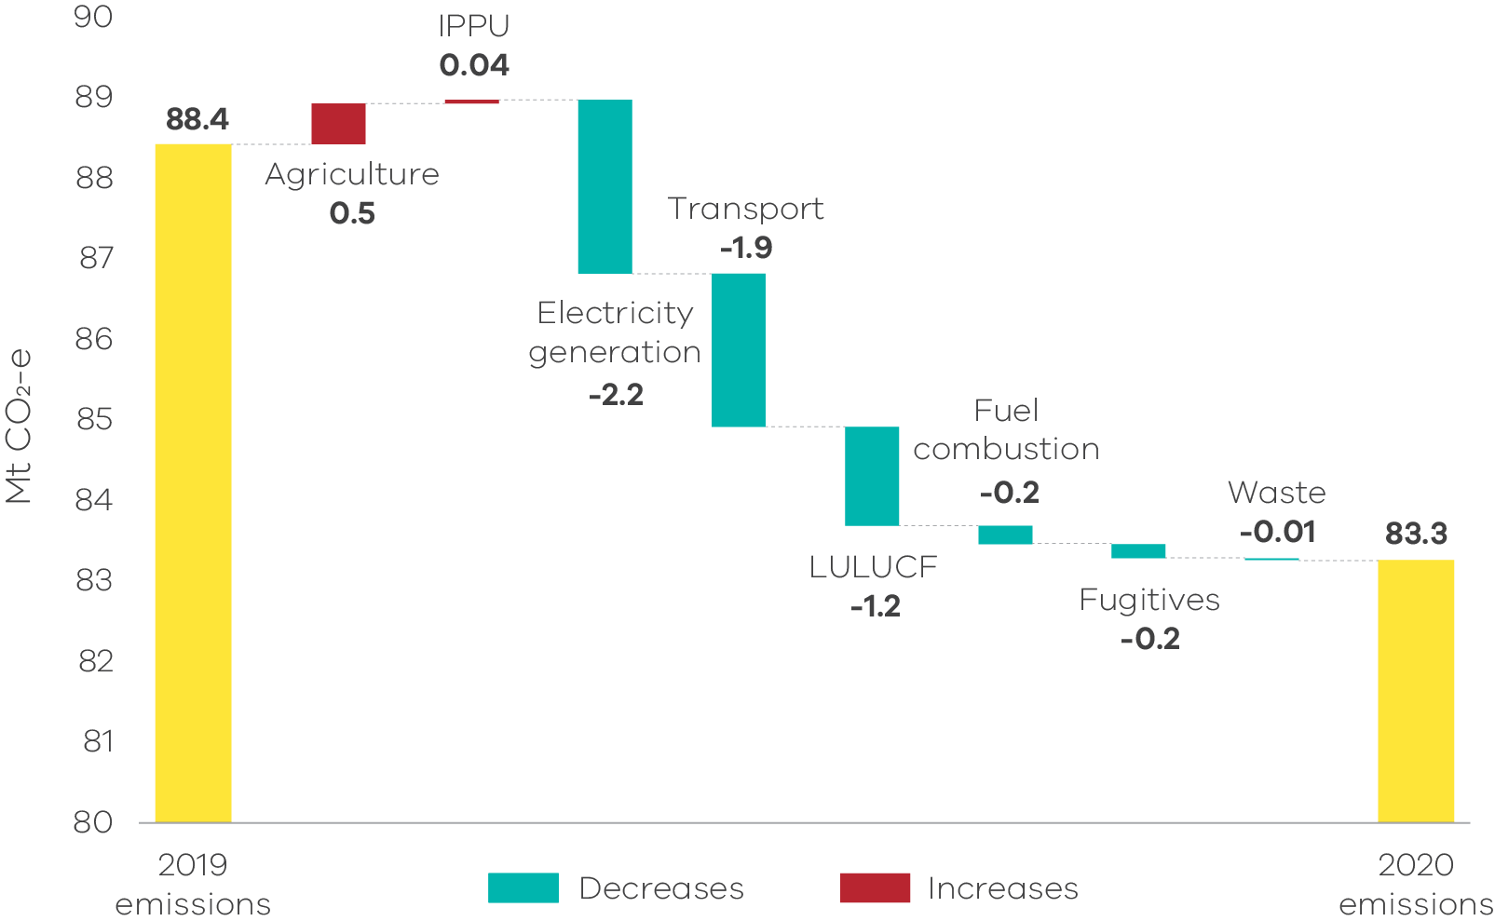
Source: Australian Greenhouse Emissions Information System (DCCEEW 2022a). Note: Y-axis starts at 80 Mt CO₂-e.
  - Victoria’s contribution to national emissions
In 2020, Victoria was the third largest contributor to Australia’s total net emissions (16.7%) behind Queensland (32%) and New South Wales (26.6%) (Figure 7).
In 2020, Victoria’s share of Australia’s total net emissions fell to 16.7% – its lowest level on record, beating the previous low of 17.1% in 2019 – after having increased from 17.9% in 1990 to a peak of 23.3% in 2011 (Figure 8).
Figure 7: Contribution to national emissions by state and territory, 2020
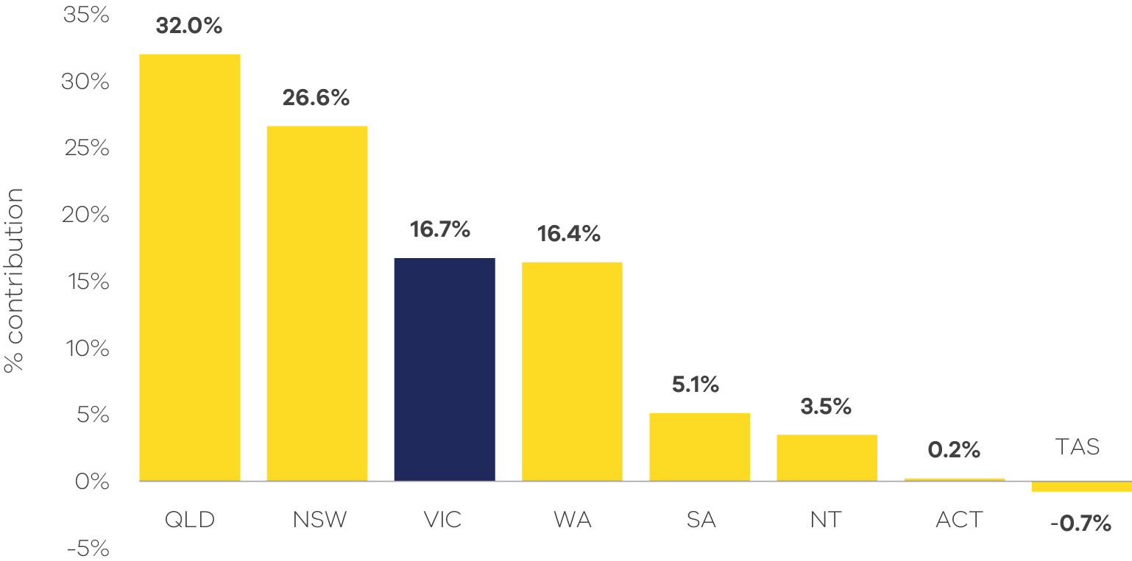
Source: State and Territory Greenhouse Gas Inventories 2020 (DCCEEW 2022d). Note: Tasmania’s share of -0.7% reflects the fact that net sequestration in the LULUCF sector in that state exceeded emissions in other sectors resulting in Tasmania recording negative total net emissions in 2020.
Figure 8: Contribution to national emissions – Victoria, 1990 to 2020
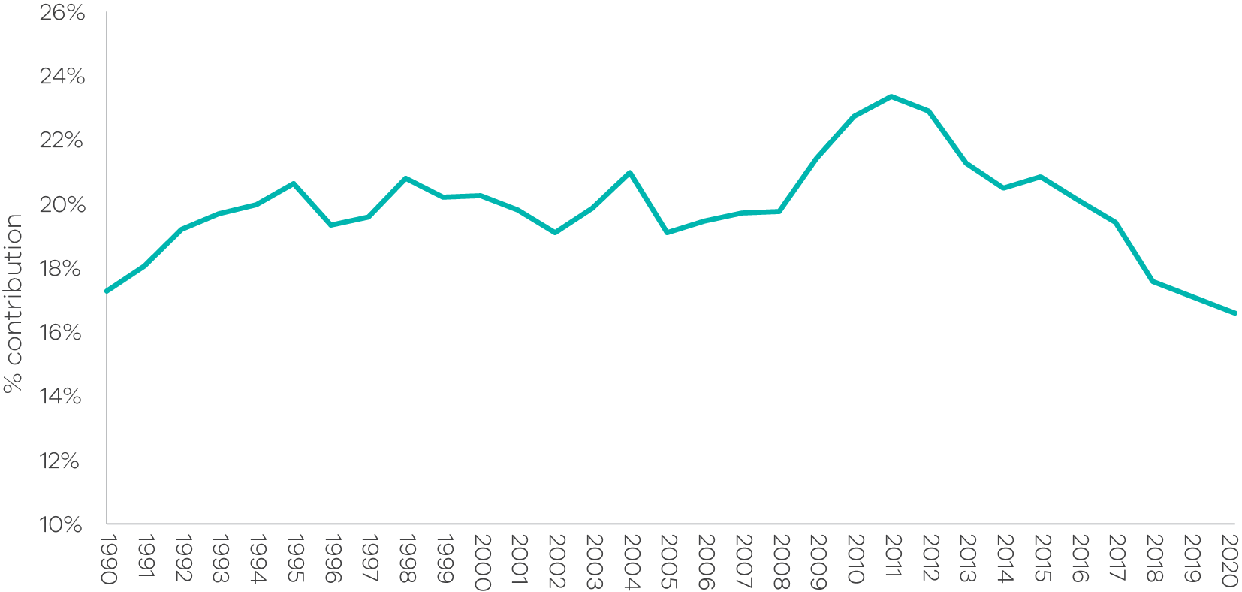
Source: State and Territory Greenhouse Gas Inventories 2020 (DCCEEW 2022d)
  - Per capita emissions
Victoria's per capita emissions – a measure of the state's total net emissions divided by its population – were 12.4 tonnes (t) CO₂-e in 2020. This was less than the national average (19.4 t CO₂-e) and lower than all States and Territories other than Tasmania and the Australian Capital Territory (ACT) (Figure 9).
Victoria’s per capita emissions have declined steadily since 2011 (Figure 10, green line), and is now less than half the level it was in 1990. Per capita emissions from household-related activities have also decreased since peaking in 1996, and by 2020 had fallen 26.3% below 1990 levels (Figure 10, yellow line).
Figure 9: Per capita emissions in Australia and by state and territory, 2020
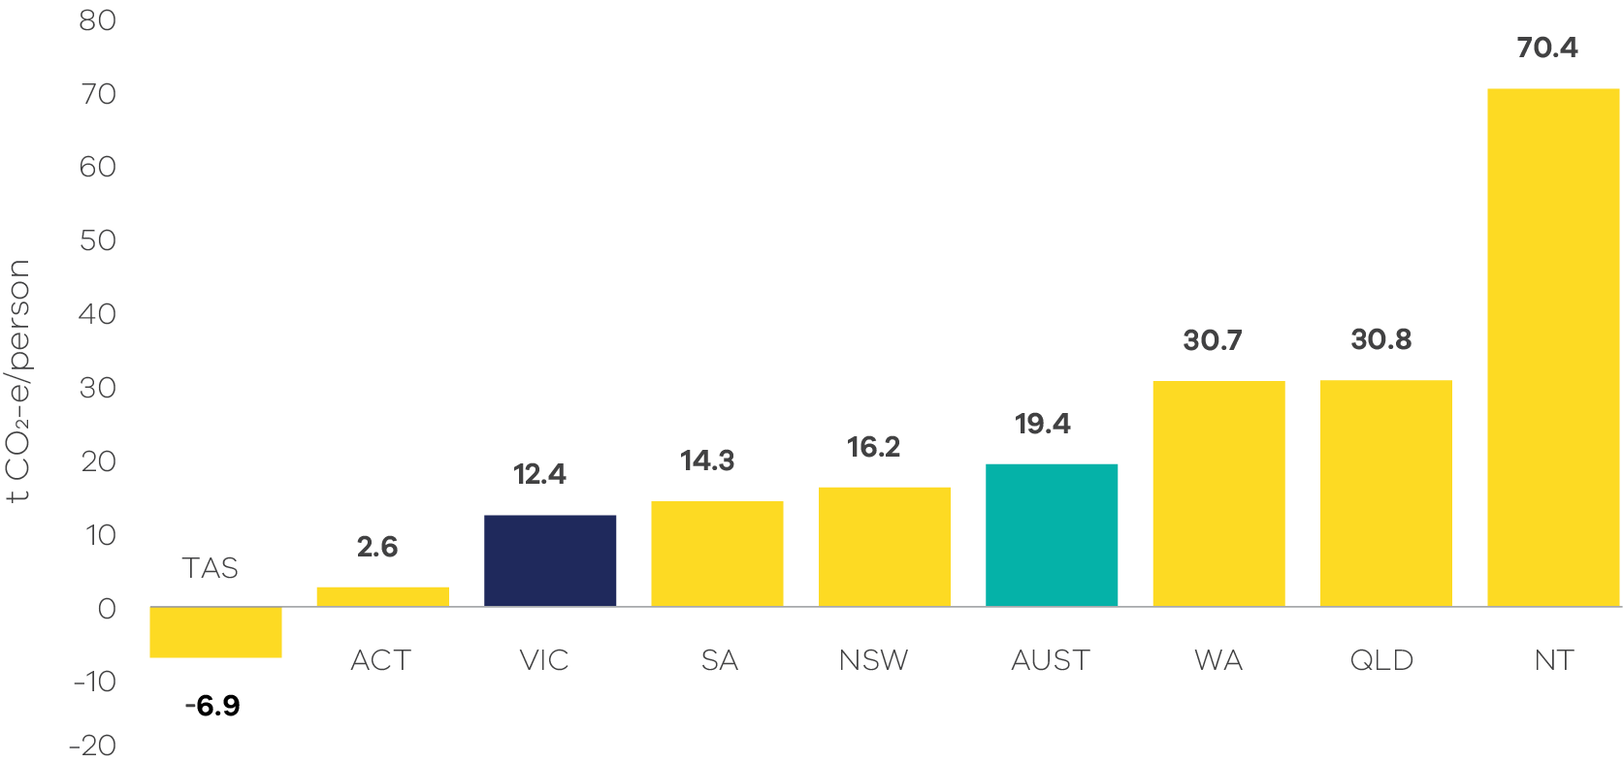
Source: Analysis based on State and Territory Greenhouse Gas Inventories 2020 (DCCEEW 2022d) and Australian Demographic Statistics 2021 (ABS 2022a).
Note: Tasmania’s figure of -6.9 t CO₂-e per capita reflects the fact that net sequestration in the LULUCF sector exceeded emissions in other sectors, resulting in Tasmania recording negative total net emissions in 2020.
Figure 10: Changes in per capita emissions, residential per capita emissions, and population growth – Victoria, 1990 to 2020
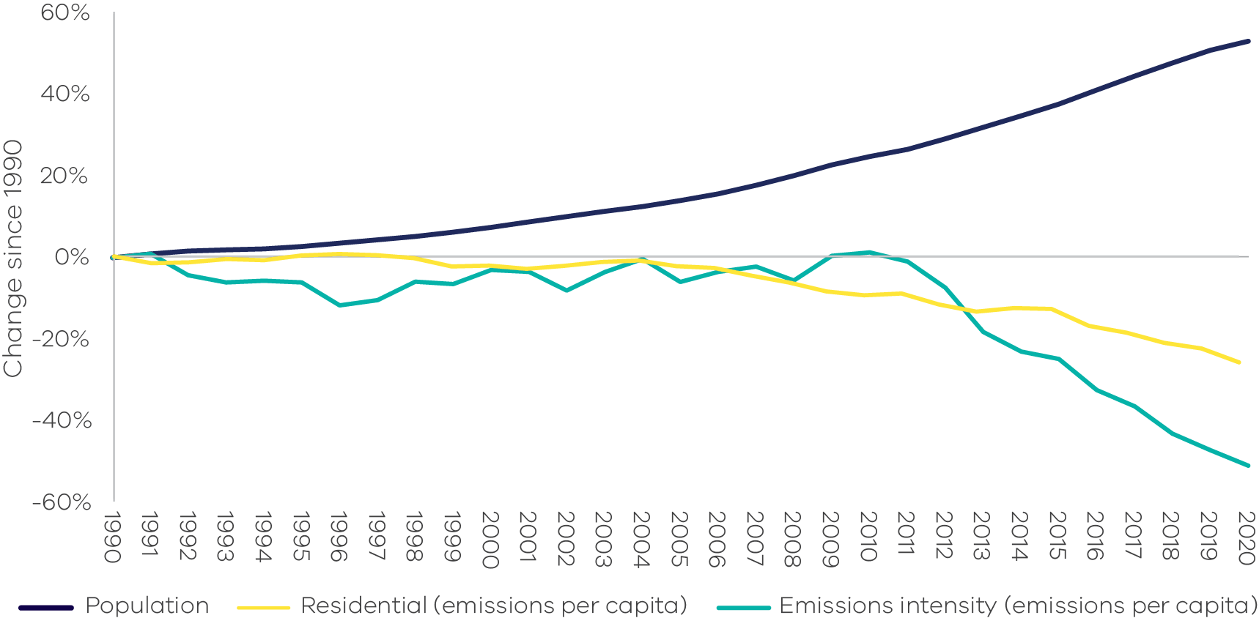
Source: Analysis based on Australian Greenhouse Emissions Information System (DCCEEW 2022a), State and Territory Greenhouse Gas Inventories 2020 (DCCEEW 2022d) and Australian Demographic Statistics 2021 (ABS 2022a)
  - Emissions and Gross State Product
Between 1990 and 2020, real Gross State Product (GSP) increased by 127% while emissions fell by 24.7% (Figure 11), resulting in the emissions intensity of the Victorian economy – measured as total net emissions divided by GSP – declining by 66.8%, from 0.53 to 0.18 kg CO₂-e per $GSP (Figure 12).
Figure 11: Greenhouse gas emissions and real GSP – Victoria, 1990 to 2020
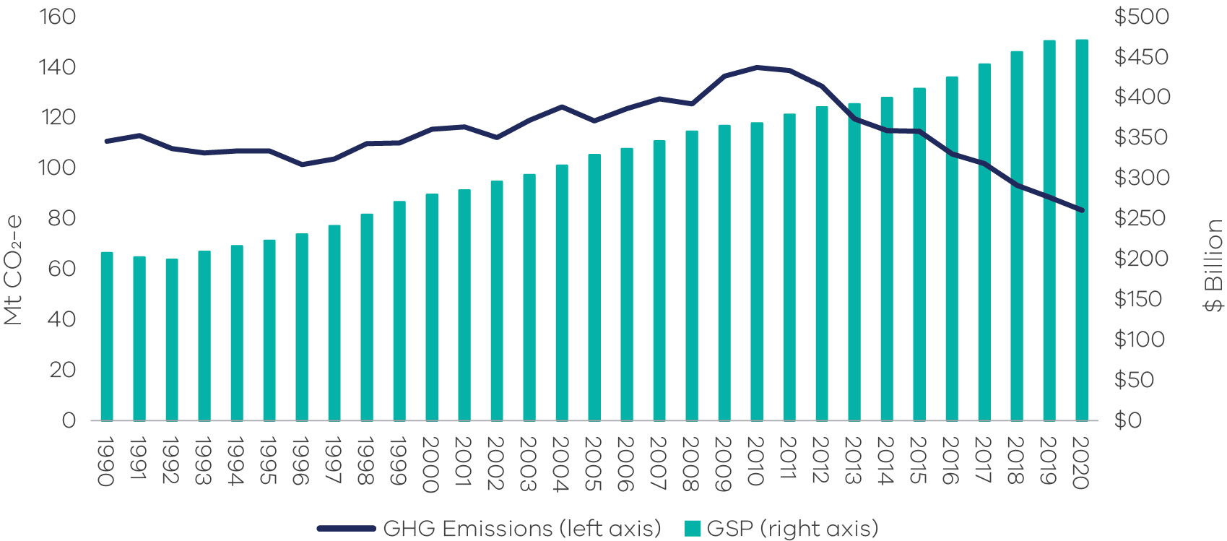
Source: Analysis based on State and Territory Greenhouse Gas Inventories 2020 (DCCEEW 2022d) and Australian National Accounts: State Accounts, 2020-21 (ABS 2021a).
Figure 12: Change in real GSP and emissions intensity (emissions per unit of GSP) – Victoria, 1990 to 2020
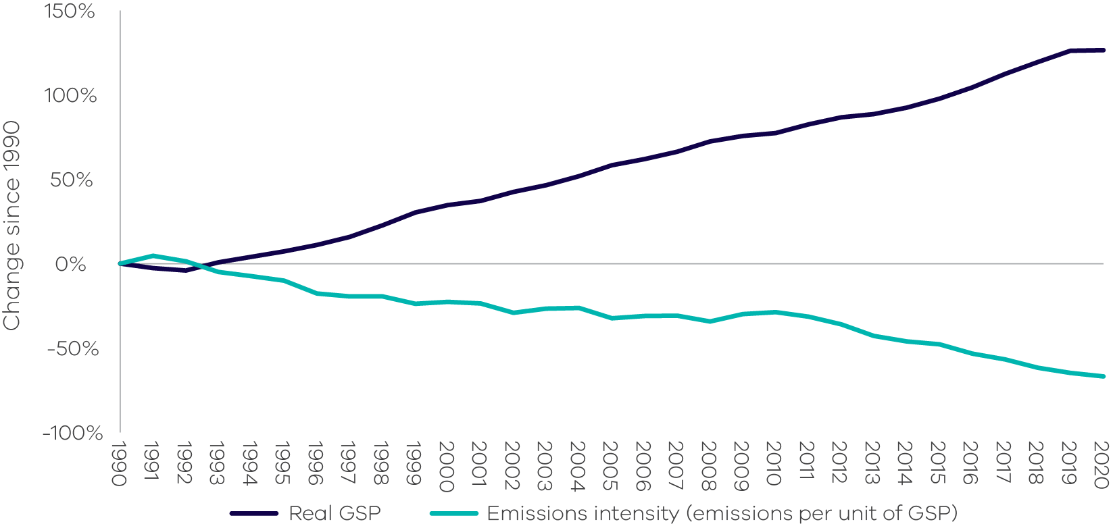
Source: Analysis based on State and Territory Greenhouse Gas Inventories 2020 (DCCEEW 2022d) and Australian National Accounts: State Accounts, 2020-21 (ABS 2021a).
  - Emissions by greenhouse gas type
Carbon dioxide (CO₂) was the largest contributor to total net emissions in 2020 at 59.5 Mt CO₂-e (71.4%), followed by methane (CH₄) at 17.1 Mt CO₂-e (20.5%), nitrous oxide (N₂O) at 3.8 Mt CO₂-e (4.6%) and hydrofluorocarbons (HFCs) at 2.8 Mt CO₂-e (3.4%). Other gases included perfluorocarbons (PFCs) at 0.04 Mt CO₂-e (0.05%) and sulphur hexafluorides (SF6) at 0.02 Mt CO₂-e (0.03%) (Figure 13).
The largest source of CO₂ emissions was combustion of fossil fuels associated with electricity generation, transport and fuel combustion sectors. The LULUCF sector continued to be a CO₂ emissions sink (due to sequestration from the sector).
The agriculture sector was the main source of CH₄ emissions, predominantly from livestock digestive processes. There were also smaller contributions of CH₄ emissions from the waste (mainly from solid waste disposal) and fugitive emissions (mainly from the distribution of natural gas) sectors.
Agriculture was also the main source of N2O emissions, which arise from agricultural soils due to microbial and chemical transformations associated with nitrogen fertiliser application.
HFCs, PFCs and SF₆ emissions arise from the industrial processes and product use (IPPU) sector, including, for example, HFC emissions from air conditioning and refrigeration units, PFC emissions from aluminium smelting and SF₆ emissions from electricity supply and distribution networks.
Figure 13: Victoria’s greenhouse gas emissions by gas type and sector, 2020
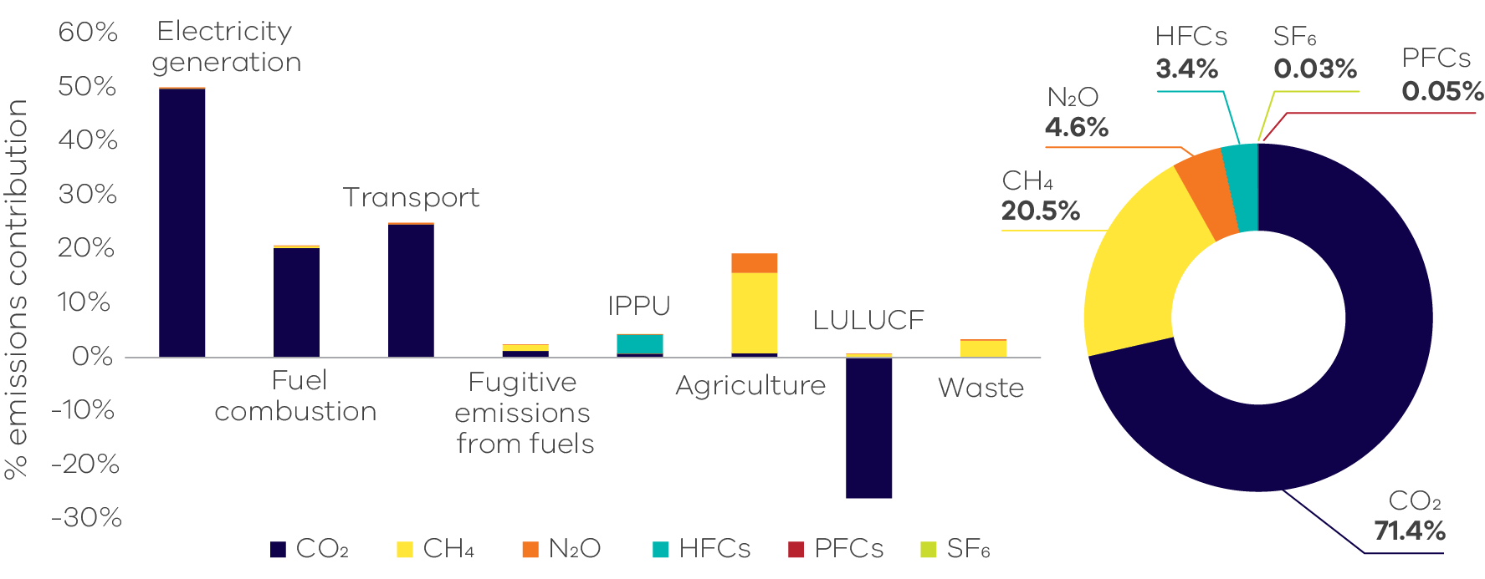
Source: Australian Greenhouse Emissions Information System (DCCEEW 2022a)
- Emissions by sector (IPCC categories)
This chapter presents information on Victoria’s greenhouse gas emissions by sector, the activities that drive these emissions and the key factors influencing emissions trends. Sectors are based on the five categories identified in the Intergovernmental Panel on Climate Change’s (IPCC) International Guidelines, namely:
- Energy
- Industrial processes and product use (IPPU)
- Agriculture
- Land use, land-use change and forestry (LULUCF)
Waste.
The energy sector is disaggregated into four sub-sectors: electricity generation, fuel combustion from stationary sources, transport and fugitive emissions from fuels.
This report relies on the National Inventory Report 2020 (DCCEEW 2022c) as its primary source of information on activities that drive sectoral emissions. It also draws on Commonwealth Government statistics for Victoria, academic and Victorian Government publications and consultation with experts to obtain additional insights into the factors that influenced sectoral emissions trends over the period 1990 to 2020.
Figure 14 presents the share of Victoria’s net emissions in 2020 by sector and energy sub-sectors. The energy sector remains the largest contributor to Victoria’s emissions, with the majority of emissions coming from the electricity subsector (41.7 Mt CO₂-e), followed by transport and fuel combustion. Beyond of the energy sector, the next highest contributor to Victorian emissions was agriculture, contributing 19.3% of net emissions (16.1 Mt CO₂-e) in 2020.
Figure 14: Victorian emissions by sector and energy sub-sectors, 2020
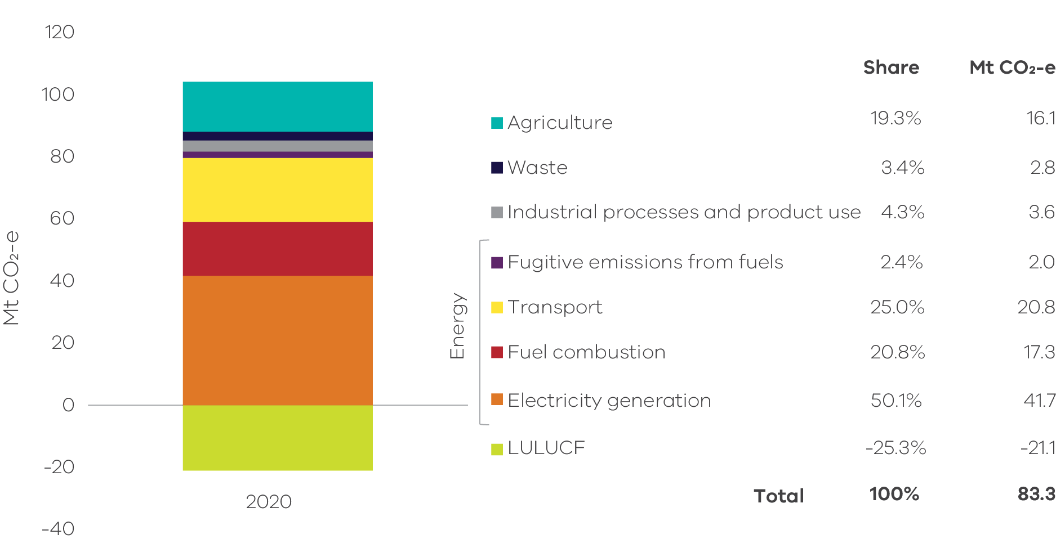
Source: Australian Greenhouse Emissions Information System (DCCEEW 2022a).
Note: numbers may not sum due to rounding.
Figure 15: Emissions by sector and energy sub-sectors – 1990, 2005 and 2020
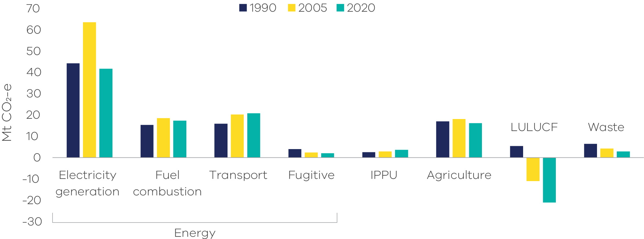
Source: Australian Greenhouse Emissions Information System (DCCEEW 2022a)
Figure 15 presents emissions by sector in 1990, 2005 and 2020. Key points to note include:
- emissions from electricity generation, fuel combustion and agriculture increased between 1990 and 2005, but declined between 2005 and 2020;
- emissions from transport and IPPU increased between 1990 and 2005, and continued to increase to 2020 despite the impact of the pandemic in the first half of 2020 in the case of transport;
- LULUCF was a net source of emissions in 1990 but sequestered more emissions than it generated in both 2005 and 2020 (i.e. the sector provided net sequestration in both years); and
emissions from waste and fugitive emissions from fuels declined between 1990 and 2005 and continued to do so to 2020.
Table 1 and Figure 16 provide further details on the scale of changes in sectoral emissions between 2005 and 2020. The electricity generation sub-sector experienced the largest reduction in net emissions, followed by LULUCF, agriculture, waste and fuel combustion.
Table 1: Change in emissions by sector and energy sub-sector between 2005 and 2020, Victoria
Source: Australian Greenhouse Emissions Information System (DCCEEW 2022a). Note: Numbers may not sum due to rounding
Sector | 2005  Mt CO₂-e | 2020  Mt CO₂-e | Change 2005 to 2020 Mt CO₂-e
Electricity generation | 63.5 | 41.7 | -21.8 ↓
Fuel combustion | 18.5 | 17.3 | -1.1 ↓
Transport | 20.2 | 20.8 | 0.6 ↑
Fugitive emissions | 2.4 | 2.0 | -0.3 ↓
IPPU | 2.8 | 3.6 | 0.8 ↑
Agriculture | 18.1 | 16.1 | -2.0 ↓
LULUCF | -11.0 | -21.0 | -10.0 ↓
Waste | 4.2 | 2.8 | -1.4 ↓
Total (net emissions) | 118.6 | 83.3 | -35.3 ↓

Figure 16: Change in emissions between 2005 and 2020 by sector and energy sub-sector, Victoria
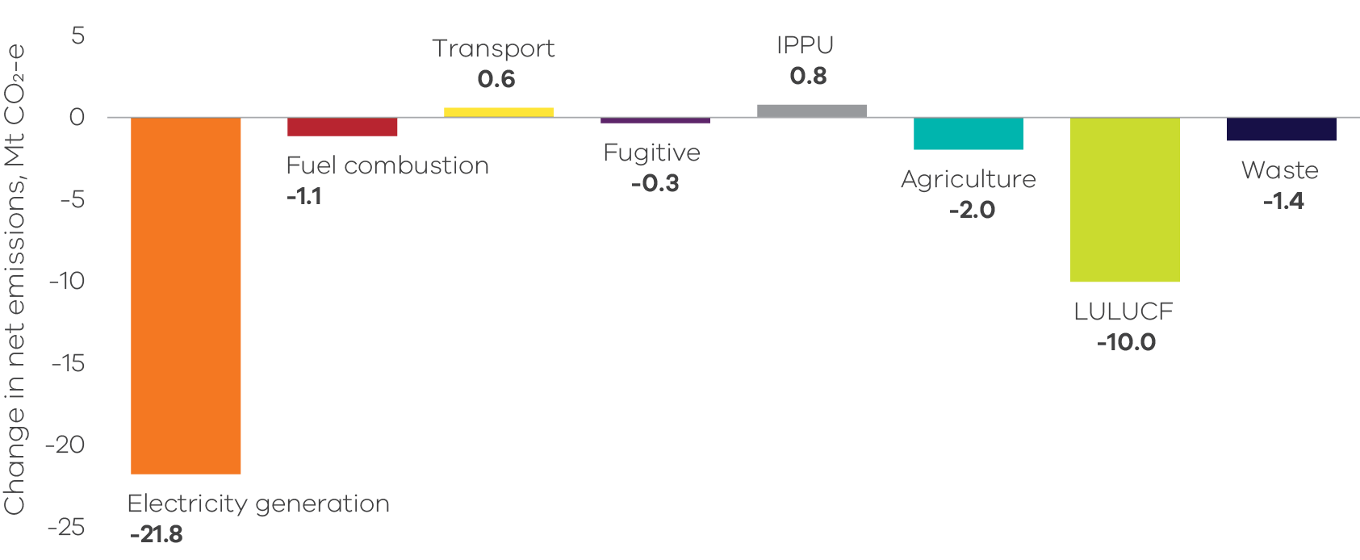
Source: Australian Greenhouse Emissions Information System (DCCEEW 2022a)
  - Energy
The energy sector is comprised of the following sub-sectors – electricity generation, fuel combustion, transport and fugitive emissions from fuels. Figure 17 shows the contribution of each sub-sector to Victoria’s total net emissions in 2020 – collectively, the energy sector was responsible for 98.3% of Victoria’s total net emissions in that year.
Figure 17: Energy sub-sectors and their contributions to total net emissions in Victoria, 2020
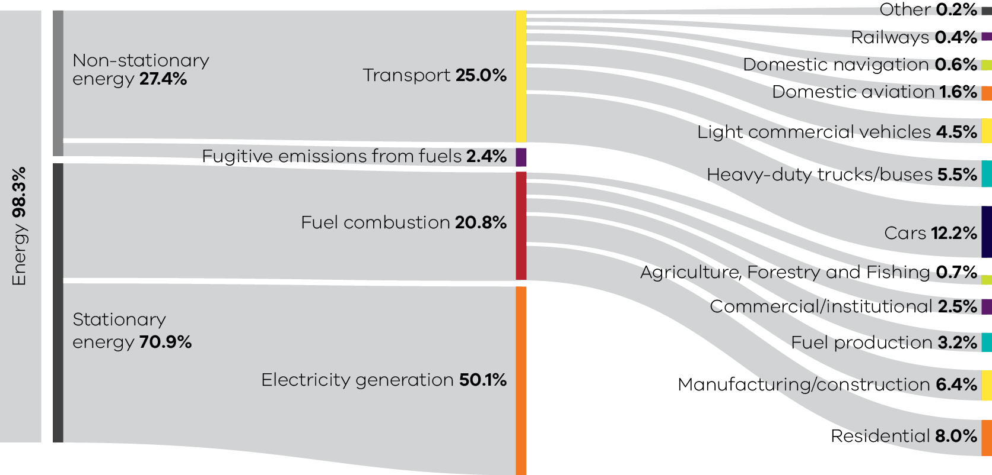
Source: Australian Greenhouse Emissions Information System (DCCEEW 2022a).
Note: numbers may not sum due to rounding.
    - Electricity generation
Sources of emissions
Emissions from electricity generation arise from the combustion of fuels to generate power supplied to the electricity grid.
International emissions accounting requires that emissions data are recorded for production rather than consumption. Therefore, in accordance with these accounting requirements, this sub-sector includes all emissions released from electricity generated in Victoria (some of which is exported for consumption in other states). Emissions associated with electricity imported by Victoria from other states are not included as part of Victoria’s net emissions but instead are included in the emissions inventories of those states where the electricity is generated.
Electricity generation in Victoria
In 2020, emissions from fossil fuel fired-electricity generation accounted for approximately half (50.1%) of Victoria’s total net emissions. Most electricity emissions were from Victoria’s brown coal-fired power stations, with the remaining emissions largely from gas-powered generation and a small amount from other fossil fuels.
Three brown coal-fired power stations were operating in 2020, all located in the Latrobe Valley: Yallourn, Loy Yang A and Loy Yang B. Approximately 69% of the state’s electricity was generated by these power stations, slightly down from around 71% in 2019. The reduction was due to unplanned generator outages caused by ageing infrastructure (in particular Loy Yang A’s outage that lasted from May to December 2019) (DCCEEW 2022b, CER 2021, Macdonald-Smith 2019, AER 2020, AER 2021). These power stations generated 33,704 GWh of electricity and emitted 39.5 Mt CO₂-e or 47.4% of Victoria’s total net emissions in 2020 (CER 2021).
Large and medium gas-fired power stations were responsible for emitting 1.4 Mt CO₂-e or 1.7% of Victoria’s total net emissions in 2020 (CER 2021). There was a slight decrease of their share of electricity emissions: from 6.8% in 2019 to 6.4% in 2020 (DCCEEW 2022b).
Renewable electricity, which made up 24.3% of Victoria’s electricity generation in 2020 (DELWP 2021), produces no emissions.
Emissions trends and drivers
Figure 18 shows the trend in emissions from electricity generation since 1990.
Emissions from electricity generation increased from 1990 to a peak in 2012. Emissions then fell to 2014 and rose again in 2015, before declining significantly through to 2020. This decline was associated with the reduction of coal-fired electricity generation (mostly contributed by the closure of Hazelwood Power Station in March 2017), the significant increase of renewable electricity generation (AER 2020 and CER 2018) and continued improvements in energy efficiency, through programs such as Victorian Energy Upgrades (VEU) Program.
Figure 18: Emissions from electricity generation – Victoria, 1990 to 2020 (left) and share of 2020 net emissions (right)
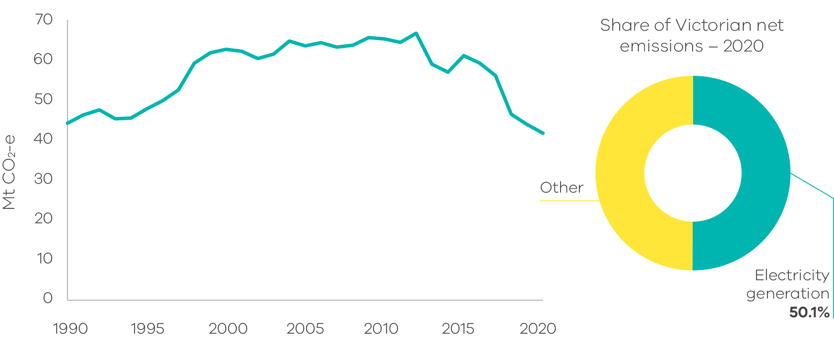
Source: Australian Greenhouse Emissions Information System (DCCEEW 2022a)
Box 1: Victoria’s changing electricity system
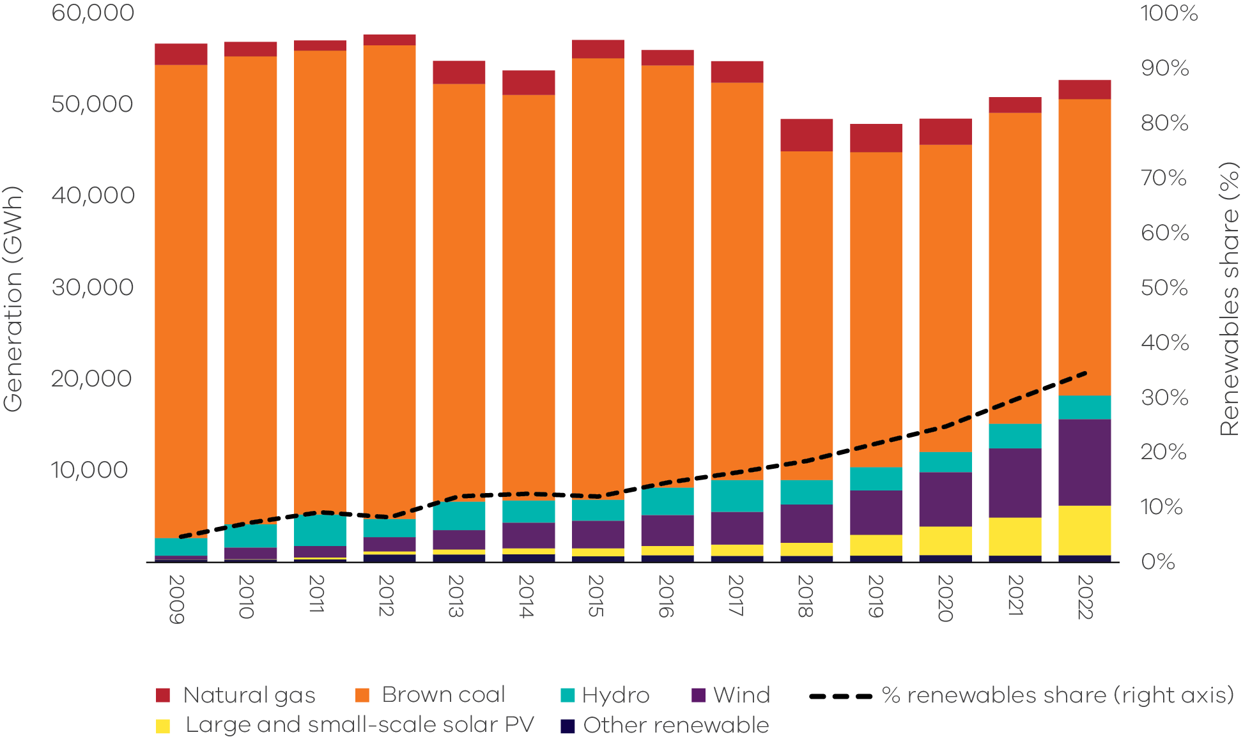
Source: NEM Review, Metered generation (as generated); Australian Government Department of Climate Change, Energy, the Environment and Water, Australian Energy Statistics; and Departmental estimates.
The transition from coal to renewables
Underlying the decline in emissions from electricity generation in Victoria is a transformation of the state’s electricity system. Victoria’s brown coal-powered electricity generators are reaching the end of their economic lives and are gradually being decommissioned. Over the last decade, Morwell (2014), Anglesea (2015) and Hazelwood (2017) power stations have closed, with Yallourn scheduled for closure in 2028. Simultaneously, the pace of renewable energy installation and use is accelerating, with renewables’ contribution to electricity generation increasing by 5 percentage points from 24.3% in financial year 2020 to 29.3% in financial year 2021 (DELWP 2021). This growth is underpinned by Victoria’s Renewable Energy Targets of 25% by 2020, 40% by 2025 and 50% by 2030. Over the calendar year to December 2020, renewable energy sources generated more than 26% of Victoria’s electricity, meeting the first Victorian Renewable Energy Target (DELWP 2021).
As of June 2022, there was a total of 9,624 MW of renewable capacity operating in Victoria made up of 2,479 MW of wind, 1,243 MW of large and commercial-scale solar, 3,446 MW rooftop solar PV, 2,306 MW of hydroelectricity and 150 MW of biomass. A further 1,998 MW of wind and solar is under construction or being commissioned. In addition, renewable energy projects totalling 26,094 MW have been announced or are in early stages of development, which is more than five times the combined capacity of Victoria’s three brown coal-fired power stations. (AEMO 2022a)
Households are playing a key part in the renewable energy transition by installing hundreds of thousands of small-scale rooftop solar systems and contributing the third largest share of generation behind coal and wind in 2021-22. From 2001 to 2018, around 384,000 systems with a combined capacity of 1,564 MW were installed in Victoria. From January 2019 to May 2022 there was a dramatic increase in the installation of small-scale systems with 236,000 systems installed with a combined capacity of 1,845 MW – more than doubling the installed capacity of rooftop solar systems in Victoria (CER 2022). This increase was the result of the falling cost of solar systems and the Victorian Government’s Solar Homes program, introduced in August 2018.
A complex transformation
The transformation of our electricity system is not without its challenges. Maximising the use of wind and solar resources when they are abundant, while maintaining the stability of the electricity grid is a complicated task for electricity network operators. By 2025, there is expected to be enough renewable generation in the grid to meet 100% of demand at times on mild, sunny and windy days from renewables alone. However, transporting those electrons to where and when they are needed is complex as the system was not originally designed to operate with varied and distributed energy sources. New integrated approaches are needed to generation and transmission, including the role of energy storage and demand response. The Victorian Government is working closely with generators, transmission and distribution companies and the Australian Energy Market Operator to prepare for a world in which renewables produce the vast majority of electricity, including by investing in new transmission infrastructure.
The increase in distributed renewables such as rooftop solar is also changing the shape of electricity demand over the course of the day, introducing a source of volatility for the system operator to manage. Today, electricity demand tends to spike in the mornings as people get ready for work, then plunge in the middle of the day as houses and businesses that have installed rooftop solar generate and consume their own electricity. As the sun sets, and solar generation falls, demand for electricity reaches its peak as people return home to prepare meals and heat or cool their homes.
Smoothing out these peaks and troughs requires flexible sources of capacity to ramp up or down as needed, a service which the current fleet of brown coal-fired power stations is unable to provide. These coal-fired power plants are also ageing and regularly face outages, sometimes for planned maintenance, but other times due to unexpected failures. Outages at coal-fired power plants were a key factor in the high prices and volatility seen in the electricity market in 2022.
New technologies to help smooth the transition
New technologies will help meet the challenges associated with integrating more renewables as Victoria shifts to a net zero emissions electricity system.
Energy storage technologies, that can rapidly release electricity into the grid when needed, will be a key part of the solution and Victoria is pioneering their use. For example, the 300 MW Victorian Big Battery — the largest of its kind in Australia – helps Victoria use more wind and solar by storing energy when these power sources are abundant, increases grid reliability, and enables more energy to flow into Victoria from interstate. Households and neighbourhoods are also installing batteries – accelerated by the Solar Homes solar battery rebate which has assisted more than 8,600 households to install a battery to store their excess solar energy by July 2022 (SV 2022) and the Neighbourhood Battery Initiative.
Operating together, rooftop solar and batteries across hundreds of homes can be formed into a Virtual Power Plant, which enables people to share electricity and take the stress off the power grid during peak demand times and improve grid reliability. Solar Victoria’s Virtual Power Plant pilot program is making it easier for Victorians to join a Virtual Power Plant and reduce their energy costs by making the most of renewable energy from solar panels and batteries.
Technologies that help Victorians use energy smarter and more efficiently, to smooth out peaks and troughs in demand throughout the day, are another crucial part of the transition. The Victorian Energy Upgrades Program provides discounts for a range of energy saving activities including for in-home displays that help Victorians monitor their electricity usage in real time. The program has helped 169,000 households to install one of these displays in 2021 alone (ESC 2022), so that they can now understand and manage their energy use to reduce energy costs and emissions.
New, complementary sources of generation will both accelerate the transition to zero emissions and enhance the resilience of the Victorian electricity grid. Offshore wind farms produce electricity more consistently than onshore and have a different generation profile which will complement onshore wind and solar. The Victorian Government is developing an Offshore Wind Strategy to meet its targets of 2,000 MW of offshore wind by 2032, 4,000 MW by 2035 and 9,000 MW by 2040.
These technologies will ensure that the electricity grid in Victoria remains reliable, secure and delivers lower power prices for Victorians as it transitions to a high renewables, net zero emissions grid.
    - Fuel combustion
Sources of emissions
Fuel combustion emissions arise from burning fuels for activities such as the production of fuels (for example oil and fossil gas extraction, oil refining and coal mining); generating heat, steam or pressure for manufacturing operations; and burning fossil gas for heating, hot water and cooking in households and businesses.
Fuel combustion does not include emissions from fuel combustion for electricity generation or transport – emissions from these activities are accounted for in the electricity generation and transport sub-sectors respectively.
Fuel combustion in Victoria
Residential activities are the largest source of emissions from fuel combustion in Victoria, followed by manufacturing industries and construction and fuel production (Figure 19).
Fossil gas is the major fuel used for fuel combustion in Victoria, representing 61% of the total fuels used in 2020. In that year, Victoria consumed a total of 239 petajoules (PJ) of fossil gas in fuel combustion activities, with the highest consumption in the residential (49%), manufacturing (25%) and commercial (15%) activity sub-categories (DCCEEW 2021a).
Other fuels contributing to fuel combustion include on-site use of diesel, liquified petroleum gas (LPG) and various petroleum-based oils.
Victoria’s Gas Substitution Roadmap
Reducing emissions associated with fuel combustion (and fugitive emissions) within Victoria’s fossil gas sector is the focus of Victoria’s recently released Gas Substitution Roadmap. The Roadmap summarises how the State will use energy efficiency, electrification, hydrogen and biogas to drive down emissions from fossil gas over time.
Over 2 million Victorians use fossil gas in their homes and businesses – more than any other state or territory. With fossil gas prices rising steadily, and international events causing uncertainty in fossil gas supply and price around the world, the Roadmap outlines how Victorians will be assisted to switch to efficient electric appliances and save on their energy bills – whilst freeing up a diminishing gas resource for industries and processes that rely on fossil gas.
For more information, please visit Victoria’s Gas Substitution Roadmap.
Figure 19: Fuel combustion emissions by activity sub-categories – Victoria, 2020
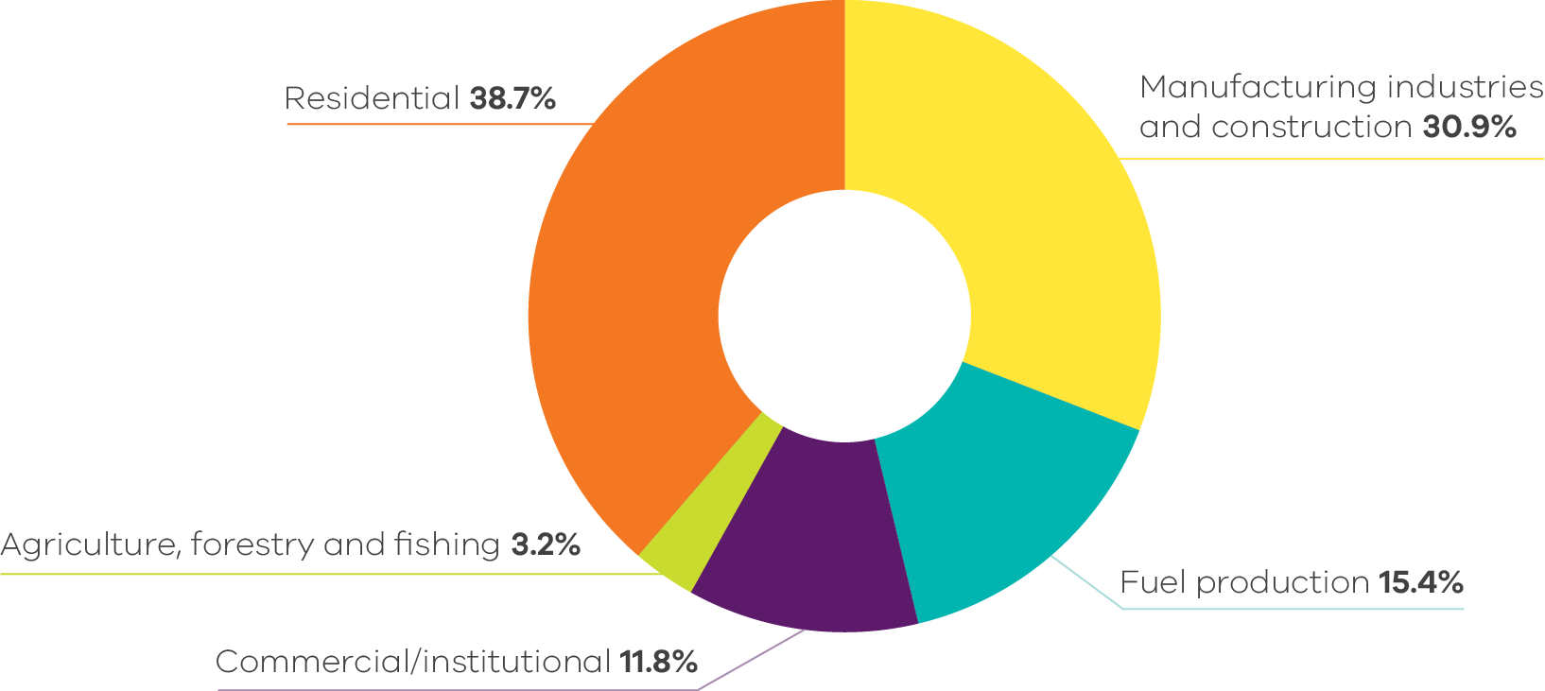
Source: Australian Greenhouse Emissions Information System (DCCEEW 2022a)
Emissions trends and drivers
Fuel combustion accounted for 20.8% of Victoria’s total net emissions in 2020 – the third largest share of total net emissions behind electricity generation and transport.
Fuel combustion emissions were 15.3 Mt CO₂-e in 1990 – reaching their peak at 18.8 Mt CO₂-e in 2012 – before declining slightly to 17.3 Mt CO₂-e in 2020 (Figure 20). Population growth and increased economic activity in Victoria contributed to higher fuel combustion emissions in 2020 than 1990 (with emissions predominately from the residential and commercial sectors). However, in the last decade, emissions growth flattened, most likely caused by a reduction in industrial fossil gas use, as well as ongoing improvements in appliance efficiency and building performance.
Interannual variability in emissions over the 30-year period is associated with differences in the rate of economic growth and seasonal variations driving residential heating demand (i.e. colder versus milder winters).
Figure 20: Emissions from fuel combustion – Victoria, 1990 to 2020 (left) and share of 2020 net emissions (right)
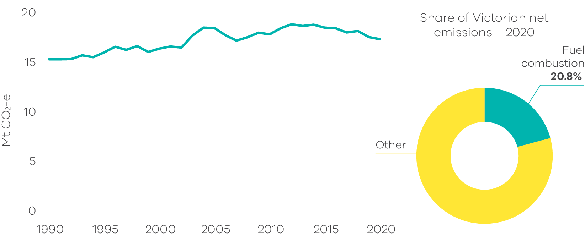
Source: Australian Greenhouse Emissions Information System (DCCEEW 2022a)
Figure 21: Emissions by fuel combustion sub-categories – Victoria, 1990 to 2020
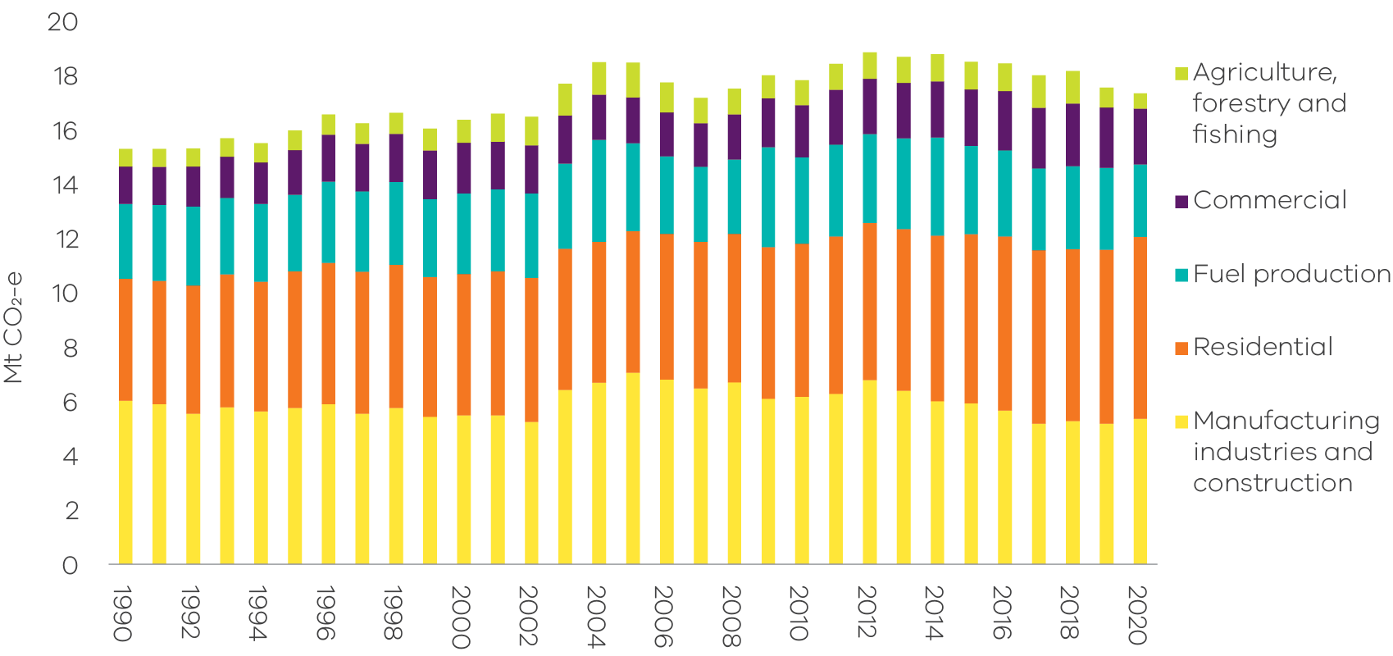
Source: Australian Greenhouse Emissions Information System (DCCEEW 2022a)
The residential sector was the largest contributor to fuel combustion emissions in 2020 at nearly 39% – up from 30% in 1990 (Figure 21).
In 1990 manufacturing and construction contributed the largest share of fuel combustion emissions at 39.4% (6 Mt CO₂-e). The manufacturing and construction sector’s share has been gradually declining and was overtaken by the residential sector as the largest source of fuel combustion emissions in 2014 (Figure 21).
Fuel combustion emissions from manufacturing and construction generally declined between 1990 and 2002, with a sharp increase in 2003 due to growth in the output of metal and mineral production and food processing. Following a peak in 2005, and a temporary spike in 2012, emissions from this sub-category reduced in line with the overall decline in heavy manufacturing activity in the state (Figure 22).
Figure 22: Trends in emissions in the four major fuel combustion sub-categories – Victoria, 1990 to 2020
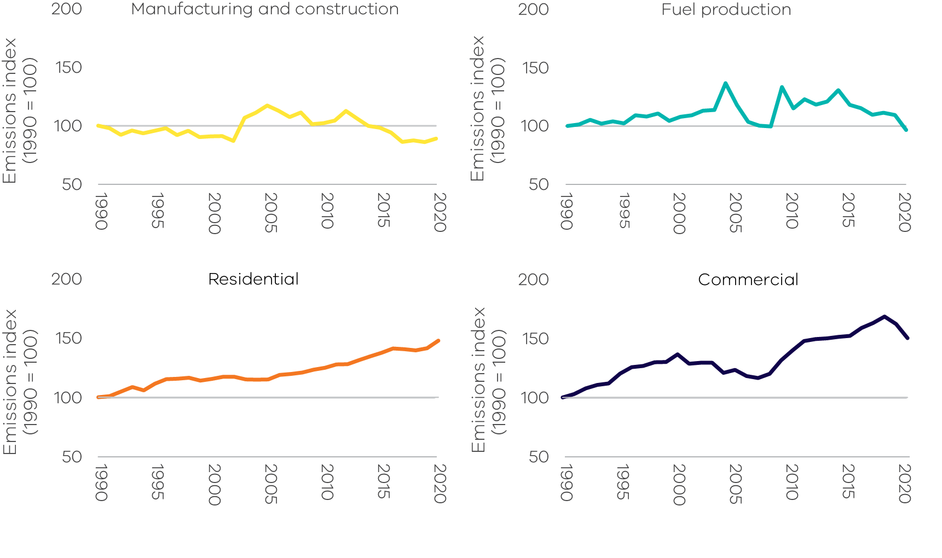
Source: Australian Greenhouse Emissions Information System (DCCEEW 2022a)
Fuel combustion emissions from fuel production were at similar levels in 1990 (2.8 Mt CO₂-e) and 2020 (2.7 Mt CO₂-e) with variation in between, including a peak of 3.8 Mt CO₂-e in 2004 (Figure 22). Between 2019 and 2020, emissions decreased by 11.7% (0.35 Mt CO₂-e) as transport fuel demand declined following pandemic-related reductions in transport activity.
A shift towards a services-based economy has increased commercial sector fuel combustion emissions, particularly over the decade to 2020 while residential sector emissions have grown steadily since 1990 (Figure 22). Residential sector fuel combustion emissions have grown in line with population and the associated fossil gas demand for water and space heating (Figure 23). The residential sub-category surpassed manufacturing as the major user of fossil gas in Victoria in 2006 (DCCEEW 2021a).
Figure 23: Trends in residential fossil gas consumption and population – Victoria, 1990 to 2020
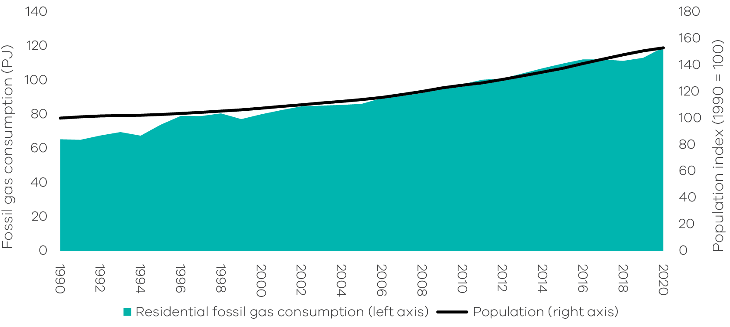
Source: Australian Energy Statistics, Table F (DCCEEW 2021a) and Australian Demographic Statistics (ABS 2022a)
    - Transport
Sources of emissions
Emissions from transport arise from the combustion of fuels such as petrol, diesel and LPG in passenger and commercial motor vehicles, railways, domestic aviation and navigation (i.e. shipping).
Emissions from electricity used to power public transport (i.e. metropolitan trains and trams) and to drive electric vehicles are not included as they are accounted for in electricity generation.
Transport in Victoria
In 2020, road transportation was responsible for the vast majority (89.5%) of emissions from the transport sector, with the major contributors being cars (48.7%), heavy-duty trucks and buses (21.9%) and light commercial vehicles (18%) (Figure 24).
Passenger transport activity has tended to increase steadily with population growth over time but in 2020, passenger transport activity (passenger kilometres travelled) decreased for the first time since 1990, due to pandemic-related reductions in vehicle use (DCCEEW 2021a).
Figure 24: Transport emissions by sub-categories – Victoria, 2020
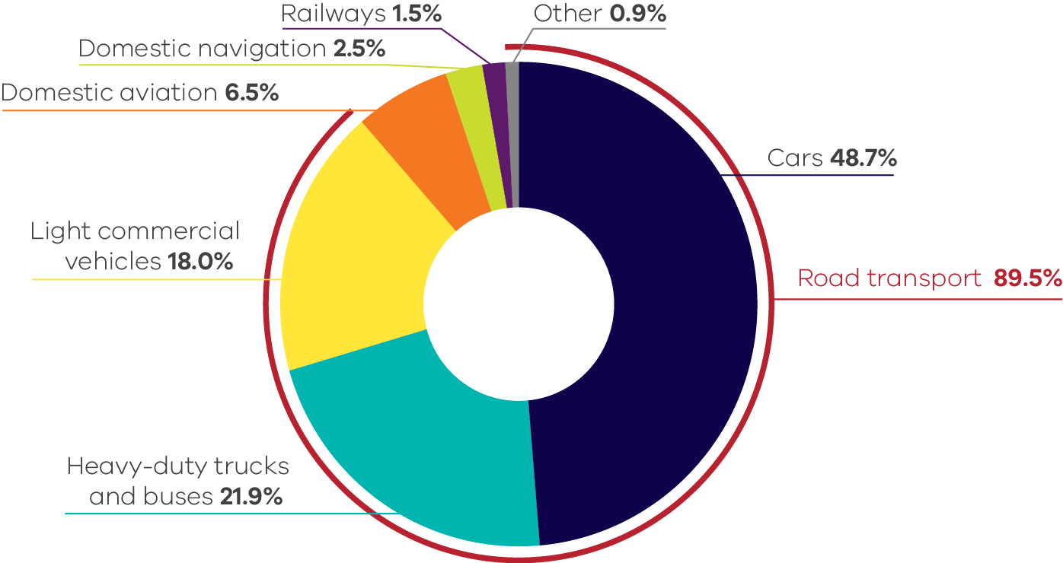
Source: Australian Greenhouse Emissions Information System (DCCEEW 2022a)
Despite an increase in public transport use (heavy rail, light rail and buses) since 1990, cars have remained the dominant mode of transport in Melbourne (Figure 25).
The transport sector consumed 294 petajoules (PJ) of energy in 2020, with the main fuels being diesel (47%), petrol (45%), LPG (3%) and domestic aviation fuel (2%) (DCCEEW 2021a).
In 2020 diesel overtook petrol as the top transport fuel being consumed for the first time since 1990 (DCCEEW 2021a), due to the afore-mentioned reductions in passenger transport activity. Travel restrictions reduced passenger vehicle use, resulting in a noticeable dip in petrol sales, while freight activity levels and truck movements were much less affected, reflected in diesel sales remaining relatively unaffected over the period (DCCEEW 2021d and DCCEEW 2020a).
Figure 25: Total passenger kilometres travelled – Melbourne, 1990 to 2020
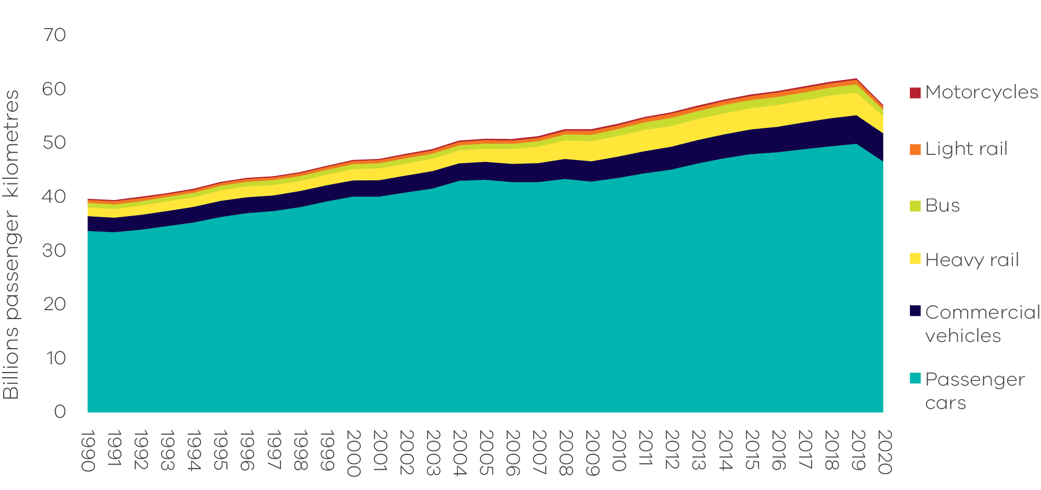
Source: Australian Infrastructure Statistics (BITRE 2021a)
Emissions trends and drivers
Transport emissions grew by 4.9 Mt CO₂-e (30.7%) between 1990 and 2020 – with most growth occurring in the period between 1990 and 2005 at 4.3 Mt CO₂-e compared to growth in 2005 to 2020 of 0.6 Mt CO₂-e. The combined growth from 1990 to 2020 represented the largest growth in absolute emissions from any sector/sub-sector over the period (Figure 26). Transport contributed 25% of Victoria’s net emissions in 2020 – the second largest share behind electricity generation. Transport emissions growth trends to 2020 have been influenced by the COVID-19 pandemic in 2020 (see Box 2: COVID-19 impacts on transport emissions) with emissions increases over 1990-2020 and 2005-2020 would likely have been greater in the absence of the impacts of the pandemic on transport demand.
Figure 26: Emissions from transport – Victoria, 1990 to 2020 (left) and share of 2020 net emissions (right)
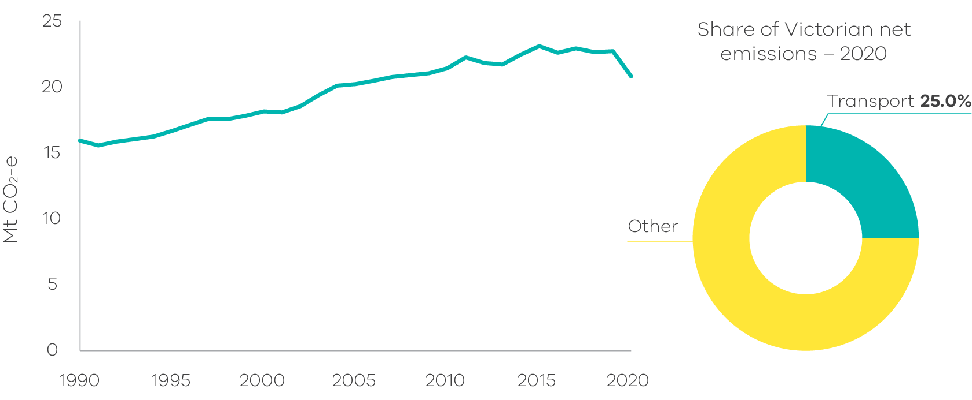
Source: Australian Greenhouse Emissions Information System (DCCEEW 2022a)
While cars have remained the largest source of transport emissions over the thirty years to 2020, their share has decreased from 60.8% to 48.7% over this period, with emissions growing by only 0.5 Mt CO₂-e (4.7%) (Figure 27), slower than both population (52.9%) and economic growth (127%).
Figure 27: Emissions by transport sub-categories – Victoria, 1990 to 2020
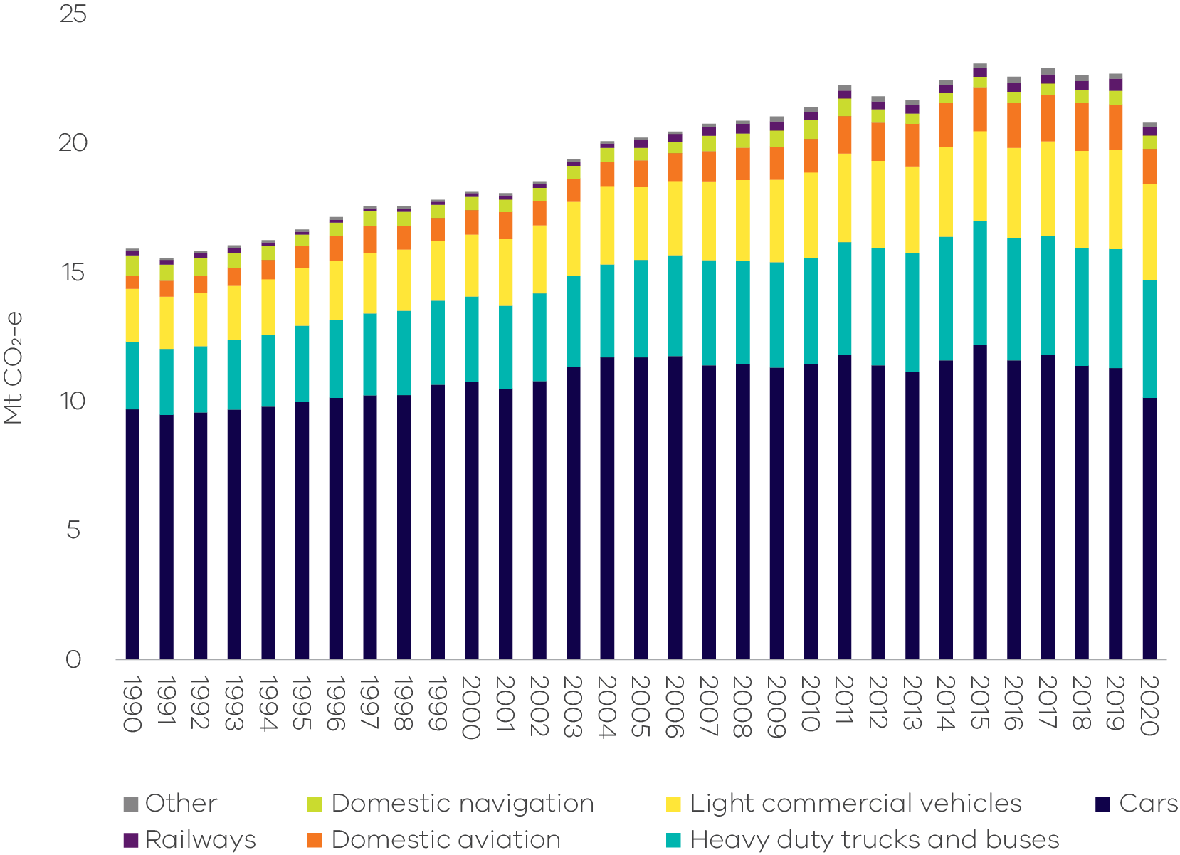
Source: Australian Greenhouse Emissions Information System (DCCEEW 2022a)
The slower growth of emissions from cars since 2005 despite population and economic growth (Figure 28 and Figure 29) is likely due to improvements in vehicle emissions intensity as sales of new vehicles shifted to more efficient models. In 2002, the National Transport Commission (NTC) estimated the average emissions intensity of new passenger and light commercial vehicles sold in Australia to be 252.4 g CO₂ per km (NTC 2021). In 2020, the Federal Chamber of Automotive Industries (FCAI) reported the average intensity to be 150 g CO₂ per km (NTC 2021). Despite this improvement, the emissions intensity of new vehicles in Australia is still significantly higher than leading nations.
Figure 28: Trends in passenger motor vehicle emissions and population – Victoria, 1990 to 2020
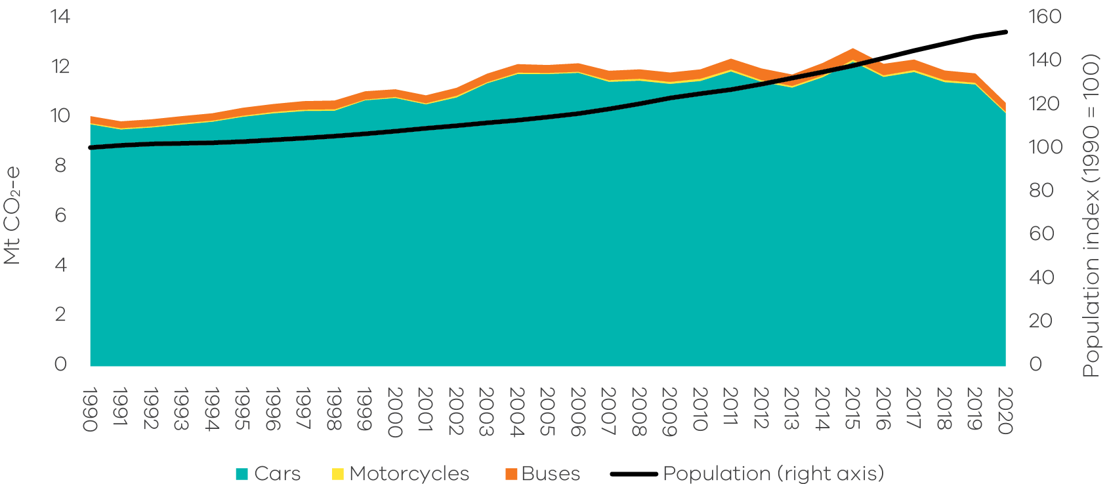
Source: Analysis based on Australian Greenhouse Emissions Information System (DCCEEW 2022a) and Australian Bureau of Statistics (ABS 2022a)
Improvements in passenger vehicle emissions were partially offset by increasing consumer preferences for larger vehicles, particularly sports utility vehicles (SUVs) (BITRE 2021b and NTC 2021) and light commercial vehicles, the latter of which experienced 82.1% growth in emissions since 1990 (Figure 29).
Transport emissions growth over the last five years would have been higher were it not for the relatively lower greenhouse gas emissions of diesel compared with petrol-powered vehicles. From 2016 to 2020, the number of diesel vehicles increased by 38% while the number of petrol vehicles grew by only 5% (ABS 2021c). The increase in diesel vehicles was associated with both the growth in freight transport (Figure 29) and a shift in consumer preferences toward diesel passenger cars and light commercial vehicles.
In freight transport, there is some evidence of a decoupling of economic growth and emissions since 2014 (Figure 30). However, it is too early to tell if this trend will continue, particularly with recent rapid growth of light commercial vehicle sales, spurred by federal government incentives.
The domestic aviation emissions sub-sector experienced the fastest growth of all transport sub-sectors between 1990 and 2020, with emissions increasing by around 171% (Figure 29). This reflects growth in business- and tourism-related air travel since 1990. In 2020, although the number of domestic passengers at Melbourne Airport fell by 26.7% from 2019, the 18.9 million passengers recorded still represented a large increase on the 4.8 million recorded in 1990 (BITRE 2022).
Figure 29: Trends in emissions from the four major transport sub-categories – Victoria, 1990 to 2020
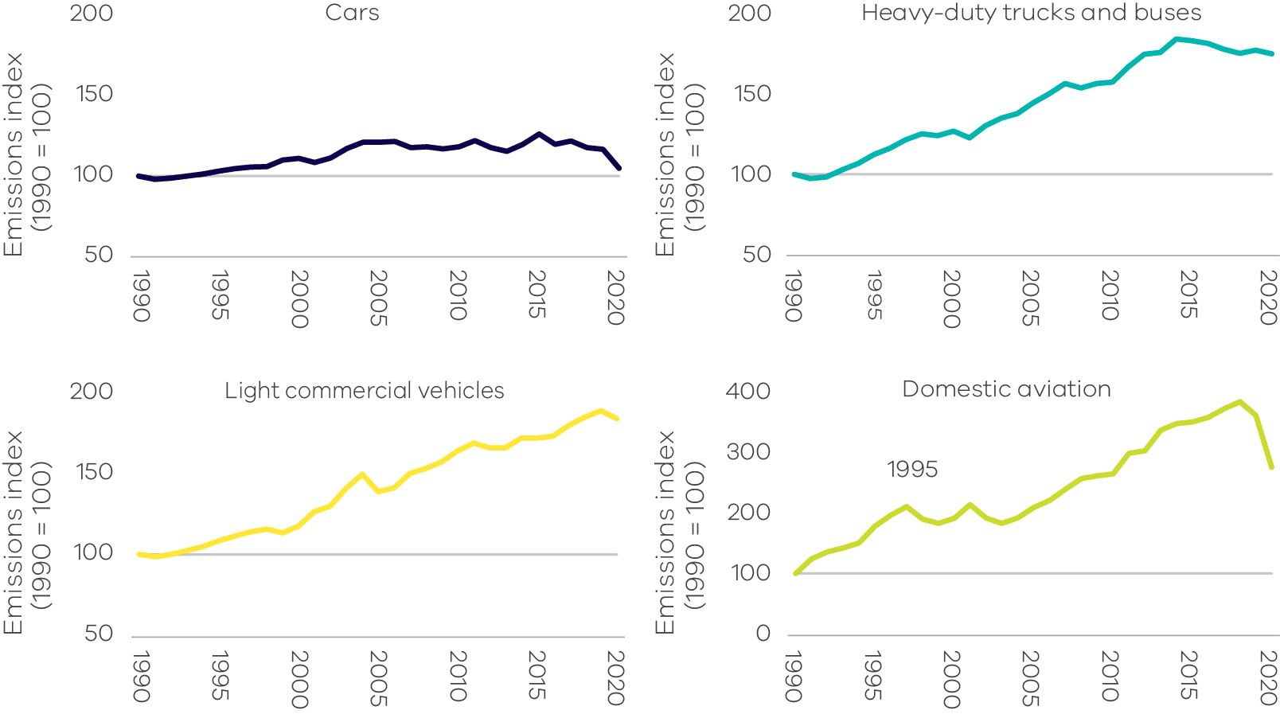
Source: Australian Greenhouse Emissions Information System (DCCEEW 2022a)
Figure 30: Trends in freight vehicle emissions and GSP – Victoria, 1990 to 2020
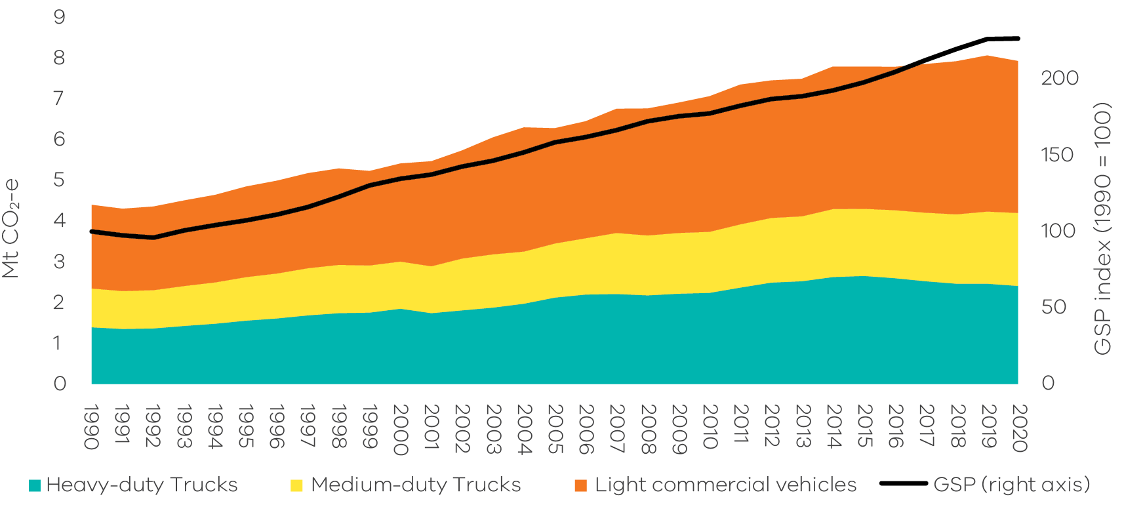
Source: Analysis based on Australian Greenhouse Emissions Information System (DCCEEW 2022a) and Australian Bureau of Statistics (ABS 2021a)
Box 2: Impacts of COVID-19 on transport emissions
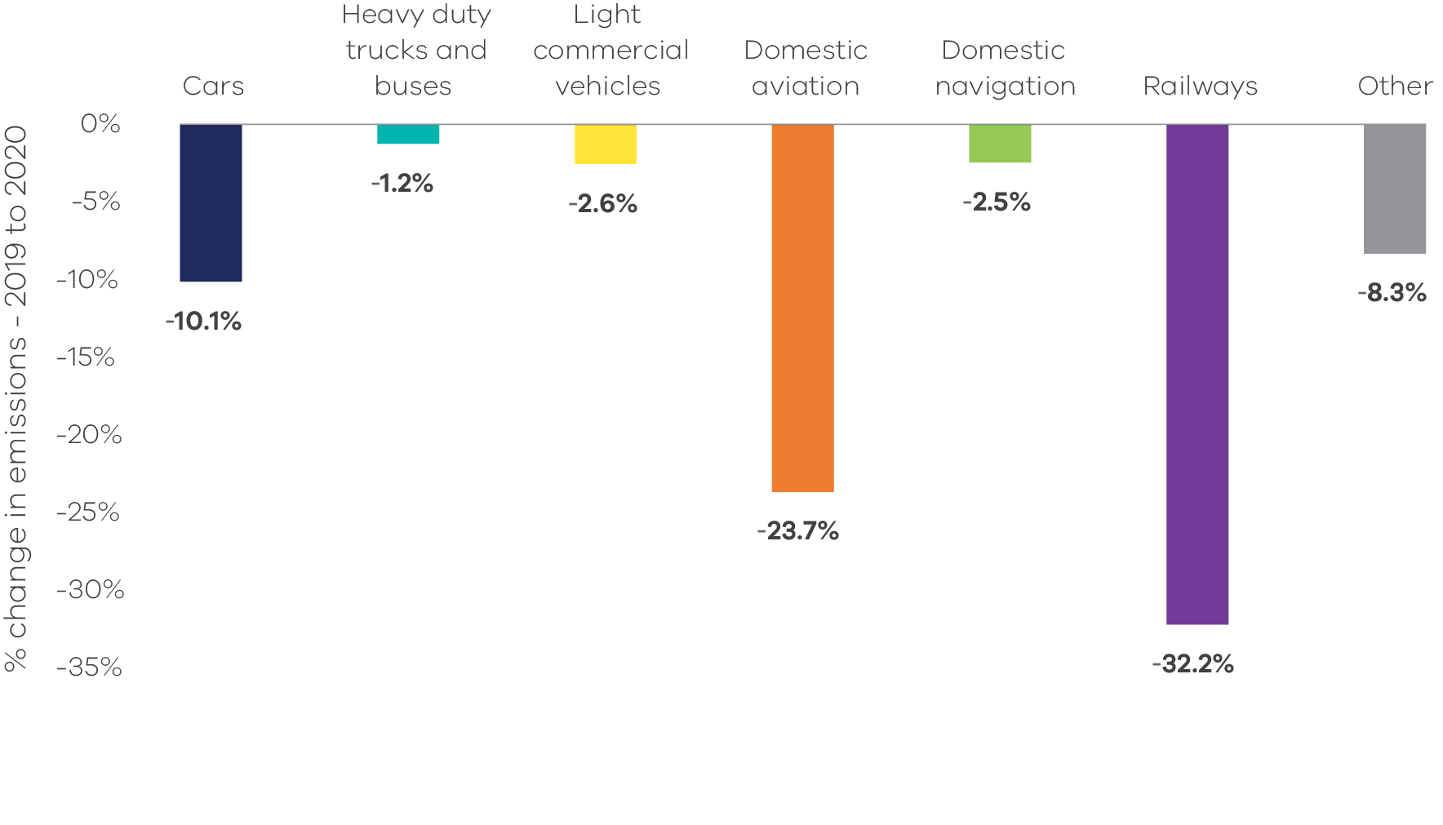
Source: Australian Greenhouse Emissions Information System (DCCEEW 2022a)
The 1.9 Mt CO₂-e (8.4%) fall in Victoria’s transport emissions between 2019 and 2020 is at least partly due to the impacts of the COVID-19 pandemic in the first half of 2020. Major decreases in emissions were observed in:
- cars, down by 1.1 Mt CO₂-e (10.1%);
- domestic aviation, down by 0.4 Mt CO₂-e (23.7%); and
railways, down by 0.2 Mt CO₂-e (32.2%).
According to Australia’s Bureau of Infrastructure and Transport Research Economics (BITRE) (2021a), stay-at-home orders and travel restrictions reduced transport related activity and resulted in:
- total passenger kilometres (pkm) travelled decreasing by 8% (5 billion passenger km travelled) in Melbourne with:
- light rail and heavy rail pkm decreasing by 44.9% and 30.3% respectively,
- bus pkm decreasing by 29.6%, and
- cars pkm falling by 7%;
- overall total vehicle kilometres (vkm) travelled in Victoria decreasing by 5.4% (3.7 billion vkm travelled);
- reduced aircraft movements by 24.2% at Melbourne airport; and
decreased public transport passenger movements in Melbourne by 22.9% for heavy rail and 31.0% for light rail.
Google’s Community Mobility Report for Victoria (below) shows major reductions in travel to non-residential locations from April 2020 onwards as stay-at-home orders were in place and the general public’s preference shifted away from public transport as a means of travel. Visits to retail/recreation, parks, and workplaces declined significantly – in line with retail and recreation venue closures, reduced outdoor time due to restrictions in place, partial closures of playgrounds, and increased working from home, and a general reticence to spend time in public places.
However, freight activity levels by road remained relatively stable between 2019 and 2020 (BITRE 2021a):
- Intrastate freight activity increased from 29 to 29.5 billion tonne-km, in line with the spike of online retail activities occurring across Australia from January 2020 (ABS 2022b).
- Interstate freight activity decreased from 16.6 to 14.5 billion tonne-km in line with state border entry restrictions.
Overall total domestic freight activity decreased slightly, by 1.6 billion tonne-km (3.5%).
As the pandemic has continued into 2022, transport emissions are likely to be affected in future editions of this report.
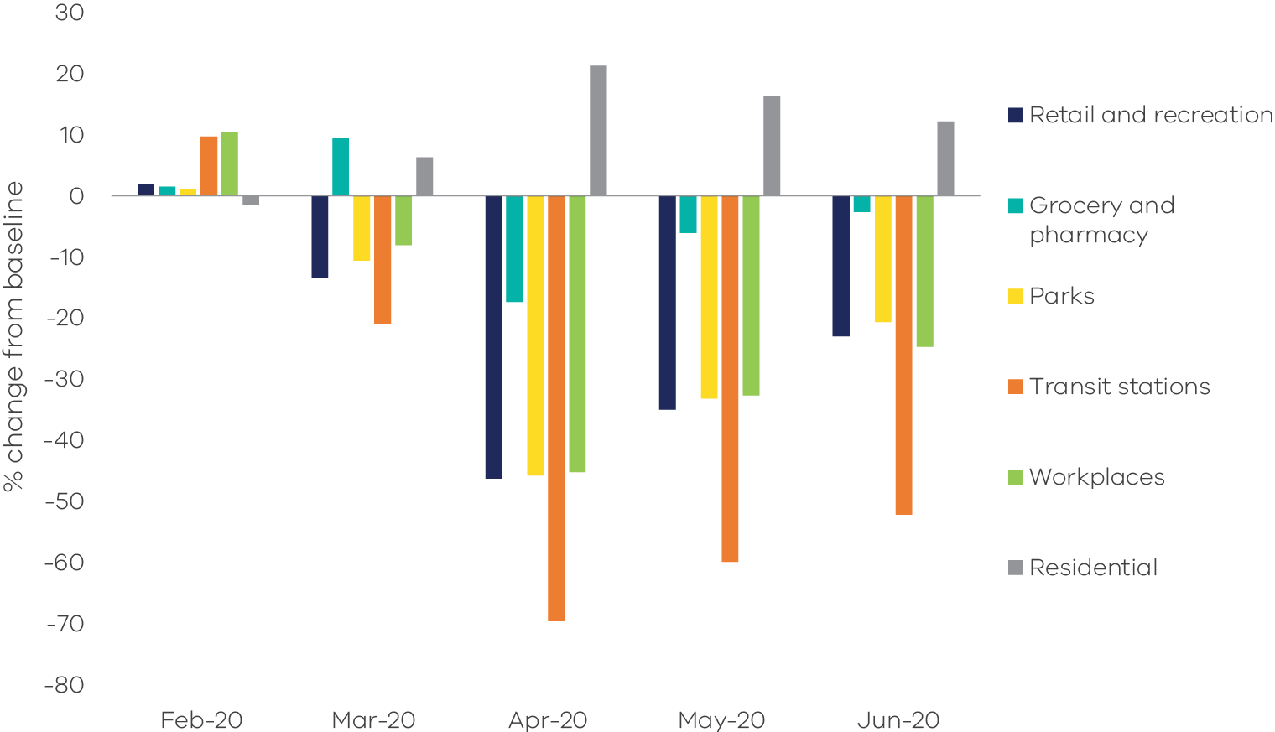
Source: Google COVID-19 Community Mobility Reports (Google 2022)
*Google’s baseline is based on a five-week period from 3 January to 6 February 2020, i.e. summer holidays
    - Fugitive emissions from fuels
Sources of emissions
Fugitive emissions result from the release or leaks of gases from the venting and flaring of gases during the exploration, extraction, production, processing, storage, transmission and distribution of fossil fuels including coal, oil and fossil gas. Emissions from decommissioned coal mines are also included in this sub-sector.
Fugitive emissions do not include emissions from the combustion of fuels in activities such as electricity generation, the operation of mining plants and equipment or the transportation of fossil fuels by road, rail or sea. These are accounted for in the electricity generation, fuel combustion and transport sub-sectors respectively.
Fugitive emissions from fuels in Victoria
In 2020, 42.5% of fugitive emissions in Victoria resulted from leakages during the exploration, production, transmission, storage and distribution of fossil gas.
Most of the remaining fugitive emissions were associated with flaring and venting as part of oil and fossil gas production and processing. Additional emissions came from leakage during the exploration, production, storage and distribution of oil and flaring in Victoria’s petroleum industry, which is concentrated in the offshore regions of the Otway and Gippsland basins.
A small contribution to Victoria’s total fugitive emissions (less than 1%) occurs from the extraction of solid fuels, particularly from brown coal mines.
Victoria’s fugitive emissions (2 Mt CO₂-e in 2020) are significantly lower than those of New South Wales (12.5 Mt CO₂-e), Western Australia (9.3 Mt CO₂-e) and Queensland (21.6 Mt CO₂-e) due to the greater volumes and types of coal and fossil gas production in those states.
Emissions trends and drivers
Victoria’s fugitive emissions rose from 4 Mt CO₂-e in 1990 to a peak of 4.1 Mt CO₂-e in 1995. Emissions then declined to a low of 1.6 Mt CO₂-e in 2014 before increasing again – with interannual variability – to reach 2 Mt CO₂-e in 2020 (Figure 31). In 2020, this sub-sector accounted for 2.4% of Victoria’s total net emissions.
Crude oil production in Victoria fell by 92% between 1990 and 2020 (DCCEEW 2021b). This contributed to the general downward trend from 1990 to 2015 (Figure 31). Increased emissions from flaring during oil and fossil gas production and processing contributed to increased fugitive emissions after 2016.
Although there was interannual variability, the annual volume of fossil gas consumption remained relatively stable between 1990 and 2005 (at 259 PJ both in 1990 and 2005). This was followed by a generally increasing trend to reach a peak in 2018 (291 PJ) before declining slightly to 281 PJ in 2020 (DCCEEW 2021a). Key factors behind changes in fossil gas demand after 2005 include the population growth rate, which doubled from around 1% per annum from 1990 to 2005 to 2% per annum from 2006 to 2020 and interannual variability including seasonal variation in the demand for fossil gas for heating and variation in annual levels of GPG to help meet electricity demand.
The level of fugitive emissions associated with fossil gas consumption has moderated over time due to improvements in transmission, storage and distribution resulting in reduced fossil gas leakages.
Fossil gas production was generally stable between 1990 and 2002, after which production increased significantly to cater both for expanding Victorian residential demand and increasing exports to other states. In 2020, production levels were 203% higher than in 1990 (DCCEEW 2021b).
Figure 31: Fugitive emissions from fuels – Victoria, 1990 to 2020 (left) and share of 2020 net emissions (right)
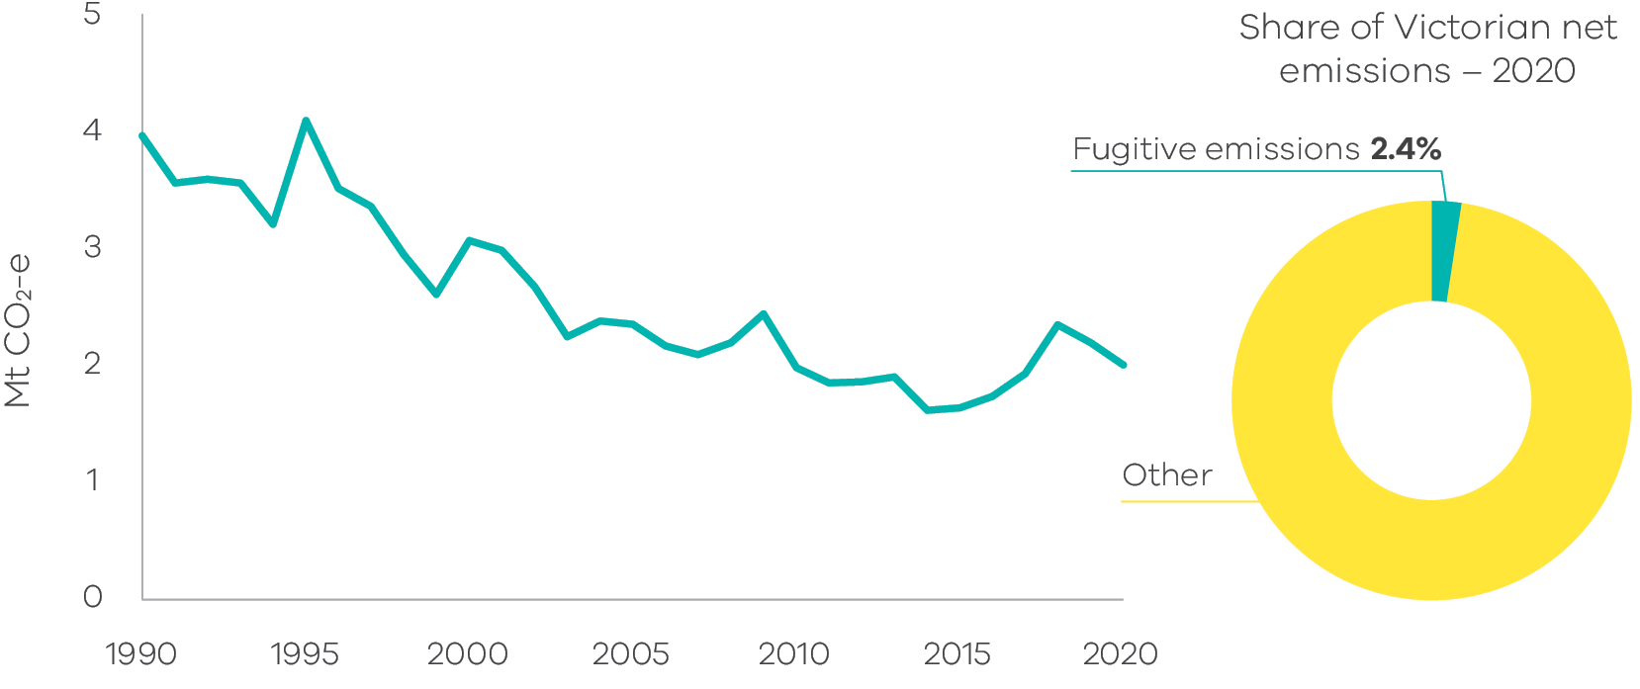
Source: Australian Greenhouse Emissions Information System (DCCEEW 2022a)
  - Industrial processes and product use (IPPU)
Sources of emissions
Industrial processes include emissions generated from a range of production processes involving, for example:
- the use of carbonates (e.g. limestone, dolomite, magnesite, etc.);
- carbon when used as a chemical reductant (e.g. iron and steel or aluminium production); and
chemical industry processes (e.g. ammonia and nitric acid production).
Product use includes emissions associated with the use of synthetic gases such as:
- hydrofluorocarbons (HFCs) in refrigeration and air conditioning, foam blowing, fire extinguishers, aerosols/metered dose inhalers and solvents;
- sulphur hexafluoride (SF6) in electrical equipment; and
perfluorocarbons (PFCs) arising from primary aluminium production.
Emissions associated with the consumption of electricity or combustion of fuels in industrial production are accounted for in the electricity generation and fuel combustion sub-sectors.
IPPU emissions in Victoria
In 2020, 79.3% of Victoria’s IPPU emissions resulted from the use of synthetic greenhouse gases (mainly HFCs), primarily for refrigeration and air conditioning in commercial, residential and transport activities.
The remaining 20.7% of IPPU emissions resulted from activities such as minerals, metals and chemicals production.
Emissions trends and drivers
Victoria’s IPPU emissions fell between 1990 and 1995, before rising steadily to 2010. Emissions declined briefly from 2012-15, before resuming their rise from 2016 to 2020, with some interannual variability. In 2020, this sector accounted for 4.3% of Victoria’s total net emissions (Figure 32).
Figure 32: Emissions from industrial processes and product use (IPPU) – Victoria, 1990 to 2020 (left) and share of 2020 net emissions (right)
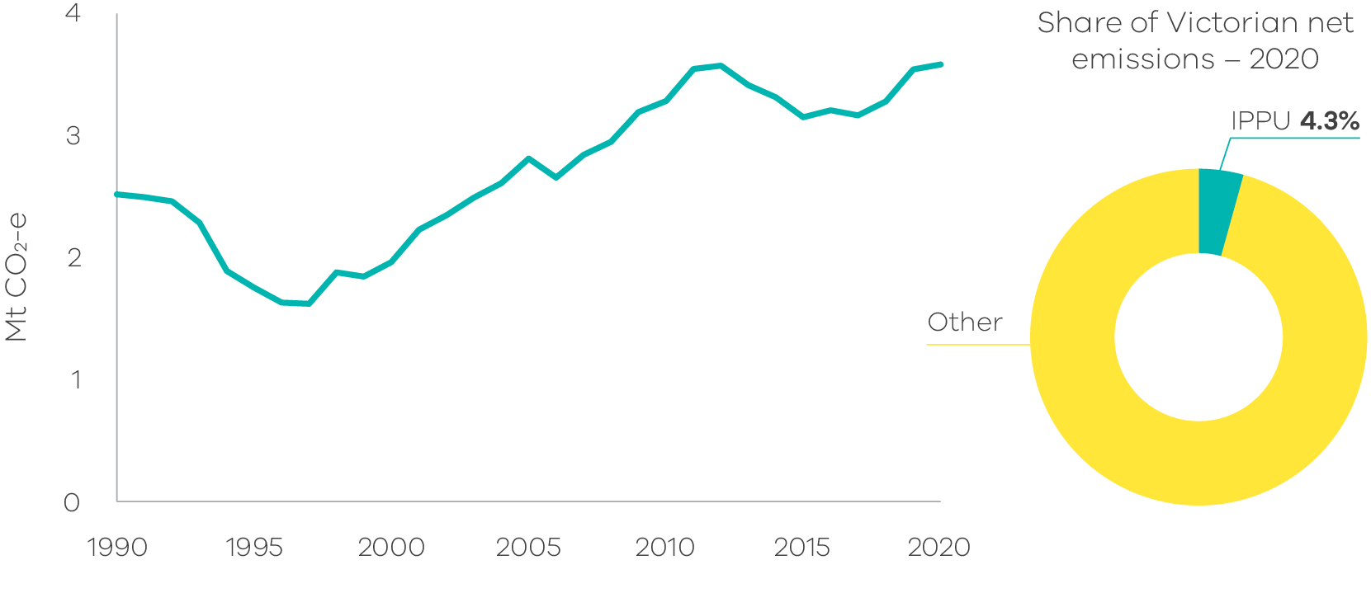
Source: Australian Greenhouse Emissions Information System (DCCEEW 2022a)
Increasing use of HFCs, primarily for air-conditioning and refrigeration, but also in aerosol propellants, fire protection and insulating foams, was the major driver of growth in IPPU emissions. From 1995 to 2020, HFCs grew from 1.4% to 79.3% of total IPPU emissions (Figure 33). The growth in emissions is attributable to HFCs replacing ozone-depleting hydrochlorofluorocarbons (HCFCs) in response to a phase out of HCFCs which commenced in the mid-1990s, and to population growth with associated demand for equipment and appliances that use HFCs.
The phase out of HCFCs was largely completed by 2018. HFCs themselves are now subject to a phase-out with their replacement by alternative substances with lower climate impacts (Brodribb and McCann 2020). Both phase-outs are driven by the Montreal Protocol on Substances that Deplete the Ozone Layer.
From 2016 to 2020, growth in the regulated bank of refrigerants in Australia slowed as the use of lower global warming potential (GWP) refrigerants increased. There is evidence to suggest that the GWP value of the Australian bank of refrigerants may have peaked in 2019-20 (Brodribb, McCann and Dewerson 2021). This suggests growth in Victoria’s HFC-related IPPU emissions may begin to slow in the near future.
IPPU emissions trends are also reflective of changes in economic activity. Slower economic growth in the early 1990s is likely to have contributed to the fall in IPPU emissions between 1990 and 1995, as manufacturing output softened. The growth in IPPU emissions after 1995 would have been higher were it not for changes in industrial activity in Victoria, which partially offset the rise of HFC emissions from refrigeration and air conditioning units. For instance, after 1995, emissions from the chemicals industry dropped substantially due to the closure of several chemical production facilities and from 2011 to 2020, the closure of facilities producing clinker and lime also moderated growth in IPPU emissions.
Figure 33: Emissions from HFC use by activity – Victoria, 1990 to 2020
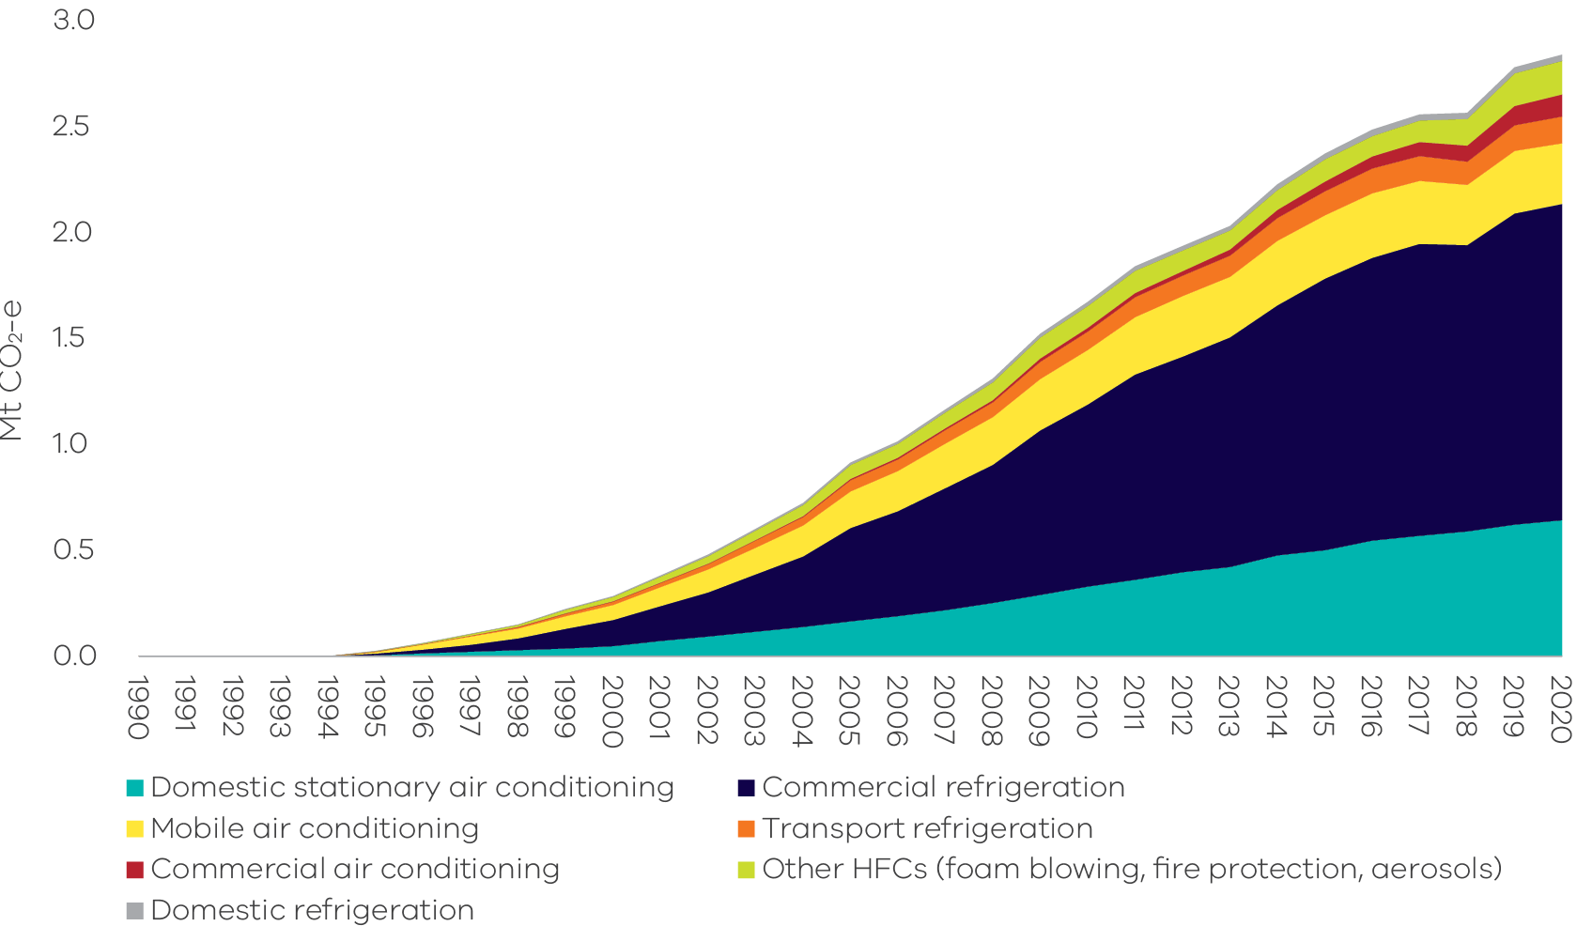
Source: Australian Greenhouse Emissions Information System (DCCEEW 2022a)
  - Waste
Sources of emissions
Emissions from the waste sector arise from the decomposition of organic waste in landfills and from the direct release of greenhouse gases during wastewater treatment. Emissions include:
- methane from the anaerobic decomposition of organic matter from solid waste in landfills and wastewater treatment plants; and
nitrous oxide from the nitrification and denitrification of urea and ammonia in wastewater treatment plants.
Carbon dioxide (CO₂) emissions from the combustion of methane captured from landfills and wastewater treatment plants, and the combustion of biomass for electricity generation, are reported in the energy sector. Emissions associated with energy used for managing and transporting waste are accounted for in the electricity generation, fuel combustion and transport sub-sectors.
CO₂ emissions from carbon stock transfers of harvested wood products (e.g. paper, wood) to landfill are reported in the LULUCF sector. However, methane emissions from the decomposition of wood and paper in landfill are reported in the waste sector.
Waste emissions in Victoria
The main sources of waste sector emissions in 2020 were the disposal of solid waste to landfill (63.9% of total waste sector emissions) and the treatment of domestic, commercial and industrial wastewater (32.9%). Waste decomposes in landfills over decades which means emissions from landfill in a given year are from a combination of older as well as more recently deposited waste. Most landfills in Victoria operate in accordance with best practice in greenhouse gas management, such as capturing and combusting landfill gas. This significantly reduces greenhouse gas emissions from this sector.
Factors influencing interannual variability in wastewater emissions include changing volumes of wastewater discharged by large industry and changes in the operational management and efficiencies of wastewater treatment plants. Many of Victoria’s wastewater treatment plants already capture the methane produced from the treatment process to burn as renewable biogas, generating clean electricity. Victorian water corporations are actively exploring opportunities to increase the amount of biogas captured and minimise greenhouse gas emissions from wastewater treatment at the source as part of the industry’s broader efforts to achieve net-zero emissions by no later than 2035.
Emissions trends and drivers
Victoria’s waste sector emissions declined between 1990 and 2013 before increasing through to 2017 and declining again in 2018. Waste emissions have remained stable to 2020 (Figure 34).
In 2020, the waste sector was responsible for 3.4% of Victoria’s total net emissions – emissions from the sector in 2020 were 2.8 Mt CO₂-e, significantly below the 6.4 Mt CO₂-e emitted in 1990 (Figure 34).
Notwithstanding some annual variation, the solid waste subsector's share has remained at around 70% on average and wastewater subsector's share has been around 28% between 1990 and 2020. Additionally, there has been a small but growing share of waste emissions associated with biological treatment of solid waste – from 0.1% of waste emissions in 1990 to 2.6% in 2020 (Figure 35).
Figure 34: Emissions from waste – Victoria, 1990 to 2020 (left) and share of 2020 net emissions (right)
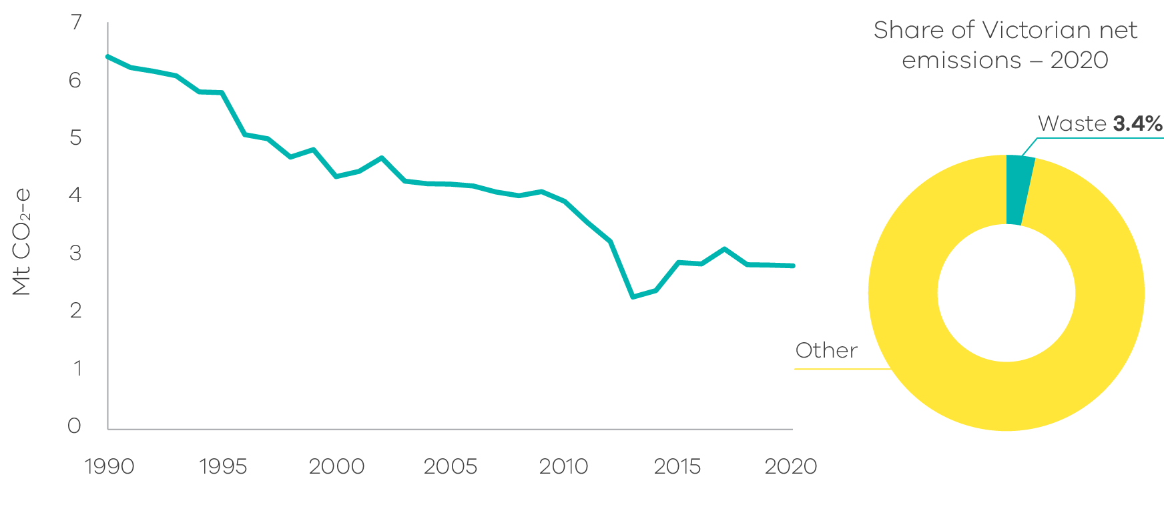
Source: Australian Greenhouse Emissions Information System (DCCEEW 2022a)
Figure 35: Emissions by waste sector sub-categories – Victoria, 1990 to 2020
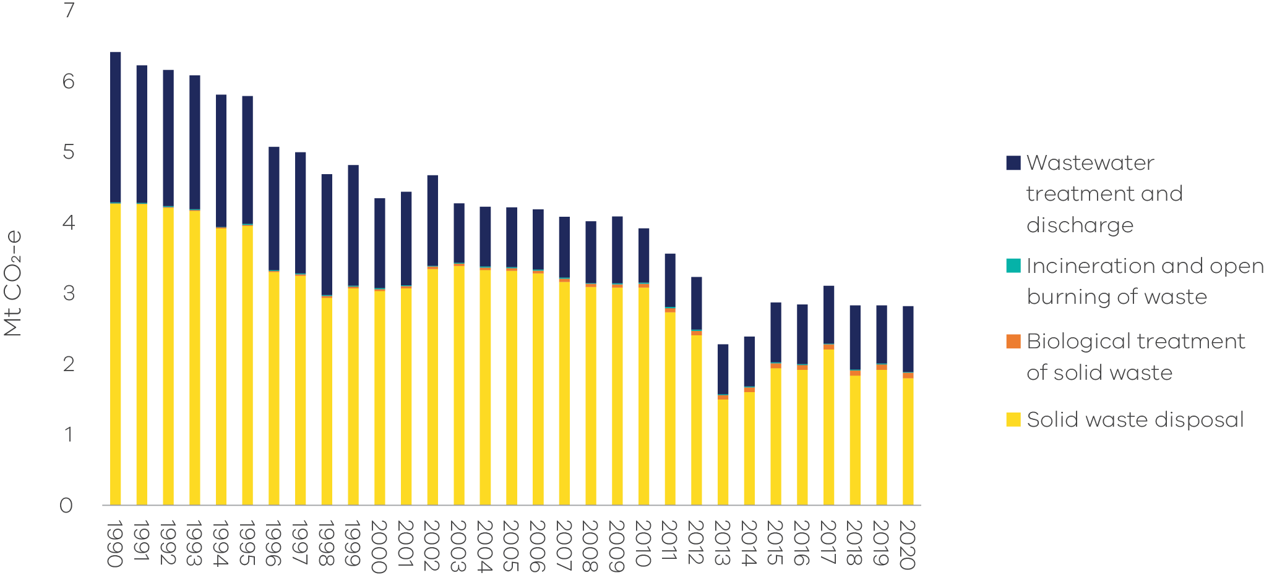
Source: Australian Greenhouse Emissions Information System (DCCEEW 2022a)
Despite steady population growth over the last thirty years, waste emissions from the two major subsectors of solid waste management and wastewater treatment have both more than halved. Emissions associated with management of solid waste fell by 57.8% between 1990 and 2020 despite increased volumes of solid waste produced by Victoria’s expanding population. This was due to increased landfill gas capture and combustion; improved landfill management practices reducing methane leakage; greater levels of materials recycling; and increased diversion of organics from the waste stream to composting and electricity generation. These changes have contributed to a flattening trend in solid waste disposal emissions over the last decade, even as the population has increased by 22.6% (Figure 36).
Similarly, emissions from wastewater decreased by 56.5% between 1990 and 2020, remaining stable for most of the last two decades, with changes due to more efficient wastewater treatment processes and increased methane capture from wastewater treatment plants.
Although emissions from biological treatment of solid waste only accounted for 2.6% of total waste emissions in 2020, they have grown significantly since 1990. This waste sub-category includes processes such as windrow composting and enclosed anaerobic digestion – which is considered an emerging waste treatment pathway in Australia. There are now several waste-to-energy facilities operating in Victoria utilising anaerobic digestion process to produce biogas as a fuel for energy production including at Woolert, Melton and Colac, with many more facilities now in the planning phase.
Emissions from incineration and open burning of solid waste have remained stable over the last two decades and contributed only 0.6% to waste emissions in 2020. Some of the main sources of emissions included in this sub-category are the incineration of solvents and municipal and clinical waste.
Figure 36: Trends in emissions by the major waste sub-categories – Victoria, 1990 to 2020
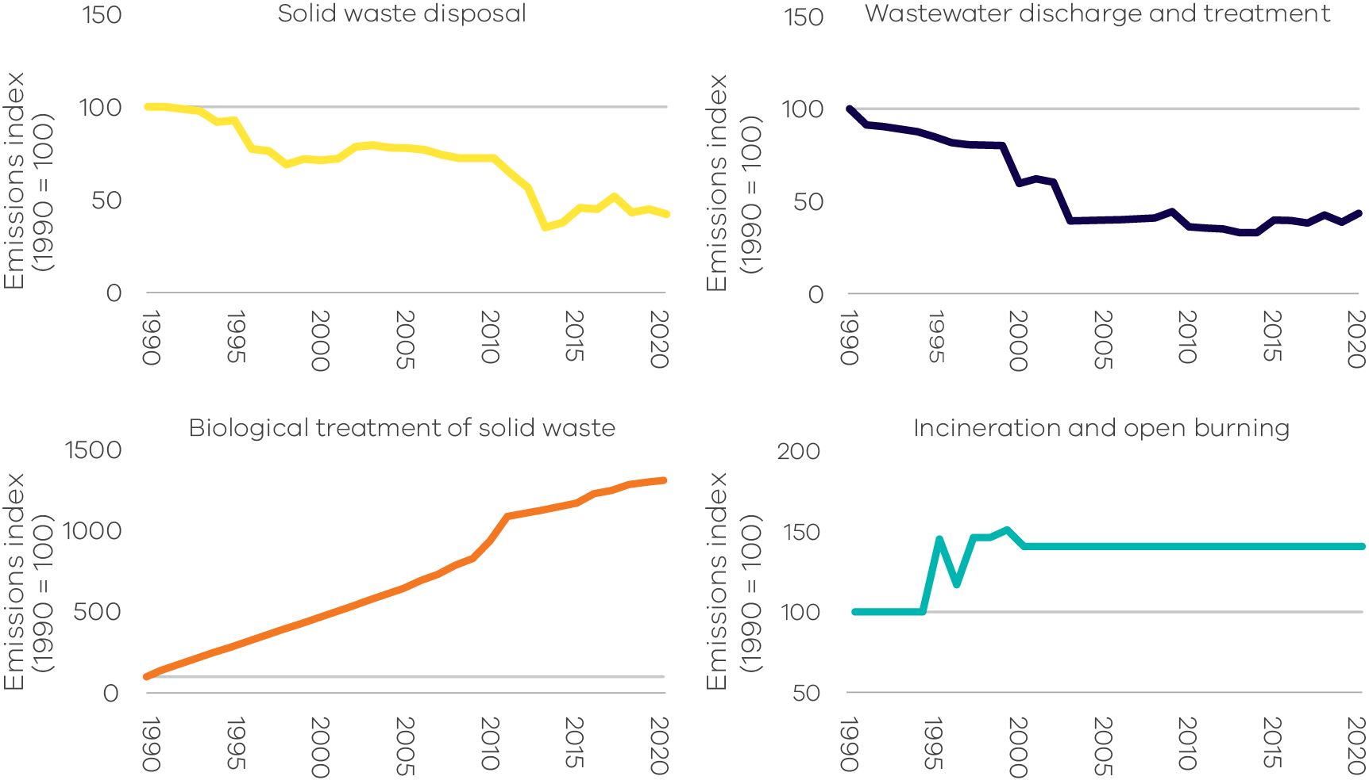
Source: Australian Greenhouse Emissions Information System (DCCEEW 2022a)
  - Agriculture
Sources of emissions
Agriculture sector emissions result from:
- enteric fermentation which occurs due to the digestive processes of ruminants (e.g. cattle, sheep) through which microbes decompose and ferment food in the animals’ digestive tract or rumen and which produces methane emissions;
- manure management, with emissions from the anaerobic decomposition of organic matter contained in manure;
- the release of nitrous oxide from cropping and pasture land with emissions from processes in the soil following the application of fertilisers, crop residues and animal waste; and
emissions from burning agricultural residues.
Emissions associated with the use of electricity, fuel consumption to operate equipment and transport are accounted for in the energy sector. Carbon sequestration associated with tree planting and vegetation or agroforestry activities are accounted for in the land use, land use change and forestry sector.
Agriculture emissions in Victoria
Livestock enteric fermentation was the main source of agriculture sector emissions in Victoria in 2020 (68.6%), followed by the release of nitrous oxide from cropping and pastures (17.7%) and manure management (9.1%). Emissions from urea application and liming (both for soil conditioning) were 4.1% of agriculture emissions.
Under enteric fermentation, dairy and beef cattle (pasture-fed) contributed the most emissions to total agriculture emissions at 25.6% and 23.4% respectively.
Emissions trends and drivers
Victoria’s agriculture emissions fluctuated significantly between 1990 and 2020. The sector accounted for 19.3% of Victoria’s net emissions in 2020 – the fourth largest share of total emissions behind electricity generation, transport and fuel combustion (Figure 37).
The interannual variation in total agriculture emissions was driven mainly by seasonal conditions and by domestic food demand and exports.
Figure 37: Emissions from agriculture – Victoria, 1990 to 2020 (left) and share of 2020 net emissions (right)
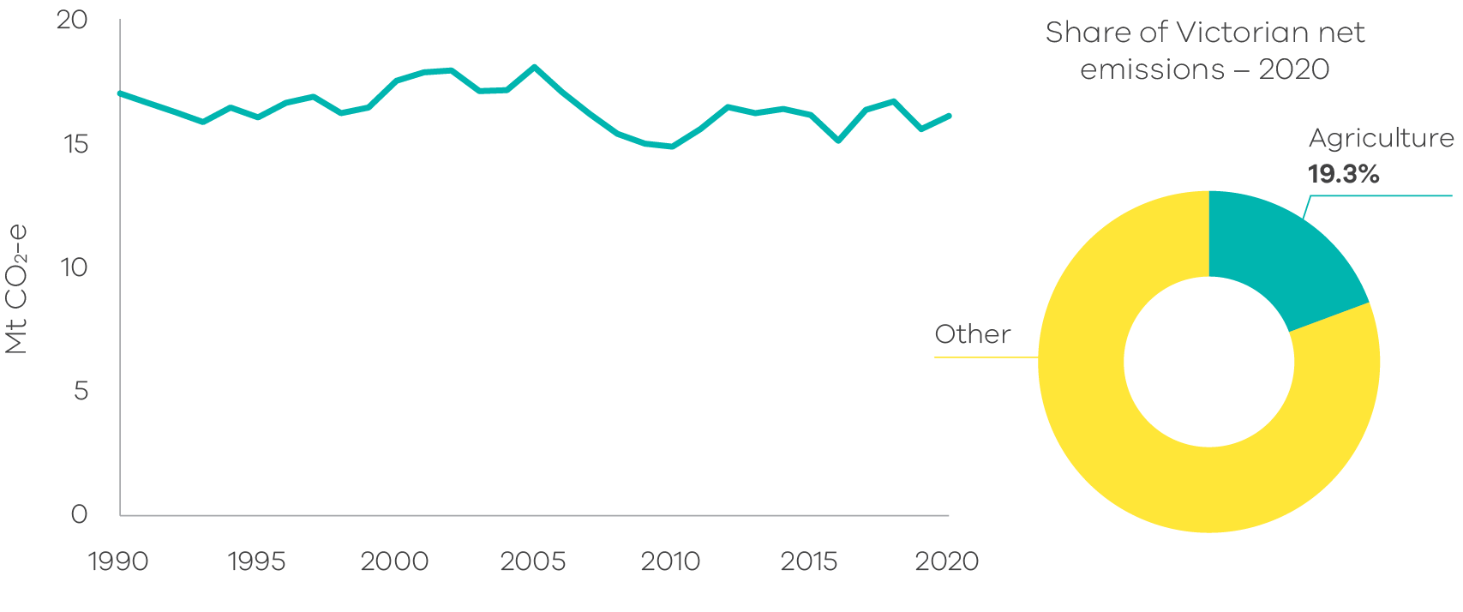
Source: Australian Greenhouse Emissions Information System (DCCEEW 2022a)
Figure 38 presents the trend in agriculture emissions by activity sub-categories. Enteric fermentation has been responsible for the largest share of agriculture emissions for three decades but its share of emissions has declined from 79.2% in 1990 to 68.6% in 2020 while the share of other sub-categories has increased over the same period, including agriculture soils (from 12.8% to 17.7%), manure management (from 6.9% to 9.1%), and urea application (from 0.3 to 2.4%).
Reduced enteric fermentation emissions from sheep grazing was the main contributor to the 5.4% decline in agriculture sector emissions from 1990 to 2020, primarily due to a decline in the sheep population since 1990 – likely driven by seasonal and market conditions. Emissions from cattle were higher in 2020 compared to 1990, however interannual fluctuations occurred throughout the period reflecting variation in cattle numbers.
Figure 38: Emissions by agriculture sector sub-category – Victoria, 1990 to 2020
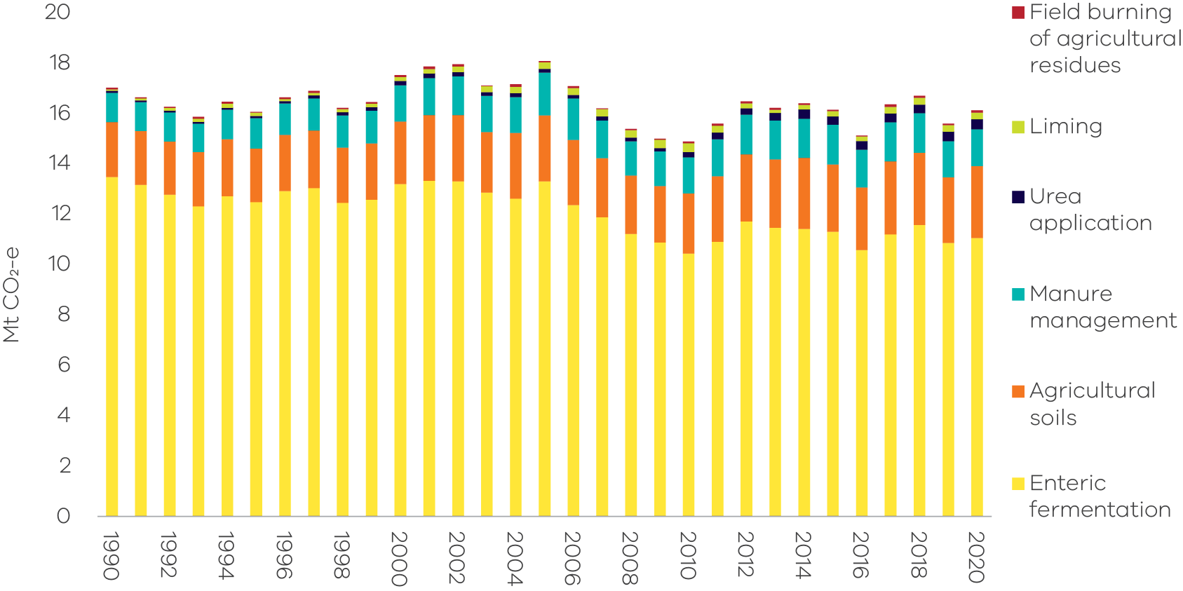
Source: Australian Greenhouse Emissions Information System (DCCEEW 2022a)
Figure 39 presents trends in sheep and cattle populations and emissions from 1990 to 2020. Despite the decline in the sheep population since 1990, there were just over four times as many sheep as cattle in Victoria in 2020. Victoria’s cattle population was particularly influenced by the millennium drought that affected Victoria from 1997 to 2009. Cattle numbers initially remained steady, then declined towards the end of the drought in the late 2000s. Numbers increased with the return to more favourable conditions in 2010 and 2011. Nonetheless, cattle emissions were nearly three times higher than sheep emissions in 2020 due to the higher emissions intensity of cattle compared with sheep.
Figure 39: Sheep and cattle populations and emissions – Victoria, 1990 to 2020
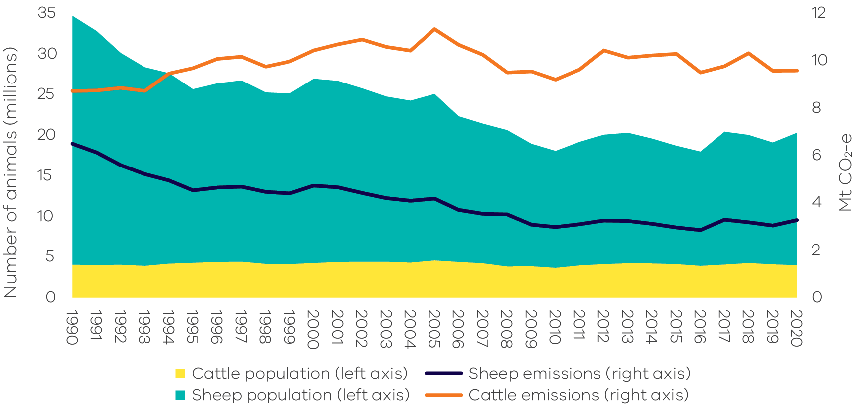
Source: Analysis based on Australian Greenhouse Emissions Information System (DCCEEW 2022a)
Note: includes all the mechanisms that give rise to emissions from livestock, including enteric fermentation, manure management, urine and faeces on grazing land and atmospheric deposition of nitrous oxide.
Figure 40 presents trends in the four sub-categories with the greatest contributions to emissions from agriculture.
Emissions from enteric fermentation decreased by 18% between 1990 and 2020 due to the factors outlined above. Emissions from the other three major sub-categories (manure management, agricultural soils and urea application) increased from 1990 to 2020, although no clear trend has emerged in manure management emissions, which vary depending on livestock numbers, manure management practices and climate factors.
Emissions from agricultural soils grew by 0.6 Mt CO₂-e (4.9%) between 1990 and 2020. An expansion of the total area of crop cultivation – particularly for wheat, barley and canola – and associated increases in the application of nitrogen fertilisers, crop residue and animal wastes – were responsible for this growth. The total area of crop cultivation almost doubled, from 1.8 to 3.5 million hectares between 1990 and 2020, while the application of fertilisers increased from just under 50,000 to 328,000 tonnes of nitrogen (an increase of 561%) over this period. This also contributed to a significant increase in urea application emissions which grew nearly seven-fold between 1990 and 2020 (Figure 40), with particularly strong growth in the last decade (DCCEEW 2022a).
Figure 40: Trends in emissions for the four major agriculture sub-categories – Victoria, 1990 to 2020
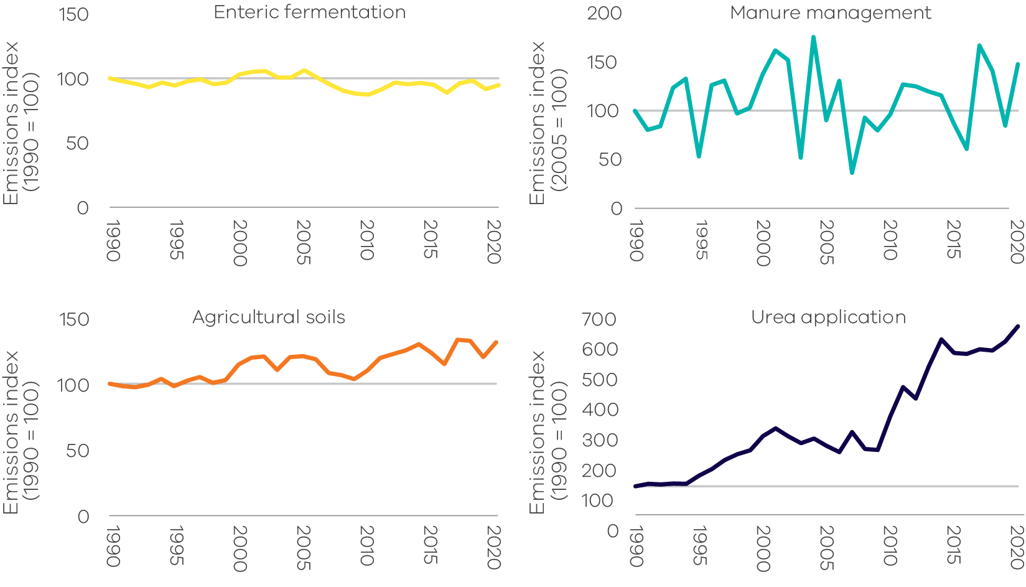
Source: Australian Greenhouse Emissions Information System (DCCEEW 2022a)
  - Land Use, Land-Use Change and Forestry
Sources of emissions
The land use, land-use change and forestry (LULUCF) sector includes emissions and the removal (sequestration) of greenhouse gases resulting from direct human-induced land use, land-use change and forestry activities. This includes emissions and removals from the clearance of forested land and conversion to other land uses; from new forests planted on previously unforested land; and from other practices that change emissions and removals (forest management, cropland management and grazing land management). Emissions and removals associated with infrequent, extreme bushfire events are reported based on long run trends in carbon stock change and have a limited impact on annual emissions (see Box 3: Accounting for emissions from the 2019-2020 Eastern Victorian bushfires).
Fossil fuel combustion associated with forestry and land management activities – such as diesel used in logging machinery – is accounted for in the fuel combustion sub-sector. Emissions from burning agricultural residues, and non-CO₂ emissions associated with land use such as the application of fertilisers, are accounted for in the agriculture sector.
Box 3: Accounting for emissions from the 2019-2020 Eastern Victorian bushfires
The summer 2019-20 bushfires burnt over 1.5 million hectares in Victoria, including in East Gippsland LGA (1.1 million hectares), Towong LGA (205,000 hectares) and Alpine LGA (187,000 hectares). The substantial majority of the area burnt was public land and a relatively small proportion was plantation forest (around 7,800 hectares).
Bushfires initially release significant amounts of carbon dioxide, with the forests then generally recovering over time and generating a significant carbon sink in the years following the fire. For example, within 10 years of the summer 2002-2003 bushfires in the ACT, Victoria and New South Wales more than 98 per cent of forest cover was observed to return, with full recovery of the forest expected to be complete over time (DCCEEW 2020b).
Consistent with international rules and practice, the ‘natural disturbances’ provision of IPCC greenhouse gas accounting rules is used in reporting net emissions from infrequent, extreme bushfires in temperate forests, which are beyond human control. Under this provision, the long-run trend in carbon stock change in the forests is used, reflecting the balance of the carbon lost in the fire which is re-absorbed by future regrowth.
The Commonwealth Government will carry out ongoing monitoring of forest regeneration and make adjustments to Victoria’s emissions inventory as needed to ensure it reflects the long run impacts of the bushfires on our emissions and the climate. This monitoring is particularly important given that the historically observed, long-term equilibrium of carbon released and reabsorbed may not continue into the future as climate change results in more frequent and extreme fire weather, and longer fire seasons.
Emissions in Victoria
The main sources of Victoria’s LULUCF emissions and removals are forest lands and grasslands, specifically from land classified as:
- Forest land remaining forest – comprising changes in the native forest estate including fires and harvesting from that estate and pre-1990 plantations.
- Land converted to forest land – comprising plantations established since 1990 and regeneration of previously cleared land.
- Grassland remaining grassland – includes all areas of grassland not reported under land converted to grassland, comprising grasslands and shrublands (woody areas that do not meet the definition of forest).
- Forest land converted to cropland, grasslands, wetlands and settlements – comprising primary and secondary clearing of forest land since 1972 to enable a change in land use and changes in soil carbon and other emissions resulting from land use change.
Figure 41: LULUCF net emissions – Victoria, 1990 to 2020 (left) and share of 2020 net emissions (right)
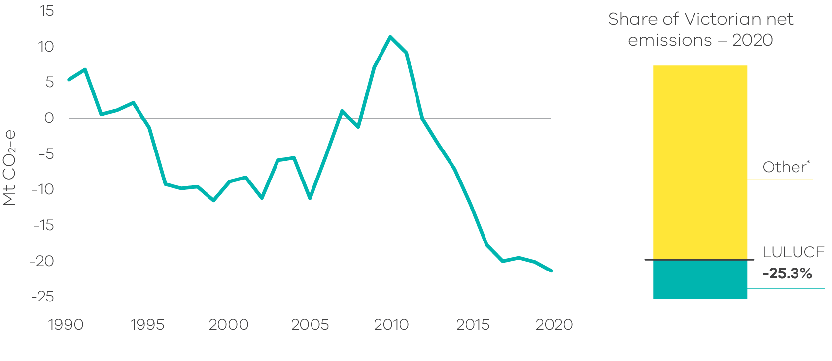
*All other sectors' share equal 125.3%
Source: Australian Greenhouse Emissions Information System (DCCEEW 2022a)
Emissions trends and drivers
Victoria’s LULUCF emissions fluctuated significantly between 1990 and 2020 (Figure 41). LULUCF was a net sink (sequestration exceeded emissions) from 1995 to 2006, 2008 and from 2012 to 2020, and a net source of emissions (emissions exceeded sequestration) from 1990 to 1994, 2007 and from 2009 to 2011. Over the period 1990 to 2020, LULUCF provided a cumulative net sink of approximately -172.6 Mt CO₂-e. In 2020, in net terms, the LULUCF sector sequestered 21.1 Mt CO₂-e of emissions, equivalent to 25.3% of total Victorian emissions.
Figure 42 presents net emissions across all LULUCF sub-categories.
Forest land remaining forest land was the largest contributor to net emissions in 2020 at 13.1 Mt CO₂-e with substantial interannual variation (including being a net source in 1994-95 and 2007-12). Changes in this sub-category were driven by wildfire (also commonly referred to as “bushfire”) emissions and removals and changes to carbon pools from forest estates (see a. Forest land remaining forest land for further detail).
Figure 42: Emissions from LULUCF sub-categories – Victoria, 1990 to 2020
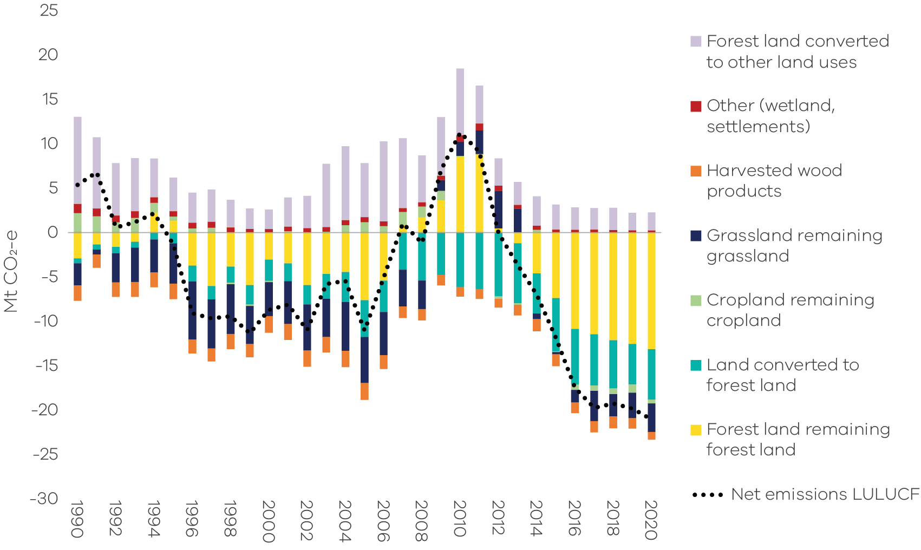
Source: Analysis based on Australian Greenhouse Emissions Information System (DCCEEW 2022a)
Land converted to forest land was a net sink of 5.7 Mt CO₂-e in 2020. Removals by this sub-category increased in scale from 1990 to a peak in 2012 before declining slightly – it nonetheless remained a substantial net sink from 2013 to 2020. A key historical driver of sequestration in this sub-category was the expansion of commercial forestry plantations (see b. Land converted to forest land for further detail).
Grassland remaining grassland was a net sink of 3.2 Mt CO₂-e in 2020, predominantly due to grassland soils (which provided 96.1% of this sequestration). Throughout the 1990s and early 2000s, this sub-category provided a net sink, but became a net source of emissions between 2009 and 2013 before again providing a net sink from 2014 to 2020. Changes in this sub-category are largely driven by changes in land management practices (particularly changes in pasture, grazing and fire management) and climate, which determine the amount of live biomass and dead organic matter, as well as the amount of residues, root and manure inputs to soil carbon (see c. Grassland remaining grassland for further detail).
Forest land converted to other land uses was a relatively small contributor to net emissions in 2020 but fluctuated significantly between 1990 and 2020. The primary drivers of trends in this sub-category are primary forest clearing, farmers’ terms of trade and weather conditions. Long-standing regulations on land clearing have assisted in constraining the emissions from this sub-category (see d. Forest land converted to cropland, grassland, wetlands and settlements for further detail).
Contributions from the other, harvested wood products and cropland remaining cropland sub-categories are relatively small with interannual variation based mainly on market demand for agricultural and harvested wood products.
- Forest land remaining forest land
This sub-category includes emissions/removals derived from modelled changes in carbon pools in:
- harvested native forests;
- other native forests; and
plantations established before 1990.
Removals from this sub-category increased marginally from 2019 to 2020, from 12.5 Mt CO₂-e to 13.1 Mt CO₂-e.
Figure 43 shows net emissions from forest land remaining forest land resulting from activities such as wildfire and prescribed burning; and other sources of emissions including changes in living biomass, dead organic matter and soil carbon in harvested native forest and other native and pre-1990 plantation forests. The years where wildfire and prescribed burning are net emissions sinks (e.g. 2013 to 2020) are years in which carbon removed through vegetation regrowth after wildfires and prescribed burns outweighed carbon released during fires.
Emissions changes in carbon pools in native forests changed from a net sink in 2009 to a net source of emissions from 2010 to 2013. This was due to harvested native forest soils becoming a significant source of emissions from 2009 to 2014 as a change to wetter climate conditions during that period increased emissions from soils, overwhelming the contribution of above ground forest sequestration from 2010 to 2013. Soil carbon emissions from harvested native forest carbon pools (a subset of emissions changes in carbon pools shown in Figure 43) peaked in 2012 and were around 5% of the State’s net emissions in that year.
Figure 43: Net emissions from fire (wildfire and controlled burning) and other sources – Victoria, 1990 to 2020
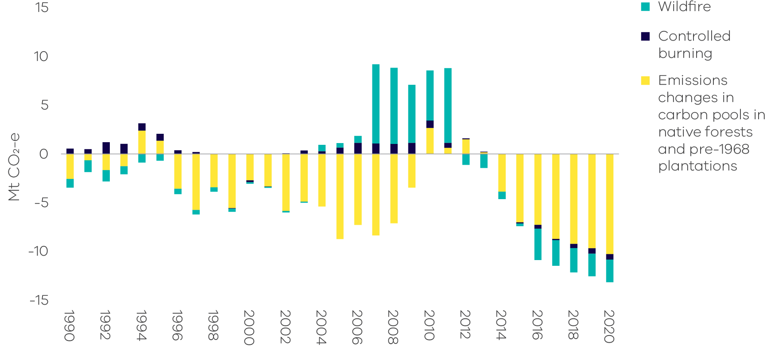
Source: Analysis based on Australian Greenhouse Emissions Information System (DCCEEW 2022a)
Note: Non-anthropogenic natural disturbances – including some but not all wildfires – are reported as a long run trend in emissions, reflecting the balance of carbon lost and later re-absorbed by future regrowth. This approach is in accordance with the ‘natural disturbance’ provision of IPCC accounting rules and leaves anthropogenic emissions and removals as the main drivers.
- Land converted to forest land
This sub-category includes net emissions/removals from:
- for-harvest plantations established since 1990, which are mainly hardwood;
- environmental plantings established since 1990;
- regrowth of forest on land cleared for cropping or grazing; and
regeneration of areas cleared of forest since 1972 from natural seed stocks. This may be a combination of regeneration for environmental purposes on protected land or on land that is maintained by the landowner. Regeneration on land cleared prior to 1990 is also captured in this sub-category.
Removals from this sub-category increased from 2019 to 2020, from 4.6 Mt CO₂-e to 5.7 Mt CO₂-e.
Over the past three decades, sequestration from plantations has increased significantly (Figure 44) in line with the rapid expansion of hardwood plantations in response to the Commonwealth Government’s Managed Investment Act 1998, which increased the finance available for plantation establishment. The Managed Investment Act was repealed in 2016 and the rate of plantation establishment in Victoria has been close to zero since 2013. The scale of sequestration from plantations also declined after 2012 as short-rotation hardwood plantations were harvested.
Sequestration through regrowth on cleared land generally increased after 1990, and particularly so after 2012. Natural regeneration has been a small but material source of both emissions and removals between 1990 and 2020. The years where natural regeneration was a net emissions source were due to the impacts of disturbances such as temporary forest dieback caused by factors like disease, insect attack and stressful climate conditions.
Figure 44: Net emissions from land converted to forest land – Victoria, 1990 to 2020
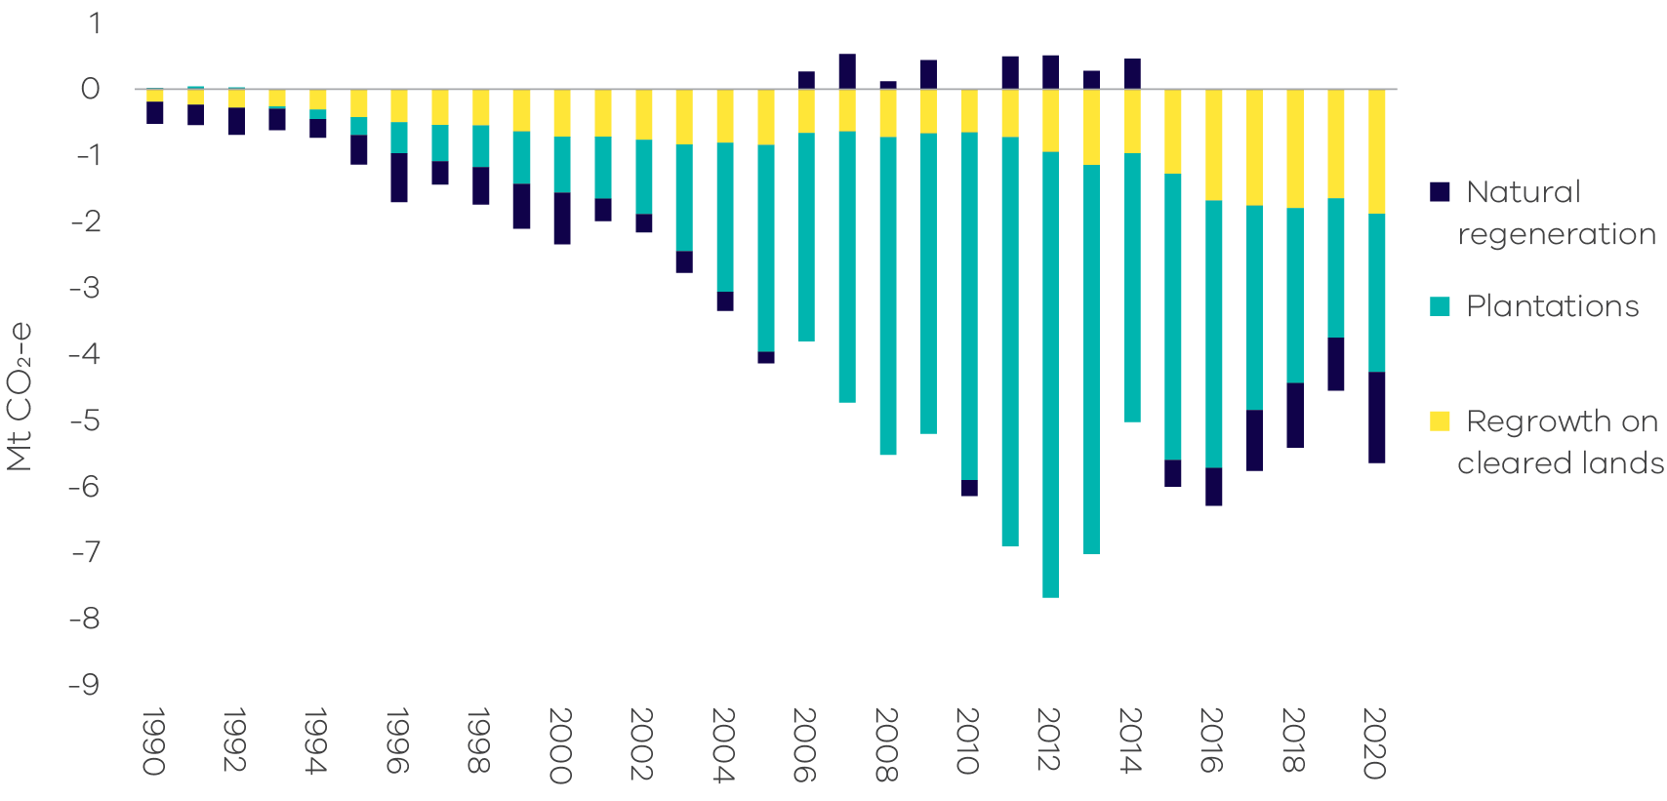
Source: Analysis based on Australian Greenhouse Emissions Information System (DCCEEW 2022a)
- Grassland remaining grassland
In Victoria, grassland remaining grassland includes:
- herbaceous grassland (soil carbon);
- changes in sparse woody or shrubland extent (i.e. increases or losses of woody vegetation not categorised as forest); and
biomass burning.
Removals from this sub-category increased by 0.3 Mt CO₂-e from 2019 to 2020, from 2.9 Mt CO₂-e to 3.2 Mt CO₂-e.
Herbaceous grassland soils are the dominant contributor to emissions and removals in this sub-category contributing 96.1% of removals in 2020. Herbaceous grassland soils changed from providing net removals from 1990 to 2008 to a net source of emissions from 2009 to 2013 – wetter climatic conditions may have contributed to this change (Figure 45).
Permanent changes in land management practices generate changes in the levels of soil carbon or woody biomass stocks. Over time the carbon stocks will reach a new equilibrium and the rate of net emissions or removals associated with the changed management practice will approach zero.
Figure 45: Net emissions from grassland remaining grassland – Victoria, 1990 to 2020
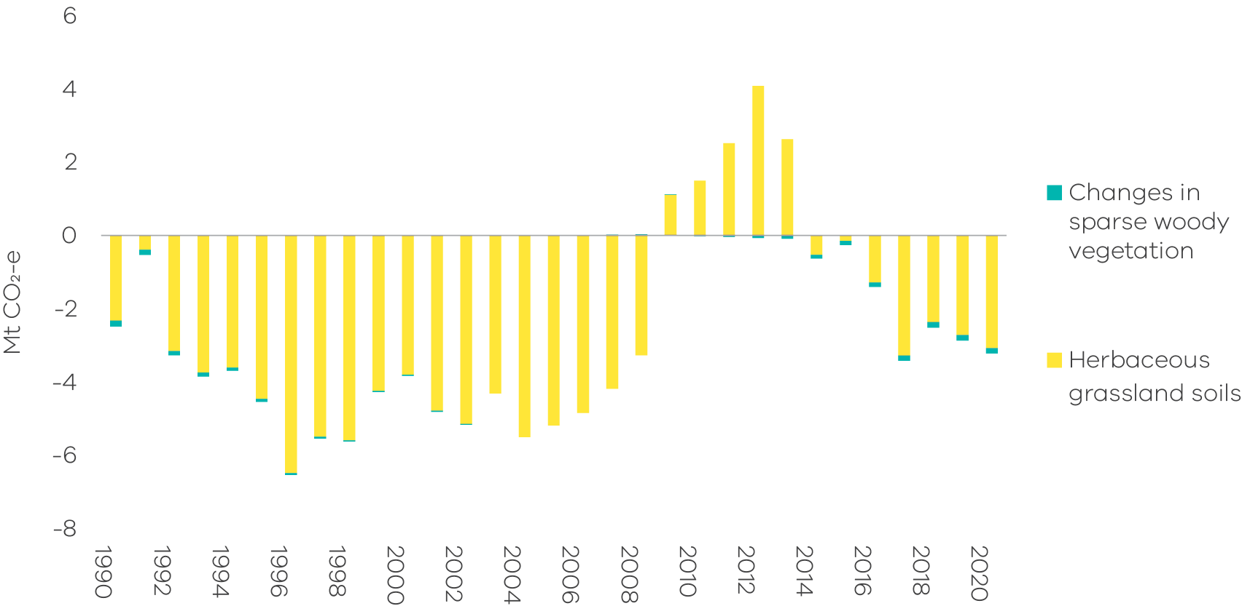
Source: Analysis based on Australian Greenhouse Emissions Information System (DCCEEW 2022a)
- Forest land converted to cropland, grassland, wetlands and settlements
This sub-category includes:
- emissions from the primary conversion of land that was forested in 1972;
- emissions from secondary or re-clearance of forest which has regrown on cleared land – where forest regrows on converted lands, the sequestration is included in the sub-category land converted to forest; and
indirect emissions from loss of soil carbon and other emissions and removals associated with the new land use, including emissions from decaying organic matter. Indirect emissions are highest in the two years after clearing and then decline. Non-CO₂ emissions associated with application of fertilisers and the management of crops are accounted for in the agriculture sector.
Emissions from this sub-category increased by a 0.1 Mt CO₂-e from 2019 to 2020, from 1.5 Mt CO₂-e to 1.6 Mt CO₂-e (Figure 46).
The primary drivers of trends in this sub-category are primary forest clearing, farmers’ terms of trade and weather conditions. Long-standing regulations on land clearing have assisted in constraining the emissions from this sub-category.
Figure 46: Sources of emissions and removals from forest land converted to cropland, grassland, wetlands and settlements – Victoria, 1990 to 2020
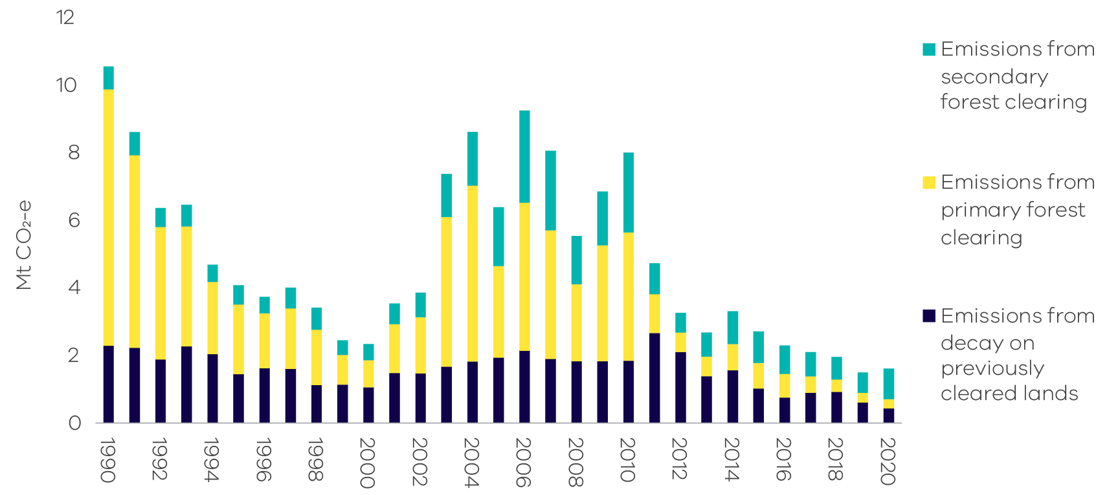
Source: Analysis based on Australian Greenhouse Emissions Information System (DCCEEW 2022a)
Uncertainty in LULUCF emissions estimates
Uncertainty is a characteristic of any estimation process. According to Australia’s National Greenhouse Gas Inventory 2020 (NGGI), the estimated uncertainties for total net emissions in 2020 emissions are:
- +/- 3.1% excluding net emissions from LULUCF; and
+/- 5.3% when LULUCF is included.
The higher uncertainty associated with LULUCF is due to the complexity of biological processes, the measurement and data collection techniques and the challenges of representing biological processes in mathematical models.
It is not practicable to directly measure emissions and sequestration in the LULUCF sector. Instead, the Full Carbon Accounting Model (FullCAM) is used to estimate emissions and removals arising from changes in above and below ground biomass, dead organic matter, soil carbon and changes in land use and management techniques.
FullCAM uses data on climate, soils and land management practices, as well as land use changes observed from satellite imagery, and is supplemented by additional data and models as appropriate.
The overarching approach to estimating net emissions in the LULUCF sector is continually reviewed by the DCCEEW, with changes being made to both the assumptions in FullCAM as knowledge advances; and to data as improved information becomes available.
When changes are made, these are applied to the historical data series back to 1990. Appendix A describes the main methodological changes between the Victorian Greenhouse Gas Emissions Report 2019 and the current (2020) report and the impact they have had on LULUCF emissions data between 1990 and 2019.
Changes will continue to occur in future years as further improvements in estimation methods occur.
Updated historical LULUCF data
The LULUCF emissions presented in this report for the years 1990 to 2019 differ from those in the Victorian Greenhouse Gas Emissions Report 2019 due to improvements in data and emissions estimation methodologies. These include:
- FullCAM updates – Historical data has been revised due to updates to FullCAM parameters and plantations recalibrations;
- Carbon stock changes – Improved modelling of carbon stock changes associated with combustion and prescribed fires; and
Expanded plantations dataset – Adoption of more comprehensive representative calibration dataset via collaborations with industry.
Information on the recalculations involved is presented in Appendix A.
- Emissions by economic sector – 2020
Chapter 2 presented emissions data based on sectors defined in accordance with IPCC guidelines. This chapter presents information on Victoria’s emissions by economic sector defined in accordance with the following Australian and New Zealand Standard Industry Classification (ANZSIC) divisions:
- electricity, gas, water and waste services
- manufacturing
- commercial services
- agriculture, forestry and fishing
- transport, postal and warehousing
- mining
- construction
residential.
  - Direct (Scope 1) emissions by economic sector
Direct emissions (also known as Scope 1 emissions) result from an activity within an entity’s own operational boundary – for example:
- Direct emissions from manufacturing include emissions resulting from combustion of fuels, transport, waste management and greenhouse gas leakage from industrial processes directly related to manufacturing processes such as the production of food, paper, textiles and chemicals.
- Direct emissions from agriculture, forestry and fishing include emissions from activities such as the application of fertilisers, livestock management and the combustion of fuels. It also includes emissions and sequestration of CO₂ from forest and grassland management.
Direct emissions from the residential sector include emissions from transport activities, the consumption of gas for heating and cooking and emissions associated with the use of waste and wastewater services.
Figure 47 shows that in 2020, the electricity, gas and water supply sector (54%) was responsible for the largest share of Victoria’s direct emissions, followed by the residential sector (23%), manufacturing (9%) and transport, postal and warehousing (7%).
Figure 47: Share of Scope 1 emissions by economic sector – Victoria, 2020
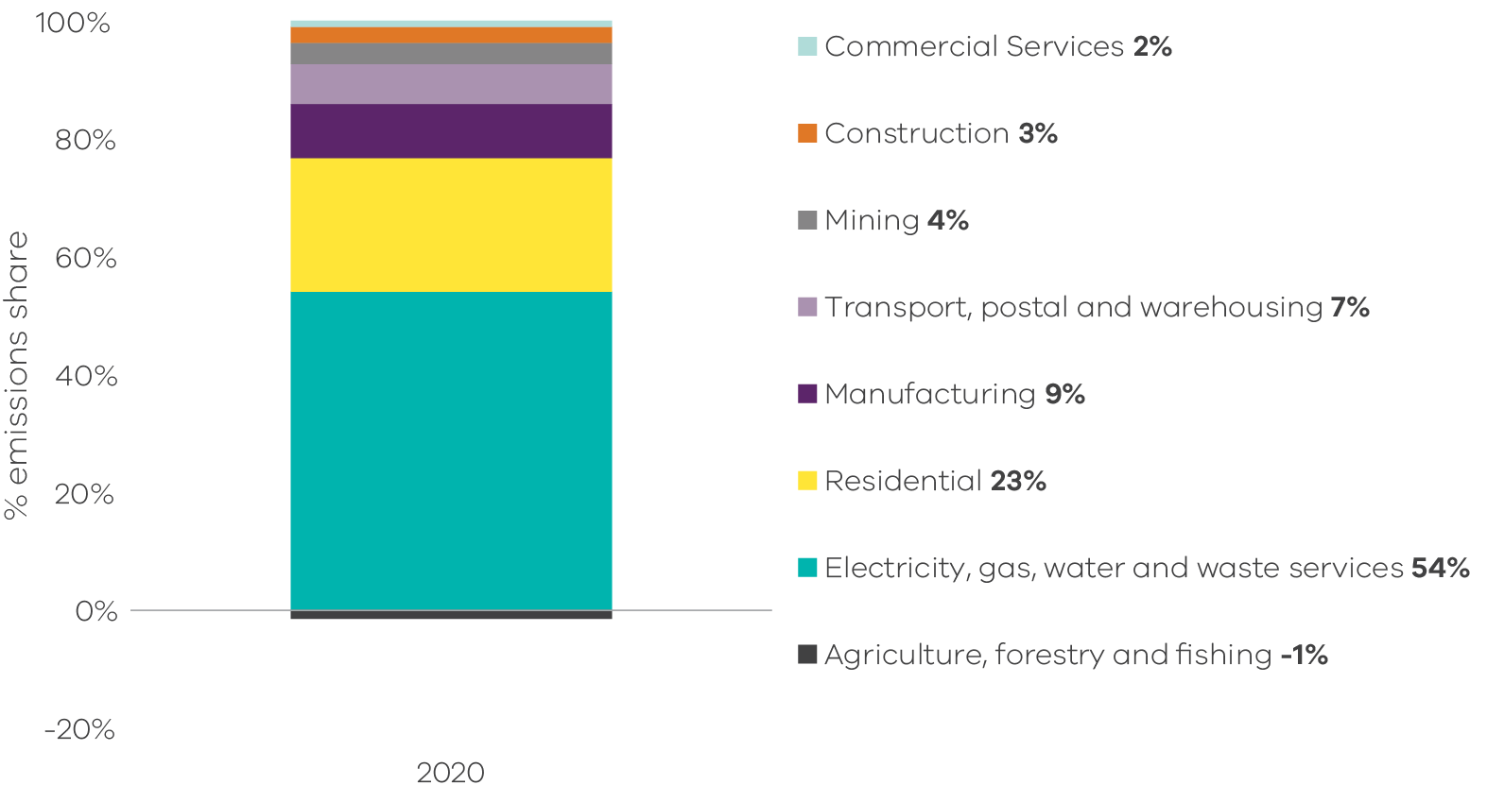
Source: Australian Greenhouse Emissions Information System (DCCEEW 2022a)
  - Allocation of Scope 2 emissions from electricity generation to end-users
In this section, emissions resulting from electricity generation are allocated to economic sectors according to the volume of electricity consumed by each sector. The emissions attributable to electricity consumption are referred to as indirect or Scope 2 emissions.
Information on sectoral responsibility for Scope 2 emissions enables a deeper understanding of the demand drivers responsible for electricity sector emissions.
Figure 48 shows that in 2020, commercial services (35%) was responsible for the largest share of Scope 2 emissions, followed by the residential (24%) and manufacturing (21%) sectors. The electricity, gas, water and waste services sector (14%) includes emissions associated with electricity consumed by this sector for its own use.
Note – unlike the emissions accounting reflected in Chapter 2 in which emissions from electricity generation are accounted for in the state or territory where generation takes place, the approach to allocating Scope 2 emissions to end-use economic sectors takes into account net imports and exports of electricity between jurisdictions through the National Electricity Market. Scope 2 emissions factors reflect data on electricity generation and emissions in each state or territory.
Figure 48: Share of Scope 2 emissions by economic sector – Victoria, 2020
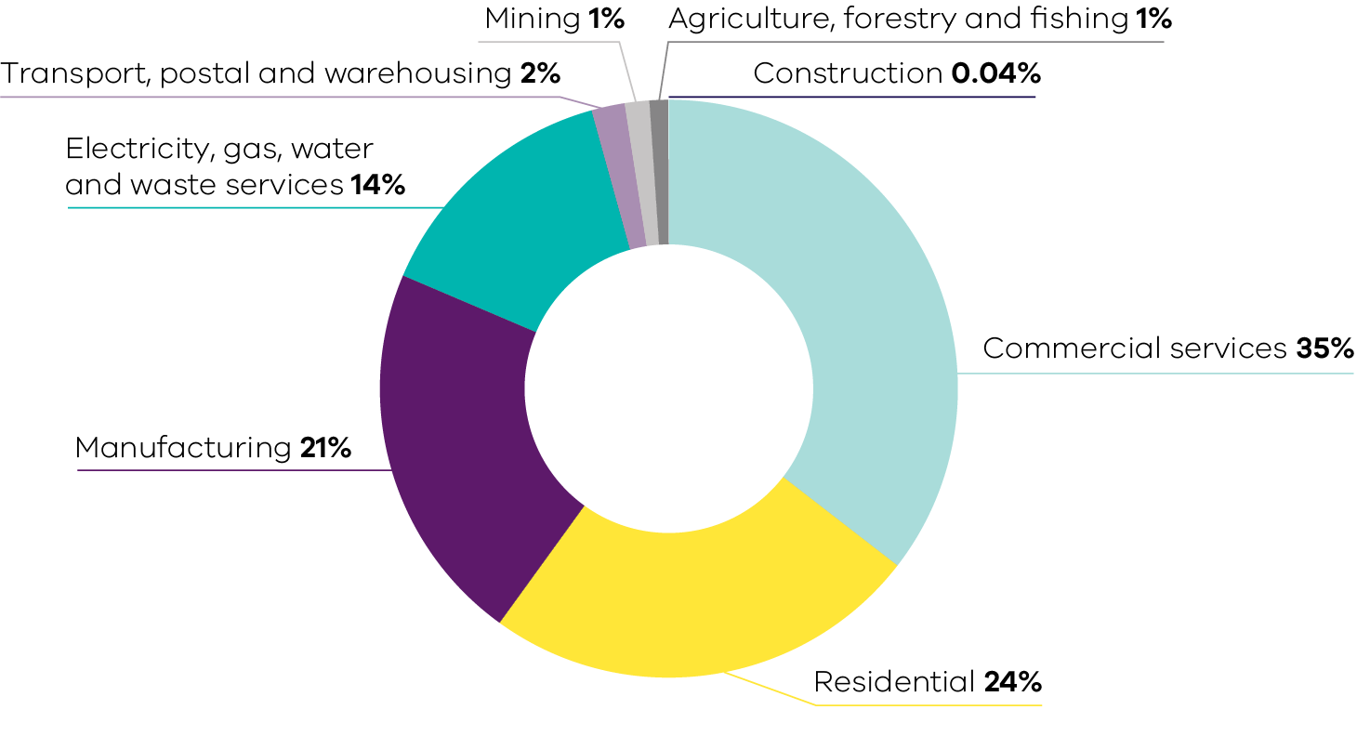
Source: Australian Greenhouse Emissions Information System (DCCEEW 2022a)
  - Scope 1 plus Scope 2 emissions by economic sector
This section combines the analysis in the previous two sections to allocate Scope 1 plus Scope 2 emissions to each economic sector.
Consistent with DCCEEW’s approach to the National Greenhouse Gas Inventory, the electricity, gas, water and waste services sector is excluded from this allocation process to avoid double counting of Scope 1 emissions from electricity generation which are fully allocated to other sectors that consume the electricity.
Figure 49 shows that in 2020, the residential sector was responsible for the largest share of Scope 1 plus Scope 2 emissions (28.5 Mt CO₂-e, 40%), followed by commercial services (15.9 Mt CO₂-e, 22%) and manufacturing (15.9 Mt CO₂-e, 22%).
Figure 49: Scope 1 plus 2 emissions by economic sector – Victoria, 2020
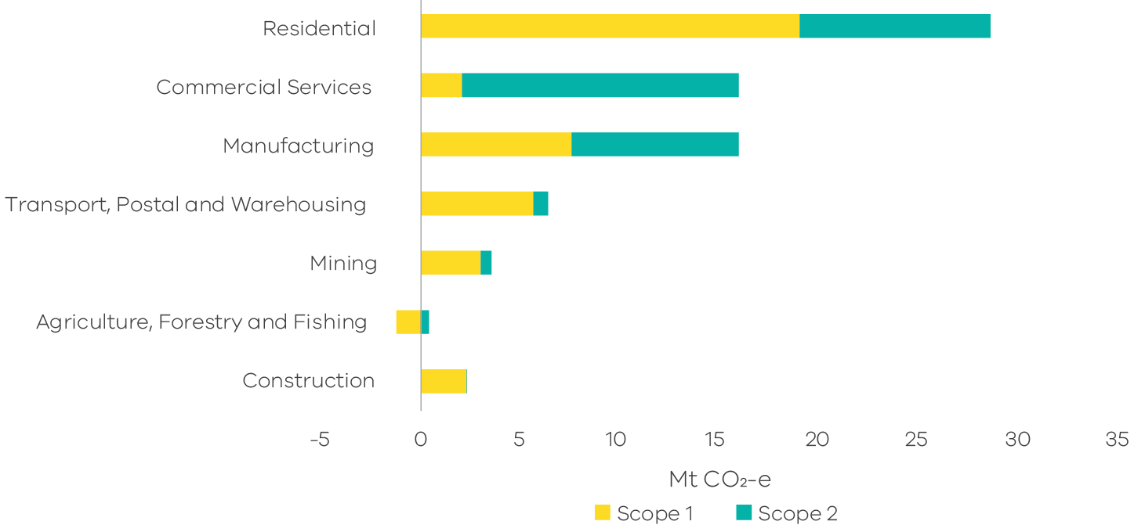
Source: Australian Greenhouse Emissions Information System (DCCEEW 2022a)

Appendix A: Revision of historical greenhouse gas emissions data
DCCEEW reviews and, as necessary, revises national and state/territory greenhouse gas data annually to ensure the data are produced in a manner consistent with the latest international methodologies; and to reflect improved estimation methods and new sources of information as these become available. To maintain consistency of data series across time, when revisions occur, past emissions estimates are recalculated for all years in the historical record to 1990.
This review process has resulted in revised emissions data for Victoria for the years 1990 to 2019 – particularly for the LULUCF and fugitive emissions from fuels sectors. Consequently, data for 1990 to 2019 in this year’s report differ from those presented in the Victorian Greenhouse Gas Emissions Report 2019.
A summary of these recalculations by sector, together with an explanation of the changes, is presented in section 10.1 of the National Inventory Report 2020 – Volume 2 (DCCEEW 2022c).
The most significant points to note in relation to Victoria are:
- FullCAM and carbon stock modelling updates (LULUCF sector) that reflect
- updates to FullCAM parameters and plantations recalibrations to incorporate a thinning response;
- carbon stock changes from the combustion and subsequent recovery of live biomass based on expanded spatial simulation of prescribed fires; and
- adoption of more comprehensive representative calibration dataset via collaborations with industry.
- Developments in fugitive emissions from fossil gas distribution (fugitives emissions from fuels sector) – changes reflect a new methodology based on facility-based estimation in accounting for unaccounted for gas (UAFG) in gas distribution (instead of using the previous method of aggregating data to a state level and multiplying by a fixed UAFG percentage).
Minor revision to HFCs emissions estimation (IPPU sector) – revision to equipment retirement mechanism and disposal profile, as well as other minor improvements to the HFC modelling.
Figure 50 shows the trend in Victoria’s total net emissions between 1990 and 2019 as presented in the Victorian Greenhouse Gas Emissions Report 2019 and the current (2020) report.
Figure 50: Change in trends in Victoria’s total net emission between 1990 and 2019 in the 2020 v 2019 emissions reports
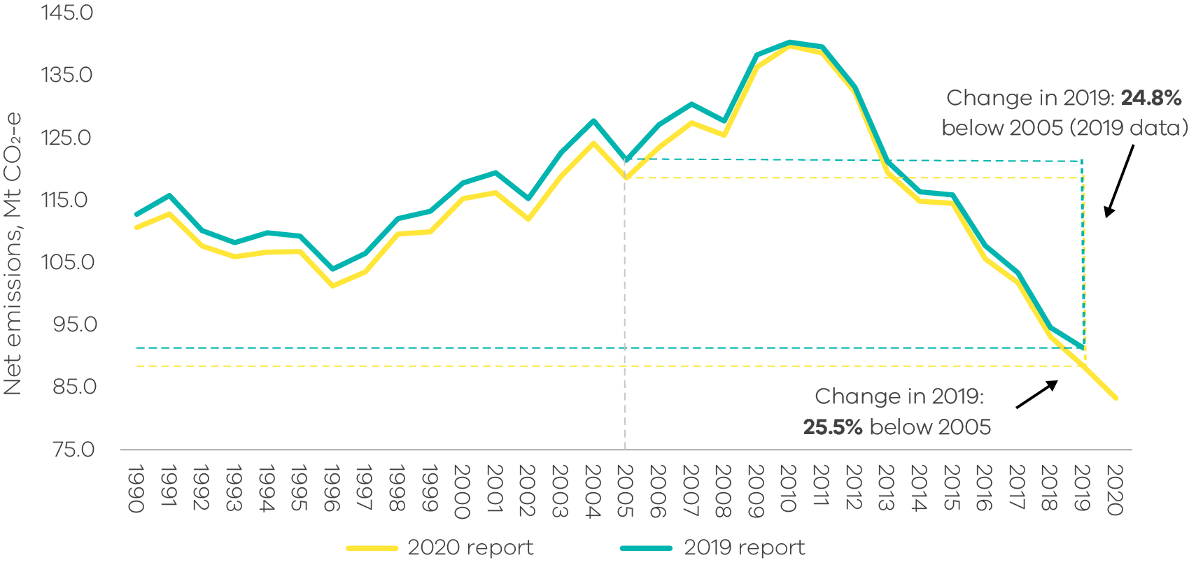
Source: State and Territory Greenhouse Gas Inventories 2020 (DCCEEW 2022d) and State and Territory Greenhouse Gas Inventories 2019 (DCCEEW 2021c)
Table 2 focuses on the impact of these changes in 2005 and 2019 – it shows that:
- total net emissions in 2005 have been revised from 121.4 Mt CO₂-e to 118.6 Mt CO₂-e (a reduction of 2.86 Mt CO₂-e); and
total net emissions in 2019 have been revised from 91.3 Mt CO₂-e to 88.4 Mt CO₂-e (a reduction of 2.92 Mt CO₂-e).
Consequently, the Victorian Greenhouse Gas Emissions Report 2020 shows Victoria’s total net emissions in 2019 were 25.5% below 2005 levels whilst the Victorian Greenhouse Gas Emissions Report 2019 showed the reduction between 2005 and 2019 as being 24.8%.
While there have been minor changes in historical data in most sectors and sub-sectors, the most significant change is in the LULUCF sector which has seen estimated net sequestration increase by 2.46 Mt CO₂-e in 2005 and 2.42 Mt CO₂-e in 2019 in the 2020 emissions report compared with the 2019 report.
Further detail on the changes in LULUCF data is presented in section A.1.
Table 2: Change in emissions by sector between 2005 and 2019 as reported in 2020 vs 2019Victorian Greenhouse Gas Emissions Reports
Source: State and Territory Greenhouse Gas Inventories 2020 (DCCEEW 2022d) and State and Territory Greenhouse Gas Inventories 2019 (DCCEEW 2021c)
Sector/sub-sector | Difference in emissions (Mt CO₂-e) 2005 | Difference in emissions (Mt CO₂-e) 2019
Electricity generation | 0.00 | 0.00
Fuel combustion | 0.00 | 0.09
Transport | 0.00 | -0.01
Fugitive emissions | 0.00 | -0.78
IPPU | -0.26 | 0.21
Agriculture | 0.00 | 0.00
LULUCF | -2.46 | -2.42
Waste | -0.14 | 0.00
Total | -2.86 | -2.92

A.1 – Further detail on revisions to historical LULUCF data
Figure 51 shows the trend in LULUCF emissions between 1990 and 2019 as presented in the 2019 and 2020 reports.
Figure 51: Change in trends in LULUCF emissions between 1990 and 2019 in the 2020 v 2019 emissions reports
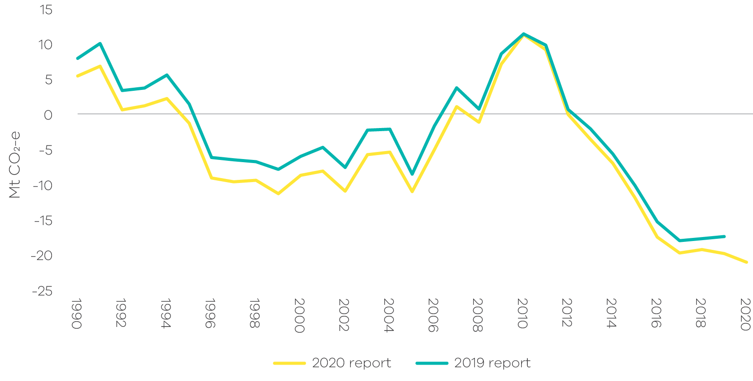
Source: State and Territory Greenhouse Gas Inventories 2020 (DCCEEW 2022d) and State and Territory Greenhouse Gas Inventories 2019 (DCCEEW 2021c)
Changes by LULUCF sub-category
Figure 52 disaggregates the data in Figure 51 according to major LULUCF sub-categories:
- Forest land remaining forest land – changes in this sub-category contributed significantly to the revised trends in LULUCF data between 1990 and 2019. Key factors contributing to the changes include: updated spatial observations of forest cover change and revised weather and climate data using improved methodology for pre-1990 plantations; and a reduction in the maximum time used in FullCAM for forest to recover live biomass after partial harvest.
- Grassland remaining grassland – changes in this sub-category contributed moderately to overall revised trends between 1990 and 2019. The changes result from a revision of land areas and land-use allocations across the LULUCF sectors; an update of the clay content map layer and database updates affecting the crop yield and grazing pressure; revision of activity data for grass and shrub transitions and biomass burning emissions due to annual updates in image analysis and updated carbon dynamics modelling consistent with the revisions for non-temperate fire management.
- Land converted to forest land – changes in this sub-category had a minor impact on historical data between 1990 and 2000. After 2000, the changes were discernible but had less impact on LULUCF emissions than the previous two sub-categories. Factors that contributed to the changes for this sub-category include: plantation recalibration to incorporate a thinning response and updates to FullCAM parameters; changes to spatial inputs and FullCAM calibration with the introduction of coastal sub-model; spatial updates to clay content data layer based on new soil-data; revision of spatial datasets for forest cover change based on annual analysis of satellite imagery; and non-temperate fire updates.
- Cropland remaining cropland – changes in this sub-category had a minor impact on historical data between 2009 and 2019 but had a small yet discernible impact in the period prior to 2009. Changes reflect: a revision of land areas and land-use allocations across LULUCF sectors; an update of the clay content map layer; database updates affecting the crop yield and grazing pressure; and minor corrections to the perennial woody crop parameters.
Forest land converted to other uses – changes in this sub-category had a minor impact on historical data across 1990 to 2019 – sequestration across the timeseries has been reduced by an average of 0.1 Mt CO₂-e p.a. Contributions to changes include: updates and improvements in spatial observations of forest cover change and in agricultural parameters; an update of the clay content map layer; non-temperate fire updates; updated application of stratified emission factor values that are based on both soil type and climate zone; and updated CH₄ and CO₂ emissions from young reservoirs (up to 20 years old).
Figure 52: Emissions from Victoria’s main LULUCF sub-categories – Comparison of 2019 and 2020 reports
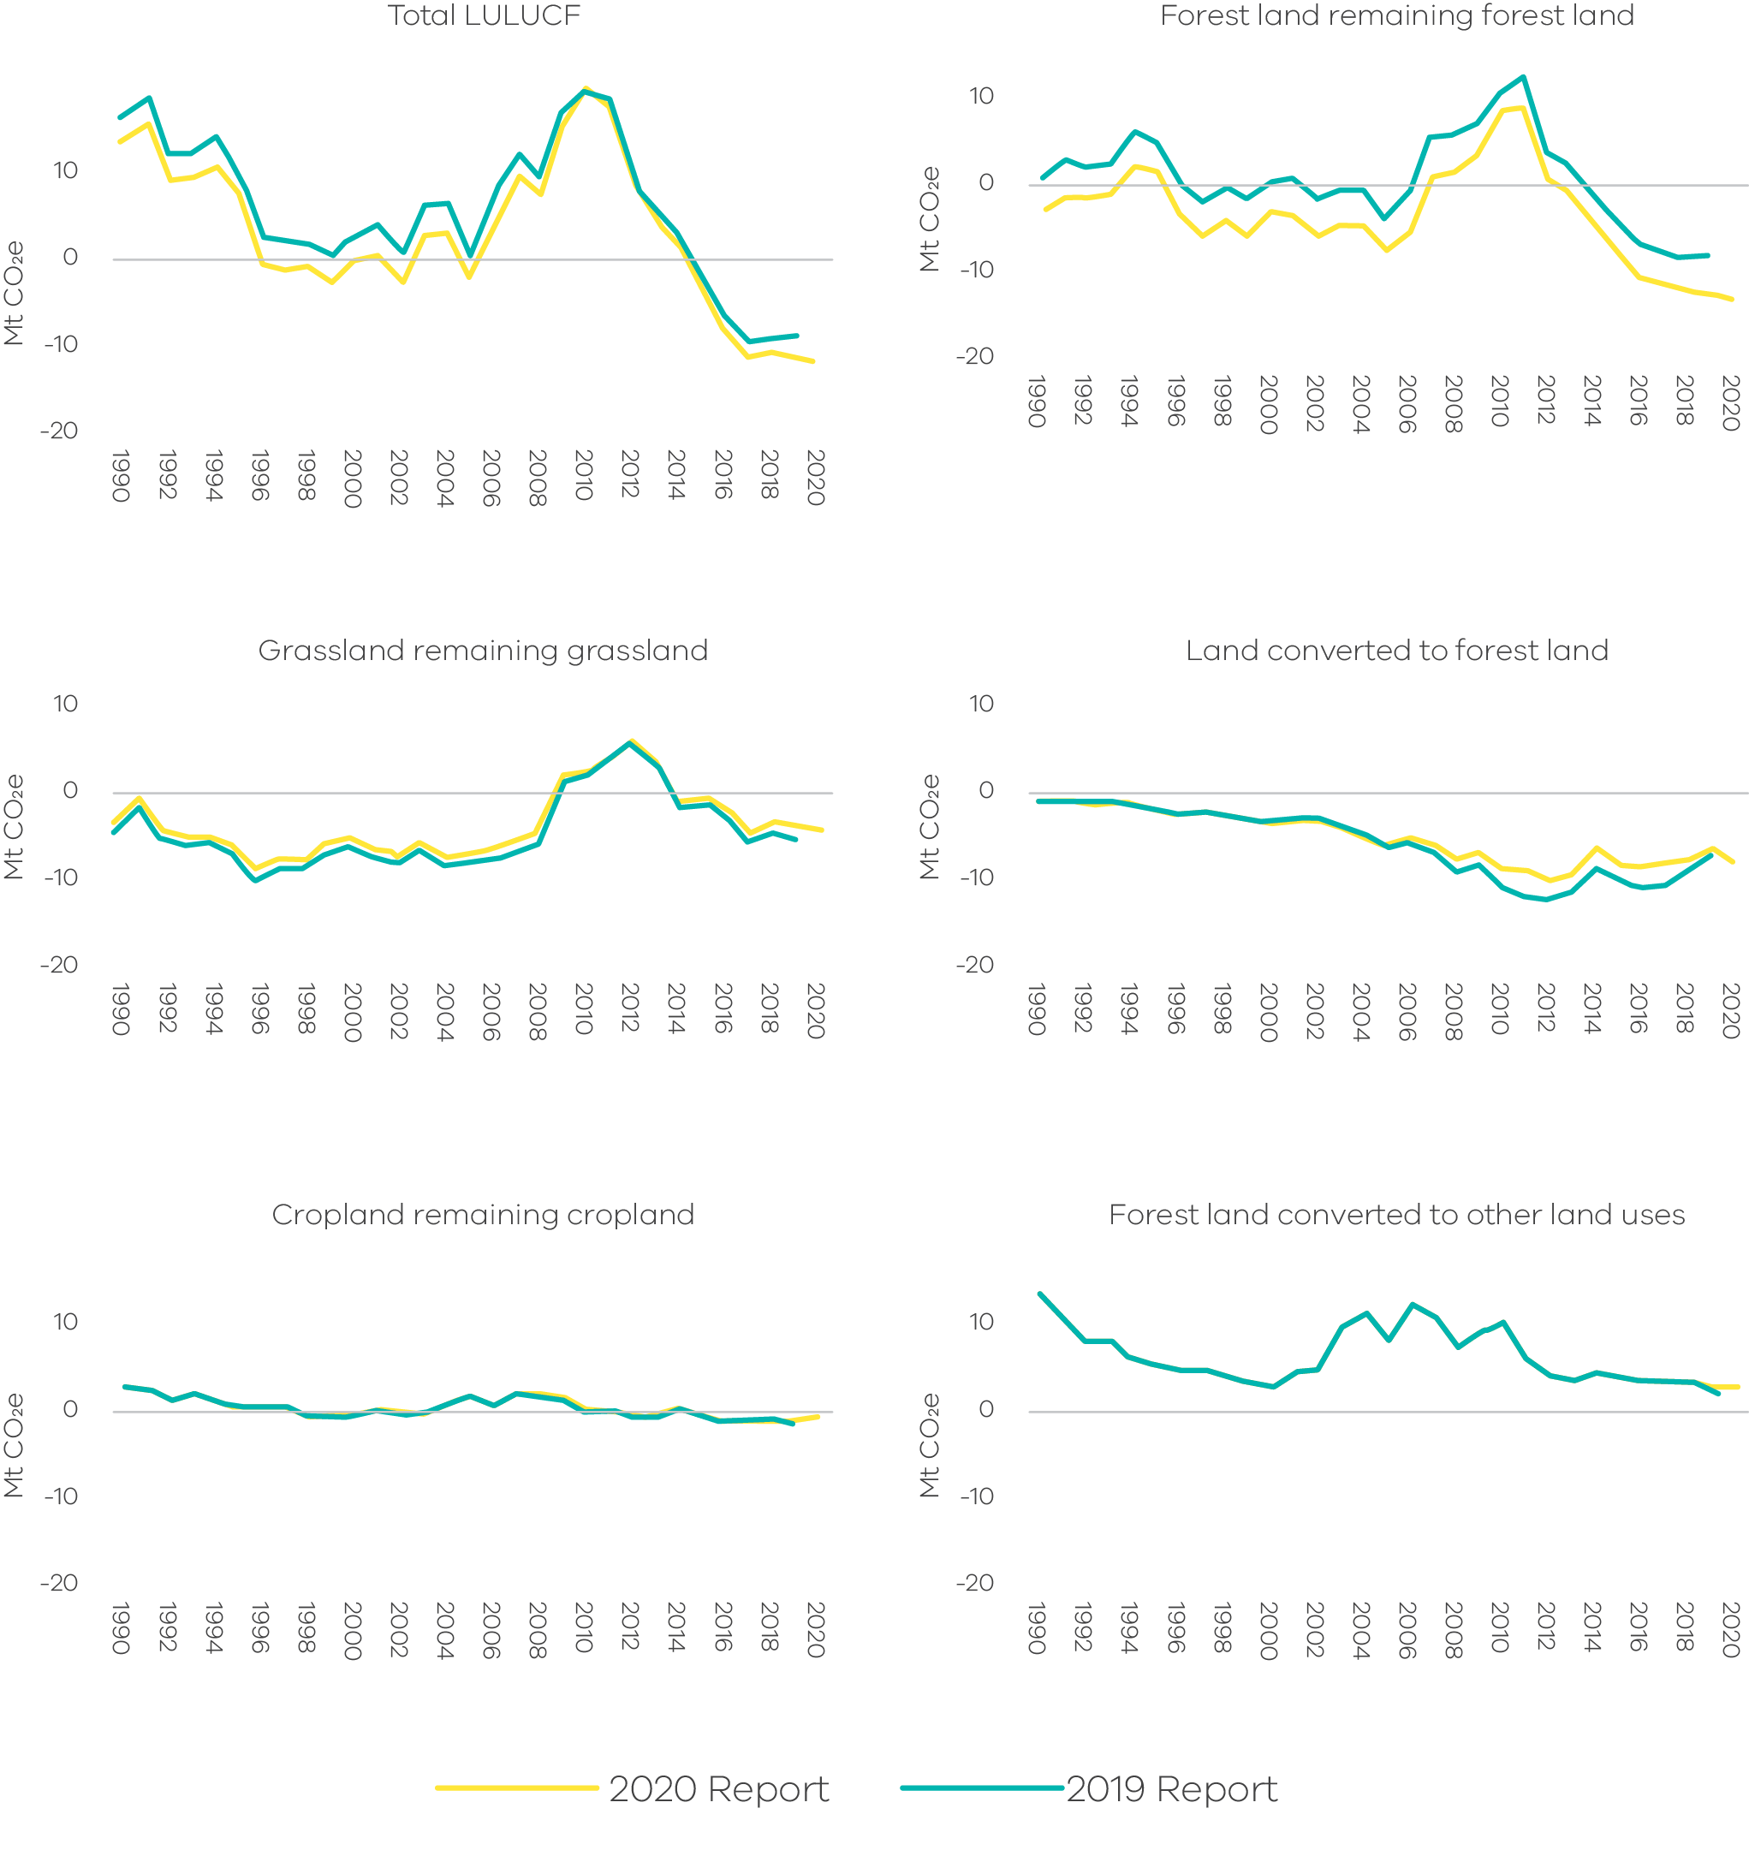
Source: State and Territory Greenhouse Gas Inventories 2020 (DCCEEW 2022d) and State and Territory Greenhouse Gas Inventories 2019 (DCCEEW 2021c)

Abbreviations and acronyms
AEMO | Australian Energy Market Operator
The Act | Climate Change Act 2017
ANZSIC | Australian and New Zealand Standard Industrial Classification
CH4 | Methane
CO₂ | Carbon dioxide
CO₂-e | Carbon dioxide equivalent
DCCEEW | Commonwealth Department of Climate Change, Energy, the Environment and Water
FullCAM | Full Carbon Accounting Model
GPG | Gas-powered generation
GSP | Gross State Product
HCFCs | Hydrochlorofluorocarbons
HFCs | Hydrofluorocarbons
HWP | Harvested Wood Products
IPCC | Intergovernmental Panel on Climate Change
IPPU | Industrial Processes and Product Use
KP | Kyoto Protocol
LULUCF | Land use, land-use change and forestry
N2O | Nitrous oxide
Mt | Million tonnes
MW | Megawatt
MWh | Megawatt hours
NEM | National Electricity Market
ODS | Ozone-Depleting Substances
PFCs | Perfluorocarbons
PJ | Petajoules
pkm | Passenger kilometres
SF6 | Sulphur hexafluorides
UAFG | Unaccounted for gas
UNFCCC | United Nations Framework Convention on Climate Change
vkm | Vehicle kilometres

References
Australian Bureau of Statistics (ABS). 2021a. "Australian National Accounts: State Accounts, 2020-21” In Table 1 – Gross State Product, Chain volume measures and current prices. Canberra. Commonwealth of Australia
———. 2021b. “Australian National Accounts: State Accounts, 2020-21” In Table 3 – Expenditure, Income and Industry Components of Gross State Product, Victoria, Chain volume measures and current prices. Canberra. Commonwealth of Australia
———. 2021c. “93090DO001_2021 Motor Vehicle Census, Australia, 2021” In Table 5 – Motor Vehicles on Register, Type of fuel–by State/Territory: Census years. Canberra. Commonwealth of Australia.
———. 2022a. "Australian Demographic Statistics, Sep 2021." Canberra. Commonwealth of Australia
———. 2022b. “Retail Trade, Australia, April 2022”. Canberra. Commonwealth of Australia
Australian Energy Market Operator (AEMO) 2022a. Electricity – Generation Information Page, NEM Generation Information Pages
———. 2022b. ‘NEM Engineering Framework – priority actions’, June 2022
Australian Energy Regulator (AER). 2020. "State of the Energy Market 2020." Melbourne. Commonwealth of Australia
———. 2021. “State of the Energy Market 2021.” Melbourne. Commonwealth of Australia
Bureau of Infrastructure and Transport Research Economics (BITRE). 2021a. "Australian infrastructure statistics Yearbook 2021. Canberra. Commonwealth of Australia
———. 2021b. " Australia’s light vehicle fleet – some insights" Canberra. Commonwealth of Australia.
———. 2022. "Airport Traffic Data 1985–86 to 2020–21." Canberra. Commonwealth of Australia
Brodribb and McCann. 2020. "Cold hard facts 2020", edited by Expert Group. Canberra Commonwealth of Australia
Brodribb, McCann and Dewerson. 2021. “Cold Hard Facts 2021”, edited by Expert Group, report prepared for the Department of Agriculture, Water and the Environment, Canberra. Commonwealth of Australia
Clean Energy Regulator (CER). 2018. "Greenhouse and energy information for designated generation facilities 2015-16." Canberra. Commonwealth of Australia
———. 2021. "Greenhouse and energy information for designated generation facilities 2019-20." Canberra. Commonwealth of Australia
———. 2022. "Postcode data for small-scale installations." Canberra. Commonwealth of Australia
Department of Environment, Land, Water and Planning (DELWP). 2021. Victorian Renewable Energy Target 2020/21 Progress Report. Melbourne. The State of Victoria.
Department of Climate Change, Energy, the Environment and Water (DCCEEW). 2020a. “Australian Petroleum Statistics – Issue 287. June 2020.” In Sales of petroleum products by state marketing area, by month, Australia. Canberra. Commonwealth of Australia
———.2020b. “Estimating greenhouse gas emissions from bushfires in Australia’s temperate forests: focus on 2019-20.” Canberra. Commonwealth of Australia
———.2021a. "Australian Energy Statistics." In Table F – Australian energy consumption, by state and territory, by industry and fuel type, energy units. Canberra. Commonwealth of Australia
———. 2021b. "Australian Energy Statistics” In Table I – Australian production of primary fuels, by state and territory, physical units. Canberra. Commonwealth of Australia
———. 2021c. "State and Territory Greenhouse Gas Inventories 2019." Canberra. Commonwealth of Australia
———. 2021d. “Australian Energy Update 2021” Canberra. Commonwealth of Australia
———. 2022a. "Australian Greenhouse Emissions Information System." Canberra. Commonwealth of Australia
———. 2022b. "Australian Energy Statistics.” In Table O – Electricity generation in Victoria, by fuel type, physical units, April 2022. Canberra. Commonwealth of Australia
———. 2022c. "National Greenhouse Gas Inventory Report: 2020." Canberra. Commonwealth of Australia
———. 2022d. "State and Territory Greenhouse Gas Inventories 2020." Canberra. Commonwealth of Australia
Essential Services Commission (ESC) 2022, “Victorian Energy Upgrades Performance Report 2021”, June 2022
Google 2022. “COVID-19 Community Mobility Reports”, Accessed 22 June 2022. https://www.google.com/covid19/mobility/
Madonald-Smith 2019. “AGL hit by further outages at Loy Yang”, The Australian Financial Review, Accessed 22 June 2022. https://www.afr.com/companies/energy/agl-hit-by-further-outages-at-loy-yang-20190918-p52sn4
National Transport Commission (NTC). 2021. “Carbon Dioxide Emissions Intensity for New Australian Light Vehicles 2020.” Melbourne. Commonwealth of Australia
Solar Victoria (SV) 2022. ”Solar Homes Program reporting – July 2022”

2020 is the latest year for which official emissions data, published by the Commonwealth Government, is available.
This sector has been renamed from direct combustion in previous reports to fuel combustion to be consistent with the naming convention used by the Commonwealth Government.
Percentage contributions of each sector are calculated in terms of sectors' shares of total net emissions (which takes into account net sequestration by the LULUCF sector).
Activity is defined as a process that generates greenhouse gas emissions or uptake. In some sectors, it refers to the level of production or manufacture for a given process or category (DCCEEW 2022c).
Transport activity refers to vehicle kilometres travelled and transport fuel consumed (DCCEEW 2022c).
DCCEEW prepares National Greenhouse Accounts that include a series of annual publications to meet Australia’s international obligations under the UNFCCC and Kyoto Protocol (KP). These include State and Territory Greenhouse Gas Inventories and the National Inventory Report. Victoria’s Greenhouse Gas Emissions reports apply UNFCCC accounting provisions rather than KP accounting because the former includes a more comprehensive set of land categories and the identification of emissions from land clearing events. UNFCCC reporting rules and guidelines are those adopted under decision 24/CP.19 – known as the Revision of the UNFCCC reporting guidelines on annual inventories for Parties included in Annex I to the Convention; and the Intergovernmental Panel on Climate Change (IPCC) 2006 Guidelines for National Greenhouse Gas Inventories (IPCC 2006).
Financial years to June 30 – for example, the year 2012 refers to the Australian financial year from 1 July 2011 to 30 June 2012.
Residential sector per capita emissions are residential sector emissions divided by population. Residential sector emissions are emissions arising from activities in households involving the consumption of electricity, the consumption of gas for heating and/or cooking, transport activities, the use of refrigeration and air conditioning units and the use of waste and wastewater services. To allocate emissions associated with residential sector use of transport fuels and refrigerants, DCCEEW has used either information from the National Greenhouse and Energy Reporting (NGER) scheme, or economic modelling utilising the most recent version of the Supply-Use Tables, their corresponding Input-Output Tables for product details and the Energy Account published by the Australian Bureau of Statistics (ABS) (DCCEEW 2022c).
DCCEEW produces LULUCF emissions data under the rules for reporting applicable to both the UNFCCC and the Kyoto Protocol. Victorian Greenhouse Gas Emissions reports apply the UNFCCC’s emissions accounting provisions
Percentage contributions of each sector are presented as a share of total net emissions (i.e. they take into account sequestration in the LULUCF sector).
In this report, shares of emissions from each sector are compared against Victoria’s total net emissions, which includes negative emissions from sequestration in the LULUCF sector. Using this approach, the shares of emissions from non-LULUCF sectors add up to more than 100%. When sequestration from the LULUCF sector is excluded, energy emissions were 78.3% of total emissions from Victoria’s non-LULUCF sectors in 2020.
Fuel consumption data sourced from Australian Energy Statistics and adjusted to exclude international aviation fuel. This is consistent with the UNFCCC accounting framework which excludes international aviation and shipping for national inventories.
FCAI’s 2020 emissions intensity figure for new passenger cars and light SUVs was estimated using a different methodology than that used by NTC in previous years. Therefore the comparison between 2002 and 2020 is only indicative
For instance, the average emissions intensity of new passenger vehicles in Australia is higher than each of the 30 member states of the European Economic Area, which had an average of 122 gCO2 per km in 2019 (NTC 2021).
Also includes emissions from flaring during exploration.
These emissions are from equipment operating as designed, as opposed to leakages.
Data are not available for most HFC emissions sources prior to 1995.
Australian bank of refrigerants refers to the sum of all refrigerants contained in refrigeration and air conditioning equipment in Australia (Brodribb and McCann 2020)
Estimates of Victorian HFC-related IPPU emissions are subject to uncertainty and are based on data from DCCEEW. DCCEEW estimates State and Territory product use emissions from ozone-depleting substances (ODS) substitutes (primarily HFCs) by dividing national emissions from ODS substitutes by the population of each state/territory.
Biogenic CO2 from paper, wood, garden, food or other biomass is assumed to experience uptake and release within 100 years through photosynthesis. As per 2006 IPCC Guidelines, biogenic CO2 is assumed to have a neutral global warming potential and, as such, is reported as a memo item in the National Inventory Report.
Principles of conversion of carbon and mass are respected when estimating rates of decomposition – consequently, no double counting of carbon occurs.
DCCEEW produces LULUCF emissions data under the rules for reporting applicable to both the UNFCCC and under the Kyoto Protocol. The Victorian Greenhouse Gas Emissions Report 2020 uses LULUCF data following the UNFCCC emission accounting provisions. The definitions of the land relating to each LULUCF sub-category and the principal sources of emissions and removals are available in National Inventory Report 2020 Volume 2 Chapter 6.
Fires here refer primarily to controlled burning. Extreme natural disturbance fires are excluded
Forests include all vegetation with a vegetation height of at least 2 metres and crown canopy cover of 20% or more and lands with systems with a woody biomass vegetation structure that currently fall below these threshold but which, in situ, could potentially reach the threshold values of the definition of a forest.
These four sub-categories account for more than 90% of total emissions from the LULUCF sector. While emissions from other sub-categories are not described in this section of the Report, their net emissions are accounted for in the total net LULUCF emissions presented in Figure 41 and Figure 42.
Wetter climate conditions stimulates microbial activity in soils, resulting in higher emissions from soil microbes.
The electricity, gas, water and waste services sector's Scope 2 emissions include own use by electricity generators that does not necessarily meet the National Greenhouse Accounts (NGA) Factors 2020 definition of scope 2 emissions.

