Victoria’s Climate Change Strategy 2026–30
Table of Contents
Acknowledgement of Country 3
Foreword 4
Net zero: A prosperous, fair and strong Victoria 5
Victoria is leading the nation 6
Victoria is a global leader 7
We're delivering results 8
Supporting a thriving economy 9
Climate change is impacting Victoria now 10
Achieving our ambitious targets 11
Where Victoria's emissions come from 12
Our pledges will cut emissions across sectors 14
Focusing on what matters to Victorians 16
Helping households with the cost of living and lowering costs for business 17
Putting jobs and workers first in the transition 24
Building for the future 33
Protecting our kids, families and communities 38
Progressing self-determination 44
Yoorrook Justice Commission 45
Next steps 47
New Adaptation Action Plans 48
Appendix: Reporting on Victoria’s Climate Change Strategy 2021–25 50
Our strategy delivered real benefits 51
Glossary 53
Publication information 56

Acknowledgement of Country
The Victorian Government acknowledges Traditional Owners as the original custodians of the lands, waters and sea across Victoria.
For tens of thousands of years, Traditional Owners in Victoria have practised lore, customs and languages – these practices offer knowledge systems and the foundation of a culture designed to sustainably care for Country and respond to the challenges of climate change.
In the face of colonisation and dispossession, Traditional Owner communities remain diverse and resilient, with deep and ongoing connections to Country.
We know climate change disproportionately impacts Traditional Owner communities by compounding the loss of connections to Country and by posing a risk to cultural heritage, including traditional lores, customs and practices.
The Victorian Government recognises that only Traditional Owners can speak for Country and the knowledge, know-how, skills and practices of traditional knowledge systems. Victoria is also on a pathway to Treaty, which aims to ensure Traditional Owners always have the freedom and power to make decisions that affect their communities, culture and Country.
The Victorian Government is committed to self-determination, as outlined in the Victorian Aboriginal Affairs Framework and Self-Determination Reform Framework. Traditional Owners' legal and cultural rights in Victoria are recognised through both state and federal legislation, including the Traditional Owner Settlement Act 2010 (Vic), Aboriginal Heritage Act 2006 (Vic), and Charter of Human Rights and Responsibilities Act 2006 (Vic), and the Native Title Act 1993 (Cth).
Through this strategy, the Victorian Government continues its commitment to self-determination and forming genuine partnerships with Traditional Owners and Aboriginal Communities.

Foreword
Victoria has come a long way since releasing our last Climate Change Strategy in 2021.
We’ve built for the future – by bringing back the SEC, to put power back in the hands of the people, with an initial $1 billion investment in renewable energy.
We’ve delivered cost of living help for households – by passing nation-leading energy standards for renters and homes, and expanding bill-saving programs like the VEU.
We’ve put Victorian jobs and workers first – with Australia’s first Gas Substitution Roadmap, to reserve gas for local industry, and help households slash their energy bills.
We’ve secured a better future for our kids – by bringing forward our net zero target to 2045, and enshrining this in legislation.
We’re proud of our achievements and record – but we know there is still more to do.
This Climate Change Strategy 2026–30 sets a course for the next five years of our state’s transition, with a firm focus on what matters most to Victorians: helping with the cost of living; building for the future; putting jobs and workers first; and protecting kids, families and communities.
It’s not an exhaustive list of everything we’ll do in that time – we’ve always made policy continuously, and we’ll continue doing that. Victoria has led the nation on climate action, and we'll continue to do so.

Hon. Jacinta Allan MP
Premier of Victoria
Hon. Lily D’Ambrosio MP
Minister for Climate Action
Minister for Energy and Resources
Minister for the State Electricity Commission

Net zero: A prosperous, fair and strong Victoria

Climate action and prosperity go hand in hand
We're building a net zero economy that keeps Victoria growing – creating new jobs, attracting investment and supporting industries to stay competitive and resilient.

A fair and people-first transition will benefit all Victorians
We're prioritising equity and inclusion on the path to net zero emissions, to ensure all workers and communities can benefit from new opportunities.

Preparing for climate impacts protects our future
We're acting now to safeguard our communities, environment and livelihoods from climate impacts – building a stronger future for generations to come.
Victoria's Climate Change Strategy 2026–30 is focused on what matters. It is backed by over $8.5 billion announced since the last Climate Change Strategy in 2021, building on the $2 billion that backed it then.

Victoria is leading the nation
- Earliest net zero emissions target of any major jurisdiction in Australia
- First jurisdiction in Australia to set a 2035 target
- Nation-leading minimum energy standards for renters (one-third of Victorians)
- Reduced emissions intensity 50% faster than the national average since 2014
- Brought back the SEC with a $1 billion initial investment
- First Gas Substitution Roadmap in the nation
- Biggest energy storage targets in the nation by 2035

Victoria is a global leader
Victoria is playing its part in limiting global temperature increase to 1.5°C
Table 1: 2035 targets
Country or state | 2035 target
Finland | Net zero
Scotland | 80%
Victoria | 75-80%
United Kingdom | 78%
Queensland | 75%
New South Wales | 70%
Australia | 62-70%
Japan | 59%
New Zealand | 51-55%
Canada | 45-50%

Countries producing over 80% of global greenhouse gas emissions have pledged to reach net zero

We're delivering results

Halved emissions per person since 2005
The bar chart below (Figure 1) shows emissions per person halved from 2005 (24.58 tonnes CO₂-e) to 2003 (12.35 tonnes CO₂-e).
Figure 1: Emissions per person halved from 2005 to 2023
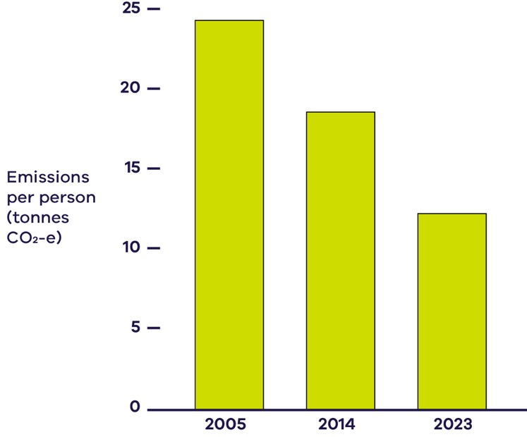
- 42% of electricity produced by renewable energy in 2024–25, and Victorian wholesale power prices were consistently the lowest in the country
- 30% of Victorian homes have solar installed
- 100% of electricity supplied by the SEC for Victoria's public schools, hospitals, trains and other government operations is from renewable sources
- 8x more zero emission vehicle sales compared to 2021
- 1.8 million hectares of state forest protected by ending native timber harvesting six years early

Supporting a thriving economy

Our economy has grown while we’ve cut emissions
The chart below (Figure 2) shows that GSP increased by 57.5% from 2005 to 2023, while emissions fell 31.4% from 2005 to 2023.
Figure 2: GSP increased by 57% from 2005 to 2023
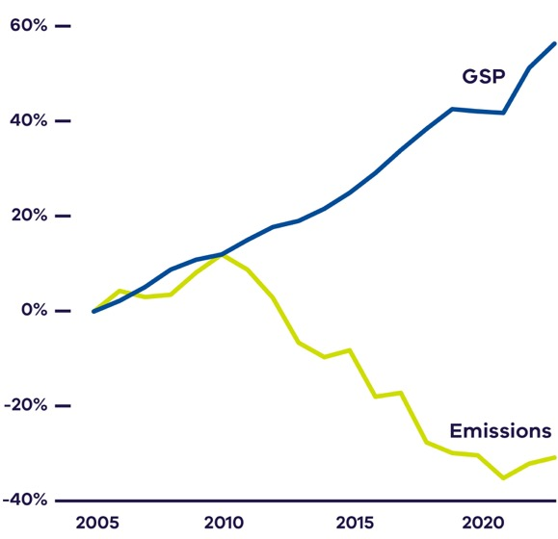

Creating future jobs and growth

Driving economic growth
Victoria’s gross state product is projected to be $63 billion higher between 2022 and 2070 if Victoria meets its targets and there is strong global action.

Delivering positive returns
Every $1 invested to improve resilience to climate change impacts could deliver a $9.60 return on investment. (Source: Insurance Council of Australia, 2022)

Creating new jobs
Victoria’s energy workforce is projected to grow by more than 60% by 2040 to 67,000 workers.

Climate change is impacting Victoria now
As of 2024:
- Average temperature has increased 1.2 °C since 1910
- The number of very hot days per decade has more than doubled since 1986–2005
- More intense, frequent and longer heatwaves since the 1950s
- Average annual rainfall has decreased, but extreme rainfall events have almost doubled since 1958–1985
- Snow depth and cover have decreased in alpine regions since the late 1950s
If global emissions continue to increase, by the 2050s Victoria can expect:
- Average temperature to increase by around 1.5 °C (1.1–1.9 °C)
- Hot days warmer by around 2 °C
- Around 40 heatwave days each year
- Increasingly intense extreme rainfall events, including thunderstorms
- Sea level rise between 0.13 m and 0.32 m
Find out more about Victoria's Climate Science Reports and Victoria's Future Climate Tool: climatechange.vic.gov.au/victorias-changing-climate

Achieving our ambitious targets
We’ve reduced emissions by 31.4% and are within range of our 2025 target.
The chart below (Figure 3) shows Victoria's greenhouse gas emission reduction targets below 2005 levels – 2020: 15-20%; 2025: 28-33%; 2030: 45-50%; 2035: 75-80%, and; net-zero by 2045.
The chart details historic greenhouse gas emissions in Victoria – 2005: 122.7 Mt CO₂-e; 2020: 84.6 Mt CO₂-e; 2023: 84.2 Mt CO₂-e. Data shows that we beat our 2020 target of 15-20% below 2005 levels.
The chart also shows that current actions will see Victoria’s emissions fall an additional 13 Mt CO₂-e by 2030, equivalent to 42% below 2005 levels.
Figure 3: Victoria's greenhouse gas emission reduction targets
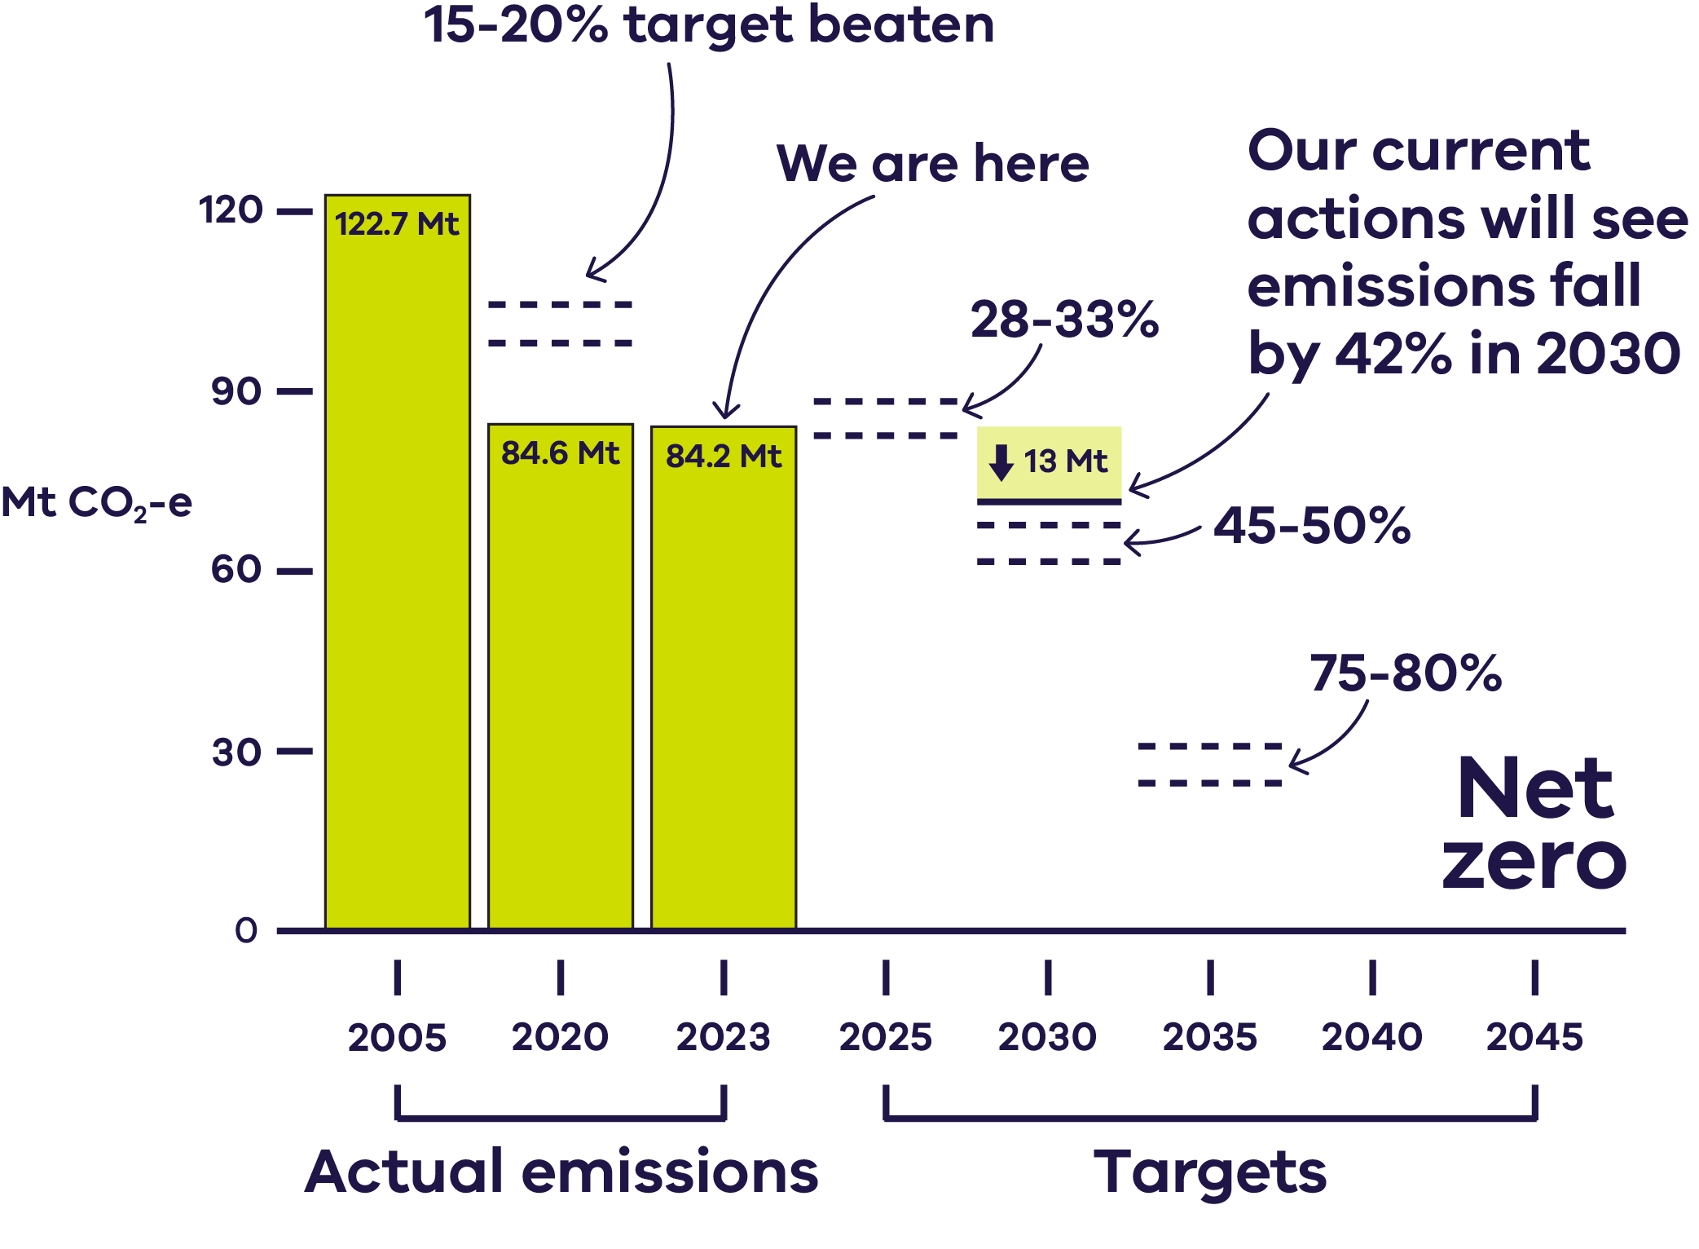
Note: Targets refer to % below Victoria's 2005 greenhouse gas emission levels
Our new emissions reduction pledges continue our strong progress – helping to meet our future targets.
Additional action by governments, communities and businesses will help us achieve our ambitious targets.

Where Victoria's emissions come from
Figure 4: Breakdown of Victoria’s total greenhouse gas emissions by sector
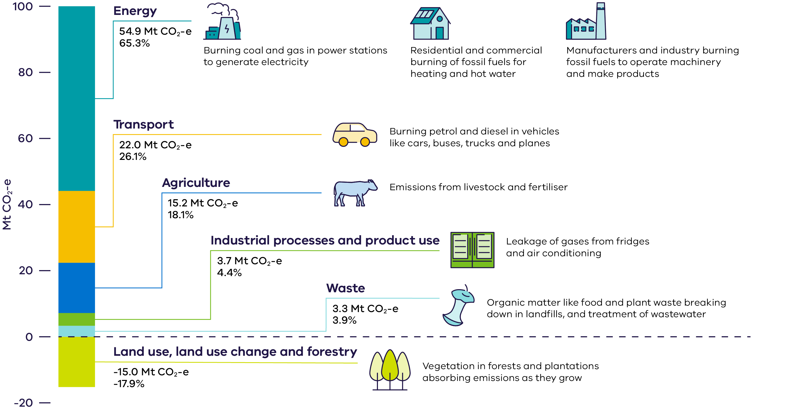
Victoria publishes its latest emissions at: climatechange.vic.gov.au/greenhouse-gas-emissions
Figures represent latest emissions data from 2023
Table 2: Breakdown of Victoria’s total greenhouse gas emissions by sector
Sector | Emissions (Mt CO₂-e) | Share of Total (%) | Main Sources / Description
Energy | 54.9 | 65.3% | Burning coal and gas in power stations to generate electricity; residential and commercial burning of fossil fuels for heating and hot water; manufacturers and industry burning fossil fuels to operate machinery and make products.
Transport | 22.0 | 26.1% | Burning petrol and diesel in vehicles such as cars, buses, trucks and planes.
Agriculture | 15.2 | 18.1% | Emissions from livestock and fertiliser.
Industrial processes and product use | 3.7 | 4.4% | Leakage of gases from refrigeration and air-conditioning systems.
Waste | 3.3 | 3.9% | Organic matter like food and plant waste breaking down in landfills, and treatment of wastewater.
Land use, land use change and forestry (LULUCF) | –15.0 | –17.9% | Vegetation in forests and plantations absorbing emissions as they grow.

Our pledges will cut emissions across sectors

Energy
Securing affordable and reliable renewable energy for Victorian households and businesses to create jobs and lower household bills.

Transport
Providing Victorians with greater sustainable transport options, and helping them lower their cost of living.

Agriculture
Partnering with industry to support a profitable and productive sector that takes ambitious action on climate change.

Waste
Building a thriving circular economy and reducing methane released from landfills.

Industrial processes and product use
Acting locally to improve how refrigeration, air-conditioning equipment and refrigerant gases are managed, while pushing for stronger national policies for cleaner alternatives.

Land use, land use change and forestry
Continuing to plant millions of trees across private and public land, boosting our agricultural sector and restoring our great outdoors – including through the BushBank Program.

Victorian Government operations
Leading by example and cutting emissions from government operations while driving action across the economy.
3x more emissions reductions from our combined pledges 2026–30, than our pledges 2021–25

To find out more
Visit: climatechange.vic.gov.au/victorian-government-action-on-climate-change

Focusing on what matters to Victorians
- Helping households with the cost of living and lowering costs for business
- Putting jobs and workers first in the transition
- Building for the future
- Protecting kids, families and communities

Helping households with the cost of living and lowering costs for business
We're helping Victorians benefit from our renewable energy future.
From efficient electric homes and appliances to solar panels and zero emission vehicles, our programs are making it easier to upgrade, electrify and save.

Empowering Victorians to be part of the energy transition
Solar Victoria has supported the installation of more than 324,000 rooftop solar systems and 70,000 hot water systems

Helping households shift to solar
Victorians are embracing rooftop solar on their offices, warehouses and homes. Rooftop solar contributed almost 11% of Victoria’s energy in 2024–25.
The Solar Homes Program is supporting Victorian households to reduce their energy bills and emissions with rebates and interest-free loans for rooftop solar and efficient hot water systems.
The Solar for Community Housing Program is also supporting a clean energy transition for some of Victoria's residents experiencing vulnerability and disadvantage by partnering with community housing providers to install rooftop solar panels to relieve pressures for low-income Victorians.

Go all-electric and save
The Gas Substitution Roadmap is helping households and businesses shift from fossil gas to cleaner, cheaper, electric alternatives. This preserves gas for the industries that need it, putting Victorian jobs and households first.
Existing households with solar photovoltaic (PV) who fully electrify their homes can save around $2,000 per year on their energy bills. That’s why we’ve introduced nation-leading standards and legislation to avoid locking in expensive and polluting new gas infrastructure, and to help Victorians slash their energy bills long-term.

Energy upgrades for homes and businesses
The Victorian Energy Upgrades (VEU) program helps households and businesses lower energy bills and cut emissions. Victorians can access rebates and discounts on energy-efficient products like electric appliances, weather sealing, and window glazing.
The VEU is the largest program of its kind in the country, and in 2024 alone it cut Victoria’s emissions by 4.9 Mt CO₂-e.
Over 2.4 million households and 180,000 businesses have participated in the VEU since 2009. Households have saved over $2 billion on their energy bills.

Figure 5: Energy-efficient, cost saving features for Victorian homes
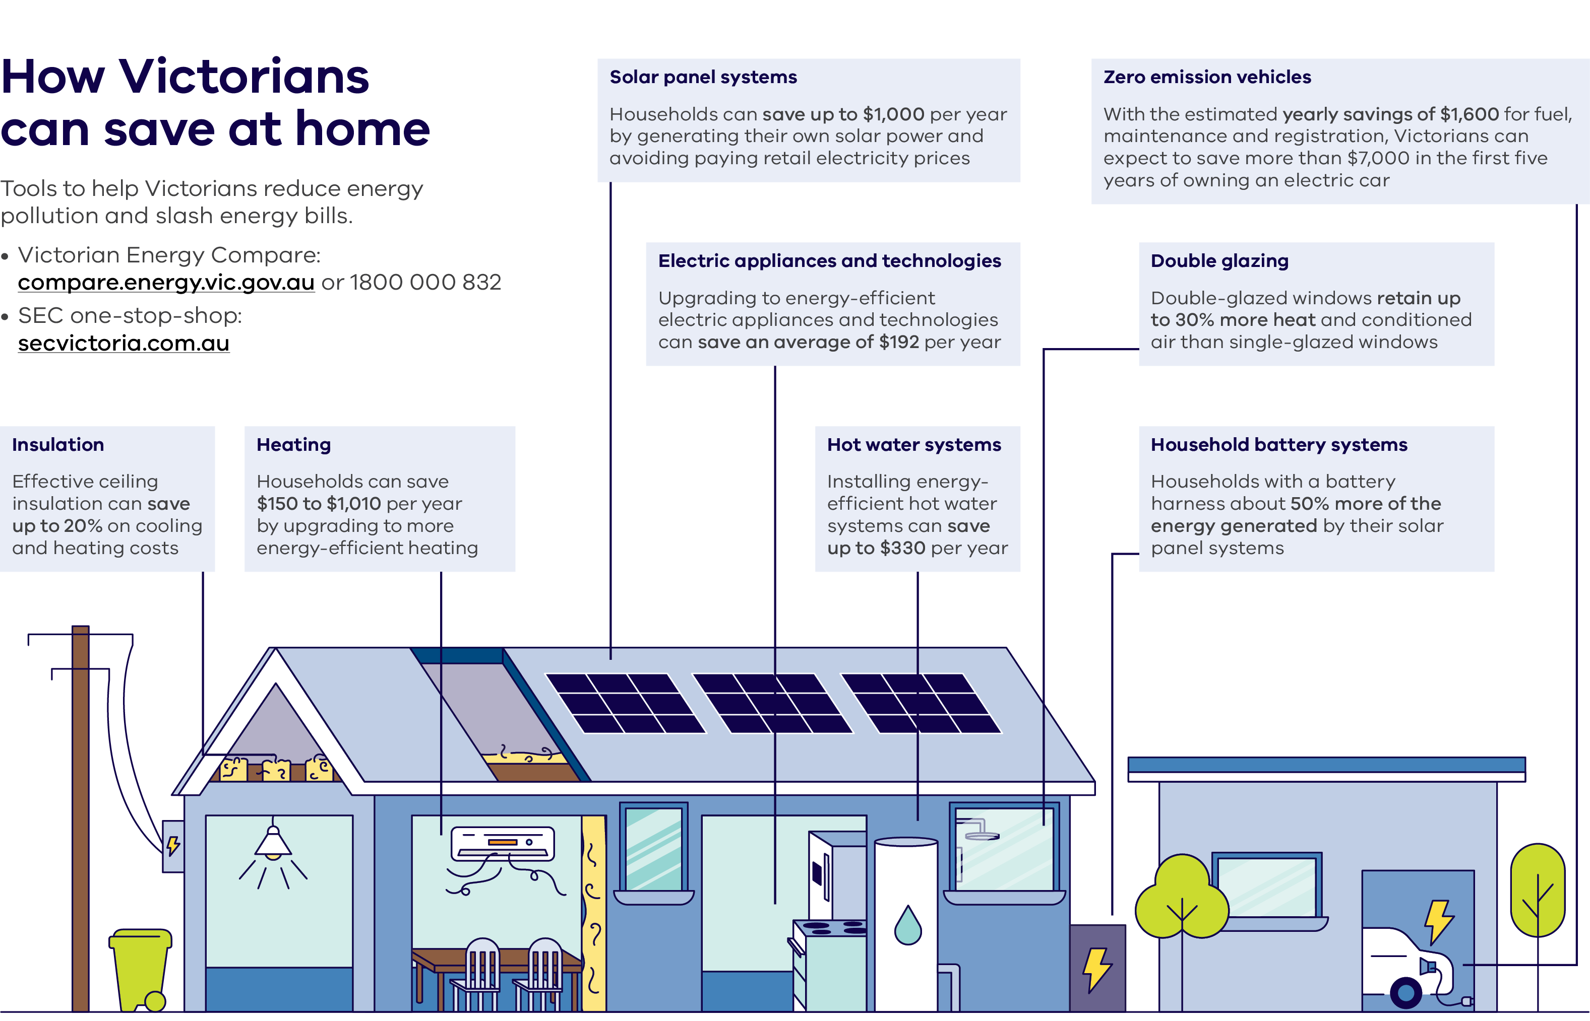

How Victorians can save at home
Tools to help Victorians reduce energy pollution and slash energy bills.
- Victorian Energy Compare: compare.energy.vic.gov.au or 1800 000 832
- SEC one-stop-shop: secvictoria.com.au
Energy-efficient, cost saving features for Victorian homes include:
- Insulation – Effective ceiling insulation can save up to 20% on cooling and heating costs
- Heating – Households can save $150 to $1,010 per year by upgrading to more energy-efficient heating
- Solar panel systems – Households can save up to $1,000 per year by generating their own solar power and avoiding paying retail electricity prices
- Electric appliances and technologies – Upgrading to energy-efficient electric appliances and technologies can save an average of $192 per year
- Hot water systems – Installing energy-efficient hot water systems can save up to $330 per year
- Zero emission vehicles – With the estimated yearly savings of $1,600 for fuel, maintenance and registration, Victorians can expect to save more than $7,000 in the first five years of owning an electric car
- Double glazing – Double-glazed windows retain up to 30% more heat and conditioned air than single-glazed windows
- Household battery systems – Households with a battery harness about 50% more of the energy generated by their solar panel systems

Cheaper, more comfortable and resilient homes

Making homes more resilient
Inefficient homes cost more to heat and cool. We're taking action to ease that pressure.
Through the VEU program we're helping Victorians understand their energy use and supporting the uptake of energy-efficient appliances.
In 2026, the VEU will also re-introduce support for ceiling insulation – helping the 60% of households in Victoria that currently have no or insufficient insulation.
By upgrading to energy-efficient products Victorians can save money while making homes healthier to live in year round.
The Energy Efficiency in Social Housing Program will deliver over 50,000 upgrades across 23,600 properties, including replacing gas appliances with efficient electric alternatives, draught and gap sealing, ceiling insulation, gas disconnections and rooftop solar. The Victorian and Commonwealth Governments are contributing $209.4 million through this program and the Commonwealth Government’s Social Housing Energy Performance Initiative.

Raising standards for climate-proof homes
In a nation-leading measure, Victoria introduced new minimum rental standards in 2025. These will deliver cheaper, cleaner and more comfortable home energy for millions of Victorians. One-third of Victorians are renters, and we know that every dollar counts.
From 1 March 2027, standards will require draught proofing, efficient shower heads, energy-efficient cooling and heating, and ceiling insulation.
Also from 1 March 2027, gas hot water systems at end-of-life must be replaced with efficient electric alternatives.

Affordable and sustainable transport for everyone
More than 2,100 new train services since 2014 and 9,400 extra bus services since 2021

Investing in public transport
Our significant investments in public transport will keep Victorians moving for decades to come – reducing congestion and emissions, boosting productivity and making it easier for people to get around.
Melbourne's trains and trams are powered with 100% renewable energy retailed by the SEC. We're now focusing on creating a cleaner, smarter bus fleet – new transport buses will be purchased as zero emission buses in accordance with the Zero Emission Bus Transition Plan.
We've invested $988 million to improve our train and bus network across the state. This means a cleaner, more frequent and better service for our growing communities.
We are also delivering free public transport for under 18s, as well as free statewide travel for seniors on weekends.
The Metro Tunnel is the biggest transformation of Melbourne’s rail network in more than 40 years and frees up space in the City Loop to run more trains, more often, on more lines.
- Enabling 500,000 more low-emissions passenger trips per year
- Five new world-class underground train stations
- Powered with 100% renewable energy retailed by the SEC
- Better access to education, hospitals, housing and jobs
- 8,700m² of new green space and more than 500 new trees in and around station precincts will create cool, green and inviting spaces

Encouraging walking and riding
Short car trips cost households money and congest our roads. But many of these trips can be replaced by walking or riding.
We've set a target of 25% of trips made by active transport by 2030. New, safer riding routes and pedestrian-friendly streets mean Victorians will be able to keep the car at home, stay healthy and save money.

Supercharging our zero emission vehicles future
In 2021 we set a target for 50% of new light vehicle sales by 2030 to be zero emission vehicles (ZEVs). At the time, ZEVs made up 1.7% of new sales. We're now well on our way to meeting that target, with ZEV sales rising to 13.6% in September 2025, and Victoria having the highest share of any Australian state in the first half of 2025.
With the estimated yearly savings of $1,600 for fuel, maintenance and registration, Victorians can expect to save more than $7,000 in the first five years of owning an electric car.
By 2035 all Victorian Government passenger cars and vans will be ZEVs. This will reduce operating costs and emissions, while growing Victoria’s second-hand ZEV market, helping Victorians make the switch.
We've delivered 410 km of new and upgraded walking and riding paths and lanes since 2015

Putting jobs and workers first in the transition
Victoria is one of the best places to live and work, with world-leading capabilities and a highly skilled workforce.
Strong climate action means Victoria will see more jobs – jobs for the future, spread across all corners of the state.

Creating more jobs for Victorians
Since 2014 Victoria has had the highest jobs growth in the country – nearly one in four jobs today were created in that time – while meeting our nation-leading climate targets

New economic opportunities
Over the past decade, Victoria has led other states in real economic growth, and business investment growth.
The Economic Growth Statement lays out our actions for a stronger economy and a stronger future, and our Industry Policy provides the framework to drive competitiveness and productivity, and build economic resilience. This protects existing strengths and positions Victoria to seize key opportunities, such as critical minerals processing, renewable energy supply chains and the circular economy.

Boosting investment
The $150 million Victorian Investment Fund will boost business investment and expand priority sectors, creating jobs and cementing Victoria as the place to do business. It includes a $50 million regional stream dedicated to supporting fast-growing businesses to enhance economic development, generating capital investment and new jobs in regional cities and towns.

More jobs in local industries
Victoria's energy workforce is expected to grow by more than 60% between 2025 and 2040, powered by our once-in-a-generation investment in the renewable energy transition.
The forthcoming Victorian Energy Jobs Plan and the Women in Energy Strategy will collectively call on the energy industry, education and training sector, and governments to collaborate in tackling workforce challenges related to the energy transition. This builds on our support in the last strategy to upskill and support workers to take on clean energy jobs.

Local critical minerals and rare earths jobs
Victoria's first Critical Minerals Roadmap aims to attract world-class minerals development and investors, while maintaining strong environmental standards and empowering local communities. It's a generational opportunity to establish well-paid, skilled jobs in regional Victoria and secure a world-leading role in a supply chain that is essential to the renewable energy transition.
Our energy workforce is projected to grow to 67,000 workers in 2040
Figure 6: Renewable energy jobs across the state
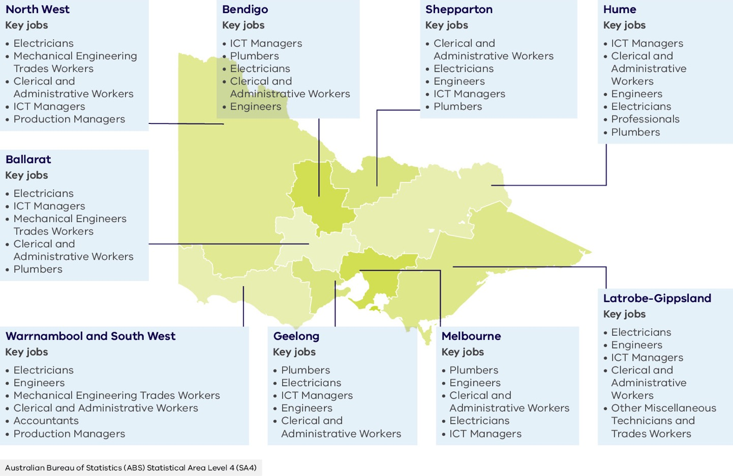

Renewable energy jobs across the state
Table 3: Renewable energy jobs across the state, specified by region
Region | Key jobs
North West | - Electricians  - Mechanical Engineering Trades Workers  - Clerical and Administrative Workers  - ICT Managers  - Production Managers
Bendigo | - ICT Managers  - Plumbers  - Electricians  - Clerical and Administrative Workers  - Engineers
Shepparton | - Clerical and Administrative Workers  - Electricians  - Engineers  - ICT Managers  - Plumbers
Hume | - ICT Managers  - Clerical and Administrative Workers  - Engineers  - Electricians  - Professionals  - Plumbers
Ballarat | - Electricians  - ICT Managers  - Mechanical Engineers Trades Workers  - Clerical and Administrative Workers  - Plumbers
Warrnambool and South West | - Electricians  - Engineers  - Mechanical Engineering Trades Workers  - Clerical and Administrative Workers  - Accountants  - Production Managers
Geelong | - Plumbers  - Electricians  - ICT Managers  - Engineers  - Clerical and Administrative Workers
Melbourne | - Plumbers  - Engineers  - Clerical and Administrative Workers  - Electricians  - ICT Managers
Latrobe-Gippsland | - Electricians  - Engineers  - ICT Managers  - Clerical and Administrative Workers  - Other Miscellaneous Technicians and Trades Workers
Source: Australian Bureau of Statistics (ABS) Statistical Area Level 4 (SA4)

Investing in a skilled and inclusive workforce
With workforce development programs tailored for critical areas, fulfilling career pathways are being created for young people and mid-career workers alike.

Supporting women in energy
The Women in Energy Strategy will support the full participation of women in Victoria’s renewable energy transition, addressing their historically low representation in the sector.
The strategy will bring together industry, education, government, and stakeholders to tackle the key barriers facing women in the energy workforce.

Driving energy jobs and growth with the SEC
To date, the SEC has invested in 819 MW of new generation and storage capacity, including the Melbourne Renewable Energy Hub and SEC Renewable Energy Park in Horsham. Together, these projects will deliver enough energy to power around 250,000 homes and create more than 400 full-time equivalent jobs during peak construction.

Upskilling and reskilling trades
We’re extending Solar Victoria’s training program over the next three years. The program trains plumbers in heat pump installation, upskills the construction industry to deliver 7-star all-electric homes and mentors electricians working on rooftop solar installations and electrification.
We’re also partnering with the Commonwealth Government and Plumbing Industry Climate Action Centre to support the $40 million National Training Centre in New Energy Skills to reskill thousands of plumbers and gas fitters.

Latrobe Valley’s renewable energy future
We’ve worked with local businesses, industry groups, schools, training providers and the community in the Latrobe Valley to help navigate economic changes, starting with our support during the closure of Hazelwood Power Station in 2017. Since 2017, we've invested more than $1.6 billion in programs and major infrastructure projects that have created jobs and improved local services, resulting in thousands more workers in Gippsland.

Partnering with the TAFE sector
Through Free TAFE and Skills First, we’re providing fee-free or government-subsidised access to training pathways into clean economy jobs.
The $50 million TAFE Clean Energy Fund is also establishing Clean Energy Centres at TAFEs in Morwell, Warrnambool and the Asia Pacific Renewable Energy Training Centre in Ballarat.

Growing knowledge and skills in agriculture
We’re collaborating with industry to help farmers reduce emissions, enhance productivity, and improve climate resilience. This includes partnering with industry, supply chains and the Zero Net Emissions Agriculture Cooperative Research Centre to provide outreach and services that build capability on reducing emissions and carbon farming, and to demonstrate solutions on-farm.

Helping industries towards a net zero future
We’re positioning Victoria to be a leader in low-carbon production by leveraging our affordable and reliable energy supply, industrial capabilities, natural resources, skilled workforce and research expertise.

Supporting a profitable and productive agriculture sector
Victoria is Australia’s largest agricultural exporter and has its largest workforce, supporting over $20 billion in annual exports and around 150,000 jobs. We're driving innovation in agriculture by investing in research and commercialisation of new technologies. This boosts farm productivity, supports export competitiveness and positions Victoria as a leader in climate-smart production.

Building Victoria's circular economy
Shifting to a circular economy will boost our state’s economy by up to $6.7 billion, help to create more than 3,900 new jobs, and establish new skills in design, repair and materials usage across Victoria.

Decarbonising freight
Victoria's freight contributes $36 billion to the state's economy and supports 240,000 jobs – more than any other state. Victoria Delivers is our new plan released in 2025 to meet the challenge of growing freight volumes with actions to build the foundation for a low-carbon future. It provides a clear and aligned roadmap for investment confidence in low emission vehicles and technology, and encourages the use of more freight on rail to lower emissions, traffic and road trauma, and improve productivity.

Sustainably growing Victoria’s plantation estate and supporting farm forestry
Backed by $190 million, we're supporting projects ranging from large-scale industrial plantations to integrated farm forestry. This includes the $120 million Gippsland Plantations Investment Program – the largest single investment in plantation establishment in Victoria’s history which will underpin 2,000 new and existing jobs in regional Victoria.
The Victorian Plantations Support Program and Trees on Farms Program are building the foundations for integration with agriculture, increasing adoption and market access for farm-grown timber and supporting greater uptake for carbon storage on private land.

Building for the future
The choices we make today about how we power our homes and industries, design our communities and build our infrastructure will shape the future of Victoria for generations.
That's why we're planning and building with purpose: to create a more sustainable, connected and climate-resilient state.

Delivering a historic investment in renewable energy
Affordable energy is the backbone of our economy – it's critical to almost everything we do. As Victoria transitions from ageing, unreliable brown coal, we must build a balance of renewable generation and storage to keep our electricity system stable and sustainable.
Victoria has met every renewable energy target it has set to date. Achieving our targets drives economic activity across the state contributing to new energy industries and more local jobs.

Renewable electricity generation
- 40% by 2025 (42% renewable electricity in 2024–25)
- 65% by 2030
- 95% by 2035

Energy storage capacity
- At least 2.6 GW* by 2030
- At least 6.3 GW by 2035

Offshore wind energy
- At least 2 GW by 2032
- 4 GW by 2035
- 9 GW by 2040

Transforming Victoria’s electricity sector

Building large-scale energy storage to support renewables
Victoria is already the home of big batteries. These batteries improve the reliability of Victoria’s electricity system by providing vital energy storage.

A planned and orderly transmission network
The Victorian Transmission Plan is about building the new energy infrastructure we need to keep the lights on, as coal closes. It proposes the creation of renewable energy zones that signal to the community, landholders, and industry where new energy infrastructure should be developed.

Bringing back the SEC
The SEC is a government-owned renewable energy company that is investing in renewable energy generation and storage projects that help Victorians reduce their energy bills. We've allocated an initial $1 billion towards delivering 4.5 GW of new renewable generation and storage projects by 2035. Almost 20% of this target, 819 MW, is already being built.

Developing our offshore wind energy industry
Victoria is building a thriving offshore wind sector, leading the way for Australia’s first offshore wind energy projects. We've established Offshore Wind Energy Victoria to unlock the state's world-class offshore wind resource.

Closing coal-fired generation
We're providing market certainty for new renewable investment with agreed closure timelines for coal-fired power plants. This certainty will help secure investment for replacement renewables and energy storage, keeping us on track to meet our renewable energy targets.

Improving planning and approval processes
We're fast-tracking the transition to cheaper, cleaner renewable energy by streamlining planning and approval processes.

Planning for our sustainable future

Guiding sustainable growth
Our long-term vision sets a path for growth that protects the environment, strengthens communities and builds resilience to future challenges. We're planning for cities and towns to adapt to climate change by focusing on sustainable building and urban design that makes homes and workplaces more liveable.
In 2025 the Victorian Government released the Plan for Victoria, and the Activity Centres Program. Everyone should have the opportunity to live in a well-designed home, at an affordable price, in a place they can thrive. That's why we’re planning for homes in and around 60 train and tram zone activity centres, encouraging more than 300,000 homes to be built close to public transport, jobs and services.
Together, these measures set Victorians up to live in communities which aren't just more sustainable, but also cheaper to live in, by providing more homes in areas with better access to walking, cycling and public transport.

Planning and managing for climate resilience
We're investing early to embed climate resilience into our planning, design and construction to improve infrastructure and keep Victorians safe.
Recent reforms of the Planning and Environment Act 1987 require climate change to be considered when preparing or amending planning schemes.
We're already taking direct action for a more climate resilient environment, through programs such as More Trees for a Cooler Greener West.
We're also seeking to embed climate considerations into government budget and procurement processes, and undertake departmental climate risk assessments to provide more resilient and reliable services to Victorians.
In 2025, the Victorian Government released its second Climate-related Risk Disclosure Statement. This builds transparency and supports the public to understand the Government’s approach to identifying managing climate-related risks and opportunities.

Powered by the SEC
From July 2025, the SEC is powering 5% of Victoria’s electricity market. It is retailing 100% renewable electricity to the Victorian Government. This includes everything from metropolitan and regional hospitals to some of Victoria’s most iconic and loved places like Flinders Street Station, Werribee Open Range Zoo, and the Royal Botanic Gardens.

Protecting our kids, families and communities
Nothing is more important than providing a better future for our kids.
Climate change is already being felt across Victoria, but we know that future generations will feel it more. Our climate actions protect them now and tomorrow.

Improving health and wellbeing

Tackling climate change and its health impact
In Victoria, around half the population has already experienced climate-related health impacts such as heat-related illness. Climate change is also impacting mental health and wellbeing, especially among young people and communities that face increased stress, anxiety and trauma related to environmental changes.
We're taking a coordinated, whole-of-system approach to climate and health in collaboration with partners across government, health and community sectors.
The Victorian Public Health and Wellbeing Plan 2023–27 recognises climate change and its impact on health as a key priority. We're taking action by reducing emissions to limit long-term health risks, building resilient communities that can adapt to climate-related challenges like extreme heat and poor air quality, and providing targeted support for those who need it most. The plan also highlights the shared benefits of climate and health action, particularly in areas like healthy eating and active living.

Driving climate action across public health
Climate Health Victoria (CHV), part of the Department of Health, is leading climate action across Victoria’s public health system. We're supporting partners to cut emissions, improve health and wellbeing and deliver high-value care.
CHV also helps health organisations prepare for climate risks through practical tools and advice, including a climate risk toolkit and a partnership with the Victorian Aboriginal Community Controlled Health Organisation to assess climate risks and identify opportunities to strengthen infrastructure.

Greening Victoria's health system
We're investing $40 million in the Energy Efficiency and Solar Program to install solar panels and improve energy efficiency in public hospitals, aged care facilities, and ambulance stations. By installing over 7,200 kw-peak of rooftop solar we're helping to reduce costs and emissions in our health system.

Strengthening the natural environment for future generations
From forests and rivers to coastal habitats, Victoria’s natural environments store carbon, protect biodiversity, and sustain our way of life. They're home to our unique plants and animals, and offer spaces for people to connect with nature.
That’s why we’ve invested nearly $800 million since 2014 – the largest biodiversity investment in Victoria’s history – to protect and restore these precious places for generations to come.

Greening urban spaces
We’re committing over $20 million to plant one million trees across Melbourne through the More Trees for a Cooler, Greener West and More Trees in Melbourne programs. These initiatives provide shade, expand green spaces, reduce pollution, and help combat urban heat.

Restoring native ecosystems
The BushBank Program is restoring over 20,000 hectares of native vegetation by 2035, enhancing biodiversity, storing carbon, and creating economic opportunities for Traditional Owners.

Regenerating forests
The Future Forests Program is providing $40 million to regenerate 1,200 hectares of native forests, manage pests, improve fire ecology and support research on ecological thinning to improve climate resilience.

Shaping marine futures
We’re investing $1.84 million to prepare for our participation in blue carbon markets by mapping coastal ecosystem health, identifying restoration opportunities, and trialling new techniques. A Blue Carbon Statement will drive coordinated action and attract private investment.

Supporting kids and schools

Sustainable schools
Our schools are embracing sustainability programs and building environmental sustainability into their lessons.
Our early childhood services are helping kids to care for the environment and build wellbeing practices into their daily routines.
Through the ResourceSmart Schools program, schools get practical support to reduce emissions, water and waste, save on bills, connect to the environment and share lessons beyond the school gate. We're also helping schools install solar panels through our Greener Government School Buildings Program to generate renewable energy, reduce their greenhouse gas emissions and save on their power bills.

Bush kinders
Bush kinders provide children with opportunities to learn and play in nature, while fostering care and understanding for environmental sustainability as they grow and develop.

Teaching students about future climate‑ready careers
Teachers are supporting students to learn about climate action and future‑focused careers.
The Clean Energy Equipment Fund helps tech schools to purchase the high-quality equipment and develop learning programs to teach students about careers in renewable energy.
The SEC is also leading a student education program to inform, inspire and empower students to take part in the energy transition and the opportunities it brings, providing practical examples of jobs and career pathways.

Improving disaster and emergency management

Strengthening resilience
As Victoria faces more frequent and intense extreme weather events, we’re investing in stronger emergency services, recovery support and tools to reduce risk before disasters strike.
This includes boosting firefighting resources, maintaining critical bushfire and emergency assets, and improving emergency management information and early warning systems to keep communities safe, informed and empowered to act.
We’re also supporting local resilience so businesses and communities can recover more quickly and cost-effectively.

Climate-ready practices and preparations
We’re incorporating future climate scenarios into emergency management planning and updating climate vulnerability assessments. Bushfire risk assessments are improving our strategic land use planning, and adaptation options are being developed for property and assets impacted by coastal hazards and sea level rise.
Our Code of Practice for Bushfire Management on Public Land 2025 supports the efficient, effective, integrated and consistent management of fire and fire-related activities on public land.
Through this, we’re protecting human life, health, residential property, critical infrastructure, community assets and the natural environment while increasing community resilience and healthy ecosystems.

Protecting Victoria’s water system
With drier conditions and growing flood risks, protecting our water system remains a priority. We’re funding the Maintaining water cycle climate action: Becoming net zero and disaster ready program to implement the Water Cycle Adaptation Action Plan to reduce the vulnerability of the water system to climate-related risks.
We’re also reducing flood risk through the continued rollout of the Victorian Floodplain Management Strategy and 10 regional strategies.

Protecting energy supply in the face of extreme weather
We've supported the installation of energy backup systems at community hubs, essential service sites and key local businesses in 27 towns, which consists of:
- energy resilience solutions in 24 towns
- Community Microgrids and Sustainable Energy Program projects in three towns.
An energy back-up system consists of solar PV, battery storage and generators managed by a smart controller. This allows a property to have power during outages, giving residents continued access to information, hot water, and device charging.
Our 100 Neighbourhood Batteries Program has also expanded its scope to support energy resilience. Eligible applicants can access grants of up to $400,000 per battery project for energy back-up systems that will increase energy resilience in their community.

Council pledges
Victorian councils are delivering ambitious climate action policies to reduce Victoria's emissions and support local communities to respond and adapt to climate change.
Find out more about local council actions at:
climatechange.vic.gov.au/local-government/council-pledges.

Progressing self-determination
The Victorian Government acknowledges the diversity of Traditional Owner communities across Victoria, whose cultures are as rich and unique as the lands for which they are custodians.
Over generations, Traditional Owners have maintained their strong spiritual connections to land, to waters, to the skies and all the living things and natural resources, which are collectively known as Country.
The Victorian Government’s Water is Life Roadmap recognises the intrinsic connection to Country and the significant cultural and ecological knowledge of how to care for Country. It provides a pathway to deliver thriving cultural economies, and benefits for Traditional Owners and all Victorians.
Victoria’s transition to net zero creates opportunities for Traditional Owners to share in the benefits of emerging industries, including new revenue streams, employment, capacity building and renewable energy sources for communities.
Through initiatives like the BushBank Program and the First Peoples' Adoption of Renewable Energy Program, the Victorian Government continues to embed self‑determination and support Traditional Owners to achieve their goals for Country.

Supporting Traditional Owners and their climate action goals
The Traditional Owner Climate Action Grants Program has provided $1.1 million for Traditional Owners to build capability and capacity to care for Country and meet a range of on-the-ground climate action needs. This program recognises that each Traditional Owners Corporation has distinct climate action priorities and objectives.

Yoorrook Justice Commission
The Yoorrook Justice Commission (the Commission) was Australia's first formal truth-telling inquiry into historic and ongoing systemic injustices perpetrated against Traditional Owners through colonisation. Over four years, thousands of Victorians took part and shared their truths with the Commission through written submissions, testimonies and witness statements.
In July 2025, the Commission delivered its final reports and recommendations. The Commission noted how the impacts of climate change on Traditional Owners are acute and extend to health and wellbeing, housing, energy security, cultural and spiritual wellbeing, and capacity to live on and care for Country. The Commission also noted the impacts of climate change to Country – of the changes in season, loss of animal populations, changes in animal behaviour, damage to water systems and increased risk of climate emergencies.
The Commission considered Victorian Government engagement and partnership with Traditional Owners and Aboriginal Communities to be a crucial element in Victoria’s transition to a net zero and climate resilient state. Genuine partnership is necessary to ensure that Traditional Owners can benefit from the opportunities created by the transition and progress their climate priorities in line with self-determination principles.
The Victorian Government acknowledges the Commission's recommendation for the development of a First Peoples' Climate Justice Strategy. The Victorian Government will seek to advance Traditional Owners' objectives and priorities. The Victorian Government shares the Commission’s goals of truth and justice and will carefully consider the Commission’s findings and recommendations before delivering a formal response.
“First Peoples’ knowledge is critical to pathways to mitigate and adapt to climate change and help heal Country. First Peoples are willing to share this knowledge for the benefit of all. To enable this, the State must ensure that First Peoples have the power, authority, control and resources to engage in a self-determining process.”
Yoorrook Justice Commission,
Yoorrook for Transformation:
Third Interim Report (2025) p.397
Find out more about the Yoorrook Justice Commission: yoorrook.org.au.

Next steps
Communities, businesses and governments all have a part to play in reducing emissions and building climate resilience.
We will continue to lead the way, building on the actions in this strategy to create a prosperous, fair and strong Victoria.
The Climate Action Act 2017 provides a strong set of milestones to plan for and implement climate action.
Table 4: Milestones to plan for and implement climate action
Year | Milestone
2026 | Adaptation Action Plans 2027–31
2027 | End of interim target period 2021–25 report
2028 | Set Victoria’s emissions reduction target for 2040
2029 | Victoria's Climate Science Report 2029
2030 | Victoria's Climate Change Strategy 2031–35

New Adaptation Action Plans

Our vision for a climate resilient Victoria
- Households and communities have the knowledge and capability to manage climate impacts
- Victoria's industries and workforces have the skills and resources to support a thriving economy and manage climate impacts
- Victoria's infrastructure and settlements can withstand climate impacts
Victoria's natural environment is valued and healthy

Our priorities will shape the new plans
Being prepared in 2026, the Adaptation Action Plans 2027–31 will be shaped by this strategy and underpinned by our commitment to support self-determination for Traditional Owners, to care for Country and culture in a changing climate and to benefit from the transition.

Helping households with the cost of living and lowering costs for business
- Focus on the most at-risk individuals and communities and support them to reduce their vulnerability and exposure to climate impacts
- Provide information and advice to households and communities to manage climate risks and seize opportunities

Building for the future
- Focus on the most at-risk assets and services and implement risk mitigation strategies, including feasible opportunities to build back better or support managed transition
- Ensure planning, design, location and procurement standards for new assets and services seek to minimise climate risks

Putting jobs and workers first in the transition
- Focus on the most at-risk critical industry sectors and workforces and support them to reduce their vulnerability and exposure to climate impacts
- Provide information and advice to industries and businesses to manage climate risks and seize opportunities to build a climate resilient economy

Protecting kids, families and communities
- Support emergency management and preparedness for more frequent and intense climate-related events
- Focus on climate-related risks to Victoria’s natural environment and implement strategies to maximise biodiversity conservation and support ecosystem services
- Support nature-based solutions that connect Victorians to the natural environment, reduce emissions and build climate resilience

Appendix: Reporting on Victoria’s Climate Change Strategy 2021–25
We've reduced emissions by 31.4% since 2005 – from 122.7 to 84.2 Mt CO₂-e. That’s within the range of our 2025 target of 28–33%.

Delivering on the strategy
Victoria's Climate Change Strategy 2021–25 set out the pathway to achieving net zero emissions and building resilience to the impacts of climate change. The strategy:
- established ambitious 2025 and 2030 targets
- outlined the state’s plan for reducing emissions
- set out a vision and priorities for a more climate resilient Victoria.
Over the last five years, we have reduced emissions; driven the transition to renewable energy while creating jobs and reducing energy bills; helped industry, agriculture and transport to start decarbonising; and supported vital infrastructure, services, industries, and environment to adapt to climate change.

A strong foundation for more action
We built on Victoria's Climate Change Strategy 2021–25. Since its release we've legislated Victoria’s 2025, 2030 and 2035 emissions reduction targets, brought forward net zero to 2045, and put in place strong renewable energy generation, offshore wind and energy storage targets.
We've made major policy announcements that advance Victoria's climate action legacy, such as bringing back the SEC, and Australia's first Gas Substitution Roadmap.
In 2022, we released our first Adaptation Action Plans across seven systems with over 120 actions to build our climate resilience. A report on these plans will be released with the Adaptation Action Plans 2027–31.
Find out more: climatechange.vic.gov.au/victorias-climate-change-strategy

Our strategy delivered real benefits

A clean energy economy
- Set strong renewable energy targets: 65% by 2030 and 95% by 2035
- Brought back the SEC: investing $1 billion into new public renewable energy and storage projects
- Supported jobs: nearly 4,000 through the Victorian Renewable Energy Target and Victorian Energy Upgrades program
- Created new skills: trained more than 6,000 workers in renewable energy and energy-efficient technologies through Solar Victoria
- Led by example: 100% of electricity supplied by the SEC for Victoria's public schools, hospitals, trains and other government operations is from renewable sources

Innovation for the future
- Funded innovation: offshore wind projects, renewable hydrogen and zero emission farm equipment
- Launched zero emission buses: began replacing our diesel bus fleet with zero emission buses, with 88 rolled out to date
- Released and updated: the Gas Substitution Roadmap

Resilient farms and forests
- Planted trees: 3.5 million seedlings planted for plantations and 2,700 hectares of habitat planted under the BushBank Program
- Helped farmers reduce emissions: worked with 250 farm businesses to estimate, understand and reduce their on-farm emissions

Climate smart businesses and communities
- Powered homes with solar: installed over 400,000 solar PV, hot water and battery systems through the Solar Homes Program
- Improved home energy efficiency: over 2.4 million households have participated in the Victorian Energy Upgrades program since 2009 and have saved over $2 billion on their energy bills
- Upgraded business energy efficiency: saved businesses an average of $3,700 on annual energy bills through the Victorian Energy Upgrades program
- Recovered waste: 70% of all waste generated was recovered in Victoria as of 2023–24, among the strongest rate in the nation

A climate resilient Victoria
- Delivered home energy upgrades: over 22,000 under the Energy Efficiency in Social Housing Program
- Built back-up power systems: at community hubs, essential service sites and local businesses in 27 towns
- Protected our coasts: $13.8 million in 2023 to protect coastal communities

Glossary
Table 5: Glossary of terms used in this document and their definitions
Term | Definition
Aboriginal Community | Refers to and acknowledges all Aboriginal and/or Torres Strait Islander people living in Victoria. Community can be used to describe the entire Victorian Aboriginal and/or Torres Strait Islander Community or smaller specific Communities.
Adaptation Action Plans | The Victorian Government’s plans across seven systems to ensure Victoria’s climate resilience, now and in the future. The seven systems are: built environment, education and training, health and human services, natural environment, primary production, transport, and water cycle systems.
Climate adaptation | Action taken to reduce the adverse consequences of climate change or harness opportunities by building resilience now into our environments, our economy and society.
Climate change | Changes in the state of the climate, including an increase in the occurrence of extreme weather events, long-term changes in weather patterns and sea-level rise, attributed directly or indirectly to human activity.
Climate hazards | A natural or human-caused event or condition that may cause damage and loss.
Climate risk | The potential negative effects of a climate hazard, including environmental, societal and financial impacts, which includes consequences on lives, livelihoods, health and wellbeing, ecosystems and species, economic, infrastructure, services, social and cultural assets (IPCC, 2021).
Disaster | A serious disruption of the functioning of a community or a society at any scale due to hazardous events interacting with conditions of exposure, vulnerability and capacity, leading to one or more of the following: human, material, economic or environmental losses and impacts.
Extreme weather events | A weather event that is rare at a particular place and time of year. Examples of extreme weather events are heatwaves, bushfires, storms, floods and droughts.
First Peoples or First Nations people | Refers to peoples or nations of people connected to an area prior to colonisation. These terms have some general acceptance but may not be the term preferred by individuals or specific groups of Aboriginal and/or Torres Strait Islander peoples.
Fossil fuels | Non-renewable energy sources formed from the remains of plants and animals that were buried by layers of rock over millions of years. Common fossil fuels are coal, oil and natural gas.
Greenhouse gas emissions | The production of gases that trap heat in the Earth's atmosphere and contribute to global warming. Greenhouse gases include carbon dioxide, methane, nitrous oxide, hydrofluorocarbons, perfluorocarbons and sulphur hexafluoride.
GSP | Refers to Gross State Product, which details the total economic production of a state economy and is the state equivalent to Gross Domestic Product (GDP).
Mt CO₂-e | A unit of measurement that converts all greenhouse gases to a million tonnes of carbon dioxide equivalent.
Net zero | Achieving an overall balance between greenhouse gas emissions produced and greenhouse gas emissions taken out of the atmosphere.
Renewable energy | Energy that comes from resources that are continually replenished such as sunlight, wind, rain, tides, waves and geothermal heat.
Resilience | The ability of a system, community or society exposed to climate hazards to resist, absorb, accommodate, adapt to, transform and recover from the effects of a hazard in a timely and efficient manner, including through the preservation and restoration of its essential basic structures and functions through risk management.
SEC | The SEC is a government-owned renewable energy company that is investing in renewable energy generation and storage projects that help Victorians reduce their energy bills.
Traditional Owner | An Aboriginal and/or Torres Strait Islander person who has traditional connections to an identified geographical area of Country.
Zero emission vehicles (ZEVs) | Vehicles that do not use petroleum fuels and therefore do not emit greenhouse gas emissions from the tailpipe. Examples include battery electric vehicles and hydrogen fuel cell electric vehicles.

Publication information

Acknowledgements
We acknowledge and respect Victorian Traditional Owners as the original custodians of Victoria’s land and waters, their unique ability to care for Country and deep spiritual connection to it.
We honour Elders past and present whose knowledge and wisdom has ensured the continuation of culture and traditional practices.
DEECA is committed to genuinely partnering with Victorian Traditional Owners and Victoria’s Aboriginal community to progress their aspirations.

Copyright
© The State of Victoria Department of Energy, Environment and Climate Action, November 2025.

Creative Commons
This work is licensed under a Creative Commons Attribution 4.0 International licence, visit the Creative Commons website (http://creativecommons.org/licenses/by/4.0/).
You are free to re-use the work under that licence, on the condition that you credit the State of Victoria as author. The licence does not apply to any images, photographs or branding, including the Victorian Coat of Arms, and the Victorian Government and Department logos.
ISBN 978-1-76176-585-8 (pdf/online/MS word)

Disclaimer
This publication may be of assistance to you but the State of Victoria and its employees do not guarantee that the publication is without flaw of any kind or is wholly appropriate for your particular purposes and therefore disclaims all liability for any error, loss or other consequence which may arise from you relying on any information in this publication.

Accessibility
To receive this document in an alternative format, phone the Customer Service Centre on 136 186, email customer.service@delwp.vic.gov.au, or contact National Relay Service on 133 677. Available at DEECA website (www.deeca.vic.gov.au).
End of document.

All targets have been converted to common 2005 baseline for comparison.
CMIP6-based projections, under high emissions scenario (SSP3-7.0), compared to 1986–2005 baseline for temperature statistics and 1995–2014 baseline for sea level rise
780 MW operating and 1.8 GW of utility scale storage committed, not including households and neighbourhood batteries​

